Unique Gut microbiome signature with expression of microbial oncogenes among the breast cancer patients of India

Srinidhi Narayani Seenivasan1,2, Samrat Ashok Vasudevan1, Durairaj Karthika 1, Parthasarathy Ayothi1, Avinash Kumar Raghupathy3, Manoj Kumar Bhaskar3, Buvaneswari Gajendhran1, Gowdham Manivel1, Firoz Rajan4, Ezhil Selvan4, Jeevithan Shanmugam5, Sundaresan Mohanraj3,6, Arulraj Ramakrishnan1,3,7, Ganesan Velmurugan1,6*

¹Chemomicrobiomics Laboratory, Department of Biochemistry & Microbiology, KMCH Research Foundation, Coimbatore 641 014, Tamil Nadu, India.
²School of Chemical and Biotechnology, SASTRA (Deemed to be University), Thanjavur 613 401, Tamil Nadu, India.
³Cardio-Hepato-Renal and Metabolic Research Unit, Department of Biochemistry & Microbiology, KMCH Research Foundation, Coimbatore 641 014, Tamil Nadu, India.
⁴Department of Surgical Oncology, Comprehensive Cancer Center, Kovai Medical Center & Hospital, Coimbatore 641 014, Tamil Nadu, India.
⁵Department of Community Medicine, KMCH Institute of Health Science & Research, Coimbatore 641 014, Tamil Nadu, India.
⁶Central Research Laboratory, KMCH Institute of Health Science & Research, Coimbatore 641 014, Tamil Nadu, India.
⁷Liver Unit, Kovai Medical Center & Hospital, Coimbatore 641 014, Tamil Nadu, India.

*Correspondence:

Dr. G. Velmurugan M.Sc., Ph.D.,
Scientist
Chemomicrobiomics Laboratory
Department of Biochemistry & Microbiology
KMCH Research Foundation
Coimbatore 641 014
Tamil Nadu, India
Email: vel@kmchrf.org
Phone: +91 94434 62111

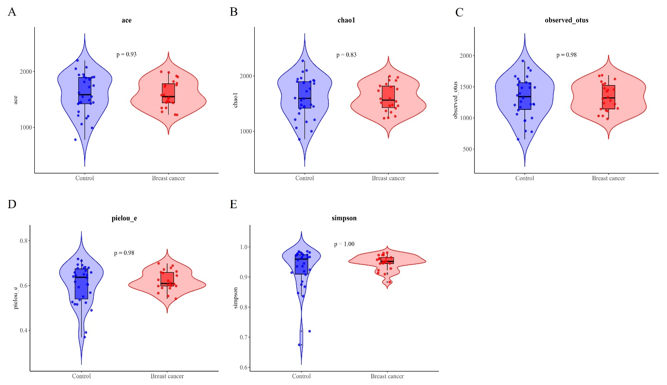

Supplementary Figure S 1: Additional alpha diversity indices of breast cancer patients and healthy controls. (A) ACE estimator (p=0.93), (B) Chao1 estimator (p=0.83), (C) Observed OTUs (p=0.98), (D) Pielou’s evenness (p=0.98), and (E) Simpson index (p=1.00). No statistically significant differences were observed for these indices across groups. Significance based on Wilcoxon rank-sum test * p < 0.05, ** p < 0.01, *** p < 0.001.

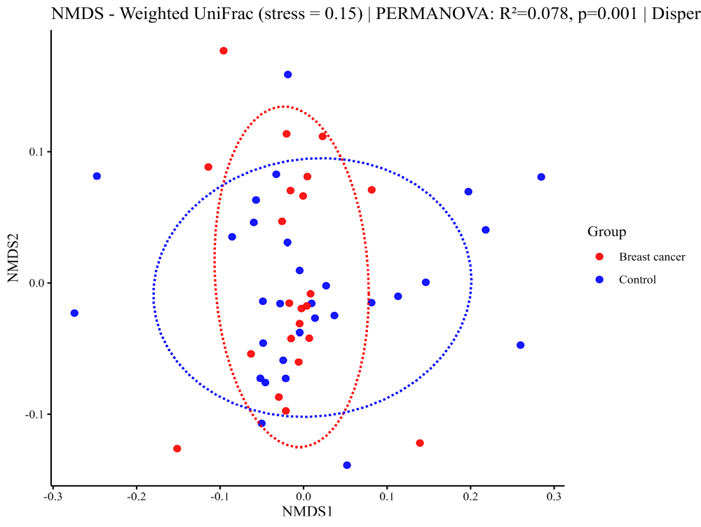
A

Supplementary Figure S2: Beta diversity analysis of breast cancer patients and healthy controls using weighted UniFrac distances. Non-metric multidimensional scaling (NMDS) ordinations are shown.

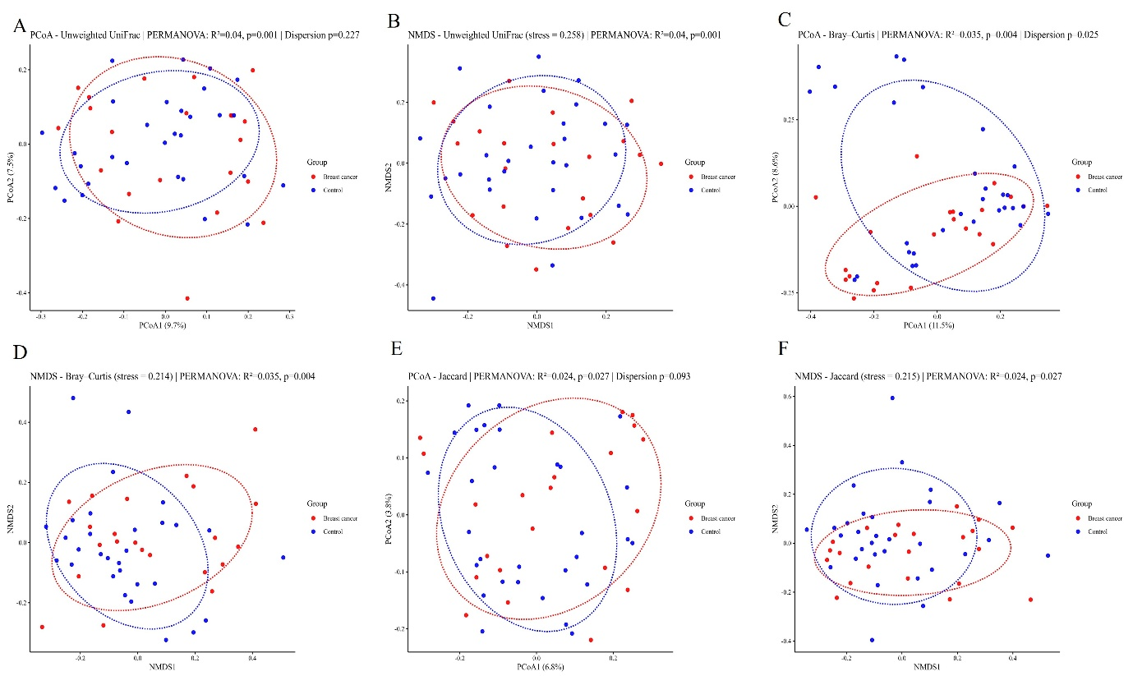

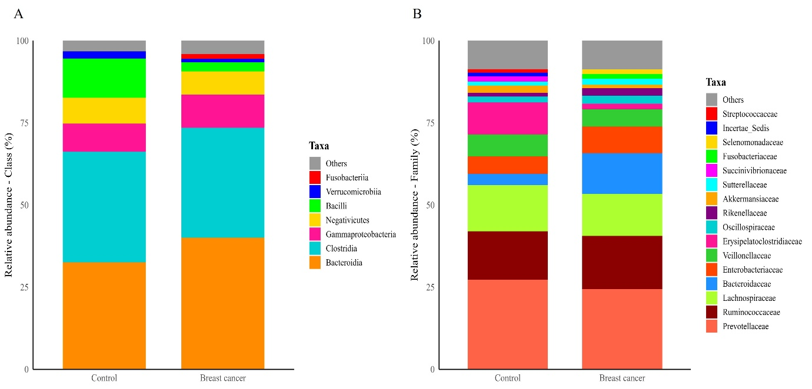
Supplementary Figure S3: Beta diversity analyses of breast cancer patients and healthy controls using alternative distance metrics. (A, B) Unweighted UniFrac, (C, D) Bray–Curtis, and (E, F) Jaccard distances are displayed as PCoA and NMDS ordinations.
Supplementary Figure S4: (A, B) Relative abundance of gut bacterial class and family in breast cancer patients and healthy controls.

