Supporting Information

Panel S1: Additional description of catch data
Fishermen were trained to record their fishing operations, where one datasheet represents one fishing day/date/set. When catch was landed, the count of all target species and bycatch was recorded as the total count along with the estimated weight (kg) for each day. Fishers also recorded the fate of each species groups. In addition to the primary targets (tuna and tuna-like species), other fish, invertebrate, and elasmobranchs were almost always retained. Sea turtles and dolphins were released, and some larger sharks and rays (e.g., mobulids) were sometimes released. Up to five individuals were randomly sampled from each species group, including sea turtles and dolphins if taken onboard, and length measurements were taken.
Catch species were recorded using the local names, some of which correspond to species and others to higher taxonomic groupings. Dolphins were not identified to the genus or species level in our translated dataset, but an earlier study of small cetacean bycatch that included photos taken by five of the captains found that the majority are spinner dolphins (Stenella longirostris), followed by common bottlenose dolphins (Tursiops truncatus), Indo-Pacific common dolphin (Delphinus delphis tropicalis), Risso’s dolphin (Grampus griseus), and pantropical spotted dolphin (Stenella attenuata) (Kiszka et al. 2021). These species are listed as globally Least Concern on the IUCN Red List (IUCN 2025). However, there is elevated concern for dolphins in the parts of the Indian Ocean–including Pakistani waters–partly due to fishing impacts, which are mostly unrecorded but likely substantial (Kiszka et al. 2021). We use the term “dolphin” as synonymous with “small cetacean” in the literature; technically, the much larger orcas (Orcinus orca) belong to the dolphin family.
For sea turtles, 17 individuals were identified as olive ridley turtles (Lepidochelys olivacea, globally Vulnerable), two as green turtles (Chelonia mydas, globally Least Concern) (IUCN 2025), and the remainder were not identified to species level. Like small cetaceans, sea turtles are a conservation concern in the northern Indian Ocean and Arabian Sea due to cumulative impacts, including substantial bycatch in fisheries, poaching, and other land-based threats that have reduced nesting populations substantially (Roberson et al. 2022; Al Ameri et al. 2022).
Dolphins and sea turtle interactions were always recorded as counts. Tuna and tuna-like species were meant to be recorded as the total count and the estimated weight (kg) of each species group, although counts were often missing. By frequency of capture (non-zero sets), the tuna and tuna-like group mostly consisted of dolphinfish (Coryphaena hippurus), yellowfin tuna (Thunnus albacares), billfish (Istiophoridae and Xiphias gladius), frigate tuna (Auxis thazard), longtail tuna (Thunnus tonggol), kawakawa (Euthynnus affinis), and skipjack tuna (Katsuwonus pelamis), 2) sharks and rays (elasmobranchii), and 3) other retained catch, which was dominated by queenfish (Scomberoides spp.) but included 38 additional catch groups or species: The majority were bony fish genera, with a few invertebrate and crustacean groups (eg squid, prawns).
Captains occasionally recorded sightings of species of interest. There were 351 bird sightings that were mostly unidentified, with some records of masked booby (Sula dactylatra) and shearwaters (Procellariidae). There were 138 cetacean sightings mostly unidentified dolphins or whale species, but a few humpback whales (Meganoptera novangalie) and one blue whale (Balaenoptera musculus) were identified to species level. Captains recorded four elasmobranch sightings (one unidentified mobulid, one unidentified shark, and two whale sharks, Rhincodon typus) and four sea turtle sightings. Sightings were clearly denoted in the logbooks in multiple ways, providing high confidence that bycatch records used in this analysis included only entangled individuals.
Panel S1 References
Al Ameri, Hm, S Al Harthi, A Al Kiyumi, et al. 2022. “Biology and Conservation of Marine Turtles in the Northwestern Indian Ocean: A Review.” Endangered Species Research 48 (May): 67–86. https://doi.org/10.3354/esr01183.
Anderson, RC, M Herrera, AD Ilangakoon, et al. 2020. “Cetacean Bycatch in Indian Ocean Tuna Gillnet Fisheries.” Endangered Species Research 41: 39–53. https://doi.org/10.3354/esr01008.
IUCN. 2025. “The IUCN Red List of Threatened Species.” Version 2025.2.
Kiszka, Jeremy J., Muhammad Moazzam, Germain Boussarie, Umair Shahid, Babar Khan, and Rab Nawaz. 2021. “Setting the Net Lower: A Potential Low‐cost Mitigation Method to Reduce Cetacean Bycatch in Drift Gillnet Fisheries.” Sec. 3111. Aquatic Conservation: Marine and Freshwater Ecosystems 31 (11): 3111–19. https://doi.org/10.1002/aqc.3706.
Roberson, Leslie A., and Chris Wilcox. 2025. “Fishery Bycatch Rates Largely Driven by Variation in Individual Vessel Behaviour.” Nature Sustainability 8 (8): 871–81. https://doi.org/10.1038/s41893-025-01602-z.
Roberson, Leslie, Chris Wilcox, Germain Boussarie, et al. 2022. “Spatially Explicit Risk Assessment of Marine Megafauna Vulnerability to Indian Ocean Tuna Fisheries.” Fish and Fisheries 23 (5): 1180–201.

SI Panel 2: Additional description of statistical analysis
To isolate the marginal effect of the captain from the key environmental and tactical variables influencing the catchability of dolphins and sea turtles, we used generalized additive models (GAMs) implemented in mgcv in R (Wood 2015). To determine the best model, we used the Akaike Information Criterion (AIC) in a stepwise procedure (Roberson and Wilcox 2025).
We first fitted a global model for each taxonomic group to capture variation in bycatch across individual gillnet sets, as a function of fishing practices and environmental conditions. Because the objective was to model variability in bycatch rates (entanglements) rather than mortality or effects on populations, the response variable was the count of bycaught individuals, and recorded life status was not included in the model. Each species model included a unique ID for the captain as well as factors they recorded, which are typical for models of bycatch or target catch rates, including the time and location of the set, season-month, year, and whether the net was set at the surface or the bottom (two captains briefly used bottom-sets instead of surface sets). The season-month was formatted as the chronological month of the fishing season, which begins in mid August after a closed season in June-July during the summer monsoon, and continues through mid-May when fishing effort begins to cease.
Missing records of haul location prevented inclusion of a drifting distance factor. The shift to sub-surface sets was not recorded in this expanded version of the dataset, precluding testing of this specific intervention. However, the year factor captures this and other changes in fishing practices over time, as well as potential changes in the abundance of bycatch species. Anecdotal information from program managers indicates that captains began switching to subsurface sets before the official resolution in March 2015. The program expanded over time to include more captains—with several joining in 2015—meaning the analysis does not capture changes in the performance of individual captains over time from a common baseline.
We included two categories of retained catch as predictor variables, which were recorded in kg: tuna and tuna-like species and all other retained catch. Total net area (number of panels multiplied by the length and drop of each panel) was included as an effort offset. Given the rarity of bycatch, we used a Tweedie distribution, a mixture of Poisson and gamma distributions, which effectively handles zero-inflated count data (Shono 2008). Tweedie distributions accommodate the strongly right-skewed and zero-heavy nature of bycatch counts while allowing continuous positive responses. Model residuals and smooth diagnostics were inspected to confirm adequate fit. Negative binomial distributions were explored during model development and yielded qualitatively similar inference and residual diagnostics; Tweedie models were retained due to marginally better fit and demonstrated performance with zero-inflated bycatch data in comparable fisheries applications (Shono 2008).
We then compared the global model that had all factors included, along with a term for the captain as a random effect, to the same model without the captain factor. If the random effect for captain improved the AIC score, we compared all possible combinations of factors using the dredge function from the mumin package (Barton 2015), selecting the model with the lowest AIC as the best model. If there were multiple models within a 95% confidence interval of the model with the lowest AIC (ΔAIC < 2), we selected the simpler one with fewer covariates. We assessed the importance of the covariates in the best models using the summed AICc weights from the dredge function in the mumin package (Barton 2015). Based off visual exploration of the raw data, we tested the best models with different variations of some predictor variables, including year, target catch, and set time as both continuous predictors and smooths. We re-ran the best models excluding nine observations where the set type (bottom or surface) was not recorded. Finally, we compared the best model to the same model with the captain factor excluded.
Captain identity was first included as a random effect to test whether meaningful heterogeneity in bycatch rates existed among captains. A significant random effect means that something about the individual captains as a group helps explain observed variations in bycatch, whereas a fixed effect tells us how individual captains drive high or low bycatch. We re-ran the best models for both bycatch species with the captain as a fixed effect with an additional penalty (“paraPen”) on the captain term (Wood 2015), to prevent estimates running towards infinity for captains with no recorded bycatch (five of the 13 captains had zero dolphin catch). Although all captains caught sea turtles, we applied the penalty to improve the coefficient estimates given the uneven sample sizes. Additionally, we used deviation contrast coding instead of the default treatment contrasts (Wood 2015). Deviation coding (also called sum or sum contrast coding) compares each level of the captain factor to the grand mean, which provides a better picture of the individual captains than the default setting where the reference is automatically selected as the first factor level (in sequential or alphabetical order). Additionally, we set the reference level to the only captain with data for all five years (Captain 2), which was also one of the captains with the most records overall. Importantly, the deviation coding setting does not change the fact that the reference level (one of the captains) does not receive a regression coefficient estimate because its effect is the baseline level for comparison. Here, we cannot calculate the “missing” regression coefficient from the intercept because the models included set type as a random effect.
We then conducted post-hoc comparisons between captains for each bycatch species using estimated marginal means (EMMs) in the R package emmeans (Lenth and Piaskowski 2025). We conducted pairwise contrasts of the captains’ EMMs using Wald tests with Tukey-adjusted p-values. Estimated marginal means allow pairwise comparisons between groups using a reference grid of factor level combinations, with each covariate fixed at its mean value. Comparing the regression coefficients and the EMMs within each model allowed us to compare each captain’s performance to the rest of the captains for each of the two species.
Finally, we explored whether captains with high bycatch of one species tended to have high bycatch of the other. To test this relationship between dolphin and sea turtle bycatch, we used two correlation tests. First, we calculated the Pearson’s correlation coefficient (r) between each species pair (each captain’s raw regression coefficients for dolphins and sea turtles). Then, to generate more robust estimates of the coefficients for each captain, we bootstrapped each estimate 1,000 times before calculating the mean Pearson’s coefficient and 95% confidence intervals for each species pair. We repeated this process for the EMMs.
Panel S2 References
Barton, Kamil. 2015. Package ‘Mumin.’
Lenth, R, and J Piaskowski. 2025. Emmeans: Estimated Marginal Means, Aka Least-Squares Means. V. R package version 2.0.0. Released. https://CRAN.R-project.org/package=emmeans.
Roberson, Leslie A., and Chris Wilcox. 2025. “Fishery Bycatch Rates Largely Driven by Variation in Individual Vessel Behaviour.” Nature Sustainability 8 (8): 871–81. https://doi.org/10.1038/s41893-025-01602-z.
Shono, Hiroshi. 2008. “Application of the Tweedie Distribution to Zero-Catch Data in CPUE Analysis.” Fisheries Research 93 (1–2): 154–62. https://doi.org/10.1016/j.fishres.2008.03.006.
Wood, Simon. 2015. Package ‘Mgcv.’

SI Figure 1: GAM smooth plots
- Dolphins
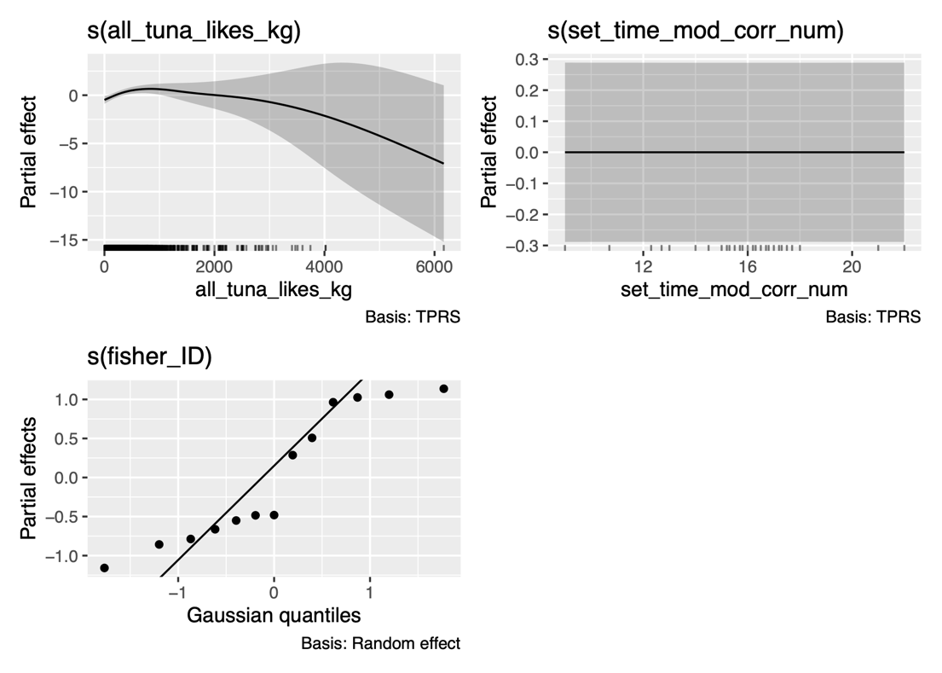
B) Sea Turtles
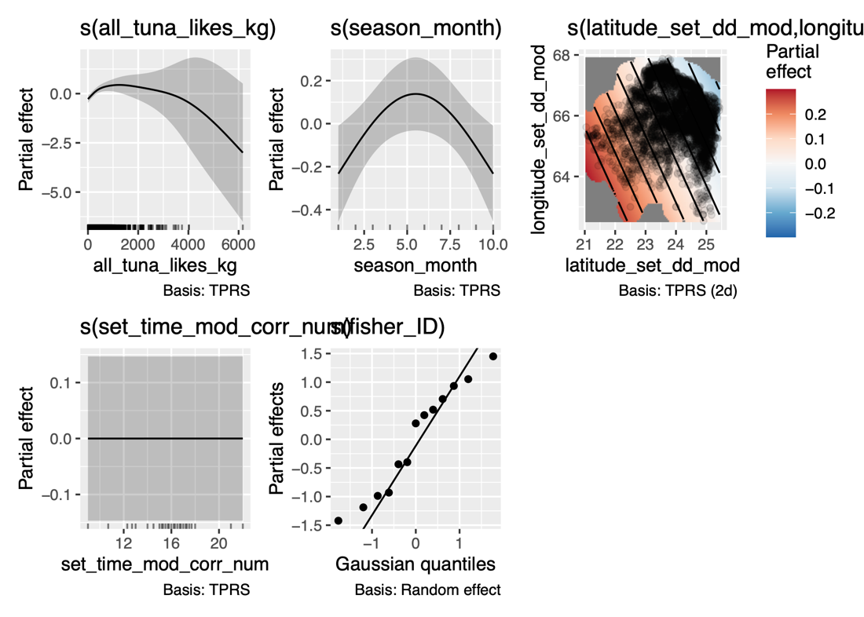
Figure S1: Smooth plots of the GAM outputs for predictors included in the best models of (a) dolphins and (b) sea turtles. Smooth plots show the relationship between bycatch rates (counts of dolphins or sea turtles per gillnet set) and the fitted nonparametric terms with 95% confidence intervals (grey shading). Season-month was included as the chronological month of the fishing season (August=1, May=10, June and July are closed seasons), fishing location as a 2-D spatial smooth, and the captain factor (“fisher_ID”) as a random effect. Time of day gear was set (“set time mod corr num”) improved the AIC of both models but was not significant. Of the smooth factors, tuna catch and captain were significant (p<0.05) for dolphins. Tuna catch, captain, season-month, and latitude longitude were significant for sea turtles.

