Table 1. Variable source, associated hypothesis, level of data, and inclusion in reduced model

 | Source: CGSS or NBSC | Associated with Hypothesis?
Zero Fertility Desire | CGSS: Without policy restrictions how many children do you want? | N/A (dependent variable)
Gender | CGSS: gender | Hypothesis 3,4,5
Rural Hukou | CGSS: what is your current household registration status? | Hypothesis 2
College | CGSS: what is your highest level of education? | Hypothesis 1
Student status | CGSS: what is your highest level of education? | Control
Parent College | CGSS: What is the highest level of education received by your father and/or your mother? | Control
Full time mom | CGSS: What is your mother’s employment status when you were 14? | Control
Has partner | CGSS: what is your marital status? (Married, cohabiting) | Control
Has sibling | CGSS: family members | Control
Has brother | CGSS: family members | Control
Subjective Income | CGSS: What do you think your family income compared to an average Chinese family when you were 15? | Control
Self-rated Health | CGSS: How do you rate your current health condition on a 5-point scale? | Control
Economic Region  (East==1, Middle==2,  Northeast==3,  West==4) | CGSS: interview location, provincial | Control

Table 2. Young adults with zero fertility desire, grouped by education (percentage)

Highest Education | 2012 | 2015 | 2017 | 2018 | 2021 | 2023
9 years or less | 10.23 | 6.17 | 11.03 | 12.47 | 12.43 | 5.78
Secondary 9+ | 22.50 | 38.38 | 31.58 | 29.87 | 23.15 | 19.05
Post Secondary 12+ | 67.27 | 55.46 | 57.4 | 57.65 | 64.42 | 75.15

Table 3. Young adults with zero fertility desire, grouped by Hukou status (percentage)

Hukou | 2012 | 2015 | 2017 | 2018 | 2021 | 2023
Rural | 33.91 | 43.79 | 61.53 | 47.07 | 45.11 | 61.63
Urban | 66.09 | 56.21 | 38.47 | 52.93 | 54.89 | 38.37

Table 4. Logistic Regressions of Zero Fertility Desire, Odds Ratios.
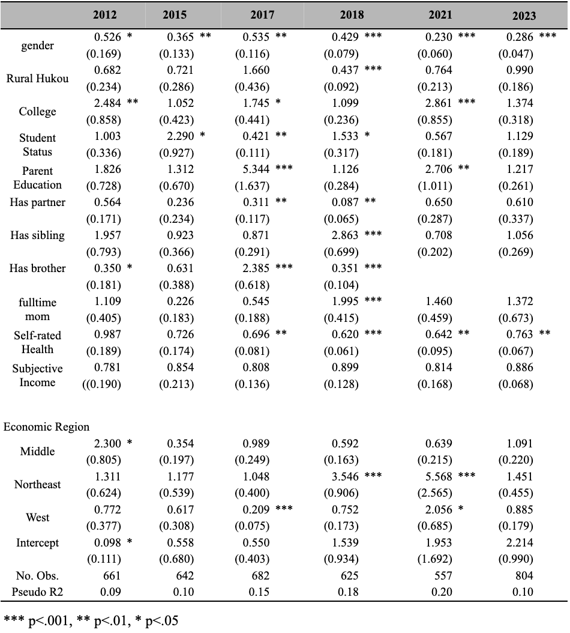

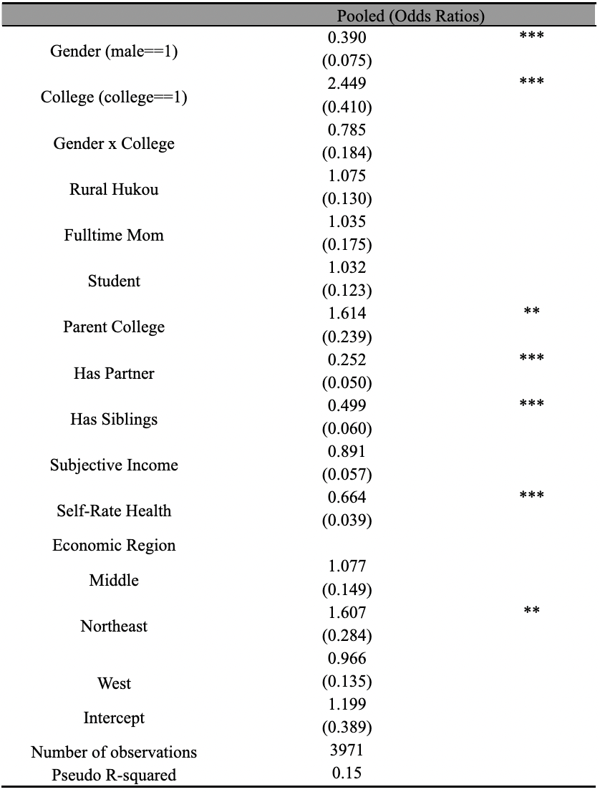
Table 5. Logistic Regression of Zero Fertility Desire with Gender x Education Interaction

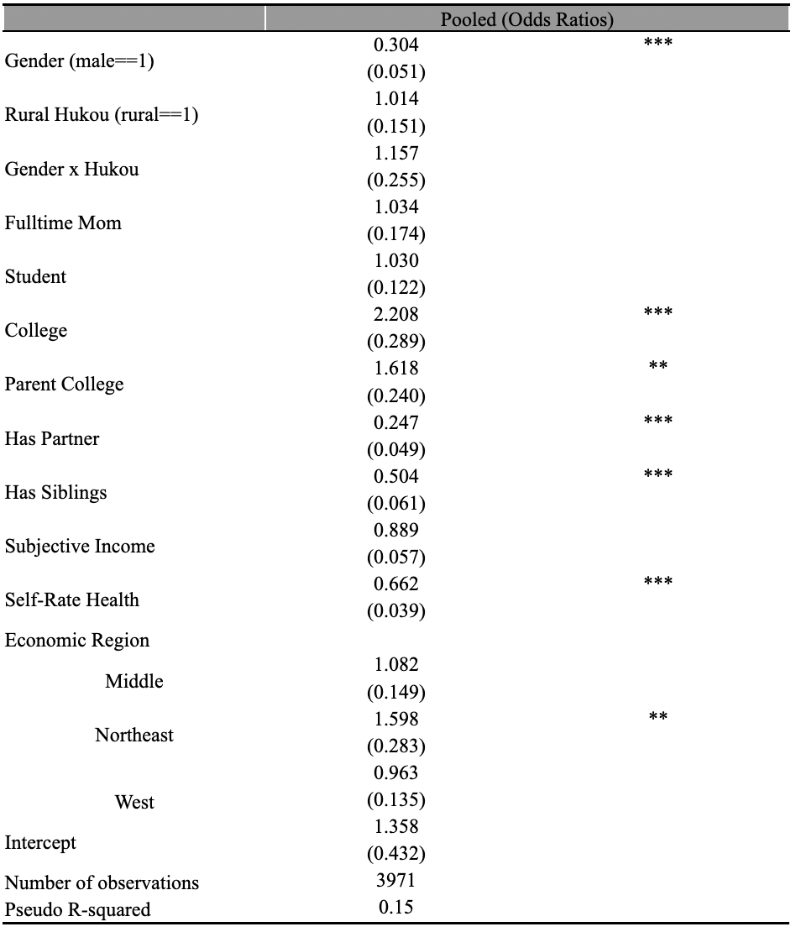
Table 6. Logistic Regression of Zero fertility Desire with Interaction Gender x Hukou
Table 7. Tabulation of young adults aged 18 to 24 by province, 2021

Province | Freq. | Percent | Cum.
Inner Mongolia | 6 | 1.04 | 1.04
Beijing | 32 | 5.54 | 6.57
Ningxia | 15 | 2.60 | 9.17
Anhui | 9 | 1.56 | 10.73
Shangdong | 31 | 5.36 | 16.09
Shanxi | 29 | 5.02 | 21.11
Guangxi | 25 | 4.33 | 25.43
Jiangsu | 32 | 5.54 | 30.97
Jiangxi | 96 | 16.61 | 47.58
Hebei | 17 | 2.94 | 50.52
Henan | 39 | 6.75 | 57.27
Zhejiang | 32 | 5.54 | 62.80
Hubei | 26 | 4.50 | 67.30
Hunan | 55 | 9.52 | 76.82
Gansu | 29 | 5.02 | 81.83
Fujian | 5 | 0.87 | 82.70
Liaoning | 22 | 3.81 | 86.51
Chongqing | 64 | 11.07 | 97.58
Shaanxi | 14 | 2.42 | 100.00
Total | 578 | 100.00

