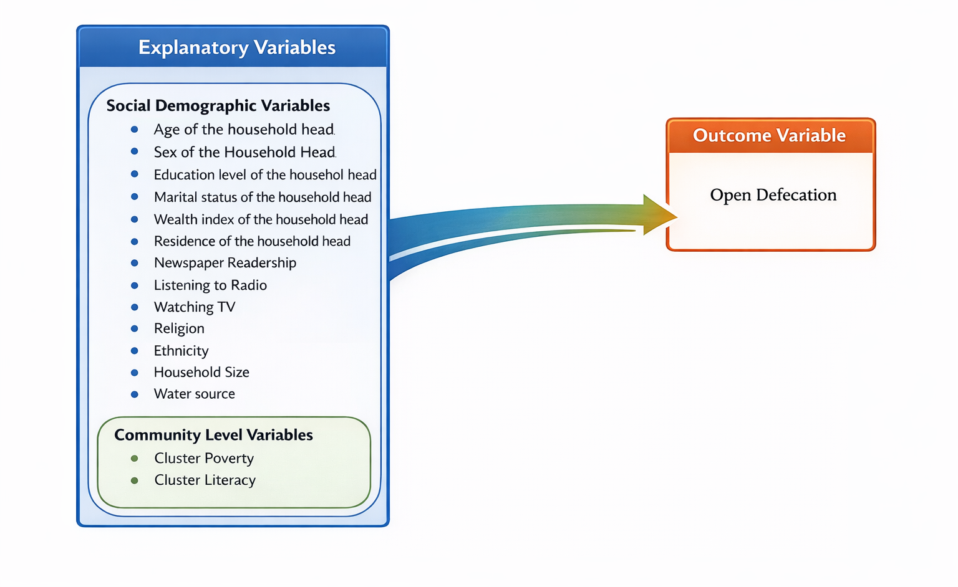
Figure 1: Conceptual Framework

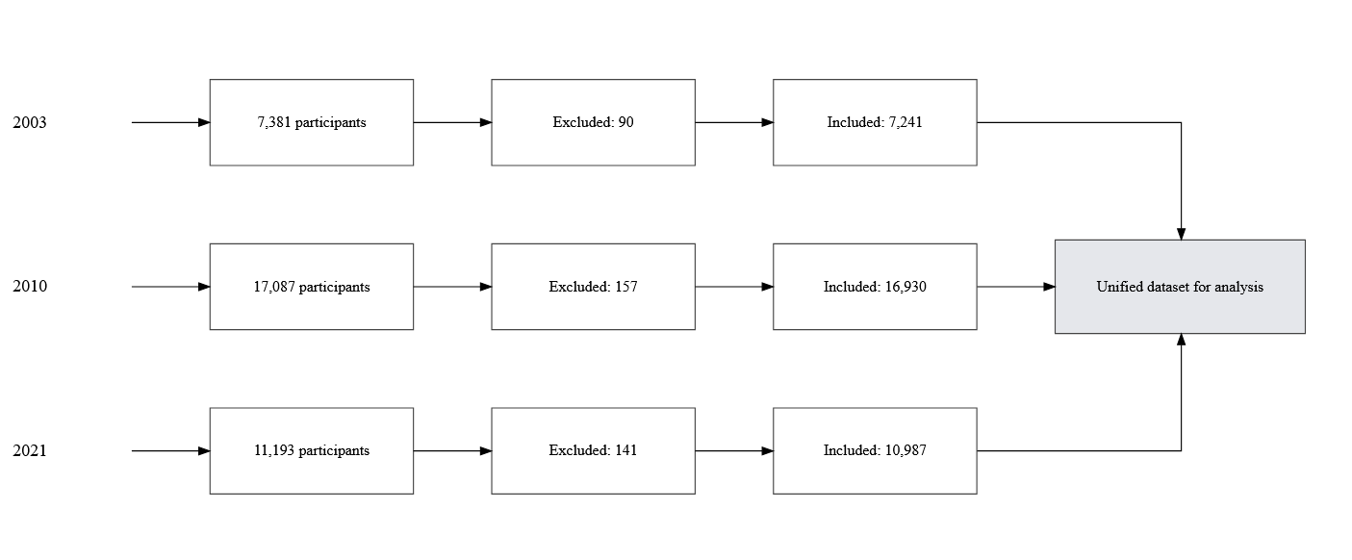
Figure 2:Sample Size

Table 1: Bivariate analysis
Variable | Category | 2003 OR (95% CI) | 2010 OR (95% CI) | 2021 OR (95% CI)
HH head age | 15–29 yrs | 1.00 | 1.00 | 1.00
 | 30–44 yrs | 0.61 (0.48, 0.78) *** | 0.70 (0.61, 0.80) *** | 0.67 (0.57, 0.78) ***
 | 45–59 yrs | 0.75 (0.58, 0.96) * | 0.70 (0.59, 0.83) *** | 0.69 (0.58, 0.83) ***
 | 60+ yrs | 0.93 (0.73, 1.20) | 0.66 (0.54, 0.82) *** | 0.71 (0.59, 0.85) ***
Sex of HH head | Male | 1.00 | 1.00 | 1.00
 | Female | 0.37 (0.28, 0.49) *** | 0.49 (0.41, 0.58) *** | 0.66 (0.54, 0.79) ***
Education of HH head | No education | 1.00 | 1.00 | 1.00
 | Primary | 0.27 (0.21, 0.34) *** | 0.32 (0.27, 0.38) *** | 0.53 (0.46, 0.62) ***
 | Secondary+ | 0.03 (0.02, 0.04) *** | 0.05 (0.04, 0.06) *** | 0.15 (0.12, 0.19) ***
Marital status of head | In union | 1.00 | 1.00 | 1.00
 | Not in union | 0.38 (0.29, 0.49) *** | 0.40 (0.35, 0.45) *** | 0.81 (0.66, 0.99) *
Wealth index | Poor | 1.00 | 1.00 | 1.00
 | Middle | 0.00 (0.00, 0.03) *** | 0.12 (0.09, 0.15) *** | 0.25 (0.21, 0.29) ***
 | Rich | 0.00 (0.00, 0.01) *** | 0.02 (0.02, 0.03) *** | 0.07 (0.06, 0.09) ***
 | Richest | 0.00 (0.00, 0.00) *** | 0.001 (0.001, 0.001) *** | 0.00 (0.00, 0.01) ***
Residence | Urban | 1.00 | 1.00 | 1.00
 | Rural | 82.27 (47.92, 141.25) *** | 28.05 (21.22, 37.08) *** | 15.11 (11.84, 19.28) ***
Region | Centre | 1.00 | 1.00 | 1.00
 | Boucle du Mouhoun | 13.56 (5.41, 34.02) *** | 16.02 (9.69, 26.49) *** | 11.36 (6.05, 21.34) ***
 | Cascades | 9.44 (3.56, 25.05) *** | 12.14 (7.59, 19.42) *** | 3.57 (1.79, 7.12) ***
 | Centre-Est | 37.07 (13.99, 98.24) *** | 47.03 (28.58, 77.39) *** | 17.26 (9.49, 31.41) ***
 | Centre-Nord | 38.44 (14.29, 103.41) *** | 31.86 (19.84, 51.14) *** | 18.36 (9.56, 35.23) ***
 | Centre-Ouest | 24.37 (9.62, 61.69) *** | 31.28 (18.67, 52.43) *** | 15.87 (8.68, 29.03) ***
 | Centre-Sud | 62.24 (20.22, 191.64) *** | 56.06 (33.94, 92.62) *** | 21.91 (11.49, 41.79) ***
 | Est | 216.59 (62.30, 752.91) *** | 115.13 (66.01, 200.78) *** | 31.16 (16.45, 59.02) ***
 | Hauts-Bassins | 5.08 (2.01, 12.86) ** | 5.01 (3.14, 8.01) *** | 3.39 (1.76, 6.55) ***
 | Nord | 19.47 (7.90, 47.99) *** | 16.95 (10.14, 28.34) *** | 12.99 (6.66, 25.35) ***
 | Plateau Central | 54.44 (19.12, 155.06) *** | 12.35 (7.12, 21.43) *** | 14.15 (7.48, 26.77) ***
 | Sahel | 31.20 (11.76, 82.81) *** | 57.11 (34.56, 94.38) *** | 21.60 (6.37, 73.28) ***
 | Sud-Ouest | 64.74 (22.57, 185.64) *** | 48.36 (29.83, 78.39) *** | 31.49 (16.65, 59.57) ***
Ethnicity | Bobo | 1.00 | 1.00 | 1.00
 | Dioula | 0.79 (0.32, 1.95) | 0.51 (0.26, 0.98) * | 0.18 (0.05, 0.57) **
 | Fulfulde | 2.97 (1.21, 7.31) * | 4.28 (2.69, 6.81) *** | 2.61 (1.41, 4.84) **
 | Gourmantché | 18.09 (6.63, 49.42) *** | 10.19 (5.76, 18.02) *** | 2.54 (1.37, 4.71) **
 | Gourounsi | 1.50 (0.59, 3.87) | 1.90 (1.10, 3.27) * | 1.59 (0.88, 2.88)
 | Lobi | 4.17 (1.75, 9.92) ** | 3.48 (1.88, 6.44) *** | 3.23 (1.38, 7.56) **
 | Mossi | 1.58 (0.71, 3.51) | 1.24 (0.82, 1.87) | 0.72 (0.43, 1.20)
 | Senoufo | 1.22 (0.49, 3.04) | 1.07 (0.64, 1.80) | 0.72 (0.33, 1.57)
 | Touareg/bella | 1.87 (0.52, 6.68) | 20.56 (9.33, 45.28) *** | 6.66 (1.03, 43.00) *
 | Dagara | — | 1.87 (1.07, 3.27) * | 1.12 (0.60, 2.11)
 | Bissa | 2.67 (1.02, 6.97) * | 2.44 (1.43, 4.15) ** | 1.32 (0.73, 2.39)
 | Other Ethnic | 1.25 (0.47, 3.33) | 0.70 (0.41, 1.18) | 0.76 (0.43, 1.34)
Newspaper readership | Yes | 1.00 | 1.00 | 1.00
 | No | 19.30 (12.26, 30.38) *** | 12.93 (10.53, 15.89) *** | 4.87 (3.68, 6.45) ***
Radio | Yes | 1.00 | 1.00 | 1.00
 | No | 0.28 (0.22, 0.35) *** | 0.49 (0.43, 0.56) *** | 0.61 (0.53, 0.69) ***
TV | Yes | 1.00 | 1.00 | 1.00
 | No | 0.07 (0.05, 0.10) *** | 0.10 (0.08, 0.12) *** | 0.18 (0.15, 0.21) ***
Internet | Yes | — | 1.00 | 1.00
 | No | — | — | 0.07 (0.05, 0.10) ***
Religion | Traditional | 1.00 | 1.00 | 1.00
 | Christian | 0.08 (0.05, 0.14) *** | 0.95 (0.72, 1.24) ns | 0.30 (0.21, 0.42) ***
 | Muslim | 0.08 (0.05, 0.12) *** | 0.83 (0.71, 0.98) * | 0.22 (0.15, 0.30) ***
Household size | 1–4 members | 1.00 | 1.00 | 1.00
 | >4 members | 1.18 (1.01, 1.37) * | 1.08 (0.96, 1.22) | 1.45 (1.29, 1.63) ***
Water source | Improved | 1.00 | 1.00 | 1.00
 | Unimproved | 10.55 (5.97, 18.63) *** | 3.91 (3.13, 4.88) *** | 2.64 (2.13, 3.26) ***
Cluster poverty | Low | 1.00 | 1.00 | 1.00
 | Moderate | 14.24 (8.84, 22.94) *** | 14.12 (10.32, 19.31) *** | 15.92 (11.58, 21.87) ***
 | High | 75.81 (45.28, 126.94) *** | 70.37 (49.11, 100.82) *** | 38.30 (27.86, 52.67) ***
Community literacy | Low | 1.00 | 1.00 | 1.00
 | Medium | 0.67 (0.40, 1.11) | 0.36 (0.26, 0.50) *** | 0.56 (0.43, 0.74) ***
 | High | 0.06 (0.04, 0.10) *** | 0.06 (0.04, 0.08) *** | 0.09 (0.06, 0.13) ***

Table 2: Multilevel 2021 Results
Factors associated with OD 2021

Variable | Category |  | Null model OR (95% CI) | Model 1 OR (95% CI) | Model 2 OR (95% CI) | Model 3 OR (95% CI)
Age of HH head | 15–29 years |  | 1.00 | 1.00 | 1.00 | 1.00
 | 30–44 years |  | — | 0.79 (0.65–0.96) * | — | 0.83 (0.69–1.02)
 | 45–59 years |  | — | 0.57 (0.46–0.71) *** | — | 0.60 (0.49–0.75) ***
 | ≥60 years |  | — | 0.53 (0.42–0.67) *** | — | 0.55 (0.44–0.69) ***
Sex of HH head | Male |  | 1.00 | 1.00 | 1.00 | 1.00
 | Female |  | — | 0.74 (0.59–0.93) ** | — | 0.74 (0.59–0.93) **
Education HH head | No education |  | 1.00 | 1.00 | 1.00 | 1.00
 | Primary |  | — | 0.84 (0.71–1.00) | — | 0.88 (0.74–1.05)
 | Secondary+ |  | — | 0.72 (0.56–0.93) ** | — | 0.76 (0.59–0.97) **
Marital status of HH head | In union |  | 1.00 | 1.00 | 1.00 | 1.00
 | Not in union |  | — | 1.29 (0.99–1.67) | — | 1.33 (1.02–1.72) *
Wealth index | Poor |  | 1.00 | 1.00 | 1.00 | 1.00
 | Middle |  | — | 0.23 (0.20–0.26) *** | — | 0.25 (0.21–0.28) ***
 | Rich |  | — | 0.06 (0.05–0.08) *** | — | 0.08 (0.06–0.10) ***
 | Richest |  | — | 0.00 (0.00–0.01) *** | — | 0.01 (0.00–0.01) ***
Residence | Urban |  | 1.00 | — | 1.00 | 1.00
 | Rural |  | — | — | 2.13 (1.42–3.19) *** | 1.13 (0.75–1.71)
Region | Centre |  | 1.00 | — | 1.00 | 1.00
 | Boucle du Mouhoun |  | — | — | 1.63 (0.88–3.01) | 0.92 (0.48–1.76)
 | Cascades |  | — | — | 1.31 (0.65–2.64) | 0.92 (0.43–1.96)
 | Centre-Est |  | — | — | 5.29 (2.93–9.54) *** | 3.94 (2.09–7.42) ***
 | Centre-Nord |  | — | — | 2.68 (1.41–5.11) ** | 1.96 (1.01–3.79) *
 | Centre-Ouest |  | — | — | 3.05 (1.67–5.56) *** | 2.04 (1.09–3.84) *
 | Centre-Sud |  | — | — | 4.06 (2.15–7.66) *** | 3.36 (1.75–6.48) ***
 | Est |  | — | — | 4.72 (2.40–9.31) *** | 2.88 (1.28–6.46) *
 | Hauts-Bassins |  | — | — | 0.92 (0.50–1.70) | 0.62 (0.32–1.21)
 | Nord |  | — | — | 1.63 (0.86–3.11) | 1.35 (0.70–2.62)
 | Plateau Central |  | — | — | 2.68 (1.44–5.01) ** | 2.39 (1.26–4.52) **
 | Sahel |  | — | — | 2.60 (1.11–6.09) * | 1.09 (0.44–2.68)
 | Sud-Ouest |  | — | — | 5.14 (2.72–9.70) *** | 2.94 (1.38–6.26) **
Ethnicity | Bobo |  | 1.00 | 1.00 | 1.00 | 1.00
 | Dioula |  | — | 1.00 (0.27–3.74) | — | 0.98 (0.26–3.73)
 | Fulfulde |  | — | 1.54 (0.93–2.55) | — | 1.20 (0.71–2.01)
 | Gourmantché |  | — | 1.10 (0.60–1.99) | — | 0.58 (0.29–1.17)
 | Gourounsi |  | — | 1.80 (1.04–3.14) * | — | 1.03 (0.58–1.85)
 | Lobi |  | — | 1.52 (0.69–3.35) | — | 0.84 (0.36–1.97)
 | Mossi |  | — | 0.89 (0.57–1.39) | — | 0.63 (0.40–1.01)
 | Senoufo |  | — | 1.52 (0.72–3.19) | — | 1.77 (0.83–3.80)
 | Touareg / other nomadic |  | — | 3.64 (0.63–21.04) | — | 3.36 (0.56–20.12)
 | Dagara |  | — | 0.91 (0.46–1.77) | — | 0.44 (0.20–0.95) *
 | Bissa |  | — | 2.38 (1.32–4.29) ** | — | 1.08 (0.58–2.04)
 | Other |  | — | 0.86 (0.54–1.37) | — | 0.71 (0.44–1.13)
Newspaper readership | Yes |  | 1.00 | 1.00 | — | 1.00
 | No |  | — | 1.12 (0.78–1.60) | — | 1.11 (0.78–1.59)
Radio | Yes |  | 1.00 | 1.00 | — | 1.00
 | No |  | — | 0.90 (0.80–1.02) | — | 0.90 (0.80–1.03)
TV | Yes |  | 1.00 | 1.00 | — | 1.00
 | No |  | — | 0.83 (0.71–0.96) * | — | 0.86 (0.74–1.00) *
Internet | Yes |  | 1.00 | 1.00 | — | 1.00
 | No |  | — | 0.89 (0.63–1.26) | — | 0.93 (0.66–1.32)
Religion | Traditional |  | 1.00 | 1.00 | — | 1.00
 | Muslim |  | — | 0.45 (0.33–0.61) *** | — | 0.49 (0.36–0.68) ***
 | Christian |  | — | 0.62 (0.46–0.85) ** | — | 0.66 (0.49–0.90) **
Household size | 1–4 members |  | 1.00 | 1.00 | — | 1.00
 | >4 members |  | — | 0.83 (0.71–0.97) * | — | 0.80 (0.69–0.94) **
Water source | Improved |  | 1.00 | 1.00 | — | 1.00
 | Unimproved |  | — | 1.28 (1.08–1.51) ** | — | 1.36 (1.15–1.61) ***
Cluster poverty | Low |  | 1.00 | — | 1.00 | 1.00
 | Moderate |  | — | — | 7.64 (4.84–12.05) *** | 2.00 (1.25–3.19) **
 | High |  | — | — | 17.36 (10.26–29.38) *** | 2.36 (1.37–4.07) **
Community literacy | Low |  | 1.00 | — | 1.00 | 1.00
 | Medium |  | — | — | 1.06 (0.81–1.39) | 1.13 (0.86–1.49)
 | High |  | — | — | 0.73 (0.49–1.10) | 0.99 (0.65–1.50)
ICC |  | 0.587 |  | 0.270 | 0.250 |  | 0.237
Log likelihood |  | −5223.87 |  | −4272.92 | −4921.03 |  | −4213.79
AIC |  | 10451.73 |  | 8607.84 | 9880.07 |  | 8523.58
BIC |  | 10466.34 |  | 8834.28 | 10018.85 |  | 8874.20

