Supplemental Materials

Table S1. The sequences of the miR-34 modified forms.
AM1 | UGGCAGUGUAUUAGCUGGUUGU | AM21 | UGGCAGUGUCUUAGCCGGUUGU
AM2 | UGGCAGUGUGUUAGCUGGUUGU | AM22 | UGGCAGUGUCUUAGCUAGUUGU
AM3 | UGGCAGUGUUUUAGCUGGUUGU | AM23 | UGGCAGUGUCUUAGCUCGUUGU
AM4 | UGGCAGUGUCAUAGCUGGUUGU | AM24 | UGGCAGUGUCUUAGCUUGUUGU
AM5 | UGGCAGUGUCGUAGCUGGUUGU | AM25 | UGGCAGUGUCUUAGCUGAUUGU
AM6 | UGGCAGUGUCCUAGCUGGUUGU | AM26 | UGGCAGUGUCUUAGCUGCUUGU
AM7 | UGGCAGUGUCUAAGCUGGUUGU | AM27 | UGGCAGUGUCUUAGCUGUUUGU
AM8 | UGGCAGUGUCUGAGCUGGUUGU | AM28 | UGGCAGUGUCUUAGCUGGAUGU
AM9 | UGGCAGUGUCUCAGCUGGUUGU | AM29 | UGGCAGUGUCUUAGCUGGCUGU
AM10 | UGGCAGUGUCUUGGCUGGUUGU | AM30 | UGGCAGUGUCUUAGCUGGGUGU
AM11 | UGGCAGUGUCUUCGCUGGUUGU | AM31 | UGGCAGUGUCUUAGCUGGUAGU
AM12 | UGGCAGUGUCUUUGCUGGUUGU | AM32 | UGGCAGUGUCUUAGCUGGUCGU
AM13 | UGGCAGUGUCUUAACUGGUUGU | AM33 | UGGCAGUGUCUUAGCUGGUGGU
AM14 | UGGCAGUGUCUUACCUGGUUGU | AM34 | UGGCAGUGUCUUAGCUGGUUAU
AM15 | UGGCAGUGUCUUAUCUGGUUGU | AM35 | UGGCAGUGUCUUAGCUGGUUCU
AM16 | UGGCAGUGUCUUAGAUGGUUGU | AM36 | UGGCAGUGUCUUAGCUGGUUUU
AM17 | UGGCAGUGUCUUAGGUGGUUGU | AM37 | UGGCAGUGUCUUAGCUGGUUGA
AM18 | UGGCAGUGUCUUAGUUGGUUGU | AM38 | UGGCAGUGUCUUAGCUGGUUGC
AM19 | UGGCAGUGUCUUAGCAGGUUGU | AM39 | UGGCAGUGUCUUAGCUGGUUGG
AM20 | UGGCAGUGUCUUAGCGGGUUGU

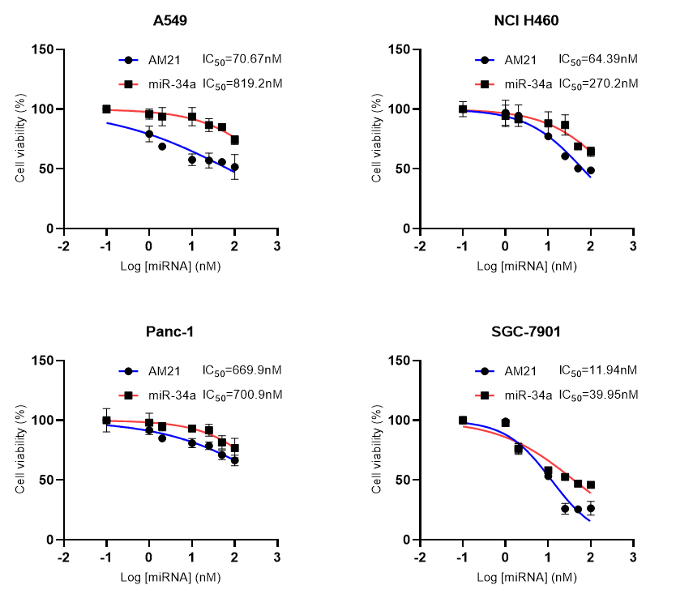
Figure S1. The inhibitory roles of miR-34a and AM22 in the proliferation of A549, NCI H460, Panc-1, and SGC-7901 cells.

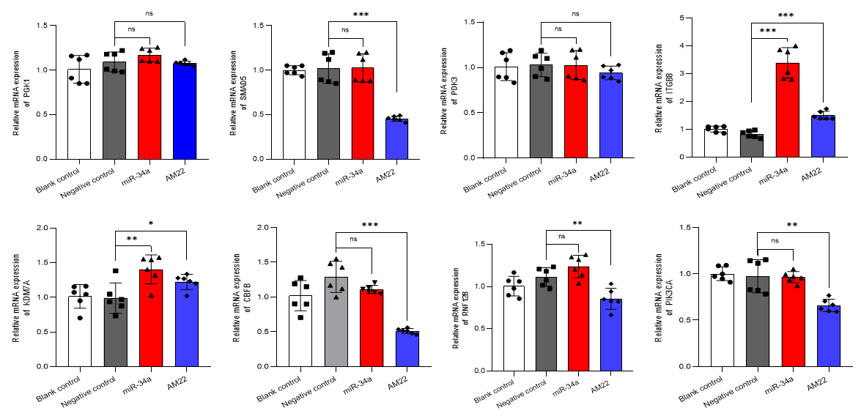
Figure S2. Real-time PCR data showed the mRNA expression of PGK1、SMAD5、KDM7A、PIK3CA、CBFB、PDK3、RNF128 and ITGB8 were transfected with 50nM of AM22 and miR-34a in HCT-116 cells.

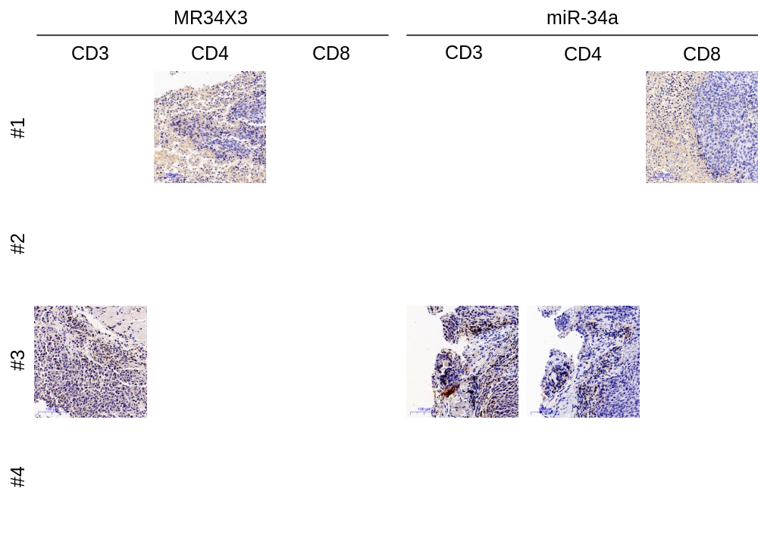
Figure S3. The effect of miR-34a and MR34X3 on the function of T cells. IHC stains demonstrated higher prevalence of infiltrated CD8⁺ and CD4⁺ T cells in the MR34X3-treated tumors than those treated by miR-34a.

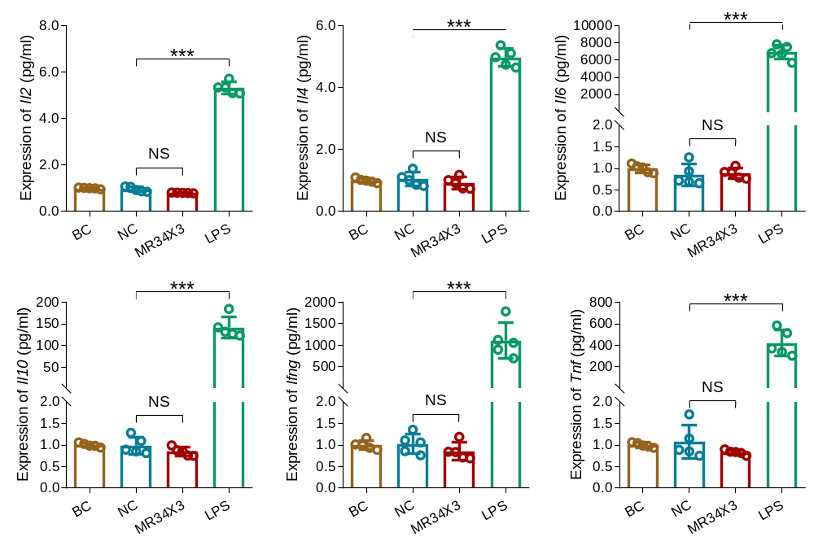
Figure S4. The effect of MR34X3 agomir on the production of cytokines in mice. The mice were intravenously injected with 10 nmol MR34X3 agomir for 16h (n=5). LPS was used as positive control. BC, blank control; NC, negative control. Data represent mean ± SD. Significance was assessed by two-sided t-test. ***P<0.001; NS, no significance.

