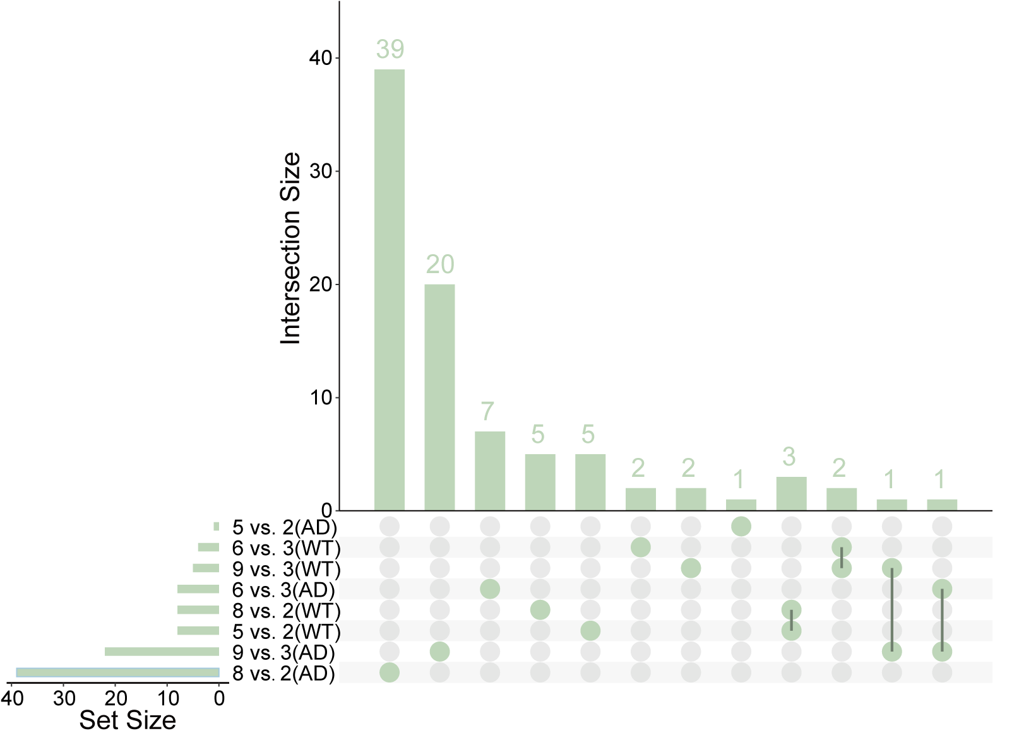
Fig. S1 Venn diagram showing the intersect of disease-specific down-regulated genes in hippocampus.

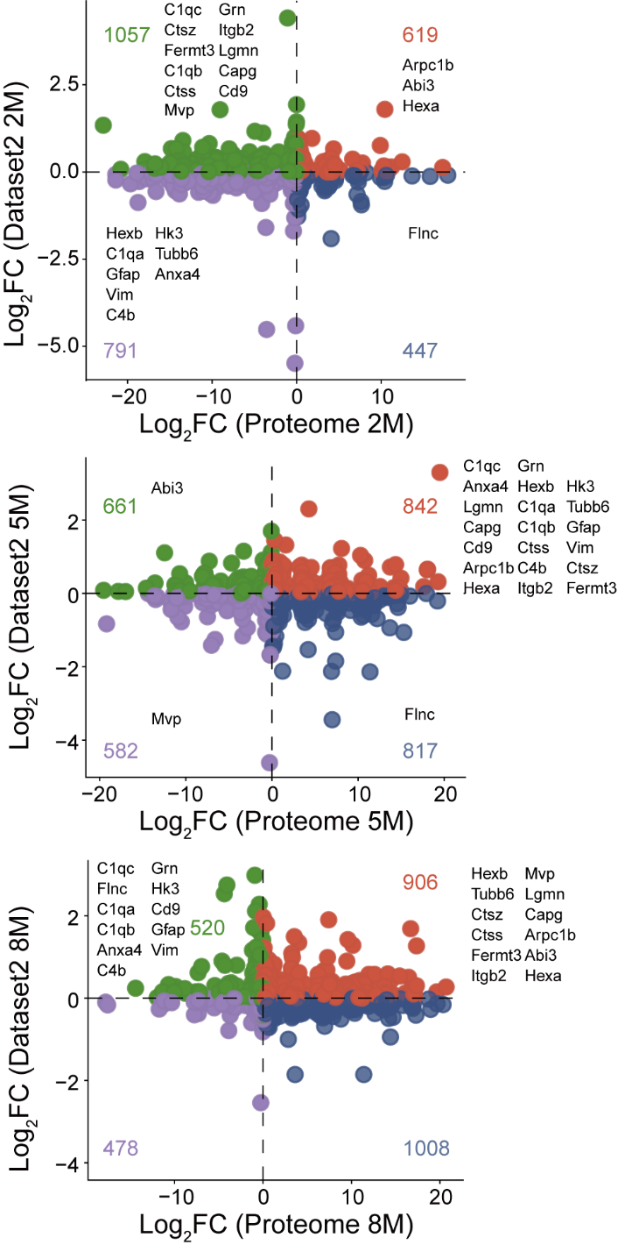
Fig. S2 Scatter plots showing the expression patterns in bulk RNA-seq dataset2 and proteomics dataset different time points.

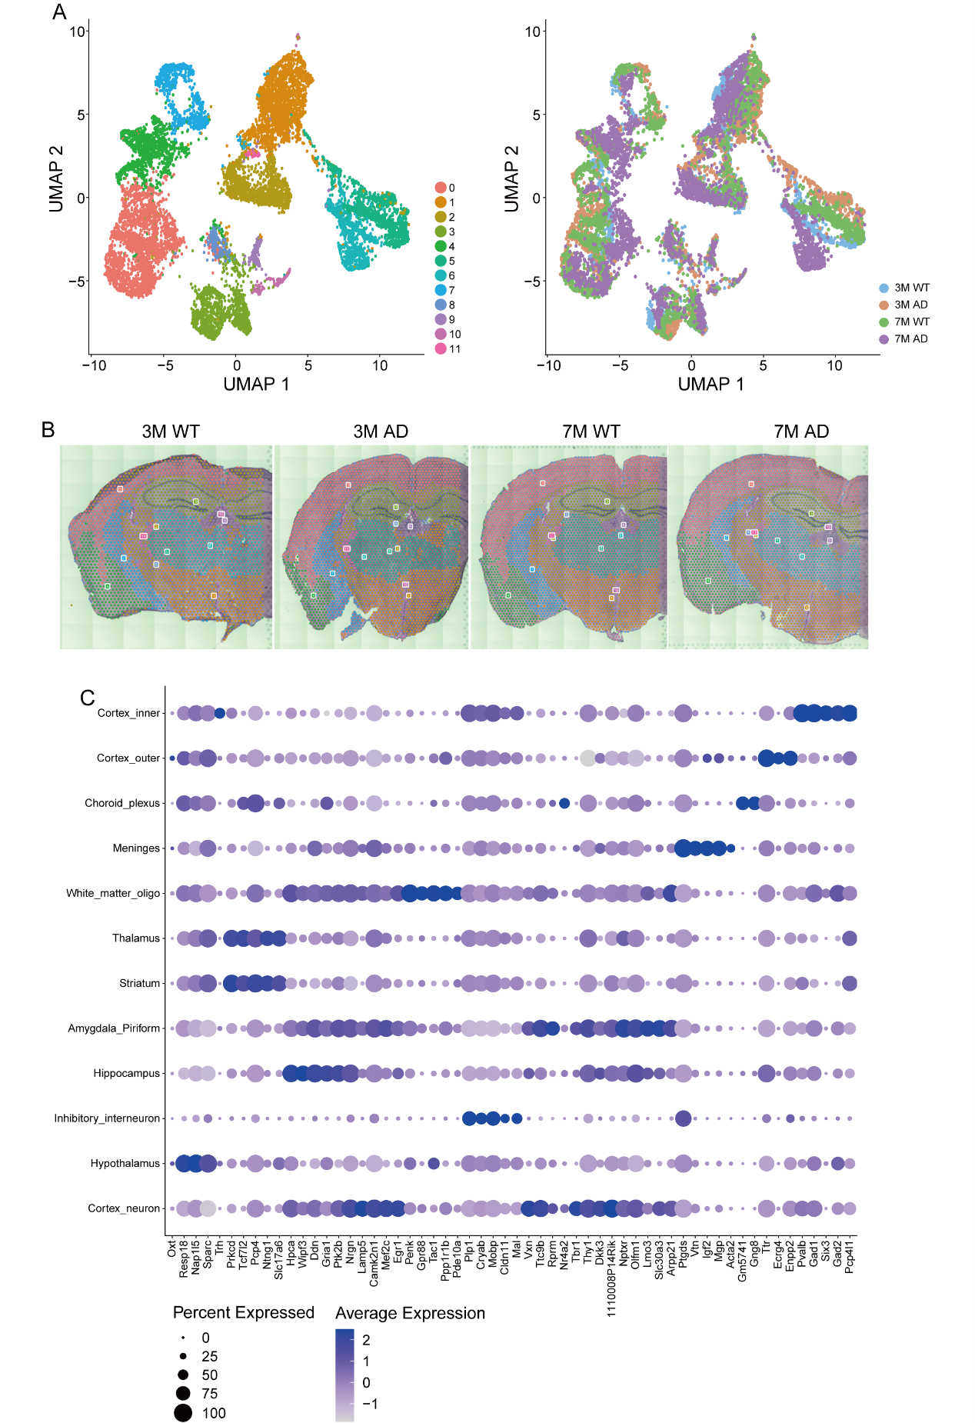
Fig. S3 Spatial transcriptomics preprocessing and annotation. A Batch correction analysis showing successful integration of spatial transcriptomics samples across different processing batches. B Unsupervised clustering analysis with spatial distribution overlay. C Heatmap showing expression of canonical marker genes across identified clusters.

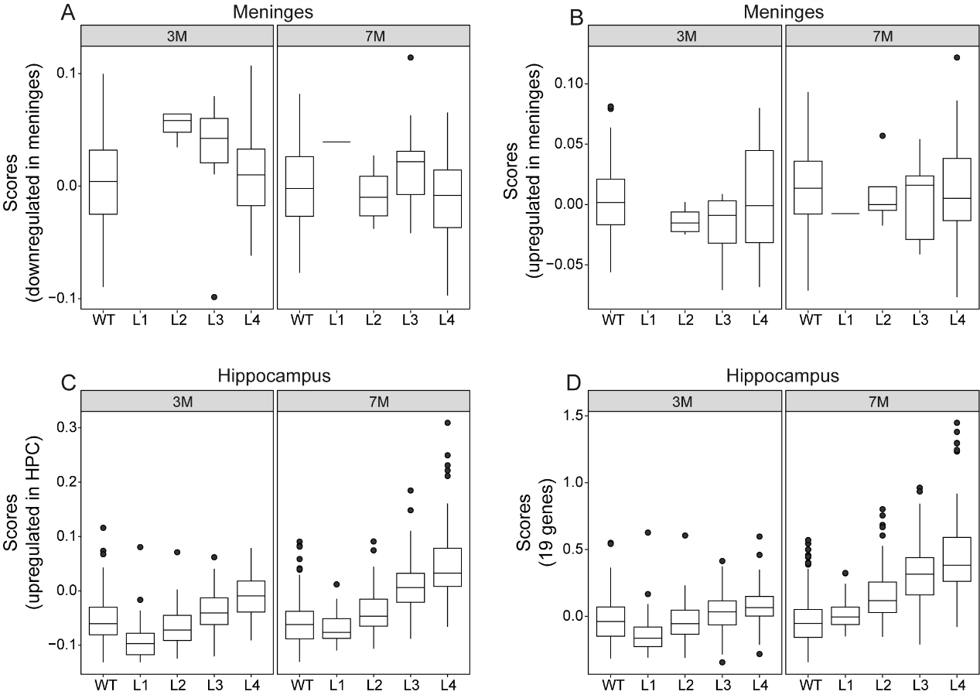
Fig. S4 Box plots displaying disease-specific gene module scores across disease progression stages in hippocampus and meninges spots.

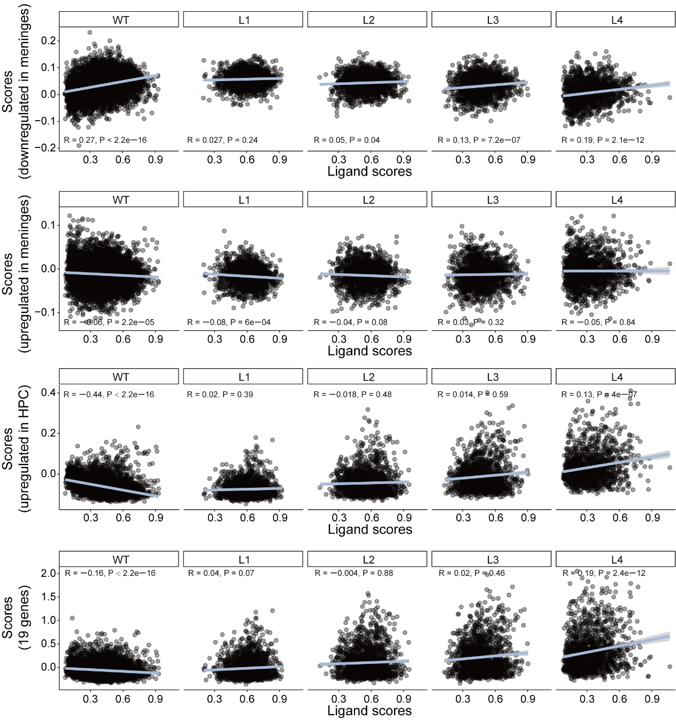
Fig. S5 Scatter plots showing Spearman correlations between ligand expression scores with disease-specific gene modules.

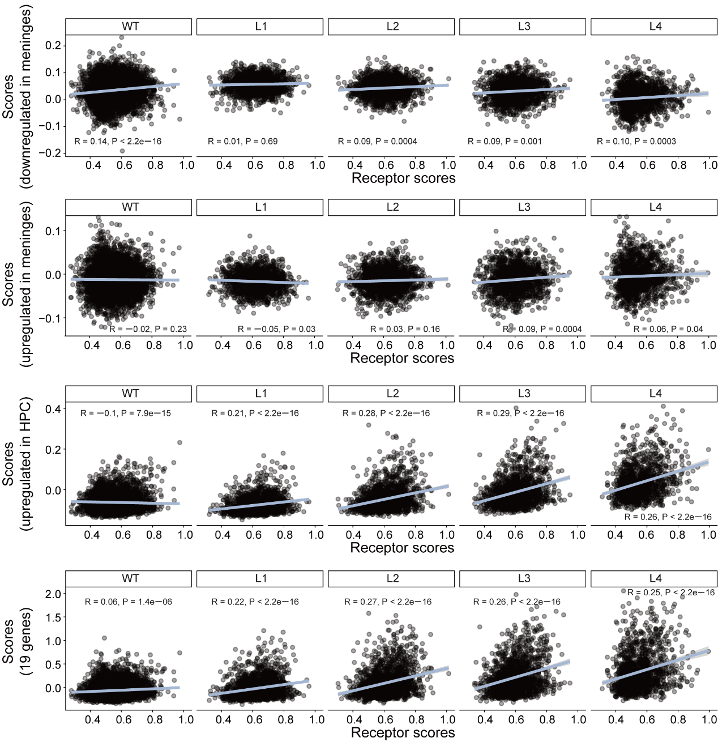
Fig. S6 Scatter plots showing Spearman correlations between receptor expression scores with disease-specific gene modules.

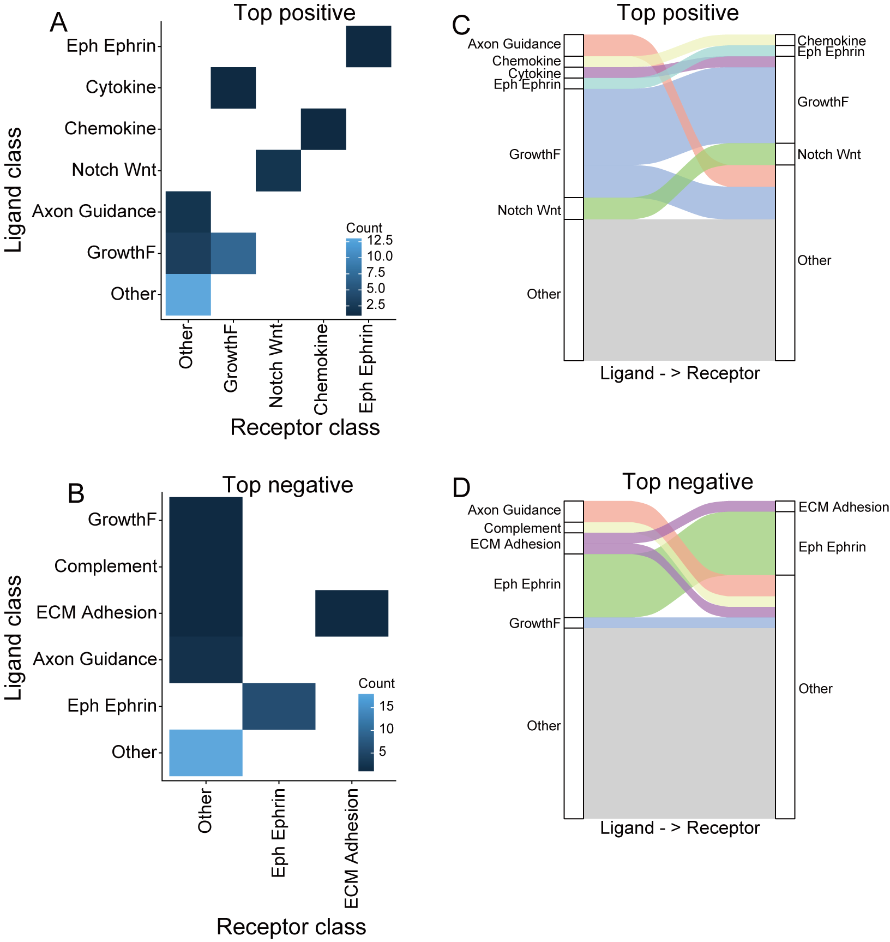
Fig. S7 Heatmap and Sankey diagrams displaying top the class of ligand-receptor pairs significantly correlated with hippocampus 19 genes.

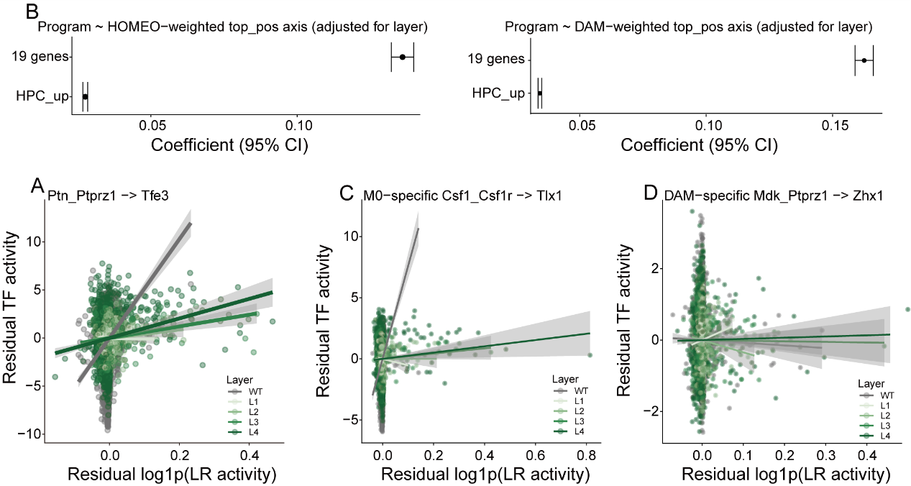
Fig. S8 Additional TF-LR network analyses. A, C, D Representative scatter plots showing transcription factor-ligand-receptor (TF-LR) residual correlations after controlling for disease stage and spatial effects. B Layer-controlled effects analysis demonstrating that TF-LR correlations remain significant after accounting for cortical layer identity.

