Fig S1 Distribution of ICC values for all radiomic features. The red line indicates the threshold of ICC = 0.75, used to divide the features into a high-repeatability group (n = 815) and a low-repeatability group (n = 501).
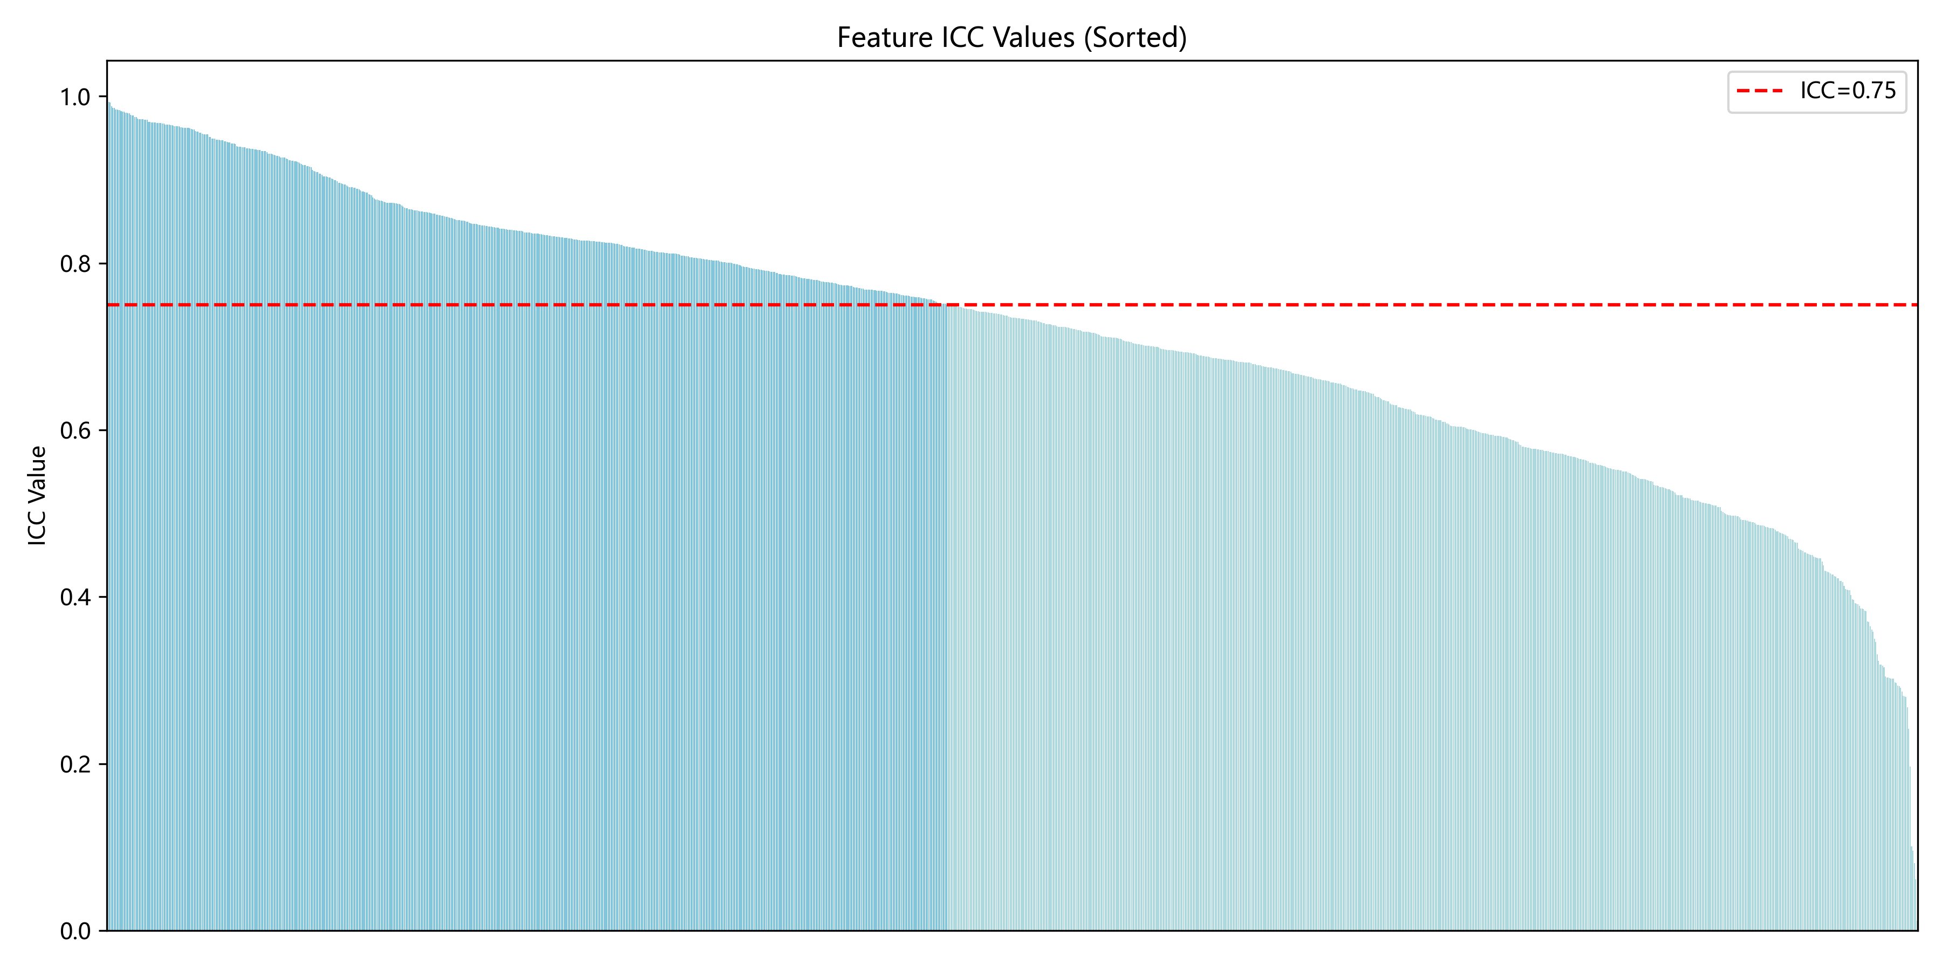

Fig S2 (A–C) Relationships between all radiomic features (RFs), high-repeatability RFs, low-repeatability RFs, and tumor volume.(D–E) Scatter plots showing the correlation between tumor volume and high-repeatability RFs (D), and low-repeatability RFs (E).

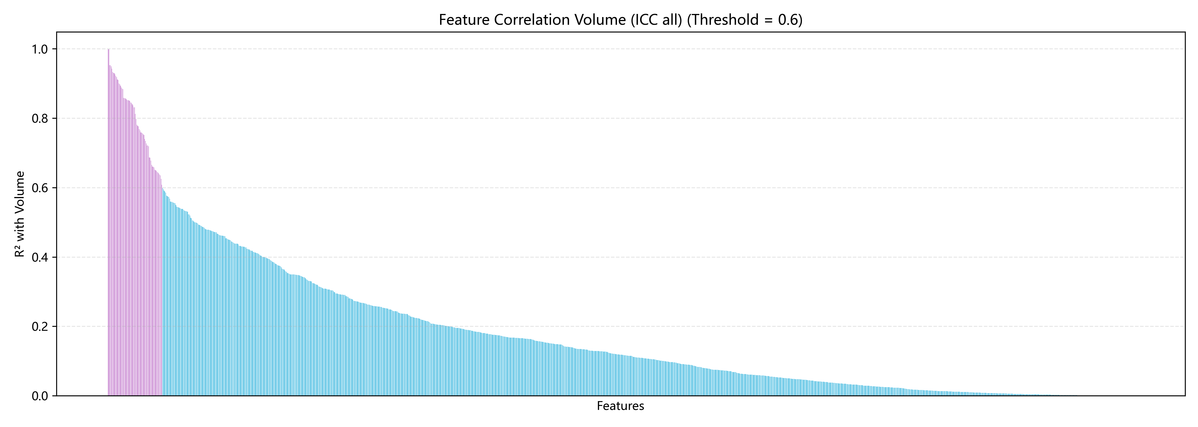
A
B
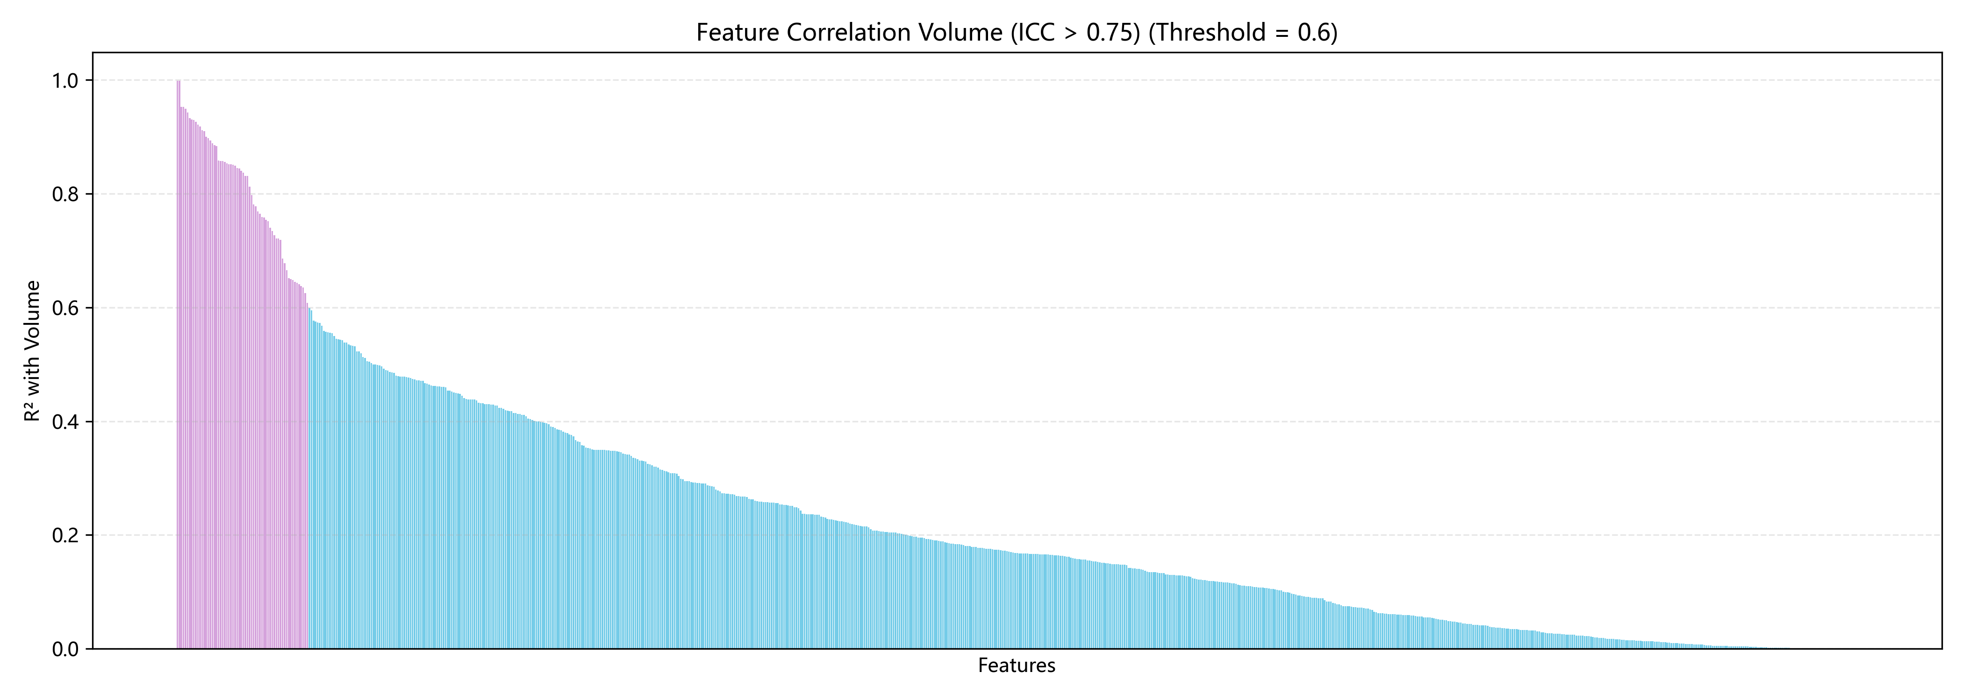
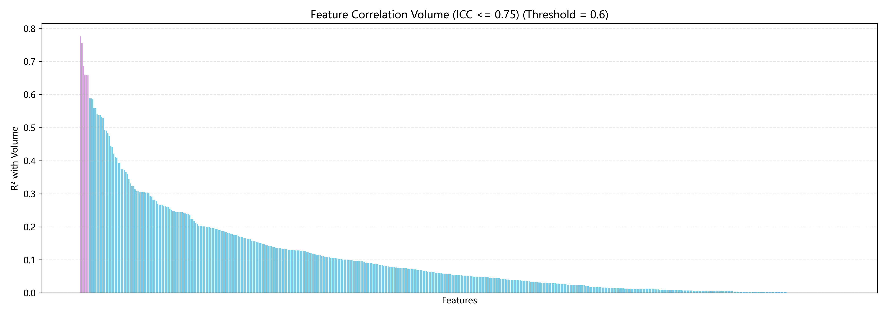
C
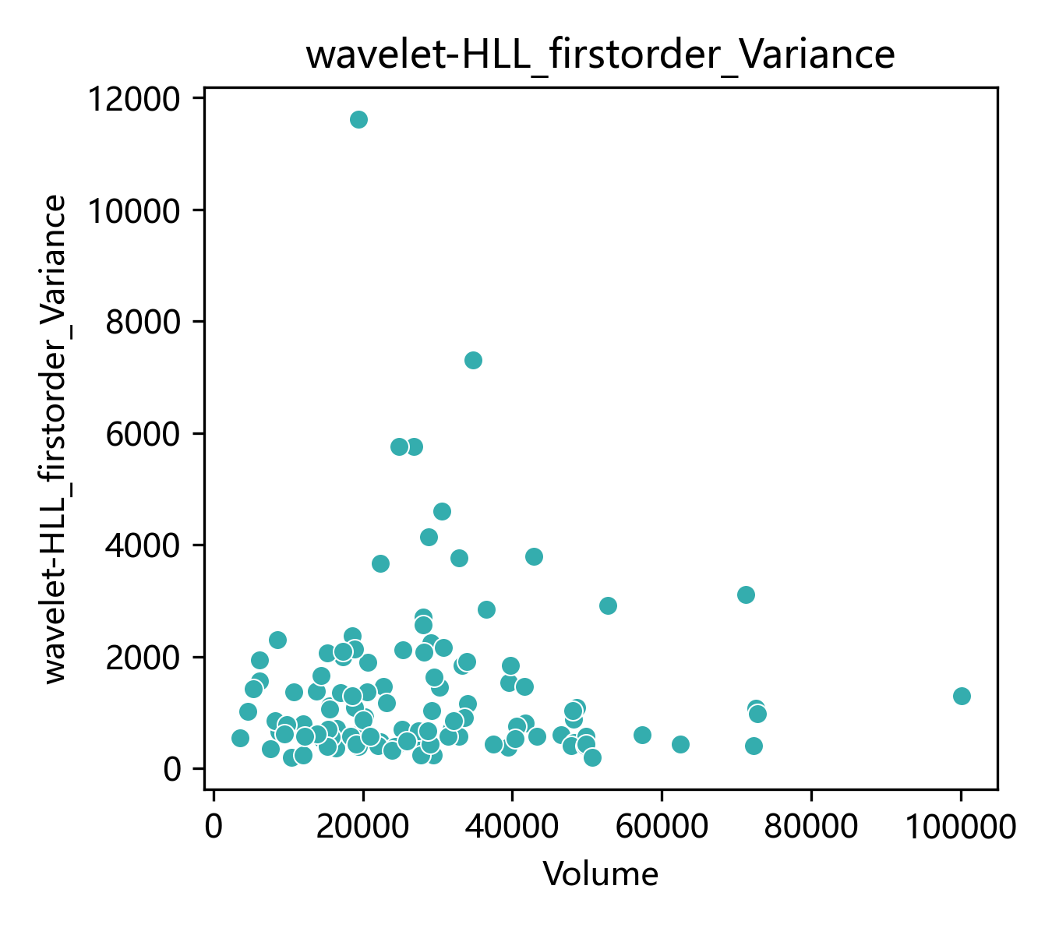
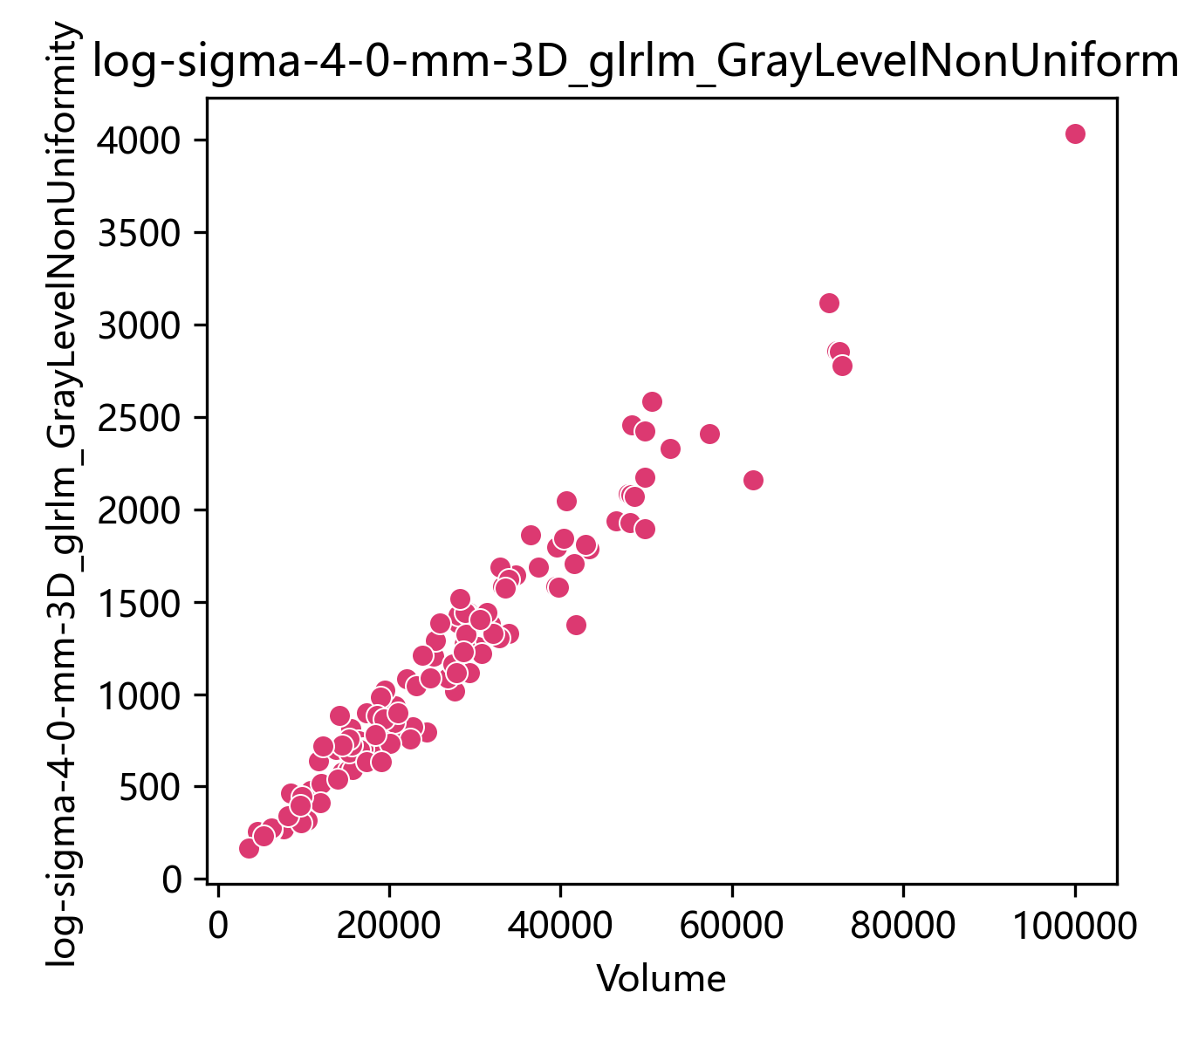
D
E

Fig S3 Distribution of redundant features across different feature groups."all" represents the full feature set,"gt075" represents the high-reproducibility feature group (ICC > 0.75),"lt075" represents the low-reproducibility feature group (ICC ≤ 0.75).
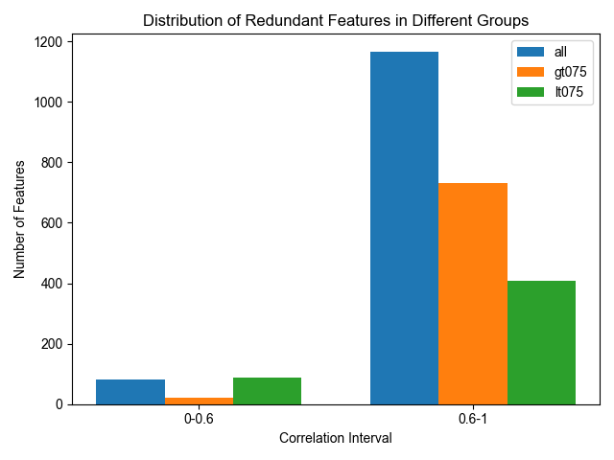

Fig S4 The LASSO feature selection process across different feature groups is illustrated.For high-reproducibility radiomic features (RFs), 8 features most predictive of PCR were selected (A, B) and listed in Table S4.For low-reproducibility RFs, 17features were selected (C, D) and listed in Table S5.From the entire feature group, 14 RFs were selected (E, F) and presented in Table S6.
A
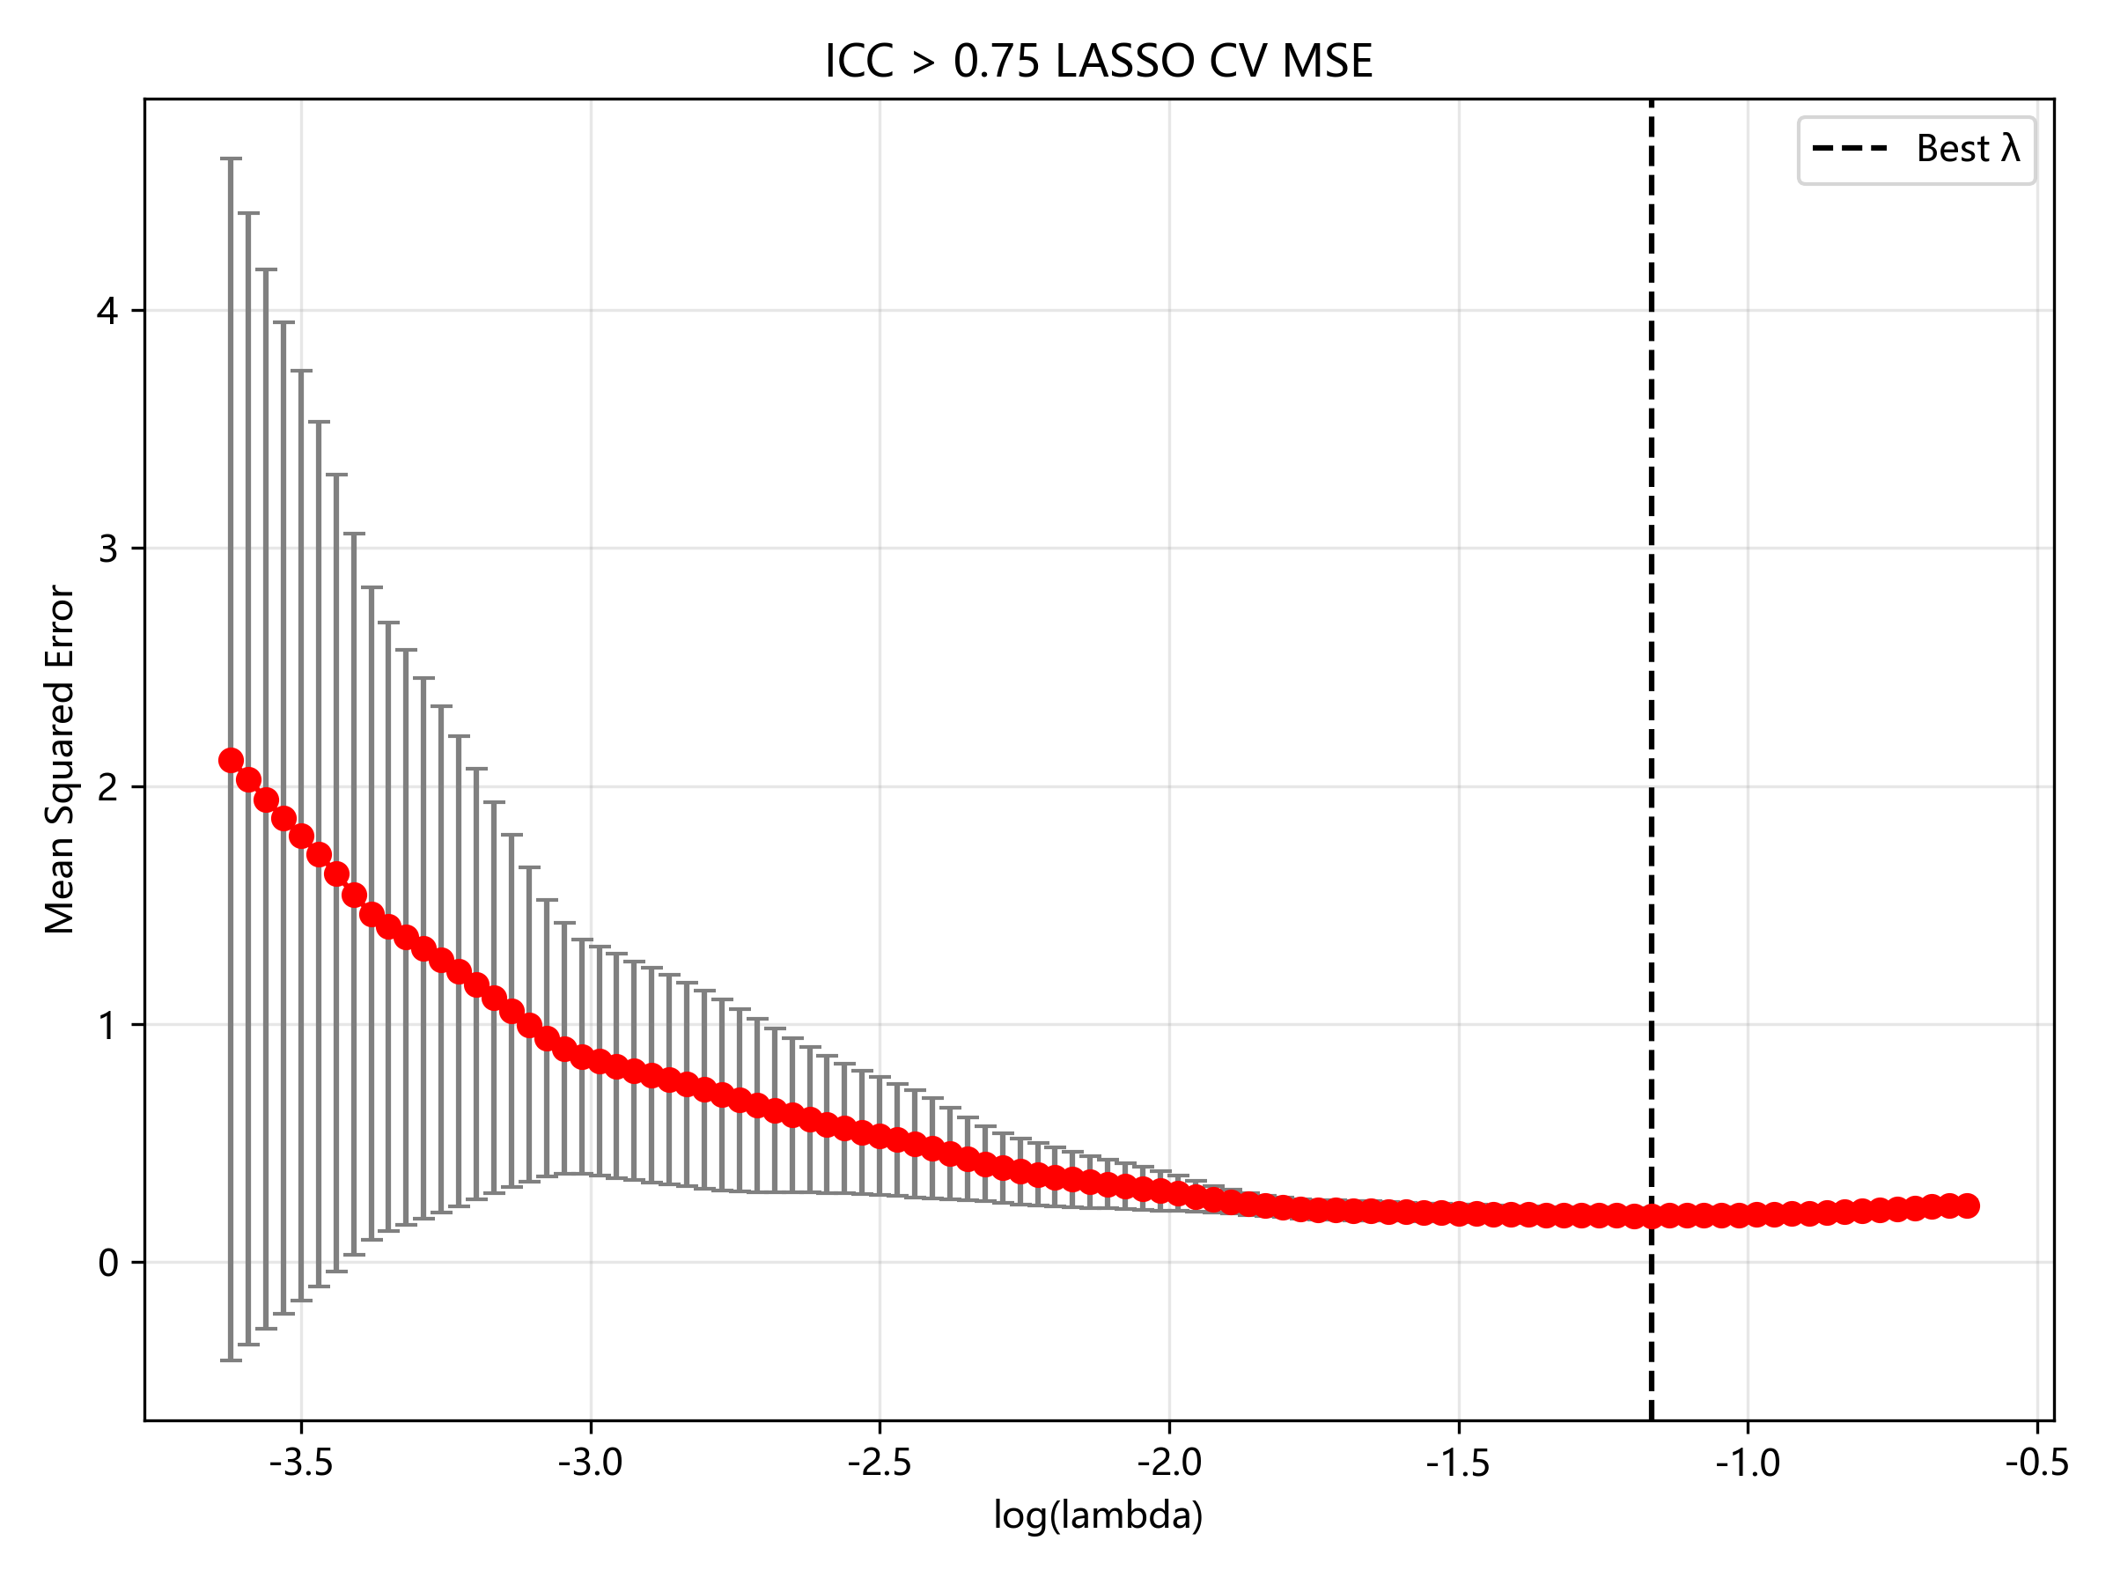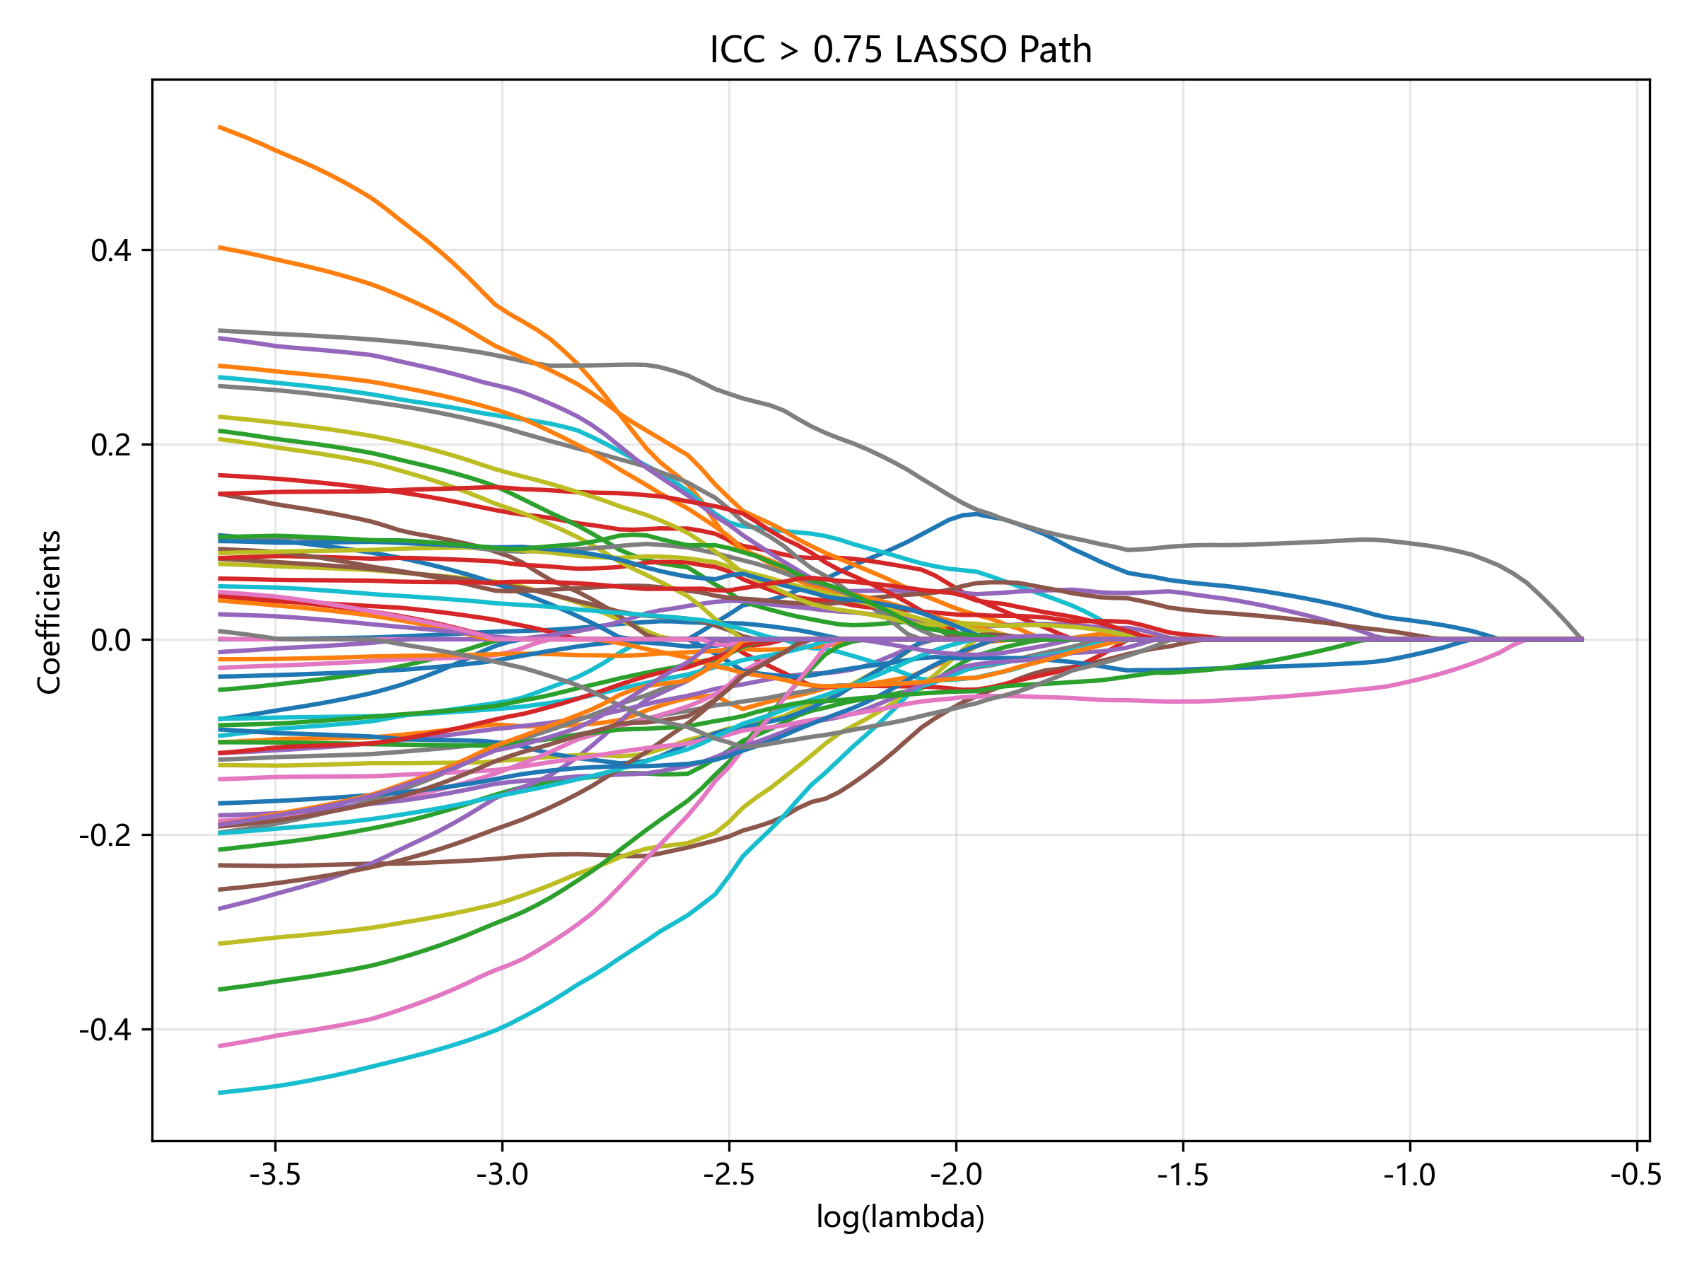
C
B
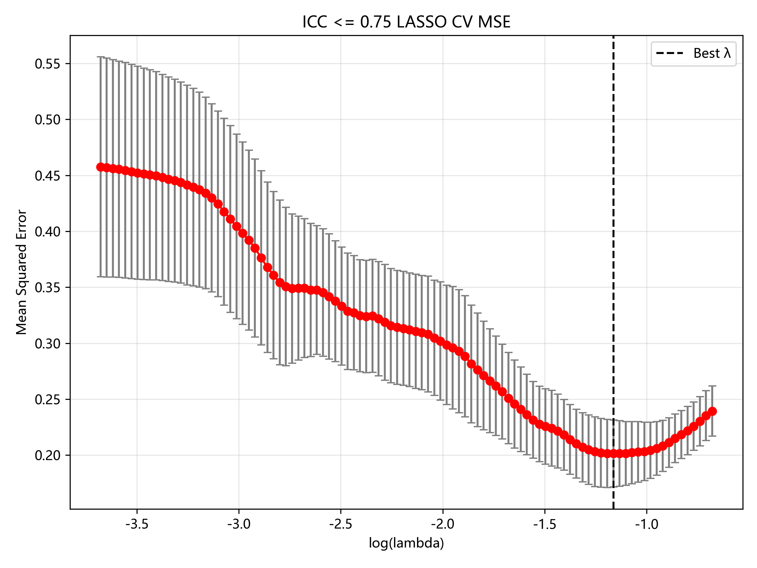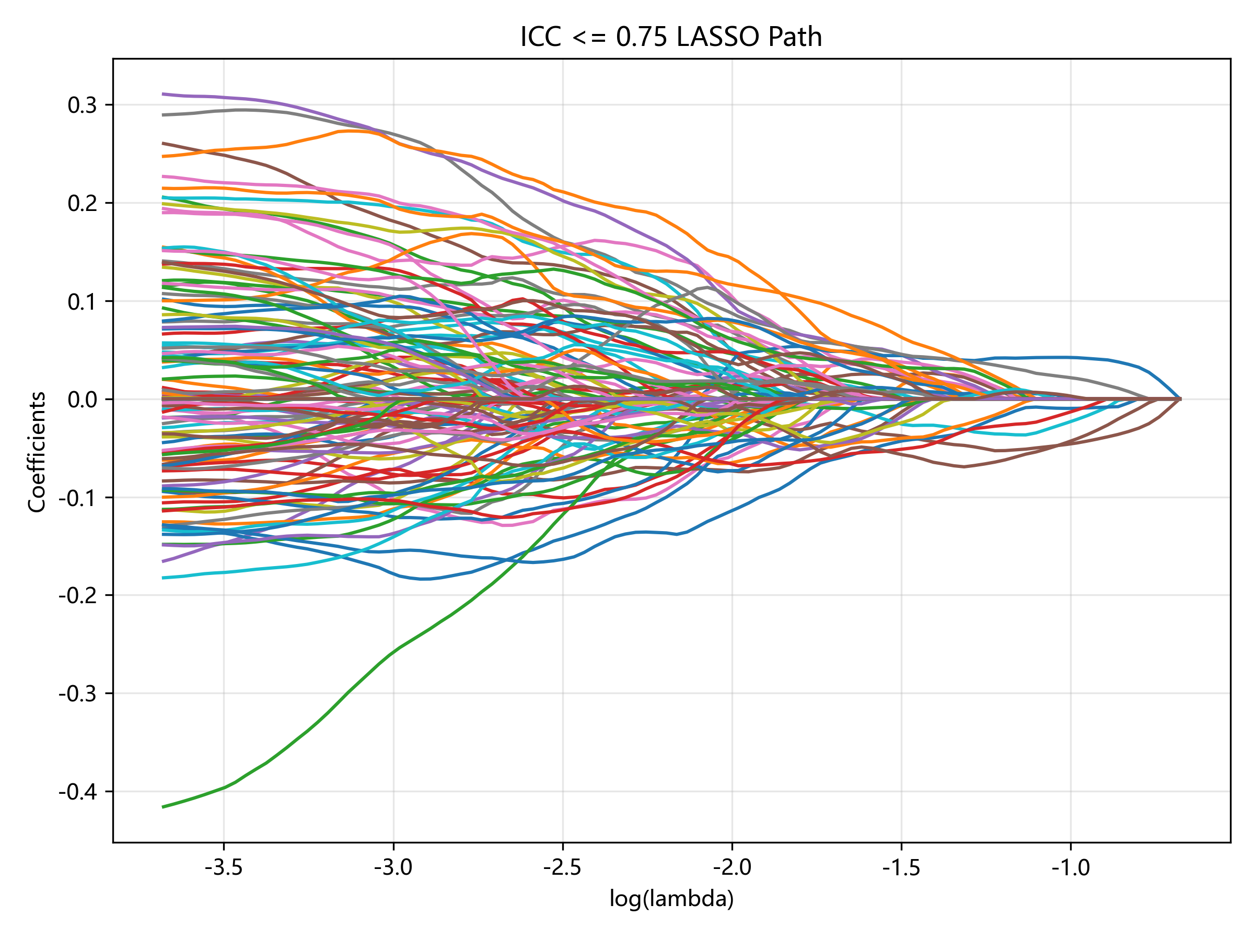
F
E
D
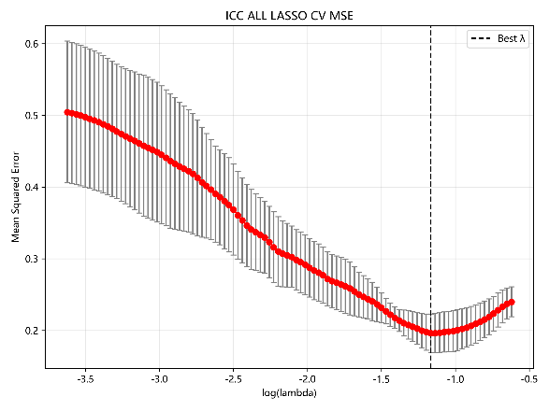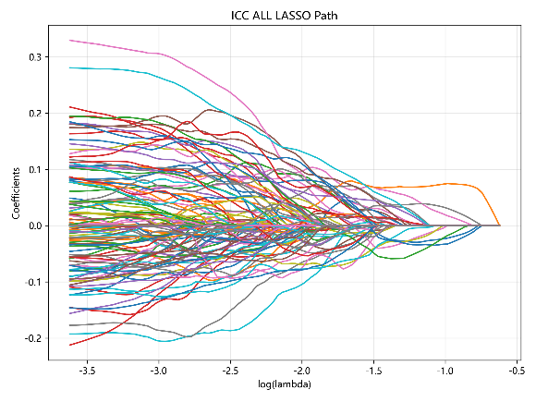

Fig S5 The performance of the three models under five different algorithms. (A-C) High repeatability group training set, validation set, test set ROC(D-F) Low repeatability group training set, validation set, test set ROC(G-I) Full feature group training set, validation set, test set ROC
C
B
A
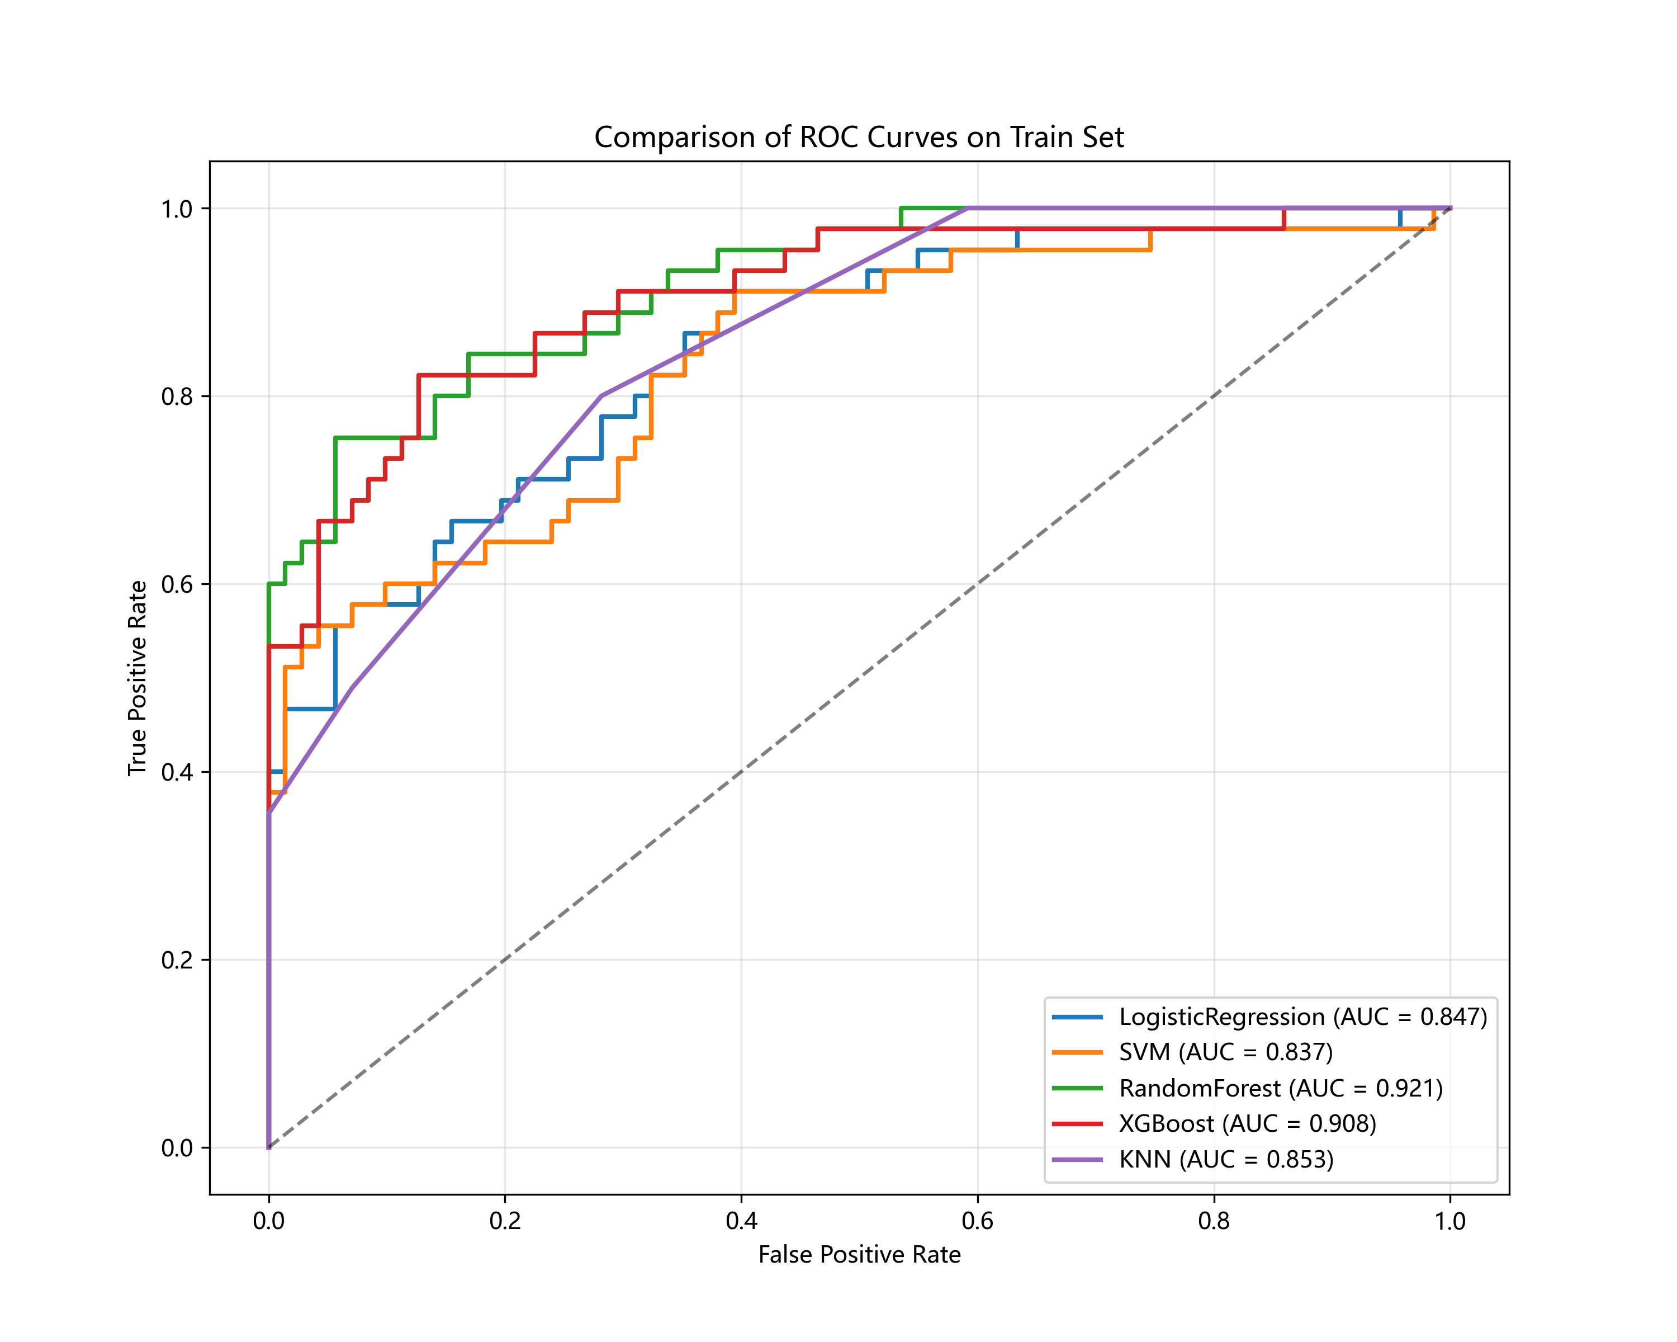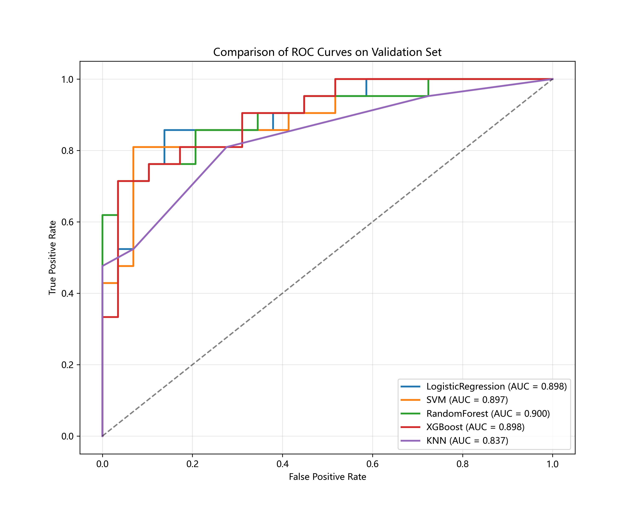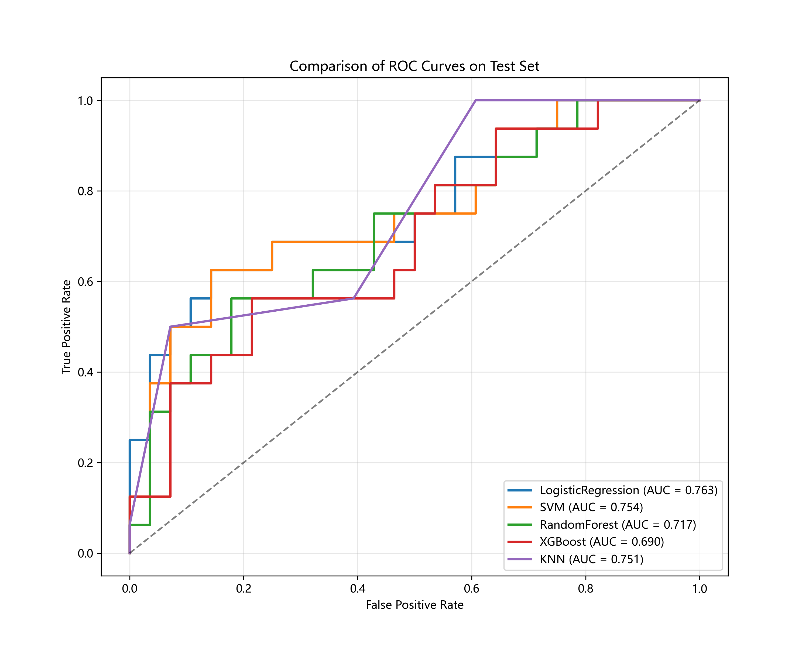
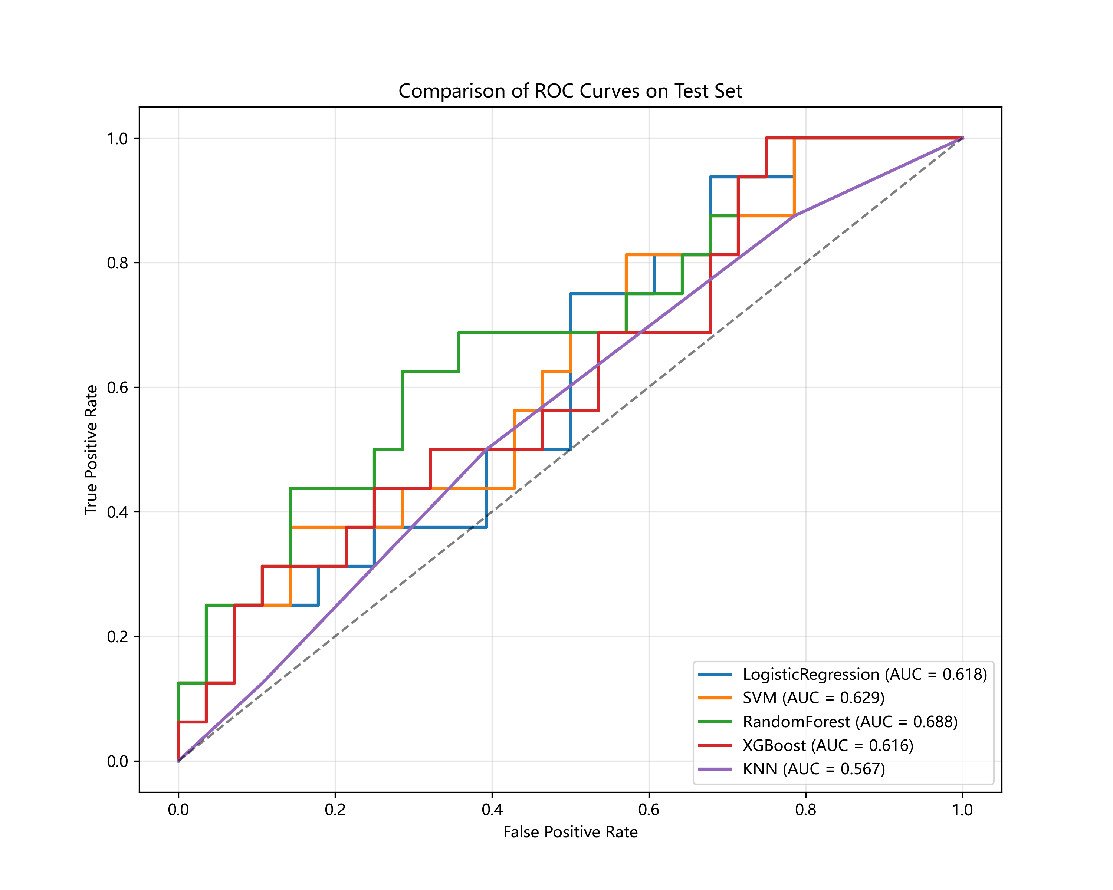
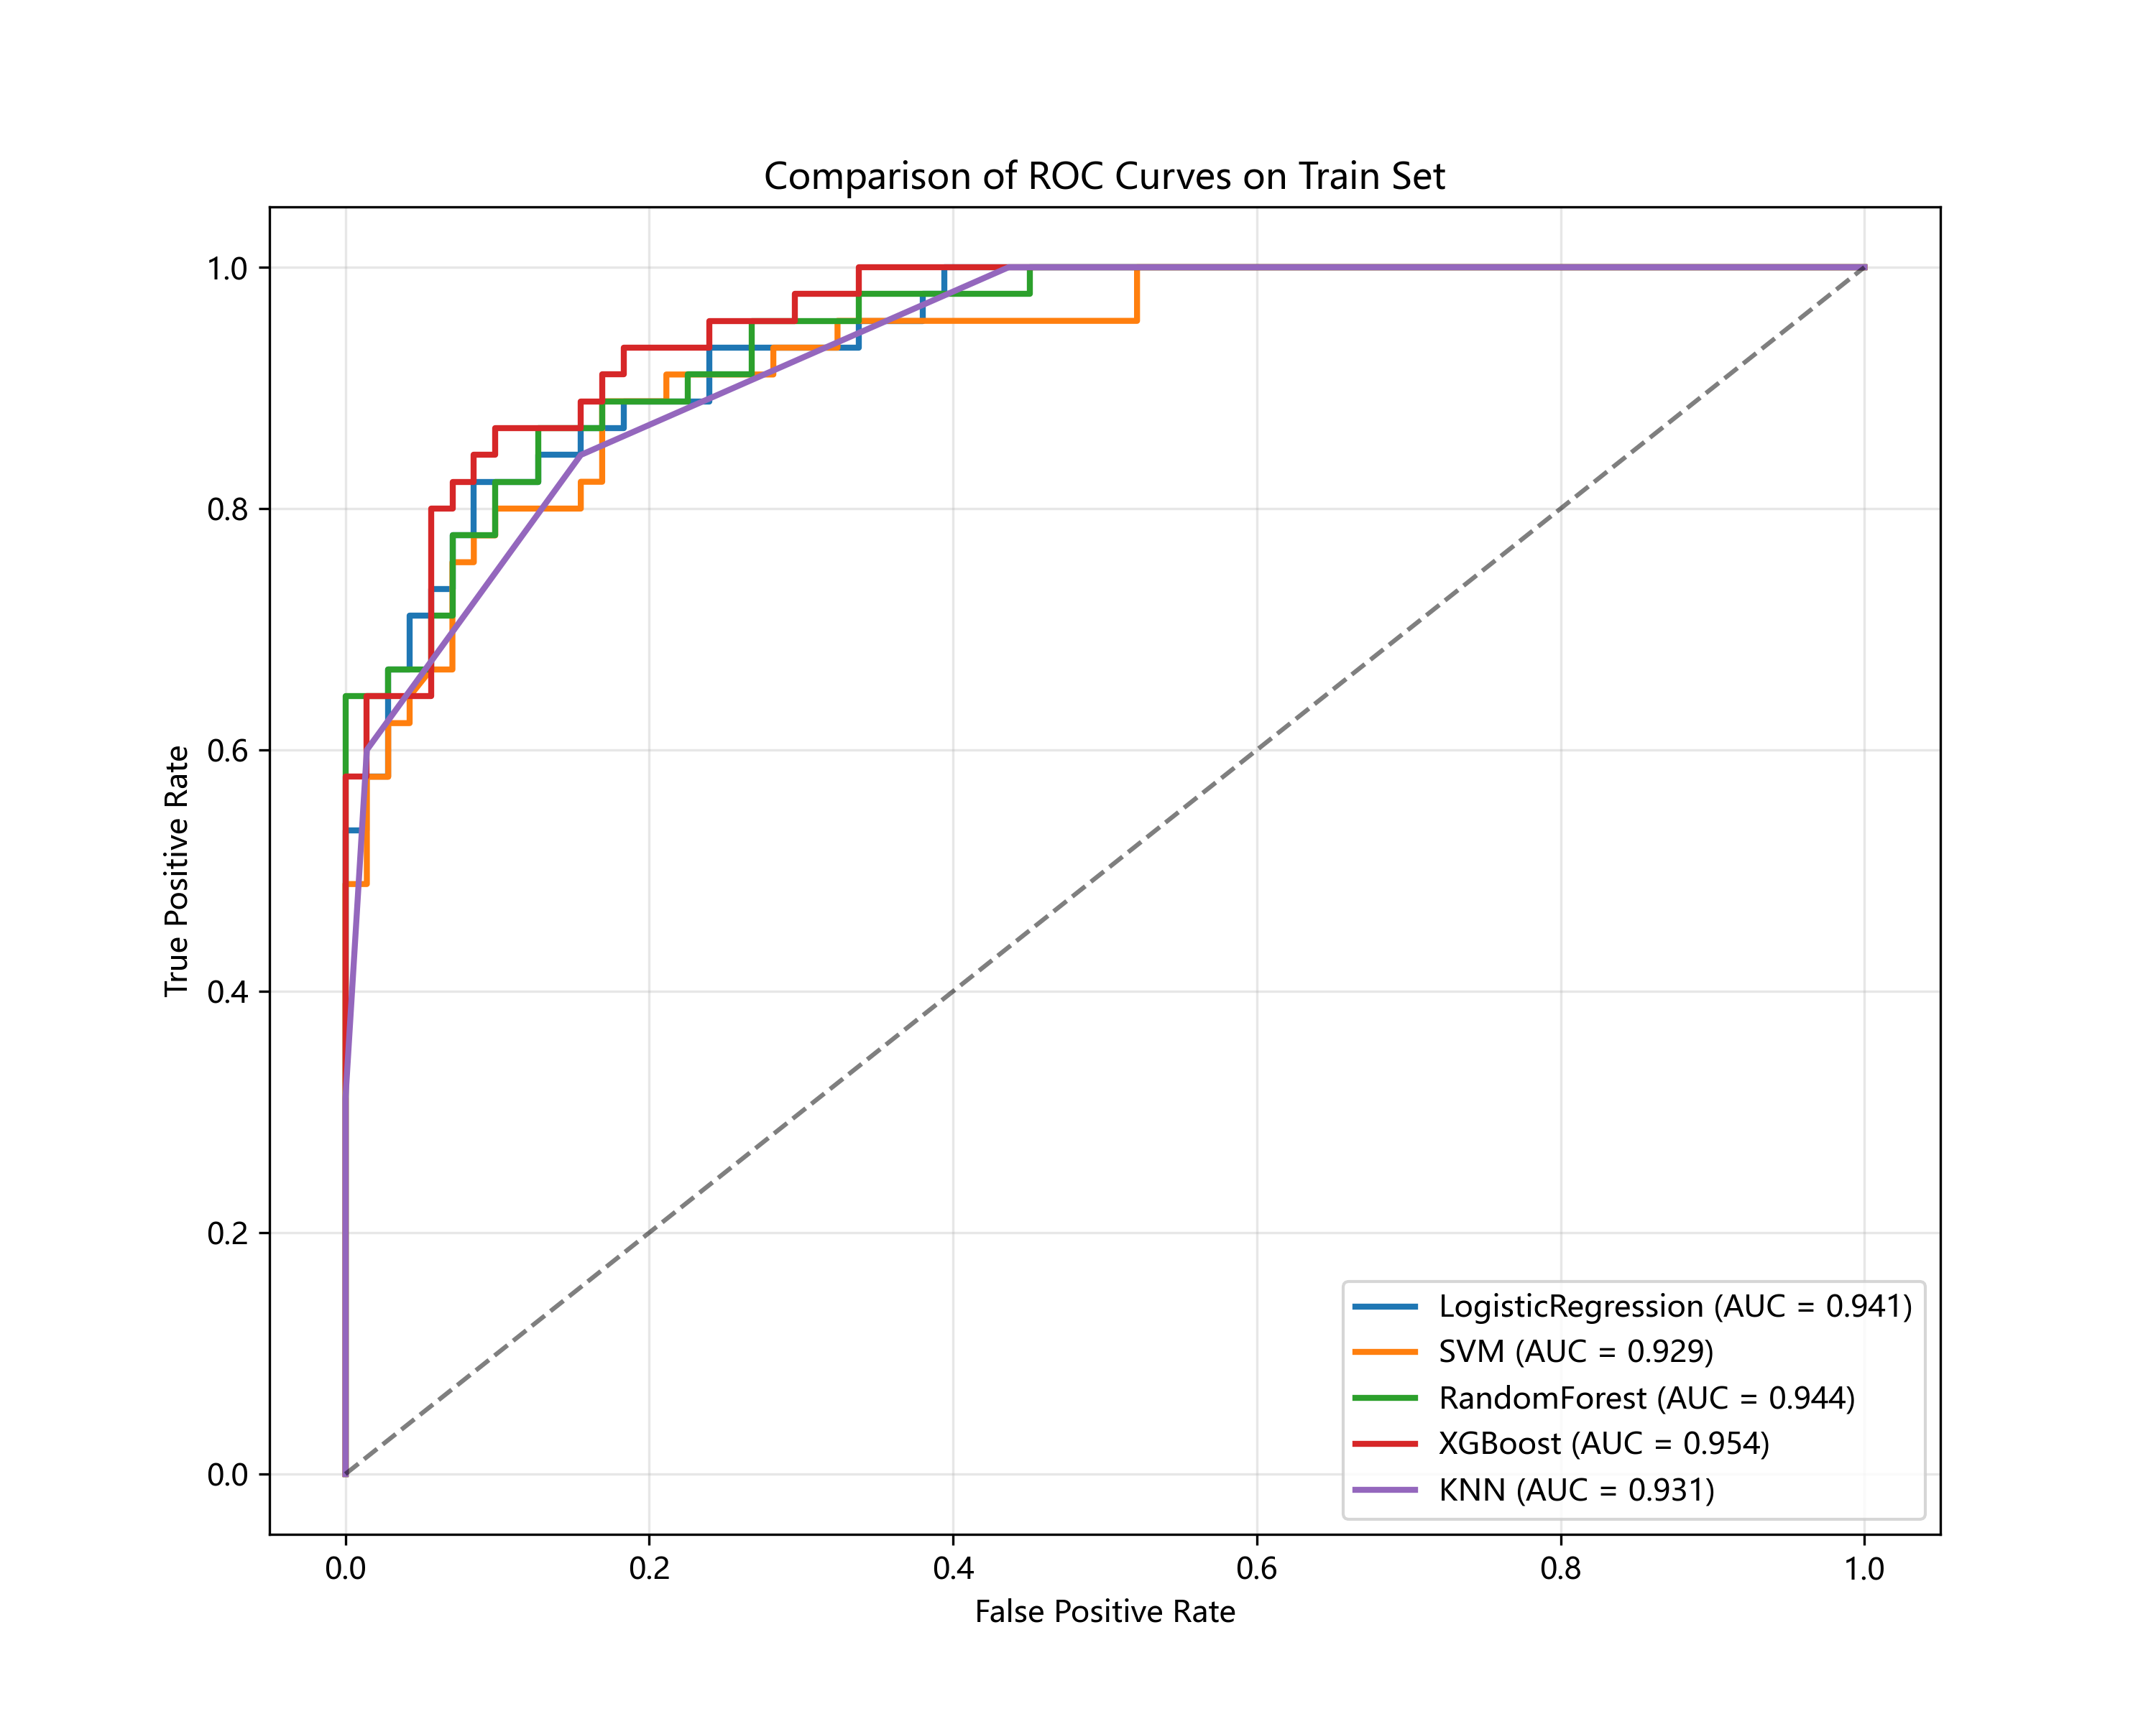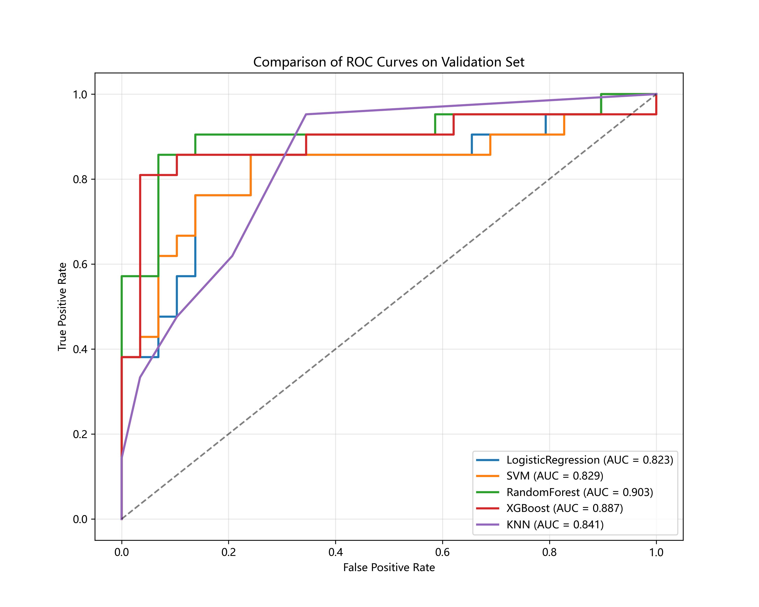
F
D
E
I
H
G
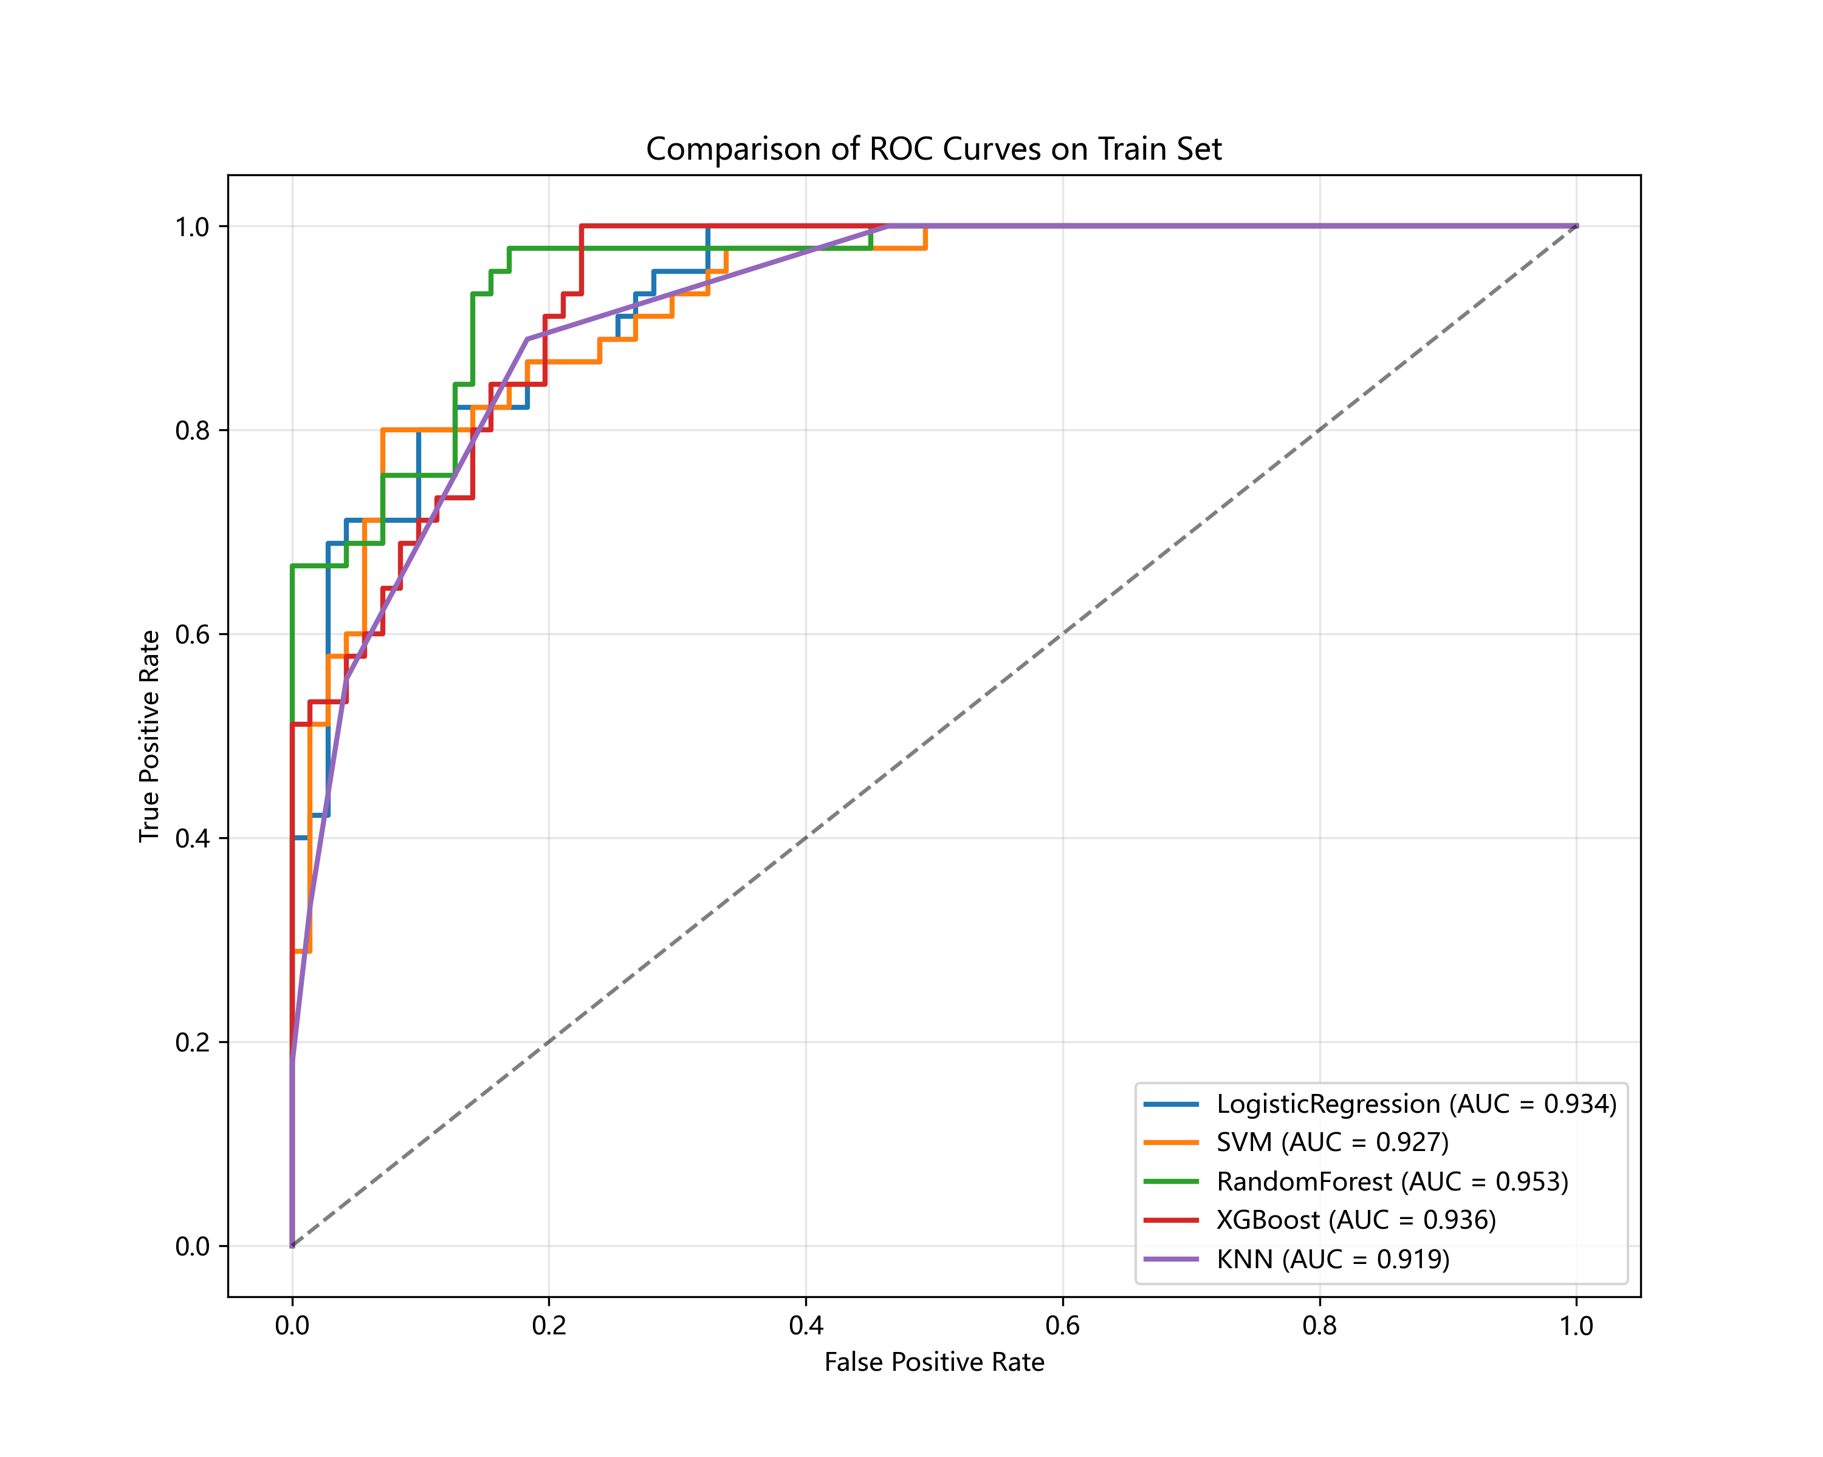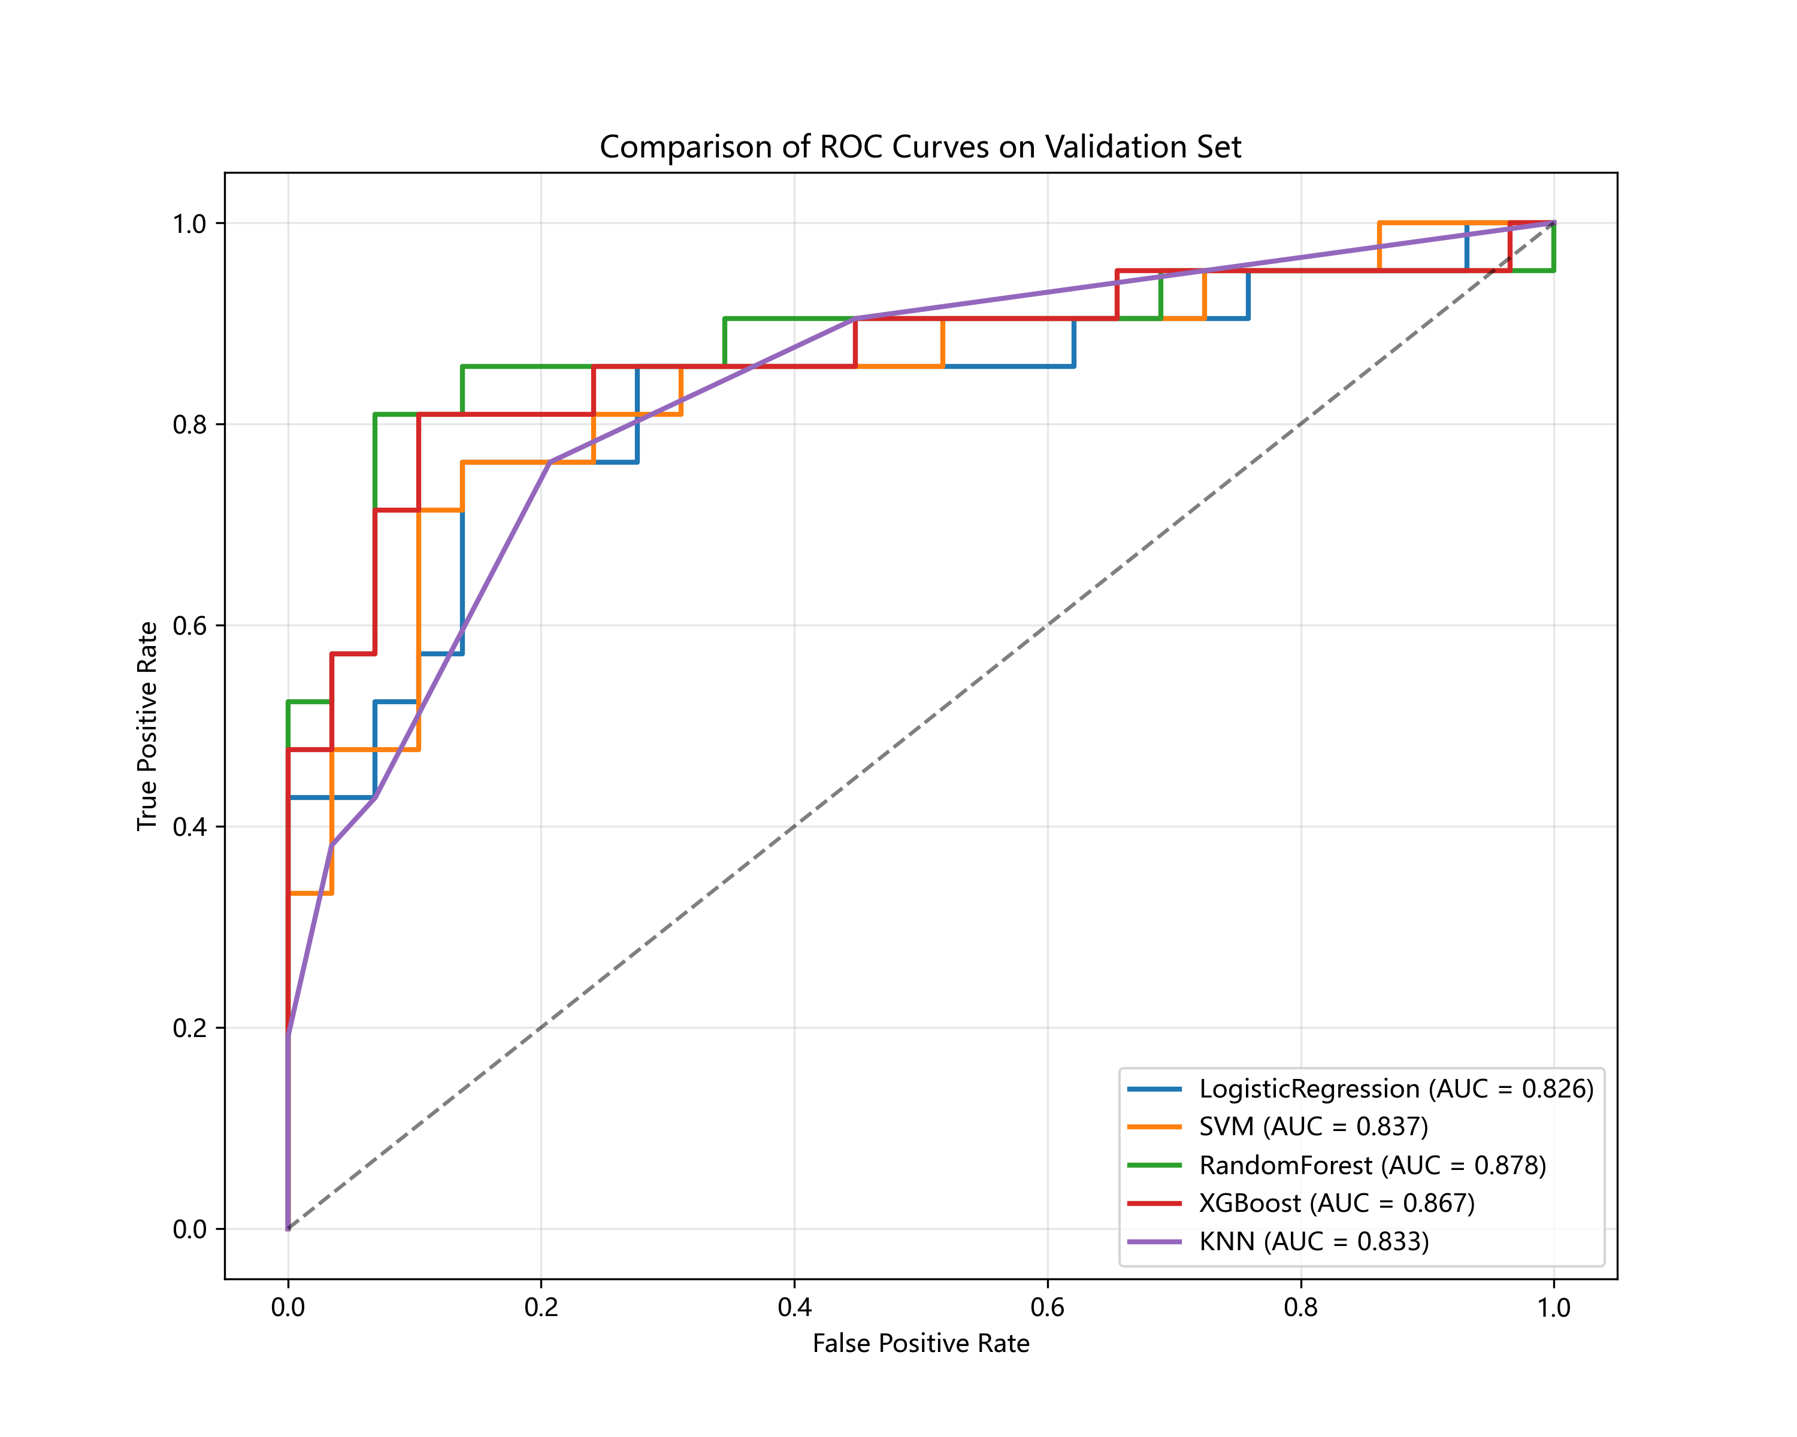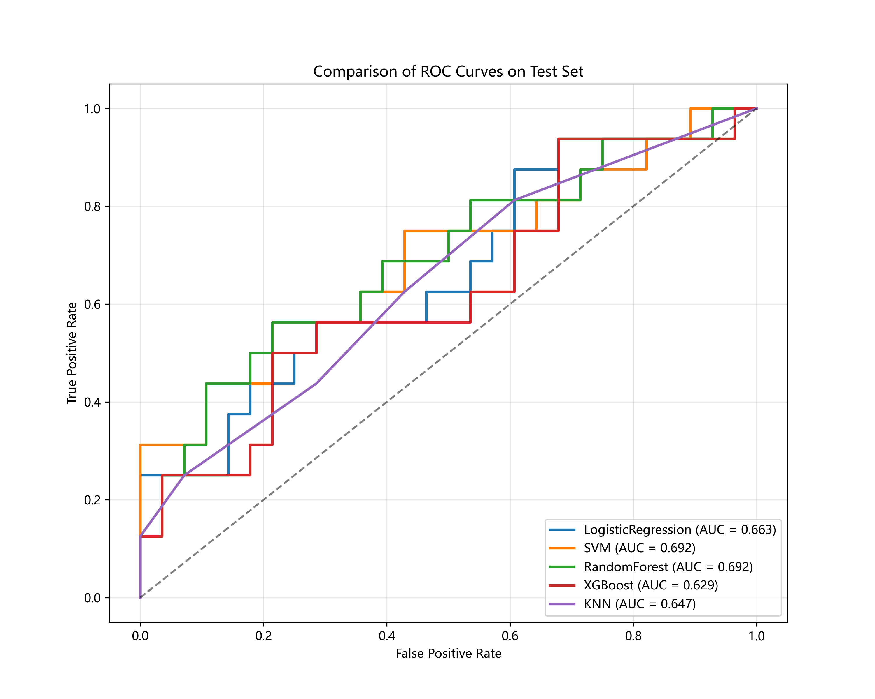

Fig S6 Decision curve analysis (A) and calibration curve (B) for the logistic regression (LR) model developed using high-reproducibility features.
A
B
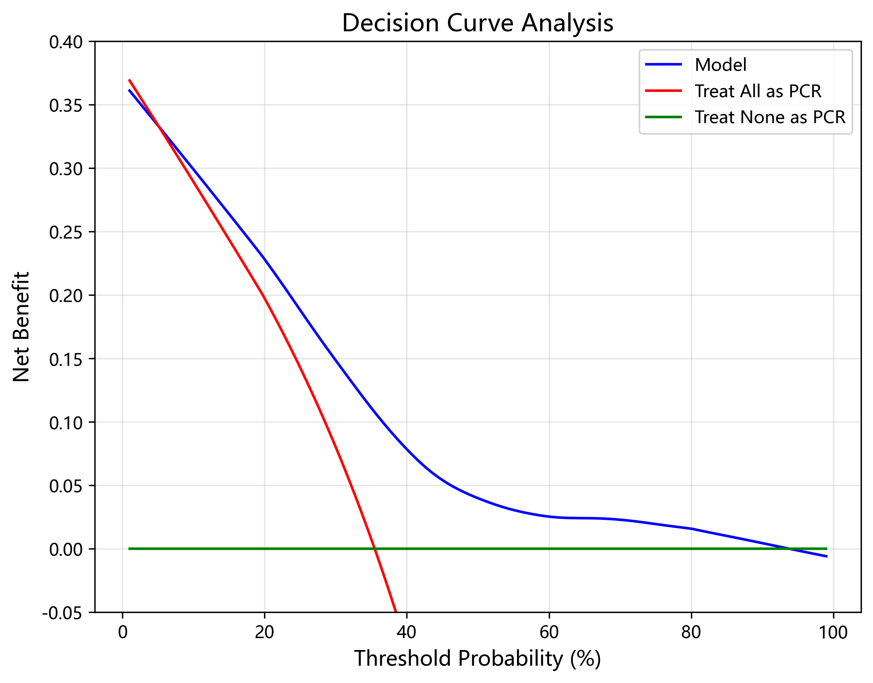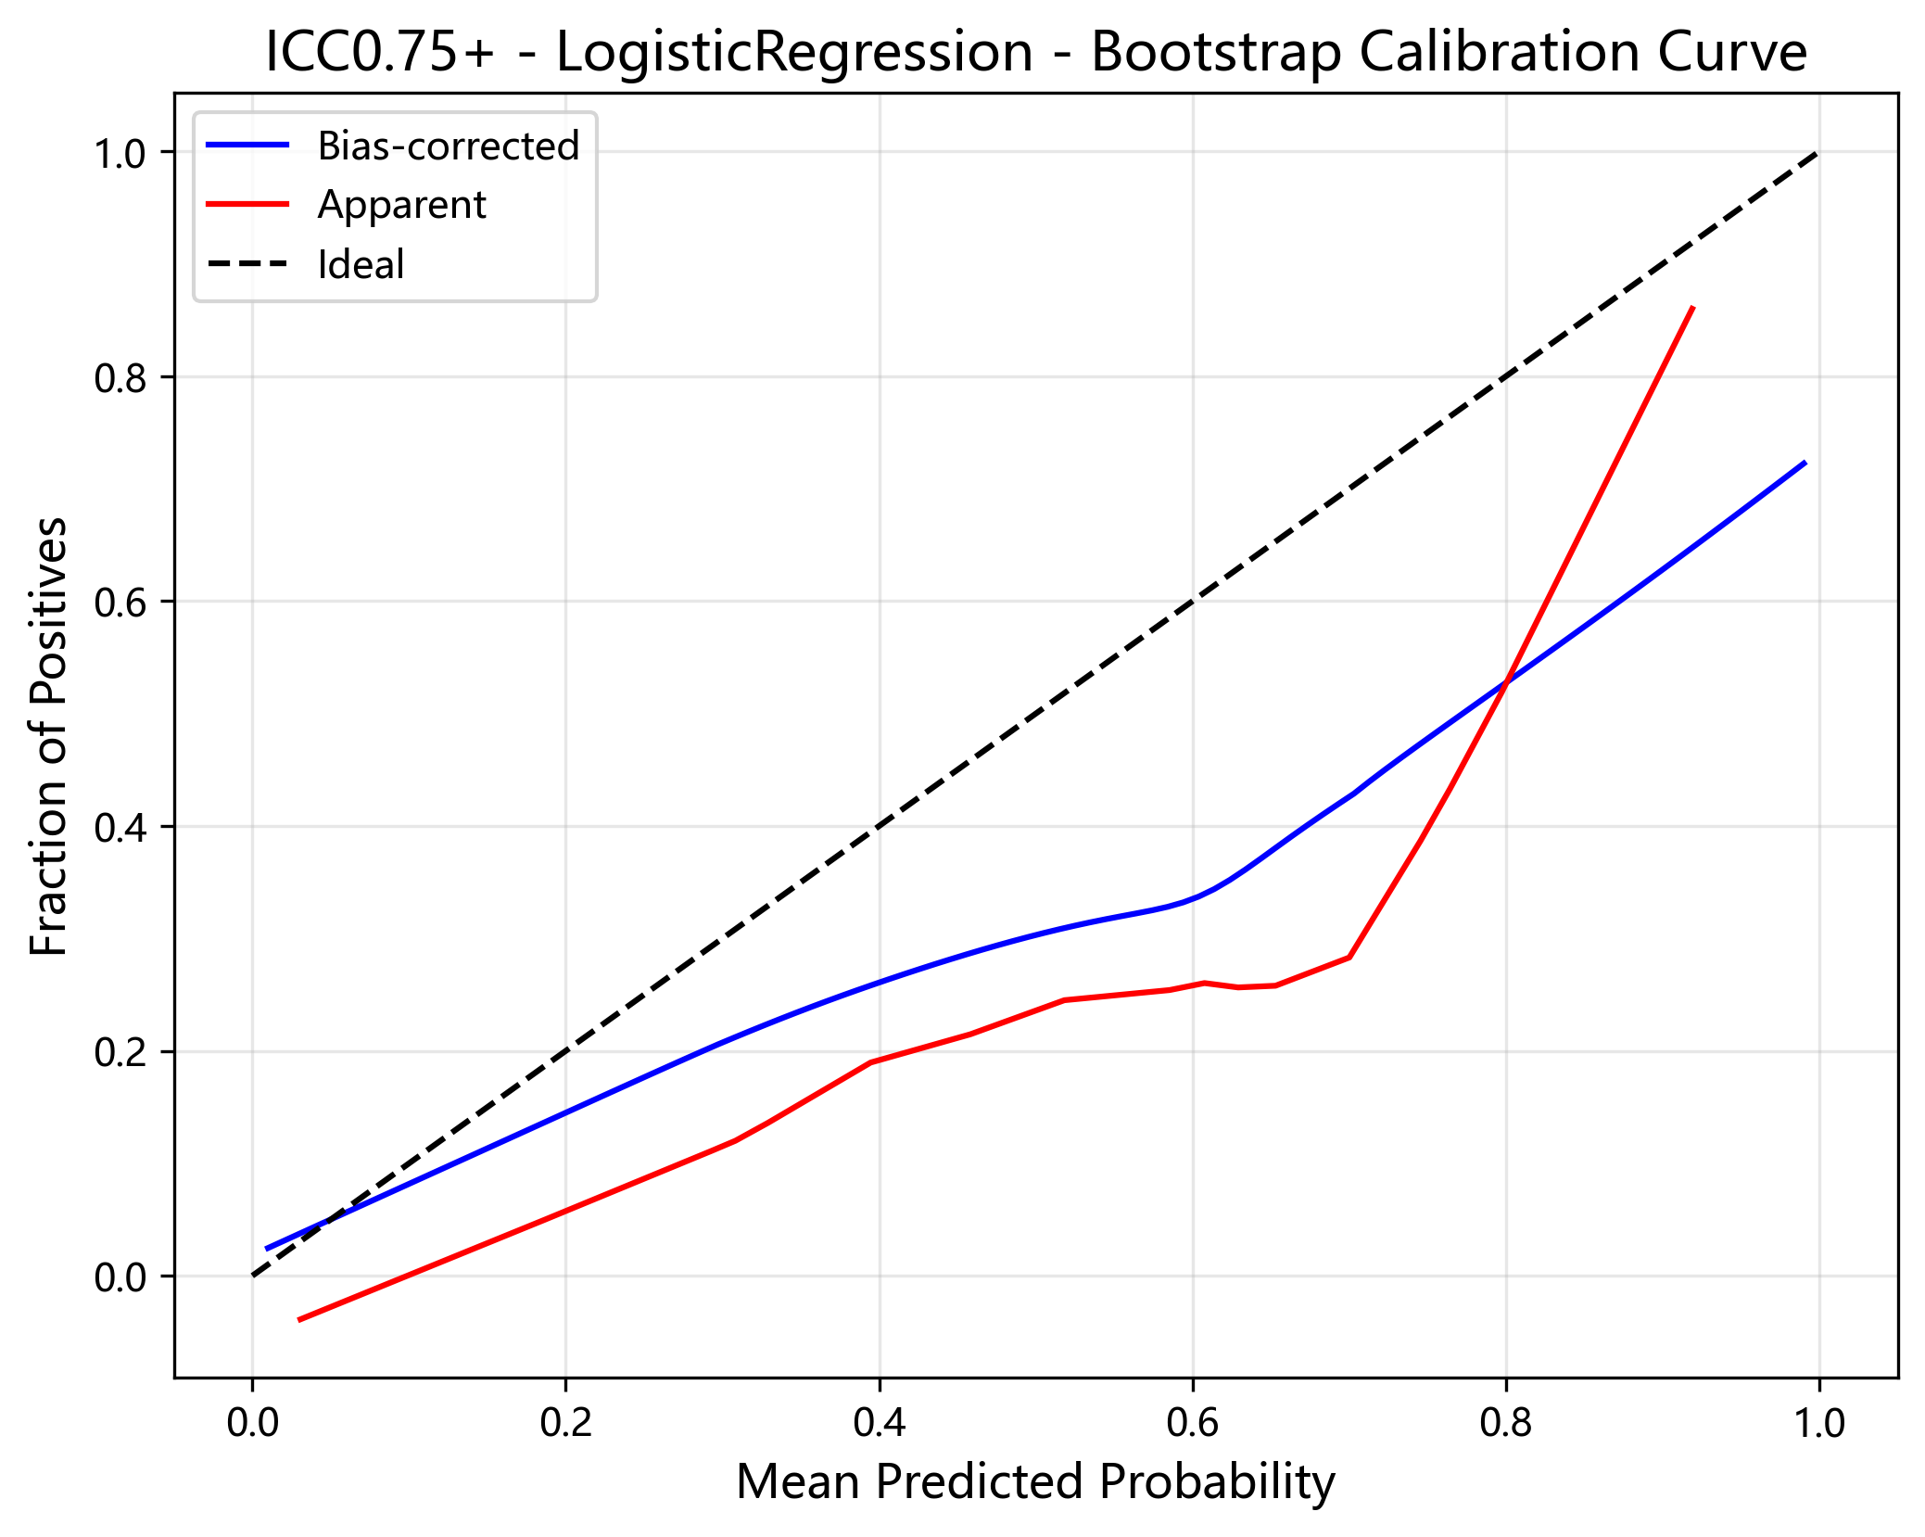

Table S1 Image preprocessing, perturbation, and feature extraction parameters
Category | Parameter | Value
Preprocessing | Resampled voxel size (mm) | 1 × 1 × 1
Preprocessing | Image/mask interpolator | B-spline
Preprocessing | Default pixel value for resampling (HU) | −1000
Perturbation | Translation distances (voxels) | 0.0, 0.2, 0.4, 0.6, 0.8
Perturbation | Rotation angles (degrees) | −10, 0, 10
Perturbation | Contour randomization intensity (x, y, z) | 1.0, 1.0, 1.0
Perturbation | Smoothing sigma (x, y, z) | 10, 10, 10
Perturbation | Number of perturbations | 40
Discretization | Discretization method | Fixed bin count
Discretization | Bin count* | 8, 16, 32, 64, 128
Filtering | Image types | Original (unfiltered), LoG (3D), Wavelet
Filtering | LoG sigma (mm) | 1, 2, 3, 4, 5
Filtering | Wavelet type | coif1
Filtering | Wavelet level (start, total) | 0, 1
Filtering | Wavelet sub-bands | LLL, LLH, LHL, LHH, HLL, HLH, HHL, HHH
Feature extraction | Feature classes | Shape, First-order, GLCM, GLRLM, GLSZM, GLDM, NGTDM

Table S2 Univariate analysis of clinical variables
 | Characteristic | p
1 | Age(%) | 0.66
2 | Gender(%) | 0.37
3 | Smoking history(%) | 0.23
4 | Drinking history(%) | 0.08
5 | Family History(%) | 0.52
6 | Tumor location(%) | 0.54
7 | Clinical T stage(%) | 0.19
8 | Clinical N stage(%) | 0.57
9 | Radiation dose(%) | 0.52
10 | Chemotherapy (%) | 0.06

Table S3 Selected Features in the High-Repeatability Group
 | Feature name
1 | log-sigma-2-0-mm-3D_glcm_Imc1
2 | log-sigma-2-0-mm-3D_gldm_SmallDependenceLowGrayLevelEmphasis
3 | log-sigma-5-0-mm-3D_glrlm_LongRunHighGrayLevelEmphasis
4 | wavelet-LLH_glcm_Correlation
5 | wavelet-LLH_glcm_DifferenceVariance
6 | wavelet-HLL_firstorder_Median
7 | wavelet-HLH_glszm_SizeZoneNonUniformity
8 | Volume

Table S4 Selected Features in the Low-Repeatability Group
 | Feature name
1 | log-sigma-2-0-mm-3D_glszm_SmallAreaLowGrayLevelEmphasis
2 | log-sigma-4-0-mm-3D_glszm_GrayLevelVariance
3 | log-sigma-5-0-mm-3D_gldm_LargeDependenceHighGrayLevelEmphasis
4 | wavelet-LLH_glcm_ClusterProminence
5 | wavelet-LLH_ngtdm_Contrast
6 | wavelet-LHL_firstorder_Mean
7 | wavelet-LHL_firstorder_Median
8 | wavelet-LHL_firstorder_Skewness
9 | wavelet-LHL_glrlm_RunEntropy
10 | wavelet-LHH_glcm_ClusterShade
11 | wavelet-HLL_firstorder_Mean
12 | wavelet-HLH_glszm_GrayLevelVariance
13 | wavelet-HLH_glszm_HighGrayLevelZoneEmphasis
14 | wavelet-HLH_gldm_DependenceNonUniformity
15 | wavelet-HHL_glszm_GrayLevelVariance
16 | wavelet-LLL_gldm_SmallDependenceLowGrayLevelEmphasis
17 | Volume

Table S5 Selected Features in the All-Feature Group
 | Feature name
1 | log-sigma-2-0-mm-3D_glcm_Imc1
2 | log-sigma-2-0-mm-3D_gldm_SmallDependenceLowGrayLevelEmphasis
3 | log-sigma-5-0-mm-3D_gldm_LargeDependenceHighGrayLevelEmphasis
4 | wavelet-LLH_glcm_ClusterProminence
5 | wavelet-LHL_firstorder_Mean
6 | wavelet-LHL_firstorder_Skewness
7 | wavelet-LHL_glrlm_RunEntropy
8 | wavelet-LHH_glcm_ClusterShade
9 | wavelet-HLL_firstorder_Mean
10 | wavelet-HLL_firstorder_Median
11 | wavelet-HLH_glszm_HighGrayLevelZoneEmphasis
12 | wavelet-HLH_gldm_DependenceNonUniformity
13 | wavelet-HHL_glcm_MCC
14 | Volume

