SUPPLEMENTARY INFORMATION

Figure S1. SNP-based phylogenetic tree instance and its associated Graph Attention Network (GAT) model (n=1,000) for the rifampicin resistance

Phylogenetic tree for the rpoB mutation Ser450Leu (Mutation presence - red; Mutation absence – grey)
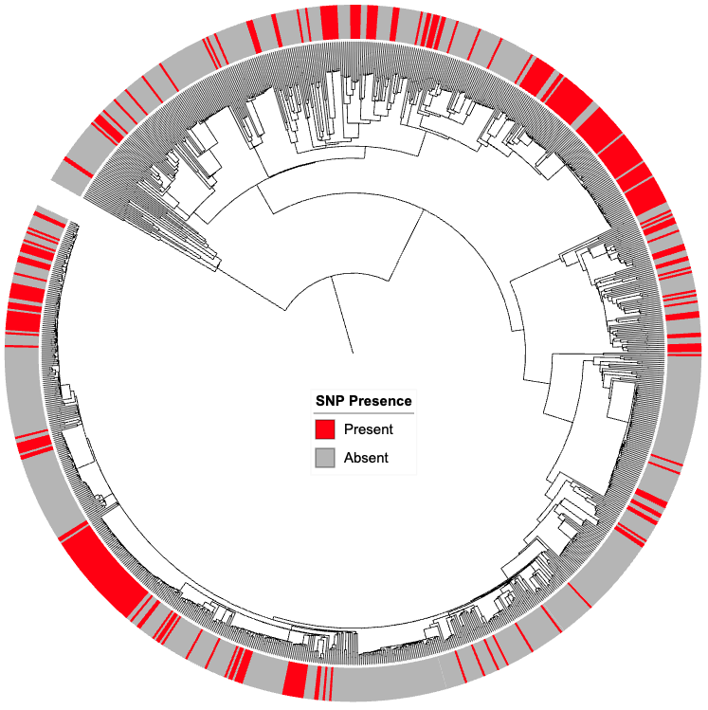

- GAT input graph for (A). This graph structure (the rpoB - Ser450Leu) is used as input for GAT training, allowing the model to propagate and weight information through biologically relevant neighbours. (Mutation presence - red; Mutation absence – grey)

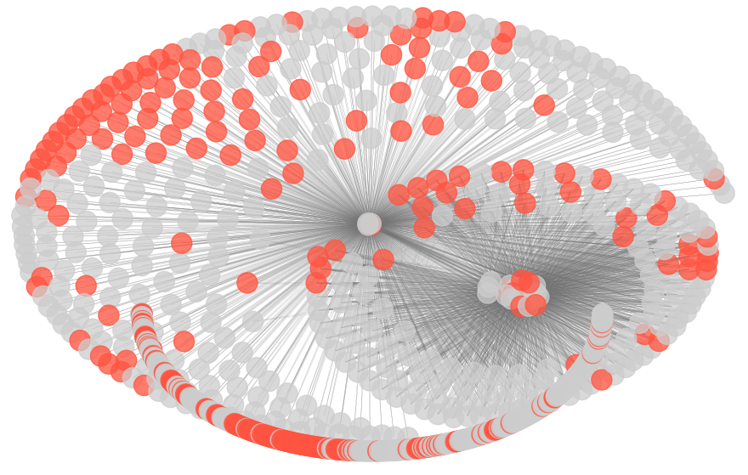

Table S1. Model architecture
Stage | Layer | Heads | Concat | Output shape
Node feats | Input  (node feature-SNP presence; Edges-node connection; Edge-length) | – | – | Node×1
Message pass 1 | GATConv (out=32 per head) | 8 | Yes | Node×(32x8=256)
Norm/act | BN → ELU → Dropout | – | – | Node×256
Message pass 2 | GATConv (out=256, head=1) | 1 | No | Node×256
Residual | BN(x₂) + x₁ → ELU → Dropout | – | – | Node×256
Readout | GlobalAttention (gate: 256→1) | – | – | Batch×256
MLP | FC(256→32) → BN → ReLU → Dropout → FC(32→2) | – | – | Batch×2
BN: batch normalisation; ELU: Exponential Linear Unit (ELU) function; FC: Fully connected linear layer; ReLu: Rectified Linear unit

Table S2. Test set predictions from the Graph Attention Network (GAT) Models across the 42 variants*
Gene | SNP mutation | Parsimony Score** | Label* | Prediction
embB | met306val | 62 | 1 | 1
rrs | n.514a>c | 17 | 1 | 1
pncA | c.-11a>g | 12 | 1 | 1
embB | gly406asp | 10 | 1 | 1
pncA | _p.met1? | 7 | 1 | 0
eis | c.-37g>t | 5 | 1 | 0
ethA | c.-7t>c | 4 | 1 | 0
pnca | trp68arg | 4 | 1 | 1
inhA | c.-770t>a | 4 | 1 | 0
rpoB | his445arg | 3 | 1 | 1
inhA | c.-779g>t | 3 | 1 | 1
gyrB | ser447phe | 3 | 1 | 1
pncA | val180phe | 3 | 1 | 1
rpoB | ile491phe | 3 | 1 | 1
pncA | pro54leu | 1 | 1 | 0
whib6 | c.-75delg | 132 | 0 | 0
tsnr | leu232pro | 129 | 0 | 0
gyra | gly668asp | 129 | 0 | 0
ahpC | c.-88g>a | 24 | 0 | 0
rpoB | c.2628t>g | 24 | 0 | 0
rpoC | glu1092asp | 17 | 0 | 0
glpK | c.510c>t | 7 | 0 | 0
rv3236c | ala370thr | 7 | 0 | 0
rpoB | c.309c>t | 6 | 0 | 0
gyrB | c.1578g>a | 4 | 0 | 0
embB | c.1602c>t | 4 | 0 | 1
ubiA | c.294c>t | 2 | 0 | 0
ubiA | c.228t>c | 2 | 0 | 0
ppe35 | gly258asp | 2 | 0 | 0
rpoC | pro601leu | 2 | 0 | 0
rpoC | c.186c>t | 2 | 0 | 1
gyrB | val301leu | 2 | 0 | 0
ndH | val18ala | 2 | 0 | 0
rv1979c | asp286gly | 2 | 0 | 0
rv0010c | ile87met | 2 | 0 | 0
embC | asn394asp | 2 | 0 | 0
rv3083 | c.105g>a | 2 | 0 | 0
gid | c.330g>t | 2 | 0 | 0
rpoC | c.517c>a | 2 | 0 | 0
fbiA | c.337c>t | 2 | 0 | 1
rpoA | c.972c>t | 1 | 0 | 0
lpqB | c.1689a>g | 1 | 0 | 0
* 15 under positive selection (label = 1) and 27 neutrally evolving (label = 0); ** from the Fitch parsimony algorithm
Table S3. WHO Drug resistance Uncertain variants predicted to be under positive selection with confidence scores of at least 0.55

Gene | Change | Confidence | MDR+ (%)* | No. Sub-Lin.** | Prominent Lineage (freq. %)*** | Notes
rpoC | Val483Gly | 0.99 | 4513 (49.4) | 37 | 2.2.1 (33.0) | Compensatory¹⁹
rpoC | Lys445Arg | 0.99 | 328 (49.1) | 32 | 2.2.1 (63.0) | Compensatory²⁷
rpoC | Ile491Val | 0.99 | 1848 (49.5) | 44 | 2.2.1 (67.0) | Compensatory
rpoC | Glu1033Lys | 0.95 | 109 (49.1) | 22 | 2.2.1 (46.0) | -
ubiA | Arg240Cys | 0.94 | 135 (48.7) | 28 | 4.6.1.2 (49.0) | Putative²⁸
rpoC | Asp485Tyr | 0.92 | 705 (49.7) | 32 | 2.2.1 (79.0) | Compensatory²³
Rv1979c | Arg409Gln | 0.76 | 0 (-) | 0 | 2.2.1 (-) | Putative¹⁸
rrs | n.1489C>T | 0.75 | 9 (39.1) | 11 | 2.2.1 (36.0) | -
ubiA | Ala249Thr | 0.75 | 535 (50.0) | 28 | 2.2.2 (88.0) | -
embA | c.-16C>A | 0.75 | 467 (49.1) | 41 | 2.2.1 (36.0) | -
ethA | Pro334Ala | 0.75 | 376 (24.9) | 21 | 2.2.1 (99.0) | -
embA | c.-8C>A | 0.75 | 347 (49.4) | 34 | 2.2.1 (81.0) | -
rpoC | Val431Met | 0.75 | 197 (49.0) | 36 | 2.2.1 (43.0) | -
rpsA | Ala412Val | 0.75 | 196 (42.9) | 14 | 2.2.1 (98.0) | Putative²⁹
whiB6 | Ala66Thr | 0.75 | 192 (48.5) | 11 | 2.2.1 (94.0) | -
katG | c.-507C>G | 0.74 | 979 (49.57) | 22 | 2.2.1 (98.0) | -
mmpS5 | c.-74G>T | 0.74 | 1557 (46.9) | 27 | 2.2.1 (98.0) | Putative³⁰
Rv1258c | Val245Met | 0.74 | 0 (-) | 0 | 2.2.1 (-) | -
ubiA | Val188Ala | 0.71 | 266 (49.7) | 22 | 4.3.3 (84.0) | Putative²⁴
rrl | n.2771C>T | 0.71 | 257 (17.5) | 48 | 2.2.1 (17.0) | -
rrl | n.2725A>G | 0.71 | 218 (18.8) | 43 | 2.2.1 (21.0) | -
rrl | n.2715T>C | 0.71 | 214 (20.1) | 43 | 2.2.1 (21.0) | -
rrl | n.2726T>A | 0.71 | 180 (20.0) | 49 | 2.2.1 (21.0) | -
rrl | n.2712C>T | 0.71 | 149 (19.0) | 47 | 2.2.1 (21.0) | -
rrl | n.2751G>A | 0.71 | 137 (19.2) | 49 | 2.2.1 (16.0) | -
rpoC | Asn698Ser | 0.64 | 408 (49.6) | 29 | 2.2.1 (70.0) | Compensatory²³
rpoC | Val483Ala | 0.63 | 1570 (49.7) | 33 | 2.2.1 (52.0) | Putative²¹
rrl | n.-49G>C | 0.55 | 21 (23.1) | 15 | 3 (94.0) | ⁻
* None of the variants are present in the sensitive samples in the 100K dataset; MDR+ indicates the number of samples containing the variant that fall into multidrug-resistant (MDR), pre-extensively drug-resistant (Pre-XDR), or extensively drug-resistant (XDR) categories. % presence refers to the proportion of MDR+ samples in the 100K database that carry the variant. ** represents the number of distinct sublineages in which the variant is found, capturing the breadth of its phylogenetic distribution. *** denotes the sublineage in which the variant is most observed; % Occurrence indicates the percentage of variant-containing samples that belong to this specific sublineage.

