Supplementary Material

Additional Figure 1 – Directed acyclic graph (DAG) representing the theoretical relationships among the study variables.
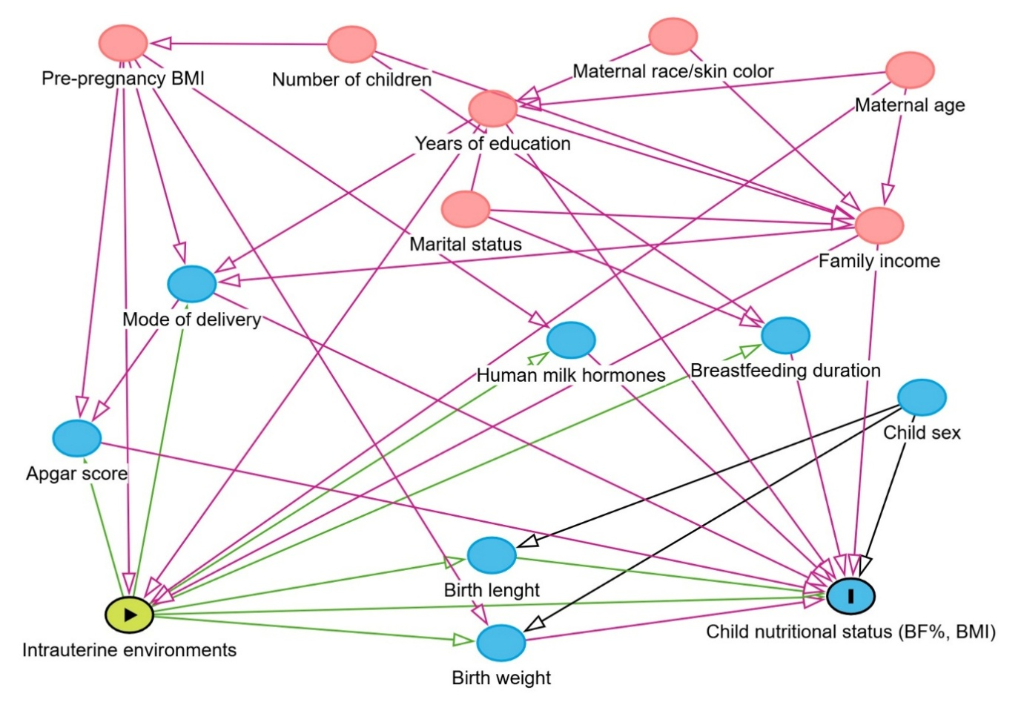
Developed by the author (2025).

Supplementary Table 1 - Spearman correlation (ρ) between leptin in human milk and BMI-for-age Z-score in newborns and preschool children, stratified by gestational clinical conditions associated with adverse intrauterine environments - IVAPSA cohort, phases I and II (2011-2019) - Porto Alegre (RS) / Brazil.
 |  | BMI/A Z-SCORE
Group |  | 7 days | 15 days | 1 month | 3 months | 6 months | preschool age
Pospartum leptin
DM | ρ | 0.886 | 0.900 | 0.600 | 1.000 | -1.000
 | p-value | 0.019 | 0.037 | 0.400
 | n | 6 | 5 | 4 | 4 | 3 | 1
SAH | ρ | 1.000 | 0.600 | 0.500 | -0.500 | 0.100 | 1.000
 | p-value |  | 0.285 | 0.667 | 0.667 | 0.873
 | n | 4 | 5 | 4 | 3 | 5 | 2
Smoking | ρ | 0.077 | 0.250 | 0.246 | -0.248 | -0.430 | -1.000
 | p-value | 0.812 | 0.409 | 0.376 | 0.392 | 0.214
 | n | 12 | 13 | 15 | 14 | 10 | 2
IUGR | ρ | 0.090 | 0.491 | 0.311 | 0.476 | 0.257 | -0.200
 | p-value | 0.848 | 0.217 | 0.453 | 0.233 | 0.623
 | n | 7 | 8 | 8 | 6 | 6 | 5
Control | ρ | 0.168 | -0.064 | 0.095 | -0.392 | -0.591 | 0.257
 | p-value | 0.602 | 0.853 | 0.748 | 0.166 | 0.056
 | n | 12 | 11 | 14 | 14 | 11 | 6
30 days leptin
DM | ρ |  |  |  | -0.020 | 0.811 | 0.231
 | p-value |  |  |  | 0.944 | 0.004 | 0.521
 | n |  |  |  | 15 | 10 | 10
SAH | ρ |  |  |  | 0.800 | 0.657 | 1.000
 | p-value |  |  |  | 0.104 | 0.156
 | n |  |  |  | 5 | 6 | 3
Smoking | ρ |  |  |  | 0.309 | 0.206 | 0.458
 | p-value |  |  |  | 0.090 | 0.335 | 0.134
 | n |  |  |  | 31 | 24 | 12
IUGR | ρ |  |  |  | -0.341 | -0.709 | 0.429
 | p-value |  |  |  | 0.255 | 0.015 | 0.397
 | n |  |  |  | 13 | 11 | 6
Control | ρ |  |  |  | -0.260 | -0.116 | 0.309
 | p-value |  |  |  | 0.051 | 0.419 | 0.085
 | n |  |  |  | 57 | 51 | 32
BMI-for-age (BMI/A): body mass index for age; DM: diabetes mellitus; SAH: systemic arterial hypertension; IUGR: intrauterine growth restriction; ρ: Spearman’s correlation coefficient.

Supplementary Table 2 - Spearman correlation (ρ) between adiponectin in human milk and BMI-for-age Z-score in newborns and preschool children, stratified by gestational clinical conditions associated with adverse intrauterine environments - IVAPSA cohort, phases I and II (2011-2019) - Porto Alegre (RS) / Brazil.
 |  | BMI/A Z-SCORE
Group |  | 7 days | 15 days | 1 month | 3 months | 6 months | preschool age
Pospartum adiponectin
DM | ρ | -0.800 | -0.700 | -0.800 | -1.000 | 1000
 | p-value | 0.104 | 0.188 | 0.104
 | n | 5 | 5 | 5 | 3 | 3 | 1
SAH | ρ | -0.400 | -0.700 | -1.000 | -1.000 | -0.200 | -1.000
 | p-value | 0.600 | 0.188 |  |  | 0.747
 | n | 4 | 5 | 3 | 3 | 5 | 2
Smoking | ρ | 0.189 | 0.068 | 0.314 | 0.121 | -0.082 | -1.000
 | p-value | 0.557 | 0.817 | 0.220 | 0.666 | 0.811
 | n | 12 | 14 | 17 | 15 | 11 | 2
IUGR | ρ | -0.143 | -0.119 | -0.333 | -0.643 | -0.029 | -0.800
 | p-value | 0.787 | 0.779 | 0.420 | 0.119 | 0.957 | 0.200
 | n | 6 | 8 | 8 | 7 | 6 | 4
Control | ρ | 0.783 | 0.378 | -0.15 | 0.018 | -0.127 | 0.000
 | p-value | 0.003 | 0.226 | 0.958 | 0.950 | 0.709 | 1.000
 | n | 12 | 12 | 14 | 15 | 11 | 7
30 days adiponectin
DM | ρ |  |  |  | -0.257 | 0.200 | 0.500
 | p-value |  |  |  | 0.623 | 0.747 | 0.667
 | n |  |  |  | 6 | 5 | 3
SAH | ρ |  |  |  | -0.200 | 0.257 | 0.500
 | p-value |  |  |  | 0.747 | 0.623 | 0.667
 | n |  |  |  | 5 | 6 | 3
Smoking | ρ |  |  |  | -0.307 | -0.309 | 0.400
 | p-value |  |  |  | 0.265 | 0.385 | 0.6
 | n |  |  |  | 15 | 10 | 4
IUGR | ρ |  |  |  | -0.417 | 0.086 | -0.600
 | p-value |  |  |  | 0.265 | 0.872 | 0.400
 | n |  |  |  | 9 | 6 | 4
Control | ρ |  |  |  | 0.068 | -0.027 | 0.200
 | p-value |  |  |  | 0.810 | 0.937 | 0.704
 | n |  |  |  | 15 | 11 | 6
BMI-for-age (BMI/A): body mass index for age; DM: diabetes mellitus; SAH: systemic arterial hypertension; IUGR: intrauterine growth restriction; ρ: Spearman’s correlation coefficient.

Supplementary Table 3 - Spearman correlation (ρ) between insulin in human milk and BMI-for-age Z-score in newborns and preschool children, stratified by gestational clinical conditions associated with adverse intrauterine environments - IVAPSA cohort, phases I and II (2011-2019) - Porto Alegre (RS) / Brazil.
 |  | BMI/A Z-SCORE
Group |  | 7 days | 15 days | 1 month | 3 months | 6 months | preschool age
Pospartum insulin
DM | ρ | 0.429 | 0.500 | -0.700 | 0.000 | -0.200
 | p-value | 0.397 | 0.391 | 0.188 | 1.000 | 0.800
 | n | 6 | 5 | 5 | 4 | 4 | 1
SAH | ρ | -0.200 | -0.200 | -1.000 | -0.500 | 0.200 | -1.000
 | p-value | 0.800 | 0.747 |  | 0.667 | 0.747
 | n | 4 | 5 | 3 | 3 | 5 | 2
Smoking | ρ | 0.140 | 0.293 | 0.211 | -0.032 | -0.309 | -1.000
 | p-value | 0.665 | 0.310 | 0.417 | 0.909 | 0.355
 | n | 12 | 14 | 17 | 15 | 11 | 2
IUGR | ρ | -0.396 | -0.048 | -0.179 | 0.333 | -0.200 | 0.100
 | p-value | 0.379 | 0.911 | 0.702 | 0.420 | 0.747 | 0.873
 | n | 7 | 8 | 7 | 8 | 5 | 5
Controle | ρ | 0.473 | -0.027 | -0.055 | -0.183 | -0.200 | 0.086
 | p-value | 0.142 | 0.937 | 0.852 | 0.532 | 0.580 | 0.872
 | n | 11 | 11 | 14 | 14 | 10 | 6
30 days insulin
DM | ρ |  |  |  | -0.429 | 0.600 | 1.000
 | p-value |  |  |  | 0.397 | 0.285
 | n |  |  |  | 6 | 5 | 3
SAH | ρ |  |  |  | 0.100 | -0.029 | -0.500
 | p-value |  |  |  | 0.873 | 0.957 | 0.667
 | n |  |  |  | 5 | 6 | 3
Smoking | ρ |  |  |  | 0.279 | 0.697 | 1.000
 | p-value |  |  |  | 0.315 | 0.025
 | n |  |  |  | 15 | 10 | 4
IUGR | ρ |  |  |  | -0.024 | -0.250 | 0.500
 | p-value |  |  |  | 0.955 | 0.589 | 0.667
 | n |  |  |  | 8 | 7 | 3
Control | ρ |  |  |  | -0.447 | 0.203 | -0.393
 | p-value |  |  |  | 0.082 | 0.527 | 0.383
 | n |  |  |  | 16 | 12 | 7
BMI-for-age (BMI/A): body mass index for age; DM: diabetes mellitus; SAH: systemic arterial hypertension; IUGR: intrauterine growth restriction; ρ: Spearman’s correlation coefficient.

