Supplementary Tables and Figures
Supplementary Table 1. Demographic Information for Immunohistochemical Cohort
Controls (n=17), DLB without depression (DLB-D, n=17), DLB with depression (DLB+D, n=15); Age at death (ANOVA) F(2)=2.628, p=0.083; Post-mortem Interval (PMI, hours, Kruskal-Wallis) H(2)=0.506, p=0.777; Gender (Chi-squared test) χ2(2)=2.362, p=0.364.
Supplementary Table 2. Demographic Information for Biochemical Cohort
Controls (n=12), DLB without depression (DLB-D, n=12), DLB with depression (DLB+D n=12); Age at death (ANOVA) F(2)=0.124, p=0.884; pH (ANOVA) F(2)=0.216, p=0.326; Post-mortem Interval (PMI, hours, Kruskal-Wallis) H(2)=6.190, p=0.045*, Gender (Chi-squared test) χ2(2)=1.636, p=0.576. * PMI not significant between groups after post-hoc analysis.

Supplementary Table 3. Antibodies used in the study.
DB – dot blot; F-IHC – fluorescent immunohistochemistry.

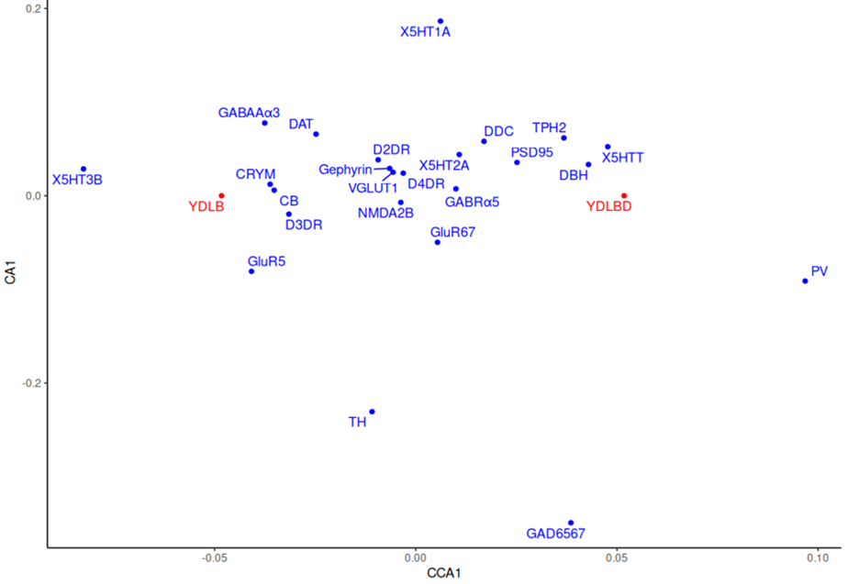
Supplementary Figure 1. Multivariate analyses.
Constrained Ordination (CCA) plot of protein expression scores for individual proteins in depressed and non-depressed DLB patients. Red points represent the score for the depressed and non-depressed state.

