Redox fluctuations induced the production of hydroxyl free radicals and transformation of Fe solid phases in two paddy soils
Qiong Zhang, Weihao Zhang, Xiaoying Pan, Jiewen Yang *

Table S1 Related physicochemical properties of the soils
Soil | pH** | SOM (g kg⁻¹) | Fe_{d} (g kg⁻¹) | Fe_{o} (g kg⁻¹) | Fe_{p} (g kg⁻¹)
DS | 5.40 | 30.29 | 24.68±1.50 | 5.36±0.13 | 0.95±0.01
XT | 6.33 | 28.23 | 14.77±0.33 | 2.84±0.04 | 0.39±0.01
* SOM = Soil organic matter. SOM was determined according to Walkley-Black Method.¹
**Well-ordered Fe oxides (Fe_{d}) were extracted using the dithionite-citrate-bicarbonate (DCB) method, poorly crystalline Fe (Feo) was extracted using the ammonium oxalate method, and the organically complexed Fe (Fe_{p}) was extracted using sodium pyrophosphate at pH 8.5.²⁻⁵ Fe in the extractant was diluted and determined using ICP-OES (Avio 550 Max, PerkinEimer, USA).

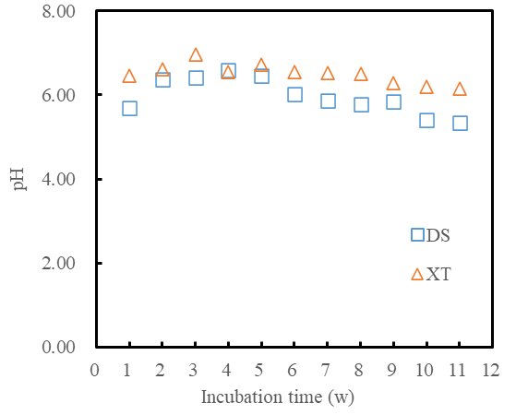

Figure S1. Variation of pH of soil reaction systems during 11 w anoxic incubation.

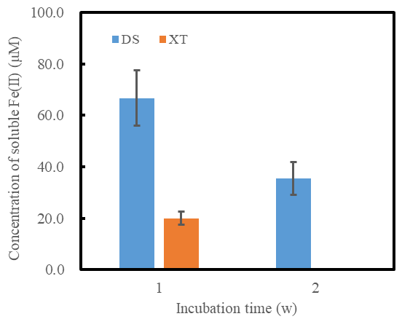
(a)

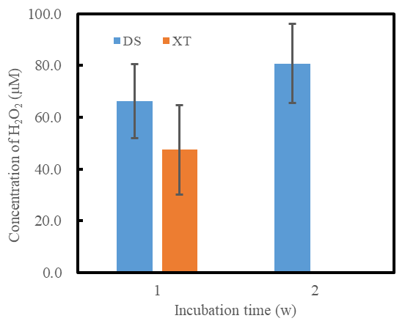
(b)

Figure S2. Redox fluctuation induced production of aqueous Fe(II) (a) and H₂O₂ (b) during anoxic incubation.

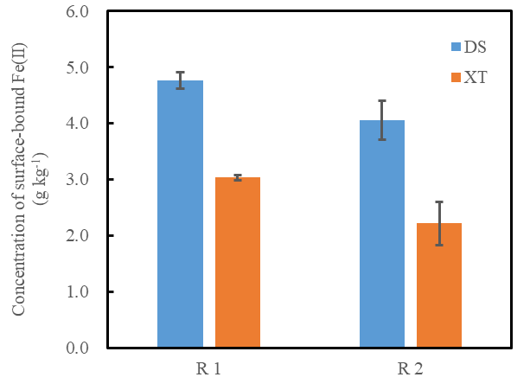
(a)

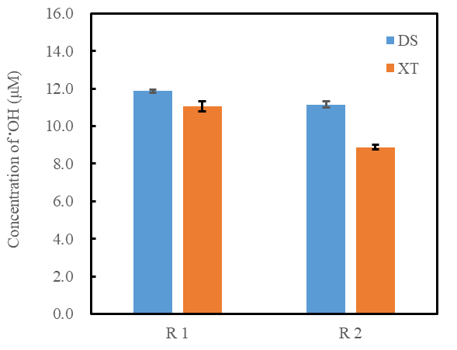
(b)

Figure S3. Effect of redox fluctuation mode on production of surface-bound Fe(II) (a) and •OH (b). R1: 1 w anoxic incubation, 1 d bubbling with O₂ and 1 w anoxic incubation; R2: 2 w anoxic incubation, 1 d bubbling with O₂ and 1 w anoxic incubation. Determination of surface-bound Fe(II) and •OH were performed at the end of last anoxic incubation by exposing the reaction systems to air oxidization.

Table S2 6-k ⁵⁷Fe Mössbauer parameters for the original soil and soil samples treated with re-oxidization and 11 w anoxic incubation.
Treatment | Phase ª | Area, %  (std dev) | CS ^{b}, mm s⁻¹  (std dev) | QS ^{c} mm s⁻¹  (std dev) | LW ^{d} mm s⁻¹  (std dev) | Hyperfine field, T  (std dev)
DS
Original | Q-Fe(II) | 6.36 | 1.25275(0.162) | 2.91297(0.287) | 1.02924(0.144) | -
 | Q-Fe(III) | 20.70 | 0.43861(0.0463) | 0.76185(0.0801) | 1.04837(0.181) | -
 | Fe(III)-OxHy | 19.44 | 0.49005(0.0549) | 0.05552(0.109) | 0.98328(0.105) | 45.19392(0.314)
 | Fe(III)-Ox | 53.49 | 0.46663(0.0124) | -0.22716(0.0249) | 0.72482(0.0281) | 49.30380(0.0601)
11 w anoxic incubation | Q-Fe(II) | 7.66 | 1.29474(0.111) | 2.94316(0.195) | 1.02924(0.144) | -
 | Q-Fe(III) | 25.80 | 0.49243(0.0405) | 0.72052(0.111) | 1.37723(0.212) | -
 | Fe(III)-OxHy | 19.32 | 0.47591(0.0489) | -0.10229(0.0962) | 0.98328(0.105) | 45.19392(0.314)
 | Fe(III)-Ox | 47.22 | 0.45922(0.0124) | -0.21920(0.0248) | 0.72482(0.0281) | 49.30380(0.0601)
4 w anoxic - 1 w oxic incubation | Q-Fe(II) | 9.47 | 1.11471(0.0868) | 2.68319(0.145) | 1.02924(0.144) | -
 | Q-Fe(III) | 23.05 | 0.41652(0.0318) | 0.66542(0.0678) | 1.10390(0.172) | -
 | Fe(III)-OxHy | 19.61 | 0.40648(0.0447) | -0.07779(0.0883) | 0.98328(0.105) | 45.19392(0.314)
 | Fe(III)-Ox | 47.87 | 0.45463(0.0114) | -0.27367(0.0228) | 0.72482(0.0281) | 49.30380(0.0601)
XT
Original | Q-Fe(II) | 11.10 | 1.30821(0.0859) | 2.94596(0.156) | 1.02924(0.144) | -
 | Q-Fe(III) | 32.40 | 0.46550(0.0364) | 0.80765(0.0783) | 1.29414(0.147) | -
 | Fe(III)-OxHy | 16.46 | 0.51305(0.0580) | -0.33407(0.114) | 0.98328(0.105) | 45.19392((0.314)
 | Fe(III)-Ox | 40.03 | 0.47009(0.0146) | -0.23228(0.0291) | 0.72482(0.0281) | 49.30380(0.0601)
11 w anoxic incubation | Q-Fe(II) | 16.04 | 1.49181(0.0757) | 2.60324(0.146) | 1.33824(0.194) | -
 | Q-Fe(III) | 24.49 | 0.41811(0.0441) | 0.85189(0.0823) | 1.15819(0.106) | -
 | Fe(III)-OxHy | 41.07 | 0.47393(0.0141) | -0.23131(0.0274) | 0.79209(0.0597) | 45.19392(0.314)
 | Fe(III)-Ox | 18.40 | 0.49509(0.0184) | -0.23407(0.0362) | 0.56424(0.118) | 49.30380(0.0601)

Table S2 Continued
4 w anoxic - 1 w oxic incubation | Q-Fe(II) | 11.66 | 1.47748(0.144) |  | 2.65994(0.313) | 1.02924(0.144) | -
 | Q-Fe(III) | 27.15 | 0.40541(0.0934) |  | 0.87832(0.219) | 1.29784(0.260) | -
 | Fe(III)-OxHy | 8.25 | 0.83660(0.195) |  | -0.80807(0.382) | 0.98328(0.105) | 45.19392(0.314)
 | Fe(III)-Ox | 52.95 | 0.43964(0.0181) |  | -0.18555(0.0361) | 0.772482(0.0281) | 49.30380(0.0601)
ª Abbreviations: Q-Fe(II) = solid-associated Fe(II), e.g., in primary minerals, silicate-associated or adsorbed; Q-Fe(III) = paramagnetic Fe(III), e.g., in ferrihydrite and lepidocrocite, or complexed/silicate-associated Fe(III); Fe(III)-OxHy = poorly crystalized Fe(III)-(oxy)hydroxides like ferrihydrite; Fe(III)-Ox = well crystalized Fe(III) oxides like goethite; ^{b} Average center shift with respect to alpha iron; ^{c} Quadrupole shift; ^{d} Line width.

Table S3 Molecular characteristics of DOC in soils after 11 w anoxic incubation
*NOSC = nominal oxidation state of carbon.

Soil | Percentage of each molecular composition (%) |  |  |  | AImod | DBE | MW | H/C | O/C | NOSC* | DBE-O
Soil | CHO | CHON | CHOS | CHONS
DS | 40.30 | 26.15 | 6.74 | 4.71 | 0.26 | 9.77 | 450.19 | 1.25 | 0.42 | -0.25 | 0.50
XT | 39.86 | 26.98 | 4.46 | 3.09 | 0.30 | 11.00 | 455.94 | 1.18 | 0.44 | -0.16 | 0.97

References
(1) Nelson, D.W.; Sommers, L.L. Total carbon, organic carbon, and organic matter. In Methods of soil analysis. Part3, Chemical methods; Sparks, D.L. Ed.; Soil Science Society of America, Inc.: Madison, Wisconsin, USA, 1996; pp 964-1013.
(2) Mehra, O.P.; Jackson, M.L. Iron oxide removal from soils and clays by a dithionitecitrate system buffered with sodium bicarbonate. Clays Clay Miner. 1960, 7, 317-327.
(3) McKeague, J.A.; Day, J.H. Dithionite- and oxalate-extractable Fe and al as aids in differentiating various classes of soils. Can. J. Soil Sci. 1966, 46, 13-22.
(4) McKeague, J.A. An evaluation of 0.1M pyrophosphate and pyrophosphate-dithionite in comparison with oxalate as extractants of the accumulation products in podzols and some other soils. Can. J. Soil Sci. 1967, 47, 95-99.
(5) Zhang, J.; Zhang, L.; Wang, P.; Huang, Q.; Yu, G.; Li, D.; Shen, Q.; Ran, W. The role of non-crystalline Fe in the increase of SOC after long-term organic manure application to the red soil of southern China. Eur. J. Soil Sci. 2013, 64, 797-804.

