Optimization and Life-Cycle Assessment of Biochar Production through Microwave–Assisted Pyrolysis of Industrial Hemp Hurd
Nived S Menon¹, Rejeti Venkat Srinadh¹, Neelancherry Remya^{1*}
¹School of Infrastructure, Indian Institute of Technology Bhubaneswar, Argul, Odisha, 752050, India.
*Corresponding author: remya@iitbbs.ac.in

Figures
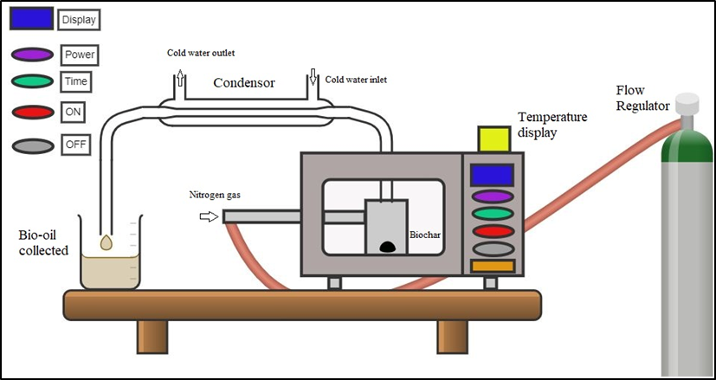
Fig. 1 Schematic diagram of MAP setup

Tables
Table S1. Fit summary of developed model for HB yield and HHV
 | Linear |  | 2FI |  | Quadratic |  | Cubic |  | Lack of Fit
 | p-value | R² | p-value | R² | p-value | R² | p-value | R² | F-value | p-value
HB yield | 0.0002 | 0.81 | 0.2024 | 0.84 | < 0.0001 | 0.99 | 0.1140 | 0.99 | 3.82 | 0.1140
HHV | 0.0059 | 0.57 | 0.7392 | 0.53 | < 0.0001 | 0.98 | 0.1031 | 0.99 | 4.10 | 0.1031
Table S2 Validation of the model for HB yield and HHV
MW Power (W) | Time (min) | HB yield (%) |  |  | HHV (MJ/kg)
MW Power (W) | Time (min) | Observed | Predicted | Error | Observed | Predicted | Error (%)
700 | 17.5 | 35.2 | 29.7 | 5.5 | 13.0 | 12.2 | 6.5
500 | 10 | 88.6 | 93.7 | 5.1 | 14.4 | 14.8 | 2.7
1000 | 15 | 8.7 | 12.5 | 3.8 | 25.4 | 27.2 | 6.6
Average Error |  |  |  | 4.8 |  |  | 5.2

Table S3 Various solutions based on the optimization of biochar yield and HHV
Number | MP (W) | Residence time (mins) | Yield (%) | HHV (MJ/kg) | Desirability
1 | 1000 | 7 | 37.6 | 24.9 | 0.52
2 | 500 | 12.3 | 75.3 | 15.1 | 0.38
3 | 500 | 12.8 | 77.9 | 15.1 | 0.38
4 | 1000 | 30 | 16.8 | 29.5 | 0.31

Table S4. Data related to EF estimation
Feedstock Type | Woody residue
Carbonization Method | Closed carbonization (MAP)
Carbonization Scale | Unspecified
Amount of HH (MHH) | 100 t/yr
Moisture content of HH (m) | 9.85 %
EF (without surplus energy utilization) [Class 6] | 0.10
EF (with surplus energy utilization) [Class 17] | -0.78
HB yield in terms of dry weight of HH | 41.7 %
Scenario specific annual HB Production (MHB) | 4.11 t/yr
Utilization rate (u) | 100 %

Table S5. Impact result using ReCiPe Midpoint (H)
Name | Impact result | Unit
Fine particulate matter formation | 0.66 | kg PM_{2.5} eq.
Fossil resource scarcity | 28.23 | kg oil eq.
Freshwater ecotoxicity | 4.92 | kg 1,4-DCB
Freshwater eutrophication | 0.16 | kg P eq.
Global warming | 167.35 | kg CO₂ eq.
Human carcinogenic toxicity | 4.96 | kg 1,4-DCB
Human non-carcinogenic toxicity | 3199.92 | kg 1,4-DCB
Ionizing radiation | 5.38 | kBq Co-60 eq.
Land use | 1437.69 | m²a crop eq.
Marine ecotoxicity | 7.39 | kg 1,4-DCB
Marine eutrophication | 1.14 | kg N eq.
Mineral resource scarcity | 18.94 | kg Cu eq.
Ozone formation, Human health | 2.01 | kg NO_{x} eq.
Ozone formation, Terrestrial ecosystems | 2.63 | kg NO_{x} eq.
Stratospheric ozone depletion | 0.003 | kg CFC11 eq.
Terrestrial acidification | 3.99 | kg SO₂ eq.
Terrestrial ecotoxicity | 2380.14 | kg 1,4-DCB
Water consumption | 0.78 | m³
Table S6. Environmental impacts by different stages of HB production
Groups | Global warming potential  (kg CO₂ eq.) | Ozone depletion  (kg CFC-11-eq.) | Photochemical oxidant  (kg ethylene-eq.) | Acidification (kg SO₂-eq.) | Eutrophication  (kg P-eq.)
Hemp farming | -2.94 | 0 | 1.11*10⁻³ | 9.13*10⁻³ | 0
Harvesting | 80.83 | 1.11*10⁻⁸ | 0.13 | 4.50 | 3.13*10⁻²
Transportation | 47.83 | 3.53*10⁻⁷ | 0.28 | 0.36 | 1.04*10⁻³
MAP | 0 | 0 | 1.99 | 0 | 0
Allied | 37.48 | 1.35*10⁻⁵ | 5.32*10⁻² | 0.18 | 4.29*10⁻²
Table S7. Sensitivity analysis
 |  | Hemp farming | Harvest | Transportation | Electricity | MAP | Allied
Global warming potential  (kg CO₂ Eq) | EDIP | -2.94 | 80.31 | 48.14 | 0.08 | 49.58 | 37.67
Global warming potential  (kg CO₂ Eq) | CML 2001 | -2.94 | 80.83 | 47.96 | 0.08 | 0 | 37.64
Global warming potential  (kg CO₂ Eq) | ReCiPe Midpoint (H) | -2.94 | 80.83 | 47.83 | 0.08 | 0 | 37.48
Global warming potential  (kg CO₂ Eq) | ILCD 2.0 2018 | -2.94 | 80.83 | 47.98 | 0.10 | 0 | 38.62
Ozone depletion  (kg CFC-11-Eq) | EDIP | 0 | 1.06*10⁻⁸ | 3.24*10⁻⁷ | 4.27*10⁻¹⁰ | 0 | 1.21*10⁻⁵
Ozone depletion  (kg CFC-11-Eq) | CML 2001 | 0 | 1.11*10⁻⁸ | 3.53*10⁻⁷ | 4.88*10⁻¹⁰ | 0 | 1.35*10⁻⁵
Ozone depletion  (kg CFC-11-Eq) | ReCiPe Midpoint (H) | 0 | 1.11*10⁻⁸ | 3.53*10⁻⁷ | 4.89*10⁻¹⁰ | 0 | 1.35*10⁻⁵
Ozone depletion  (kg CFC-11-Eq) | ILCD 2.0 2018 | 0 | 1.40*10⁻⁸ | 4.34*10⁻⁷ | 5.69*10⁻¹⁰ | 0 | 1.63*10⁻⁵
Photo-chemical oxidant  (kg ethylene-Eq) | EDIP | - | - | - | - | - | -
Photo-chemical oxidant  (kg ethylene-Eq) | CML 2001 | 0 | 1.22*10⁻⁵ | 3.21*10⁻³ | 1.16*10⁻⁵ | 2.84 | 1.23*10⁻²
Photo-chemical oxidant  (kg ethylene-Eq) | ReCiPe Midpoint (H) | 1.11*10⁻³ | 0.13 | 0.28 | 1.95*10⁻⁵ | 1.99 | 5.32*10⁻²
Photo-chemical oxidant  (kg ethylene-Eq) | ILCD 2.0 2018 | 1.11*10⁻³ | 0.13 | 0.28 | 1.95*10⁻⁵ | 1.99 | 5.32*10⁻²
Acidification (kg SO₂-Eq) | EDIP | 7.86*10⁻³ | 3.53 | 0.45 | 3.06*10⁻⁵ | 0 | 0.19
Acidification (kg SO₂-Eq) | CML 2001 | 6.32*10⁻³ | 2.98 | 0.33 | 2.78*10⁻⁵ | 0 | 0.20
Acidification (kg SO₂-Eq) | ReCiPe Midpoint (H) | 9.13*10⁻³ | 4.50 | 0.36 | 2.72*10⁻⁵ | 0 | 0.18
Acidification (kg SO₂-Eq) | ILCD 2.0 2018 | 1.13*10⁻² | 5.56 | 0.48 | 3.57*10⁻⁵ | 0 | 0.24
Eutro-phication  ^{($}kg PO₄-Eq, &kg P-Eq) | EDIP | - | - | - | - | - | -
Eutro-phication  ^{($}kg PO₄-Eq, &kg P-Eq) | $CML 2001 | 1.50*10⁻³ | 2.46 | 8.15*10⁻² | 1.02*10⁻⁵ | 0 | 5.61*10⁻²
Eutro-phication  ^{($}kg PO₄-Eq, &kg P-Eq) | &ReCiPe Midpoint (H) | 0 | 3.13*10⁻² | 1.04*10⁻³ | 6.75*10⁻⁶ | 0 | 4.29*10⁻²
Eutro-phication  ^{($}kg PO₄-Eq, &kg P-Eq) | &ILCD 2.0 2018 | 0 | 3.13*10⁻² | 1.03*10⁻³ | 6.74*10⁻⁶ | 0 | 4.28*10⁻²

