Supplementary Material
Note: Tables and figures are displayed in order of appearance in the manuscript

Table 1. Baseline characteristics of patients attending the epilepsy clinic, stratified by seizure-free status
 | Not seizure free  (n=1217) | Seizure free  (n=392)
Age, mean (+/-SD) | 39.9 (15.1) | 42.7 (17.2)
Female, n (%) | 651 (53.1%) | 203 (51.8%)
Seizure type, n (%)  Focal  Generalised  Other | 789 (64.8%)  324 (26.6%)  104 (8.5%) | 247 (63.0%)  105 (26.8%)  40 (10.2%)
Ethnicity, n (%)  White  Black  Asian  Mixed  Others | 1008 (82.8%)  19 (1.6%)  85 (7.0%))  14 (1.2%)  91 (7.5%) | 322 (82.1%)  4 (1.0%)  18 (4.6%)  8 (2.0%)  40 (10.2%)
Index of Multiple Deprivation, n (%)  1 (Most deprived)  2  3  4  5 (Least deprived) | 510 (41.9%)  279 (22.9%)  163 (13.4%)  140 (11.5%)  125 (10.3%) | 153 (39.0%)  80 (20.4%)  50 (12.8%)  59 (15.1%)  50 (12.8%)
Aetiology, n (%)  Genetic  Tumour  Autoimmune  Hippocampal Sclerosis  Vascular Lesion  Trauma  Stroke  Cortical malformation  Structural  Metabolic  Others | 109 (9.0%)  63 (5.2%)  23 (1.9%)  65 (5.3%)  44 (3.6%)  29 (2.4%)  33 (2.7%)  77 (6.3%)  11 (0.9%)  2 (0.2%)  761 (62.5%) | 43 (11.0%)  38 (9.7%)  9 (2.3%)  22 (5.6%)  15 (3.8%)  11 (2.8%)  7 (1.8%)  18 (4.6%)  1 (0.3%)  1 (0.3%)  227 (57.9%)

Figure 1. Cross-correlation heatmap of all 24 features

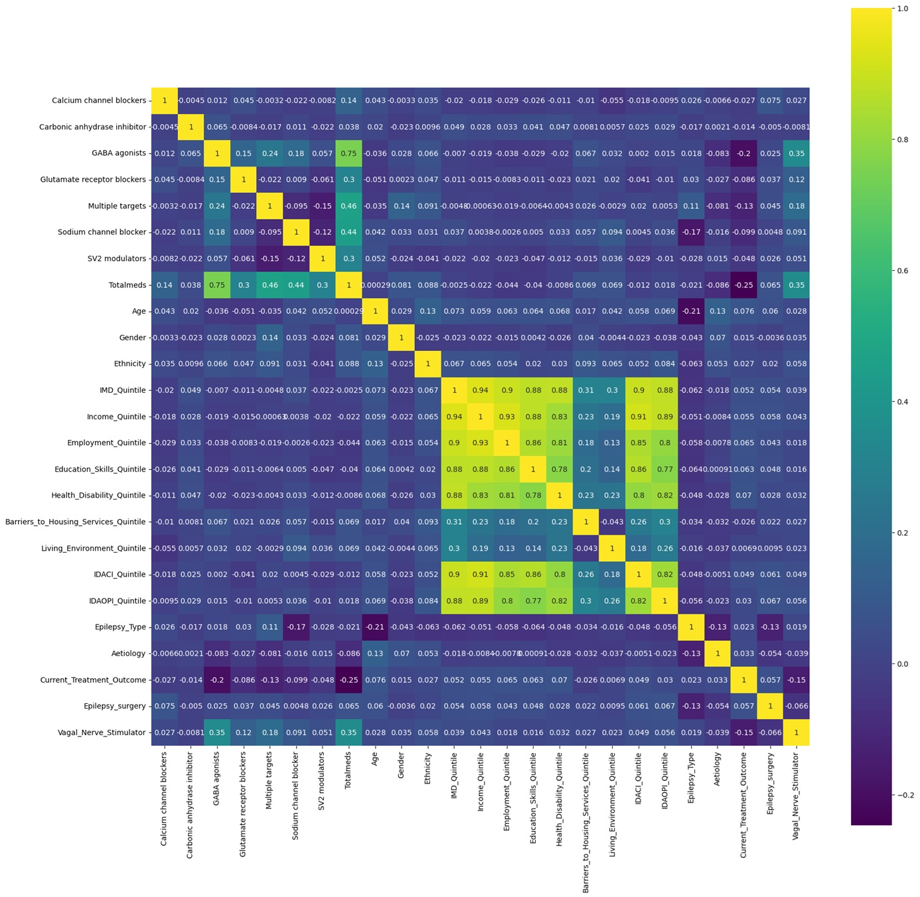

Figure 2. Correlation value against target variable (epilepsy treatment outcome)

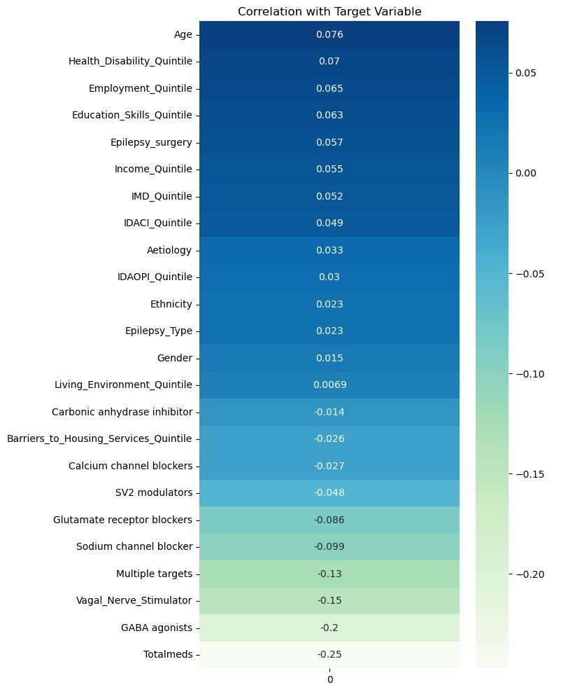

Figure 3. Feature importance ranking using Chi² univariate testing

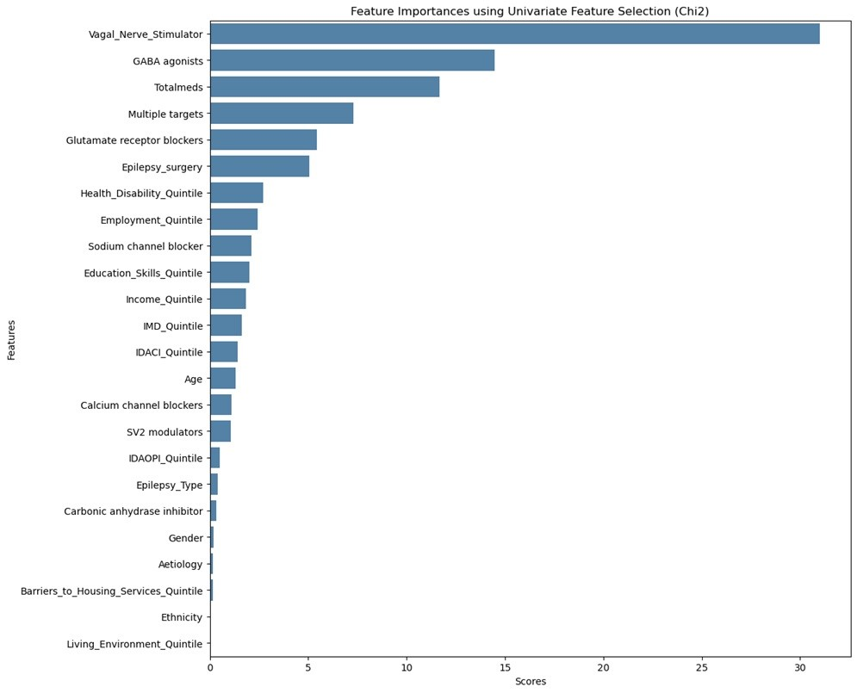

Figure 4. Feature contribution towards model prediction using random forest model

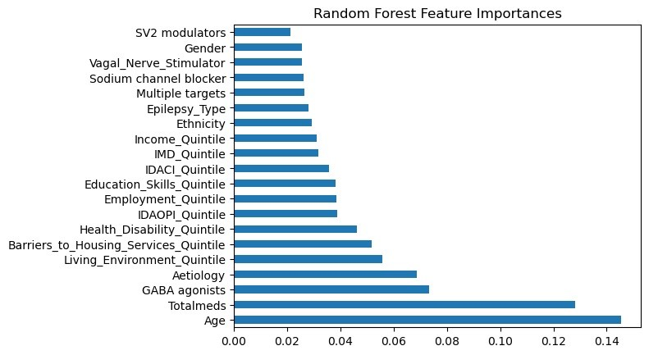

Table 2. Model performance for approach one with all predictor variables

Model | Mean Accuracy | Mean Precision | Mean Recall | Hyperparameter
Logistic regression | 75.6% | 71.6% | 75.6% | {'C': 0.216, 'multi_class': 'ovr', 'penalty': 'l2', 'solver': 'newton-cg'}
Random Forest | 75.6% | 70.6% | 75.6% | {'n_estimators': 1000, 'min_samples_split': 5, 'min_samples_leaf': 4, 'max_features': 'auto', 'max_depth': 40, 'criterion': 'gini', 'bootstrap': False}
Gradient Boosting | 75.0% | 70.0% | 75.0% | {'n_estimators': 50, 'max_depth': 3, 'loss': 'log_loss', 'learning_rate': 0.178, 'criterion': 'squared_error'}

Table 3. Model performance for approach one with demographic predictor variables only

Model | Mean Accuracy | Mean Precision | Mean Recall | Hyperparameter
Logistic regression | 75.6% | 57.2% | 75.6% | {'C': 1.57, 'multi_class': 'ovr', 'penalty': 'l2', 'solver': 'newton-cg'}
Random Forest | 75.9% | 72.3% | 75.9% | {'n_estimators': 833, 'min_samples_split': 10, 'min_samples_leaf': 4, 'max_features': 'sqrt', 'max_depth': 80, 'criterion': 'gini', 'bootstrap': False}
Gradient Boosting | 74.8% | 67.4% | 74.8% | {'n_estimators': 50, 'max_depth': 3, 'loss': 'log_loss', 'learning_rate': 0.178, 'criterion': 'squared_error'}

Table 4. Model performance for approach two with smote and demographic predictor variables only

Model | Mean Accuracy | Mean Precision | Mean Recall | Hyperparameter
Logistic regression | 66.0% | 67.0% | 66.0% | {'C': 0.065, 'multi_class': 'ovr', 'solver': 'sag'}
Random Forest | 84.0% | 84.0% | 84.0% | {'n_estimators': 777, 'min_samples_split': 2, 'min_samples_leaf': 1, 'max_features': 'sqrt', 'max_depth': 60, 'criterion': 'gini', 'bootstrap': True}
Gradient Boosting | 83.0% | 83.0% | 82.0% | {'n_estimators': 100, 'max_depth': 5, 'loss': 'log_loss', 'learning_rate': 0.094, 'criterion': 'squared_error'}

Figure 5. Precision-recall curve of the three models for each fold when the original dataset is used
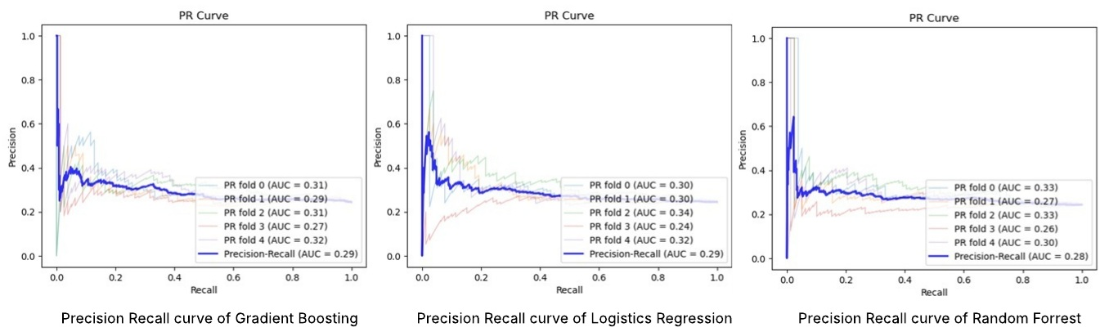

Figure 6. Precision-recall curve of the three models for each fold when smote is used to balance the dataset
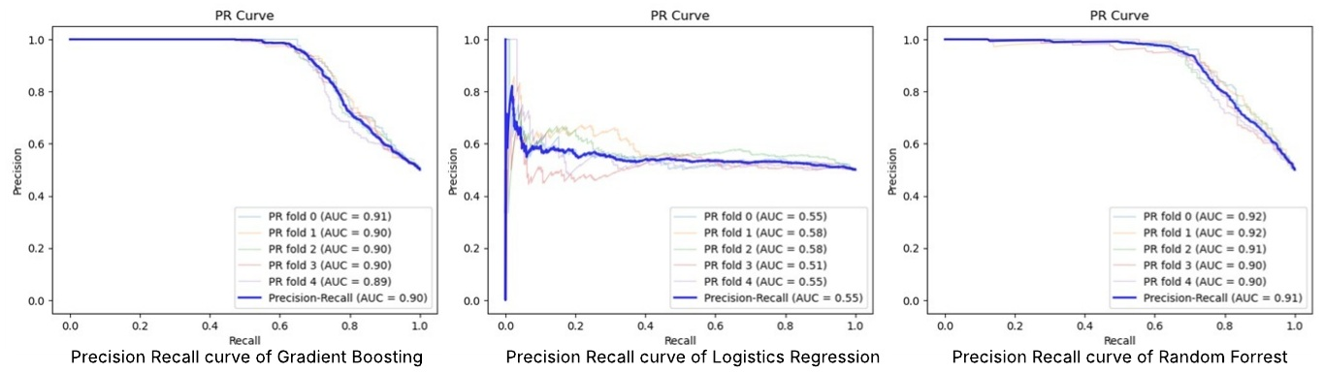

APPENDIX 1

# Create a dictionary to map the old ethnicity categories to the new ones
ethnicity_mapping = {
"WHITE BRITISH": "White",
"WHITE IRISH": "White",
"ANY OTHER WHITE BACKGROUND": "White",
"PAKISTANI (ASIAN OR ASIAN BRITISH)": "Asian",
"ANY OTHER ASIAN BACKGROUND": "Asian",
"INDIAN (ASIAN OR ASIAN BRITISH)": "Asian",
"BANGLADESHI (ASIAN OR ASIAN BRITISH)": "Asian",
"AFRICAN (BLACK OR BLACK BRITISH)": "Black",
"ANY OTHER BLACK BACKGROUND": "Black",
"CARIBBEAN (BLACK OR BLACK BRITISH)": "Black",
"WHITE AND BLACK CARIBBEAN (MIXED)": "Mixed",
"WHITE AND BLACK AFRICAN (MIXED)": "Mixed",
"ANY OTHER MIXED BACKGROUND": "Mixed",
"WHITE AND ASIAN (MIXED)": "Mixed",
"CHINESE (OTHER ETHNIC GROUPS)": "Asian",
"NOT STATED": "Others",
"System Generated": "Others",
"ANY OTHER ETHNIC GROUP": "Others",
}

# Create a dictionary to map the old epilepsy_type categories to the new ones
Epilepsy_Type_mapping = {
"Other syndrome": "Other epilepsy",
"Unclassified": "Other epilepsy",
"Epilepsy syndrome with onset in childhood": "Other epilepsy",
"Focal epilepsy": "Focal epilepsy",
"Generalised epilepsy": "Generalised epilepsy",
"Idiopathic Generalised Epilepsy Syndrome": "Generalised epilepsy",
"Reflex epilepsy": "Other epilepsy",
"Neonatal / Infantile Epilepsy Syndrome": "Other epilepsy",

}
Aetiology_mapping = {
"Unknown": "Others",
"Other": "Others",
}

