SUPPLEMENTAL MATERIAL TO:
Exercise training in hypertrophic cardiomyopathy: a systematic review, meta-analysis, and meta-regression
BY:
Adrián Bayonas-Ruiz^{1,2}
Juan R. Gimeno-Blanes^{3,4,5}
Francisca M. Muñoz-Franco⁶
María Sabater-Molina^{3,7,8}
Bárbara Bonacasa^{1,2*}
ADDRESS FOR CORRESPONDANCE:
Dr. Bárbara Bonacasa, Department of Physiology. Human Physiology Area. Edificio LAIB Departamental. Campus CC Salud-El Palmar. Universidad de Murcia, Spain, Tel +34 868 88 5066, e-mail: bonacasa@um.es

TABLE OF CONTENTS
TABLES
Supplemental Table 1 3
Supplemental Table 2 5
Supplemental Table 3 6
Supplemental Table 4 7
Supplemental Table 5 8
Supplemental Table 6 10
Supplemental Table 7 11
FIGURES
Supplemental Figure 1 13
METHODS
Supplemental Methods 17
RESULTS
Supplemental Results 18

.
Supplemental Table 1. PRISMA checklist.
Section and Topic | Item # | Checklist item | Page(s) where item is reported
TITLE
Title | 1 | Identify the report as a systematic review. | Page 1
ABSTRACT
Abstract | 2 | See the PRISMA 2020 for Abstracts checklist. | Yes
INTRODUCTION
Rationale | 3 | Describe the rationale for the review in the context of existing knowledge. | 2
Objectives | 4 | Provide an explicit statement of the objective(s) or question(s) the review addresses. | 2
METHODS
Eligibility criteria | 5 | Specify the inclusion and exclusion criteria for the review and how studies were grouped for the syntheses. | 3
Information sources | 6 | Specify all databases, registers, websites, organisations, reference lists and other sources searched or consulted to identify studies. Specify the date when each source was last searched or consulted. | 3
Search strategy | 7 | Present the full search strategies for all databases, registers and websites, including any filters and limits used. | 3
Selection process | 8 | Specify the methods used to decide whether a study met the inclusion criteria of the review, including how many reviewers screened each record and each report retrieved, whether they worked independently, and if applicable, details of automation tools used in the process. | 3
Data collection process | 9 | Specify the methods used to collect data from reports, including how many reviewers collected data from each report, whether they worked independently, any processes for obtaining or confirming data from study investigators, and if applicable, details of automation tools used in the process. | 3
Data items | 10a | List and define all outcomes for which data were sought. Specify whether all results that were compatible with each outcome domain in each study were sought (e.g. for all measures, time points, analyses), and if not, the methods used to decide which results to collect. | 4
Data items | 10b | List and define all other variables for which data were sought (e.g. participant and intervention characteristics, funding sources). Describe any assumptions made about any missing or unclear information. | 4
Study risk of bias assessment | 11 | Specify the methods used to assess risk of bias in the included studies, including details of the tool(s) used, how many reviewers assessed each study and whether they worked independently, and if applicable, details of automation tools used in the process. | 5
Effect measures | 12 | Specify for each outcome the effect measure(s) (e.g. risk ratio, mean difference) used in the synthesis or presentation of results. | 5-6
Synthesis methods | 13a | Describe the processes used to decide which studies were eligible for each synthesis (e.g. tabulating the study intervention characteristics and comparing against the planned groups for each synthesis (item #5)). | 4-6
Synthesis methods | 13b | Describe any methods required to prepare the data for presentation or synthesis, such as handling of missing summary statistics, or data conversions. | 4-5
Synthesis methods | 13c | Describe any methods used to tabulate or visually display results of individual studies and syntheses. | 4
Synthesis methods | 13d | Describe any methods used to synthesize results and provide a rationale for the choice(s). If meta-analysis was performed, describe the model(s), method(s) to identify the presence and extent of statistical heterogeneity, and software package(s) used. | 4-5
Synthesis methods | 13e | Describe any methods used to explore possible causes of heterogeneity among study results (e.g. subgroup analysis, meta-regression). | 4-5
Synthesis methods | 13f | Describe any sensitivity analyses conducted to assess robustness of the synthesized results. | 6
Reporting bias assessment | 14 | Describe any methods used to assess risk of bias due to missing results in a synthesis (arising from reporting biases). | 5
Certainty assess. | 15 | Describe any methods used to assess certainty (or confidence) in the body of evidence for an outcome. | 4-6
RESULTS
Study selection | 16a | Describe the results of the search and selection process, from the number of records identified in the search to the number of studies included in the review, ideally using a flow diagram. | 3, Figure 1
Study selection | 16b | Cite studies that might appear to meet the inclusion criteria, but which were excluded, and explain why they were excluded. | 3
Study characteristics | 17 | Cite each included study and present its characteristics. | 3, 6, Suppl. Table 3-4
Risk of bias in studies | 18 | Present assessments of risk of bias for each included study. | Suppl. Table 2
Results of individual studies | 19 | For all outcomes, present, for each study: (a) summary statistics for each group (where appropriate) and (b) an effect estimate and its precision (e.g. confidence/credible interval), ideally using structured tables or plots. | Results section
Results of syntheses | 20a | For each synthesis, briefly summarise the characteristics and risk of bias among contributing studies. | Results + Suppl T2
Results of syntheses | 20b | Present results of all statistical syntheses conducted. If meta-analysis was done, present for each the summary estimate and its precision (e.g. confidence/credible interval) and measures of statistical heterogeneity. If comparing groups, describe the direction of the effect. | Table 1
Results of syntheses | 20c | Present results of all investigations of possible causes of heterogeneity among study results. | Table 2
Results of syntheses | 20d | Present results of all sensitivity analyses conducted to assess the robustness of the synthesized results. | 7
Reporting biases | 21 | Present assessments of risk of bias due to missing results (arising from reporting biases) for each synthesis assessed. | 7
Cert. of evidence | 22 | Present assessments of certainty (or confidence) in the body of evidence for each outcome assessed. | Results
DISCUSSION
Discussion | 23a | Provide a general interpretation of the results in the context of other evidence. | 10-14
Discussion | 23b | Discuss any limitations of the evidence included in the review. | 10-14
Discussion | 23c | Discuss any limitations of the review processes used. | 14
Discussion | 23d | Discuss implications of the results for practice, policy, and future research. | 14
OTHER INFORMATION
Registration and protocol | 24a | Provide registration information for the review, including register name and registration number, or state that the review was not registered. | 3, provided
Registration and protocol | 24b | Indicate where the review protocol can be accessed, or state that a protocol was not prepared. | 3, prospero
Registration and protocol | 24c | Describe and explain any amendments to information provided at registration or in the protocol. | N.A.
Support | 25 | Describe sources of financial or non-financial support for the review, and the role of the funders or sponsors in the review. | Fund.section
Competing interests | 26 | Declare any competing interests of review authors. | Interest disclosure
Availability of data, code, etc | 27 | Report which of the following are publicly available and where they can be found: template data collection forms; data extracted from included studies; data used for all analyses; analytic code; any other materials used in the review. | 3-4
From: Page MJ, McKenzie JE, Bossuyt PM, Boutron I, Hoffmann TC, Mulrow CD, et al. The PRISMA 2020 statement: an updated guideline for reporting systematic reviews. BMJ 2021;372:n71. doi: 10.1136/bmj.n71. This work is licensed under CC BY 4.0. To view a copy of this license, visit https://creativecommons.org/licenses/by/4.0/

Supplemental Table 2. Systematic literature search equations and results.
# | Search equation | Results
PubMed search < origin to 2025, December 10th >
1 | "Exercise" [MeSH] OR "Endurance Training" [MeSH] OR "Resistance Training" [MeSH] OR "High-Intensity Interval Training" [MeSH] OR "Cardiorespiratory Fitness" [MeSH] OR "Physical Conditioning, Human" [MeSH] OR "Exercise Therapy" [MeSH] OR exercise [Title/Abstract] OR "exercise train*" [Title/Abstract] OR "resistance train*"[Title/Abstract] OR "resistance exercise"[Title/Abstract] OR "strength train*"[Title/Abstract] OR "endurance exercise"[Title/Abstract] OR "endurance train*"[Title/Abstract] OR "aerobic exercise" [Title/Abstract] OR "aerobic train*" [Title/Abstract] OR HIIT [Title/Abstract] | 548,123
2 | "Cardiomyopathy, hypertrophic" [MeSH] OR "hypertrophic cardiomyopath*" [Title/Abstract] OR HCM [Title/abstract] OR "Left ventricular hypertrophy" [Title/Abstract] OR LVH [Title/Abstract] | 45,268
3 | 1 AND 2 | 2,771
Web of Science search < origin to 2025, December 10th >
1 | Exercise (Topic) OR endurance training (Topic) OR resistance train* (Topic) OR cardiorespiratory fitness (Topic) OR exercise train* (Topic) OR resistance train* (Topic) OR resistance exerc* (Topic) OR endurance exercise (Topic) OR endurance train* (Topic) OR aerobic exerc* (Topic) OR aerobic train* (Topic) | 1,318,675
2 | TS=("hypertrophic cardiomyopathy" OR hypertrophic cardiomyopath* OR HCM OR "left ventricular hypertrophy" OR LVH) | 92,444
3 | 1 AND 2 | 7,356
Cochrane Library search < origin to 2025, December 10th >
1 | MeSH descriptor: [Exercise] explode all trees  MeSH descriptor: [Endurance Training] explode all trees  MeSH descriptor: [Resistance Training] explode all trees  MeSH descriptor: [High-Intensity Interval Training] explode all trees  MeSH descriptor: [Cardiorespiratory Fitness] explode all trees  MeSH descriptor: [Physical Conditioning, Human] explode all trees  MeSH descriptor: [Exercise Therapy] explode all trees  OR exercise OR exercise train* OR resistance train* OR resistance exercise OR strength train* OR endurance exercise OR aerobic exercise OR aerobic train* OR HIIT: ti,ab,kw | 169,380
2 | MeSH descriptor: [Cardiomyopathy, Hypertrophic] explode all trees OR hypertrophic cardiomyopath*: ti,ab,kw OR HCM: ti.ab,kw OR left ventricular hypertrophy: ti,ab,kw OR LVH: ti,ab,kw | 3,423
3 | 1 AND 2 | 474

Supplemental Table 3. Domain-based assessment of the risk of bias of each study included according to the ROBINS-I V2 tool.
STUDY/DOMAIN | Bias due to confounding | Bias in classification of interventions | Bias in selection of participants  into the study | Bias due to devia-tions from inten-ded interventions | Bias due to missing data | Bias in measurement of outcomes | Bias in selection of the reported result
Basu |  |  |  |  |  |  | 
Bayonas-Ruiz
Gudmundsdottir
Klempfner
Limongelli
MacNamara, HIT
MacNamara, MIT
Saberi
Wasserstrum
Green circles indicate low risk of bias; yellow question marks indicate moderate risk of bias, both in the corresponding domain and for the corresponding study.

Supplemental Table 4. TESTEX scale scores of the studies included in the meta-analysis and meta-regression.
 | Basu | Bayonas-Ruiz | Gudmundsdottir | Klempfner | Limongelli | MacNamara | Saberi | Wasserstrum
Study quality
1 — Eligibility criteria specified | 1 point | 1 point | 1 point | 1 point | 1 point | 1 point | 1 point | 1 point
2 — Randomization specified | 1 point | - | 1 point | - | - | - | 1 point | -
3 — Allocation concealment | 1 point | - | 1 point | - | - | 1 point | 1 point | -
4 — Groups similar at baseline | 1 point | - | 1 point | - | - | 1 point | 1 point | -
5 — Blinding of assessor (for at least one key outcome) | 1 point | - | 1 point | - | - | - | 1 point | -
Study reporting
6 — Outcome measures assessed in 85% of patients ➝ max 3 points | 2 points | 3 points | 3 points | 3 points | 3 points | 2 points | 2 points | 2 points
7 — Intention-to-treat analysis | - | 1 point | 1 point | 1 point | 1 point | - | 1 point | -
8 — Between-group statistical comparisons reported ➝ max 2 points | 2 points | - | 2 points | - | - | 2 points | 2 points | -
9 — Point measures and measures of variability for all reported outcomes | 1 point | 1 point | 1 point | 1 point | 1 point | 1 point | 1 point | 1 point
10 — Activity monitoring in control groups | - | - | - | - | - | - | 1 point | -
11 — Relative exercise intensity remained constant | 1 point | 1 point | 1 point | 1 point | - | 1 point | 1 point | 1 point
12 — Exercise volume and energy expenditure | 1 point | 1 point | 1 point | 1 point | 1 point | 1 point | 1 point | 1 point
Total points out of 15 | 12 points | 8 points | 14 points | 8 points | 7 points | 10 points | 14 points | 6 points

Supplemental Table 5. Eligibility and exclusion criteria, patient screening and selection, study completion and HCM Risk–SCD (29)*#.
Study | Eligibility criteria | Exclusion criteria | Patients screened | Patients included | HCM  Risk-SCD
Basu | Diagnosis of HCM (LV wall thickness ≥ 15 mm in the absence of abnormal loading conditions), age 16–60 years, NYHA classes I–II, able to exercise, and commit to the protocol defined programme duration. | Competitive athletes, syncope history (exercise-induced), poorly controlled LV arrhythmias, surgical myectomy, severely reduced LVEF (<35%), LVOT ≥ 50 mmHg at rest, following Valsalva or squatting, awaiting or recent device implantation (<3 months), known CAD (>50% on coronary angiography or prior intervention), exercise limited by a non-cardiac cause, phenocopies of HCM, renal failure, and pregnancy (or expected). | 636 | 40 exercise  40 controls  85% study completion | Not calculable yet possibly  Low – Moderate  (no LA size data)  “Most subjects did not exhibit severe HCM phenotype”
Bayonas-Ruiz | Not specified. | Not specified. | 2 | 2 and 100% completion | Low – Moderate
Gudmundsdottir | Adults (≥18 years) with confirmed phenotypic HCM, defined by a maximal LV wall thickness ≥15 mm in the absence of other primary causes of LVH or ≥13 mm in a first-degree relative carrying a definite or likely disease-causing genetic variant. | Peak LVOT gradient ≥30 mmHg at rest or with a Valsalva manoeuvre provocation of ≥50 mmHg immediately after exercise; history of exercise-induced syncope or ventricular arrhythmias within the last year; severe angina symptoms (Canadian Cardiovascular Society class III–IV); hemodynamically severe valvular dysfunction; <3 months after septal reduction therapy; severe hypertension (SBP >200 mm Hg or DBP >110 mm Hg); patients who were already performing dedicated moderate- or high-intensity exercise >1 hour weekly; recent (1 month) changes in medication that may affect exercise capacity or hemodynamics); inability to exercise; and pregnancy (or expected). | 575 | 30 exercise  29 controls  90% study completion | Not calculable yet possibly:  Low – Moderate  (no data on LA size, but 48% in the exercise group had NSVT history and one patient had previous VT).
Klempfner | NYHA functional class II or III, a stable clinical condition during the preceding six months, and the basic physical capability to undertake the proposed exercise program and to adhere to the testing and safety requirements. | History of exercise induced syncope, uncontrolled ventricular arrhythmia, NYHA class IV; heart failure or severe angina (Canadian Cardiovascular Society (CCS) grading of angina III–IV) and non-cardiac causes of exercise limitations. | Not specified | 20  completion not reported | Not calculable yet possibly:  Low – Moderate  (no data on NSVT, 20% had FH-SCD + LVOTO at rest and NYHA II-III)
Limongelli | HCM patients with body mass index > 30 kg/m². | HCM associated with specific disease (i.e., genetic syndromes, infiltrative or storage disease, metabolic and neuromuscular disorders). | Not specified | 20  100% study completion | Not calculable yet possibly:  Low – Moderate  (3 had NSVT)
MacNamara | Age 18–65 years with diagnosed HCM, defined as the presence of LV hypertrophy with end-diastolic wall thickness ≥15 mm or wall thickness between 13 and 15mm with family history of HCM or positive genetic test in the absence of systemic diseases that can cause hypertrophy. | Exercise-induced arrhythmias, resting obstruction LVOT ≥ 50 mmHg on medical therapy, recent septal reduction therapy, pregnancy, NYHA IV symptoms, a hypotensive response to exercise (drop in SBP of > 20 mmHg from resting value or during exercise), LV systolic dysfunction, prior myocardial infarction or stroke, or inability to exercise. Patients who were already performing high intensity training and athletes were excluded to avoid detraining patients if they were assigned to moderate arm. | 53 | 22  (n= 13 for MIT group; n=9 for HIT)  68% study completion | Not calculable yet possibly:  Low – Moderate  (4/15 had NSVT but not syncope, with no data on FH-SCD).
Saberi | Age 18–80 years and a diagnosis of HCM defined by LVH with end-diastolic wall thickness ≥15 mm on 2D echocardiography in the absence of other primary causes of LVH or MWT between 13 and 15 mm in the presence of other features suggestive of HCM. | A history of exercise-induced syncope or ventricular arrhythmias; medically refractory LVOT obstruction being evaluated for septal reduction therapy; less than 3 months after septal reduction therapy or ICD placement; history of hypotensive response with exercise testing (> 20 mm Hg decrease of SBP from baseline BP or an initial increase in SBP followed by a decrease of SBP >20 mmHg); decompensation in the previous 3 months, defined as NYHA class IV congestive heart failure symptoms or Canadian Cardiovascular Society class IV angina symptoms; LVEF < 55% by echocardiography; life expectancy less than 12 months; pregnancy; inability to exercise owing to non-cardiovascular limitations; and unwillingness to refrain from competitive sports, burst activity, or heavy isometric exercise during the study. | 728 | 67 exercise  69 controls  85% study completion | Low – High  (authors self-reporting and 3 had history of VT, VT, or SCD aborted + 9 had NSVT).
Wasserstrum | LV MWT ≥15 mm, with no evidence of other pathophysiology that might cause secondary LVH; age >18 years; any clinical indication for referral to cardiac rehabilitation; availability of exercise test data prior to starting training; participation in the cardiac rehabilitation program for at least 3 consecutive months. | Inconsistent diagnosis or inability to afford participation in the rehabilitation program due to lack of insurance coverage | 162 | 45  71% study completion | Low – Moderate
* Completion refers to the number of patients included in final analysis as a percentage of the number of patients enrolled in the exercise training intervention.
# HCM Risk-SCD was calculated using the mean values of age, MWT, LA size, and LVOT gradient where available. The range of “Low – Moderate” or “Low – High“ was derived by adding both the “yes” and “no” responses of FH-SCD, NSVT and unexplained syncope to the continuous data as corresponding in studies where at least one patient had any of the conditions. For example, in a study where some patients had FH-SCD and NSVT, the lower and higher risk cases were calculated by adding both the “yes” and “no” responses after the mean values of the continuous variables, thus obtaining the lower and higher HCM Risk-SCD estimation. In studies not reporting data on any of the yes/no conditions, both responses where considered, yet this approach did not change the magnitude of the risk estimation (i.e., from “moderate” to “high”). The self-reporting of authors regarding the HCM phenotype were also registered such as in Basu et al.

Supplemental Table 6. Differences between pre- and post-intervention analyses in the exercise training and usual care groups, and between-group differences. Data are for three randomized controlled trials that included a control (usual care) group.
VARIABLE | Number of studies | Exercise training |  | Usual care (controls) |  | Between–groups differences  MD (95% CI) | p  between groups | Heterogeneity
VARIABLE | Number of studies | Sample (n) | Pre – post change MD (95% CI) | Sample (n) | Pre – post change MD (95% CI) | Between–groups differences  MD (95% CI) | p  between groups | I² | p value
BODY MASS INDEX
Body mass index (kg/m²) | 3 | 127 | -0.70 (-1.88, 0.49) | 127 | 0.05 (-1.31, 1.41) | -0.80 (-1.60, -0.00) | < 0.05 | 0% | 0.94
CPET
pVO₂ (ml·kg⁻¹·min⁻¹) | 3 | 116 | 1.59 (-0.22, 3.40) | 116 | -0.51 (-2.50, 1.48) | 2.14 (0.83, 3.45) | < 0.01 | 10% | 0.33
pVO₂ (% of predicted) | 3 | 116 | 5.07 (-0.75, 10.88) | 116 | -1.03 (-6.52, 4.47) | 6.56 (1.89, 11.23) | < 0.01 | 19% | 0.29
VO₂ at VT2 (ml·kg⁻¹·min⁻¹) | 2 | 90 | 0.66 (-0.70, 2.03) | 91 | -0.03 (-1.27, 1.22) | 0.96 (-0.58, 2.51) | 0.22 | 39% | 0.20
VE/VCO₂, at peak effort | 3 | 116 | -0.01 (-1.54, 1.53) | 116 | 0.07 (-1.09, 1.23) | 0.03 (-1.49, 1.54) | 0.97 | 73% | 0.03
Exercise time (min) | 2 | 92 | 1.02 (0.52, 1.52) | 91 | 0.49 (-0.25, 1.23) | 0.90 (-0.57, 2.37) | < 0.01 | 86% | 0.01
IMAGING
Maximal wall thickness (mm) | 2 | 90 | -0.26 (-1.76, 1.24) | 91 | 0.72 (-0.27, 1.71) | -0.90 (-1.73, -0.07) | < 0.05 | 0% | 1.00
LVOT, at rest (mm Hg) | 2 | 83 | 1.28 (-1.77, 4.33) | 83 | 0.52 (-2.37, 3.41) | 2.48 (-3.79, 8.74) | 0.44 | 70% | 0.07
LVOT, peak exercise (mm Hg) | 2 | 83 | -0.47 (-6.13, 5.20) | 83 | -1.35 (-6.42, 3.72) | 1.00 (-2.43, 4.43) | 0.57 | 0% | 1.00
E/A ratio | 2 | 59 | 0.03 (-0.17, 0.22) | 58 | -0.02 (-0.23, 0.18) | 0.05 (-0.08, 0.18) | 0.42 | 0% | 0.70
E/E’ ratio | 2 | 59 | -0.20 (-1.36, 0.96) | 58 | -0.37 (-2.38, 1.63) | 0.24 (-0.53, 1.02) | 0.54 | 0% | 0.82
BIOMARKERS
NT-proBNP (pg/mL) | 3 | 116 | -1.6 (-30.4, 27.2) | 116 | -8.5 (-34.9, 17.9) | 13.1 (-19.9, 46.2) | 0.44 | 64% | 0.06
Sample (n) indicates the number of participants in exercise training and control groups. CPET: cardiopulmonary exercise test, M.D.: Mean Difference, pVO₂: peak oxygen consumption, VT2: second ventilatory threshold, LVOT: left ventricular outflow tract gradient, NT-proBNP: N-terminal pro brain natriuretic peptide.

Supplemental Table 7. Subgroup meta-analyses of the pre- to post-intervention differences between endurance and concurrent (endurance + resistance) training.
 | Endurance training |  |  |  |  |  |  | Concurrent training |  |  |  |  |  |  | Between-groups difference
 |  | Pre-post change |  |  | Heterogeneity |  |  |  | Pre-post change |  |  | Heterogeneity |  |  |  | Heterogeneity
VARIABLE | n | M.D. (95% CI) | p |  | I² | p |  | n | M.D. (95% CI) | p |  | I² | p |  | p | I² | p
BODY MASS INDEX
BMI (kg/m²) | 72 | -0.67 (-2.50, 1.16) | 0.47 |  | 0% | 0.94 |  | 81 | -1.18 (-2.28, -0.08) | 0.04 |  | 0% | 0.68 |  | 0.64 | 0% | 0.81
CPET
pVO₂ (ml·kg⁻¹·min⁻¹) | 124 | 3.45 (0.68, 6.22) | 0.01 |  | 46% | 0.12 |  | 81 | 1.20 (-0.73, 3.12) | 0.22 |  | 0% | 0.82 |  | 0.19 | 42% | 0.47
pVO₂peak (% predicted) | 124 | 11.70 (1.47, 21.93) | 0.02 |  | 54% | 0.07 |  | 81 | 4.98 (-0.92, 10.88) | 0.10 |  | 0% | 0.56 |  | 0.26 | 20% | 0.32
IMAGING
MWT (mm) | 104 | -0.89 (-2.65, 0.87) | 0.32 |  | 0% | 0.98 |  | 55 | -0.10 (-1.51, 1.31) | 0.89 |  | 0% | 0.99 |  | 0.50 | 0% | 0.99
MD: Mean Difference, 95% CI: 95% confidence interval, BMI: body mass index; pVO₂: peak oxygen consumption; MWT: maximal wall thickness.

WEIGHT AND BODY MASS INDEX
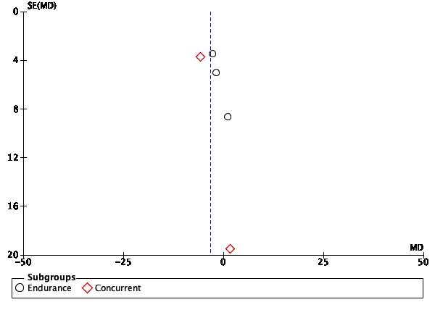 | 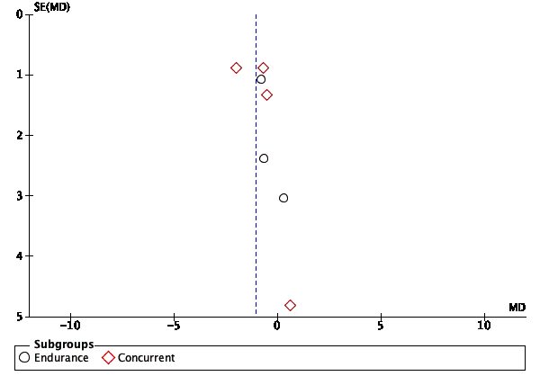
Weight | Body Mass Index
CARDIOPULMONARY EXERCISE TEST
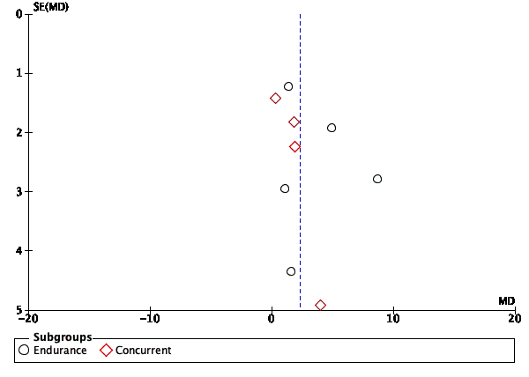 | 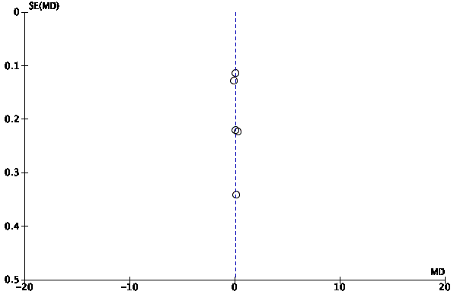
pVO₂ (mL·kg⁻¹·min⁻¹) | pVO₂ (L·min⁻¹)
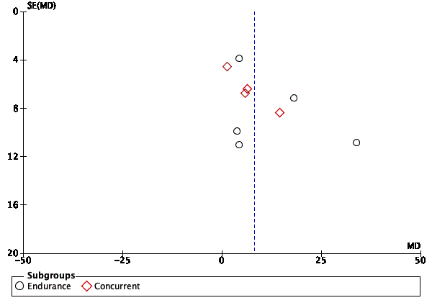 | 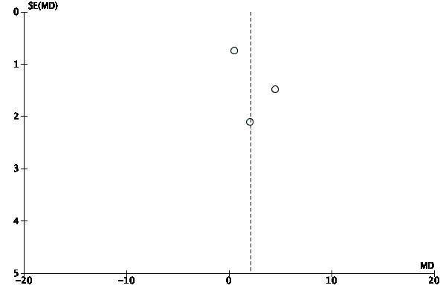
pVO₂ (% of predicted) | VO₂ at VT2
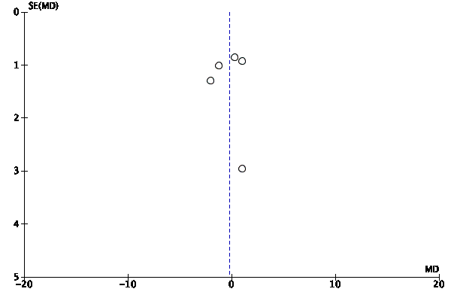 | 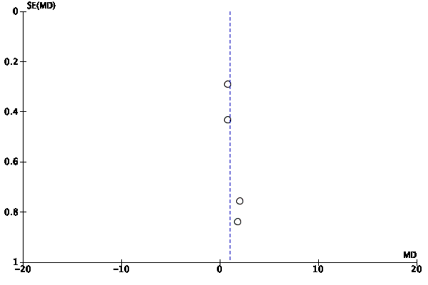
VE/VCO₂ at peak effort | Exercise time
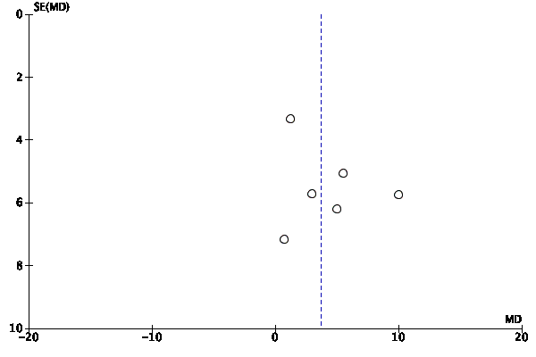 | 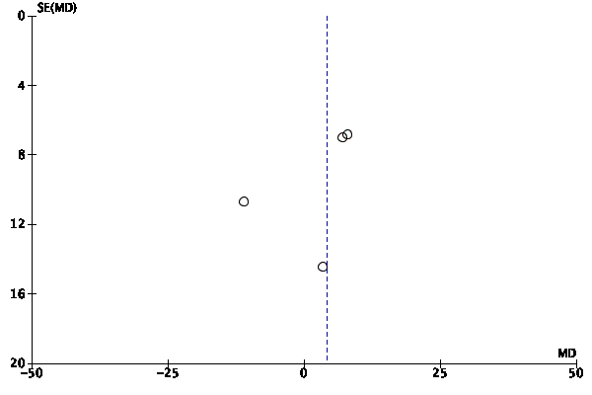
Peak HR | Peak SBP
IMAGING
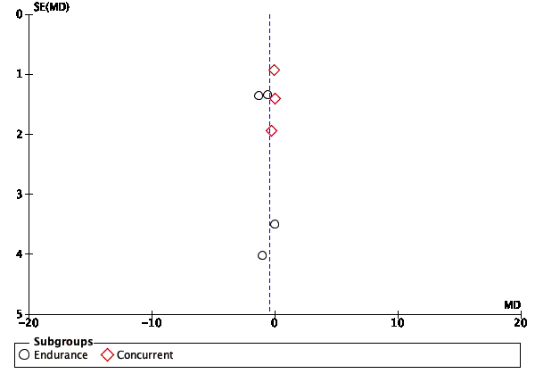 | 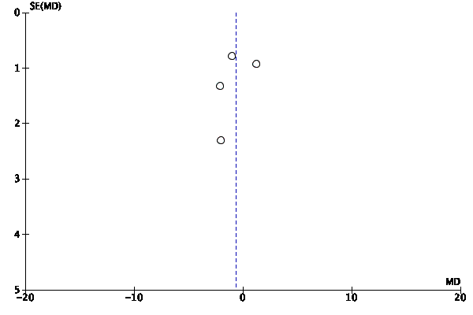
Maximal wall thickness | Posterior wall diameter
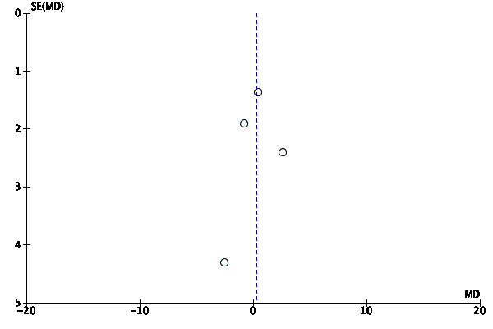 | 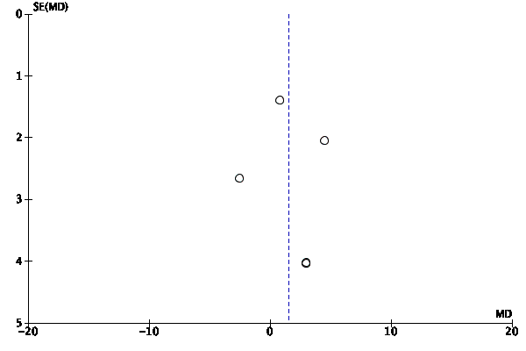
Left atrial size | LVEDD
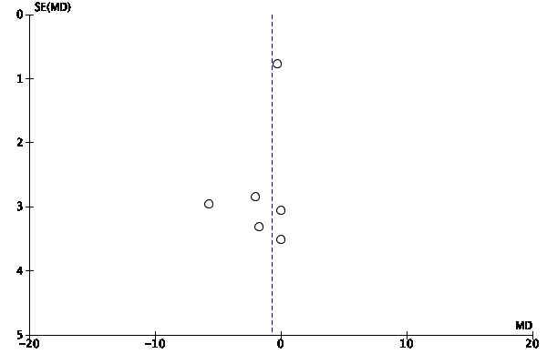 | 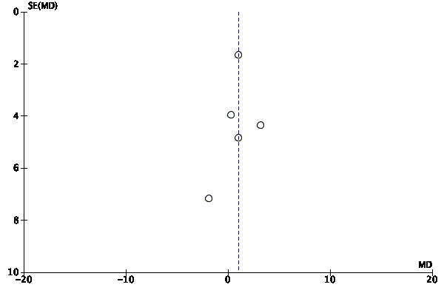
LVEF (%) | LVOT gradient, at rest
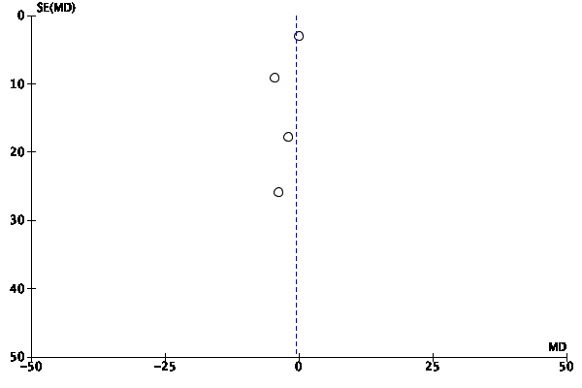 | 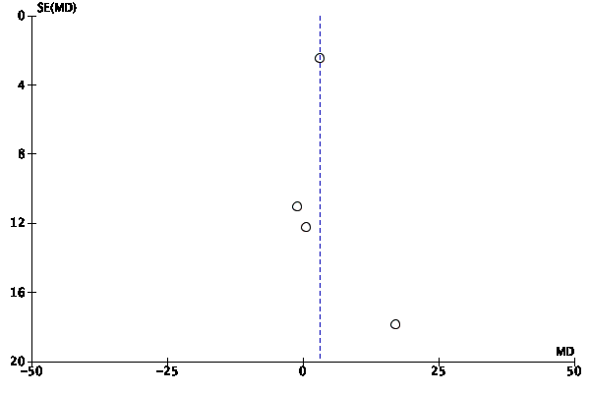
LVOT gradient, at peak effort | LVEDV index
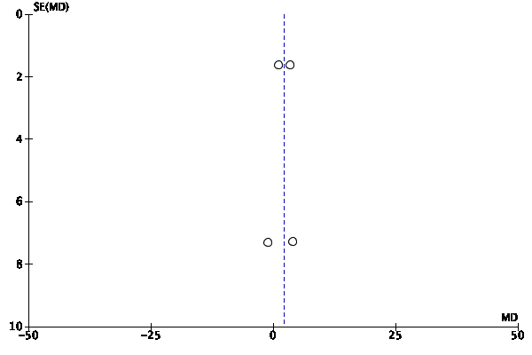 | 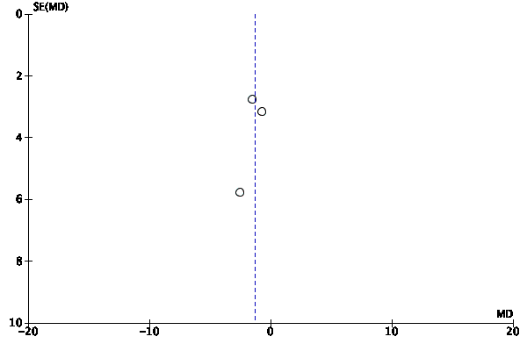
LVESV index | LAVI
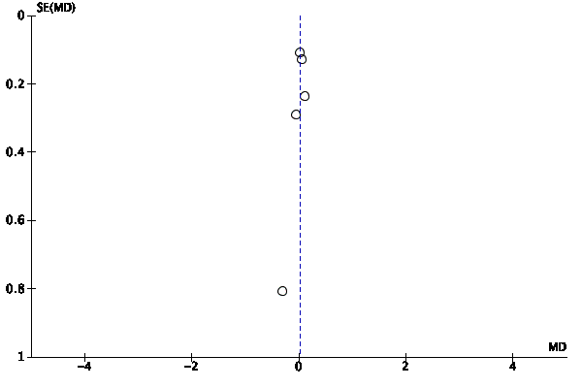 | 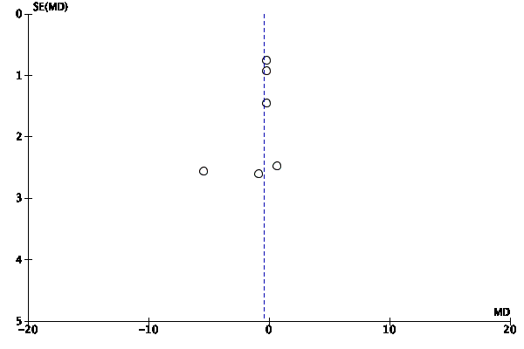
E/A ratio | E/E’ ratio
ARTERIAL PRESSURE
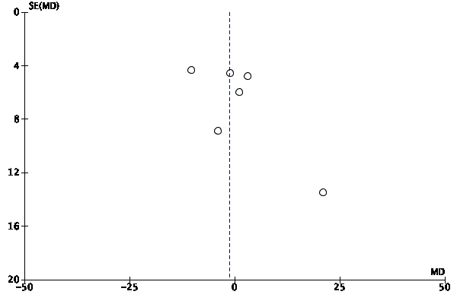 | 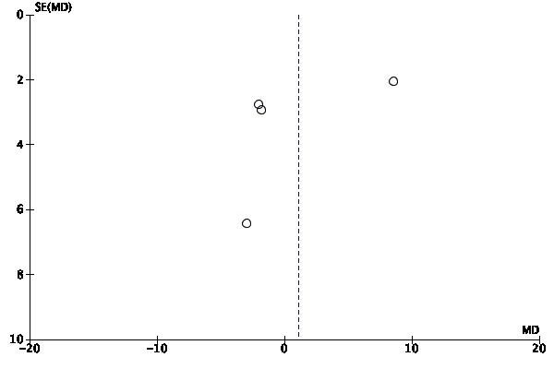
SBP at rest | DBP at rest
HEART RATE
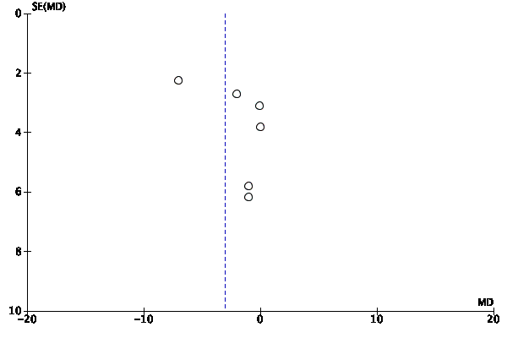 | 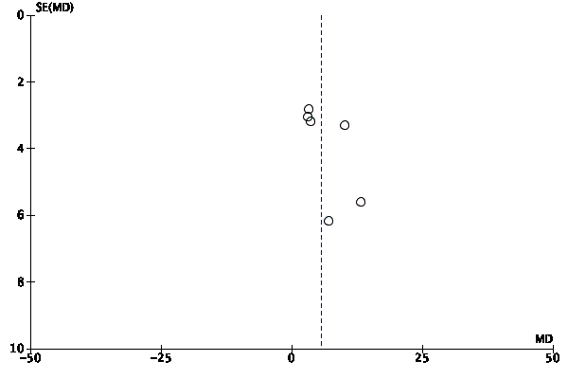
HR at rest | HRReserve
CARDIAC BIOMARKERS
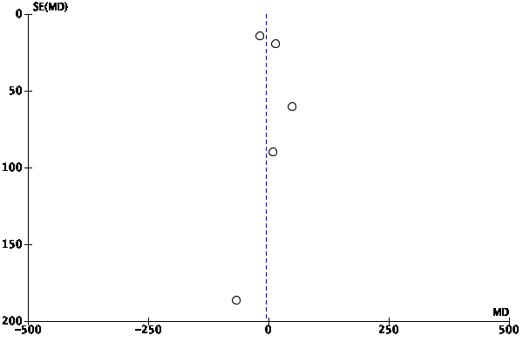
NT-proBNP
Supplemental Fig. 1 Exploratory funnel plots. Each dot represents an individual study group, and the vertical line represents the pooled effect estimate. Funnel plots are presented for descriptive purposes

Supplemental Methods. Data synthesis.
In studies where data were reported as mean (95% CI), the standard deviation was calculated using the formula: σ = (ME·√N)·z⁻¹, where ME represents the margin of error (the distance between the mean and either confidence interval limit), N is the number of subjects, and z is the critical value for a 95% confidence level, set at 1.96 assuming a normal distribution.
In studies where data were presented as mean (IQR; interquartile range), the SD (standard deviation) was estimated assuming a normal distribution using the formula: σ ≈ IQR·1.349⁻¹.
When neither the mean nor the standard deviation was reported, these values were calculated from individual subject data when possible. For example, when the number of patients in each NYHA functional class was provided but the mean and SD were not explicitly stated. Where the change in SD (ΔSD) was available it was collected alongside pre- and post-intervention SDs. Where ΔSD was not reported, the correlation coefficient ($r$) for each outcome was calculated according to the Cochrane Handbook for Systematic Reviews of Interventions (1):
$$r=(SD_{pre}^{ 2}+ SD_{post}^{ 2} - SD_{change}^{ 2})/(2×SD_{pre}×SD_{post})$$
and the ΔSD was then calculated as:
ΔSD = $\sqrt{(SD_{pre}^{ 2}+SD_{post}^{ 2} -2r×SD_{pre}×SD_{post})}$.
The combined SD (Z) for the double product (HR · SBP) was calculated considering the mean (x̄) and SD of both variables as follows (1):
SD (Z) = $\sqrt{(SD_{HR}^{ 2}×{x̄}_{SBP}^{ 2}+SD_{SBP}^{ 2}×{x̄}_{HR}^{ 2}+SD_{HR}^{ 2}×SD_{SBP}^{ 2})}$
To calculate the predicted pVO₂ (% of predicted) in studies where it was not reported, the following formulas were used: 60 - (0.55 × Age) for men and 48 - (0.37 × Age) for women, using the reported mean age (2). For example, in studies with 21 men and 9 women, the result of the formula for men was multiplied by the number of male participants, added to the result obtained for women, and then divided by the total number of participants.
When functional capacity was reported in METs, we recalculated the data into ml·kg⁻¹·min⁻¹ as previously described elsewhere (3). In studies reporting some results separately for two subgroups that did not differ in terms of the training intervention (e.g., "responders" and "non-responders"), the mean and standard deviation for the entire group were calculated by multiplying the mean of each subgroup by its number of subjects, summing the accumulated values for each subgroup, and dividing by the total number of participants.
The corresponding authors and editorial board of the journals of two studies where some variables were mentioned but not reported, or where only pre-exercise values or data of very few variables were included (4,5) were contacted via email to request the information.

Supplemental Results. Sensitivity Analyses.
Sensitivity analyses were conducted for all meta-analyses in which a study contributed an excessively large weight, as defined by the pre-established criterion. Studies were excluded to explore whether their removal influenced the overall results, in accordance with the second and third predetermined criteria. Bayonas-Ruiz et al (6) was checked in the meta-analysis of exercise time since it accounted for 51.9% of the overall MD with four study groups, but its inclusion (MD= 1.02 min, 95% CI [0.52, 1.52], p< 0.0001, I²= 13%) did not change the result (MD= 1.31 min, 95% CI [0.50, 2.12], p< 0.001, I²= 23%). On the other hand, the effect of including Saberi et al (7) in changes in LVEF was checked because it had a relative weight of 76.5% with six studies included. Its inclusion changed the MD from −2.04% [−4.75, 0.68] to −0.71% [−2.03, 0.61], but in both cases changes were non-significant (p= 0.29 vs p= 0.14) and we decided to include their data. Finally, the moderate intensity training group (n= 8 participants) from MacNamara et al (8) was removed from MD in peak HR since it had a relative weight of 38.3% with 6 groups in the analysis and its inclusion (MD= 3.65 bpm, 95% CI [−0.38, 7.69], p= 0.08, I²= 0%) produced a change of 30% in the MD and change in the significance (MD= 5.18 bpm, 95% CI [0.04, 10.31], p< 0.05, I²= 0%), meeting all three criteria.
REFERENCES
1. Higgins JP, Green S. Cochrane Handbook for Systematic Reviews of Interventions. version 6. Higgins J, Thomas J, Chandler J, Cumpston M, Li T, Page M, et al., editors. The Cochrane Collaboration; 2011.
2. de Souza CG, Franklin BA, Forman DE, Araújo CGS. Influence of age in estimating maximal oxygen uptake. J Geriatr Cardiol. 2016;13(2):126–31.
3. Jetté M, Sidney K, Blumchent G. Metabolic Equivalents (METS) in Exercise Testing, Exercise Prescription, and Evaluation of Functional Capacity. Clin Cardiol. 1990;13(8):555–65.
4. Basu J, Nikoletou D, Miles C, MacLachlan H, Parry-Williams G, Tilby-Jones F, et al. High intensity exercise programme in patients with hypertrophic cardiomyopathy: a randomized trial. Eur Heart J. 2025;46(19):1–13.
5. Gudmundsdottir H, Raja AA, Rossing K, Rasmusen H, Snoer M, Andersen LJ, et al. Exercise Training in Patients With Hypertrophic Cardiomyopathy Without Left Ventricular Outflow Tract Obstruction: A Randomized Clinical Trial. Circulation. 2025;151(2):132–44.
6. Bayonas-Ruiz A, Muñoz-Franco FM, Sabater-Molina M, González-Martínez-Moro I, Gimeno-Blanes JR, Bonacasa B. Concurrent Resistance and Cardiorespiratory Training in Patients with Hypertrophic Cardiomyopathy : A Pilot Study. J Clin Med. 2024;13(8):2324.
7. Saberi S, Agarwal PP, Attili A, Concannon M, Dries AM, Shmargad Y, et al. Effect of Moderate-Intensity Exercise Training on Peak Oxygen Consumption in Patients With Hypertrophic Cardiomyopathy A Randomized Clinical Trial. J Am Med Assoc. 2017;317(13):1–9.
8. MacNamara JP, Dias KA, Hearon CM, Ivey E, Delgado VA, Saland S, et al. Randomized Controlled Trial of Moderate-and High-Intensity Exercise Training in Patients With Hypertrophic Cardiomyopathy: Effects on Fitness and Cardiovascular Response to Exercise. J Am Heart Assoc. 2023;12(20):e031399.

