Supplementary figure 1. Poria chemical composition was determined by LC-MS/MS
Supplementary Table 1 Chemical composition information of Poria
Name | Molecular Formula | Mass Deviation (ppm) | Molecular weight | Retention time (min) | Matching score | Peak area | Relative content (%) | Chemical formula
Paeoniflorin | C₂₃ H₂₈ O₁₁ | -1.24 | 480.16257 | 20.453 | 95 | 16964529909 | 18.769 | 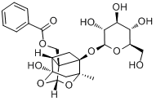
Amygdalin | C₂₀ H₂₇ N O₁₁ | -1.04 | 457.15793 | 18.98 | 92 | 16243272815 | 17.971 | 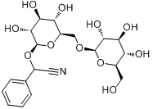
Albiflorin | C₂₃ H₂₈ O₁₁ | -0.98 | 480.16269 | 20.073 | 90.6 | 7406859492 | 8.195 | 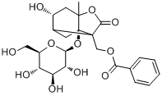
Sucrose | C₁₂ H₂₂ O₁₁ | -1.06 | 342.11585 | 1.538 | 93 | 5250208001 | 5.809 | 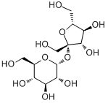
Pyrogallol | C₆ H₆ O₃ | -1.91 | 126.03145 | 7.387 | 78.2 | 5002810521 | 5.535 | 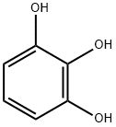
Citric acid | C₆ H₈ O₇ | -0.62 | 192.02688 | 1.637 | 88.8 | 4375690189 | 4.841 | 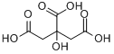
Benzoyl paeoniflorin | C₃₀ H₃₂ O₁₂ | -0.95 | 584.18882 | 26.315 | 94.8 | 2862092830 | 3.167 | 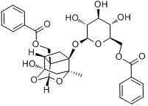
Coumarin | C₉ H₆ O₂ | -0.34 | 146.03673 | 24.04 | 85.5 | 2522063014 | 2.790 | 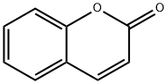
Pachymic acid | C₃₃ H₅₂ O₅ | -0.96 | 528.38097 | 46.207 | 88.8 | 2296343941 | 2.541 | 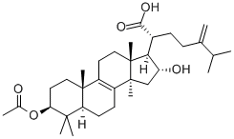
Oxypaeoniflorin | C₂₃ H₂₈ O₁₂ | -1.2 | 496.15748 | 18.679 | 91 | 2201121535 | 2.435 | 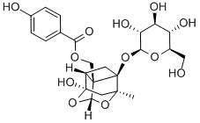
Xanthoxyline | C₁₀ H₁₂ O₄ | -0.65 | 196.07343 | 22.879 | 78.6 | 1796256850 | 1.987 | 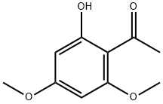
1,2,3,4,6-Pentagalloylglucose | C₄₁ H₃₂ O₂₆ | -1.33 | 940.11693 | 24.066 | 92.2 | 1391808836 | 1.540 | 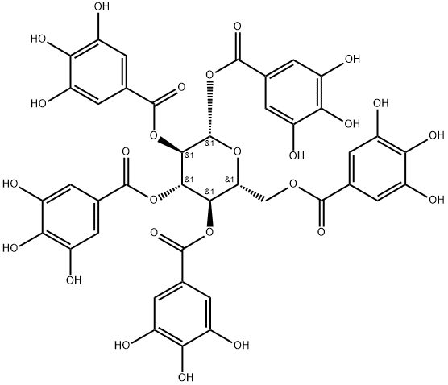
2-Pyrrolidinecarboxylic acid | C₅ H₉ N O₂ | -0.02 | 115.06333 | 1.529 | 82.8 | 1280302707 | 1.417 | 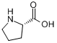
5-Hydroxymethylfurfural | C₆ H₆ O₃ | -0.14 | 126.03168 | 1.47 | 81.5 | 1174344010 | 1.299 | 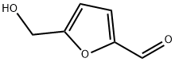
Adenosine | C₁₀ H₁₃ N₅ O₄ | -0.78 | 267.09654 | 9.49 | 90.1 | 1002608539 | 1.109 | 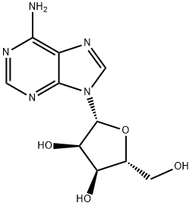
L-Valine | C₅ H₁₁ N O₂ | -0.37 | 117.07894 | 1.532 | 74.2 | 853038631.1 | 0.944 | 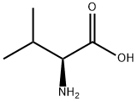
Poricoic acid A | C₃₁ H₄₆ O₅ | -0.86 | 498.33409 | 40.846 | 90.4 | 602135988.1 | 0.666 | 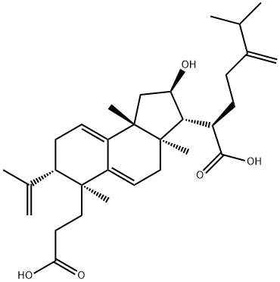
3-O-Acetyl-1α-hydroxytrametenolic acid | C₃₂ H₅₀ O₅ | -1.12 | 514.36525 | 45.424 | 79.4 | 598630694.7 | 0.662 | 