Supplementary Information

Predefined and data driven CT densitometric features predict critical illness and hospital length of stay in COVID-19 patients
Tamar Shalmon MD^{1,2}, Pascal Salazar PhD³, Miho Horie PhD^{1,2}, Kate Hanneman MD, MPH, FRCPC^{1,2}, Mini Pakkal MD, FRCR^{1,2}, Vahid Anwari MRT^{1,2} and Jennifer Fratesi MD, FRCPC^{1,2} *
¹ Joint Department of Medical Imaging, University of Toronto
² University Health Network, Toronto General Hospital, Toronto, ON, 200 Elizabeth St, Toronto, ON, M5G 2C4
³ Vital Images, Minnetonka, Minnesota, USA
* Corresponding Author: Jennifer.fratesi@uhn.ca, University Health Network, Toronto General Hospital

Supplementary Table S1. Patient characteristics and outcomes.
Median (1st quartile, 3rd quartile value), mean and p-values. Tests for differences: Man-Whitney test (continuous values) and exact Fisher test (nominal variables). Bold P-values are significant. ECMO=extracorporeal membrane oxygenation
Characteristic Value: Median (25thperc. 75thperc.). Mean. Count if categorical | All cases  (N=80) | Group 1  Not Critically Ill  (N=45) | Group 2  Critically ill  (N=35) | Difference Test P-value
Demographic, condition and CT Acquisition
Age (years) | 63 (48 74.2)  Mean: 60.7 | 63 (51 74)  Mean: 61.4 | 64 (45 74.5)  Mean: 60 | P=0.73
Sex | M: 43 F: 37 | M: 20 F: 25 | M: 23 F: 12 | P = 0.073
Conscious | Y: 61 N: 19 | Y: 39 N:6 | Y: 22 N: 13 | P= 0.018
Dyspnea | Y: 63 N: 17 | Y: 30 N: 15 | Y: 33 N: 2 | P=0.003
Comorbidities (10)  COPD  Hypertension  Diabetes  Coronary heart disease  Chronic heart disease  Chronic kidney disease  Malignancy  Cerebral vascular disease  Hepatitis B  Immunodeficiency | 0: 23  1: 17  2-3: 28  4-5: 12 | 0: 15  1: 7  2-3: 16  4-5: 7 | 0: 8  1: 10  2-3: 12  4-5: 5 | P=0.50
Lactate Dehydrogenase (U/L) | 273 (217 402)  Mean: 331 | 250 (198 328) Mean: 291 | 357 (248 476) Mean: 382 | P=0.003
Neutrophil Lymphocyte Ratio | 5.0 (3.0 10.2)  Mean: 10.6 | 4.1 (2.7 5.2) Mean: 5.71 | 9.6 (5.0 14.8) Mean: 16.8 | P= 0.0001
Contrast-enhanced CT  C=Contrast ; NC= Non-Contrast | C: 54, NC: 26 | C: 31 NC: 14 | C: 23 NC: 12 | P = 0.810
Outcome
Critically ill | Y: 35. N: 45 | - | Y: 35 N: 0 | -
ICU | Y: 32. N: 48 | - | Y: 32 N: 3 | -
Mechanical Ventilation/ECMO | Y: 25. N: 55 | - | Y: 25 N: 10 | -
Death | Y: 15. N: 65 | - | Y: 15 N: 20 | -
Days in hospital | 9 (3 30)  Mean: 18 | 4 (2 9)  Mean: 8 | 29 (13 43)  Mean: 33 | P<0.0001

Supplementary Table S2. Quantitative CT related measurements and CT Severity Scores
Median (1st quartile, 3rd quartile value), mean and p-values. Tests for differences: Man-Whitney test (continuous values) and exact Fisher test (nominal variables). Bold P-values are significant. Patients in the critically ill group had significantly higher mean density and standard deviation density values in both lungs combined and noticeable but not statistically significant lower lung volumes. Subjective scoring was significantly higher in the critically ill group for both readers.
Quantitative and Subjective CT variables: Median (25thperc. 75thperc.) Mean. Count if categorical | All cases  N=80 | Group 1  Not Critically Ill  (N=45) | Group 2  Critically ill  (N=35) | Difference Test P-value
CT Mean (HU) | -664 (-773 -550) Mean: -629 | -720 (-785 -657) Mean: -721 | -549 (-651 -391) Mean: -512 | P < 0.0001
CT Standard Deviation (HU) | 204 (137 257) Mean: 207 | 168 (118 203) Mean: 164 | 261 (225 303) Mean: 262 | P < 0.0001
CT Skewness | 1.27 (0.76 1.96)  Mean: 1.28 | 1.87 (1.10 2.170  Mean: 1.69 | 0.77 (0.37 1.28)  Mean: 0.76 | P < 0.0001
CT Kurtosis | 4.74 (2.98 9.17)  Mean: 6.22 | 8.11 (4.87 10.66)  Mean: 8.13 | 2.98 (2.30 4.18) | P < 0.0001
Q875 (HU) | -425 (-640 -126)  Mean: -379) | -588 (-669 -446)  Mean: -546 | -55 (-332 24)  Mean: -164 | P < 0.0001
F1 | 0.047 (-0.383 0.395)  Mean: 0.00 | -0.324 (-0.449 -0.057)  Mean: -0.254 | 0.421 (0.153 0.604)  Mean: 0.326 | P < 0.0001
Lung volume (ml) | 2555 (1971 3315)  Mean: 2799 | 2643 (1964 3449)  Mean: 3001 | 2305 (1980 2984)  Mean: 2540 | P=0.1582
Subjective scoring
Covid Score Reader 1 | 20 (12 26.25) Mean: 19.55 | 13 (8 19) Mean: 13.4 | 27 (23 32)  Mean: 27.5 | P < 0.0001
Covid Score Reader 2 | 20 (12 26.25) Mean: 19.55 | 12 (7 19)  Mean: 13.9 | 26 (20.5 33) Mean: 25.8 | P < 0.0001
Covid Score Mean Reader 1-2 | 16.25 (11.9 24) Mean: 17.5 | 14.5 (10 21) Mean: 15.0. | 20.7 (14.25 26.5)  Mean: 20.7 | P = 0.0020

Supplementary Figure S1. Receiver Operating Characteristic (ROC) curves and Area-Under-the-Curves (AUCs) for CT severity score (reader-1), F1, Q875, standard deviation - CT density and COVID gram score. The gray diagonal line represents the random classifier line. All cases (N=80)

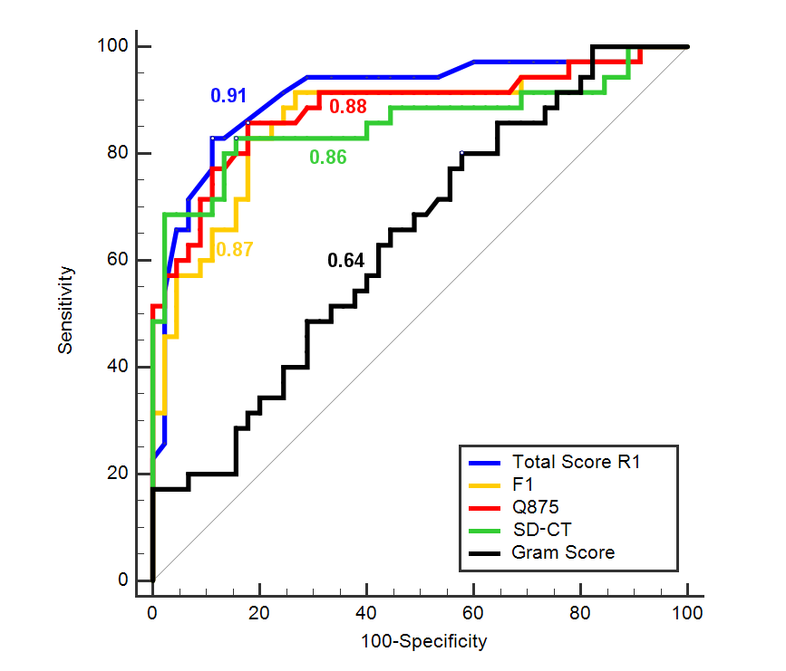

Supplementary Figure S2. F1 values vs. Neutrophil-Lymphocyte Ratio (log.10 NLR – centered) with true critical Illness cases: C1 (black triangles) and true non-critical illness cases: C0 (white dots). N=79 (1 NLR outlier removed). Overlay color and lines: estimated probabilities of critical illness (C1) from logistic regression model 3 (combining F1 and NLR). This bivariate linear model provides a clear separation for critical illness outcome on each side of the p=0.50 midline (yellow line).

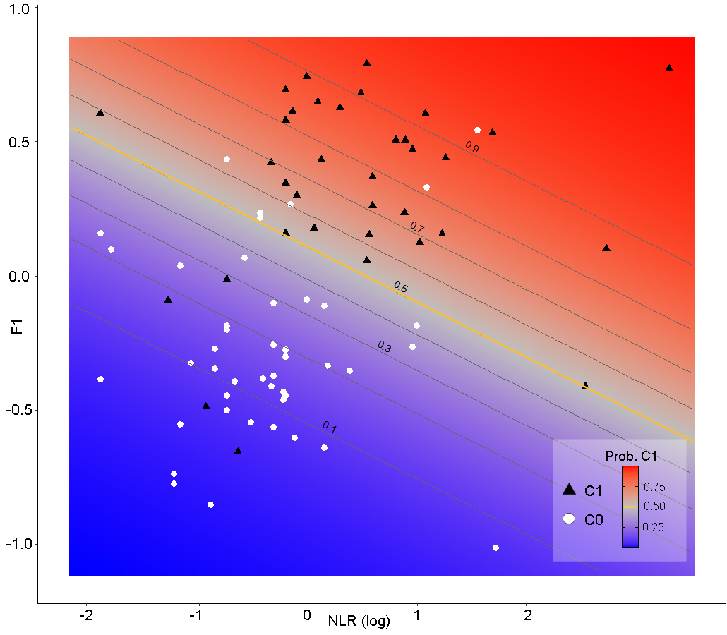

Supplementary Figure S3. Scatterplot Q875 values vs. lung volume (log scale) and Spearman rank correlations (Rho) – C1: Critically ill group. C0: Non-critically ill group. N=80. The linear relationship between Q875 CT related predictor and the lung volume is clearly visible for the C0 non-critically ill group. Lines: local regression smoothing (LOESS) trend lines.

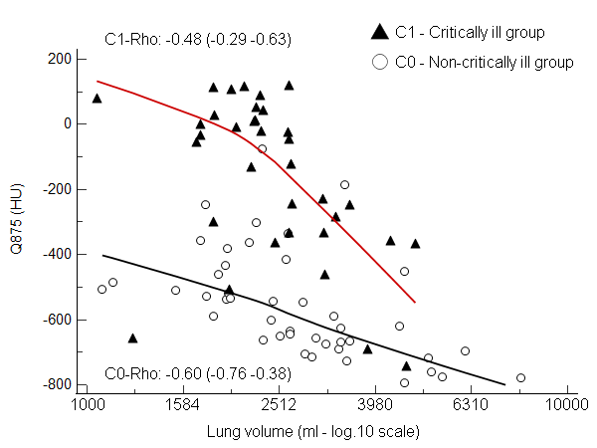

Supplementary Figure S4. Patient flow chart with inclusion and exclusion criteria for patient selection in the study.

87 patients had a positive RT-PCR test for COVID-19 after 1-3 tests
502 patients appeared in PACS search engine when searching for COVID and CT chest between March 1 and December 15, 2020
415 patients had a negative RT-PCR after 1-3 tests
85 patients did not have lung nodules/masses in their lungs on CT chest
2 patients had a history of cancer with lung nodules or masses on their CT chest
82 patients did not have sputum proven superimposed bacterial pneumonia known during their hospital stay
3 patients had a sputum test during their hospital stay showing superimposed bacterial pneumonia
80 patients had complete demographic and laboratory information in their electronic patient records
2 patients had incomplete information in their electronic patient records

