Supplementary data
Table 1: QTPP and Product Development Risk Assessment and Control Strategy of Critical Material Attributes and Critical Process Parameters on Dissolution [22-25].

Quality Attributes for  Apremilast CASD Tablets | Quality Target Product Profile (QTPP)
Indication & Population | Same as conventional BID product it is indicated indicated for the treatment of adult patients and pediatric patients 6 years of age and older and weighing at least 20 kg with active psoriatic arthritis
Dosage Form | Oral solid dosage form (tablet) with controlled-release profile
Route of Administration | Equivalent to total daily dose of BID product; optimized for once-daily administration
Dissolution Profile | Controlled release: initial burst for onset, followed by sustained release up to 24h
Therapeutic Effect | Comparable or superior efficacy; sustained plasma concentration for 24h; improved adherence

Table 2: Formulation Development Trials with different controlled release polymers
S. No. | Materials | Trial 1 | Trial 2 | Trial 3 | Trial 4 | Trial 5 | Trial 6 | Trial 7 | Trial 8 | Trial 9
S. No. | Materials | % w/w | % w/w | % w/w | % w/w | % w/w | % w/w | % w/w | % w/w | % w/w
Intragranular |  | F02 | F01 | F03 | F04 | F05 | F06 | F07 | F08 | F09
1 | Apremilast | 13.5 | 13.5 | 13.5 | 13.5 | 13.5 | 13.5 | 13.5 | 13.5 | 13.5
2 | Aerosil 200 | 0.375 | 0.375 | 0.375 | 0.375 | 0.375 | 0.375 | 0.375 | 0.375 | 0.375
3 | Kollidone VA 64 | 27 | 27 | 27 | 27 | 27 | 27 | 27 | 27 | 27
4 | Klucel LF | 5 | 5 | 5 | 5 | 5 | 5 | 5 | 5 | 5
5 | Triethyl Citrate | 1.75 | 1.75 | 1.75 | 1.75 | 1.75 | 1.75 | 1.75 | 1.75 | 1.75
 | Total weight | 47.625 | 47.625 | 47.625 | 47.625 | 47.625 | 47.625 | 47.625 | 47.625 | 47.625
Extra Granular |  | 0 | 0 | 0 | 0 | 0 | 0 | 0 | 0 | 0
6 | Microcrystalline Cellulose (Avicel PH 102) | 29.5 | 25.75 | 22 | 45.75 | 43.25 | 47 | 44.5 | 47 | 44.5
7 | Hypromellose (Methocel K100LVCR) | 20 | 23.75 | 27.5 | 0 | 0 | 0 | 0 | 0 | 0
8 | Hypromellose (Methocel K4M) | 0 | 0 | 0 | 3.75 | 6.25 | 0 | 0 | 0 | 0
9 | Hypromellose (Methocel K100M) | 0 | 0 | 0 | 0 | 0 | 2.5 | 5 | 0 | 0
10 | Ethyl Cellulose 7 cps | 0 | 0 | 0 | 0 | 0 | 0 | 0 | 2.5 | 5
11 | Colloidal Silicon Dioxide (Aerosil 200) | 0.375 | 0.375 | 0.375 | 0.375 | 0.375 | 0.375 | 0.375 | 0.375 | 0.375
12 | Stearic Acid | 2.5 | 2.5 | 2.5 | 2.5 | 2.5 | 2.5 | 2.5 | 2.5 | 2.5
1 % w/w Tween 80 in 50 mM Sodium Acetate Buffer pH 4.5, 900 ml, USP-2, 75 rpm
Time (h) | Specification | Avg ± % RSD | Avg ± % RSD | Avg ± % RSD | Avg ± % RSD | Avg ± % RSD | Avg ± % RSD | Avg ± % RSD | Avg ± % RSD | Avg ± % RSD
1 |  | 15 ± 25.4 | 7 ± 18.2 | 1 ± 29.1 | 9 ± 28.3 | 6 ± 35.7 | 8 ± 55.6 | 7 ± 36.4 | 2 ± 42.6 | 0
2 | 10-35% | 39 ± 9.4 | 22 ± 5.8 | 8 ± 9.2 | 15 ± 21.9 | 11 ± 29.1 | 14 ± 23.4 | 12 ± 18.4 | 8 ± 34.1 | 5 ± 41.8
4 |  | 58 ± 6.7 | 35 ± 3.6 | 12 ± 4.9 | 28 ± 19.5 | 25 ± 24.3 | 25 ± 24.7 | 23 ± 24.7 | 19 ± 14.7 | 11 ± 28.9
6 | 40 - 60 | 62 ± 8.1 | 45 ± 2.1 | 27 ± 7.9 | 37 ± 23.1 | 30 ± 21.7 | 33 ± 19.4 | 29 ± 29.6 | 25 ± 13.9 | 21 ± 17.4
8 |  | 79 ± 5.6 | 62 ± 6.1 | 39 ± 4.6 | 49 ± 14.7 | 43 ± 22.7 | 41 ± 16.2 | 38 ± 19.7 | 32 ± 20.3 | 29 ± 20.1
12 |  | 88 ± 7.4 | 77 ± 7.9 | 56 ± 3.7 | 61 ± 15.1 | 51 ± 17.4 | 56 ± 18.1 | 53 ± 12.3 | 51 ± 22.5 | 37 ± 10.3
16 |  | 99 ± 4.8 | 88 ± 2.4 | 72 ± 6.0 | 70 ± 12.9 | 60 ± 19.1 | 63 ± 13.4 | 60 ± 16.4 | 59 ± 12.8 | 49 ± 19.1
24 | NLT 80% | 100 ± 1.5 | 98 ± 2.3 | 89 ± 4.1 | 78 ± 14.1 | 67 ± 12.4 | 72 ± 15.2 | 69 ± 16.3 | 71 ± 10.6 | 61 ± 13.6

Table 3: Effect of surfactant concentration on dissolution of Apremilast CASD
Effect of Surfactant Concentration
Time (h) | 0 % w/w Tween 80 in 50 mM Sodium Acetate Buffer pH 4.5, 900 ml, USP-2, 75 rpm | 0.5 % w/w Tween 80 in 50 mM Sodium Acetate Buffer pH 4.5, 900 ml, USP-2, 75 rpm | 1 % w/w Tween 80 in 50 mM Sodium Acetate Buffer pH 4.5, 900 ml, USP-2, 75 rpm | 1.5 % w/w Tween 80 in 50 mM Sodium Acetate Buffer pH 4.5, 900 ml, USP-2, 75 rpm | 2 % w/w Tween 80 in 50 mM Sodium Acetate Buffer pH 4.5, 900 ml, USP-2, 75 rpm
Time (h) | Avg ± % RSD | Avg ± % RSD | Avg ± % RSD | Avg ± % RSD | Avg ± % RSD
1 | 3 ± 98.88 | 4 ± 18.9 | 7 ± 8.2 | 9 ± 10.6 | 11 ± 11.2
2 | 6 ± 60.77 | 12 ± 15.7 | 22 ± 5.8 | 22 ± 15.3 | 26 ± 9.4
4 | 19 ± 29.75 | 25 ± 11.2 | 35 ± 3.6 | 40 ± 16.4 | 45 ± 8.6
6 | 39 ± 14.32 | 45 ± 5.6 | 45 ± 2.1 | 57 ± 13.9 | 62 ± 5.7
8 | 52 ± 14.15 | 56 ± 7.9 | 62 ± 6.1 | 73 ± 8.9 | 78 ± 6.9
12 | 69 ± 9.13 | 73 ± 3.4 | 77 ± 7.9 | 91 ± 0.9 | 92 ± 4.7
16 | 74 ± 4.95 | 88 ± 2.6 | 88 ± 2.4 | 92 ± 0.9 | 94 ± 5.4
24 | 85 ± 4.78 | 91 ± 2.8 | 98 ± 2.3 | 93 ± 0.5 | 95 ± 3.2

Table 4: Effect of agitation speed on dissolution of Apremilast CASD
Effect of Agitation Speed
Time  (h) | 1 % w/w Tween® 80 in 50 mM Sodium Acetate Buffer pH 4.5, 900 ml, USP-2, 50 rpm | 1 % w/w Tween® 80 in 50 mM Sodium Acetate Buffer pH 4.5, 900 ml, USP-2, 75 rpm | 1 % w/w Tween® 80 in 50 mM Sodium Acetate Buffer pH 4.5, 900 ml, USP-2, 100 rpm
Time  (h) | Avg ± % RSD | Avg ± % RSD | Avg ± % RSD
1 | 5 ± 21.5 | 7 ± 8.2 | 22 ± 3.4
2 | 14 ± 23.4 | 22 ± 5.8 | 53 ± 2.6
4 | 26 ± 7.2 | 35 ± 3.6 | 81 ± 0.8
6 | 39 ± 4.6 | 45 ± 2.1 | 87 ± 1.0
8 | 52 ± 7.9 | 62 ± 6.1 | 89 ± 1.1
12 | 76 ± 1.9 | 77 ± 7.9 | 91 ± 1.9
16 | 89 ± 2.0 | 88 ± 2.4 | 91 ± 0.6
24 | 89 ± 1.3 | 98 ± 2.3 | 92 ± 2.8

Table 5: Effect of dissolution apparatus on dissolution of Apremilast CASD

Effect of Apparatus
Time (h) | 1% w/w Tween® 80 in 50 mM Sodium Acetate Buffer pH 4.5, 900 ml, USP-1, 75 rpm | 1 % w/w Tween® 80 in 50 mM Sodium Acetate Buffer pH 4.5, 900 ml, USP-2, 75 rpm
Time (h) | Avg  (min - max)  % RSD | Avg  (min - max)  % RSD
1 | 5 ± 25.4 | 7 ± 8.2
2 | 17 ± 16.4 | 22 ± 5.8
4 | 33 ± 10.5 | 35 ± 3.6
6 | 47 ± 8.6 | 45 ± 2.1
8 | 61 ± 7.4 | 62 ± 6.1
12 | 84 ± 3.1 | 77 ± 7.9
16 | 89 ± 1.9 | 88 ± 2.4
24 | 90 ± 0.6 | 98 ± 2.3

Table 6: Effect of media volume on dissolution of Apremilast CASD

Effect of media volume
Time (h) | 1 % w/w Tween® 80 in 50 mM Sodium Acetate Buffer pH 4.5, 500 ml, USP-2, 75 rpm | 1 % w/w Tween® 80 in 50 mM Sodium Acetate Buffer pH 4.5, 750 ml, USP-2, 75 rpm | 1 % w/w Tween® 80 in 50 mM Sodium Acetate Buffer pH 4.5, 900 ml, USP-2, 75 rpm
Time (h) | Avg ± % RSD | Avg ± % RSD | Avg ± % RSD
1 | 3 ± 47.1 | 5 ± 41.6 | 7 ± 8.2
2 | 6 ± 39.4 | 15 ± 12.9 | 22 ± 5.8
4 | 18 ± 18.8 | 33 ± 8.8 | 35 ± 3.6
6 | 26 ± 18.6 | 47 ± 11.1 | 45 ± 2.1
8 | 39 ± 7.8 | 62 ± 7.2 | 62 ± 6.1
12 | 51 ± 8.0 | 74 ± 6.3 | 77 ± 7.9
16 | 69 ± 4.4 | 82 ± 3.1 | 88 ± 2.4
24 | 83 ± 3.1 | 90 ± 2.2 | 98 ± 2.3

Table 7: Effect of dissolution media pH on dissolution of Apremilast CASD
Effect of pH
Time (h) | 1 % w/w Tween® 80 in 0.1 N HCl , 900 ml, USP-2, 75 rpm | 1 % w/w Tween® 80 in 50 mM Sodium Acetate Buffer pH 4.5, 900 ml, USP-2, 75 rpm | 1 % w/w Tween® 80 in Phosphate Buffer pH 6.8, 900 ml, USP-2, 75 rpm
Time (h) | Avg  (min - max)  % RSD | Avg  (min - max)  % RSD | Avg  (min - max)  % RSD
1 | 3 ± 15.2 | 7 ± 8.2 | 9 ± 9.1
2 | 7 ± 9.8 | 22 ± 5.8 | 13 ± 9.9
4 | 12 ± 11.2 | 35 ± 3.6 | 26 ± 3.8
6 | 28 ± 17.4 | 45 ± 2.1 | 43 ± 5.6
8 | 36 ± 8.9 | 62 ± 6.1 | 68 ± 4.4
12 | 49 ± 6.7 | 77 ± 7.9 | 75 ± 8.3
16 | 61 ± 6.2 | 88 ± 2.4 | 82 ± 5.3
24 | 82 ± 8.3 | 98 ± 2.3 | 88 ± 4.3

Table 9: Analysis of Variance
 | D2 |  |  |  | D6 |  |  |  | D24
Source | Adj SS | Adj MS | F-Value | P-Value | Adj SS | Adj MS | F-Value | P-Value | Adj SS | Adj MS | F-Value | P-Value
Model | 2094.55 | 261.818 | 261.82 | 0.004 | 3655.88 | 456.98 | 1370.95 | 0.001 | 476.242 | 59.530 | 178.59 | 0.006
Linear | 1458.37 | 486.125 | 486.12 | 0.002 | 2486.50 | 828.83 | 2486.50 | 0.000 | 73.375 | 24.458 | 73.37 | 0.013
Volume of Media | 36.13 | 36.125 | 36.13 | 0.027 | 200.00 | 200.00 | 600.00 | 0.002 | 0.125 | 0.125 | 0.37 | 0.603
Agitation Speed | 561.12 | 561.125 | 561.12 | 0.002 | 882.00 | 882.00 | 2646.00 | 0.000 | 45.125 | 45.125 | 135.37 | 0.007
Surfactant Level | 861.12 | 861.125 | 861.12 | 0.001 | 1404.50 | 1404.50 | 4213.50 | 0.000 | 28.125 | 28.125 | 84.37 | 0.012
2-Way Interactions | 327.38 | 109.125 | 109.13 | 0.009 | 660.50 | 220.17 | 660.50 | 0.002 | 47.375 | 15.792 | 47.37 | 0.021
Volume of Media*Agitation Speed | 171.13 | 171.125 | 171.13 | 0.006 | 364.50 | 364.50 | 1093.50 | 0.001 | 10.125 | 10.125 | 30.37 | 0.031
Volume of Media*Surfactant Level | 153.12 | 153.125 | 153.13 | 0.006 | 288.00 | 288.00 | 864.00 | 0.001 | 1.125 | 1.125 | 3.37 | 0.208
Agitation Speed*Surfactant Level | 3.13 | 3.125 | 3.13 | 0.219 | 8.00 | 8.00 | 24.00 | 0.039 | 36.125 | 36.125 | 108.37 | 0.009

Table 9: Dissolution Specification of Apremilast CASD
Time points | Specification Limit
2h | 10-35%
6 h | 40 – 60%
24 h | NLT 80 %

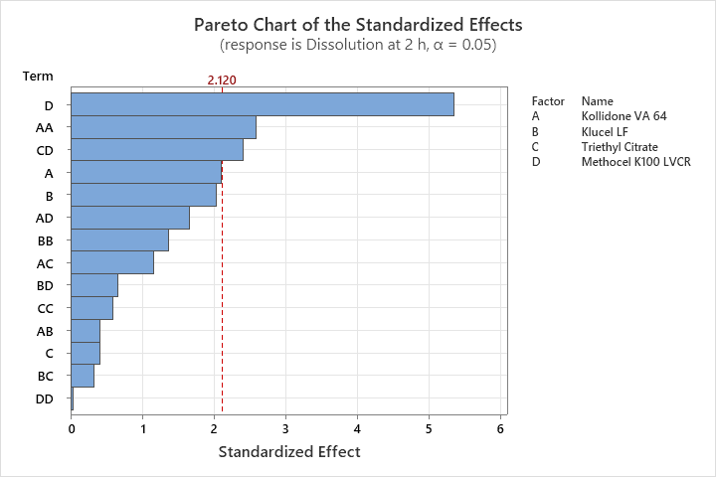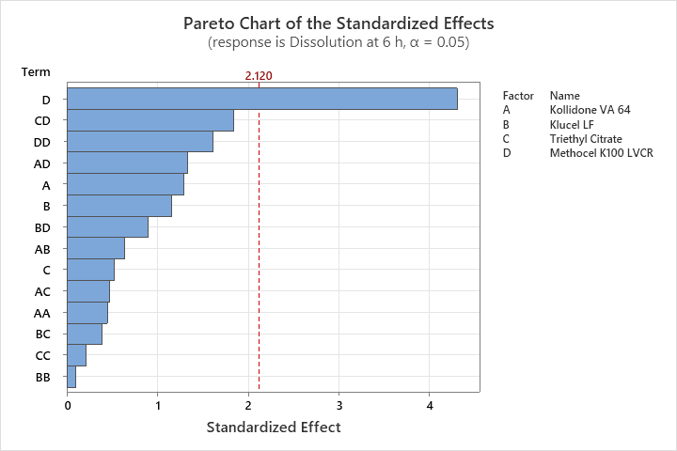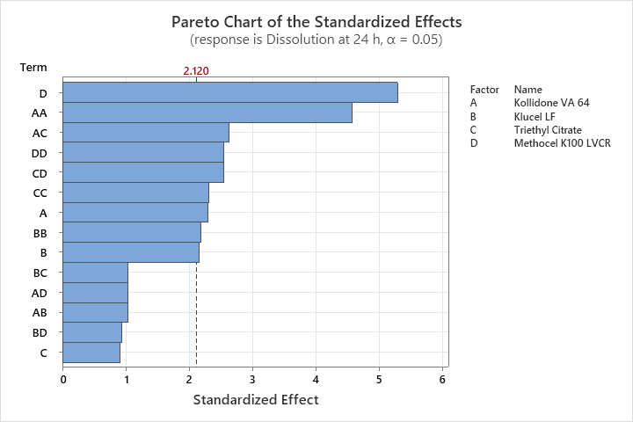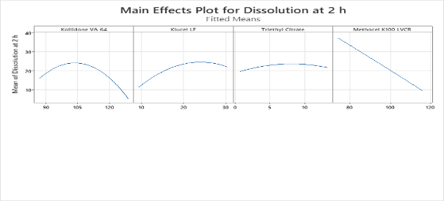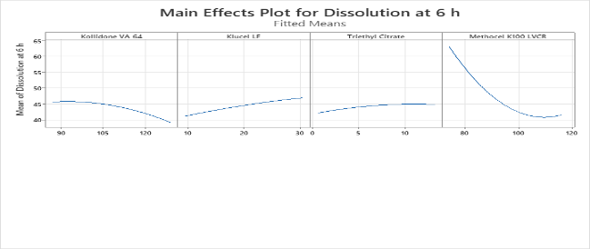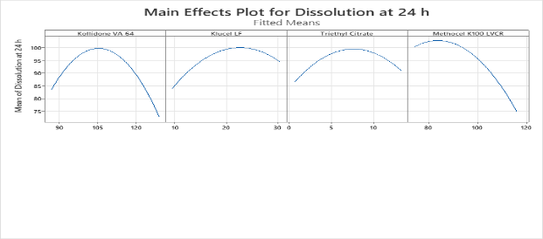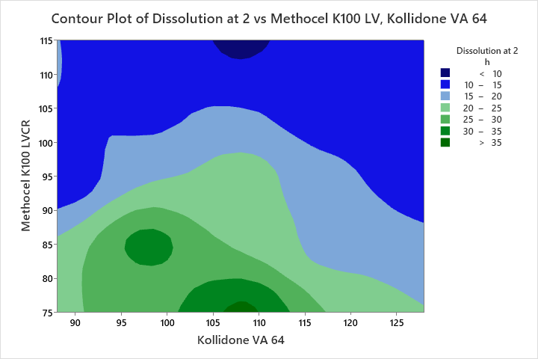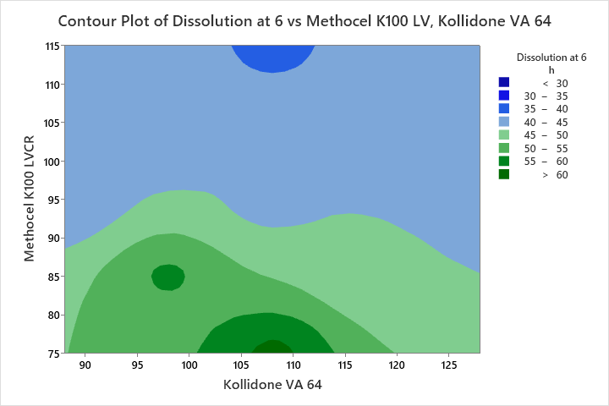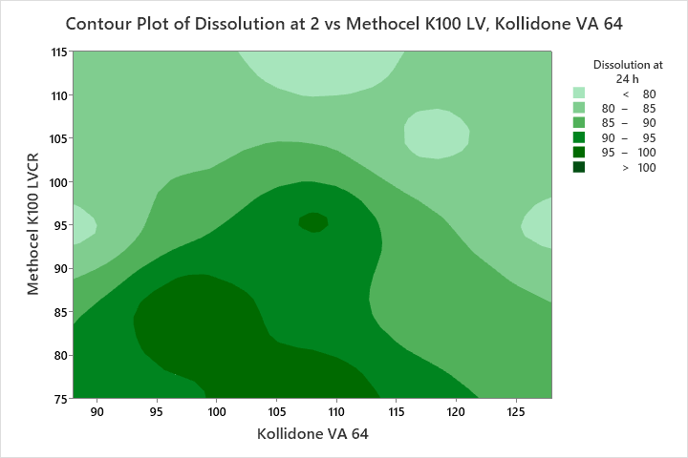
Fig 1: % dissolution of Apremilast CASD and DOE formula optimization graph by central composite design
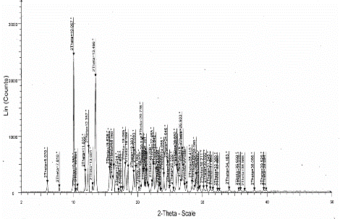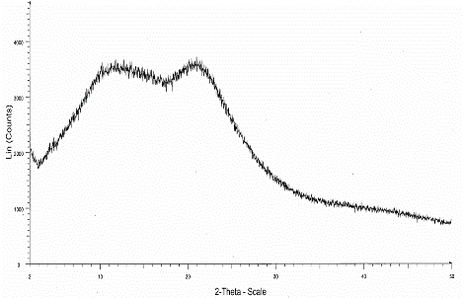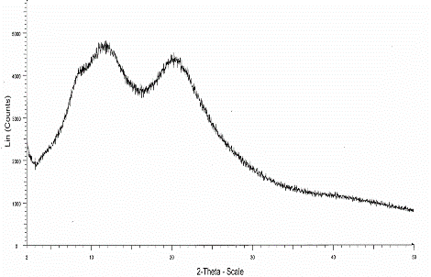
Fig 2: X-ray diffraction of Placebo Apremilast API (Crystalline), Apremilast CASD Tablets, Placebo Apremilast Tablets
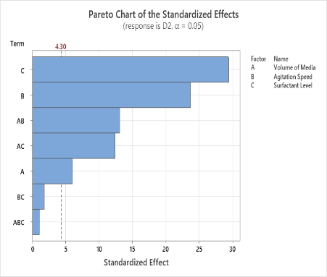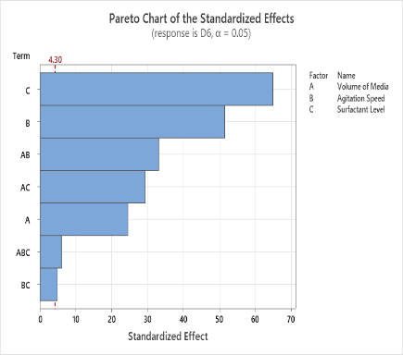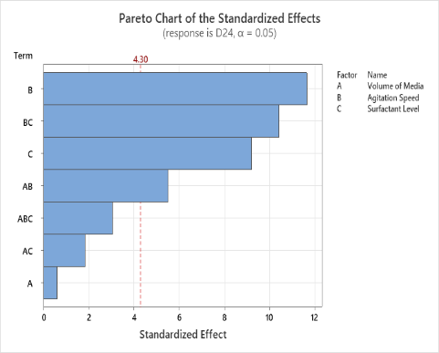
Figure 3: Pareto Chart of effects on %dissolution at 2 h(D2), 6h (D6), 24 h (D24)
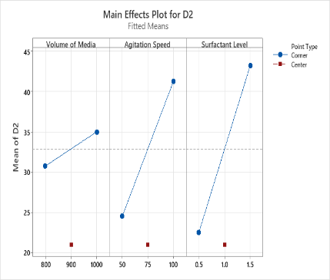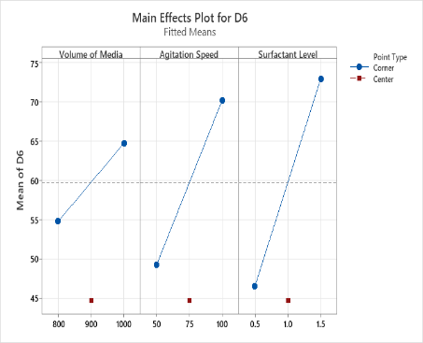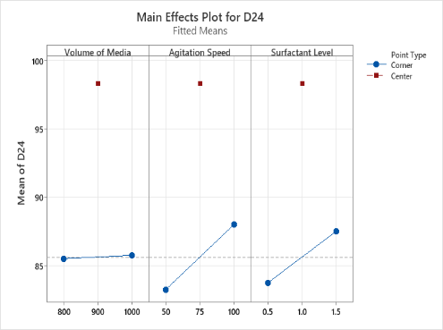
Figure 4: Main effect plot of %dissolution at 2 h(D2), 6h (D6), 24 h (D24)
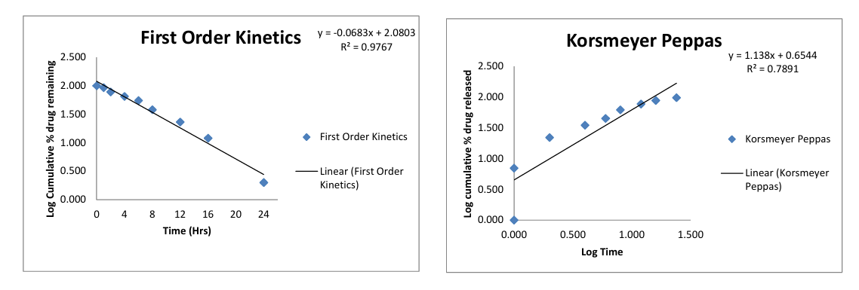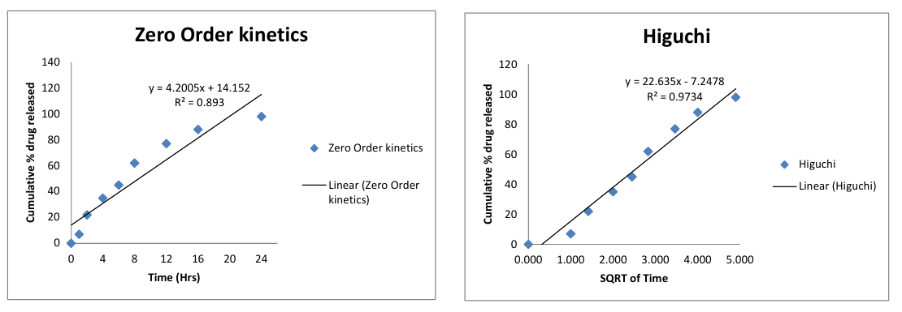
Figure 5: Different dissolution model graph of Apremilast CASD

