Image 1: Left Knee grey-scale (left) and color Doppler (right) ultrasound showing normal triangular (wedge) appearance of the lateral meniscus, homogenous echogenicity and normal vascularity on color doppler (orange arrows).
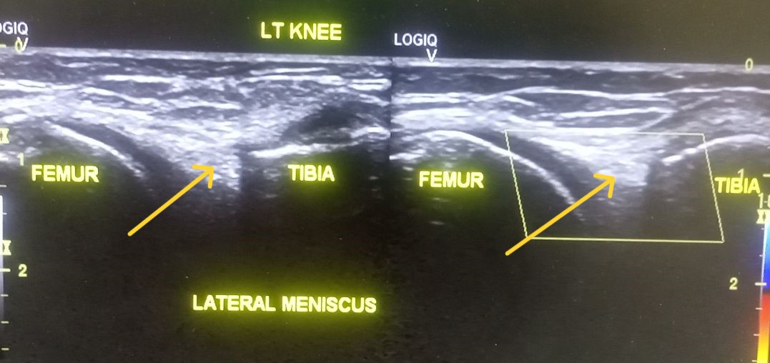

Image 2: Right Knee gray-scale (left) and color Doppler (right) ultrasound show complete loss of triangular (wedge) shaped appearance of lateral meniscus with loss of uniform echopattern (homogenous echogenicity) throughout the meniscus (green arrows) with normal vascularity.
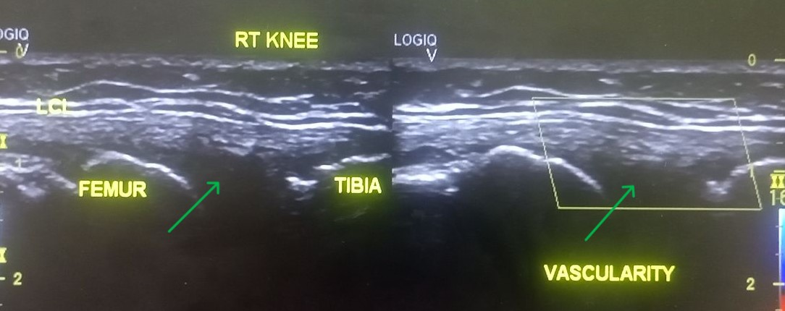

Image 3: Grey-scale (left) and colour Doppler (right) show abnormal disruption of the triangular (wedge) shaped appearance of the lateral meniscus and abnormal heterogeneous echogenicity (white arrows). No increased vascularity on colour Doppler ultrasound
