Additional information
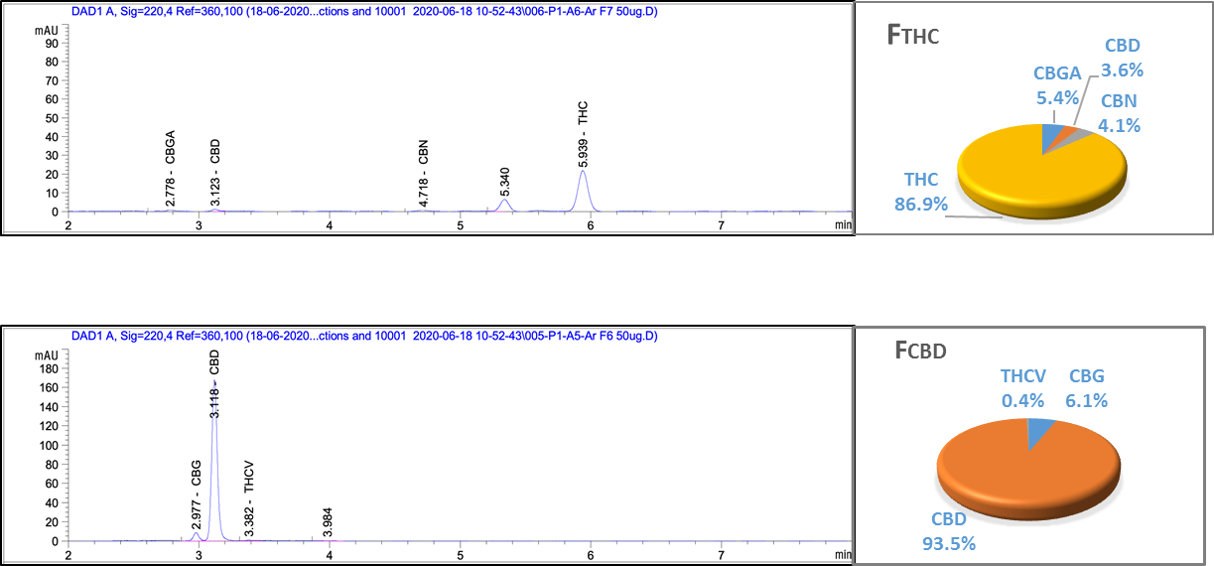
Supplementary Figure S1. HPLC profile of fractions of C. sativa Arbel extract (A) F_{CBD,} (B) F_{THC}. Composition of fractions is given as percentage of total phytocannabinoid content in pie charts.

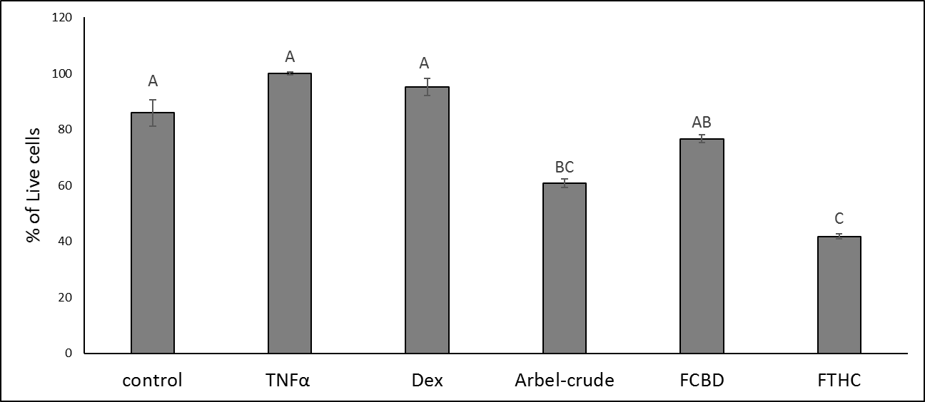
Supplementary Figure S2. Cell viability in A549 cells treated with crude and different fractions of C. sativa Arbel extract. Cells were treated with 300 ng/mL TNFα and C. sativa extract and fractions at a concentration of 5 μg/mL for 4 h. Cell number was determined using Alamar Blue fluorescence (resazurin assay). Dexamethasone (Dex; 4 μg/mL) served as a positive control. Control (methanol) treatment served as solvent (vehicle) control; TNFα is TNFα+methanol treatment control. Error bars indicate ± s.e.m. (n = 3). Levels with different letters are significantly different from all combinations of pairs by Tukey-Kramer honest significant difference (HSD; P ≤ 0.05).

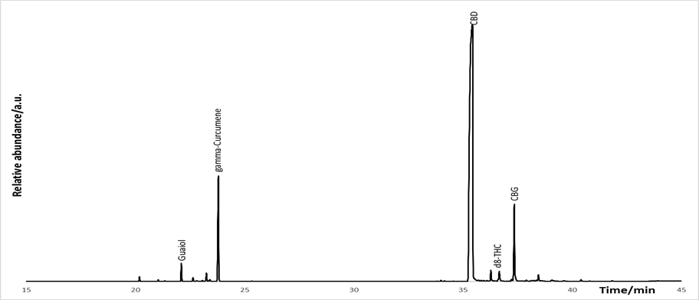
Supplementary Figure S3. Gas chromatogram of fraction F_{CBD}, with the major peak annotated with compounds i.d.

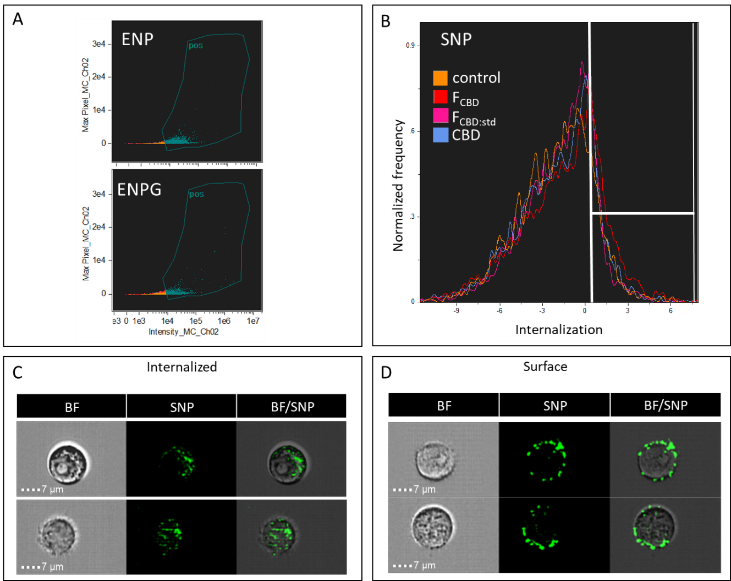
Supplementary Fig. S4. (A,B) Examples of plots of Imaging Flow Cytometry of macrophages. Differentiated KG1 cells were treated for 16 h with F_{CBD} at 7 µg/mL, F_{CBD:std} at 7 µg/mL, CBD at 4.35 µg/mL and solvent (vehicle) control and then incubated with silica beads (SNP, ENP or ENPG; 40 µg/mL) for 4 h. At least 4,000 cells for each treatment were analyzed using Amnis IDEAS software and the distribution of the cell internalization scores were plotted (marked in white lines under the curves). (A) Examples for images of plots for cells positive (pos) for ENP/ENPG. (B) Example for images of plots for cells gated with SNP-internalization score higher than 0.33. (C,D) Representative images of cells with internalized SNP beads (C) or on their surface (D), captured by the Amnis ImageStreamX. First column shows brightfield (BF) images of the cells, second column shows the SNP beads and third column shows the merged image (BF/SNP). Scale bar, 7 μm.

