Table 1. Optimization of reaction conditions for asymmetric cycloaddition of Nap-QMs with enamides
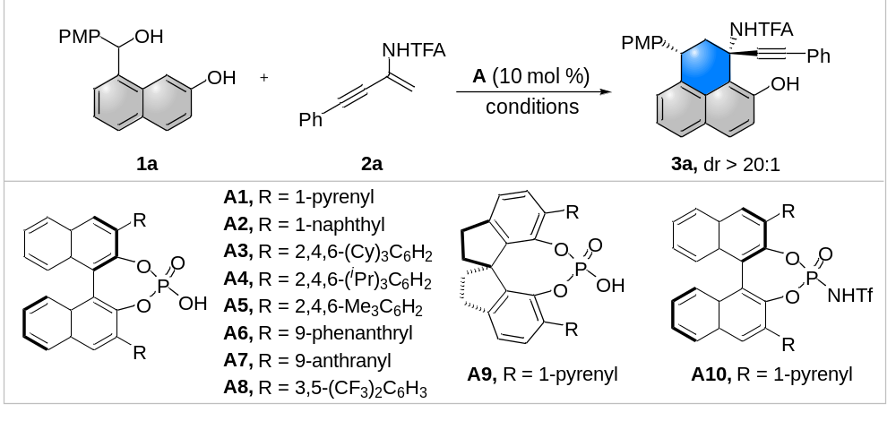
Entry | Cat. | Reaction conditions | Yield (%)ª | Ee (%)^{b}
1 | A1 | DCE, rt, 55 min | 90 | 90
2 | A2 | DCE, rt, 1.5 h | 94 | 75
3 | A3 | DCE, rt, 42 h | 41 | 33
4 | A4 | DCE, rt, 24 h | 96 | 25
5 | A5 | DCE, rt, 24 h | 97 | 41
6 | A6 | DCE, rt, 45 min | 90 | 80
7 | A7 | DCE, rt, 2 h | 97 | 81
8 | A8 | DCE, rt, 50 min | 95 | 66
9  10 | A9  A10 | DCE, rt, 4 h  DCE, rt, 25 min | 98  95 | 34  51
11 | A1 | DCM, rt, 1 h | 94 | 88
12 | A1 | CHCl₃, rt, 35 min | 96 | 85
13  14 | A1  A1 | PhF, rt, 1 h  toluene, rt, 40 min | 93  95 | 91  90
15 | A1 | PhF, 0 °C, 7 h | 92 | 93
Reaction conditions: 1a (0.05 mmol), 2a (0.06 mmol), CPA (0.005 mmol), solvent (1 mL). ªMeasured by ¹H NMR using 4-iodotoluene as internal standard. ^{b}Determined by HPLC analysis. TFA = trifluoroacetyl, PMP = 4-methoxyphenyl, DCM = dichloromethane, DCE = 1,2-dichloroethane, THF = tetrahydrofuran.
Table 2. Optimization of reaction conditions for asymmetric relay cyclization of Nap-QMs with enamides
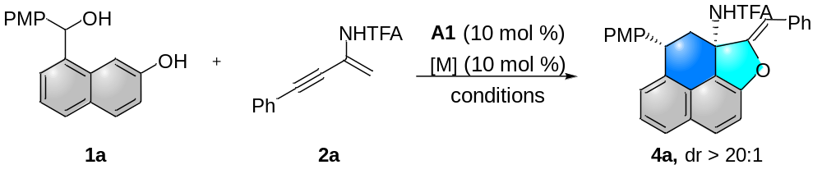
Entry | [M] | Reaction conditions | Additive | Yield (%)ª | Ee (%)^{b}
1 | Cu(MeCN)₄PF₆ | PhF, 0 °C-rt, 24 h | - | <5 | -
2 | Pd(OAc)₂ | PhF, 0 °C-rt, 24 h | - | <5 | -
3 | PdCl₂ | PhF, 0 °C-rt, 24 h | - | <5 | -
4 | IPrAuNTf₂ | PhF, 0 °C-rt, 24 h | - | <5 | -
5 | Ag₂O | PhF, 0 °C-rt, 8 h | - | 80 | 93
6 | AgNTf₂ | PhF, 0 °C-rt, 24 h | - | <5 | -
7 | AgOTf | PhF, 0 °C-rt, 24 h | - | <5 | -
8 | AgNTf₂ | PhF, 0 °C-rt, 8 h | K₂CO₃ (2 equiv) | 81 | 93
9 | AgOTf | PhF, 0 °C-rt, 8 h | K₂CO₃ (2 equiv) | 78 | 94
10^{c} | Ag₂O | PhF, 0 °C-rt, 8 h | K₂CO₃ (2 equiv) | 92 | 94
Reaction conditions: 1a (0.12 mmol), 2a (0.1 mmol), CPA (0.01 mmol), solvent (2 mL), at 0 °C, 7 h; then adding metal catalysts (0.01 mmol) at rt, 1-17 h. ªIsolated yield. ^{b}Determined by HPLC analysis. ^{c}PhF (4 mL), Ag₂O (0.02 mmol).

