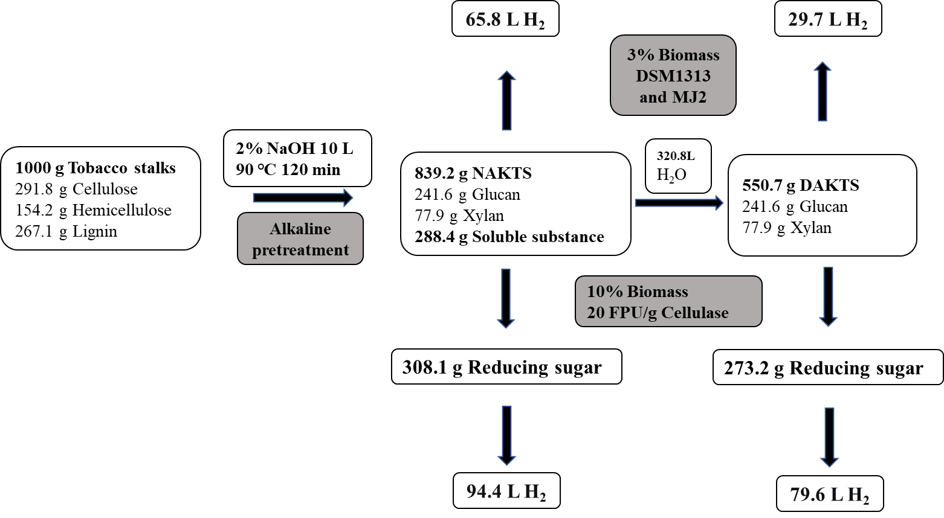
Fig. A1 Mass balance for tobacco stalks with hydrogen production.

