Supplement S3. Extended Methodological Appendix: Analytic Procedure, Reflexivity, and Rigor.

This supplement provides extended methodological details on the analytic procedure, epistemological stance, reflexivity, and strategies used to ensure rigor and credibility in the study. It is intended to complement the Methods section of the main manuscript.

Sequential analysis steps
Our sequential analysis steps, depicted in Figure 1, included: (1) preparation and familiarisation with the data; (2) domain-anchored deductive coding; (3) inductive elaboration for emergent subcodes; (4) systematic within-group comparison across informants; (5) cross-domain synthesis to identify shared and divergent patterns; and (6) the formulation of analytical propositions regarding convergences and divergences in the "visibility" of well-being domains across informant groups. This systematic comparison of perspectives, considering discrepancies as meaningful signals rather than error, constitutes a core methodological contribution to multi-informant qualitative inquiry (De Los Reyes et al., 2015; Sabbag et al., 2011).

Fig 1. Coding Categorization Diagram
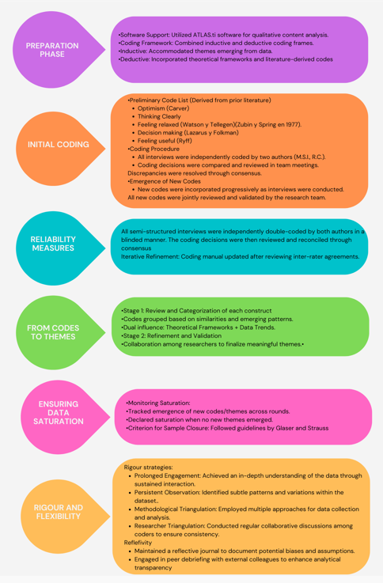

Epistemological Stance & Reflexivity
Our epistemological stance is rooted in critical realism, acknowledging an external reality of well-being in SMI while recognising that our understanding of it is shaped by subjective interpretation and social construction. This position aligns with directed content analysis, which uses a deductive framework informed by existing literature, alongside inductive elaboration to capture participant-driven meanings. We employed inter-coder checks and consensus discussions not as a positivist measure of objective truth, but as a post-positivist strategy to enhance the dependability of our interpretations. This collaborative process fostered analytical rigour by ensuring a shared understanding of code application and interpretation, thereby strengthening the credibility of our findings. Furthermore, a meticulously maintained audit trail, documenting codebook iterations and decisional memos, provides transferability by transparently linking raw data to overarching interpretations (Lincoln & Guba, 1985; Tracy, 2010).
As researchers, our team comprised clinical psychologists with experience in mental health research. Our initial assumptions, stemming from professional practice and prior literature, leaned towards a functional understanding of well-being. This deductive lens, inherent in directed content analysis, was critically examined throughout the coding and consensus process. Regular team meetings facilitated reflexive discussions, allowing us to identify and mitigate potential biases from our professional roles, ensuring that emergent participant perspectives were prioritised during inductive elaboration. This reflexive practice was crucial for preventing the deductive framework from prematurely constraining the rich, situated meanings offered by participants (Braun & Clarke, 2022).
Coding Process and Reliability
To ensure the dependability of the coding process, a pre-defined coding scheme, developed from the theoretical framework and interview guides, was initially applied and continuously refined. This iterative process involved documenting detailed definitions, clear inclusion/exclusion criteria, and exemplar quotations within the evolving codebook (available in Supplement S2). Both researchers independently coded all transcripts. Discrepancies identified during this independent coding were systematically resolved through thorough discussions and consensus-building. This collaborative approach, rather than solely focusing on a numerical agreement coefficient, aimed to harmonise interpretations and ensure the consistent application of codes across the dataset, thereby strengthening the analytic trustworthiness of the qualitative analysis (Campbell et al., 2013).
Rigor and Credibility
Multiple strategies were purposefully implemented to enhance the rigour and credibility of the study's findings, consistent with best practices in qualitative research (Tracy, 2010). These included: prolonged engagement with the data to facilitate comprehensive understanding; persistent observation to identify relevant characteristics and nuanced patterns; and methodological triangulation, integrating multiple perspectives from different informant groups. This multi-informant approach, where discrepancies are treated as data, significantly strengthens the validity of interpretations by providing a more holistic picture of the phenomenon (De Los Reyes et al., 2015). Regular team meetings were held to review newly emerging codes, discuss their application, and ensure analytical consistency. This collaborative review, coupled with independent coding and discrepancy resolution, contributed significantly to the overall dependability of the findings. Participants did not provide direct feedback on the coding process. Our adherence to relevant aspects of the Consolidated Criteria for Reporting Qualitative Research (COREQ) guidelines also informed our methodological approach (Tong et al., 2007).

