Supplementary Data 1

Table S1. RNA concentration and A_{260:280} of the cartilage samples selected for miRNA profiling determined spectrophotometrically

Group | Concentration (ng/μL) | Ratio 260/280
Control | 187.6 | 1.8
Control | 239.4 | 1.7
Control | 120 | 1.8
Control | 78 | 1.7
Early OA | 119 | 1.7
Early OA | 73.7 | 1.7
Early OA | 131.2 | 2.0
Early OA | 64.4 | 1.7
Late OA | 47.4 | 1.94
Late OA | 55.6 | 1.92
Late OA | 124.8 | 1.84
Late OA | 100.6 | 1.95
Late OA | 120.6 | 1.96

Table S2. miRNAs shortlisted for miRNA profiling by PCR arrays in cartilage tissue

OA miRNAs from literature  (n=52) |  |  |  |  | miRNAs with high expression in bone  (n=41, Human miRNATissueAtlas) |  |  |  | Lab Study: DE miRNAs in OA synovial fluid (n=7)
miR-208b-3p  miR-99a-5p  miR-29c-3p  miR-506-3p  let-7d-3p  miR-185-3p  miR-542-3p  miR-302a-3p  miR-135b-3p  miR-450b-5p  miR-30c-5p  miR-130b-3p  miR-431-3p  miR-873-3p  miR-505-3p  miR-330-3p  let-7g-5p  miR-615-3p  miR-411-3p  miR-574-3p  miR-127-3p  miR-33a-5p  miR-197-5p  miR-132-5p  miR-130a-5p  miR-99a-3p |  | miR-133a-3p  miR-885-5p  miR-345-5p  miR-7-5p  miR-376c-5p  miR-26b-5p  miR-182-5p  miR-345-3p  miR-454-3p  miR-130b-5p  miR-301a-3p  miR-885-3p  miR-342-3p  miR-20b-5p  miR-424-5p  miR-424-3p  miR-431-5p  let-7a-3p  miR-455-5p  miR-148b-3p  miR-135b-5p  let-7b-3p  miR-135a-3p  miR-10b-5p  miR-105-5p  miR-140-5p |  | miR-1343-3p  miR-186-3p  miR-376a-5p  miR-873-5p  miR-202-5p  miR-369-5p  miR-335-3p  miR-655-3p  miR-505-5p  miR-454-5p  miR-361-3p  miR-7-2-3p  miR-432-3p  miR-15b-3p  miR-379-5p  miR-216a-3p  miR-493-5p  miR-101-3p  miR-125b-2-3p  miR-376b-3p |  |  | miR-769-3p  miR-136-3p  miR-154-5p  miR-212-5p  miR-337-5p  miR-1185-5p  miR-376b-5p  miR-377-5p  miR-376c-3p  miR-656-3p  miR-539-3p  miR-3613-5p  miR-369-3p  miR-491-3p  miR-654-3p  miR-449c-5p  miR-302c-3p  miR-497-3p  miR-92b-3p  miR-376a-3p  let-7f-2-3p | miR-574-5p  miR-425-3p  miR-328-3p  miR-494-3p  miR-34b-3p  miR-191-3p  miR-331-3p

Control
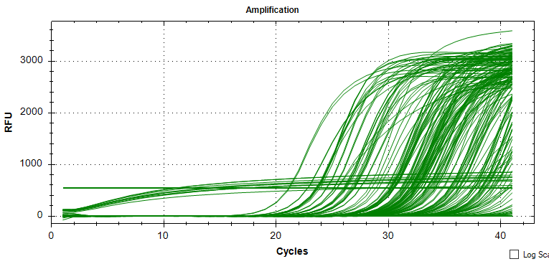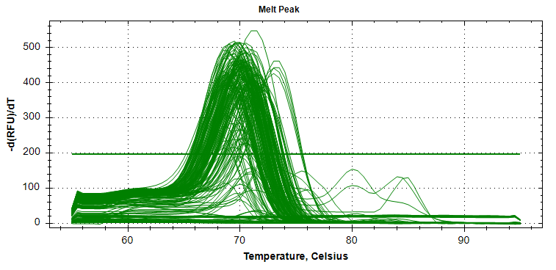
Sample 1
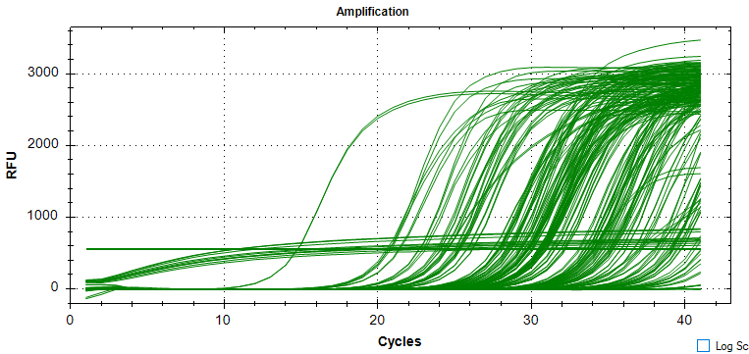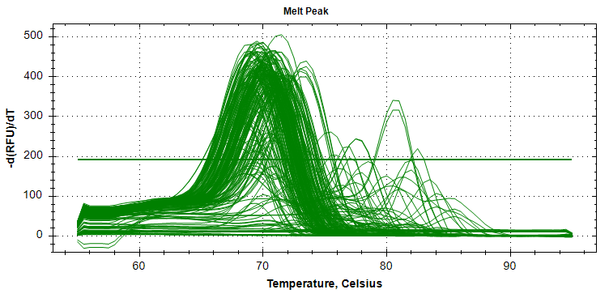
Sample 2
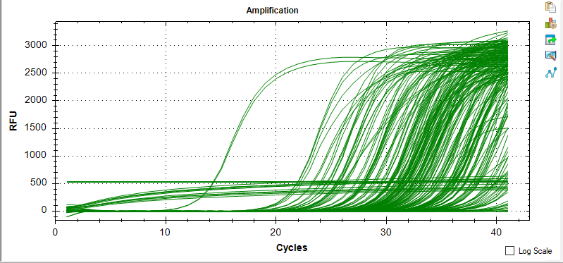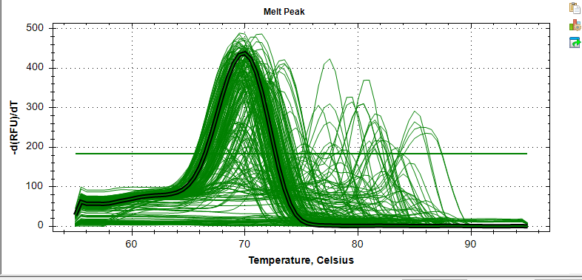
Sample 3

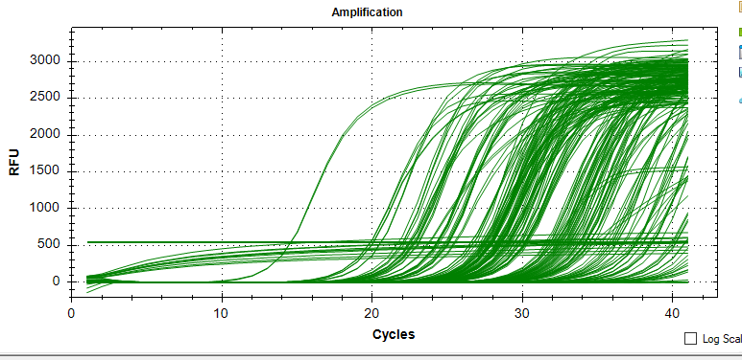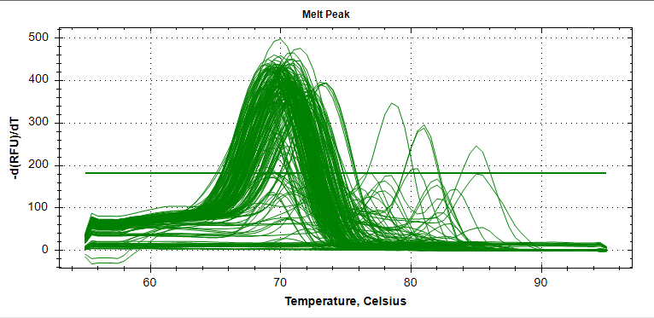
Sample 4

Fig. S1 The amplification plots and melt curve of the miRNAs in the customised 384 well PCR array plate for cartilage samples (n=4) in control group.

Early OA
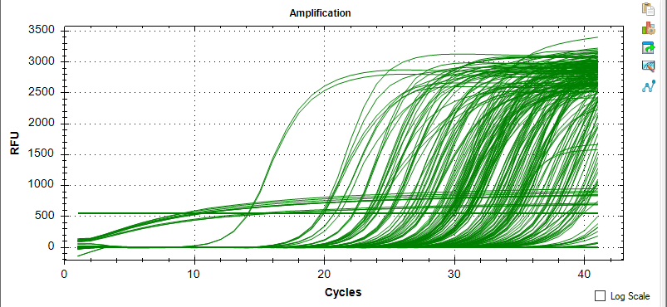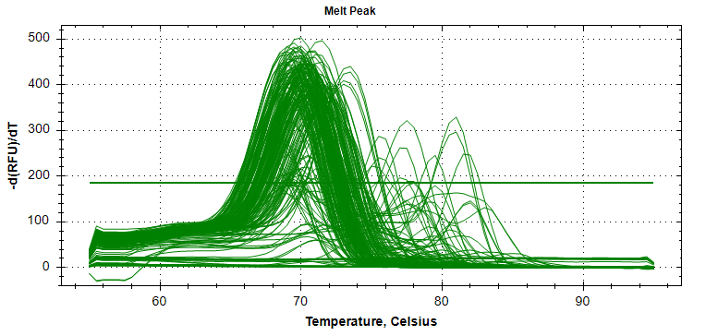
Sample 1
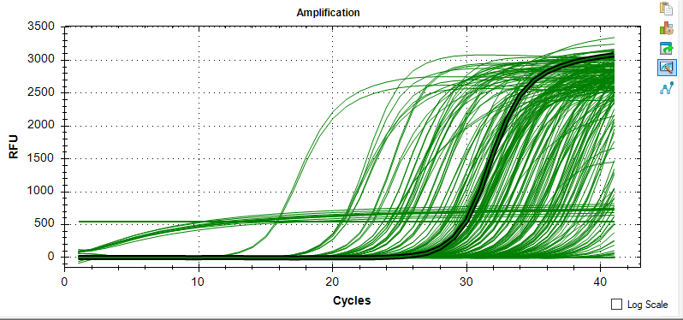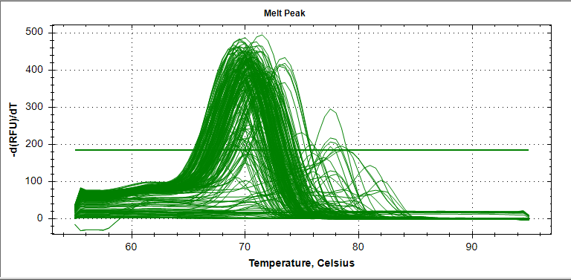
Sample 2

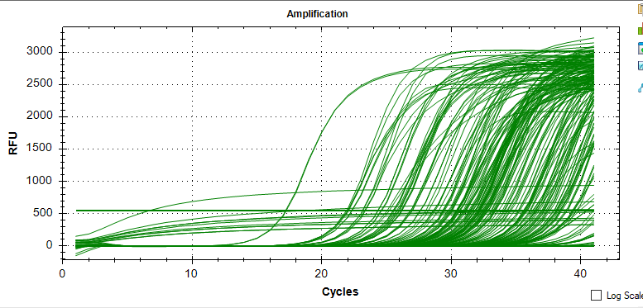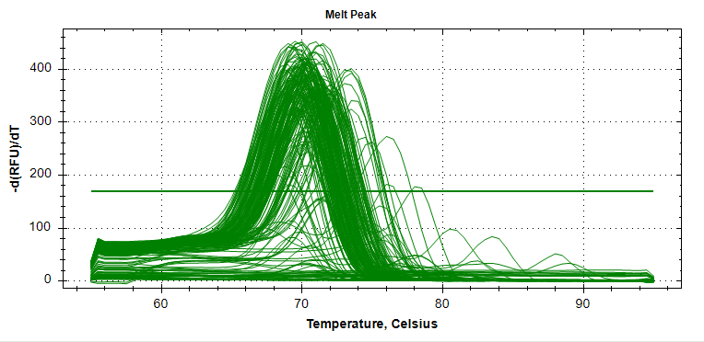
Sample 3

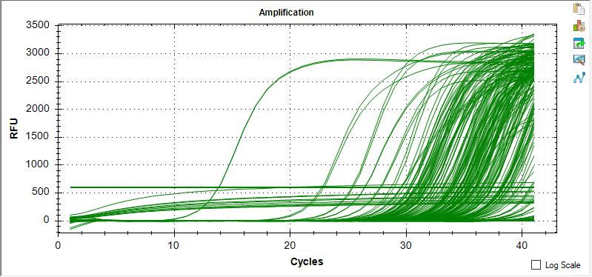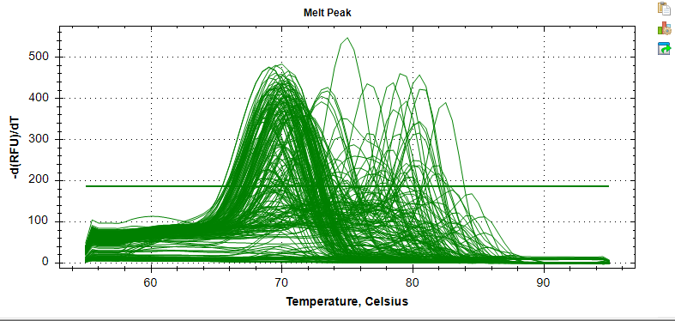
Sample 4

Fig. S2 The amplification plots and melt curve of the miRNAs in the customised 384 well PCR array plate for cartilage samples (n=4) in the early OA group.

Late OA
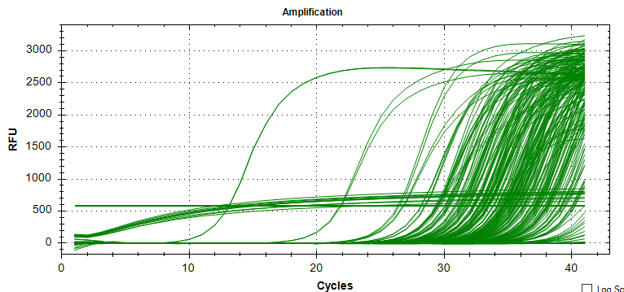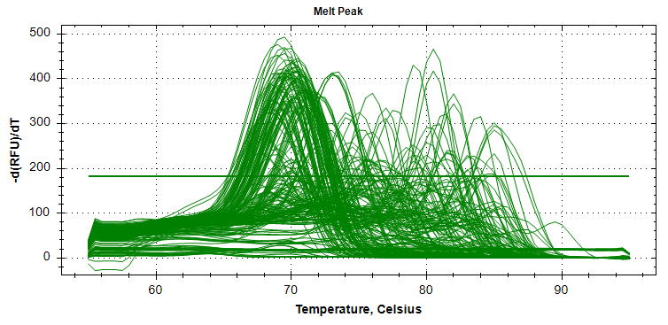
Sample 1

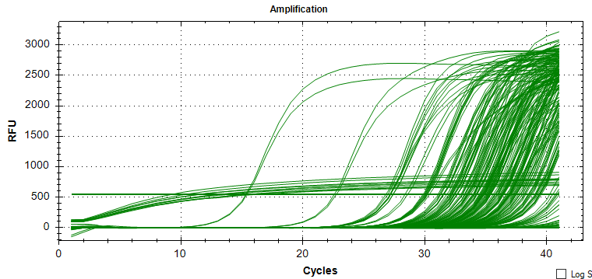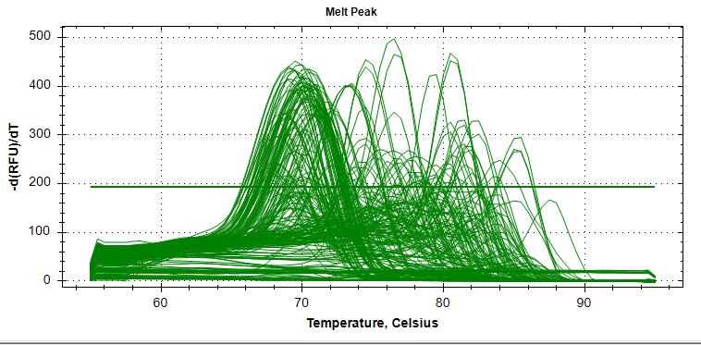
Sample 2

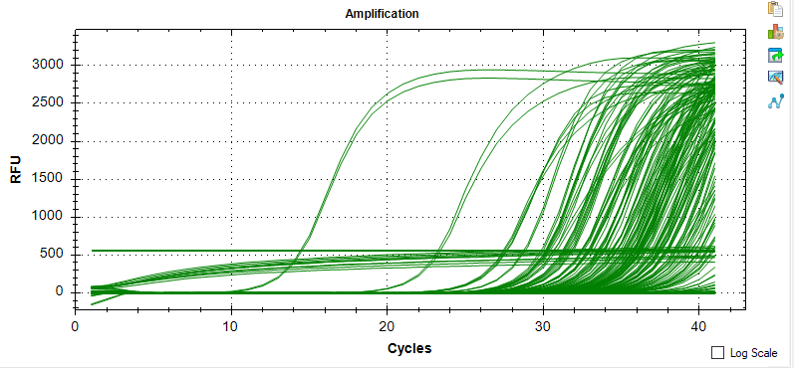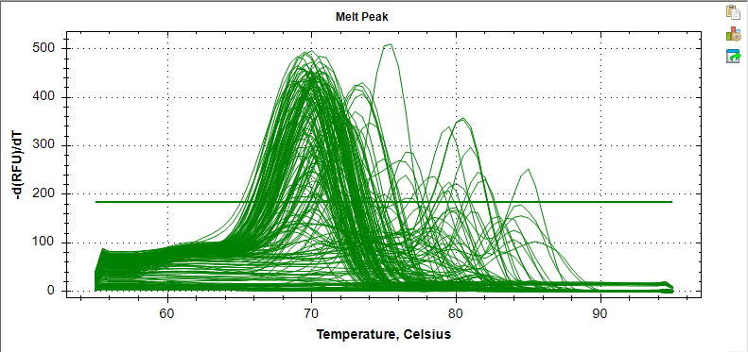
Sample 3

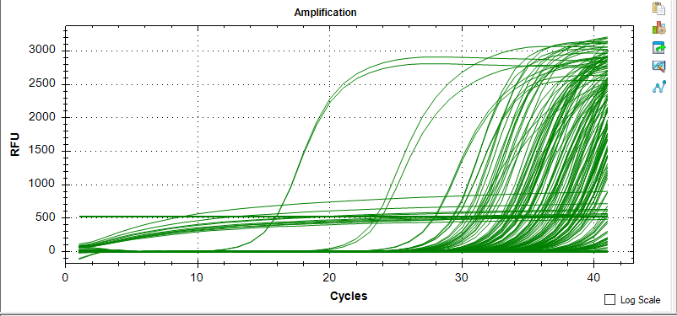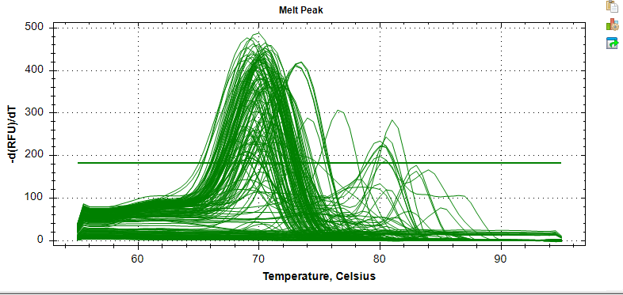
Sample 4

Fig. S3 The amplification plots and melt curve of the miRNAs in the customised 384 well PCR array plate for cartilage samples (n=4) in the late OA group.

