Table S1. miRNAs selected for in-silico target gene prediction

miRNA | Early OA vs Control |  | Late OA vs Control |  | Late OA vs Early OA
 | Fold regulation | P-value | Fold regulation | P-value | Fold regulation | P-value
miR-10b-5p | - | - | -33.22 | 0.010 | -38.69 | 4e-06
miR-148b-3p | - | - | -25.06 | 0.006 | -33.9 | 0.0049
miR-154-5p | - | - | -24.08 | 0.020 | -20.04 | 7e-05
let-7g-5p | - | - | -22.56 | 0.001 | -22.42 | 5e-05
miR-369-5p | - | - | -22.47 | 0.012 | -19.96 | 8e-05
miR-7-5p | -3.18 | 0.006 | -22.09 | 0.0002 | -6.96 | 0.0029
miR-376a-3p | - | - | -20.79 | 0.008 | -18.36 | 2e-05
miR-342-3p | - | - | -18.47 | 0.007 | -14.87 | 3e-05
miR-20b-5p | -3.66 | 0.032 | -13.38 | 0.003 | -3.65 | 0.031

Fold regulation of selected miRNAs in cartilage tissue was analysed using miRNA arrays. The comparisons included early OA versus control, late OA versus control, and late OA versus early OA groups. Data represent fold changes calculated from cartilage samples (n=4 for control and early OA groups; n=5 for the late OA group). p-values ≤ 0.05 were considered significant.

Supplementary Data 3

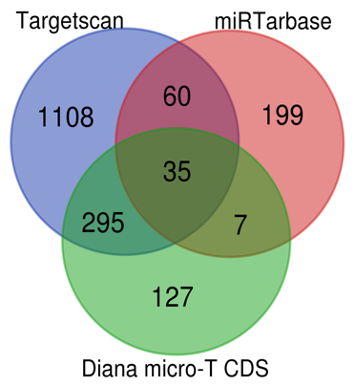
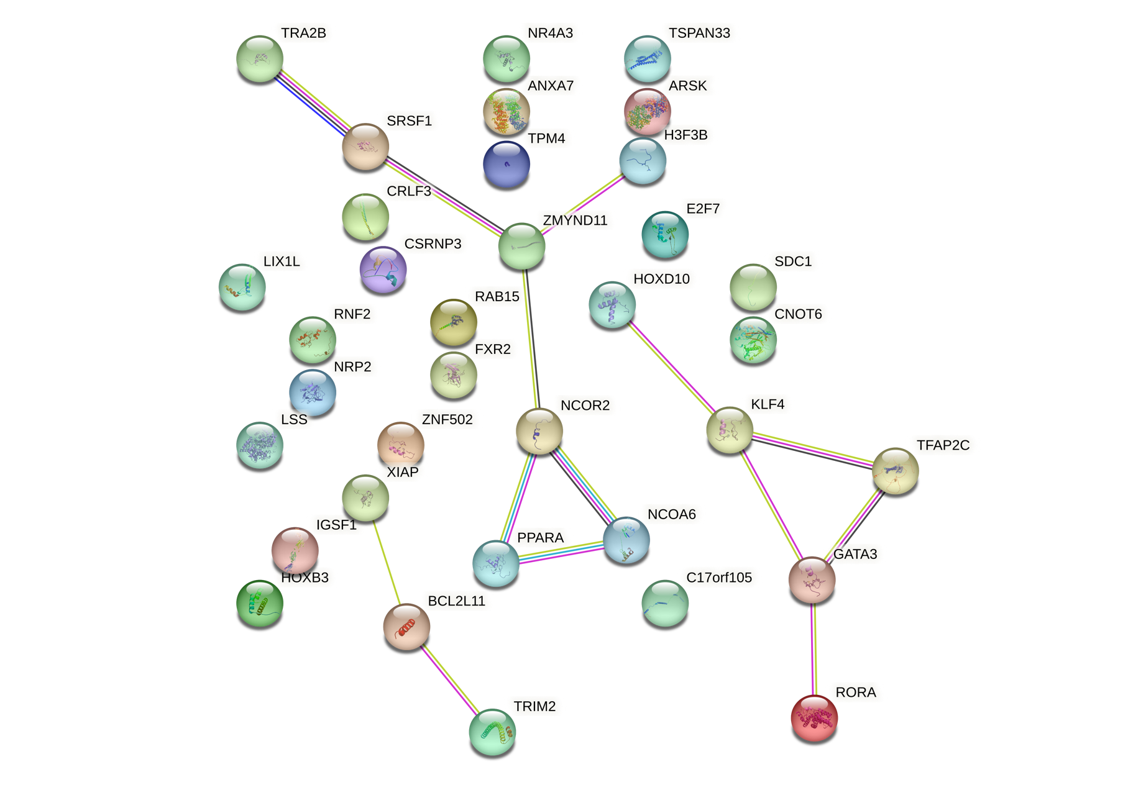
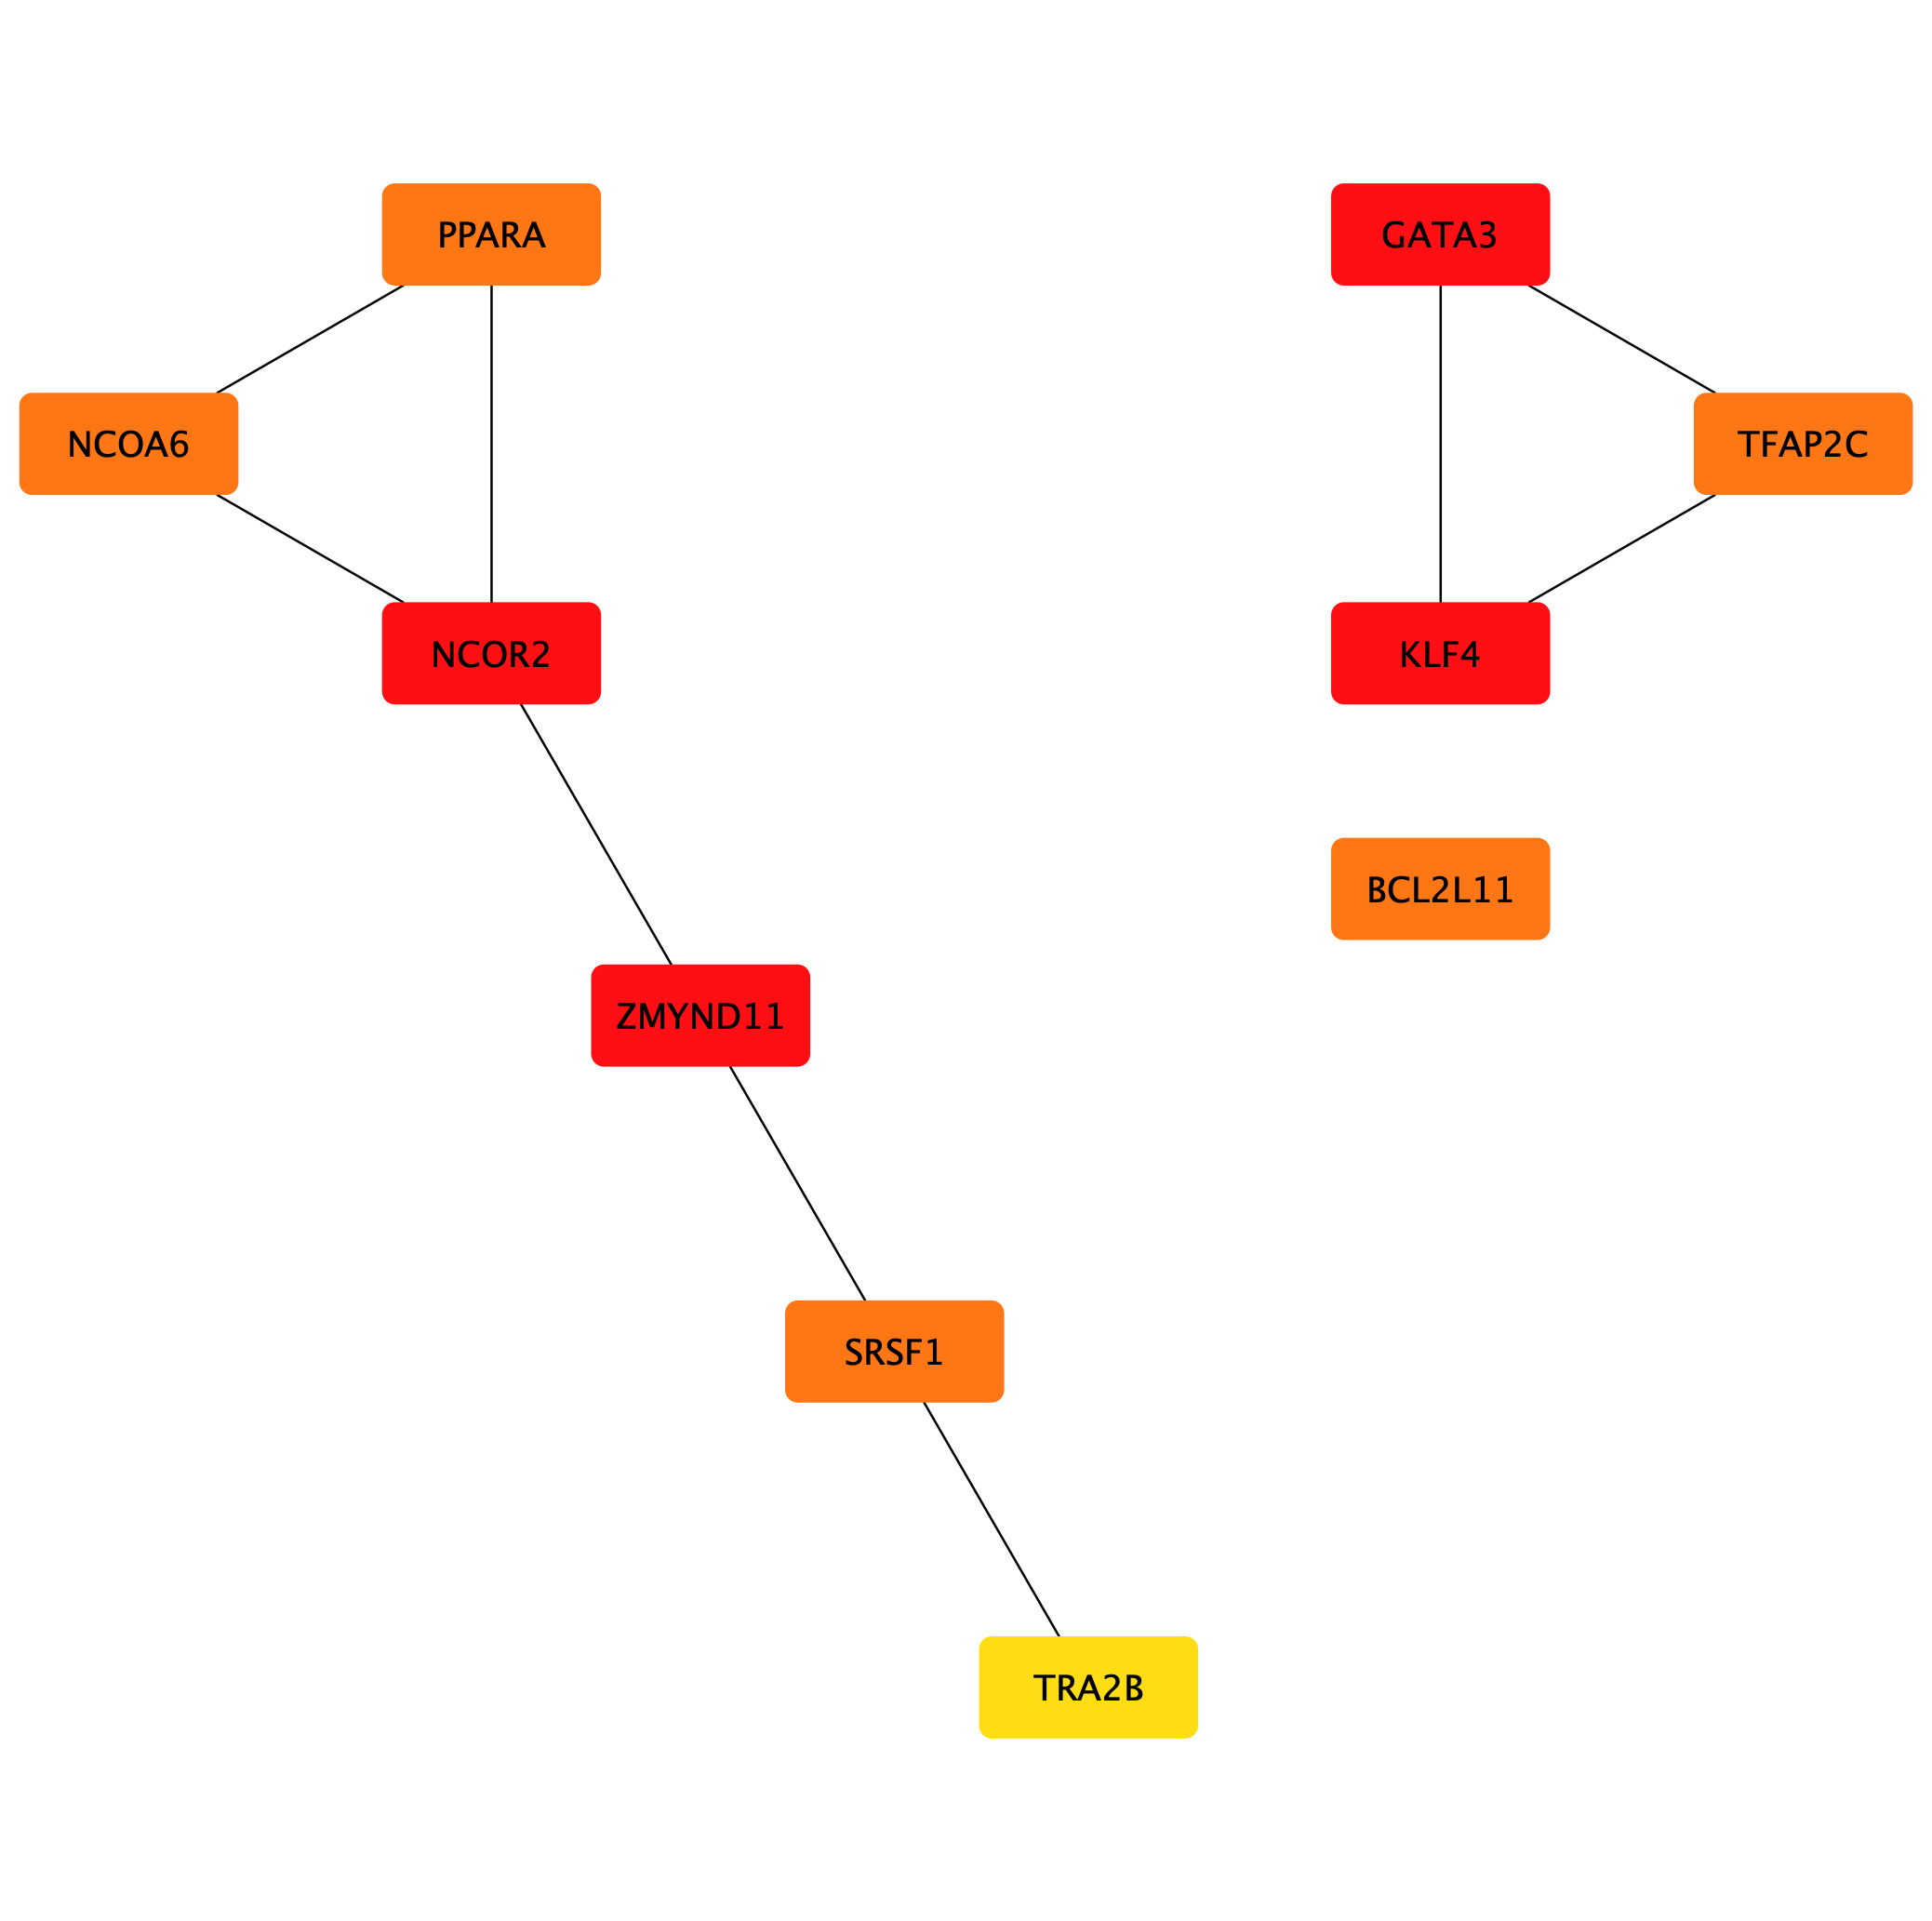
A
miR-10b-5p -33.22
Gene set enrichment analysis revealed no significant pathways
OA related genes found from OsteoDIP = 16
- NCOR2- Nuclear Receptor Corepressor 2
- KLF4- Kruppel-Like Factor 4
- BCL2L11-BCL2 Like 11
Hub Genes
Target Genes

B
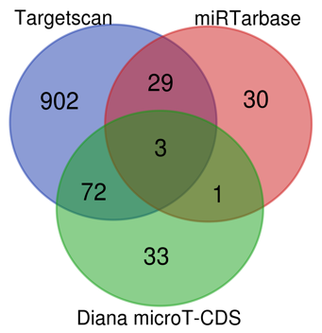
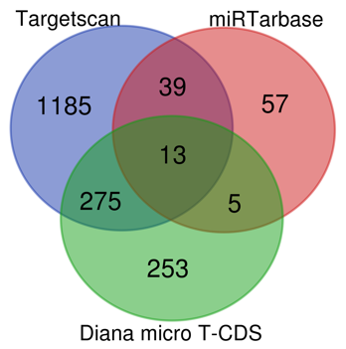
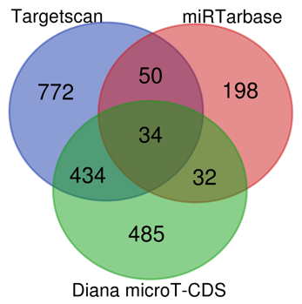
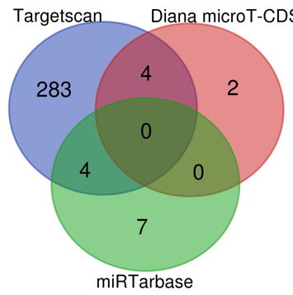
miR-154-5p -24.08
miR-376a-3p -20.79
miR-342-3p -18.47
miR-369-5p -22.47
OA related genes found from OsteoDIP
3
6
17
Poor PPI network by string analysis
Gene set enrichment analysis revealed no significant pathways

Figure S1 Representative analysis of the miRNAs with poor OA focused In-silico target gene prediction of (A) miR-10b-5p and (B) miR-154-5p, miR-376a-3p, miR-342-3p and miR-369-5p. Venn diagram shows the overlap of predicted gene targets among TargetScan, miRTarBase, and Diana microT-CDS databases.

Full Forms of the target genes mentioned in Table 1.

GATA3: GATA binding protein 3, NCOR2: Nuclear receptor co-repressor 2, KLF4: Krüppel-like factor 4, ZMYND11: Zinc finger MYND-type containing 11, NCOA6: Nuclear receptor coactivator 6, PPARA: Peroxisome proliferator-activated receptor alpha, TFAP2C: Transcription factor AP-2 gamma, BCL2L11: Bcl-2-like protein 11, SRSF1: Serine and arginine-rich splicing factor 1, TRA2B: Transformer 2 beta homolog, AGO1: Argonaute RISC catalytic component 1, TNRC6A: Trinucleotide repeat containing 6A, CDKN1B: Cyclin-dependent kinase inhibitor 1B, DCP2: mRNA-decapping enzyme 2, DNMT1: DNA (cytosine-5)-methyltransferase 1, PRKAA1: AMP-activated protein kinase alpha 1, PATL1: Protein PAT1 homolog 1, PRNP: Prion protein, TNRC6B: Trinucleotide repeat containing 6B, KPNA4: Karyopherin subunit alpha 4, THBS1: Thrombospondin 1, CASP3: Caspase-3, IGF1R: Insulin-like growth factor 1 receptor, CCND1: Cyclin D1, E2F6: E2F transcription factor 6, CDC25A: Cell division cycle 25A, MDM4: MDM4, BCL2L1: Bcl-2-like protein 1, CDKN1A: Cyclin-dependent kinase inhibitor 1A, TGFBR1: Transforming growth factor-beta receptor 1, ARRB1: Arrestin beta 1, IRS1: Insulin receptor substrate 1, PIK3CD: Phosphoinositide-3-kinase catalytic delta, EGFR: Epidermal growth factor receptor, EIF4E: Eukaryotic translation initiation factor 4E, RELA: V-rel avian reticuloendotheliosis viral oncogene homolog A, RAF1: RAF proto-oncogene serine/threonine kinase, SNCA: Synuclein alpha, TPGS2: Tocopheryl phosphate synthase 2, CHAMP1: Chromosome alignment-maintaining phosphoprotein 1, HIF1A: Hypoxia-inducible factor 1-alpha, PTEN: Phosphatase and tensin homolog, SMAD5: SMAD family member 5, STAT3: Signal transducer and activator of transcription 3, HSPA8: Heat shock protein family A member 8, DDX5: DEAD-box helicase 5, SQSTM1: Sequestosome 1, ROCK1: Rho-associated protein kinase 1, RGMA: Repulsive guidance molecule family member A, SOS2: Son of sevenless homolog 2, ITGB8: Integrin subunit beta 8, NRAS: NRAS proto-oncogene, GTPase, TXNIP: Thioredoxin interacting protein, PPP1CC: Protein phosphatase 1 catalytic subunit gamma, PCGF5: Polycomb group ring finger 5, NRBF2: Nuclear receptor binding factor 2, PIK3R3: Phosphoinositide-3-kinase regulatory subunit 3, TGFB2: Transforming growth factor-beta 2.

