Nanopore sequencing and de novo assembly of a misidentified Camelpox vaccine reveals putative epigenetic modifications and alternate protein signal peptides
Zack Saud¹*, Matthew D. Hitchings², Tariq M. Butt¹
¹ Department of Biosciences, College of Science, Swansea University, Singleton Park, Swansea, SA2 8PP, Wales, United Kingdom
² Swansea University Medical School, Swansea University, Singleton Park, Swansea, Sa2 8PP, Wales, United Kingdom
* Corresponding author
* Z. Saud: zack.saud@swansea.ac.uk

Supplementary Information 1- Evidence confirming the two deletions within the Ducapox genome
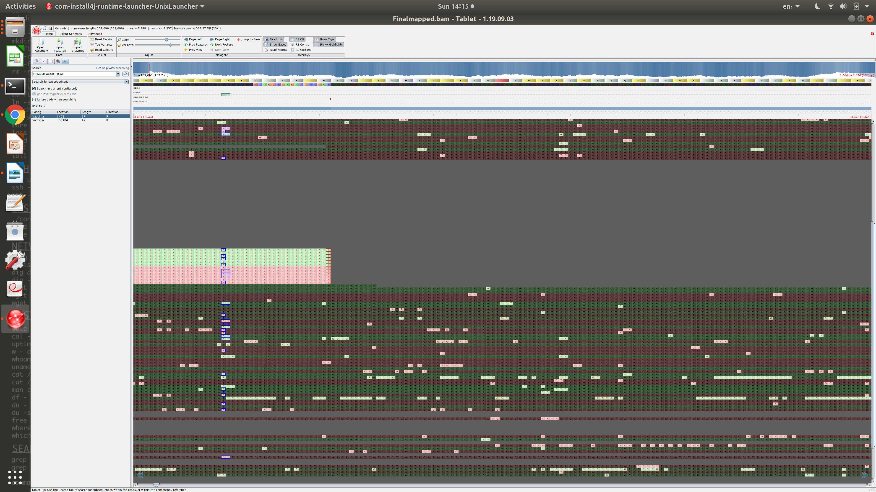
- Reads traversing the 5449 bp deletion site.
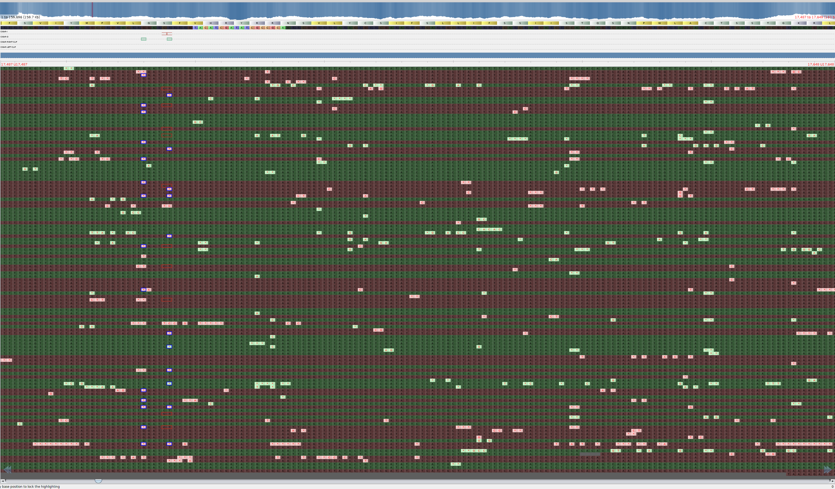
- Reads traversing the 916 bp deletion site.
c. EMBL-EBI Clustal Omega multiple sequence alignment of short read Ducapox assembly (MT648498.1), long read Ducapox assembly (Vaccinia) and VACV Acambis 3000 MVA (AY603355.1) genomes.
