Supplementary material 3

Mutation-Specific Dynamics of Dedifferentiation Trajectories and Tumor–Stromal Interactions in Thyroid Cancer

Eun Hye Joo, Young Shin Song, Han Sai Lee, Gyeongseo Jung, Eun-Jae Chung, Su-jin Kim, Yoo Hyung Kim, Sun Wook Cho, Jae-Kyung Won, Woong-Yang Park, Young Joo Park

Supplementary tables
Supplementary methods
Supplementary references

Supplementary Table 1. Top DEGs from global annotation from snRNA-seq.
Cell type | gene | avg_log2FC | pct.1 | pct.2 | p_val | p_val_adj |  | Cell type | gene | avg_log2FC | pct.1 | pct.2 | p_val | p_val_adj
Epithelial | TG | 5.199 | 0.82 | 0.122 | 0 | 0 |  | Myeloid | SLC8A1 | 4.220 | 0.774 | 0.042 | 0 | 0
Epithelial | TSHR | 4.854 | 0.891 | 0.037 | 0 | 0 |  | Myeloid | ZEB2 | 3.571 | 0.728 | 0.055 | 0 | 0
Epithelial | SLA | 4.376 | 0.691 | 0.213 | 0 | 0 |  | Myeloid | DOCK4 | 3.328 | 0.768 | 0.118 | 0 | 0
Epithelial | PAX8 | 3.947 | 0.922 | 0.046 | 0 | 0 |  | Myeloid | SLC11A1 | 3.171 | 0.416 | 0.01 | 0 | 0
Epithelial | PCSK2 | 3.747 | 0.497 | 0.011 | 0 | 0 |  | Myeloid | MRC1 | 3.077 | 0.452 | 0.011 | 0 | 0
Epithelial | KAZN | 3.231 | 0.596 | 0.061 | 0 | 0 |  | Myeloid | CSF2RA | 3.075 | 0.534 | 0.009 | 0 | 0
Epithelial | FRMD3 | 3.167 | 0.722 | 0.065 | 0 | 0 |  | Myeloid | SLC16A10 | 3.014 | 0.479 | 0.105 | 0 | 0
Epithelial | TENM1 | 3.102 | 0.679 | 0.02 | 0 | 0 |  | Myeloid | RBPJ | 2.997 | 0.642 | 0.26 | 0 | 0
Epithelial | DOCK3 | 3.067 | 0.8 | 0.039 | 0 | 0 |  | Myeloid | VCAN | 2.954 | 0.321 | 0.041 | 0 | 0
Epithelial | LINC01789 | 2.914 | 0.295 | 0.004 | 0 | 0 |  | Myeloid | NAMPT | 2.837 | 0.579 | 0.138 | 0 | 0
Epithelial | AC007262.2 | 2.909 | 0.716 | 0.028 | 0 | 0 |  | Myeloid | PLXDC2 | 2.821 | 0.795 | 0.431 | 0 | 0
Epithelial | SLC25A29 | 2.898 | 0.749 | 0.056 | 0 | 0 |  | Myeloid | CD74 | 2.804 | 0.74 | 0.223 | 0 | 0
Epithelial | LMO3 | 2.893 | 0.689 | 0.013 | 0 | 0 |  | Myeloid | GLUL | 2.790 | 0.56 | 0.095 | 0 | 0
Epithelial | SLC26A7 | 2.873 | 0.501 | 0.009 | 0 | 0 |  | Myeloid | RAPGEF1 | 2.771 | 0.723 | 0.164 | 0 | 0
Epithelial | KCNJ16 | 2.800 | 0.615 | 0.008 | 0 | 0 |  | Myeloid | KYNU | 2.766 | 0.521 | 0.011 | 0 | 0
Epithelial | UNC5C | 2.667 | 0.738 | 0.055 | 0 | 0 |  | Myeloid | DAPK1 | 2.740 | 0.554 | 0.049 | 0 | 0
Epithelial | MGAT4C | 2.651 | 0.631 | 0.013 | 0 | 0 |  | Myeloid | HLA-DRA | 2.738 | 0.58 | 0.096 | 0 | 0
Epithelial | HMGA2 | 2.637 | 0.67 | 0.087 | 0 | 0 |  | Myeloid | SRGN | 2.716 | 0.545 | 0.047 | 0 | 0
Epithelial | DANT2 | 2.635 | 0.795 | 0.049 | 0 | 0 |  | Myeloid | TYMP | 2.663 | 0.567 | 0.072 | 0 | 0
Epithelial | NAV2 | 2.603 | 0.84 | 0.122 | 0 | 0 |  | Myeloid | ABCA1 | 2.662 | 0.624 | 0.189 | 0 | 0
T&NK | PTPRC | 3.954 | 0.857 | 0.051 | 0 | 0 |  | Fibroblast | EBF1 | 4.148 | 0.722 | 0.012 | 0 | 0
T&NK | SKAP1 | 3.902 | 0.769 | 0.048 | 0 | 0 |  | Fibroblast | COL3A1 | 4.048 | 0.741 | 0.035 | 0 | 0
T&NK | ARHGAP15 | 3.646 | 0.774 | 0.049 | 0 | 0 |  | Fibroblast | COL1A2 | 4.043 | 0.78 | 0.069 | 0 | 0
T&NK | CD247 | 3.357 | 0.543 | 0.012 | 0 | 0 |  | Fibroblast | COL6A3 | 4.032 | 0.748 | 0.018 | 0 | 0
T&NK | HLA-A | 3.274 | 0.641 | 0.168 | 0 | 0 |  | Fibroblast | COL5A2 | 3.919 | 0.769 | 0.06 | 0 | 0
T&NK | CD2 | 3.272 | 0.552 | 0.006 | 0 | 0 |  | Fibroblast | CCDC102B | 3.890 | 0.567 | 0.063 | 0 | 0
T&NK | THEMIS | 3.222 | 0.436 | 0.004 | 0 | 0 |  | Fibroblast | POSTN | 3.726 | 0.558 | 0.039 | 0 | 0
T&NK | HLA-B | 3.199 | 0.689 | 0.186 | 0 | 0 |  | Fibroblast | LHFPL6 | 3.571 | 0.582 | 0.029 | 0 | 0
T&NK | SLFN12L | 3.189 | 0.55 | 0.012 | 0 | 0 |  | Fibroblast | CALD1 | 3.563 | 0.931 | 0.364 | 0 | 0
T&NK | IKZF1 | 3.149 | 0.596 | 0.027 | 0 | 0 |  | Fibroblast | TSHZ2 | 3.549 | 0.659 | 0.035 | 0 | 0
T&NK | PDE3B | 3.139 | 0.447 | 0.023 | 0 | 0 |  | Fibroblast | PDGFRB | 3.446 | 0.636 | 0.004 | 0 | 0
T&NK | IL32 | 3.130 | 0.391 | 0.025 | 0 | 0 |  | Fibroblast | SULF1 | 3.420 | 0.62 | 0.101 | 0 | 0
T&NK | HSP90AA1 | 3.111 | 0.479 | 0.232 | 0 | 0 |  | Fibroblast | PDE3A | 3.346 | 0.605 | 0.008 | 0 | 0
T&NK | PPP1R16B | 3.040 | 0.484 | 0.014 | 0 | 0 |  | Fibroblast | GPC6 | 3.299 | 0.579 | 0.114 | 0 | 0
T&NK | ANKRD44 | 3.022 | 0.755 | 0.154 | 0 | 0 |  | Fibroblast | IGFBP7 | 3.292 | 0.7 | 0.049 | 0 | 0
T&NK | C15orf53 | 3.011 | 0.264 | 0.013 | 0 | 0 |  | Fibroblast | CARMN | 3.235 | 0.551 | 0.002 | 0 | 0
T&NK | CD96 | 2.990 | 0.529 | 0.057 | 0 | 0 |  | Fibroblast | PRRX1 | 3.234 | 0.669 | 0.009 | 0 | 0
T&NK | TOX | 2.981 | 0.449 | 0.035 | 0 | 0 |  | Fibroblast | COL11A1 | 3.199 | 0.281 | 0.01 | 0 | 0
T&NK | LINC01934 | 2.978 | 0.353 | 0.008 | 0 | 0 |  | Fibroblast | COL1A1 | 3.193 | 0.674 | 0.092 | 0 | 0
T&NK | B2M | 2.947 | 0.827 | 0.447 | 0 | 0 |  | Fibroblast | CACNA1C | 3.186 | 0.669 | 0.048 | 0 | 0
Endothelial | LDB2 | 5.134 | 0.931 | 0.031 | 0 | 0
Endothelial | FLT1 | 4.636 | 0.754 | 0.016 | 0 | 0
Endothelial | CALCRL | 4.534 | 0.809 | 0.026 | 0 | 0
Endothelial | PLCB1 | 4.431 | 0.887 | 0.056 | 0 | 0
Endothelial | GRB10 | 4.307 | 0.855 | 0.053 | 0 | 0
Endothelial | TCF4 | 3.907 | 0.896 | 0.141 | 0 | 0
Endothelial | CDH13 | 3.513 | 0.67 | 0.047 | 0 | 0
Endothelial | PLPP1 | 3.454 | 0.591 | 0.125 | 0 | 0
Endothelial | INSR | 3.409 | 0.812 | 0.334 | 0 | 0
Endothelial | CACNA1C | 3.370 | 0.632 | 0.055 | 0 | 0
Endothelial | HSPG2 | 3.342 | 0.744 | 0.076 | 0 | 0
Endothelial | EGFL7 | 3.337 | 0.702 | 0.005 | 0 | 0
Endothelial | PDE4D | 3.314 | 0.881 | 0.25 | 0 | 0
Endothelial | PTPRB | 3.285 | 0.715 | 0.015 | 0 | 0
Endothelial | RAPGEF4 | 3.252 | 0.65 | 0.013 | 0 | 0
Endothelial | COL4A2 | 3.251 | 0.769 | 0.076 | 0 | 0
Endothelial | HECW2 | 3.240 | 0.63 | 0.026 | 0 | 0
Endothelial | SLCO2A1 | 3.218 | 0.495 | 0.036 | 0 | 0
Endothelial | EMCN | 3.185 | 0.603 | 0.007 | 0 | 0
Endothelial | PCDH17 | 3.166 | 0.506 | 0.002 | 0 | 0

Differential expression analysis was performed using Seurat FindAllMarkers with the MAST test. Columns indicate cell type, gene symbol, average log2 fold change (avg_log2FC), percentage of expressing cells in the given cell type (pct.1) and in all other cells (pct.2), nominal P value (p_val), and Bonferroni-adjusted P value (p_val_adj).

Supplementary Table 2. Sample processing overview with pathology and mutation
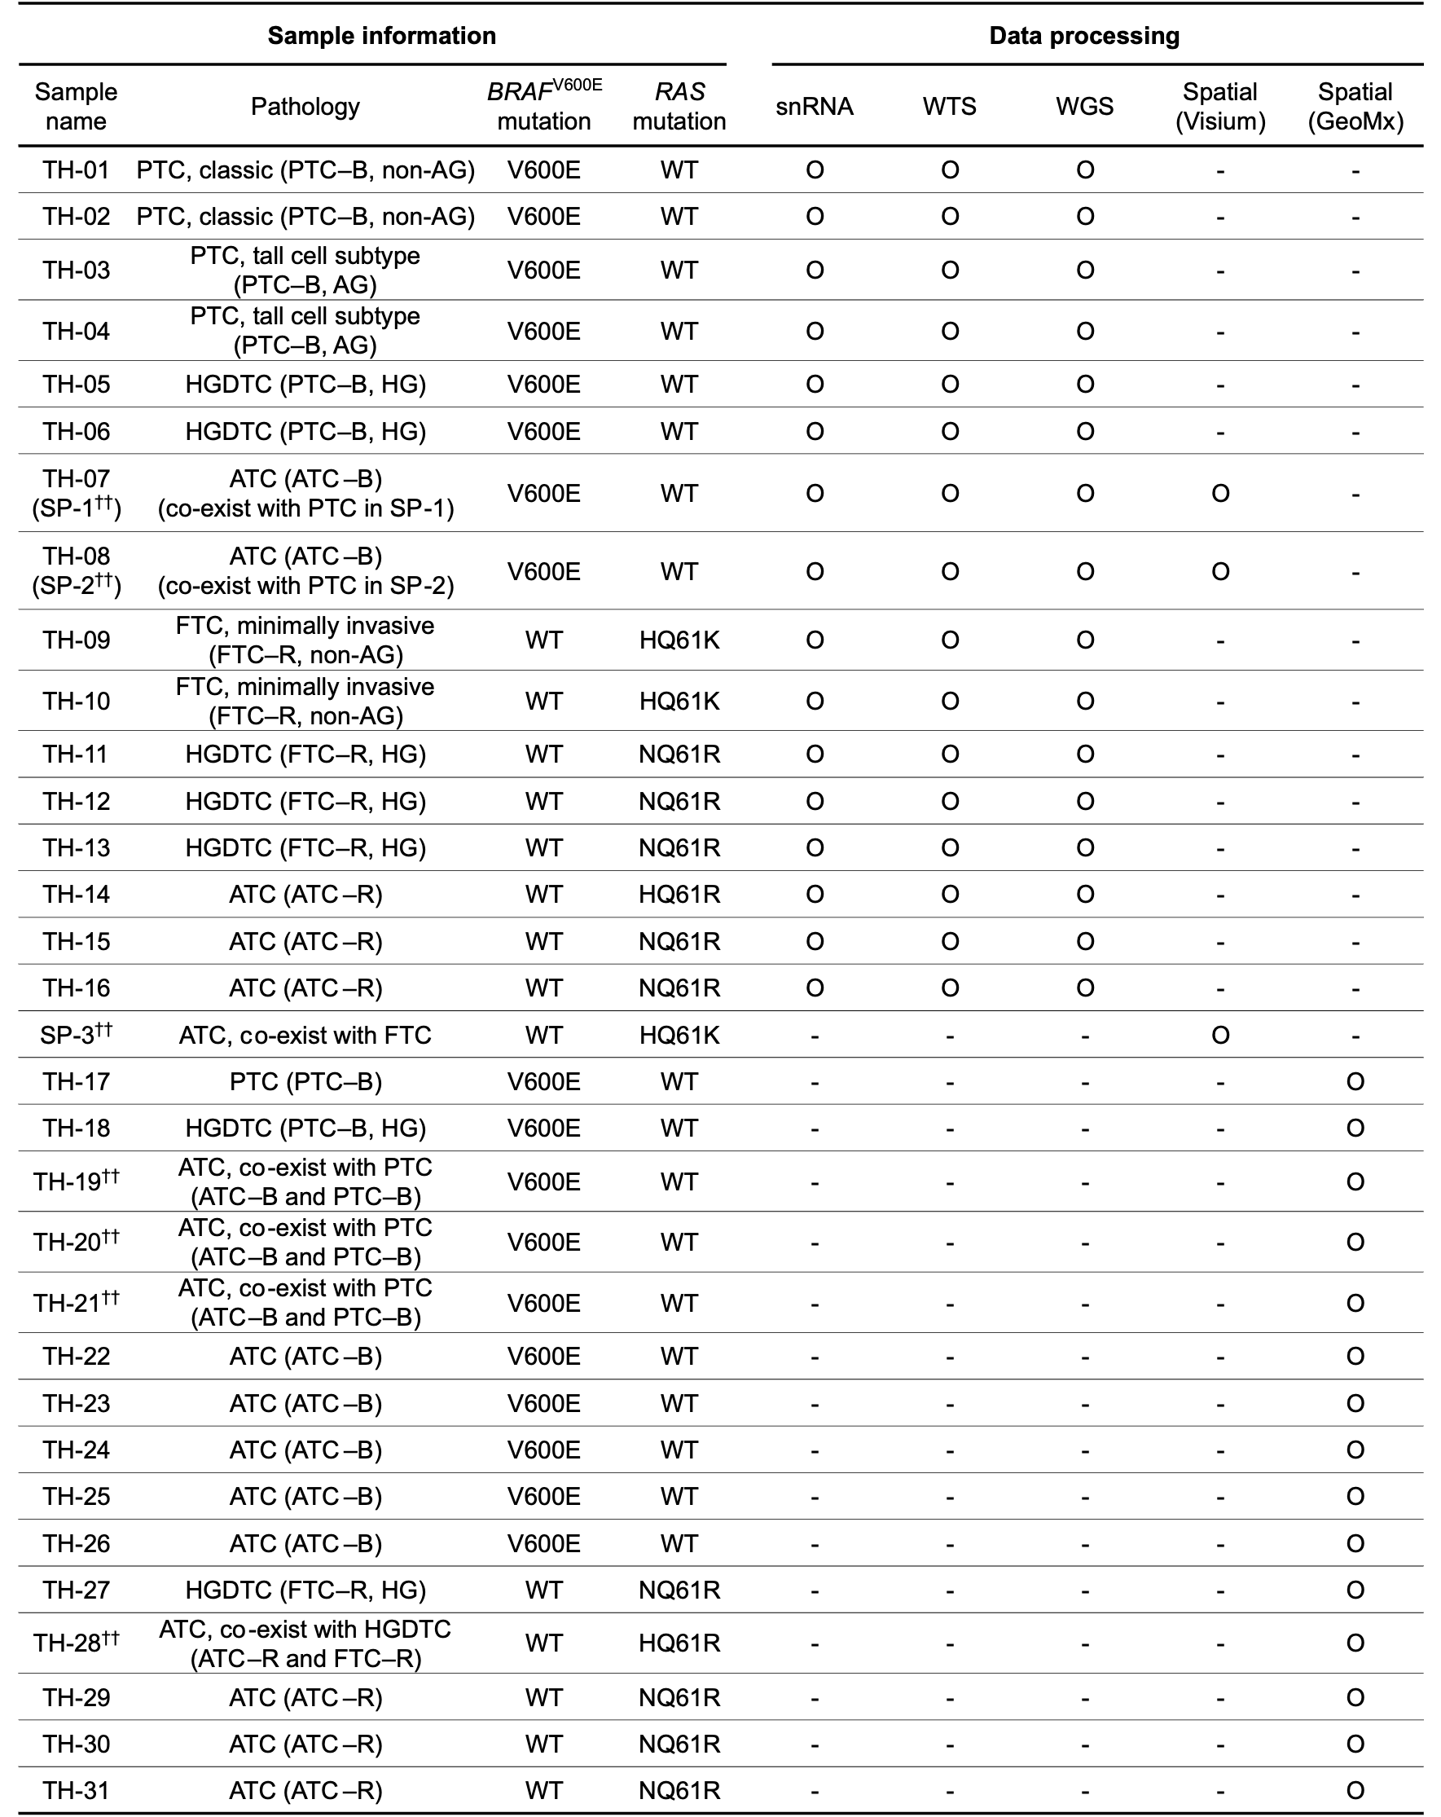
Details each thyroid cancer sample's data construction, pathological classification, and driving mutation status. The double-dagger marked (††) samples contain differentiated tumor regions alongside ATC. non-AG: non-aggressive subtype; AG: aggressive subtype; HG: high-grade subtype; PTC: papillary thyroid cancer; FTC: follicular thyroid cancer; HGDTC: High-grade differentiated thyroid carcinoma; ATC: anaplastic thyroid cancer; -B: BRAF^{V600E} mutation; -R: RAS mutation.
Supplementary methods

1. Public dataset collection and processing of single cell RNA-seq (scRNA-seq)
Publicly available scRNA-seq datasets (GSE134355[1], GSE148673[2], GSE158291[3], GSE163203[4], GSE184362[5], GSE191288[6], GSE193581[7], GSE210347[8], GSE232237[9]) were integrated to construct an integrated single-nucleus RNA (snRNA) and scRNA dataset. Low-quality cells were filtered using the Seurat package (v4.3.0.1)[10] as described above. To mitigate batch effects arising from multiple studies and sequencing platform difference, we utilized STACAS (v2.2.0)[11] with Run.STACAS function. Following batch correction, cell dimensionality was reduced using Run.UMAP function in Seurat package.
Two datasets (GSE193581 and GSE210347) were annotated with global cell types using the scGATE R package (v1.6.2)[12]. Samples derived from normal thyroid tissue were labeled ‘Normal,’ while those from adjacent thyroid carcinoma tissue were labeled ‘Adj.’ Cell type references from our snRNA-seq data were used to refine and confirm these annotations, ensuring consistency across all samples in this study.

2. Variance component analysis using linear mixed-effects modeling
To quantify the relative contributions of patient-to-patient variability and method-related variability to cell type proportions across the four cancer groups (PTC-B, ATC-B, FTC-R, and ATC-R), we employed a linear mixed-effects modeling approach. Specifically, we fit a separate linear mixed model for each cell type using the lmer() function from lme4 R package(v1.1)[13], treating both patient and data source (snRNA-seq, WTS, Visium, and GeoMx) as random effects. Variance components were extracted from each fitted model using the VarCorr() function, and 95% confidence intervals were estimated for these variance components. The extracted values were then used to generate bar plots depicting the fraction of total variance attributable to patient-related and data source–related variability, allowing us to assess whether observed differences were driven primarily by biological heterogeneity or technical factors.

3. CNV detection in 10x Visium data
Ploidy was inferred from Visium spatial transcriptomics data using the SPATA2 R package (v3.1.0)[14], focusing on chromosome arm–level CNVs. First, raw expression ratios (or log fold changes) were computed for each chromosome arm. These values were then centered around 1, and the absolute deviations from 1 were calculated. Specifically, each chromosome arm’s expression ratio was transformed with abs for all samples, and the resulting values were summed per spot to yield a cumulative CNV score. This score served as a proxy for ploidy alterations, reflecting the degree of genomic instability.

4. Classification of epithelial cells with the thyroid cancer specific public tool
To categorize thyroid epithelial cells into distinct tumor subtypes, we employed the scTypeTC package (v0.1.0) developed by Lina Lu et al[7]. First, an epithelial-only subset was derived from the snRNA-seq dataset based on established epithelial marker genes. Next, the scTypeTC() function was applied to these epithelial cells using a multinomial-lasso model, as recommended by the original study. This model assigns cells to one of four major thyroid tumor subtypes—normal thyroid follicular cells (TFC), stress-responsive PTC cells (PTC1), inflammatory ATC cells (ATC1), and mesenchymal ATC cells (ATC2)—or classifies them as undefined if the prediction confidence is below a specified threshold.

5. Cell–Cell communication validation in 10x Visium
To evaluate intercellular communication across distinct tumor regions in relation to pathological annotations, we employed the CellChat R package (v1.6.1)[15]. Tumor regions were first annotated based on pathological assessment to confirm morphological and clinical features. Subsequently, gene expression data from each region were aggregated and processed through the CellChat pipeline, which identifies statistically significant ligand–receptor interactions and computes communication probabilities. These probabilities were validated by correlating interaction strength with pathological annotations, providing biological context for the observed signaling events.
Network diagrams were generated to visualize the total interaction strength among the annotated tumor regions. Each node corresponds to a specific region, and the edges between nodes represent the magnitude of intercellular communication, with thicker edges indicating stronger interactions. The top-enriched signaling networks were identified via CellChat’s pathway enrichment analysis.

6. Validation with TMA-based Visium Dataset
Two independent TMA cores were obtained from the same hospital and patient cohort, following the identical IRB protocols described in the main methods. Spatial transcriptomics was performed using the 10x Genomics Visium platform. Raw sequencing data were processed via the Space Ranger pipeline (https://www.10xgenomics.com/support/software/space-ranger/latest) and aligned to the GRCh38 reference genome for spot identification and gene expression quantification.
Spatial Analysis To quantify cell-cell co-localization and niche interactions, we utilized the Stopover (v1.1.2) tool[16]. This independent dataset was used to validate the spatial circuits and ligand-receptor networks identified in the primary cohort, ensuring the robustness of our findings in ATC-R regions.

Supplementary references
1. Han X, Zhou Z, Fei L, Sun H, Wang R, Chen Y, Chen H, Wang J, Tang H, Ge W, et al: Construction of a human cell landscape at single-cell level. Nature 2020, 581:303-309.
2. Gao R, Bai S, Henderson YC, Lin Y, Schalck A, Yan Y, Kumar T, Hu M, Sei E, Davis A, et al: Delineating copy number and clonal substructure in human tumors from single-cell transcriptomes. Nat Biotechnol 2021, 39:599-608.
3. Peng M, Wei G, Zhang Y, Li H, Lai Y, Guo Y, Chen Y, Liu L, Xiao H, Guan H, Li Y: Single-cell transcriptomic landscape reveals the differences in cell differentiation and immune microenvironment of papillary thyroid carcinoma between genders. Cell Biosci 2021, 11:39.
4. Pan J, Ye F, Yu C, Zhu Q, Li J, Zhang Y, Tian H, Yao Y, Zhu M, Shen Y, et al: Papillary Thyroid Carcinoma Landscape and Its Immunological Link With Hashimoto Thyroiditis at Single-Cell Resolution. Front Cell Dev Biol 2021, 9:758339.
5. Pu W, Shi X, Yu P, Zhang M, Liu Z, Tan L, Han P, Wang Y, Ji D, Gan H, et al: Single-cell transcriptomic analysis of the tumor ecosystems underlying initiation and progression of papillary thyroid carcinoma. Nat Commun 2021, 12:6058.
6. Wang T, Shi J, Li L, Zhou X, Zhang H, Zhang X, Wang Y, Liu L, Sheng L: Single-Cell Transcriptome Analysis Reveals Inter-Tumor Heterogeneity in Bilateral Papillary Thyroid Carcinoma. Front Immunol 2022, 13:840811.
7. Lu L, Wang JR, Henderson YC, Bai S, Yang J, Hu M, Shiau CK, Pan T, Yan Y, Tran TM, et al: Anaplastic transformation in thyroid cancer revealed by single-cell transcriptomics. J Clin Invest 2023, 133.
8. Luo H, Xia X, Huang LB, An H, Cao M, Kim GD, Chen HN, Zhang WH, Shu Y, Kong X, et al: Pan-cancer single-cell analysis reveals the heterogeneity and plasticity of cancer-associated fibroblasts in the tumor microenvironment. Nat Commun 2022, 13:6619.
9. Lee SE, Park S, Yi S, Choi NR, Lim MA, Chang JW, Won HR, Kim JR, Ko HM, Chung EJ, et al: Unraveling the role of the mitochondrial one-carbon pathway in undifferentiated thyroid cancer by multi-omics analyses. Nat Commun 2024, 15:1163.
10. Hao Y, Hao S, Andersen-Nissen E, Mauck WM, 3rd, Zheng S, Butler A, Lee MJ, Wilk AJ, Darby C, Zager M, et al: Integrated analysis of multimodal single-cell data. Cell 2021, 184:3573-3587 e3529.
11. Andreatta M, Herault L, Gueguen P, Gfeller D, Berenstein AJ, Carmona SJ: Semi-supervised integration of single-cell transcriptomics data. Nat Commun 2024, 15:872.
12. Andreatta M, Berenstein AJ, Carmona SJ: scGate: marker-based purification of cell types from heterogeneous single-cell RNA-seq datasets. Bioinformatics 2022, 38:2642-2644.
13. Bates D, Mächler M, Bolker BM, Walker SC: Fitting Linear Mixed-Effects Models Using lme4. Journal of Statistical Software 2015, 67:1-48.
14. Kueckelhaus J, Frerich S, Kada-Benotmane J, Koupourtidou C, Ninkovic J, Dichgans M, Beck J, Schnell O, Heiland DH: Inferring histology-associated gene expression gradients in spatial transcriptomic studies. Nat Commun 2024, 15:7280.
15. Jin S, Guerrero-Juarez CF, Zhang L, Chang I, Ramos R, Kuan CH, Myung P, Plikus MV, Nie Q: Inference and analysis of cell-cell communication using CellChat. Nat Commun 2021, 12:1088.
16. Bae S, Lee H, Na KJ, Lee DS, Choi H, Kim YT: STopover captures spatial colocalization and interaction in the tumor microenvironment using topological analysis in spatial transcriptomics data. bioRxiv 2022:2022.2011.2016.516708.

