Fig. 2 Maximum likelihood phylogenetic tree of Chymotrypsin-like Serine Protease (Kimura 2-Parameter Model)

Fig. 1 Maximum likelihood phylogenetic tree of Alpha-amylase (General Time Reversible Model)

Fig. 2 Maximum likelihood phylogenetic tree of Chymotrypsin like Serine Protease (Tamura-Nei Model)

Fig. 3 Maximum likelihood phylogenetic tree of Tropomyosin (Hasegawa-Kishino-Yano model)

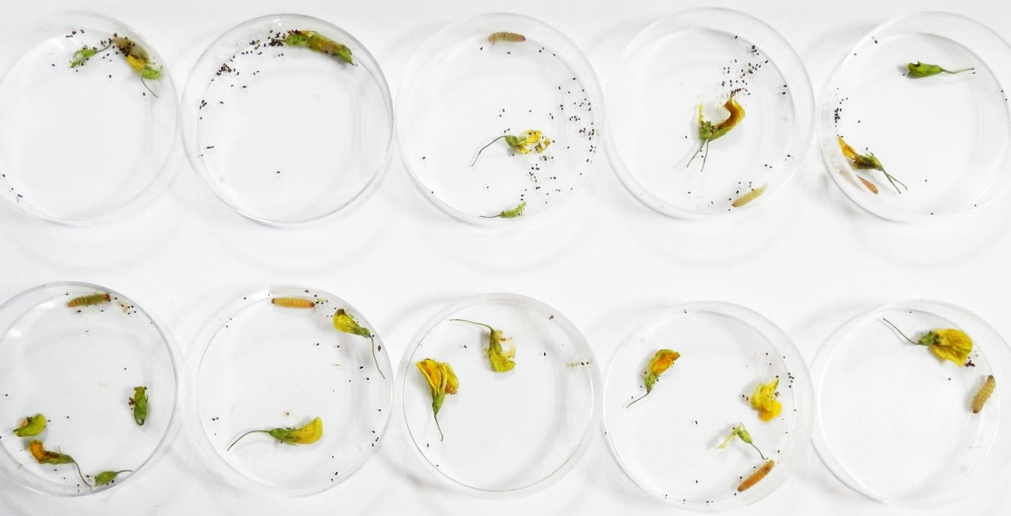
ds-α-amylase injected
Nfw-injected
Fig. 4 Comparative representative picture of observed feeding differences between nfw and gene specific dsRNA injected larvae (α-Amylase)

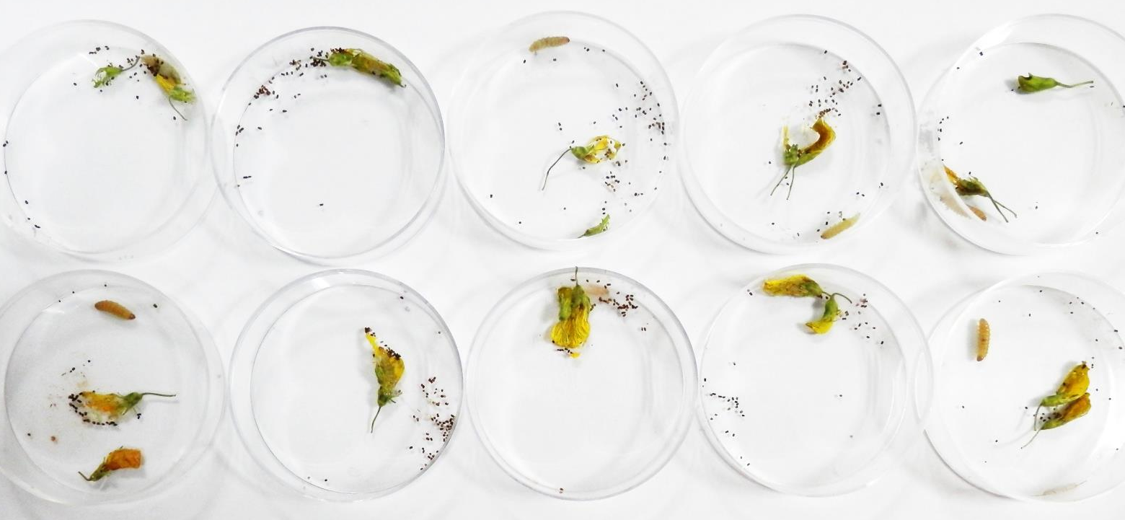
ds-CTLP injected
Nfw-injected
Fig. 5 Comparative representative picture of observed feeding differences between nfw and gene specific dsRNA injected larvae (CTLP)
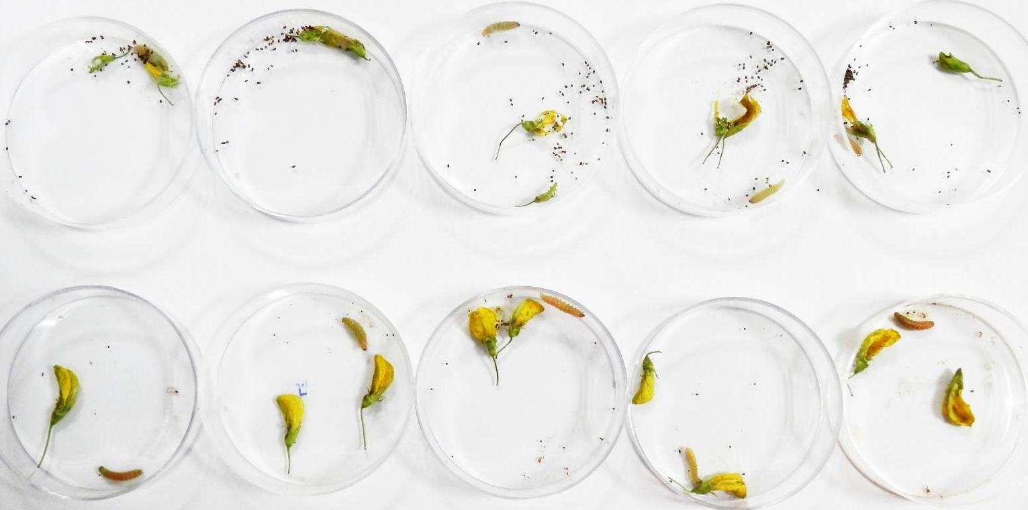
ds-TPM injected
Nfw-injected
Fig. 6 Comparative representative picture of observed feeding differences between nfw and gene specific dsRNA injected larvae (TPM)

