Table S1 Previous studies of Cs₂PtI₆ solar cell
Device | Study Type | Jsc (mA/cm²) | Voc (V) | FF % | PCE% | Ref.
FTO/CdS/Cs₂PtI₆/Spiro-OMeTAD /C | Experimental | 20.2 | 1.2 | 41 | 10.06 | [1]
FTO/WS₂/Cs2PtI6/Cu₂O/C | Numerical | 28.15 | 1.3 | 61 | 22.4 | [2]
FTO/TiO₂/Cs₂PtI₆/Cu₂O/Au | Numerical | 29.62 | 0.98 | 83.9 | 24.49 | [3]
FTO∕ZnO∕Cs₂PtI₆∕MoO₃∕C | Numerical | 16.1 | 1.4 | 90 | 20.45 | [4]
FTO/SnO₂/Cs₂PtI₆/MoO₃/C | Numerical | 26.95 | 1.11 | 78 | 23.5 | [5]
FTO/SnS₂/Cs₂PtI₆/MoTe₂/Au | Numerical | 33.19 | 1.11 | 90 | 32.98 | [6]
FTO/ZnO/Cs₂PtI₆/CuInS₂-QD/Au | Numerical | 32.9 | 1.2 | 82 | 32.7 | [7]

Table S2 Material properties of FTO, CdS and Cs₂PtI₆
Material | FTO (500 nm)  [8] | Front IDL (5 nm) | CdS[9] | Cs₂PtI₆ (200- 800 nm)  [1]
Electron affinity (eV), χ | 4 | 4 | 4.2 | 4
Relative permittivity, ɛ | 9 | 16.72 | 10 | 16.72
E_{g} (eV) band gap | 3.5 | 1.4 | 2.4 | 1.4
Electron mobility (cm²v⁻¹s⁻¹), µ_{e} | 20 | 310 | 100 | 310
Hole mobility (cm²v⁻¹s⁻¹), µ_{h} | 10 | 62 | 25 | 62
Donor density (cm⁻³), N_{D} | 1X10¹⁸ | 0 | 1X10¹⁸ | 0
Acceptor density (cm⁻³), N_{A} | 0 | 10¹⁵ | - | 10¹⁵
Effective conduction band density (cm⁻³), N_{c} | 2.2X10¹⁸ | 2.2X10¹⁸ | 2.2X10¹⁸ | 2.2X10¹⁸
Effective valence band density (cm⁻³), N_{v} | 1.8X10¹⁹ | 1.8X10¹⁹ | 1.8X10¹⁹ | 1.8X10¹⁹
Defect density (cm⁻³), N_{t} | 1X10¹⁵ | 2.5X10¹² | 1X10¹⁹ | 2.5X10¹²

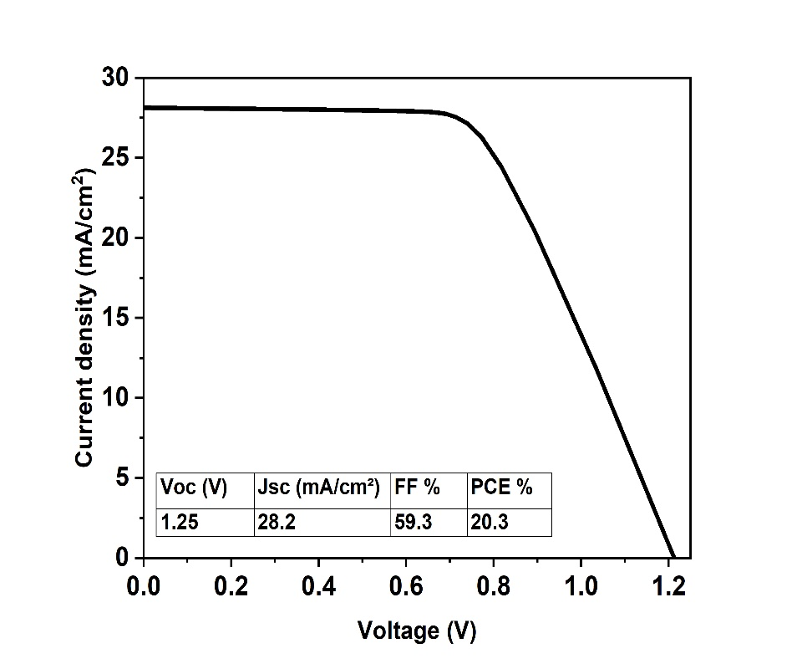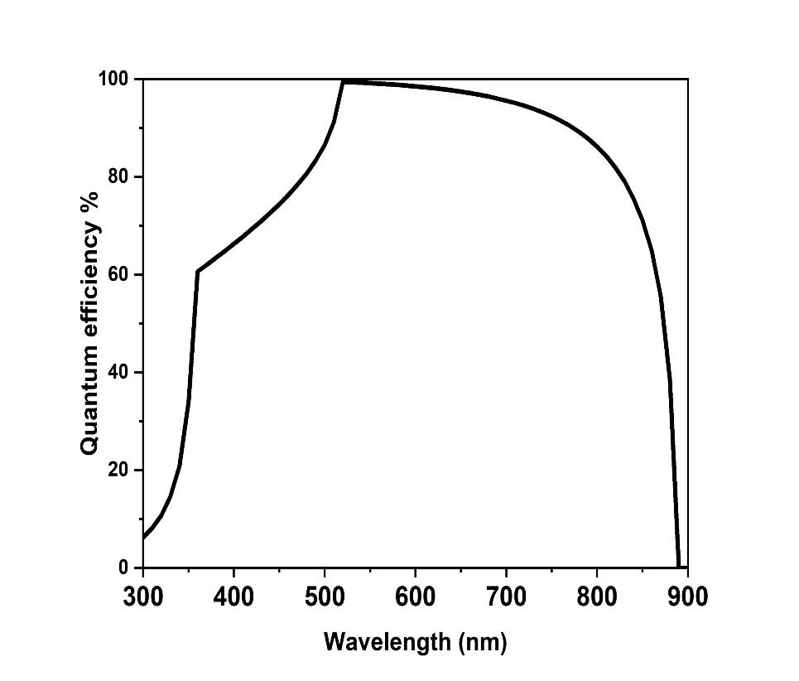
(a)
(b)
Figure S1 The numerical simulation of the optimized (FTO/CdS/Cs2PtI6/Pt) (a) J-V, (b) QE

References
[1] D. Schwartz et al., “Air Stable, High-Efficiency, Pt-Based Halide Perovskite Solar Cells with Long Carrier Lifetimes,” Phys. Status Solidi - Rapid Res. Lett., vol. 14, no. 8, pp. 1–8, 2020, doi: 10.1002/pssr.202000182.
[2] H. H. AbdElAziz, M. Taha, W. M. A. El Rouby, M. H. Khedr, and L. Saad, “Evaluating the performance of Cs2PtI6−xBrx for photovoltaic and photocatalytic applications using first-principles study and SCAPS-1D simulation,” Heliyon, vol. 8, no. 10, p. e10808, 2022, doi: 10.1016/j.heliyon.2022.e10808.
[3] F. Sultana, F. Jannat, S. Ahmed, and M. A. Alim, “A comparative numerical approach between lead-free inorganic Cs2TiBr6 and Cs2PtI6-based perovskite solar cells,” Results Opt., vol. 13, no. May, p. 100567, 2023, doi: 10.1016/j.rio.2023.100567.
[4] M. S. Shamna and K. S. Sudheer, “Device modeling of Cs2PtI6-based perovskite solar cell with diverse transport materials and contact metal electrodes: a comprehensive simulation study using solar cell capacitance simulator,” J. Photonics Energy, vol. 12, no. 3, 2022, doi: 10.1117/1.jpe.12.032211.
[5] A. Amjad, S. Qamar, C. Zhao, K. Fatima, M. Sultan, and Z. Akhter, “Numerical simulation of lead-free vacancy ordered Cs2PtI6 based perovskite solar cell using SCAPS-1D,” RSC Adv., vol. 13, no. 33, pp. 23211–23222, 2023, doi: 10.1039/d3ra04176j.
[6] M. K. Hossain et al., “An extensive study on charge transport layers to design and optimization of high-efficiency lead-free Cs2PtI6-based double-perovskite solar cells: A numerical simulation approach,” Results Phys., vol. 61, no. December 2023, p. 107751, 2024, doi: 10.1016/j.rinp.2024.107751.
[7] M. Al Razy et al., “Performance prediction of perovskite solar cell integrated with lead-free cesium platinum Iodide (Cs2PtI6) absorber and CuInS2 quantum Dot as HTL,” Micro and Nanostructures, vol. 185, no. November 2023, p. 207727, 2024, doi: 10.1016/j.micrna.2023.207727.
[8] S. Abdullahi et al., “Optical Characterization of Fluorine doped Tin Oxide (FTO) thin films deposited by spray pyrolysis technique and annealed under Nitrogen atmosphere,” Int. J. Innov. Appl. Stud., vol. 9, no. 2, pp. 947–955, 2014.
[9] L. I. Nykyruy, R. S. Yavorskyi, Z. R. Zapukhlyak, G. Wisz, and P. Potera, “Evaluation of CdS/CdTe thin film solar cells: SCAPS thickness simulation and analysis of optical properties,” Opt. Mater. (Amst)., vol. 92, no. December 2018, pp. 319–329, 2019, doi: 10.1016/j.optmat.2019.04.029.

