Positive selection affects the human ADLH2 gene expression: genetic adaptation to alcohol consumption

Helmut Schaschl*^{,1}, Tobias Goellner¹, David L Morris²

Affiliations
¹Department of Evolutionary Anthropology, University of Vienna, Djerassiplatz 1, 1030 Vienna, Austria
²Department of Medical and Molecular Genetics, Faculty of Life Sciences & Medicine, King's College London School of Medicine, Great Maze Pond, London SE1 9RT, United Kingdom

Corresponding author
*Helmut Schaschl, Email: helmut.schaschl@univie.ac.at

Supplementary Figure 1
Supplementary Table 1
Supplementary Table 7
Supplementary Table 8

Supplementary Figure S1. EHH plots of SNPs (chr12q24.12) under positive selection in European populations (see Table 1) that function as eQTLs for the ALDH2 gene.
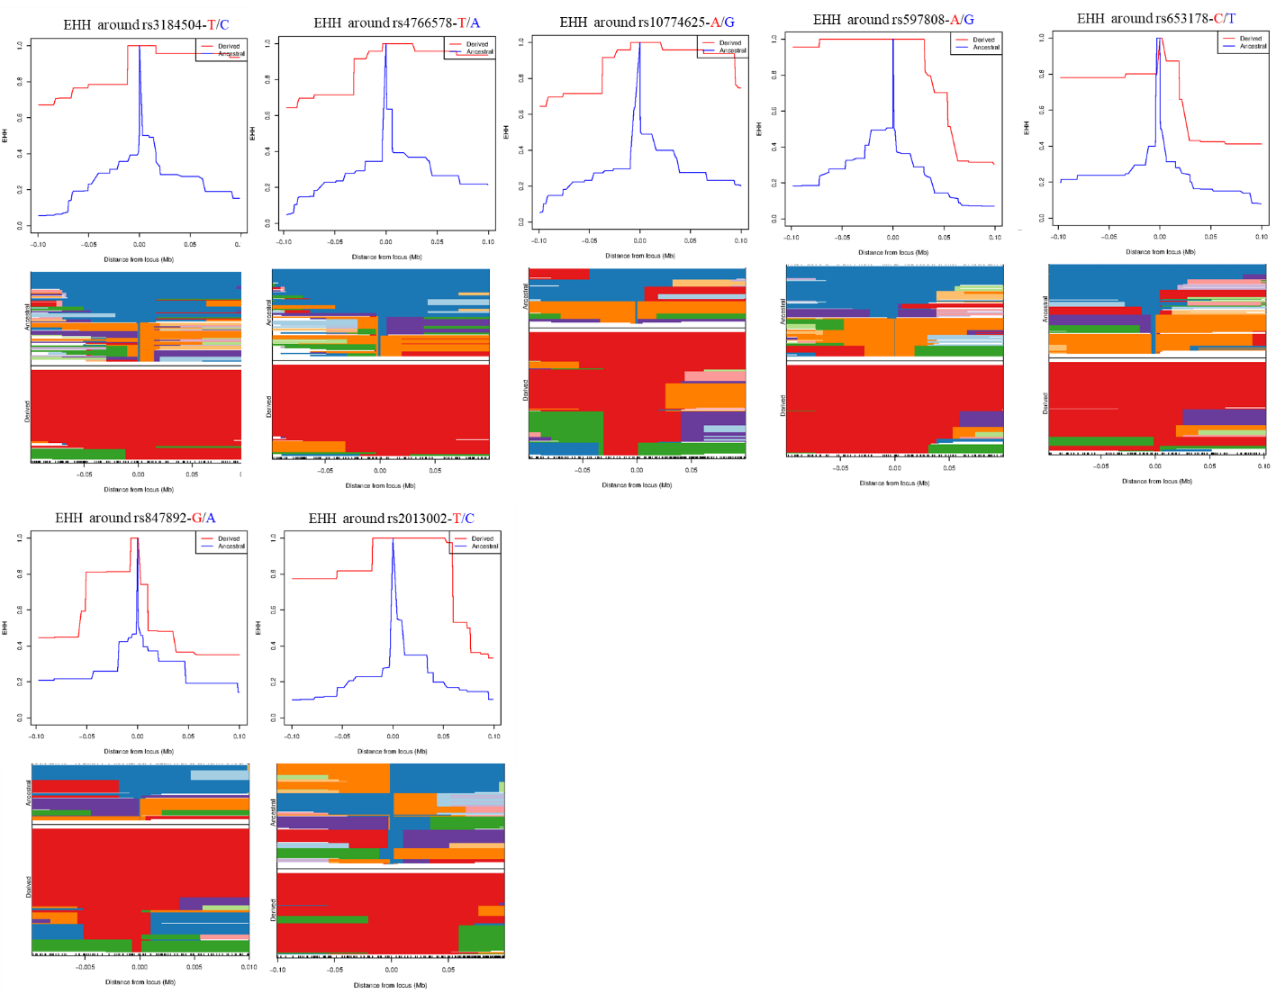

Supplementary Table S1. 1000 Genomes populations and genetic ancestries included in the study (ftp://ftp-trace.ncbi.nih.gov/1000genomes/ftp/release/20130502/).

Number of individuals | Population code | Population  description | Super population | Super population code
99 | LWK | Luhya in Webuye, Kenya | Africa | AFR
113 | GWD | Gambians from The Gambia | Africa | AFR
99 | ESN | Esan in Nigeria | Africa | AFR
91 | GBR | British in England and Scotland | Europe | EUR
99 | FIN | Finnish in Finland | Europe | EUR
107 | TSI | Toscani in Italia | Europe | EUR
86 | BEB | Bengali from Bangladesh | South Asian | SAS
102 | ITU | Indian Telugu from the UK | South Asian | SAS
96 | PJL | Punjabi from Lahore, Pakistan | South Asian | SAS
103 | CHB | Han Chinese in Beijing, China | East Asian | EAS
104 | JPT | Japanese in Tokyo, Japan | East Asian | EAS
99 | KHV | Kinhin Ho Chi Minh City, Vietnam | East Asian | EAS

Supplementary Table S7. Population pairwise F_{ST} values of the different ancestries for SNPs that are under positive selection in European populations in the human chromosomal region 12q24.12.
 | Pairwise F_{ST}
Positively selected SNP | Ancestry | AFR | EUR | SAS | EAS
rs3184504 | AFR | -
rs3184504 | EUR | 0.508 | -
rs3184504 | SAS | 0.070 | 0.363 | -
rs3184504 | EAS | 0.005 | 0.493 | 0.045 | -
rs4766578 | AFR | -
rs4766578 | EUR | 0.519 | -
rs4766578 | SAS | 0.070 | 0.375 | -
rs4766578 | EAS | 0.005 | 0.504 | 0.045 | -
rs10774625 | AFR | -
rs10774625 | EUR | 0.519 | -
rs10774625 | SAS | 0.070 | 0.375 | -
rs10774625 | EAS | 0.005 | 0.504 | 0.045 | -
rs597808 | AFR | -
rs597808 | EUR | 0.503 | -
rs597808 | SAS | 0.075 | 0.347 | -
rs597808 | EAS | 0.005 | 0.487 | 0.050 | -
rs847892 | AFR | -
rs847892 | EUR | 0.691 | -
rs847892 | SAS | 0.307 | 0.253 | -
rs847892 | EAS | 0.030 | 0.623 | 0.212 | -
rs4766897 | AFR | -
rs4766897 | EUR | 0.403 | -
rs4766897 | SAS | 0.026 | 0.326 | -
rs4766897 | EAS | - | 0.408 | 0.0268 | -
rs2013002 | AFR | -
rs2013002 | EUR | 0.447 | -
rs2013002 | SAS | 0.057 | 0.318 | -
rs2013002 | EAS | 0.005 | 0.431 | 0.033 | -

Supplementary Table S8. Estimated timing (t) of positive selection on the derived beneficial allele in thousand years ago (kya) and 95% credible interval (CI) (rounded to one decimal figure) in different populations of European ancestry.
Chr | Beneficial allele/ ancestral allele | Location | GBR |  | TSI |  | FIN
Chr | Beneficial allele/ ancestral allele | Location | t (kya) | 95% CI | t (kya) | 95% CI | t (kya) | 95% CI
12q24.12 | rs3184504-T/C | Exon, SH2B3 | 3.7 | 3.2–4.3 | 3.3 | 2.9–3.8 | 3.5 | 3.1–4.0
12q24.12 | rs4766578-T/A | Intron, ATXN2 | 3.5 | 3.0–4.0 | 4.5 | 3.6–5.2 | 4.6 | 4.0–5.1
12q24.12 | rs10774625-A/G | Intron, ATXN2 | 3.0 | 2.7–3.4 | 4.3 | 3.8–5.0 | 4.1 | 3.5–4.7
12q24.12 | rs597808-A/G | Intron, ATXN2 | 3.5 | 3.0–4.1 | 4.2 | 3.7–4.8 | 3.8 | 3.2–4.3
12q24.12 | rs653178-C/T | Intron, ATXN2 | 3.1 | 2.6–3.7 | 3.8 | 3.3–4.2 | 3.4 | 2.9–3.9
12q24.12 | rs847892-G/A | Intron, ACAD10 | 6.0 | 5.1–7.0 | 6.1 | 5.3–7.0 | 8.3 | 6.7–9.8
12q24.12 | rs2013002-T/C | Intron, ENST 00000546840.3 | 3.1 | 2.8–3.6 | 3.8 | 3.3–4.3 | 4.1 | 3.6–4.6

