Supplementary Information
Metal cofactor-level chassis engineering enables aerobic expression of tungsten formate dehydrogenases in Escherichia coli
Uyen Thu Phan^{1,†}, Jun-Min Lee^{2,†}, Toan Minh Vo¹, Min-Kyu Oh^{2,}*,Yong Hwan Kim^{1,3,}*
¹ School of Energy and Chemical Engineering, Ulsan National Institute of Science and Technology, Ulsan 44919, Republic of Korea
² Department of Chemical & Biological Engineering, Korea University, Seoul 136-763, Korea
³ Graduate of Carbon Neutrality, Ulsan National Institute of Science and Technology, Ulsan 44919, Republic of Korea
† These authors contributed equally to this work.
* Correspondence:
Min-Kyu Oh
E-mail: mkoh@korea.ac.kr
Tel: +82-2-3290-3308
Yong Hwan Kim
E-mail: metalkim@unist.ac.kr
Tel: +82-52-217-3068
This PDF file includes:
Tables S1 – S3
Figures S1 – S7

Table S1. Previously characterized genetic requirements for MeFDH1 maturation in Methylorubrum extorquens AM1.
Deletion analyses were performed as part of prior characterization of MeFDH1 maturation in M. extorquens AM1 and are summarized here to define the native W-bis-MGD maturation module.

Gene | Locus tag / UniProt ID | Functional outcome | Interpretation
moeA1 | MexAM1_META1p3050 / C5AVW2 | MeFDH1 activity abolished | Required for MeFDH1 maturation
moeA2 | MexAM1_META2p0368 / C5B450 | MeFDH1 activity retained | Not required
moeA3 | MexAM1_META1p3048 / C5AVW0 | MeFDH1 activity retained | Not required
moeA4 | MexAM1_META1p5123 / C5AU28 | MeFDH1 activity retained | Not required
moeA5 | MexAM1_META1p3047 / C5AVV9 | MeFDH1 activity retained | Not required
mobA | MexAM1_META1p5015 / C5ATS0 | No viable deletion mutant obtained | Essential for bis-MGD biosynthesis
mobB | MexAM1_META1p3049 / C5AVW1 | MeFDH1 activity abolished | Required for MeFDH1 maturation
fdhD | MexAM1_META1p3475 / C5AYB3 | MeFDH1 activity abolished | Required for MeFDH1 maturation

Table S2. Metal incorporation and enzymatic activity of purified MeFDH1 under different tungstate and molybdate supplementation conditions.
Tungsten and molybdenum incorporation into purified MeFDH1 under tungstate-only (1 mM), mixed-metal (0.5 mM tungstate + 0.5 mM molybdate), and molybdate-only (1 mM) growth conditions. Metal contents were quantified by ICP–MS using the BL1 strain. Values represent mean ± s.d. (n = 3).

Culture metal conditions | Specific activity  (U mg⁻¹ enzyme) | Metal content (mol mol⁻¹ enzyme)
Culture metal conditions | Specific activity  (U mg⁻¹ enzyme) | Fe | W | Mo
W (1 mM) | 35 ± 3 | 3.89 ± 0.04 | 0.51 ± 0.02 | 0.04 ± 0.07
W (0.5 mM)  + Mo (0.5 mM) | 10 ± 7 | 2.65 ± 0.14 | 0.22 ± 0.15 | 0.05 ± 0.01
Mo (1 mM) | 0.8 ± 1 | 4.12 ± 0.09 | 0.07 ± 0.01 | 0.15 ± 0.08

Table S3. Heterologous genes used in this study.
Gene | Source organism | GenBank / UniProt ID | Length (aa) | Mass (kDa) | Putative function
fdh1A | Methylorubrum extorquens AM1 | MexAM1_META1p5032 / C5ATT7 | 989 | ~107 | Catalytic α subunit of tungsten-dependent formate dehydrogenase (MeFDH1)
fdh1B | M. extorquens AM1 | MexAM1_META1p5031 / C5ATT6 | 572 | ~62 | Electron-transfer β subunit containing multiple Fe–S clusters
moeA1 | M. extorquens AM1 | MexAM1_META1p3050 / C5AVW2 | 416 | ~44 | Tungsten-specific insertion factor required for W-bis-MGD biosynthesis
mobA | M. extorquens AM1 | MexAM1_META1p5015 / C5ATS0 | 199 | ~20 | Molybdopterin guanylyltransferase involved in bis-MGD formation
mobB | M. extorquens AM1 | MexAM1_META1p3049 / C5AVW1 | 178 | ~19 | Accessory protein supporting tungsten insertion and cofactor assembly
fdhD | M. extorquens AM1 | MexAM1_META1p3475 / C5AYB3 | 291 | ~31 | Sulfur-transfer chaperone required for FDH maturation
tupB | Sulfitobacter dubius | DSM109990_03773 / A0ABY3ZTD1 | 234 | ~25 | ABC transporter membrane permease (TMD)
tupC | S. dubius | DSM109990_03772 / A0ABY3ZQI9 | 236 | ~26 | ABC transporter ATP-binding protein (NBD)
tupA | S. dubius | DSM109990_03771 / A0ABY3ZRX9 | 270 | ~28 | Periplasmic tungstate-binding protein (substrate-binding component)
fdwA | Cupriavidus necator H16 | H16_B1700 / Q0K0I9 | 938 | ~102 | Catalytic α subunit of tungsten-dependent formate dehydrogenase (FdwAB)
fdwB | C. necator H16 | H16_B1701 / Q0K0I8 | 569 | ~62 | Electron-transfer β subunit of FdwAB
fdhA | Lutibaculum baratangense AMV1 | N177_0493 / V4RN39 | 930 | ~104 | Predicted tungsten-dependent FDH α subunit identified by Foldseek structural homology (LbFDH)
fdhB | L. baratangense AMV1 | N177_0494 / V4RUF5 | 601 | ~66 | Predicted β subunit of LbFDH

Figure S1. Pairwise interaction analysis of MoeA1, MobA, MobB, and FdhD using bacterial adenylate cyclase two-hybrid (BACTH) assay.
Quantitative β-galactosidase activities were measured in E. coli BTH101 co-expressing T25 and T18 fusion constructs of Methylorubrum extorquens AM1 proteins. Each panel shows interactions detected when the indicated protein was fused to one adenylate cyclase fragment and co-expressed with the corresponding partner proteins. Reporter activity is expressed in Miller units and presented as mean ± s.d. (n = 3). The leucine zipper (zip) construct was used as a negative control to define baseline background reporter activity. Elevated β-galactosidase activity indicates protein–protein interaction.
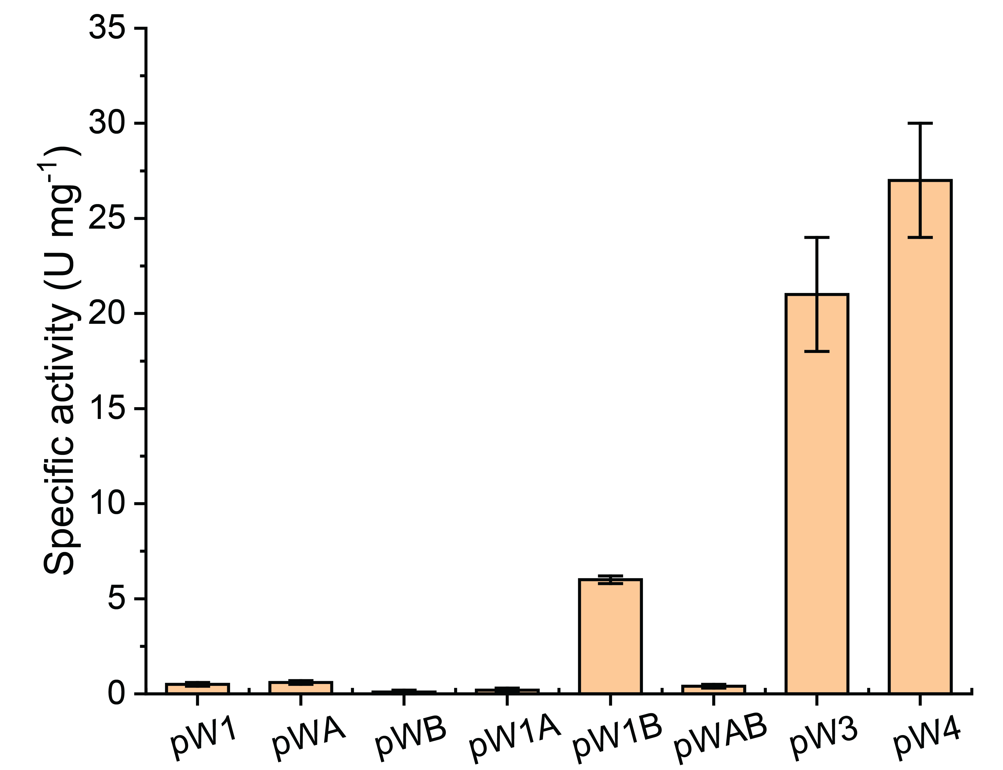

Figure S2. Specific activity of recombinant MeFDH1 expressed with different combinations of tungsten cofactor biosynthetic genes.
MeFDH1 was expressed in E. coli BL21(DE3) together with M. extorquens AM1 W-cofactor biosynthetic genes supplied on pCDFDuet-1–based plasmids: pW1 (moeA1), pWA (mobA), pWB (mobB), pW1A (moeA1–mobA), pW1B (moeA1–mobB), pWAB (mobA–mobB), pW3 (moeA1–mobA–mobB), and pW4 (moeA1–mobA–mobB–fdhD). Bars represent mean ± s.d. (n = 3).

`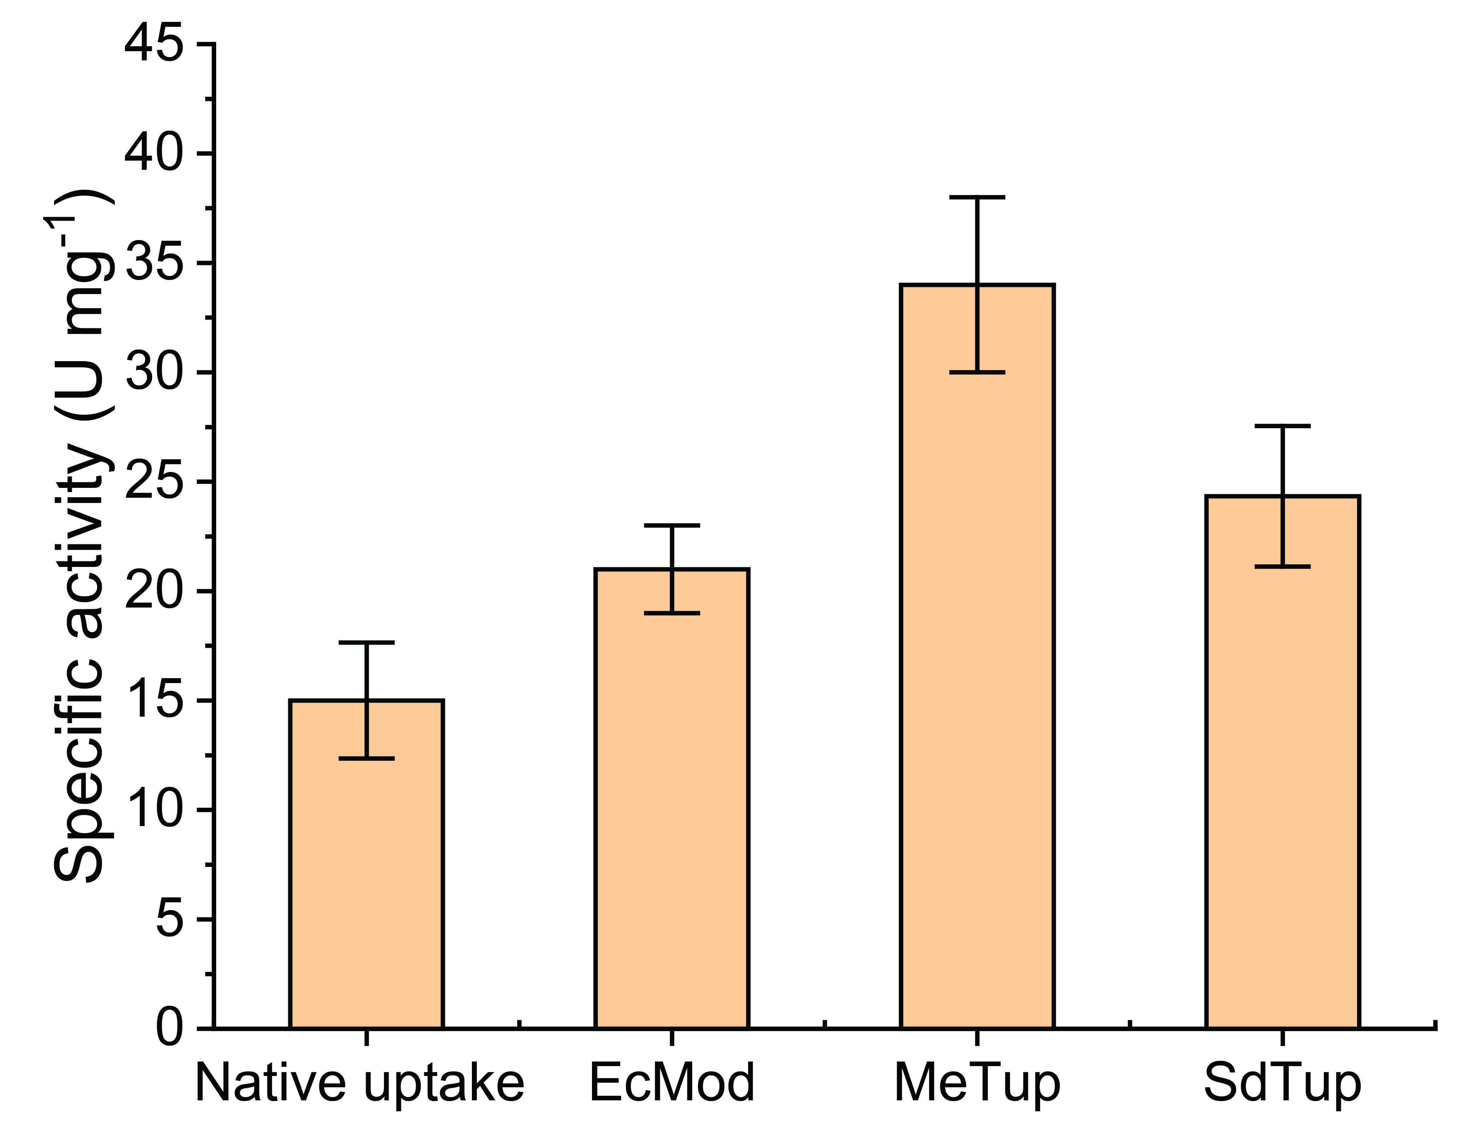

Figure S3. Effect of tungstate transport systems on MeFDH1 activity.
Recombinant MeFDH1 was expressed in E. coli BL21(DE3) together with the W-cofactor biosynthetic module (moeA1, mobA, mobB and fdhD) under native uptake (no heterologous tungstate transporter) or in the presence of alternative tungstate transport operons: modABC from E. coli K-12 (EcMod), tupBCA from Methylorubrum extorquens AM1 (MeTup), and tupBCA from Sulfitobacter dubius NA4 (SdTup). Bars represent mean ± s.d. (n = 3).

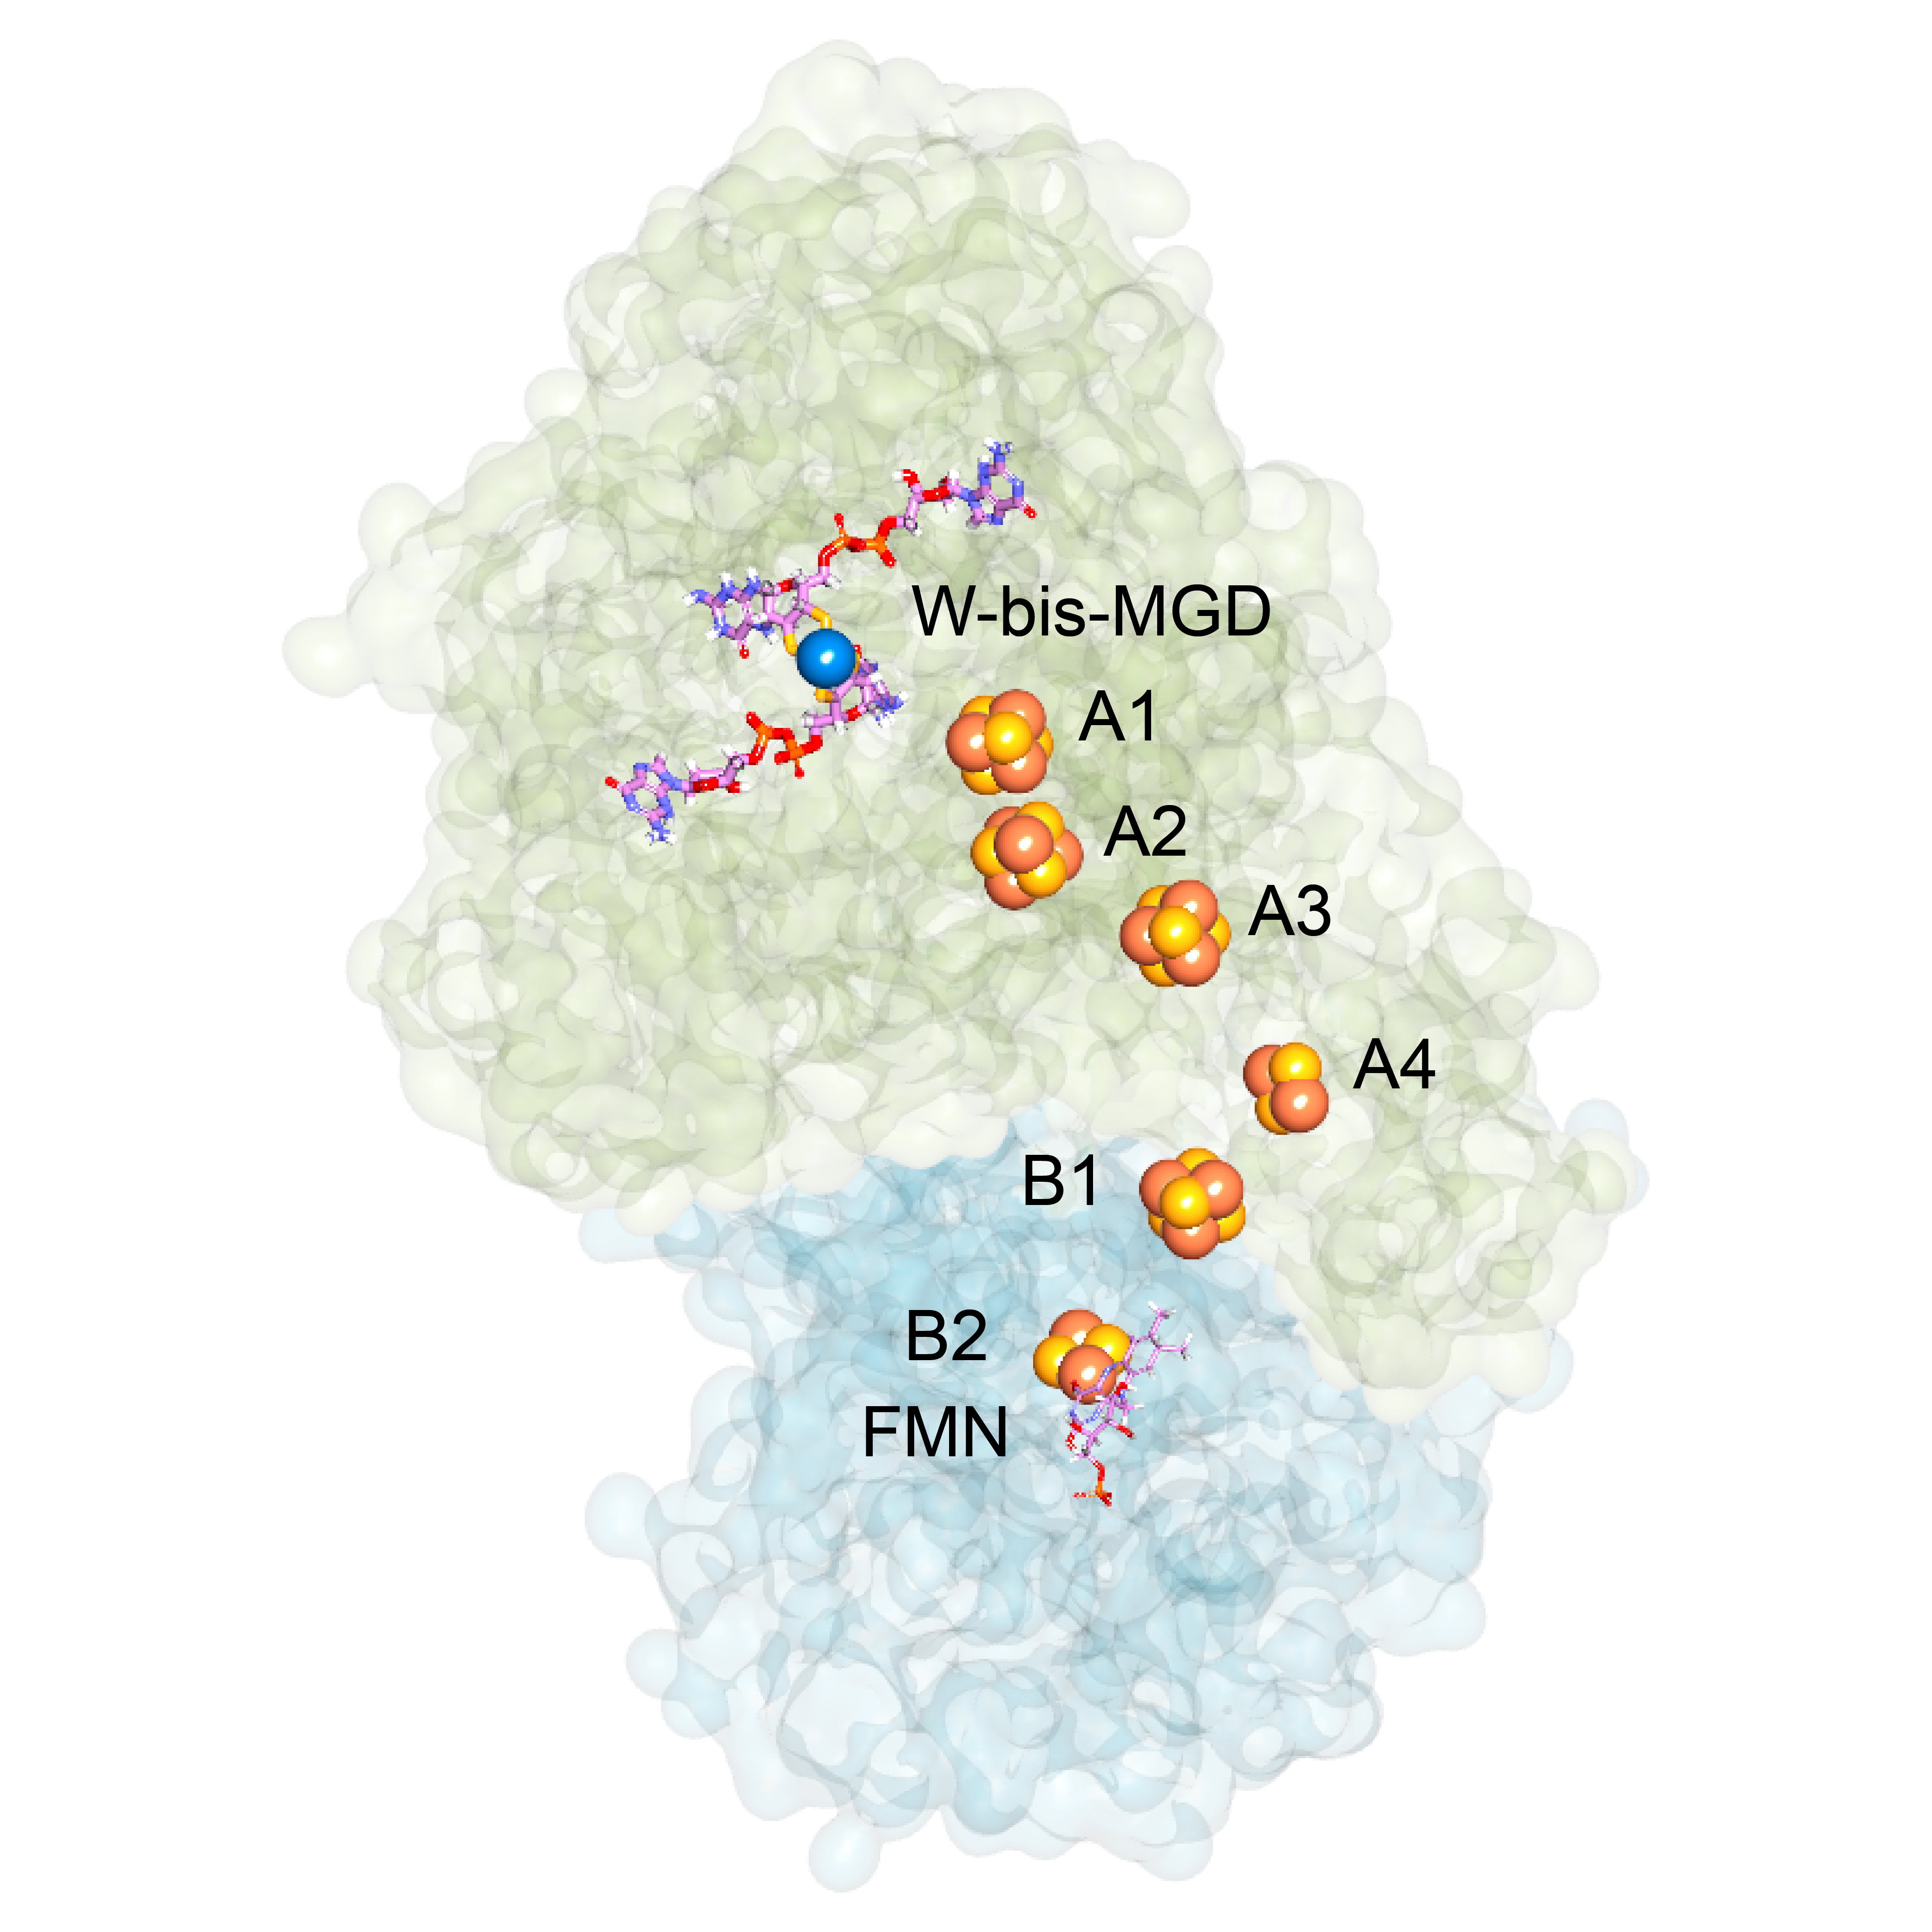

Figure S4. Distribution of Fe–S clusters within the α and β subunits of MeFDH1 (PDB 8J83).
Surface model of MeFDH1 showing the α-subunit (green) and β-subunit (blue), with all [4Fe–4S] clusters depicted as sphere models. The α-subunit contains three [4Fe–4S] clusters and one [2Fe–2S] cluster. The β-subunit houses an additional [4Fe–4S] and [2Fe–2S] cluster, completing the intramolecular relay. The tungsten–bis-MGD cofactor is shown at the catalytic center of the α-subunit, and the internal relay of Fe–S clusters trace a continuous electron-transfer pathway toward the β-subunit.

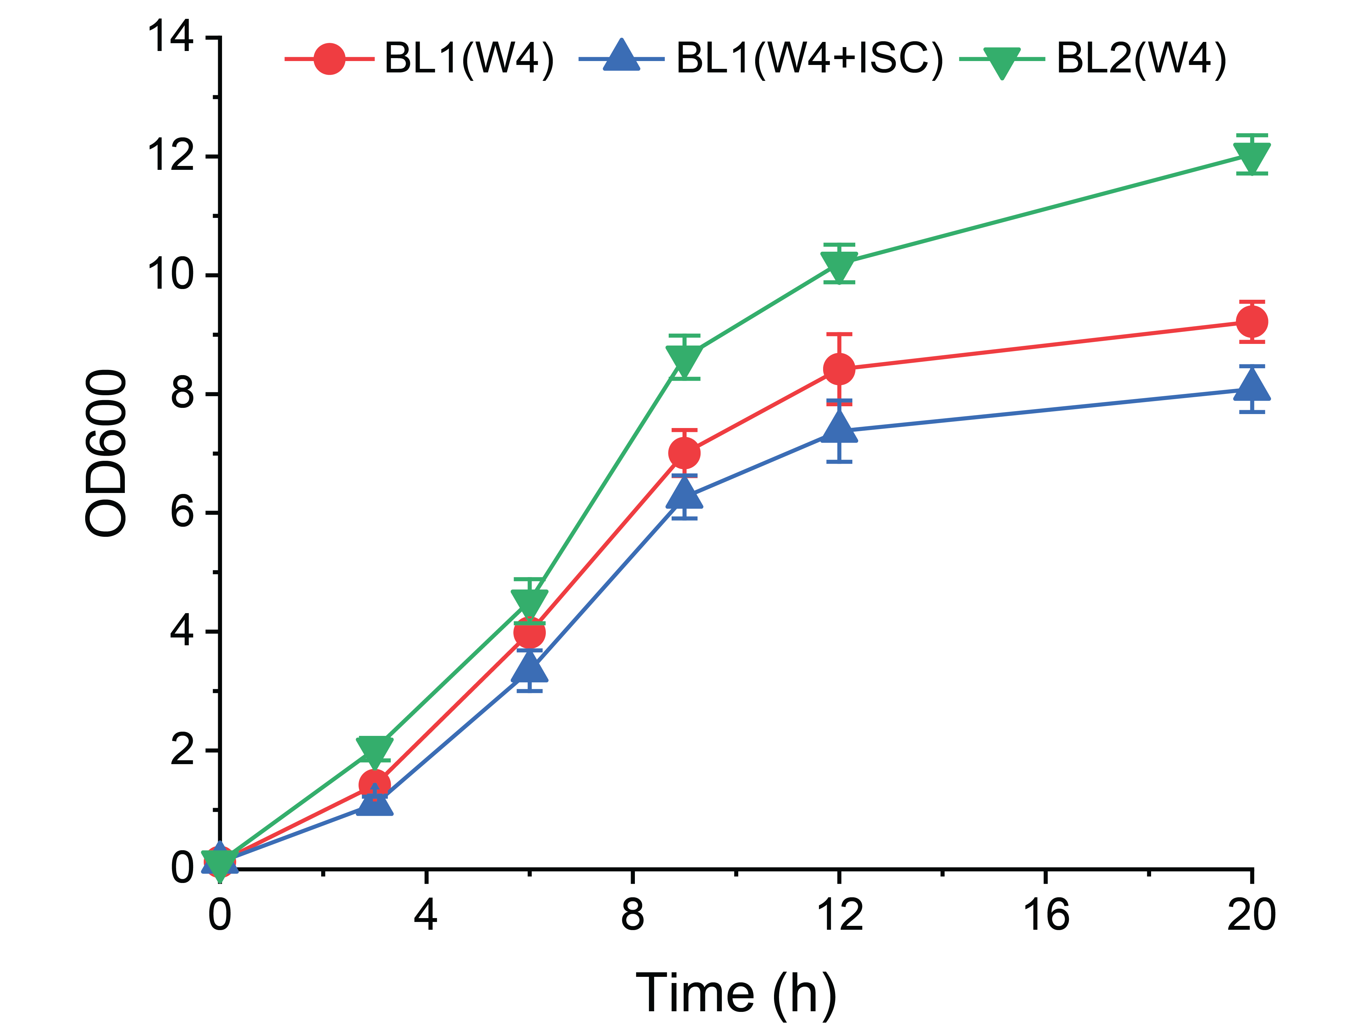

Figure S5. Growth profiles of engineered E. coli strains used for MeFDH1 production.
Cell growth of BL1(W4) (expressing moeA1, mobA, mobB and fdhD with a chromosomally integrated tupBCA), BL1(W4+ISC) (BL1 carrying a plasmid-borne isc operon, pRKISC), and BL2(W4) (BL1 with a chromosomally upregulated isc operon) was monitored by OD600 over time. Data represent mean ± s.d. (n = 3).

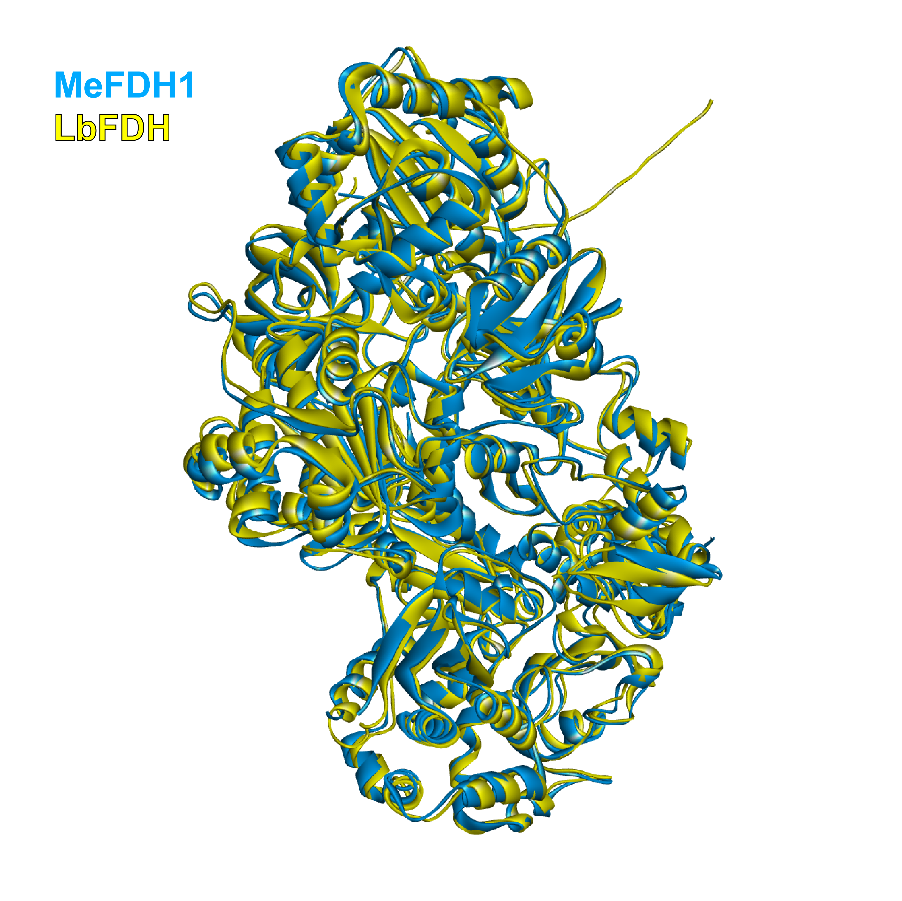

Figure S6. Structural comparison of MeFDH1 and a putative FDH from Lutibaculum baratangense AMV1 (LbFDH).
A putative tungsten-dependent formate dehydrogenase (LbFDH) was identified through Foldseek structural homology search. Predicted structural models of MeFDH1 (blue) and LbFDH (yellow) were aligned to assess overall fold conservation.

Figure S7. CO₂-reduction kinetics of MeFDH1 expressed in engineered E. coli BL2 (emerald) compared with the native enzyme from M. extorquens AM1 (navy).
a,b, Michaelis–Menten kinetics of CO₂ reduction by MeFDH1 purified from BL2 using dissolved CO₂ (a) or reduced ethyl viologen (EV•⁺; b) as the electron mediator.
c,d, Corresponding CO₂-reduction kinetics of MeFDH1 purified from the native AM1 host using dissolved CO₂ (c) or EV•⁺ (d). Data represent mean ± s.d.(n = 3).

