Supporting Online Material for:

DNA affinity driven chromatin dynamics determine Estrogen Receptor α transcriptional activity independent of RNA binding
Samuel Hunter, Halley R. Steiner, Christina L. Young, Cyna R. Shirazinejad, Erin N. Sanders, Phillip J. Elms, David T. McSwiggen, Robert T. Batey, Deborah S. Wuttke*

*Corresponding Author: deborah.wuttke@colorado.edu

Table of Contents:
Supplementary Movie 1: Single molecule tracking of ERα constructs in DMSO treated U2OS samples
Supplementary Movie 2: Single molecule tracking of ERα constructs in E2 treated U2OS samples
Extended Data 1: Expression and localization of mutant ERα constructs
Extended Data 2: Modeling of SMT residence time measurements for ERα mutants
Extended Data 3: Transcriptomic profiles of E2 response for all ERα mutant cell lines
Extended Data 4: Analysis of estrogen-response element transcriptional profiles for each ERα mutant
Supplementary Table 1: Binding affinities for each ERα mutant
Supplementary Table 2: Primer sequences used in ERα mutant construction
Supplementary Table 3: EC50 concentrations for ERα-E2 interactions
Source Data 1: Raw anisotropy values for all mutants
Source Data 2: Single molecule tracking data
Source Data 3: Residence imaging data
Source Data 4: Differential Analysis of PRO-seq datasets
Source Data 5: Raw signal intensities for Western blot
Supplementary Movie 1: Single molecule tracking of ERα constructs in DMSO treated U2OS samples. Cells are additionally stained with Hoechst (purple) and Potomac Red (orange) and the tracks overlayed. Detected ERα molecules are colored white and circled. Measured tracks are indicated by red lines

Supplementary Movie 2: Single molecule tracking of ERα constructs in E2 treated U2OS samples. Cells are additionally stained with Hoechst (false colored purple) and Potomac Red (false colored orange) and the tracks overlayed. Detected ERα molecules are colored white and circled. Measured tracks are indicated by red lines

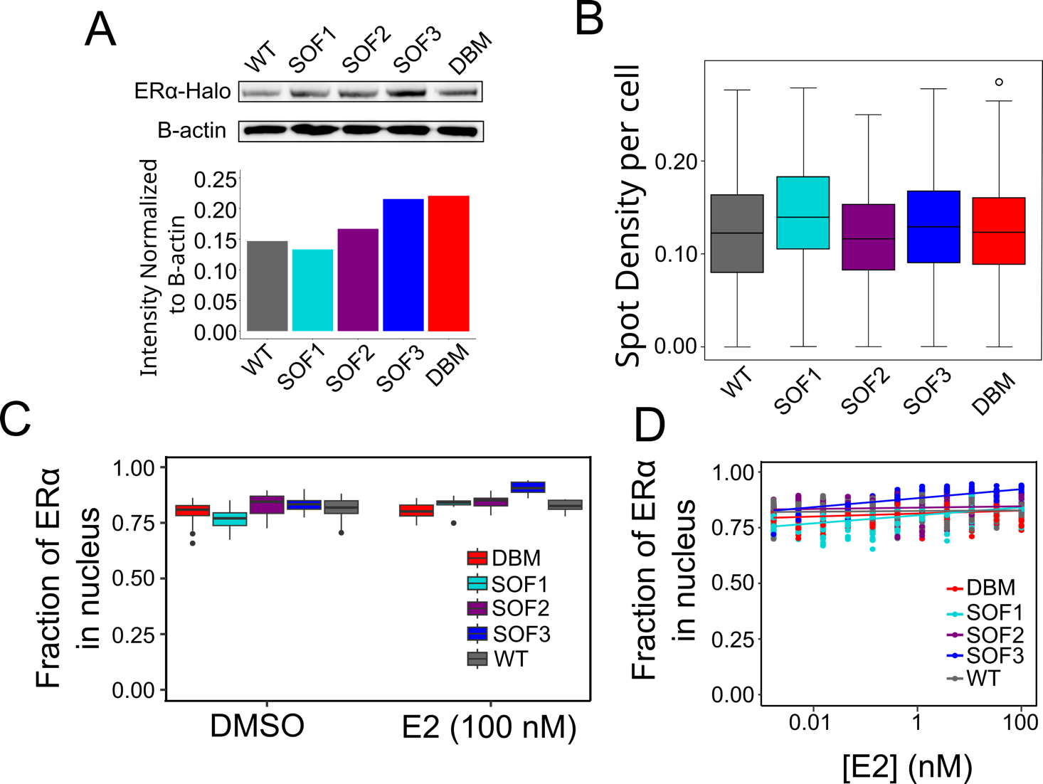
Extended Data 1: Expression and localization of mutant ERα constructs A Expression of ERα-HaloTag constructs in U2OS cells, indicated by Western blot. Barchart signal intensity normalized to B-actin intensity. B Density of ERα-HaloTag (spots/frame/μm²) as a measure of expression heterogeneity across cells. C Fraction of spots in nucleus versus cytoplasm D Fraction of spots in nucleus as a function of E2 concentration. ERα remains in the nucleus regardless of mutant status or treatment. Source Data 5

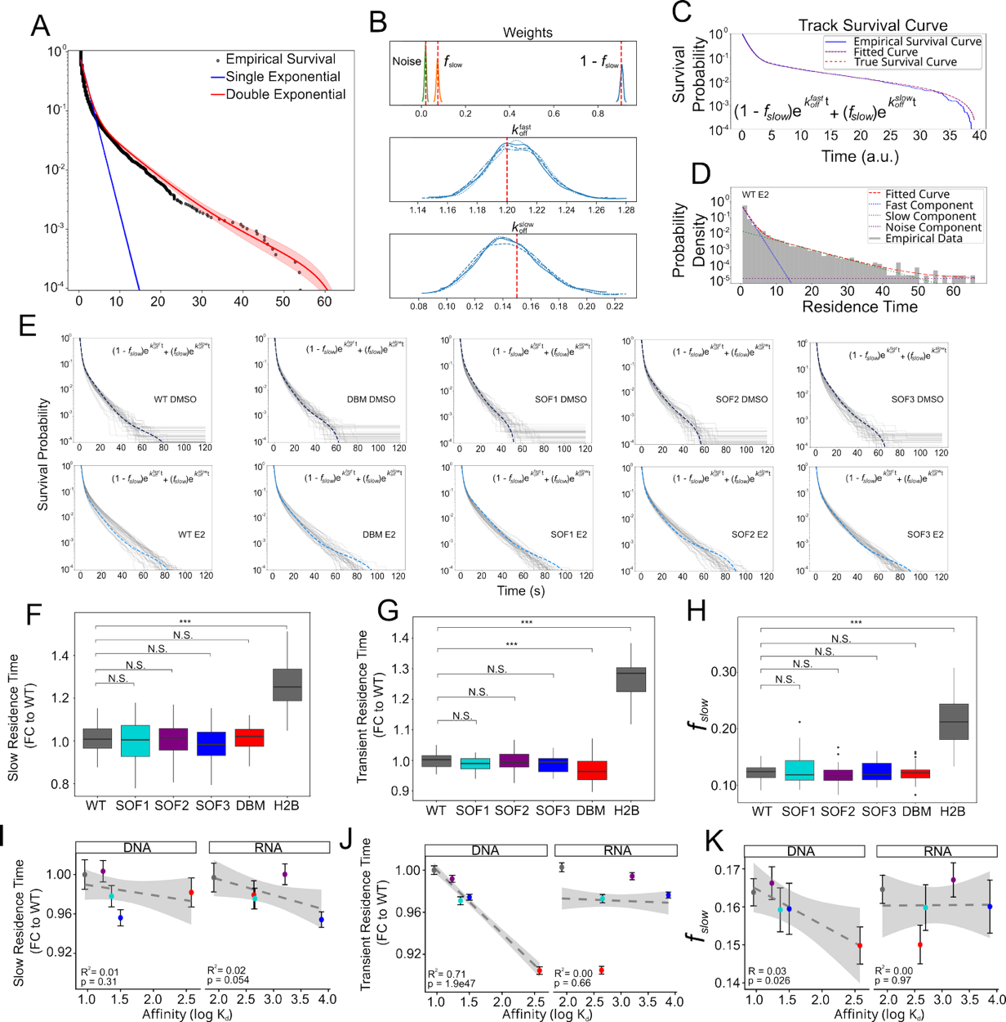
Extended Data 2: Modeling of residence data of ERα. A Selection of double exponential model. Comparison of posterior distributions of single and double exponential models indicates that the double exponential model shows vastly improved performance in predicting empirical data. B. Posterior traces for model weights (f_{slow}, 1-f_{slow}, and a uniform noise component) and rate parameters ($k_{off}^{fast}$and${ k}_{off}^{slow}$) are shown in each respective box. True values used to generate the simulated empirical data are indicated by the dotted line. C Model fits of simulated data. True values are indicated by red dotted line. Empirical simulated data is given by solid blue line. Fitted curve indicated by purple dotted line. D Probability density function (grey) of representative residence times (from E2-treated WT cells). Individual components of the double-exponential fit are indicated by the colored dotted lines (Blue: fast component. Green: slow component. Purple: uniform background noise). The summation of each component yields the double-exponential fit as indicated by the red dotted line. E Empirical survival curves for WT, DBM, SOF1, SOF2, and SOF3, in DMSO (Top) and E2 (bottom -treated conditions. A representative fit from a single survival curve in each set is indicated by the dotted line F, G, H Fitted values in DMSO treated samples for each mutant. An H2B-Halo control is included as a control to detect the longest measurable residence. ${ 1/k}_{off}^{slow}$ is indicated in F (reported as fold-change relative to WT), 1/ $k_{off}^{fast}$in G (reported as fold-change relative to WT), and f_{slow} in H (* = p < 0.05, *** = p < 0.001, Wilcoxon rank-sum test). I, J, K Linear regressions of each parameter relative to RNA and DNA affinity. DNA affinity is significantly correlated with ${1/k}_{off}^{fast}$, while RNA affinity is not significantly associated with any parameter. Error bars indicate standard error of the mean

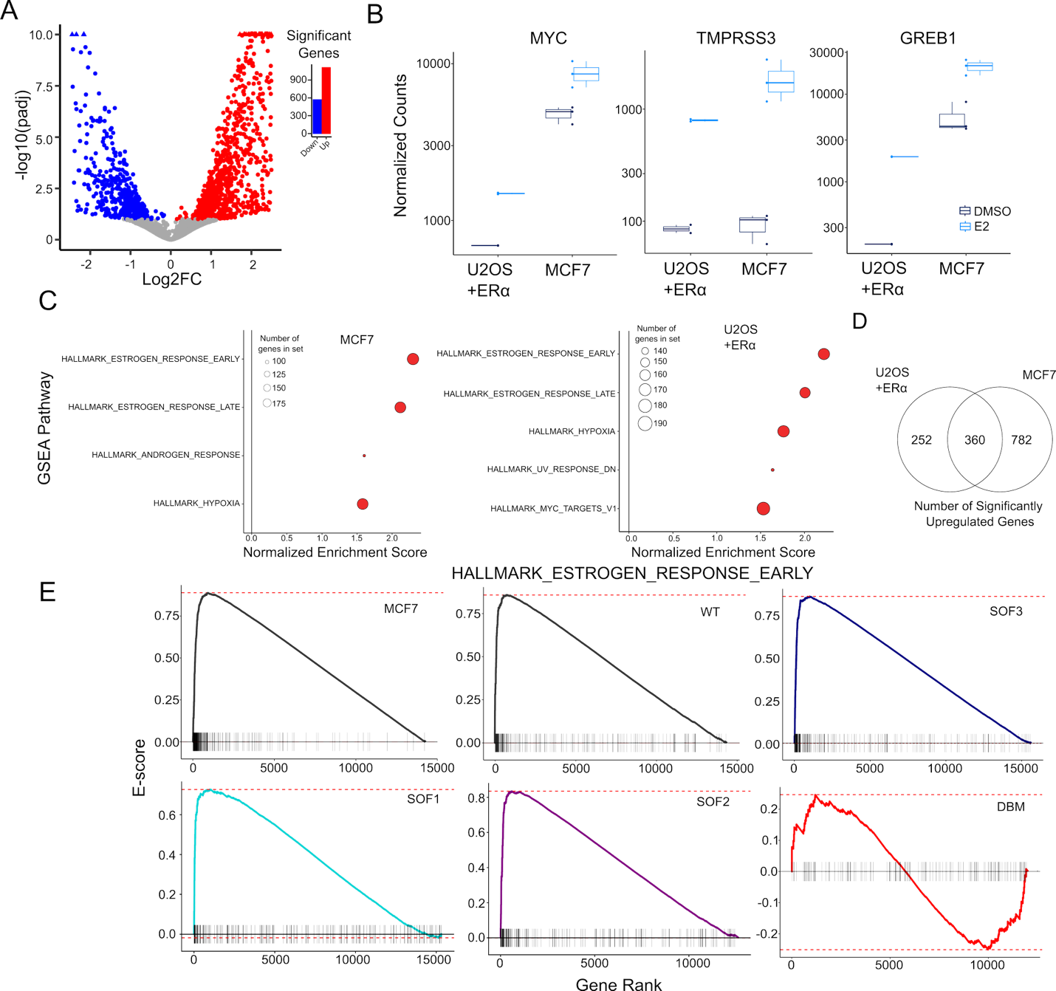
Extended Data 3 Transcriptomic profiles of E2 response. A Volcano plot of MCF7 cells treated with E2 from publicly available data (Danko et al, 2013). Significant genes are indicated in red (LFC > 0) or blue (LFC < 0) B Normalized counts of E2 responsive genes for U2OS expressing WT ERα (this study) and (MCF7) E2 response. C GSEA results of differential expression for MCF7 and U2OS cells. All mutants except for the DBM show similar upregulation of estrogen-related pathways to MCF7. D Venn diagram for the overlap of significant upregulated genes for U2OS expressing WT ERα, and MCF7 dataset from A. E Enrichment plots for one estrogen-response pathway. Maximum and minimum values are indicated by dotted line. Each tick on the x-axis indicates the location of a gene belonging to the gene set.

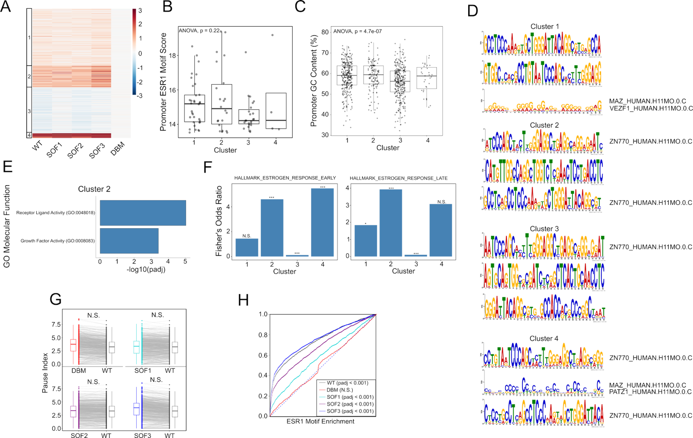
Extended Data 4: Transcriptional profiles of all mutants A Heatmap of each mutant, clustered as in Figure 4C. B Distribution of ESR1 motif scores overlapping with promoters of gene in each cluster. C Promoter GC content of each gene in each cluster from A. D Enrichment of sequence motifs in promoter of each cluster, and overlap with known motifs. E GO Terms enrichment for cluster 2. F Enrichment of genes in two estrogen response gene sets. (Left) Enrichment of each cluster from A for the Hallmark early estrogen response gene set (Right) Enrichment of each cluster from A for the Hallmark late estrogen response gene set. Enrichment given by Fisher’s odds ratio. Values greater than 1 indicate positive enrichment, values less than 1 indicate negative enrichment (N.S. = p > 0.05, * = p < 0.05, ** = p < 0.01, *** = p < 0.001, Fisher’s exact test) G Pause index measurements for each E2-responsive gene in the WT sample. Each grey line indicates the change between the mutant pause index and the WT pause index for each gene. (N.S. = Not significant, permutation test) H TFEA enrichment score for the ESR1 motif for all known bidirectional transcripts for each mutant. All mutants show activation of ESR1 enhancers, except for the DBM.

 | WT | SOF1 | SOF2 | SOF3 | DBM
DNA | 9.1$±$0.1 | 23$±$1 | 17$±$1 | 32$±$3 | 380$±$20
RNA | 81$±$3 | 460$±$30 | 1600$±$200 | >10000 | 440$±$40
FC to DNA | 1.0 | 2.6$±$0.1 | 1.9$±$0.1 | 3.5$±$0.3 | 48$±$4
FC to RNA | 1.0 | 5.6$±$0.4 | 20$±$3 | >100 | 2.1$±$0.5
Supplementary Table 1: Binding affinities (+/- S.E.) for each ERα construct. Fold-changes (FC) relative to WT are shown in the bottom two rows.

Primer name | Sequence | Construct created
RRGG_AAAA_Fwd | GCGGCGGCGGCGAGAATGTTGAAACACAAGCGC | SOF1
RRGG_AAAA_Rev | CGCCGCCGCCGCGTCTTTTCGTATCCCACCTTTCATC | SOF1
R256A_Fwd | GGGATAGCGAAAGACCGAAGAGGAGGGAGAATGTTGAAACACAAGCGCCAGAGAGATGAT | SOF2
R256A_Rev | TCGGTCTTTCGCTATCCCACCTTTCATCATTCCCACTTCGTAGCATTTACGGAGCCGGCA | SOF2
RG_Two_Fwd | GCGGCGGAATGACGAATTCGAGCTCCGT | SOF3; SOF1 as template
RG_Two_Rev | CGCCGCGCCCTCCCCATCATCTCTCT | SOF3; SOF1 as template
R234A_Fwd | GATAAAAACAGGGCGAAGAGCTGCCAGGCCTGCCGGCTCCGTAAATGCTACGAAGTGGGA | DBM
R234A_Rev | GCAGCTCTTCGCCCTGTTTTTATCAATGGTGCACTGGTTGGTGGCTGGACACATATAGTC | DBM
Supplementary Table 2: Primer sequences used in the construction of the mutants for biochemical assays
 | EC₅₀ | EC₉₀ | Y_{min} | Y_{max} | Hill Coefficient
WT | 0.216 | 1.37 | 0.103 | 0.829 | 1.19
SOF1 | 0.285 | 2.22 | 0.071 | 0.701 | 1.07
SOF2 | 0.249 | 1.47 | 0.096 | 0.751 | 1.24
SOF3 | 0.246 | 1.36 | 0.088 | 0.711 | 1.29
DBM | 0.273 | 1.40 | 0.0718 | 0.488 | 1.35
Supplementary Table 3: Parameters for fits of the dose response curve

