Supplementary table S1 Comparison of general clinical characteristics between patients with persistent HPV positivity and those who converted to negativity after cervical conization
 | Persistent HPV positivity | HPV turning negative | P value
Age |  |  | 0.715
＜40 years old | 47 | 177
≥40 years old | 21 | 88
Number of natural childbirths |  |  | 0.871
0 times | 37 | 142
1 times | 27 | 111
≥2 times | 4 | 12
Menopause |  |  | 0.27
deny | 61 | 248
yes | 7 | 17
Diabetes |  |  | 0.14
deny | 66 | 263
yes | 2 | 2
Hypertension |  |  | 0.539
deny | 64 | 254
yes | 4 | 11
Smoking |  |  | 0.378
deny | 68 | 262
yes | 0 | 3
Profession |  |  | 0.955
intellectual workers and students | 24 | 92
manual laborers | 3 | 14
retired and unemployed people | 27 | 111
other employees | 14 | 48
Educational background |  |  | 0.383
Junior high school education or below | 28 | 98
high school or technical secondary school diploma | 8 | 50
higher education and above | 32 | 117
Lymphocytes |  |  | 0.148
low | 2 | 17
normal | 59 | 201
high | 7 | 47
Leukocyte |  |  | 0.353
low | 1 | 15
normal | 65 | 242
high | 2 | 8

Supplementary table S2 Comparison of HPV types between patients with persistent HPV positivity and those who have cleared the virus.
 | Persistent HPV positivity | HPV turning negative | P value
Multiple infections |  |  | 0.672
deny | 52 | 196
yes | 16 | 69
Infection with HPV16 |  |  | 0.54
deny | 25 | 87
yes | 43 | 178
Infection with HPV18 |  |  | 0.327
deny | 60 | 221
yes | 8 | 44
Infection with HPV52 |  |  | 0.138
deny | 65 | 238
yes | 3 | 27
Other high-risk HPV infections |  |  | 0.118
deny | 41 | 186
yes | 27 | 79
Low-risk HPV infection |  |  | 0.407
deny | 67 | 256
yes | 1 | 9

Supplementary table S3 Comparison of SRSS scores between patients with persistent positive HPV and those who have turned negative
 | Median ± standard deviation | Cohen's d | P value
SRSS score of the persistently positive HPV group | 21.5±5.553 | 5.007 | ＜0.001
SRSS score of HPV negative group | 17±5.307 | 5.007 | ＜0.001

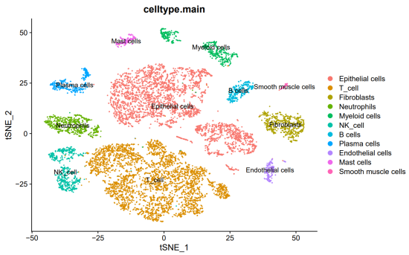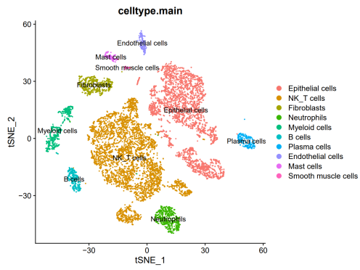
Supplementary Fig.S1 t-SNE plot showing cell types of cells captured by single-cell RNA sequencing (scRNA-seq),a.N_HPV;b.HSIL_HPV

Supplementary Fig.S2 Comparative analysis of immune cell communication in normal versus HSIL cervical tissues under HPV infection

