Supplementary Table 1
Six formulations of MSB5– and NNB5–based media, optimized for cowpea embryos, in both liquid (without agar) and solid (with agar) systems. The liquid system used four formulations (M1, M4, M5, and 1/2M5), while the solid system used six formulations (M1–M5 and 1/2M5)
 | Murashige & Skoog (MSB5) (Ramakrishnan et al., 2005) |  |  |  | Nitsch & Nitsch (NNB5)
 | M1 | M2 | M3 | M4 | M5 | 1/2M5
Basal salts strength | 1x MS | 1x MS | 1x MS | 1x MS | 1x NN | ½–strength NN
Vitamins | 1x Gamborg’s (B5) Vitamins | 1x B5 | 1x B5 | 1x B5 | 1x B5 | 1x B5
Sugars | 3% maltose | 3% trehalose | 3% sucrose | 3% sucrose | 2% sucrose | 4% sucrose
Others | 150 mg/L Casein hydrolysate, 100 mg/L L-glutamic acid, 20 mg/L Proline, 8 g/L Agar | 150 mg/L Casein hydrolysate, 100 mg/L L-glutamic acid, 20 mg/L Proline, 8 g/L Agar | 150 mg/L Casein hydrolysate, 100 mg/L L-glutamic acid, 20 mg/L Proline, 8g/L Agar | 150 mg/L Casein hydrolysate, 100 mg/L L-glutamic acid, 20 mg/L Proline,1.25 mg/L Polyvinylpyrrolidone (PVP), 8 g/L Agar | 0.05% (W/V) MES, 150 mg/L Casein hydrolysate, 100 mg/L L-glutamic acid, 20 mg/L Proline,1.25 mg/L PVP, 8 g/L Agar | 0.05% (W/V) MES, 500 mg/L Casein hydrolysate, 100 mg/L L-glutamic acid, 20 mg/L Proline,1.25 mg/L PVP, 8 g/L Agar

Supplementary Table 2
Embryo germination response of cowpea ovules (5–8 DAP) of three genotypes (IT97K–499–35, IT86D–1010 and Sasaque) cultured in four liquid MSB5– and NNB5–based media formulations under intact and perforated ovule treatments.
Medium base | Culture medium | Ovule culture treatment | No. of cultured ovules | Embryo growth rate (%)  Days after pollination (DAP)
 |  |  |  | 5 |  |  | 6 |  |  | 7 |  |  | 8
 |  |  |  | 97K | 86D | SAS | 97K | 86D | SAS | 97K | 86D | SAS | 97K | 86D | SAS
MSB5 | M1 | Intact | 30 | 0.0 | 0.0 | 0.0 | 0.0 | 3.3 | 0.0 | 0.0 | 3.3 | 0.0 | 0.0 | 0.0 | 0.0
MSB5 | M1 | Perforated | 30 | 0.0 | 0.0 | 0.0 | 0.0 | 0.0 | 0.0 | 3.3 | 3.3 | 0.0 | 0.0 | 0.0 | 0.0
MSB5 | M4 | Intact | 30 | 0.0 | 0.0 | 0.0 | 0.0 | 0.0 | 0.0 | 0.0 | 0.0 | 0.0 | 0.0 | 0.0 | 0.0
MSB5 | M4 | Perforated | 30 | 0.0 | 0.0 | 0.0 | 0.0 | 3.3 | 0.0 | 0.0 | 0.0 | 0.0 | 0.0 | 0.0 | 0.0
NNB5 | M5 | Intact | 30 | 0.0 | 3.3 | 3.3 | 0.0 | 3.3 | 0.0 | 0.0 | 0.0 | 3.3 | 0.0 | 0.0 | 3.3
NNB5 | M5 | Perforated | 30 | 0.0 | 0.0 | 0.0 | 0.0 | 0.0 | 0.0 | 0.0 | 3.3 | 3.3 | 0.0 | 0.0 | 6.7
NNB5 | 1/2M5 | Intact | 30 | 0.0 | 0.0 | 0.0 | 0.0 | 10.0 | 6.7 | 0.0 | 0.0 | 6.7 | 0.0 | 0.0 | 0.0
NNB5 | 1/2M5 | Perforated | 30 | 0.0 | 0.0 | 0.0 | 0.0 | 0.0 | 10.0 | 0.0 | 0.0 | 6.7 | 0.0 | 0.0 | 6.7
 | Stage of embryo development |  |  | Heart |  |  | Early torpedo |  |  | Late torpedo/early bent–cotyledon |  |  | Bent–cotyledon
MSB5: Murashige and Skoog basal salts with Gamborg’s B5 vitamins; NNB5: Nitsch & Nitsch basal salts with Gamborg’s B5 vitamins

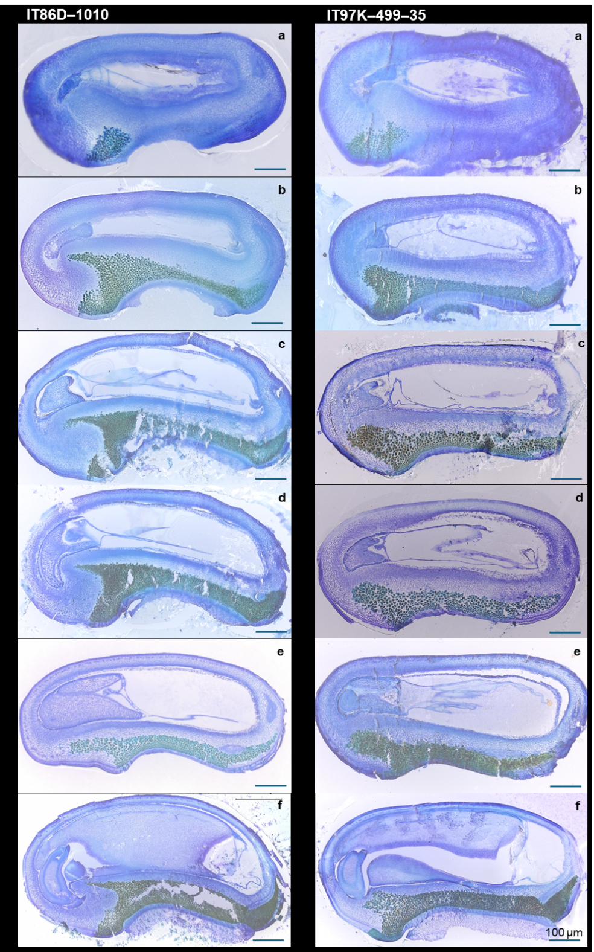
Supplemental Fig. 1
Cowpea ovule sections showing progressive embryo development from 2 to 7 days after pollination (DAP) in IT86D–1010 and IT97K–499–35. a: 16–cell embryo stage, 2 DAP; b: globular–stage embryo, 3 DAP; c: early–mid heart–stage embryo, 4 DAP; d: late heart–stage embryo, 5 DAP; e: early torpedo–stage embryo, 6 DAP; and f: late torpedo – early bent–cotyledon stage embryo, 7 DAP. Scale bars = 100 μm

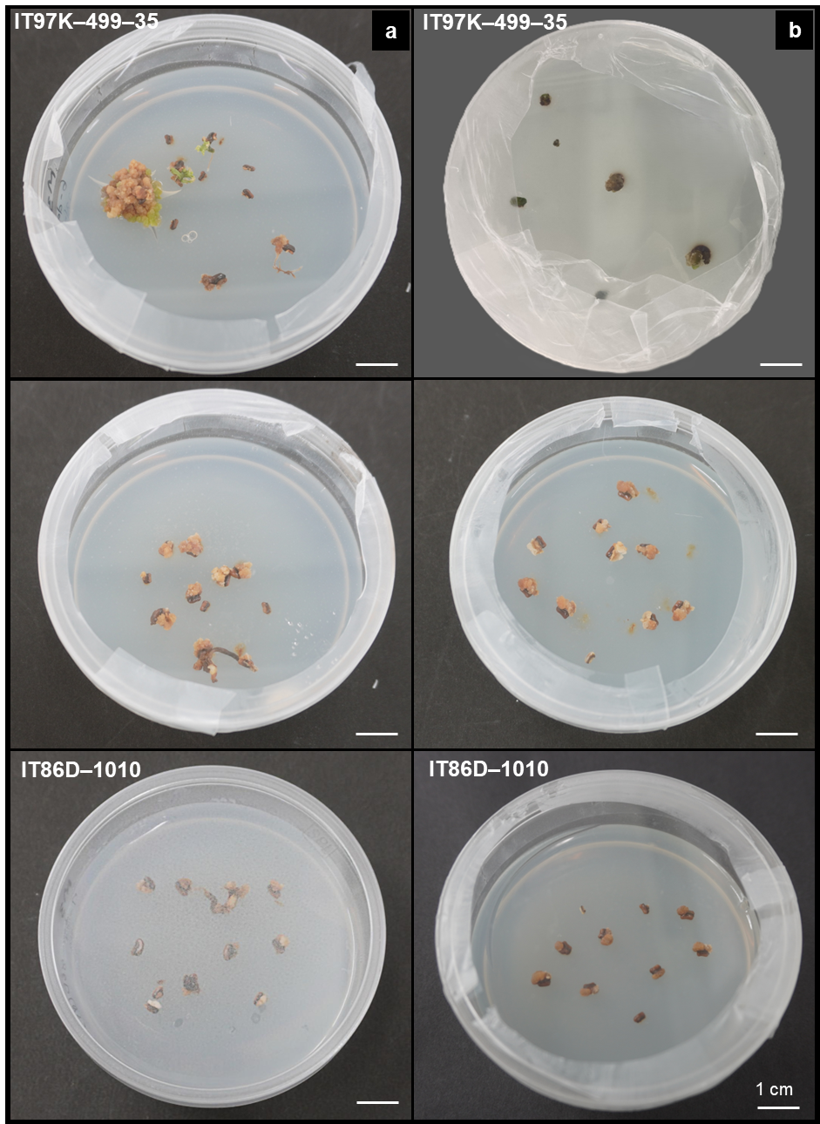
Supplemental Fig. 2
Callus formation from cultured ovules of cowpea genotypes IT97K–499–35 and IT86D–1010. a: Callus formation on hormone-free media across all basal formulations; b: Enhanced callus formation on medium supplemented with indole-3-acetic acid, kinetin, and 6-benzylaminopurine

