Supplementary File Structure
1. Title Page
Next-Generation Antimicrobials Against Multidrug-Resistant Infections in LMICs – Supplementary Material
Supplementary Material Summary:
The supplementary material provides detailed support for the main manuscript, including reproducible literature search strategies (Table S1), a PRISMA flow diagram (Figure S1), and summaries of included studies with LMIC relevance (Table S2). Comparative features, limitations, and One Health relevance are presented (Table S3), alongside knowledge gaps and research priorities (Table S4). A translational roadmap (Table S5) links clinical, veterinary, and environmental timelines with key research priorities and LMIC considerations. Mechanistic and combinatorial delivery approaches are illustrated in Figures S2–S4. Together, these materials enhance transparency, reproducibility, and practical applicability of next-generation antimicrobial strategies in LMIC contexts.
2. Table S1. Literature Search Strategy
Database | Search Terms | Date Range | Notes
PubMed | Exact string: ("antimicrobial resistance" OR "AMR") AND ("bacteriophage therapy" OR "phage") AND ("CRISPR" OR "CRISPR-Cas") AND ("engineered antimicrobial peptides" OR "AMPs") AND ("enzybiotics" OR "lysins") AND ("nanotechnology" OR "nanoparticles") | 2010–2025 | Full search string in Supplementary Table S1a; filters applied for English language, human/animal studies, and LMIC context
Scopus | See Supplementary Table S1b for exact string | 2010–2025 | Includes title/abstract/keywords search; LMIC filter applied
Web of Science | See Supplementary Table S1c for exact string | 2010–2025 | Topic search; duplicates excluded
Google Scholar | See Supplementary Table S1d for exact string | 2010–2025 | First 200 hits screened; manual LMIC relevance check
Note: Exact search strings for all databases are provided in Supplementary Tables S1a–S1d to ensure full reproducibility of the literature review.

3. PRISMA Flow Diagram
Figure S1. Literature screening and selection process
- Total records identified: 1,245 + 32 additional sources
- Duplicates removed: 287
- Titles/abstracts excluded: 765
- Full-texts assessed: 225
- Studies included: 68
(Insert simple flow diagram with boxes and arrows.)

4. Table S2. Summary of Included Studies
Modality | Study Type | Sample Size | Key Findings | LMIC Applicability | Reference
Bacteriophage Therapy | Preclinical | n = 30–50 | 70–90% bacterial load reduction; 60–80% biofilm reduction | Lyophilized phages, phage banks | [35–41]
CRISPR-Cas Antimicrobials | Preclinical/Human pilot | n = 5–15 | 80–95% in vitro bacterial killing; 40–60% early human response | Phage/nanoparticle delivery | [19–22,46–47]
Engineered AMPs | Preclinical/Phase I–II | n = 20–40 | 60–90% pathogen reduction; biofilm inhibition | Hydrogel/nanoparticle formulations | [49–51]
Enzybiotics | Preclinical/Localized trials | n = 10–25 | 80–95% bactericidal; 60–70% clinical resolution | Topical/hydrogel feasible | [24–25]
Nanotechnology Platforms | Preclinical | n = 15–30 | Targeted delivery; 65–90% bacterial reduction | Simplified hybrid systems | [52–54]

5. Table S3. Comparative Features
Strategy | Advantages | Limitations | One Health Relevance | LMIC Applicability
Bacteriophage Therapy | High specificity, biofilm clearance | Narrow host range, immune clearance | Human & veterinary; environmental AMR | Lyophilized phages, personalized cocktails
CRISPR-Cas | Precision targeting, restores susceptibility | Delivery, off-target effects | Humans, animals, environment | Phage-mediated vectors, nanoparticle delivery
Engineered AMPs | Broad-spectrum, rapid bactericidal | Protease degradation, limited systemic data | Humans, veterinary, food-animal AMR | Nanoparticle/hydrogel delivery
Enzybiotics | Rapid bactericidal, biofilm activity | Narrow spectrum, immunogenicity | Gram-positive infections, food/environment | Topical/hydrogel formulations
Nanotechnology Platforms | Targeted delivery, combinatorial therapy | Safety concerns, complex production | Human, animal, environment | Simplified hybrid systems, scalable

6. Table S4. Knowledge Gaps and Research Priorities
Modality | Knowledge Gaps | Research Priorities
Bacteriophage Therapy | Limited large RCTs; variable regulations | Multicenter trials; phage libraries; standardized manufacturing
CRISPR-Cas | Inefficient delivery; minimal human data | Early human trials; optimize vectors; monitor resistance
Engineered AMPs | Limited systemic data; stability issues | Phase II–III trials; combination therapies; stabilized formulations
Enzybiotics | Narrow spectrum; limited systemic data | Engineer Gram-negative activity; systemic trials
Nanotechnology | Limited clinical data; complex production | Safety evaluation; scalable combinatorial delivery

7. Table S5. Translational Roadmap for LMICs
Modality | Clinical Timeline | Veterinary Timeline | Environmental Timeline | Key Research Priorities | LMIC Considerations
Bacteriophage Therapy | Phase II–III (0–5 yrs) | Pilot livestock (0–5 yrs) | Wastewater AMR (5–10 yrs) | Phage libraries, RCTs | Local banks, lyophilized phages, QA training
CRISPR-Cas | Early human trials (0–5 yrs) | Livestock pathogens (5–10 yrs) | Environmental MDR gene reduction (5–10 yrs) | Delivery optimization | Phage/nanoparticle vectors; cost-effective
Engineered AMPs | Phase II–III systemic trials | Veterinary infection control | Food/environment biofilm control | Stabilized formulations | Nanoparticle/hydrogel delivery; low-cost options
Enzybiotics | Localized/topical trials | Gram-positive animal infections | Food/environmental contamination control | Broad-spectrum engineering | Lyophilized/hydrogel forms
Nanotechnology Platforms | Targeted delivery; Phase II safety/efficacy | Veterinary & environmental delivery | Multi-drug environmental decontamination | Smart/combinatorial nanoparticles | Simplified hybrid systems; scalable

8. Supplementary Figures
- Figure S1: PRISMA Flow Diagram
- Figure S2: Mechanistic overview of each modality
- Figure S3: Combinatorial delivery approaches for One Health applications
- Figure S4: Overall Evidence Quality of Next-Generation Antimicrobials
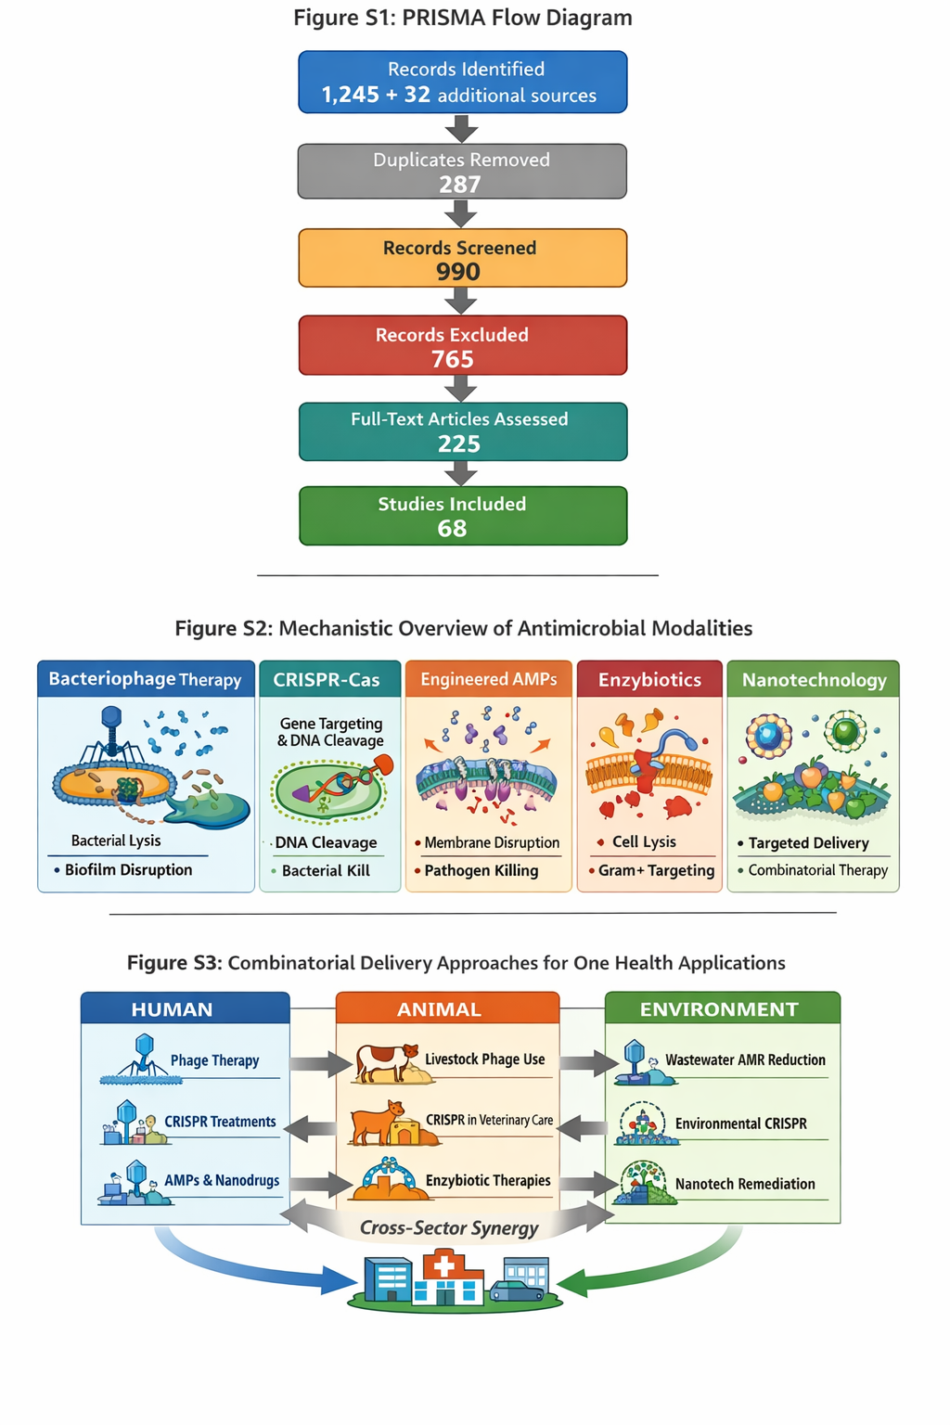

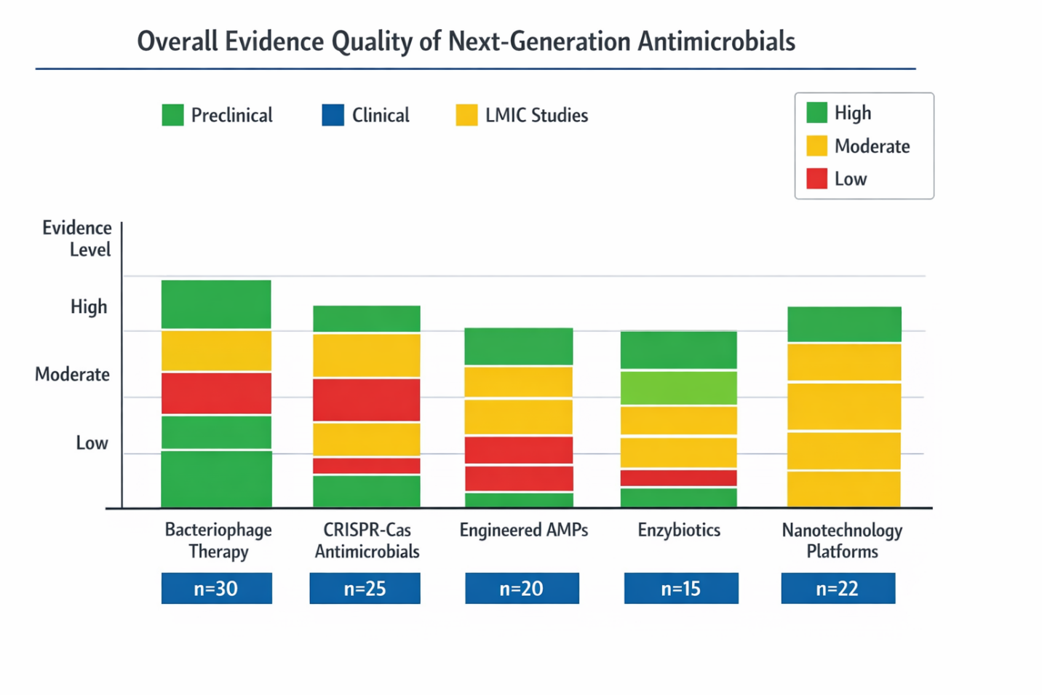
Figure S4: Overall Evidence Quality of Next-Generation Antimicrobials
The figure summarizes the quality of evidence for each antimicrobial modality, including preclinical, clinical, and LMIC-relevant studies. Stacked bars represent the relative contribution of each study type, while color-coding indicates evidence strength: green = high, yellow = moderate, red = low. Sample sizes (n) for each modality are indicated below the bars. This visualization highlights areas with robust evidence, gaps in clinical data, and LMIC applicability to guide future research and implementation strategies.
9. Abbreviations
- AMPs – Antimicrobial peptides
- AMR – Antimicrobial resistance
- MDR – Multidrug resistant
- LMICs – Low- and middle-income countries
- RCT – Randomized controlled trial

