Supplementary information for
Capillary Plasma GFAP and NfL Track In Vivo Tauopathy Progression in PS19 Mice
Anna Harima¹, Natsumi Kobayashi¹, Sharma Sanjiv², Takahiko Tokuda³, Makoto Higuchi⁴, Kaori Tsukakoshi^{5*}, Tomoaki Murakami¹*

¹Laboratory of Veterinary Toxicology, Tokyo University of Agriculture and Technology, Tokyo, Japan. ²David Price Evans Global Health and Infectious Diseases Group, Pharmacology & Therapeutics, Institute of Systems Molecular and Integrative Biology, University of Liverpool, Liverpool, United Kingdom. ³Department of Gerontology and Cognitive Pathology, Graduate School of Medicine, Osaka Metropolitan University, Osaka, Japan. ⁴Advanced Neuroimaging Center, National Institutes for Quantum Science and Technology, Chiba, Japan. ⁵Department of Chemistry, Faculty of Science, Tokyo University of Science, Tokyo, Japan

Correspondence 1: Kaori Tsukakoshi, Department of Chemistry, Faculty of Science Division I, Tokyo University of Science, 12-1 Ichigaya-Funakawara-cho, Shinjuku-ku, Tokyo 162-0826, Japan. Tel: +81-3-5228-8253; E-mail: kaori.tsukakoshi@rs.tus.ac.jp
Correspondence 2: Tomoaki Murakami, Laboratory of Veterinary Toxicology, Tokyo University of Agriculture and Technology, 3-5-8 Saiwai-cho, Fuchu-shi, Tokyo 183-8509, Japan. Tel: +81-42-367-5883; E-mail: mrkmt@cc.tuat.ac.jp

This file includes the following:
Supplementary Methods
Supplementary Figures 1-6
Supplementary Methods
Staging of brain tau pathology
The regions evaluated were: cerebral cortex (medial amygdala, cortical amygdala, piriform amygdala, piriform cortex, entorhinal cortex, parahippocampal cortex, entorhinal cortex, temporal association cortex, ventral auditory cortex, primary auditory cortex, dorsal sensory cortex, primary somatosensory cortex, parietal association cortex, posterior corpus callosum cortex), basolateral amygdala, caudate nucleus, amygdala central nucleus, hippocampus (CA1-3, dentate gyrus), mossy fibers, hypothalamus, and thalamus. AT8 immunoreactivity in each brain region was semi-quantitatively graded on a 0–3 scale (0 = absent, 1 = sparse, 2 = moderate, 3 = intense). Additionally, the presence or absence of deposition in the mossy fibers was evaluated as (+/–).

Grade | I | II | III | IV | V | VI
Cerebral cortex | 0 | 1 | 1-2 | 1-2 | 3* | 3
Basomedial amygdalar nucleus | 0 | 0-1 | 2-3 | 2-3 | 3 | 3
caudoputamen | 0 | 0 | 0-1 | 1-2 | 3 | 3
central amygdalar nucleus | 0 | 0 | 0-1 | 1-2 | 3 | 3
Hippocampus | 0 | 0 | 1-2** | 2 | 3 | 3
Hypothalamus | 0 | 0-1 | 1-2 | 2 | 3 | 3
Thalamus | 0 | 0 | 1 | 2 | 2-3 | 3
Mossy fiber | - | + | + | + | + | +
*Dosal auditory area, primary somatosensory area, posterior pariental association area, retrosplenial area: 2. **CA1-CA2: 0; CA3, dentate gyrus: 1-2

Supplementary Figures
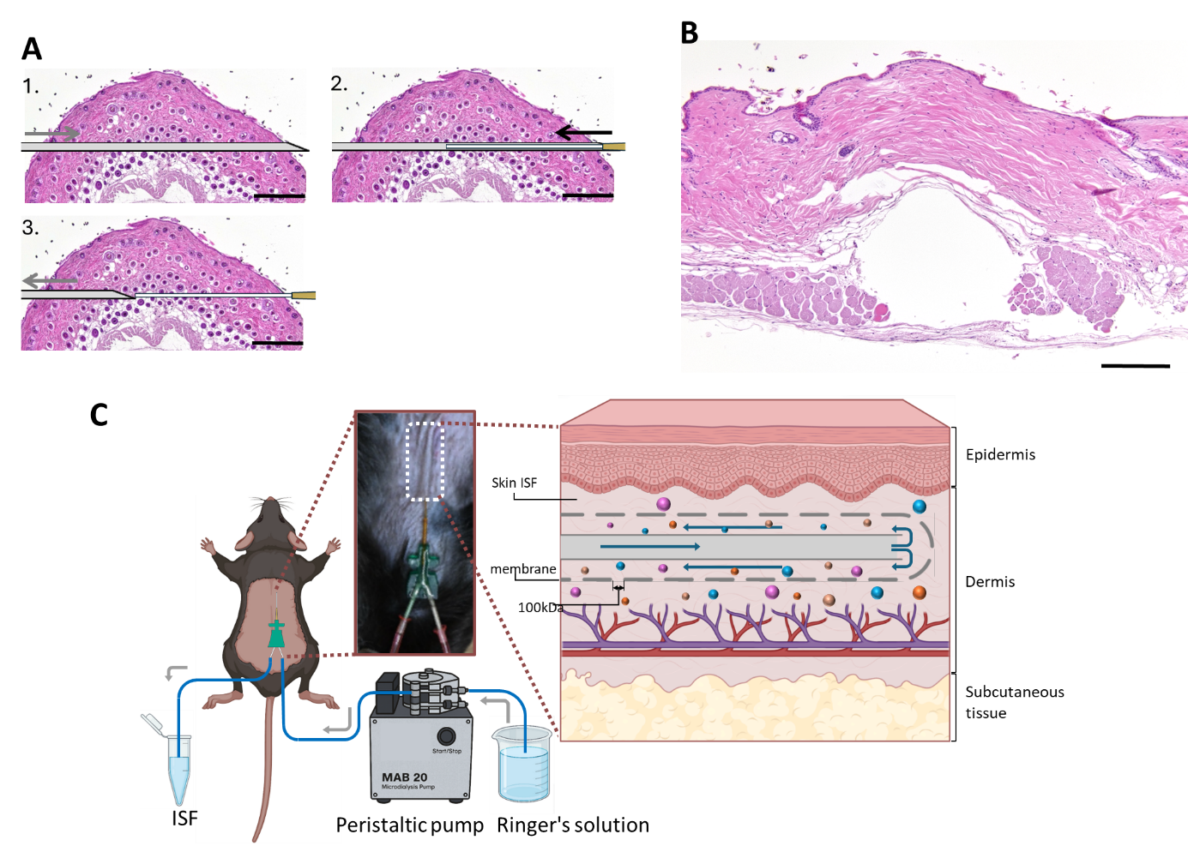
Supplementary Figure 1. Method and schematic of skin microdialysis in mice.
A) Procedure for inserting a microdialysis probe into the dermis.
(1) A 22-gauge needle is inserted as a guide into the dermis.
(2) The microdialysis probe is threaded through the needle lumen from the opposite end.
(3) The needle is gently withdrawn, leaving the probe in place within the dermis.
Scale bars = 500 μm.
B) Mouse skin after probe insertion; a small cavity remains in the dermis following probe removal.
Scale bar = 200 μm.
C) Schematic of skin ISF microdialysis. A microdialysis probe equipped with a 100 kDa cutoff semipermeable membrane is placed intradermally and connected to a peristaltic pump via FEP tubing. Ringer’s solution is perfused at a low flow rate, and dialysate containing molecules passing through the 100 kDa membrane is collected.

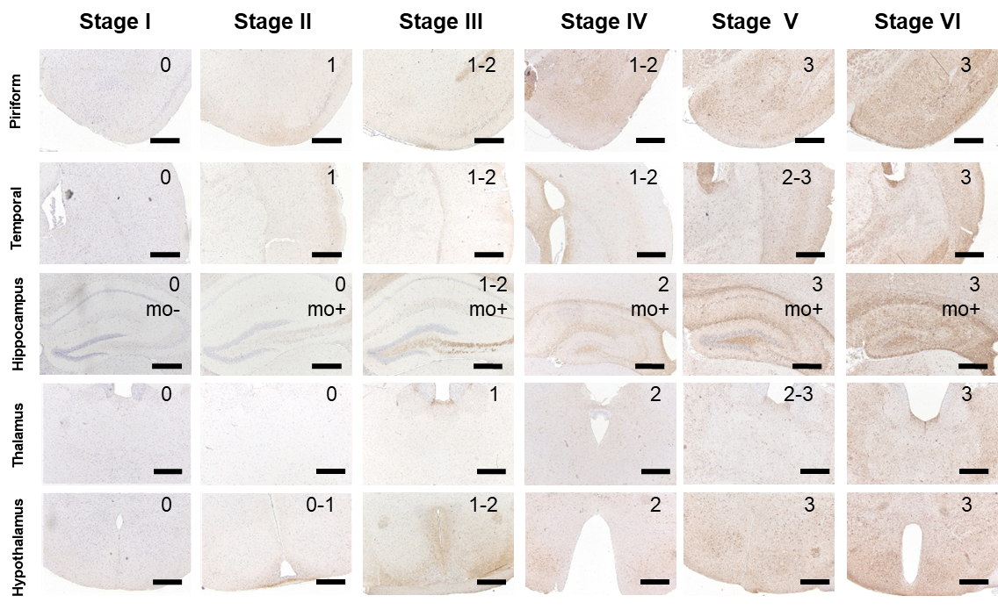
Supplementary Figure 2. Six-stage grading of brain tau pathology.
Representative AT8-stained images corresponding to each pathology stage in the piriform area (scale bar = 500 μm), temporal cortex (scale bar = 500 μm), hippocampus (scale bar = 500 μm), thalamus (scale bar = 500 μm), and hypothalamus (scale bar = 500 μm). The AT8 deposition grade (0–3) is shown in the upper right corner of each image.

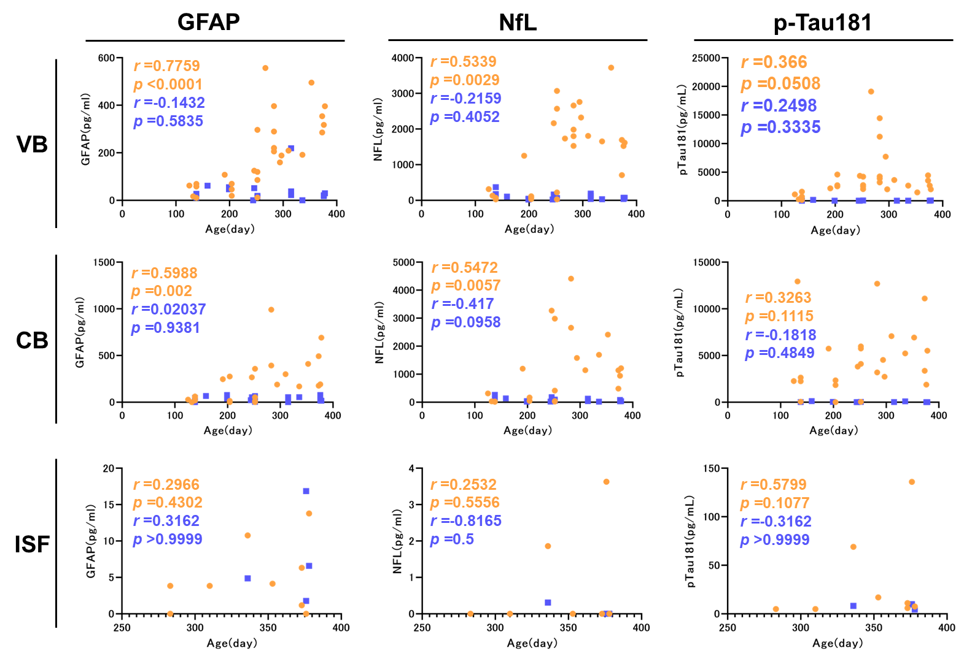
Supplementary Figure 3. Relationship between body fluid biomarker concentrations and age.
Scatter plots of GFAP, NfL, and p-Tau181 concentrations in venous blood (VB), capillary blood (CB), and skin ISF across age. PS19 mice are shown in orange and wild-type mice in blue. Spearman correlation coefficients (r) and p-values for PS19 and wild-type mice are provided within each panel. The x-axis represents age (days), and the y-axis represents biomarker concentrations (pg/mL).

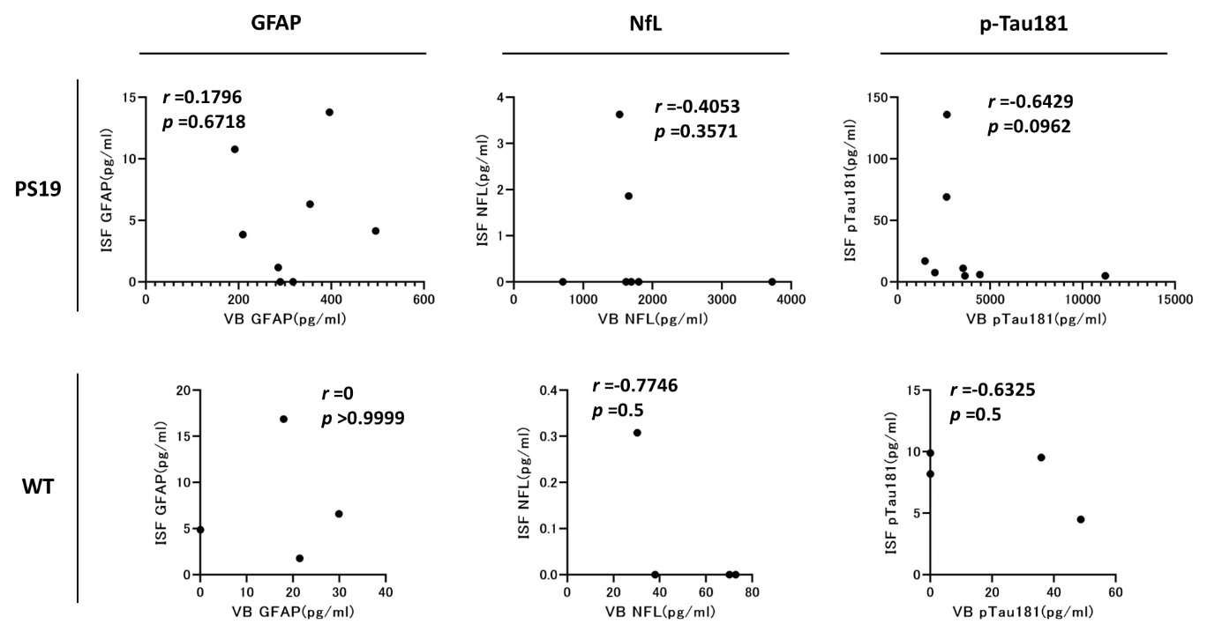
Supplementary Figure 4. Correlations between biomarker concentrations in skin ISF and venous plasma.
For PS19 and wild-type mice, biomarker concentrations in ISF and venous blood plasma (VB) were compared using Spearman’s rank correlation. Correlation coefficients (r) and p-values for each genotype are shown within each graph. The x-axis indicates VB biomarker concentrations, and the y-axis indicates ISF biomarker concentrations (pg/mL).

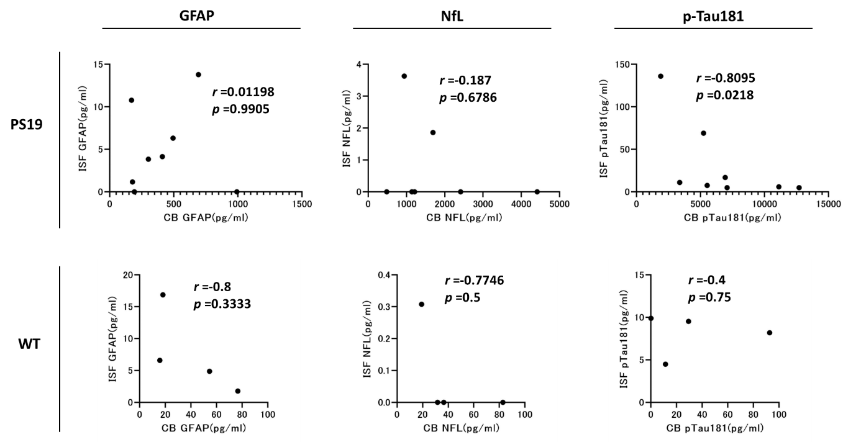
Supplementary Figure 5. Correlations between biomarker concentrations in skin ISF and capillary plasma.
For PS19 and wild-type mice, biomarker concentrations in ISF and capillary blood plasma (CB) were compared using Spearman’s rank correlation. Correlation coefficients (r) and p-values for each genotype are displayed within each plot. The x-axis represents CB biomarker concentrations, and the y-axis represents ISF biomarker concentrations (pg/mL).

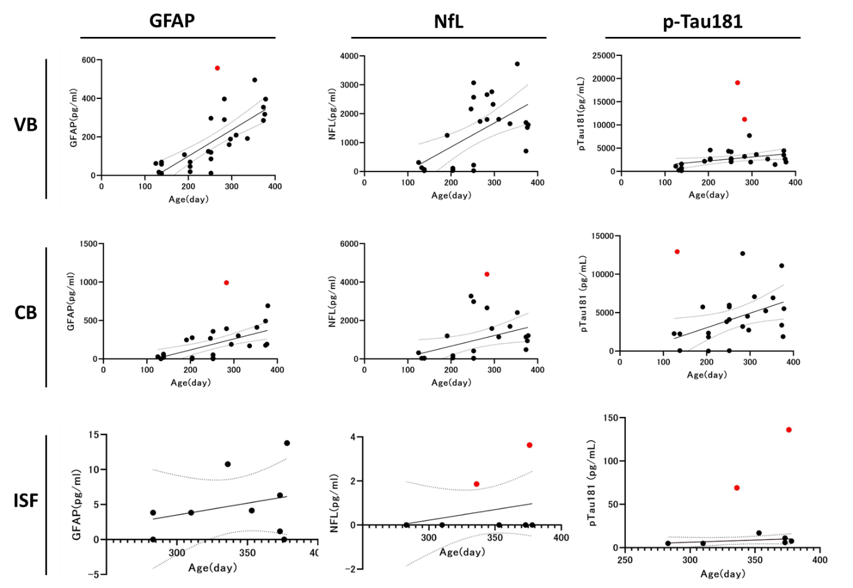
Supplementary Figure 6. Detection of outliers in body fluid biomarker concentrations in PS19 mice.
Scatter plots of GFAP, NfL, and p-Tau181 concentrations in capillary blood (CB). The x-axis represents age (days), and the y-axis represents biomarker concentrations (pg/mL). Outliers in PS19 mice were identified using a linear regression model combined with the ROUT method (Q = 1%) and are indicated in red.

