A SINGLE SPECIES, DIFFERENT REPEATOMES: GENOMIC PLASTICITY IN Passiflora foetida L.

Arthur Monteiro¹; Mariela A. Sader²; Jéssica Nascimento³; Gustavo Luna¹; Daniela Cristina Imig⁴; Andrea Pedrosa Harand¹

Supplementary Materials

Supplementary Table 1. Accessions of Passiflora foetida used for FISH
Accessions | Vouchers | Variety | Longitude | Latitude | Municipality | Source
APH0100 | UFP90688 | var. foetida | -47.71 | -15.60 | - | Embrapa-DF
APH218 | UFP100030 | var. foetida | -34.83 | -7.10 | João Pessoa-PB | Field
APH222 | UFP100031 | var. foetida | -38.24 | -10.38 | Ribeira do Pombal-BA | Field
APH219 | - | var. foetida | -39.08 | -12.68 | - | Embrapa-BA

Supplementary Table 2. Accessions from P. foetida and their respective varieties used as source for short reads. Status (native or non-native), geographic coordinates, collection site, and accession codes in the ENA or GSA platforms (PF001) are also presented. *Accession also used for individual characterization
 | Status | Longitude | Latitude | Localization | Code
Passiflora foetida
var. acapulsensis
PF071 | native | -97.2 | 18.1 | Mexico | ERR5419830
PF078 | native | -86.30 | 13.16 | Nicaragua | ERR5419836
PF102 | native | -95.95 | 16.54 | Mexico | ERR5419852
var. baraquiniana
PF008 | native | -65.36 | -26.46 | Argentina | ERR5419787
PF018* | native | -37.16 | -8.61 | Brazil | ERX5203483
PF023 | native | -40.13 | -10.67 | Brazil | ERR5419797
var. ellisonii
PF001 | - | 114.30 | 22.36 | China | CRR889390
PF064 | non native | 50.05 | -14.10 | Madagascar | ERR5419825
PF153 | non native | 141.76 | -17.17 | Australia | ERR5419888
var. foetida
PF031 | native | -71.56 | 18.39 | Dominican Republic | ERR5419803
PF057 | native | -78.66 | -4.35 | Ecuador | ERR5419819
PF107 | native | -34.83 | -7.09 | Brazil | ERR5419909
var. nigelliflora
PF007 | native | -55.56 | -27.43 | Argentina | ERR5419786
PF020 | native | -60.46 | 2.94 | Brazil | ERR5419795
PF085 | nativa | -59.84 | -20.55 | Paraguai | ERR5419841

Supplementary Table 3. Species used for comparative analyses among species of the subgenus Passiflora, as well as for comparisons within the section Dysosmia. Genome size data follow Melo & Guerra (2021), Yokoto (2011), and Zirpoli et al., (2025). Only P. ciliata does not yet have genome size information available

 | Genome size (1C) | Reference | Code ENA
Subg. Passiflora
P. caerulea | 1355,5 Mpb | Yokoto, 2011 | ERR5419862
P. ciliata | - | - | ERX5203540
P. cincinnata | 1338,7 Mpb | Yokoto, 2011 | SRX9515500
P. coccinea | 1307,8 Mpb | Yokoto, 2011 | ERR5419865
P. edulis | 1230,3 Mpb | Yokoto, 2011 | ERR5419919
P. foetida | 440,1 Mpb | Yokoto, 2011 | ERX5203483
P. incarnata | 644,5 Mpb | Yokoto, 2011 | ERR5419921
P. liguralis | 1382,8 Mpb | Yokoto, 2011 | ERR5419923
P. quadrangularis | 2621,0 Mpb | Yokoto, 2011 | ERR5419924
P. versicaria | 567,2 Mpb | Zirpoli et al., 2025 | ERX5203495
Subg. Decaloba
P. organensis | 207,3 Mpb | Yokoto, 2011 | -
P. suberosa | 668,9 Mpb | Yokoto, 2011 | ERX5203559

 |  | P. cearulea | P. coccinea | P. cincinnata | P. quadrangularis | P. edulis | P. liguralis | P. incarnata | P. foetida | P. organensis | P. suberosa
2n |  | 18 | 18 | 18 | 18 | 18 | 18 | 18 | 20 | 12 | 24
Genome size |  | 1355,5 Mpb | 1307,8 Mpb | 1338,7 Mpb | 2621,0 Mpb | 1230,3 Mpb | 1382,8 Mpb | 644,5 Mpb | 440,1 Mpb | 207,3 Mpb | 668,9 Mpb
Reads in the comparative analysis |  | 466,296 | 450,010 | 477,950 | 902,074 | 423,924 | 476,722 | 221,998 | 151,300 | 71,520 | 230,588
Coverage |  | 0.05x | 0.05x | 0.05x | 0.05x | 0.05x | 0.05x | 0.05x | 0.05x | 0.05x | 0.05x
TEs Classe I |  |  |  |  |  |  |  |  |  |  |  | Mean | SD | CV
Ty3/gypsy |  | 42,94% | 31,82% | 27,95% | 46,09% | 46,36% | 47,81% | 27,28% | 4,38% | 11,96% | 31,51% | 31.81% | 0.1482 | 0.4660
Chromovirus | CRM | 0,18% | 0,02% | 0,36% | 0,32% | 0,11% | 0,11% | 0,33% | 0,24% |  |  | 0.21% | 0.0012 | 0.5920
 | Tekay | 30,01% | 22,18% | 17,83% | 38,88% | 33,49% | 42,08% | 20,91% | 2,26% | 11,96% | 15,87% | 23.55% | 0.1250 | 0.5310
Non-chromovirus | Athila | 12,75% | 9,62% | 9,76% | 6,89% | 12,76% | 5,62% | 6,04% | 1,88% |  | 15,64% | 9.00% | 0.0431 | 0.4791
Ty1/copia |  | 17,76% | 35,95% | 35,71% | 27,42% | 18,33% | 18,11% | 18,89% | 23,55% | 0,87% | 6,63% | 20.32% | 0.1118 | 0.5502
 | Ale | 0,04% | 0,03% | 0,11% | 0,07% | 0,04% | 0,04% | 0,03% |  |  |  | 0.05% | 0.0003 | 0.5661
 | Angela | 11,57% | 29,85% | 28,64% | 26,73% | 16,14% | 17,39% | 15,12% | 19,97% | 0,01% |  | 18.38% | 0.0942 | 0.5124
 | Bianca | 0,21% | 0,21% | 0,17% | 0,09% | 0,15% | 0,13% | 0,22% | 0,47% | 0,52% | 0,90% | 0.31% | 0.0025 | 0.8210
 | Ikeros | 0,11% | 0,18% | 0,29% | 0,13% | 0,14% | 0,10% | 0,21% | 0,12% |  | 0,04% | 0.15% | 0.0007 | 0.4917
 | Ivana | 0,01% | 0,02% | 0,02% | 0,01% | 0,01% | 0,01% | 0,03% |  |  |  | 0.02% | 0.0001 | 0.5007
 | SIRE | 5,62% | 4,38% | 5,94% | 0,27% | 1,53% | 0,24% | 2,99% | 2,77% | 0,03% | 5,09% | 2.89% | 0.0230 | 0.7982
 | Tork | 0,20% | 0,28% | 0,54% | 0,12% | 0,32% | 0,20% | 0,29% | 0,22% | 0,31% | 0,60% | 0.31% | 0.0015 | 0.4921
Pararetrovirus |  |  | 0,01% |  | 0,05% | 0,01% | 0,01% | 0,01% | 0,01% |  |  | 0.02% | 0.0002 | 0.9798
TEs Classe II
 | hAT | 0,04% | 0,02% | 0,05% | 0,02% | 0,03% | 0,03% | 0,05% | 0,06% |  | 0,01% | 0.03% | 0.0002 | 0.4839
 | MuDR_Mutator | 0,01% | 0,02% | 0,03% | 0,01% | 0,02% | 0,02% | 0,02% | 0,02% |  |  | 0.02% | 0.0001 | 0.3418
SatDNA |  | 0,04% | 0,03% |  | 0,05% | 0,06% |  | 0,01% | 3,98% | 0,97% |  | 0.73% | 0.0147 | 2.0058
rDNA | 5S | 0,01% | 0,01% | 0,01% | 0,01% | 0,03% | 0,08% | 0,29% | 0,11% | 0,01% | 0,04% | 0.06% | 0.0009 | 1.4657
 | 35S | 1,00% | 1,29% | 0,93% | 0,80% | 0,87% | 1,34% | 1,65% | 3,46% | 1,79% | 1,74% | 1.49% | 0.0078 | 0.5274
LTR Unclassified |  | 4,11% | 2,90% | 1,91% | 2,33% | 3,09% | 1,61% | 3,54% | 5,86% |  | 2,89% | 3.14% | 0.0128 | 0.4083
Unclassified |  | 6,18% | 2,58% | 1,89% | 1,81% | 2,25% | 1,46% | 2,44% | 8,87% | 0,82% | 0,95% | 2.93% | 0.0257 | 0.8793
 | Total | 72,11% | 73,64% | 68,48% | 78,56% | 71,05% | 70,49% | 54,24% | 50,35% | 16,79% | 43,31%
Supplementary Table 4. Comparative analysis of repeats from eight species of the subgenus Passiflora and two species of the subgenus Decaloba identified by RepeatExplorer2. Chromosome number (Melo & Guerra, 2021), genome size (Yokoto, 2011), number of sequences automatically sampled for the comparative clustering analysis, resulting coverage, and proportion of sequences in the major clusters corresponding to different repeats are indicated
Supplementary Table 5. Comparative analysis of repeats from 15 accessions from five varieties of P. foetida. Number of sequences (reads) automatically sampled for the clustering analysis, resulting coverage, and proportion of reads in the major clusters corresponding to different repeats are indicated
 |  |  |  | var. acapulsensis |  |  | var. baraquiniana |  |  | var. ellisonii |  |  | var. foetida |  |  | var. nigelliflora
 |  |  |  | Pf071 | Pf078 | Pf102 | Pf008 | Pf018 | Pf023 | Pf001 | Pf064 | Pf153 | Pf031 | Pf057 | Pf107 | Pf007 | Pf020 | Pf085
 |  | Reads |  | 105,972 | 106,390 | 106,114 | 106,458 | 106,772 | 106,010 | 107,598 | 105,776 | 106,998 | 106,756 | 105,864 | 106,124 | 107,138 | 106,314 | 106,140
 |  | Coverage |  | 0.03x | 0.03x | 0.03x | 0.03x | 0.03x | 0.03x | 0.03x | 0.03x | 0.03x | 0.03x | 0.03x | 0.03x | 0.03x | 0.03x | 0.03x
 |  | TEs Class I |  |  |  |  |  |  |  |  |  |  |  |  |  |  |  |  | Mean | SD | CV
 |  | Ty3/gypsy |  | 4,59% | 4,64% | 4,60% | 1,11% | 4,51% | 0,76% | 4,06% | 5,08% | 4,20% | 5,15% | 1,82% | 4,40% | 4,41% | 4,28% | 3,82% | 3.83 | 0.014 | 0.366
 | Chromovirus |  | CRM | 0,41% | 0,24% | 0,45% | 0,02% | 0,17% | 0,02% | 0,14% | 0,10% | 0,14% | 0,16% | 0,07% | 0,15% | 0,09% | 0,14% | 0,03% | 0.16 | 0.001 | 0.819
 |  |  | Galadriel | 0,04% | 0,13% | 0,08% | 0,02% | 0,05% | 0,00% | 0,17% | 0,14% | 0,16% | 0,13% | 0,03% | 0,07% | 0,03% | 0,05% | 0,05% | 0.08 | 0.001 | 0.717
 |  |  | Tekay | 1,01% | 1,27% | 1,08% | 0,54% | 2,34% | 0,33% | 2,00% | 2,20% | 2,02% | 2,44% | 0,79% | 2,30% | 2,10% | 2,41% | 1,98% | 1.65 | 0.007 | 0.444
 | Non-chromovirus |  | Athila | 3,13% | 3,00% | 2,99% | 0,53% | 1,95% | 0,41% | 1,75% | 2,64% | 1,88% | 2,42% | 0,93% | 1,88% | 2,19% | 1,68% | 1,76% | 1.94 | 0.008 | 0.433
 |  | Ty1/copia |  | 21,58% | 19,66% | 21,75% | 8,22% | 29,94% | 4,98% | 36,24% | 45,83% | 36,57% | 40,40% | 19,14% | 29,55% | 36,93% | 27,44% | 26,10% | 26.96 | 0.115 | 0.425
 |  |  | Angela | 20,34% | 18,73% | 20,50% | 5,63% | 23,60% | 4,36% | 27,29% | 38,00% | 27,25% | 30,28% | 14,17% | 23,12% | 25,47% | 19,69% | 16,13% | 20.97 | 0.088 | 0.418
 |  |  | Bianca | 0,42% | 0,19% | 0,41% | 0,07% | 0,46% | 0,03% | 0,33% | 0,20% | 0,37% | 0,48% | 0,14% | 0,46% | 0,37% | 0,41% | 0,29% | 0.31 | 0.001 | 0.478
 |  |  | Ikeros | 0,08% | 0,05% | 0,06% | 0,01% | 0,12% |  | 0,09% | 0,06% | 0,08% | 0,11% | 0,03% | 0,10% | 0,09% | 0,09% | 0,07% | 0.07 | 0.000 | 0.408
 |  |  | SIRE | 0,56% | 0,53% | 0,59% | 2,47% | 5,51% | 0,57% | 8,29% | 7,35% | 8,62% | 9,28% | 4,70% | 5,66% | 10,79% | 7,11% | 9,46% | 5.43 | 0.037 | 0.676
 |  |  | TAR | 0,02% | 0,02% | 0,03% |  | 0,01% |  | 0,01% | 0,01% | 0,01% | 0,01% |  | 0,01% | 0,02% | 0,01% |  | 0.01 | 0.000 | 0.473
 |  |  | Tork | 0,16% | 0,14% | 0,16% | 0,04% | 0,24% | 0,02% | 0,23% | 0,21% | 0,24% | 0,24% | 0,10% | 0,20% | 0,19% | 0,13% | 0,15% | 0.16 | 0.001 | 0.426
 |  | LINEs |  |  |  |  |  |  | 0,23% |  |  |  |  | 0,44% | 0,01% |  | 0,01% |  | 0.17 | 0.002 | 1.196
 |  | TEs Class II
 |  |  | hAT | 0,07% | 0,07% | 0,07% | 0,01% | 0,10% | 0,00% | 0,08% | 0,07% | 0,08% | 0,13% | 0,03% | 0,08% | 0,07% | 0,05% | 0,03% | 0.06 | 0.000 | 0.541
 |  |  | MuDR_ Mutator | 0,05% | 0,04% | 0,07% | 0,02% | 0,10% | 0,01% | 0,12% | 0,10% | 0,12% | 0,15% | 0,06% | 0,08% | 0,09% | 0,06% | 0,07% | 0.08 | 0.000 | 0.507
 |  | SatDNA |  | 4,96% | 6,64% | 5,45% | 10,65% | 4,60% | 8,17% | 3,86% | 4,68% | 3,89% | 3,17% | 2,39% | 5,68% | 6,47% | 5,91% | 5,13% | 5.44 | 0.020 | 0.375
 |  | rDNA | 5S | 0,63% | 0,66% | 0,67% | 0,03% | 0,07% | 0,03% | 0,07% | 0,07% | 0,05% | 0,04% | 0,03% | 0,07% | 0,05% | 0,14% | 0,04% | 0.18 | 0.002 | 1.406
 |  |  | 35S | 3,18% | 4,85% | 4,88% | 3,47% | 3,29% | 8,48% | 4,98% | 5,63% | 5,69% | 2,37% | 1,47% | 3,56% | 1,27% | 2,31% | 1,84% | 3.82 | 0.019 | 0.511
 |  | LTR Unclassified |  | 3,82% | 3,38% | 3,76% | 1,77% | 6,49% | 2,78% | 3,60% | 3,23% | 3,41% | 4,43% | 1,66% | 7,41% | 5,92% | 6,58% | 5,35% | 4.24 | 0.017 | 0.413
 |  | Unclassified |  | 0,51% | 0,58% | 0,47% | 0,18% | 0,56% | 0,44% | 0,48% | 0,32% | 0,45% | 0,43% | 1,25% | 0,46% | 0,32% | 0,52% | 0,34% | 0.49 | 0.002 | 0.484
 |  |  | Total | 38,38% | 39,02% | 41,34% | 24,58% | 49,42% | 24,88% | 52,83% | 64,10% | 54,06% | 55,99% | 27,65% | 50,90% | 55,10% | 46,75% | 43,80%

Supplementary Table 6. Proportion of the genome (%) composed of different repetitive sequences identified in the comparative RepeatExplorer2 analysis of three species from the Dysosmia section of the subgenus Passiflora
 | P. ciliata | P. foetida | P. vesicaria
2n | - | 20 | 20
Genome size (1C) | - | 440,1 Mbp | 567,2 Mpb
Comparative clustering reads | 439,052 | 437,036 | 438,968
Coverage | - | 0.1x | 0.1x
Repeat
Class I
LTR Ty3/gypsy | 0.77% | 2.67% | 2.36%
Chromovirus
CRM | 0.03% | 0.20% | 0.17%
Galadriel |  | 0.01% | 0.02%
Tekay | 0.74% | 2.46% | 2.17%
Non-chromovirus
Athila | 0.94% | 2.09% | 2.61%
LTR Ty1/copia | 21.30% | 30.78% | 42.15%
Angela | 17.41% | 22.41% | 28.66%
Bianca | 0.05% | 0.52% | 0.42%
Ikeros | 0.02% | 0.13% | 0.11%
SIRE | 2.85% | 5.42% | 10.17%
TAR |  | 0.04% | 0.04%
Tork | 0.03% | 0.17% | 0.14%
Unclassified LTRs | 1.10% | 6.33% | 3.94%
LINEs | 0.65%
Class II
MuDR_Mutator | 0.01% | 0.06% | 0.05%
hAT | 0.01% | 0.06% | 0.05%
SatDNA | 4.22% | 1.79% | 1.43%
rDNA
5S | 0.05% | 0.09% | 0.04%
35S | 2.45% | 5.95% | 2.03%
Unclassified | 17.69% | 3.58% | 2.31%
Total | 51.30% | 48.14% | 54.06%

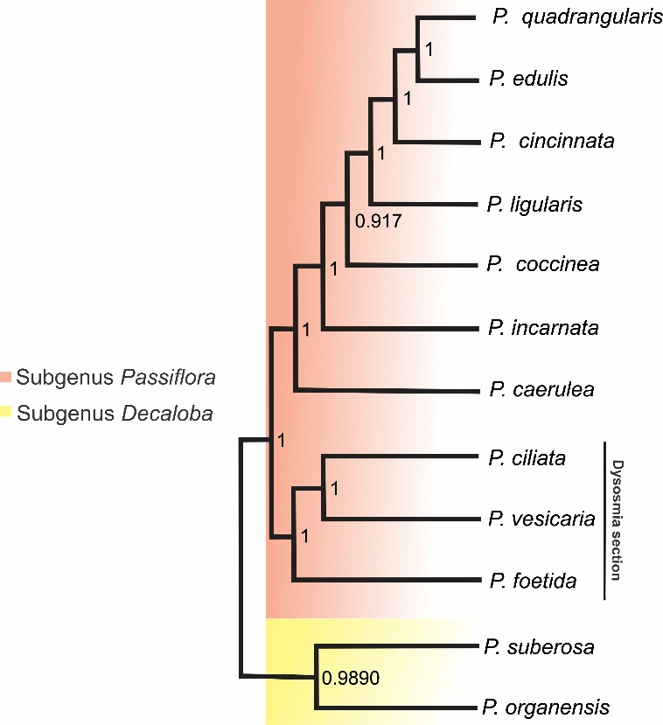
Supplementary Figure 1. Plastome phylogeny of the subgenus Passiflora, with the subgenus Decaloba used as the outgroup. The bar highlights the section Dysosmia, which is also included within the subgenus Passiflora.

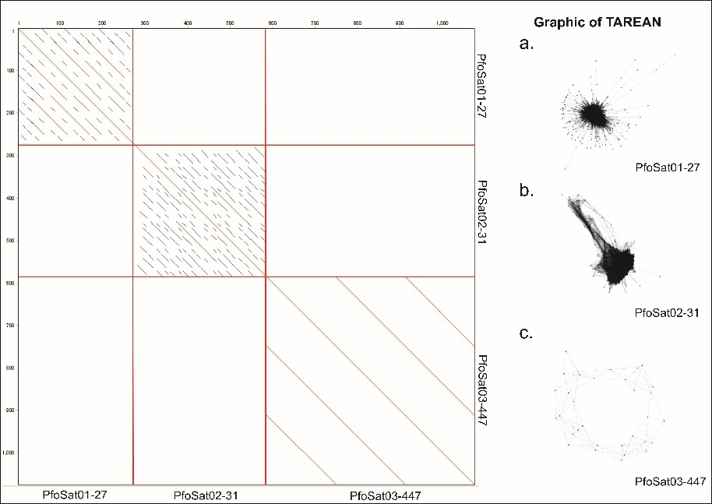
Supplementary Figure 2. Organization of P. foetida specific satellite DNAs. Left, dot plot of contigs showing tandem organization; and, right, corresponding graphs generated by TAREAN for: A. PfoSat01-27; B. PfoSat02-31; and C. PfoSat03-447.

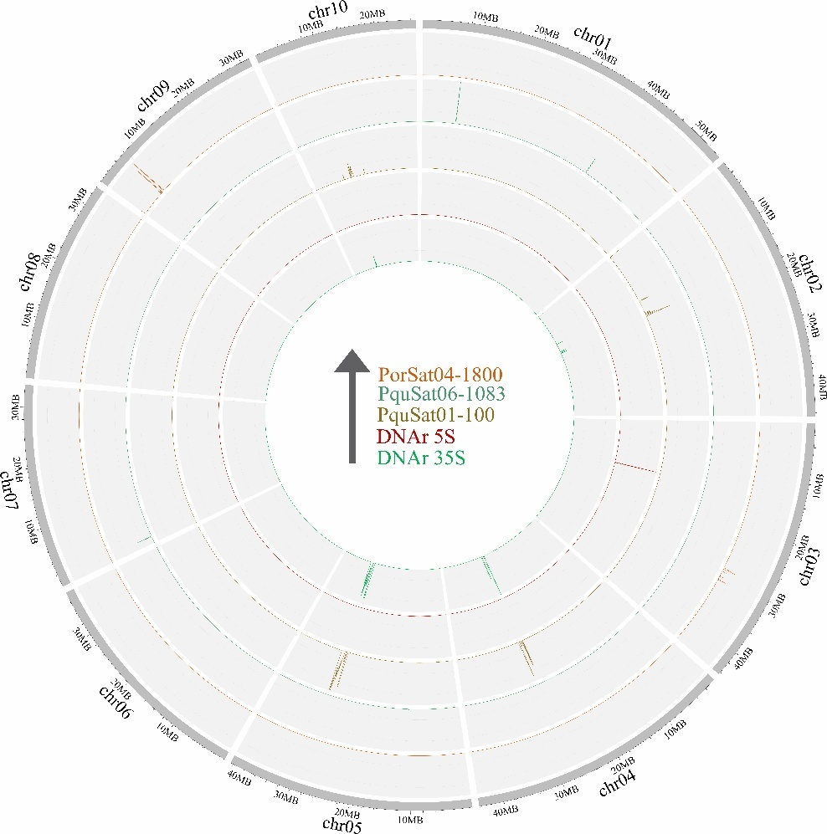
Supplementary Figure 3. Distribution of 5S and 35S rDNA sequences and shared satellites between species (PquSat01-100; PquSat06-1083; PorSat04-1800) in P. foetida pseudochromosomes. The arrow in the centre indicates the order of the sequences, from the centre to the periphery, with 5S rDNA (red), 35S rDNA (green).

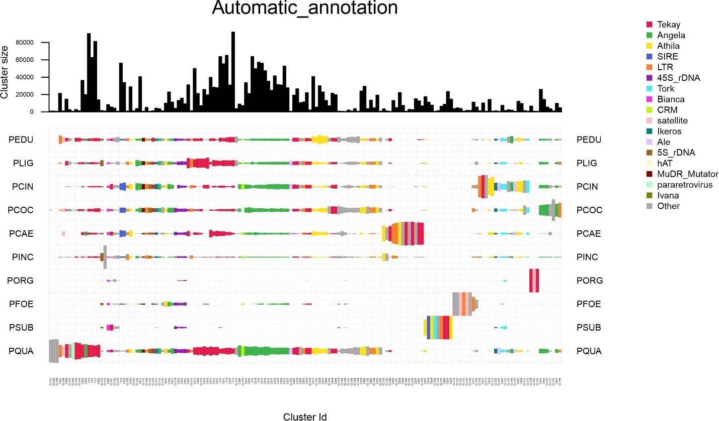
Supplementary Figure 4. Abundances of the clusters identified based on the comparative analysis performed with the RepeatExplorer2 pipeline, between species.

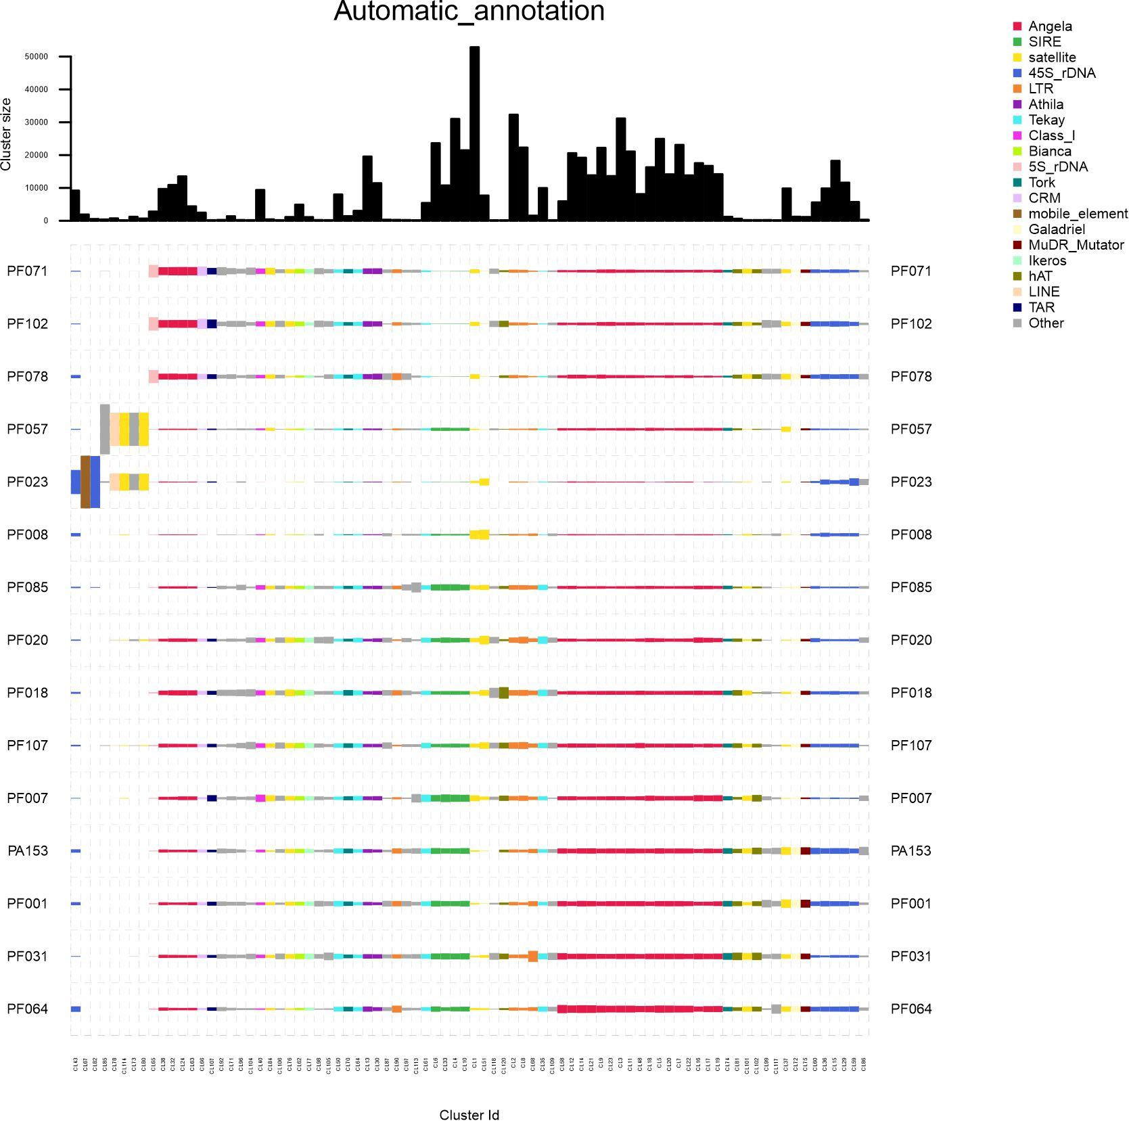
Supplementary Figure 5. Abundances of the clusters identified based on the comparative analysis performed with the RepeatExplorer2 pipeline, between individuals of the same species.

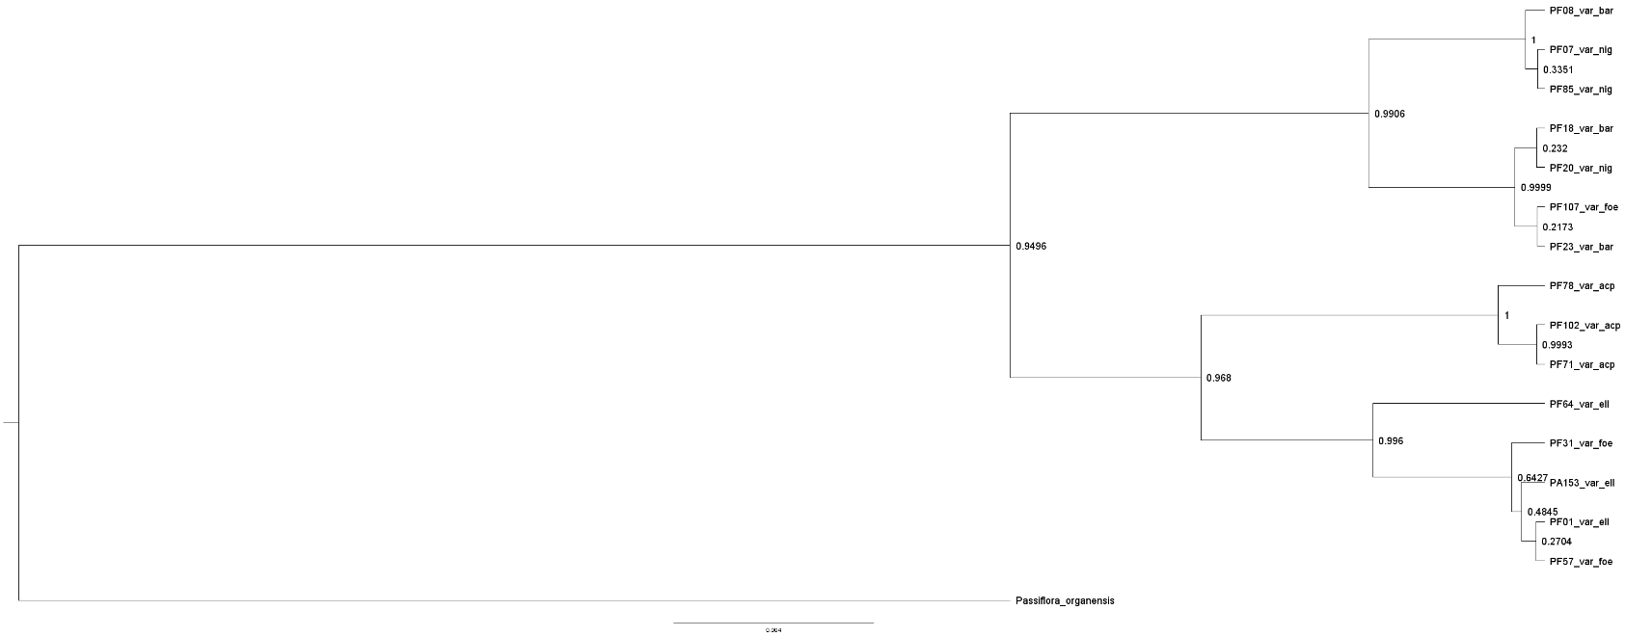
Supplementary Figure 6. Phylogenetic relationships inferred from nuclear assemblies (35S rDNA cistron) of Passiflora foetida accessions.

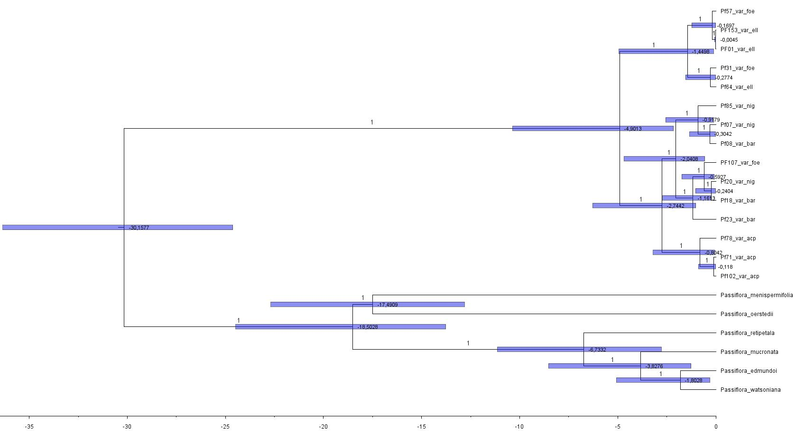
Supplementary Figure 7. Phylogenetic relationships inferred from plastome assemblies using P. foetida as a reference, with divergence time estimates based on fossil records of Passiflora.

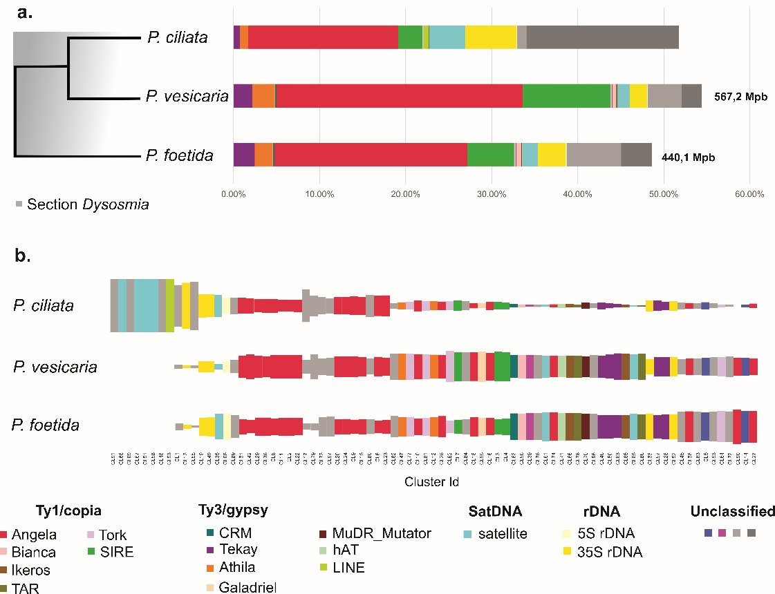

Supplementary Figure 8. Comparative abundance of repetitive DNA in different species of the section Dysosmia. a. Phylogenetic relationships inferred from plastome assemblies using P. foetida as a reference and abundances per repeat class and lineage; b. Abundances per cluster. Annotations indicated by colours.

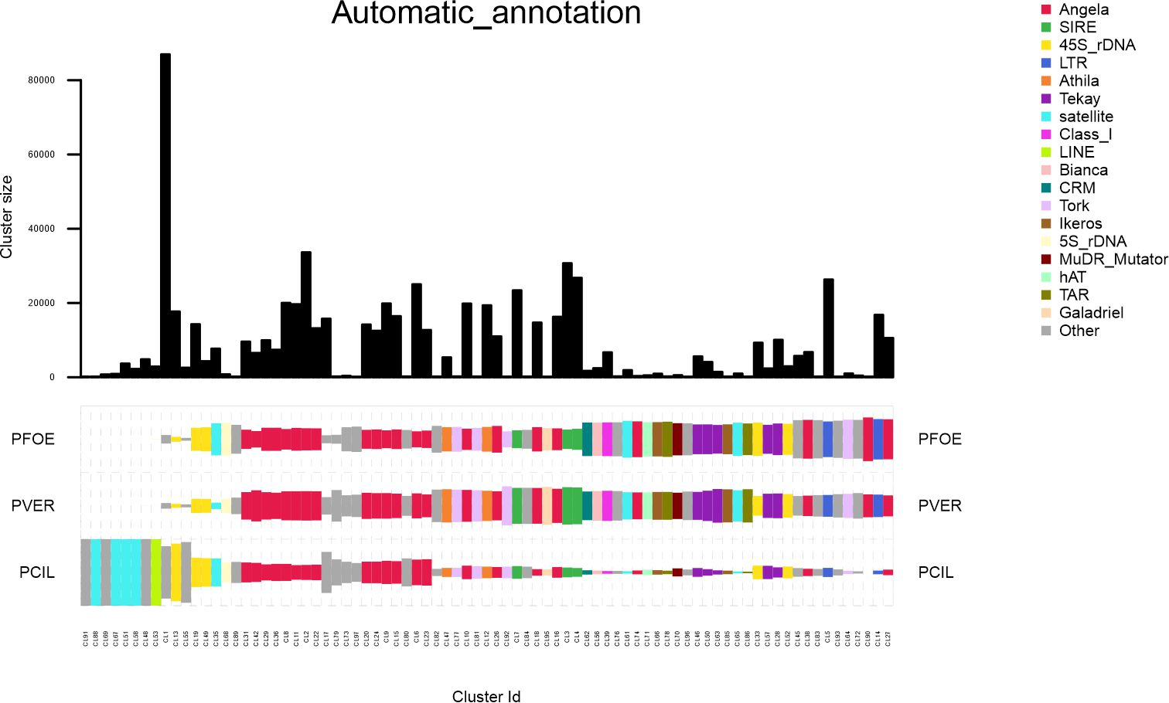
Supplementary Figure 9. Abundances of the clusters identified based on the comparative analysis performed with the RepeatExplorer2 pipeline, between species of Dysosmia section.

