Supplementary Materials

Kelp Economy Database Compilation
- Company information, including company name, website, country, region, headquarters, and bioregion (per UN Biodiversity Lab 2025).
- Ownership status, including affiliations with Indigenous Groups/Nations and if the company was active or inactive (inactive was assumed if the organization was clearly shutdown, if site copyright had lapsed, or no products exist).
- Kelp species, which we determined from products or some sort of “about” page on organizations websites. If found the common name would be noted, the order of the species and the scientific name if listed or identifiable from other publicly available information (pictures, products, etc.)
- Date of establishment was determined through a stepped approach. First checking the Hermans’ database for its establishment year, second through checking the websites of individual companies, and then lastly through checking the date of creation for social media profiles on websites such as LinkedIn, Facebook or Instagram.
- Organizational category and objectives were gathered through the information publicly available on the companies' websites with information being found commonly on the front page, or a section detailing the company.
  - The organization type was categorized into non-profit, private sector, knowledge hub (research or management related conglomerates/networks), or Guardians (Indigenous resource and stewardship organizations).
  - Organization objectives (up to 3) were categorized into: Agriculture; Bioplastics; Consultant; Food product; Kelp farming (mariculture/aquaculture; Kelp propagation;
Nutraceuticals, biostimulants, or other chemically derived applications; Processing (wholesale); Regulation/governance/policy; Research, blue carbon; Research, ecology or biology including monitoring; Research, genetics/biobanking; Research, social or economic factors; Restoration; Skincare; Spatial Planning; Stewardship; Wild kelp harvest
    - Organizational objectives were determined upon an overview of individual organizations' websites where up to three categories were represented. The first organizational category is the main priority of the organization determined by the forward-facing information available on the website(s). If there were multiple objectives, the first was listed as the primary objective of the company. Secondary and tertiary objectives were determined by the displayed priorities of the company. For example: A company which is named XX farms touts their mariculture operation which they then utilize to make kelp-based fertilizers and then they sell some dried kelp seasonally. Here the first objective would be “kelp mariculture” secondary would-be kelp “nutraceuticals, bio-stimulants or other chemically derived applications”, and the tertiary objective would be kelp as a “food product”.

PESTLE Scores and Descriptions

Political
Political scores were based on whether a region has UNDRIP legislated at the provincial/state level and/or the federal level.
Rank | Description
1 | Not enough information
2 | UNDRIP not legislated at any level
3 | UNDRIP legislated federally OR provincially/state
4 | UNDRIP Acknowledged and legislated at BOTH provincial/state and federal levels
- Alaska: Alaska receives a 3 due to having no federal legislation and having a state level act which lends itself to a DRIPA style act the “Alaska Native Claims Settlement Act” (1971) (ANCSA Regional Association, 2025)
- Baja California: Baja California receives a 2 due to the lack of any federal or state action in line with UNDRIP, but there is state level acknowledgement in line with the federal constitution (Ley de Derechos y Cultura Indígena del Estado de Baja California, 2015)
- British Columbia: British Columbia receives a 4 due to the presence of BC’s Declaration on the Rights of Indigenous Peoples Act (2019) and Canada’s United Nations Declaration on the Rights of Indigenous Peoples Act (UNDRIPA; 2021)
- Connecticut: Connecticut receives a 2 due to the lack of any federal or state level act in line with UNDRIP.
- California: California receives a 2 due to the lack of any federal or state level act in line with UNDRIP, with acknowledgment of state level support present in their “Guiding principles for Sustainable Marine Aquaculture in California” (State of California, 2021).
- Maine: Maine receives a 3 due to not having a federal act and having a state level act the “Maine Indian Claims Settlement” (Title 30, Chapter 601) (Rep. Emery, 1980)
- New Brunswick: New Brunswick receives a 3 due to the federal UNDRIPA (2021) and not having a provincial act.
- Newfoundland: Newfoundland receives a 3 due to the federal UNDRIPA (2021) and not having a provincial act.
- Nova Scotia: Nova Scotia receives a 3 due to the federal UNDRIPA (2021) and not having a provincial act.
- Oregon: Oregon receives a 2 due to the lack of a state or federal level act in line with UNDRIP.
- Prince Edward Island: Prince Edward Island receives a 3 due to the federal UNDRIPA (2021) and not having a provincial act.
- Quebec: Quebec receives a 3 due to the federal UNDRIPA (2021) and not having a provincial act.
- Sinaloa: Sinaloa receives a 2 due to the lack of any federal or state action in line with UNDRIPA, but there is state level acknowledgement in line with the federal constitution. (Congreso del Estado de Sinaloa, 2024)
- Washington: Receives a 3 due to the lack of a federal act and the presence of the Puget Sound Partnership (state agency) between the state and federally recognized tribes (Puget Sound Partnership, 2024).

Economic
Economic PESTLE scores were determined through a state/provincial literature review looking for governmental documents denoting a kelp industry development plan as well as Indigenous or community-focused economic development plans. In this case, proof of commitment included evidence of specific funding or dedicated programs for Indigenous and community development.
1 | Not enough information
2 | No plans
3 | Aquaculture plan is inclusive of kelp
4 | Indigenous/community economic development plan/program present
5 | Plan(s) that link kelp and Indigenous/community economic development but with no proof of commitment
6 | Plan(s) that link kelp and Indigenous/community economic development with proof of commitment (funding, specific program, etc.)
- Alaska: Alaska Receives a 6 due to the presence of a kelp industry development plan that promotes Indigenous development (State of Alaska, 2018) with proof of commitment via the Alaska Native Claims Settlement Act of 1971.
- Baja California: Baja California receives a 3 due to the presence of a national kelp forest restoration plan that focuses on the Baja region (Foro Mar de Cortés, 2025; Gobierno de Baja California, 2018). At the time of writing, there was no additional public information on the specifics and commitments of this plan.
- British Columbia: British Columbia receives a 6 due to the presence of the BC Coastal Marine Strategy which was co-developed with First Nations and includes provisions for the development of the kelp industry through cooperation and use of Indigenous Knowledge, as well as dedicated funding and staff for Indigenous economic development (Government of BC, 2024; Ministry of Jobs Trade and Technology, 2025).
- California: California receives a 6 due to the presence of various grants provided by the state specifically for Indigenous and Tribal development and nature based solutions (California Natural Resources Agency, 2025) as well as the in-progress Action Plan for statewide mariculture, including macroalgae. While the action plan is in development, the guiding principles it will build from link algae aquaculture and Indigenous partnerships (State of California, 2021).
- Connecticut: Connecticut receives a 3 due to the presence of the state-level seaweed mariculture development plans/guidance but lack of an Indigenous development initiatives/partnerships/plans at the state level (NOAA et al., 2018; Sea Grant Connecticut & University of Connecticut, 2024).
- Maine: Maine receives a 6 due to the inclusion of seaweed aquaculture in their drafted marine strategic outlook document plan (Maine Coastal Program & Department of Marine Resources, 2025), as well as their commitment to Indigenous economic development through the intergovernmental Maine Indian Tribal-State Commission, enacted through the Maine Indian Land Claims Settlement of 1980 (Maine Indian Tribal-State Commission, 2025)
- New Brunswick: New Brunswick receives a 4 due to a lack of any plans regarding seaweed or kelp economic development, with the closest mention being their finfish plan (New Brunswick Department of Agriculture, Aquaculture and Fisheries, 2023). However, New Brunswick is a member of a tripartite (Government of Canada; the Province of New Brunswick; and, the Aboriginal communities of New Brunswick) Joint Economic Development Initiative (JEDI) which works to expand Indigenous economic development in the province (Treasury Board of Canada Government of Canada, 2006).
- Newfoundland: Newfoundland receives a 4 due to the Indigenous Cultural Heritage Program, although not explicitly economic focused (Department of Tourism, Culture, Arts and Recreation, 2025), but a lack of a kelp development plan.
- Nova Scotia: Nova Scotia receives a 5 due to the presence of its aquaculture strategy which includes reference to algae and contains commitments to work with Indigenous people, but a lack of proof of this commitment (Government of Nova Scotia, 2012). However, we note that this is an out-of-date document, and a bill (Bill 63, “Aquaculture Modernization” Act) was introduced in March 2025 to update the strategy.
- Oregon: Oregon receives a 2 as kelp aquaculture is not permitted (GreenWave, 2025) and there is a lack of clear, state-level commitment to Indigenous economic development.
- Prince Edward Island: Prince Edward Island receives a 2 due to the lack of any kelp development or Indigenous development plans.
- Quebec: Quebec receives a 4 due to the lack of a kelp development plan and the presence of the Indigenous Initiatives Fund IV which provides funding for economic development (Gouvernement du Québec, 2025).
- Sinaloa: Sinaloa receives a score of 2 as there are no published plans specific to the kelp sector or community development.
- Washington: Washington receives a 6 due to the inclusion of kelp and aquaculture in the Action Agenda for Puget Sound prepared by the co-governance body, the Puget Sound Partnership (Puget Sound Partnership, 2022).

Social
Social (S) PESTLE scores were determined from documentation of public support for kelp/seaweed mariculture. Three studies notably covered multiple regions, these being Flaherty et al. (2019), Kotowicz et al. (2024), and Tenorio-Rodríguez et al. (2025), in which social support for a seaweed sector was expressed explicitly through surveys or inferred (by us) through public willingness to eat kelp/seaweed products. Where possible, we averaged the findings of these overarching surveys with regional specific studies (e.g., Getchis et al. 2020; Guan et al. 2022; Colombo et al. 2024; Xue 2025). Each region was assigned a score of 1 for not enough information, 2 for </=25% support, 3 for 26-50% support, 4 for 51-75% support, and a 5 for >75% support.
Rank | Description
1 | Not enough information
2 | </= 25% in support
3 | 26 - 50% in support
4 | 51 - 75% in support
5 | 76 - 100% in support
- Alaska: was given a score of 2 as 10% of the surveyed population were engaged in the seaweed aquaculture sector (Kotowicz et al., 2024).
- Baja California: received a score of 4 as 71% of the surveyed population was willing to consume seaweeds (Tenorio-Rodríguez et al., 2025)
- British Columbia: Flaherty et al. (2019) determined the following sentiments about seaweed aquaculture in BC from a survey where 59% of respondents felt “very positive” or “somewhat positive” about seaweed aquaculture.
- California: public support for seaweed aquaculture determined by Kotowicz et al. (2024) was 3%. Guan et al., (2022) on the other hand found that support ranged from 39.7%-56.8%. We therefore gave California a score of 3 (average across studies 33.2%)
- Connecticut: 9% was indicated by (Kotowicz et al., 2024), and we averaged this with the 34% who eat seaweed (21% at least once a month) from (Getchis et al., 2020) for a total support range from 15-21%, giving Connecticut a score of 2. The percentage of people in Connecticut who eat seaweed was assumed to be a reasonable representation of support for mariculture in the region because respondents indicated that supporting the local economy was one of their top 3 reasons to eat local seafood, including seaweed (Getchis et al., 2020).
- Maine: support found by Kotowicz et al., (2024) and Xue (2025) was 15% and 39% respectively. We gave Maine a score of 3 (average of 27%)
- New Brunswick, Newfoundland, and Prince Edward Island were given scores of 3 based on Flaherty et al. (2019) who determined that 31% of respondents in Atlantic Canada felt “very positive” or “somewhat positive” about seaweed aquaculture.
- Nova Scotia: in addition to the 31% support found by Flaherty et al. (2019), Kosichek et al. (2024) found that 40% of survey respondents felt positively about seaweed mariculture in Novia Scotia for an average of 35.5% and a score of 3.
- Oregon: was given a score of 2 as 2% of the surveyed populations were engaged in seaweed industries (Kotowicz et al., 2024)
- Quebec: We assigned Quebec a social score of 2 based on ~9.7% support. We determined 9.7% from the work of Colombo et al. (2024) who found that ~46.4% of Canadians eat aquatic plants regularly. Of the 207 responses from Quebec, 46.4% is 96 people which is 9.73% of all survey responses (987). Total survey responses were used to align with percentages derived from Kotowicz et al., (2024) and Flaherty et al. (2019).
- Sinaloa: received a score of 4 as 75% of the surveyed population was willing to consume seaweeds (Tenorio-Rodríguez et al., 2025)
- Washington: was given a score of 3 as 26% of the surveyed population were engaged in the seaweed aquaculture sector (Kotowicz et al., 2024).

Technology
Technology (T) scores represented the relative level of investment required to acquire permits for kelp farming, specifically. While technological investment differs across objectives and by operation, for consistency in and across regions we selected an objective (farming) which consistently required permitting in all regions. Moreover, we assumed that because downstream applications of kelp would be facilitated in regions with greater kelp production, mariculture investment may function as a proxy for downstream investment. We utilized documented costs in local currency for obtaining authorization to farm kelp as proxy for initial investment burden to local communities across regions. We note that case-by-case equipment costs and costs of individual studies required by each permitting body are highly variable and additional to those we present. If fees were per area, we assumed costs based on a 10-acre farm. If a range was given, we took the value representative of no permitting exemptions being given (e.g., the higher value)
Rank | Description
1 | Not enough information
2 | Potentially prohibitive conditions
3 | High initial investment >5000 USD
4 | Moderate initial investment (1001 – 5000 USD)
5 | low initial investment for permitting (<1000 USD)
- Alaska: received a score of 3 due to initial investment costs of at least $6225 USD (GreenWave, 2025)
- Baja California: Baja California receives a 4 due to the several studies that are required to request permits. These studies include environmental, economic and technical evaluations, with the possibility of needing more depending on the size of the project and the area within the state (FAO, 2024; Gobierno de Baja California, 2018). The initial fees amount between $12,000-22,000 MXN (~$666-1222 USD) regarding the commercial license and environmental studies; this depends on whether the company can apply for an exception for the full environmental study or not. Additional fees apply based the technological and economical evaluations they must go through, but they vary between cases (Gobierno de México, 2025; Secretaría de Medio Ambiente y Recursos Naturales, 2025.
- British Columbia: received a score of 4 due to initial fees amounting to ~$3250 CAD ($2358 USD) (LGL, 2024)
- California: received a score of 2 due to fees of at least $6470 and upwards of $500,000 USD for required environmental impact assessments (GreenWave, 2025).
- Connecticut: received a score of 4 due to fees of at least $1010 USD (GreenWave, 2025).
- Maine: received a score of 3 due to fees of at least $7233 USD (GreenWave, 2025).
- New Brunswick: received a score of 5 due to initial fees amounting to ~$250 CAD ($181 USD) (Department of Agriculture, Aquaculture and Fisheries, 2011)
- Newfoundland: received a score of 4 due to initial fees amounting to ~$2500 CAD ($1814 USD) (Department of Fisheries, Forestry and Agriculture & Aquaculture Development Division, 2022)
- Nova Scotia: received a score of 5 due to initial fees amounting to ~$950 CAD ($689 USD) (NS Reg 347/2015 | Aquaculture Licence and Lease Regulations, 2015)
- Oregon: received a score of 2 as aquaculture is not permitted. (GreenWave, 2025)
- Prince Edward Island: received a score of 5 for initial fees totaling ~$300 CAD ($218 USD), noting that these are specifically for shellfish as seaweed specific regulations are not in place (Fisheries and Oceans Canada Government of Canada, 2022)
- Quebec: received a score of 5 as the initial fees amount to ~$600 CAD ($435 USD) (Commercial Aquaculture Regulation, 2024)
- Sinaloa: Sinaloa receives a 4 due to the environmental, economic and technical evaluations required to request the permits (FAO, 2024). The initial fees amount between $12,000-22,000 MXN (~$666-1222 USD) regarding the commercial license and environmental studies; this depends on whether the company can apply for an exception for the full environmental study or not. Additional fees apply based the technological and economical evaluations they must go through, but they vary between cases (Gobierno de México, 2025; Secretaría de Medio Ambiente y Recursos Naturales, 2025).
- Washington: received a score of 4 as fees, while unclear, likely cost greater than $1000 USD (GreenWave, 2025)

Legal
Legal (L) scores were a representation of the number of permits required to begin mariculture operations on a scale of 1-6. Like the T scores, we assumed that kelp farming would be a proxy for downstream uses of kelp for consistency across regions. Where a harmonized review process was used, we considered the authorizations within it to be represented by a single permit.
Rank | Description
1 | Not enough information
2 | Activity is prohibited
3 | 10+ permits required
4 | 7 to 9 permits required
5 | 4 to 6 permits required
6 | 1 to 3 permits required
- Alaska: received a score of 3 due to its requirement of ~11 permits, licenses, and certifications from multiple government bodies (GreenWave, 2025)
- Baja California received a 5 as 3 permits are required; although, there is a possibility that additional permits would be required based on the size of the project (FAO, 2024; Vázquez-Vera & Chávez-Carreño, 2022)
- British Columbia: received a score of 5. All cultivation requires three main permits – for tenure, cultivation, and occupation. If intended for human consumption, the cultivation of kelp requires additional permits for seed sourcing and processing (4-6 permits in total) (LGL, 2024).
- California: received a score of 3 due to its requirement of ~11 permits, licenses, and certifications from multiple government bodies (GreenWave, 2025)
- Connecticut: received a score of 3 due to its requirement of ~14 permits, licenses, and certifications from multiple government bodies (GreenWave, 2025)
- Maine: received a score of 4 due to its requirement of ~9 permits, licenses, and certifications from multiple government bodies (GreenWave, 2025)
- New Brunswick: received a 6 due to the 3 permits required (license to culture, lease on land, and an occupation permit (Department of Agriculture, Aquaculture and Fisheries, 2011)
- Newfoundland: received a 6 due to the 2 permits required through harmonized processes (Department of Fisheries, Forestry and Agriculture & Aquaculture Development Division, 2022)
- Nova Scotia: received a 6 due to the 2 permits required by the provincial government (Nova Scotia Department of Fisheries and Aquaculture, 2025)
- Oregon: received a score of 2 as kelp cultivation is prohibited (GreenWave, 2025).
- Prince Edward Island: received a score of 6 as only one lease agreement through the Department of Fisheries and Oceans is required (for shellfish, there were no seaweed specific permitting processes at the time of writing) (Fisheries and Oceans Canada Government of Canada, 2022).
- Quebec: received a score of 4 due to its requirement of ~9 permits, licenses, and certifications from multiple government bodies (Fisheries and Oceans Canada & Ministère de l’Agriculture, des Pêcheries et de l’Alimentation du Québec, 2010)
- Sinaloa: received a 5 as 3 permits are required; although, there is a possibility that additional permits would be required based on the size of the project (FAO, 2024; Vázquez-Vera & Chávez-Carreño, 2022)
- Washington: received a score of 3 due to its requirement of ~11 permits, licenses, and certifications from multiple government bodies (GreenWave, 2025)

Environmental
Environmental scores were based off of the findings from Krumhansl et al. (2016), which showed positive change for the North American Pacific Fjordland (British Columbia), the Gulf of Alaska and the Southern California Bight, no change for Oregon, Washington and Vancouver Island, and negative change for North-Central California and the Aleutian Islands. Further, Krumhansl et al. (2016) found significant declines in kelp abundances in Southern New England, the Gulf of Maine, and along the Atlantic coast of Nova Scotia; moreover, while kelp declines were not found in the Gulf of St. Lawrence, Newfoundland, and Labrador, data were sparse.
Rank | Description
1 | Not enough information
2 | declining trend by >0.02
3 | declining trend by </=0.02
4 | stable (~0.00)
5 | increasing by </=0.02
6 | Increasing by >0.02
- Alaska: received a score of 5 as wild kelp populations were increasing on average at a rate of ~2%/yr.
- Baja California: Baja California received a score of 5 as populations were increasing on average at a rate ~2%/yr in Southern California.
- British Columbia: received a score of 6 as wild kelp populations were increasing on average at a rate of >2%/yr.
  - BC’s water temperature generally varies from a minimum of 6 degrees Celsius in January to a maximum of 12.7 degrees Celsius in August.
  - The BC Coast is made up of 3 marine Ecoregions according to the UN Biodiversity lab:
    - North American Pacific Fjordland across the Northern portion of BC’s Coast and Haida Gwaii.
    - Oregon, Washington, Vancouver Coast and Shelf which encompasses the Western coast of Vancouver Island through the Juan de Fuca strait.
    - Georgia Basin/ Puget Trough which encompasses the Georgia Strait and into the fjords of Southern BC.
- California: received a score of 4 (stable) overall as wild kelp populations were increasing on average at a rate of ~2%/yr in Southern California while decreasing at the same rate in Northern California.
- Connecticut: is within the Virginian ecoregion received a score of 2 as wild kelp was decreasing at a rate >2%/yr
- Maine: received a score of 2 as the Gulf of Maine ecoregion’s kelp populations were decreasing at a rate >2%/yr.
- New Brunswick: received a score of 6 as wild kelp populations were increasing on average at a rate of >2%/yr.
- Newfoundland: received a score of 6 as wild kelp populations were increasing on average at a rate of >2%/yr.
- Nova Scotia: received a score of 3 as wild kelp populations were decreasing on average at a rate of <2%/yr.
- Oregon: received a score of 4 (stable).
- Prince Edward Island: received a score of 6 as wild kelp populations were increasing on average at a rate of >2%/yr in the St. Lawrence ecoregion.
- Quebec: received a score of 6 as wild kelp populations were increasing on average at a rate of >2%/yr in the St. Lawrence ecoregion.
- Sinaloa: received a score of 1 as there are no trends recorded for this region.
- Washington: received a score of 4 (stable).

Regional Participation Maps

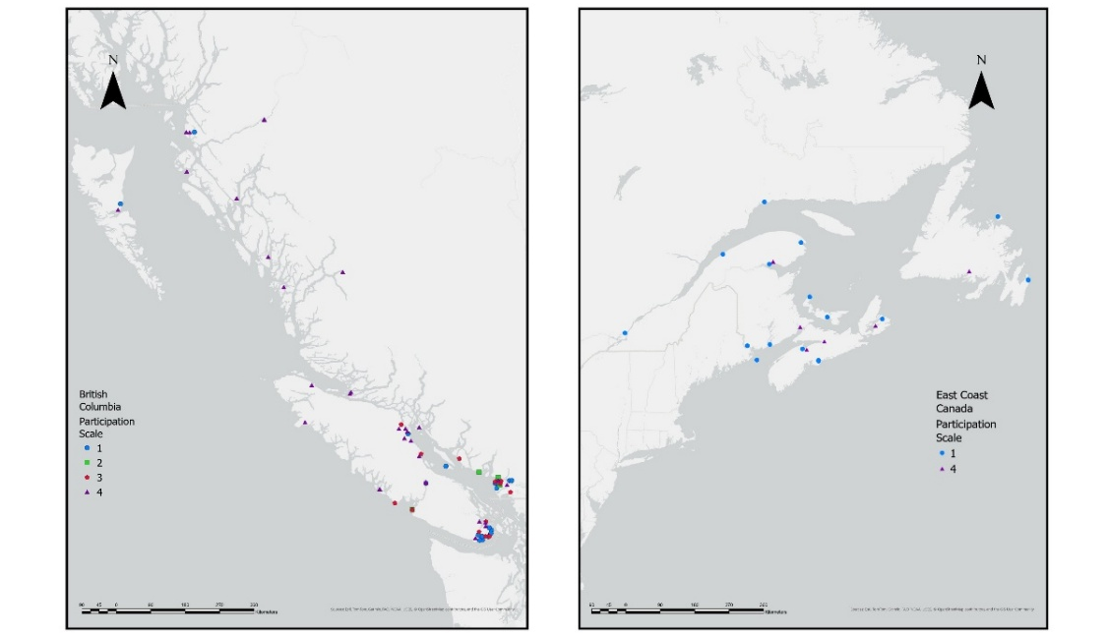
Figure 1: Map of kelp-economy organizations on Canada’s West (left) and East (right) coasts. A participation score of 1 indicated that the organization made no mention of Indigenous/community participation and/or no evidence of any consultation on public facing materials. A score of 2 was given when the organization demonstrated a low-level commitment to Indigenous/community participation. A score of 3 was given when an organization had some level of formal collaboration. Finally, a score of 4 indicated that the organization was owned (in majority or entirely) by an Indigenous Nation(s).

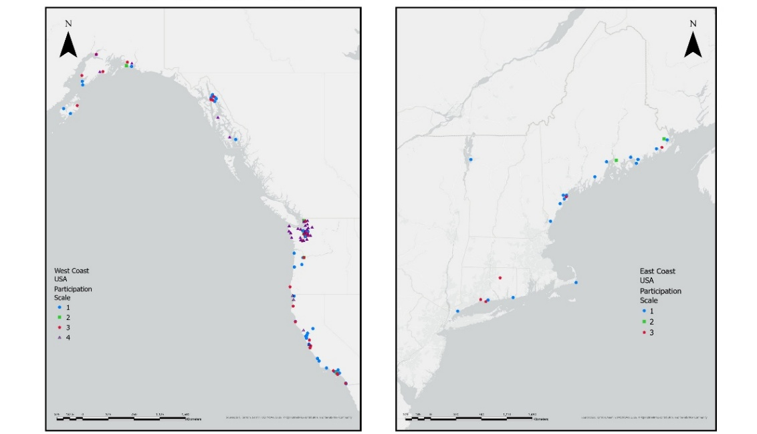
Figure 2: Map of kelp-economy organizations on the USA’s West (left) and East (right) coasts. A participation score of 1 indicated that the organization made no mention of Indigenous/community participation and/or no evidence of any consultation on public facing materials. A score of 2 was given when the organization demonstrated a low-level commitment to Indigenous/community participation. A score of 3 was given when an organization had some level of formal collaboration. Finally, a score of 4 indicated that the organization was owned (in majority or entirely) by an Indigenous Nation(s).
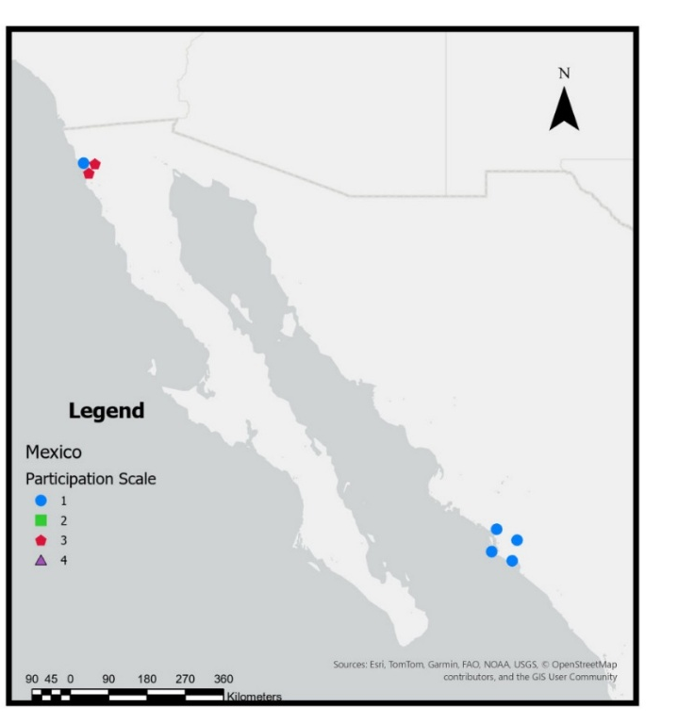
Figure 3: Map of kelp-economy organizations in Mexico. A participation score of 1 indicated no mention of the company giving back to local peoples, a 2 for some sort of interest statement or indication of hiring local peoples, 3 for community project(s) or funding initiative(s), and 4 for co-ownership.
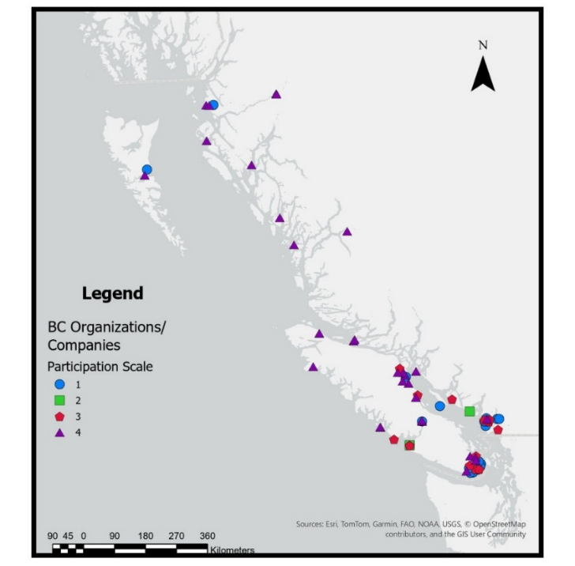
Figure 4: Map of kelp-economy organizations in British Columbia. A participation score of 1 indicated that the organization made no mention of Indigenous/community participation and/or no evidence of any consultation on public facing materials. A score of 2 was given when the organization demonstrated a low-level commitment to Indigenous/community participation. A score of 3 was given when an organization had some level of formal collaboration. Finally, a score of 4 indicated that the organization was owned (in majority or entirely) by an Indigenous Nation(s).

PESTLE Maps
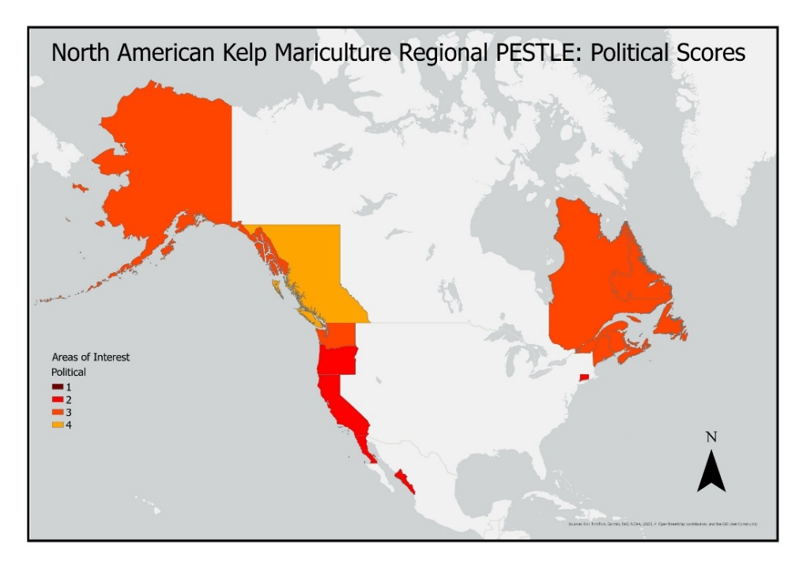
Figure 5: Political scores by state/province in North America. Scores were derived from state or province-level commitments to Indigenous rights consistent with the United Nations Declaration on the Rights of Indigenous People (UNDRIP). Here we utilized a scale from 1-4 where a score of 1 indicated “not enough information”, 2 indicated that UNDRIP was not legislated in the region, 3 indicated UNDRIP was legislated at the federal or provincial (or state) level, and 4 indicated that UNDRIP was legislated at both federal and provincial levels.
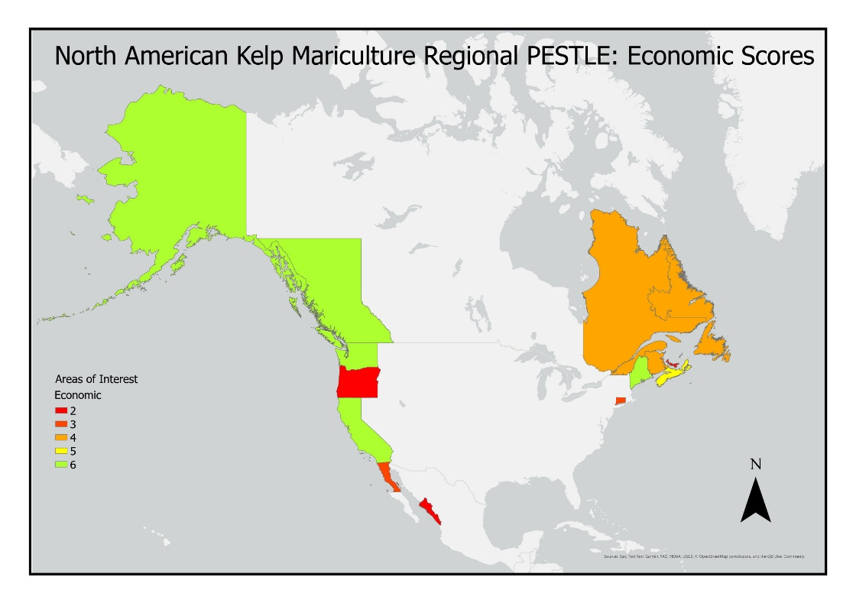
Figure 6: Economic scores by state/province in North America. A score of 1 constituted “not enough information”; 2 indicated “no plans”; 3 indicated some sort of state/province-level aquaculture plan that was inclusive of kelp/seaweed; 4 indicated the presence of some sort of state/province-level “Indigenous/community-focused economic plan”; 5 indicated plan that linked kelp economic development with an Indigenous/community-focused but with no proof of commitment, and finally; 6 indicated a plan that linked kelp and Indigenous/community-focused economic development with proof of commitment (e.g., funding specified, programs associated with, etc.).
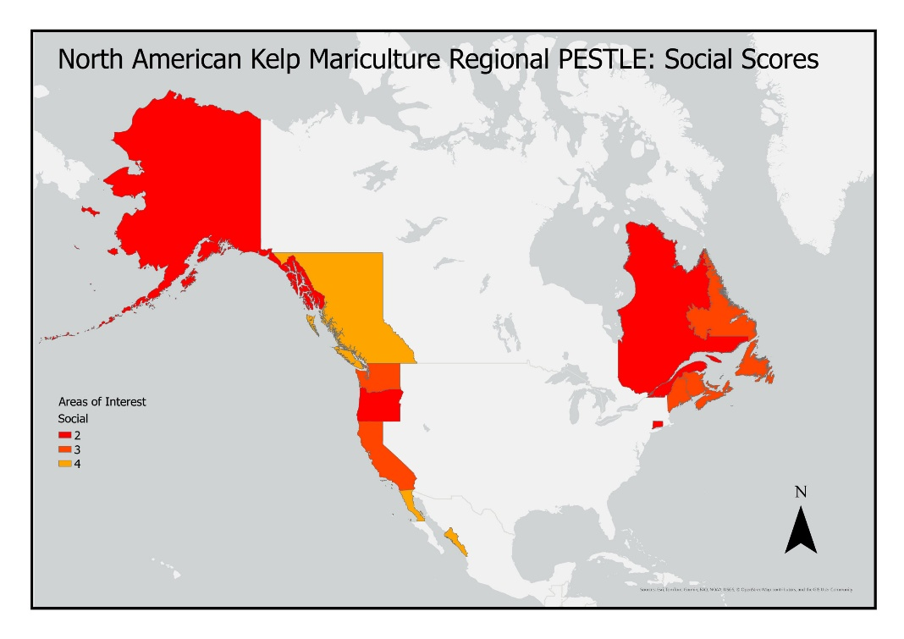
Figure 7: Social scores by state/province in North America. Scores were determined from documentation of public support for kelp/seaweed mariculture, where a score of 1 indicated not enough information, 2 for </=25% support, 3 for 26-50% support, 4 for 51-75% support, and a 5 for >75% support.
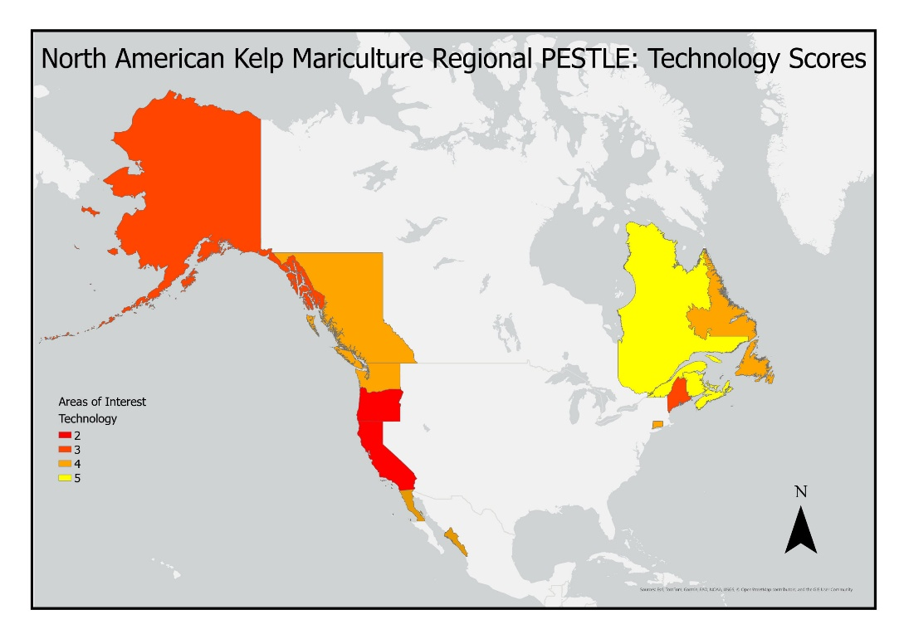
Figure 8: Technology scores by state/province in North America. Scores represented the relative level of investment required to acquire permits for kelp farming, specifically, where 1 indicated “not enough information”, 2 potentially prohibitive conditions, 3 a high level of initial investment (>$5000 USD), 4 a moderate initial investment (>1000 and <$5000 USD), and 5 a low level of initial investment (<$1000 USD).
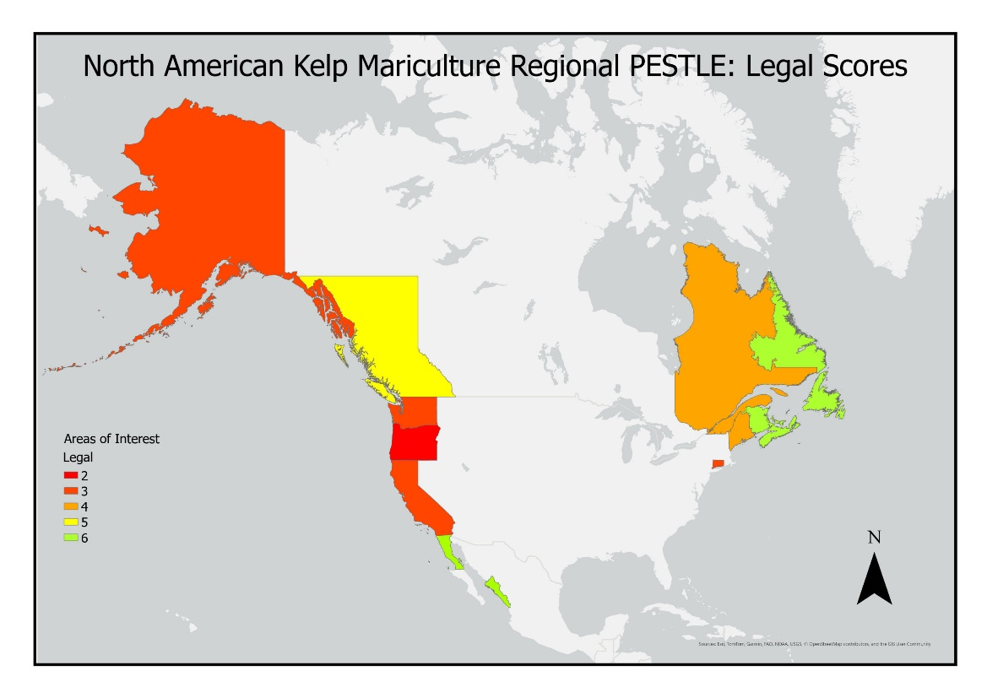
Figure 9: Legal scores by state/province in North America. Scores were a representation of the number of permits required to begin mariculture operations where a score of 1 indicated “not enough information”, 2 indicated that kelp aquaculture was not permitted, 3 indicated >10 permits or regulations were required, 4 indicated 7-9 permits or regulations, 5 indicated 4-6 permits or regulations, and 6 indicated 1-3 permits or regulations.
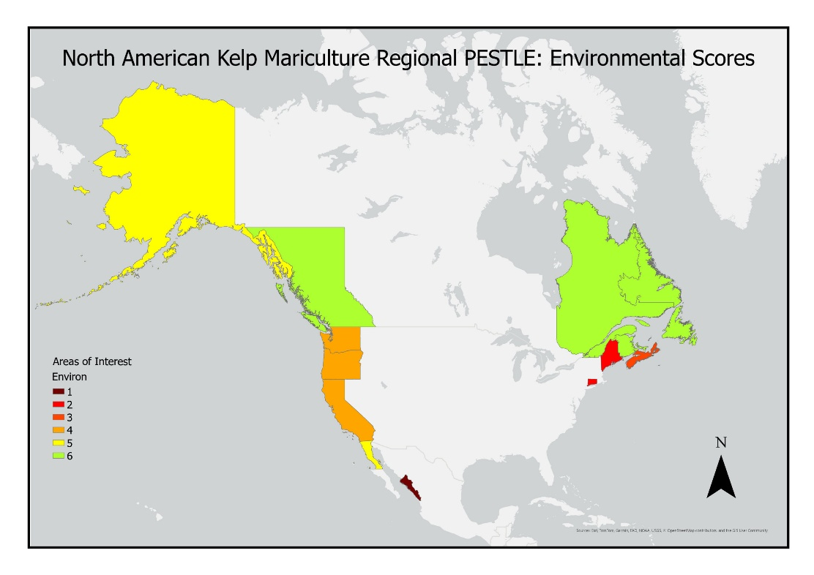
Figure 10: Environmental scores by state/province in North America. Sores were based off Krumhansl et al. (2016), which was the most recent global assessment of kelp abundance at the time of writing. A score of 1 indicated no information, 2 an annual declining trend of >2%, 3 a declining trend <2%, 4 for stable populations, 5 for increasing trend <2%, and a 6 for an increasing trend >2%.

Additional Graphs
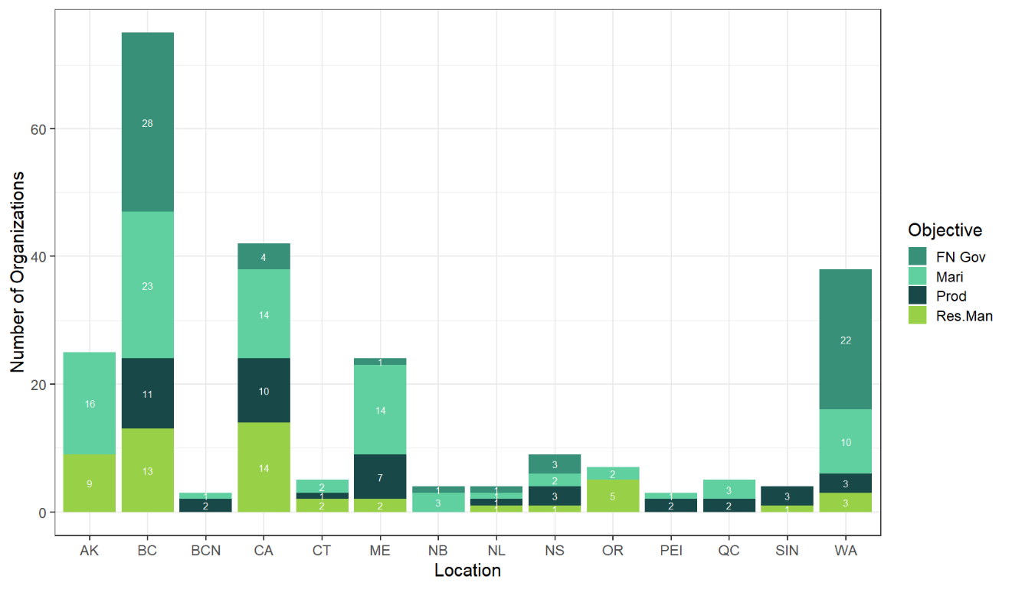
Figure 11: Number of organizations by their primary objective category per region. “Mari” = kelp mariculture (e.g., harvest, farming, seed propagation, restoration), “FN Gov” = First Nations’ governance or stewardship organizations, “Prod” = products and applications (e.g., processing, skincare, medical applications, biostimulants, etc.), and “Res.Man” = research and management.
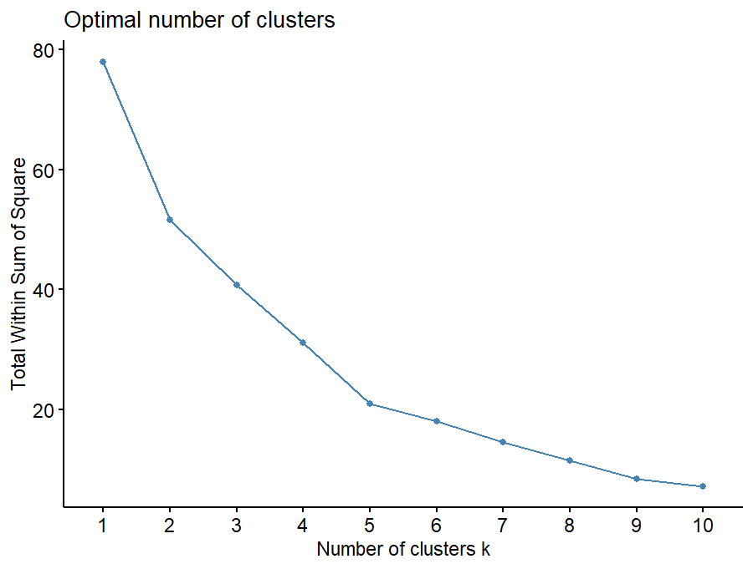
Figure 12: Scree plot for k-means clustering of states/provinces based on PESTLE scores.
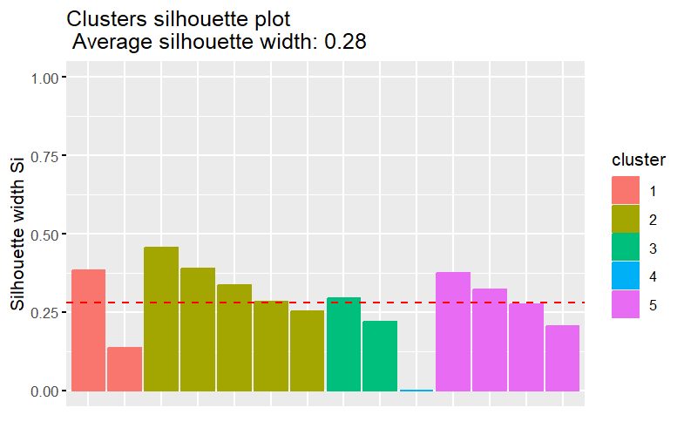
Figure 15: Silhouette plot for k-means clustering of states/provinces based on PESTLE scores.

Supplementary Material References

ANCSA Regional Association. (2025, November 21). About the Alaska Native Claims Settlement Act. ANCSA Regional Association. https://ancsaregional.com/about-ancsa/
California Natural Resources Agency. (2025). Tribal Nature-Based Solutions Program. https://resources.ca.gov/Tribal-Nature-Based-Solutions-Program
Colombo, S., Manríquez-Hernández, J. A., Music, J., & Charlebois, S. (2024). Canadians’ Opinions and Preferences regarding Seafood, and the Factors That Contribute to Their Consumption and Purchasing Habits. Sustainability, 16(3), 1111. https://doi.org/10.3390/su16031111
Commercial Aquaculture Regulation, Chapter A-20.2, r. 1 (2024). https://www.legisquebec.gouv.qc.ca/fr/document/rc/a-20.2,%20r.%201/20240203?langCont=en
Congreso del Estado de Sinaloa. (2024). Congreso aprueba reforma constitucional en materia de pueblos indígenas y afromexicanos. https://www.congresosinaloa.gob.mx/comunicados/congreso-aprueba-reforma-constitucional-en-materia-de-pueblos-indigenas-y-afromexicanos/
Declaration on the Rights of Indigenous Peoples Act, [SBC 2019] CHAPTER 44 (2019). https://www.bclaws.gov.bc.ca/civix/document/id/complete/statreg/19044
Department of Agriculture, Aquaculture and Fisheries. (2011). APPLICATION GUIDE MARINE AQUACULTURE (East Coast). https://www2.gnb.ca/content/dam/gnb/Departments/10/pdf/Services/Aquaculture/01770007-e.pdf
Department of Fisheries, Forestry and Agriculture & Aquaculture Development Division. (2022). Aquaculture Licensing Guide. https://www.gov.nl.ca/fisheries/files/Aquaculture-Licensing-Guide-May-2022-Version-1.0.pdf
Department of Tourism, Culture, Arts and Recreation. (2025). Indigenous Cultural Heritage Program. Government of Newfoundland and Labrador.
FAO. (2024). Fishery and Aquaculture Country Profiles. Mexico, 2023. Country Profile Fact Sheets. In: Fisheries and Aquaculture. Rome. Updated Mar 3, 2022. https://www.fao.org/fishery/en/facp/mex?lang=en
Fisheries and Oceans Canada Government of Canada. (2022, July 13). Prince Edward Island Shellfish Aquaculture Leasing Policy. https://www.dfo-mpo.gc.ca/aquaculture/management-gestion/pei-ipe-eng.htm#_Toc104293224
Fisheries and Oceans Canada & Ministère de l’Agriculture, des Pêcheries et de l’Alimentation du Québec. (2010). Canada – Québec Guide Application for or Modification to an Aquaculture Site in a Marine Environment. https://www.dfo-mpo.gc.ca/aquaculture/management-gestion/doc/GuideCQOct09finaleng.pdf
Flaherty, M., Reid, G., Chopin, T., & Latham, E. (2019). Public attitudes towards marine aquaculture in Canada: Insights from the Pacific and Atlantic coasts. Aquaculture International, 27(1), 9–32. https://doi.org/10.1007/s10499-018-0312-9
Foro Mar de Cortés. (2025, October 7). Gobierno, pescadores y sociedad civil unen fuerzas por la restauración de los bosques de Kelp. https://foromdc.org/ecosistemas/gobierno-pescadores-y-sociedad-civil-unen-fuerzas-por-la-restauracion-de-los-bosques-de-kelp/
Getchis, T., Russo Kelly, M., Concepcion, A., & Bovay, J. (2020). The Connecticut Seafood Survey: Assessing Seafood Consumption, Knowledge, Behaviors and Preferences of Connecticut Residents. (p. 24). Connecticut Sea Grant. CTSG-20-03.
Gobierno de Baja California. (2018). Carta Estatal Pesquera de Baja California 2000-2018. https://www.bajacalifornia.gob.mx/Documentos/Sepesca/doctos/CARTA_ESTATAL_PESQUERA_2000-2018.pdf
Gobierno de México. (2025). VENTANILLA ÚNICA PARA INVERSIONISTAS. https://ventanillaunica.economia.gob.mx/procedure/319/step/433?l=es
Gouvernement du Québec. (2025). Summary of the Indigenous Initiatives Fund IV. https://cdn-contenu.quebec.ca/cdn-contenu/adm/org/secretariat-premieres-nations-inuit/finances/fonds-initiatives/en/FIA-indigenous-initiatives-fund-IV_summary.pdf
Government of BC. (2024). B.C. Coastal Marine Strategy.
Government of Nova Scotia. (2012). Aquaculture-Strategy. https://novascotia.ca/fish/documents/NS-Aquaculture-Strategy.pdf
GreenWave. (2025). Site Evaluation: Understand the Regulations | Getting Started: Courses. Ocean Farming Hub. https://hub.greenwave.org/lms/lesson-section/understand-the-regulations/
Guan, J., McEwen, M., Rilum, S., & Wee, L. (2022). Perceptions of Seaweed Aquaculture in Santa Barbara and Ventura Counties [Master of Environmental Science and Management (MESM) Program Grou Project]. Prepared for Ocean Rainforest. https://bren.ucsb.edu/sites/default/files/2022-05/KelpWanted-%20Final%20Report%20and%20Appendices.pdf
Kosichek, H., Reimer, J., & Filgueira, R. (2024). Assessing the potential for seaweed aquaculture in Nova Scotia. Aquaculture Reports, 36, 102064. https://doi.org/10.1016/j.aqrep.2024.102064
Kotowicz, D. M., Concepcion, A., Bradt, G., Chadsey, M., Clemetson, A., Good, M., Reitsma, J., & Robidoux, J. (2024). Identifying challenges of the US domestic seaweed aquaculture industry. Aquaculture, 593, 741314. https://doi.org/10.1016/j.aquaculture.2024.741314
Krumhansl, K. A., Okamoto, D. K., Rassweiler, A., Novak, M., Bolton, J. J., Cavanaugh, K. C., Connell, S. D., Johnson, C. R., Konar, B., Ling, S. D., Micheli, F., Norderhaug, K. M., Pérez-Matus, A., Sousa-Pinto, I., Reed, D. C., Salomon, A. K., Shears, N. T., Wernberg, T., Anderson, R. J., … Byrnes, J. E. K. (2016). Global patterns of kelp forest change over the past half-century. Proceedings of the National Academy of Sciences of the United States of America, 113(48), 13785–13790. https://doi.org/10.1073/PNAS.1606102113/-/DCSUPPLEMENTAL/PNAS.1606102113.SAPP.PDF
Ley de Derechos y Cultura Indígena del Estado de Baja California, DECRETO N° 435 (2015).
LGL. (2024). RDMW Seaweed Industry Development Plan 2024. Regional District of Mount Waddington.
Maine Coastal Program & Department of Marine Resources. (2025, April 23). Maine Coastal Program STRATEGIC OUTLOOK 2026 – 2030: Draft for Public Comment. https://www.maine.gov/dmr/sites/maine.gov.dmr/files/inline-files/MCP_StrategicOutlook_2026-2030_DRAFT_4.22.2025_PublicComment.pdf
Maine Indian Tribal-State Commission. (2025). Maine Indian Tribal-State Commission. https://www.mitsc.org/
Ministry of Jobs Trade and Technology. (2025). Indigenous Economic Development Resources. Province of British Columbia. https://www2.gov.bc.ca/gov/content/employment-business/economic-development/indigenous-economic-development-resources#ProvinceofBC
New Brunswick Department of Agriculture, Aquaculture and Fisheries. (2023, June 24). New Brunswick Finfish Aquaculture Growth Strategy. Government of New Brunswick. https://www2.gnb.ca/content/dam/gnb/Departments/10/pdf/Aquaculture/nb-finfish-aquaculture-growth-strategy%202022-2030.pdf
NOAA, Sea Grant Connecticut, & University of Connecticut. (2018). Science Serving the Connecticut Coast: Connecticut Sea Grant Strategic Plan 2018-2023. https://seagrant.noaa.gov/wp-content/uploads/2023/07/CTSG_Strategic_Plan_2018-2023_ACCESSIBLE1.pdf
Nova Scotia Department of Fisheries and Aquaculture. (2025). Guide for Shellfish and Plant Marine Aquaculture Development Plans. https://novascotia.ca/fish/aquaculture/licensing-leasing/
NS Reg 347/2015 | Aquaculture Licence and Lease Regulations (2015). https://www.canlii.org/en/ns/laws/regu/ns-reg-347-2015/latest/ns-reg-347-2015.html
Puget Sound Partnership. (2022). 2022-2026 Action Agenda for Puget Sound.
Puget Sound Partnership. (2024). About the Puget Sound Partnership. https://www.psp.wa.gov/puget-sound-partnership.php
Rep. Emery, D. F. [R-M.-1. (1980, October 10). H.R.7919 - 96th Congress (1979-1980): Maine Indian Claims Settlement Act of 1980 (1980-08-01) [Legislation]. https://www.congress.gov/bill/96th-congress/house-bill/7919
Sea Grant Connecticut & University of Connecticut. (2024). Kelp Farming Guidebook. https://seagrant.media.uconn.edu/wp-content/uploads/sites/1985/2024/05/Kelp-Farming-Guide-w-Annex-5.8-MR.FINAL_.pdf
Secretaría de Medio Ambiente y Recursos Naturales. (2025). Trámite SEMARNAT-04-001. gob.mx. http://www.gob.mx/semarnat/documentos/tramite-semarnat-04-001
State of Alaska. (2018). Alaska Mariculture Development Plan. https://www.adfg.alaska.gov/Static/fishing/pdfs/mariculture/ak_mariculture_devplan_06-29-18.pdf
State of California. (2021). Guiding Principlse for Sustainable Marine Aquaculutre in California. https://www.opc.ca.gov/webmaster/_media_library/2021/06/Aquaculture-Principles-Public-20210604.pdf?_gl=1*in1ics*_ga*MTE4MTk5NDM4Ni4xNzY2MDc2NTk5*_ga_QZ1X3CHBC8*czE3NjYwNzY4NjckbzEkZzAkdDE3NjYwNzY4NjckajYwJGwwJGgw
Tenorio-Rodríguez, P. A., Nicasio-Arzeta, S., Robledo, D., & Freile-Pelegrín, Y. (2025). Consumer acceptance of edible seaweed in Mexico: An exploratory study on willingness. Food Quality and Preference, 133, 105630. https://doi.org/10.1016/j.foodqual.2025.105630
Treasury Board of Canada Government of Canada. (2006, December 7). Joint Economic Development Initiative [Examples]. https://www.tbs-sct.canada.ca/fcer-cfre/rfc-cfr/studies-etudes/jedi-icde-eng.asp
UN Biodiversity Lab. (2025, July 24). UN Biodiversity Lab | Map. https://map.unbiodiversitylab.org/earth
United Nations Declaration on the Rights of Indigenous Peoples Act, Pub. L. No. S.C. 2021, c. 14 (2021). https://laws-lois.justice.gc.ca/PDF/U-2.2.pdf
Vázquez-Vera, L., & Chávez-Carreño, P. (2022). Diagnóstico de la acuacultura en México (Fondo Mexicano Para La Conservación de La Naturaleza). https://fmcn.org/uploads/publication/file/pdf/Libro%20Acuacultura_2022.pdf
Xue, W. (2025). Study on Public Perceptions on Seaweed Aquaculture in Maine [Master of Environmental Management, Nicholas School of the Environment of Duke University]. https://dukespace.lib.duke.edu/server/api/core/bitstreams/166a788c-4f36-4a0b-8830-a0a172b3bdc2/content

