Appendix 1: Student Writing Sample Selected for EFL Writing Feedback Practice
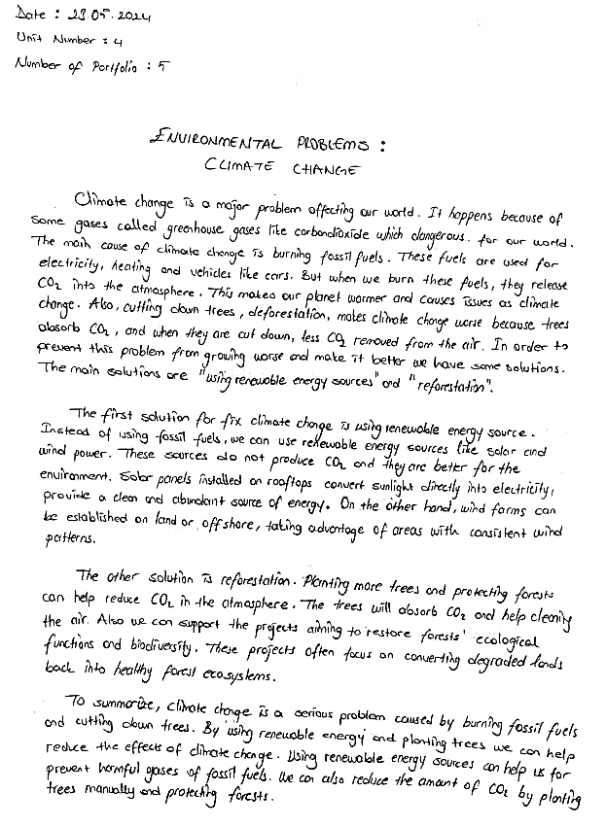

Appendix 2: Screenshots from Online AI-Assisted Feedback Training Sessions

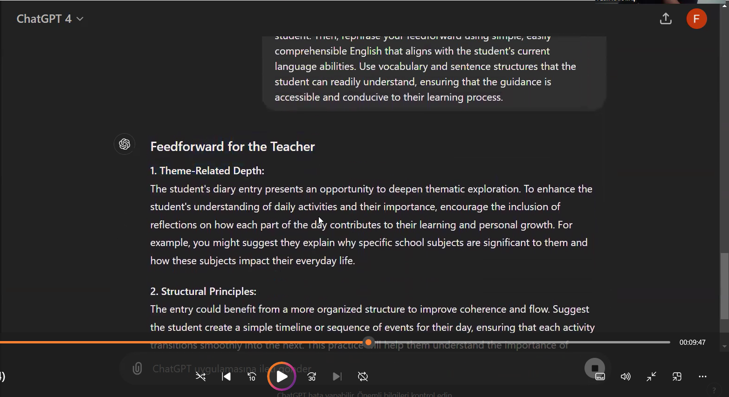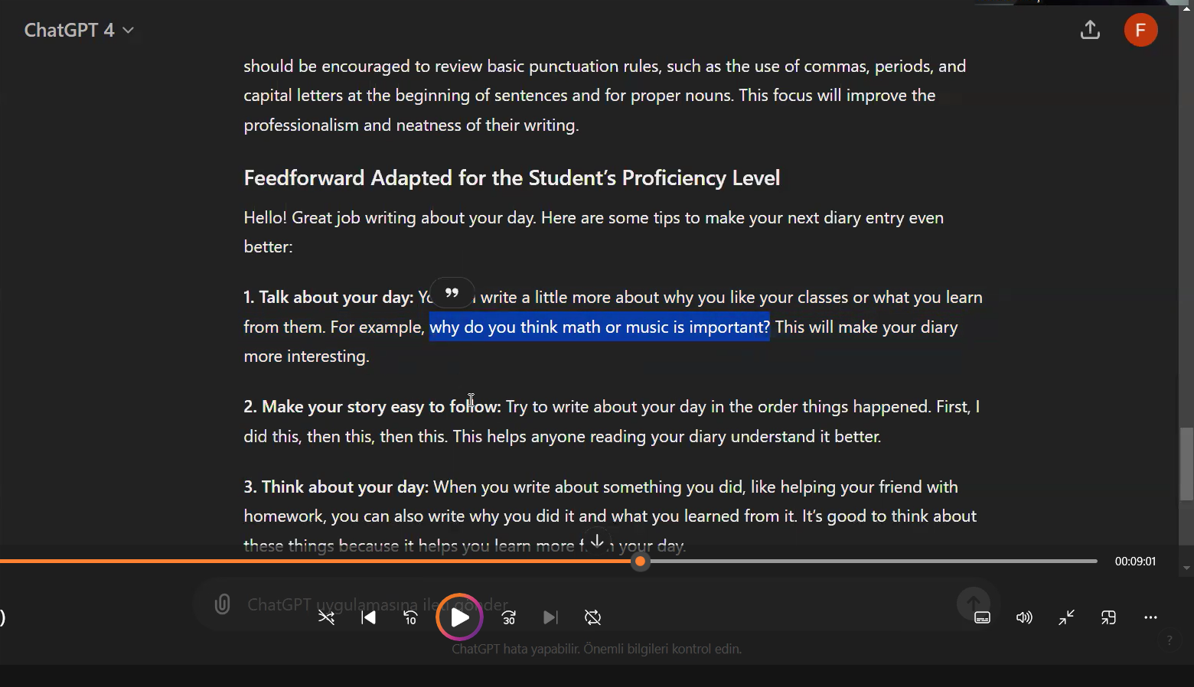

Appendix 3: Paper-Pencil Feedback Sample from Control Group Practice Sessions

