Supplementary Information

Atomic-Scale Quantum Control of Individual Spin Defects in a
Two-Dimensional Semiconductor

Kwan Ho Au-Yeung^{1,2†}, Wantong Huang^{1†}, Johanna Matusche^{1†}, Paul Greule¹, Jonas Arnold¹, Lovis Hardeweg¹, Máté Stark¹, Luise Renz¹, Affan Safeer³, Daniel Jansen³, Thomas Michely³, Jeison Fischer³, Wolfgang Wernsdorfer^{1,2,4}, Christoph Sürgers¹, Hannu-Pekka Komsa⁵, Johannes Schwenk^{1*}, Wouter Jolie^{3*}, Philip Willke^{1,2}
¹ Physikalisches Institut (PHI), Karlsruhe Institute of Technology, Karlsruhe, Germany
² Center for Integrated Quantum Science and Technology (IQST), Karlsruhe Institute of Technology, Karlsruhe, Germany
³ II. Physikalisches Institut, Universität zu Köln, Cologne, Germany
⁴ Institute for Quantum Materials and Technologies (IQMT), Karlsruhe Institute of Technology, Karlsruhe, Germany
⁵ Faculty of Information Technology and Electrical Engineering, University of Oulu, Oulu, Finland
* corresponding author: johannes.schwenk@kit.edu , wjolie@ph2.uni-koeln.de
† These authors contributed equally

Table of Contents
Supplementary Figs. 1-12 2
Supplementary Note 1. Stochastic Resonance Spectroscopy Analysis 12
Supplementary Note 2. Exchange-mediated spin-electric-coupling 14
Supplementary Note 3. Density functional theory calculations for $V_{S}^{-}$, $C_{S}^{-}$ and ${\left(2C_{S}\right)}^{-}$ 16
Supplementary Note 4. Spin–spin interaction in engineered carbon defect dimers 18

Supplementary Figs. 1-12

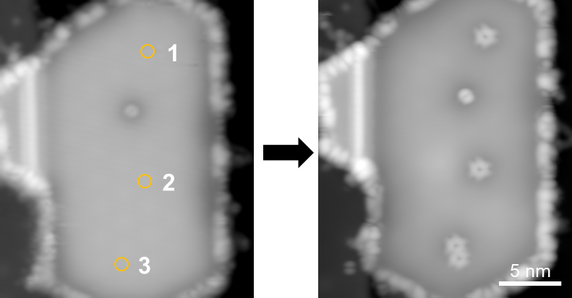

Supplementary Fig. 1. STM tip-assisted creation of point defects on intact monolayer MoS₂ islands. STM images acquired before and after tip-induced defect creation using voltage-pulse protocols. Defects are generated either by applying high-voltage pulses (>5 V, 100 ms, feedback off) at fixed tip position or by approaching the tip toward the surface first ($V_{DC}=40 mV$, $I=20 pA$, $∆z=650 pm$) followed by a voltage pulse (typically 1.7 V, 100 ms). Both methods enable creation of sulfur vacancies ($V_{S}^{-}$), while carbon substitutions ($C_{S}^{-}$) are preferably formed with the first method. Movement of $C_{S}^{-}$ (Fig. 4) has been performed via the first method. The latter required the incorporation of carbon, likely from nearby organic adsorbates or the underlying graphene substrate. The example shown above illustrates the creation of four $V_{S}^{-}$ defects at the three tip pulsing positions with the first method; an additional defect present prior to the sequence is also visible (Imaging parameters: $V_{DC}=1 V$, $I=20 pA$).

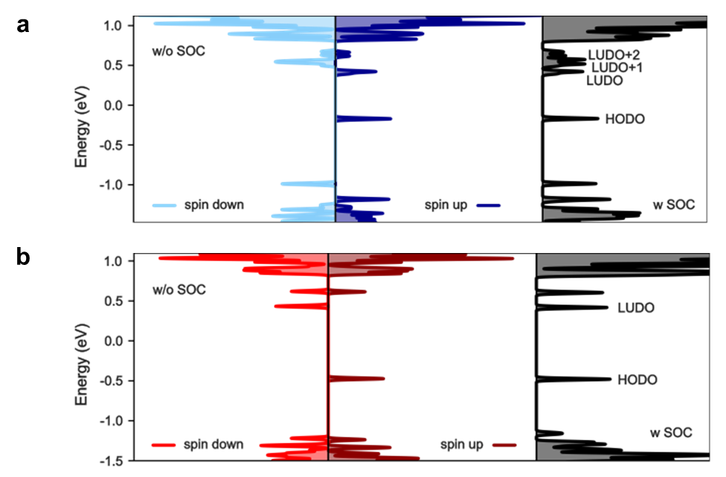
Supplementary Fig. 2. DFT-calculated density of states of a, the negatively charged top-layer sulfur vacancy $V_{S}^{-}$ in type 2 Jahn-Teller distorted state, and b, the negatively charged carbon substitutional defect${ C}_{S}^{-}$, excluding the influence of spin-orbit coupling (left) and total density of states including spin-orbit coupling (right). The Fermi level in (a, b) was set to fit the energy of the HODO in experiment.

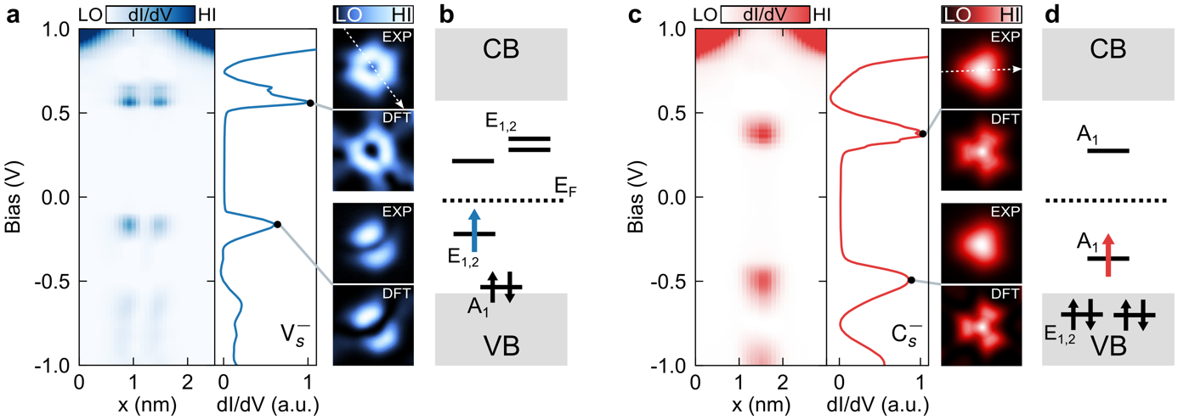
Supplementary Fig. 3. Electronic structure of spin defects. a, dI/dV line spectroscopy of $V_{S}^{-}$ (indicated by the white dotted line in the dI/dV orbital map) with integrated dI/dV spectrum (middle). dI/dV orbital maps of the states indicated by the two black dots are shown on the right (image size: 1.7 nm × 1.7 nm, +565 mV and -170 mV) along with corresponding DFT-calculations (Supplementary Section 3). b, Energy level diagram of $V_{S}^{-}$ in-gap states (CB: conduction band, VB: valence band). In the neutral state, the defect orbitals are split into one $A_{1}$ and two $E_{1,2}$ states with orbital degeneracy. Including spin-orbit coupling, charging, and Jahn-Teller distortion yields a highest occupied defect orbital (HODO) along with multiple lowest unoccupied defect orbitals (LUDO) and a single unpaired spin in one of the $E_{1,2}$states (blue arrow). Black arrows indicate the occupied A₁ spin states. c, dI/dV measurements of $C_{S}^{-}$ (dI/dV map image size: 1.7 nm × 1.7 nm; +400 mV and -480 mV). The $C_{S}^{-}$ defect shows nearly identical orbital shapes for the occupied (-480 meV) and unoccupied (+400 meV) states, which indicates a single open-shell defect configuration. Right: dI/dV orbital maps are in excellent agreement with DFT calculations (see also Supplementary Section 3) for both orbital symmetry and energetic alignment. d, Corresponding energy level diagram: The $C_{S}^{-}$ hosts a single spin in the half-occupied $A_{1}$ orbital. [Black arrows indicate occupied E_{1,2} states. Setpoints: (a, c) $V_{DC}=-1.5 V$, $I=50 pA$, $V_{mod}=10 mV$].

Supplementary Fig. 4. Additional dI/dV spectroscopy and spin density maps. a, dI/dV spectra acquired on a carbon substitution ($C_{s}^{-}$) at zero magnetic field and at an out-of-plane field of 1 T. At zero field, the spectrum exhibits a weak zero-bias Kondo resonance, which splits under applied magnetic field. The spectra are vertically offset for clarity. Black lines are fits based on inelastic electron spin transport calculations of a spin-½ system with g = 2 ¹ (Setpoints: a, $I=100 pA$, $V_{DC}=5 mV$, $V_{mod}=50 µV$) b-e, Spin contrast maps of b, a sulfur vacancy ($V_{S}^{-}$) and d, a carbon substitution ($C_{S}^{-}$), acquired with a spin-polarized STM tip. In the presence of a localized spin, inelastic electron tunneling leads to a pronounced asymmetry in the differential conductance at opposite bias polarities near zero bias. ^{1,2}. The maps are calculated from $\left|dI/dV (+V_{asym})- dI/dV (-V_{asym}) \right|$ with $V_{asym}=10 mV$ ($5 mV$) for $V_{S}^{-}$ ($C_{S}^{-}$). (c, e) dI/dV point spectra recorded at the positions indicated in (b, d), showing enhanced conductance asymmetry at negative bias in regions of high spin contrast and negligible asymmetry in regions with low contrast. All spectra were acquired at zero magnetic field and are vertically offset for clarity. [Imaging parameters: 1.12 nm × 1.12 nm; (b-c) $V=10 mV, I=200 pA, V_{mod}=0.8 mV$; (d-e) $V=5 mV, I=500 pA, V_{mod}=0.5 mV$].

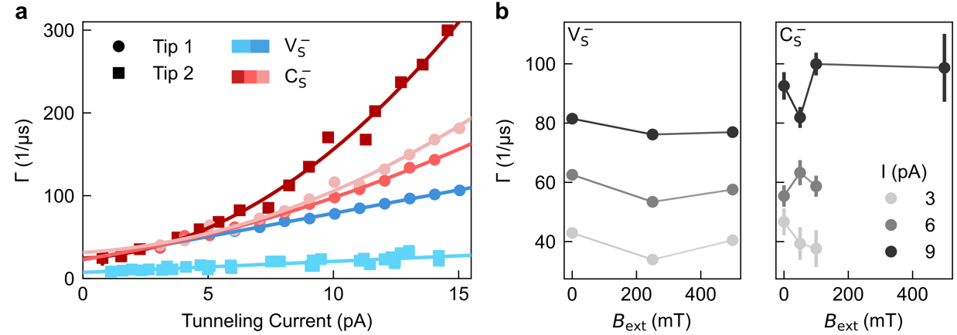
Supplementary Fig. 5. Current- and magnetic field-dependent SRS measurements. a, The total transition rate $Γ$ as a function of tunneling current $I$ for both defect types $V_{S}^{-}$ (blue) and $C_{S}^{-}$ (red) for two different tips and different defects ($V_{AC}\text{ = }2 mV$, $\left|V_{DC}\right|\text{ = }1.5-2 mV,$ $B_{ext}=0 T$). In both cases, $Γ$ increases with increasing $I$, indicating that inelastic scattering of tunneling electrons induces spin flips. $V_{S}^{-}$ exhibits both a lower zero-current relaxation rate and a more linear dependence on tunneling current than $C_{S}^{-}$, consistent with reduced local coupling to tunnelling electrons due to its spatially distributed (two-lobe) orbital overlap (HODO shown in Supplementary Fig. 3a) with the tip. From the slope in the linear part, we find that the inelastic scattering probability is $P_{T_{1}}^{V_{S}^{-}}=\left(\frac{ΔΓ}{ΔI}\right)⋅e≈\left(45±1\right)\text{\%}$ per electron. b, Transition rate $Γ$ for different external magnetic field $B_{ext}$. Data taken for different tunnelling currents $I$ and both defect types $V_{S}^{-}$ (left), $C_{S}^{-}$ (right) ($V_{AC}\text{= }2 mV$, |$V_{DC}|=1.5 mV$ for $V_{S}^{-}$ and $\left|V_{DC}\right|=2 mV$ for $C_{S}^{-}$). In general, $Γ$ does not show a strong dependence on magnetic field.

Supplementary Fig. 6. Effective magnetic moments extracted from ESR measurements. a, ESR resonance frequency $f_{0}$ of $C_{S}^{-}$ as a function of magnetic field, extracted from Fig. 2d. A linear fit using $hf_{0}\text{=}\text{2}μ(B\text{+}B_{tip})$ yields an effective magnetic moment of $μ_{C_{S}^{-}}=0.948 ± 0.016 μ_{B}$ and an effective magnetic tip field of $B_{tip}=4 ± 2 mT$ (Setpoints: $I=5 pA$, $V_{DC}=20 mV$, $V_{RF}=10 mV$). b, Effective magnetic moment $μ$ extracted from linear fits of the ESR resonance frequency as a function of $B$ for sulfur vacancies ($V_{S}^{-}$, blue) and carbon substitutions ($C_{S}^{-}$, red). They are plotted as a function of the effective magnetic tip field $B_{tip}$, also obtained from the fits. Each data point corresponds to a different defect-tip combination ($V_{S}^{-}$: 9 defects measured with 6 tips; $C_{S}^{-}$: 4 defects measured with 3 tips). Horizontal and vertical error bars are derived from the linear fits. The extracted magnetic moment shows a dependence on $\left|B_{tip}\right|$, reflecting the influence of the tip field on the resonance condition $f_{0}\text{\sim }B$ as pointed out by Ref. ³: An apparent change in $μ$ occurs, if $B_{tip}$ also changes with $B$ and is minimized for vanishing $B_{tip}$. Thus, we only average values obtained for $\left|B_{tip}\right|\text{<}10 mT$, which yields $μ_{V_{S}^{-}}=\left(0.992±0.011\right) μ_{B}$ and $μ_{C_{S}^{-}}=\left(0.975±0.007\right) μ_{B}$. In addition to the influence of $B_{tip}$, variations in $μ$ may also arise from differences in the local environment of the spin center, such as local strain or Jahn-Teller distortion.

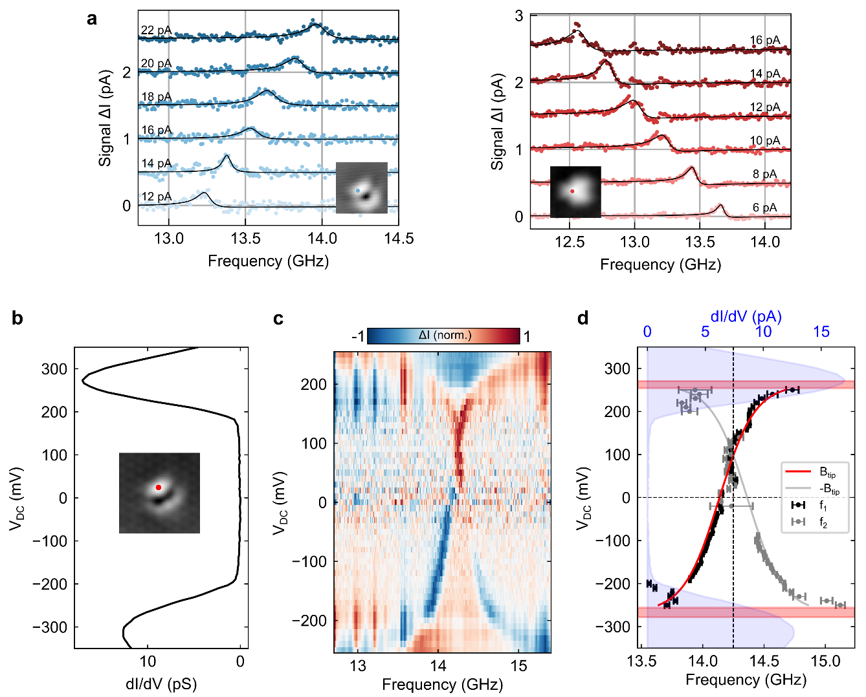
Supplementary Fig. 7. Exchange-mediated spin–electric coupling. a, ESR spectra measured on an isolated $V_{S}^{-}$ and $C_{S}^{-}$ for different tunneling current setpoints, showing systematic shifts of the resonance frequency with increased tip electrode coupling $γ_{T}$ via the effective magnetic field $B_{tip}$ generated by the magnetic STM tip, Eq. (S5). The direction of the shift depends on the relative alignment of $B_{tip}$ and the external magnetic field ($V_{DC}=20 mV$, $V_{RF}=5-10 mV$, $B_{ext}=450-520 mT$). b, dI/dV spectrum acquired on a sulfur vacancy defect showing resonant tunneling through the highest occupied (HODO) and lowest unoccupied (LUDO) defect orbitals. The measurement position is indicated in the inset STM topography ($I=200 pA$, $V_{DC}=-350 mV$, $V_{mod} = 8 mV$; inset: $I=20 pA$, $V_{DC}=40 mV$, 2 nm × 2 nm). c, Colormap of the ESR signal recorded on the same defect as in (b), plotted as the normalized tunneling current difference as a function of frequency and applied bias voltage $V_{DC}$. Vertical stripe features are artifacts from the RF transfer function that are pronounced at high tunneling currents. Owing to the bistability of the tip magnetization, two mirrored resonance branches can be observed. As $V_{DC}$ approaches the defect orbital energies, the resonance frequency exhibits strongly non-linear shifts with opposite sign for HODO and LUDO ($B = 510 mT$, $V_{DC}=30 mV$, $I=4 pA$, $V_{RF}=8 mV$). d, Extracted resonance frequencies $f_{1}$ and $f_{2}$ from the data in (c). The red curve shows a fit to the dominant branch $f_{1}$using the exchange-field model (Eq. S5), yielding $ϵ=-267±11 meV$, $U=530±17 meV$, $γ_{T}=32±3 mT$, and $B_{0}=-4.1±0.5 mT$(fixed $P=-1$). The mirrored fit (grey) reproduces the weaker branch $f_{2}$. Horizontal bars indicate the orbital energies extracted from the SEC; the dI/dV spectrum from (b) is shown in the background for reference.
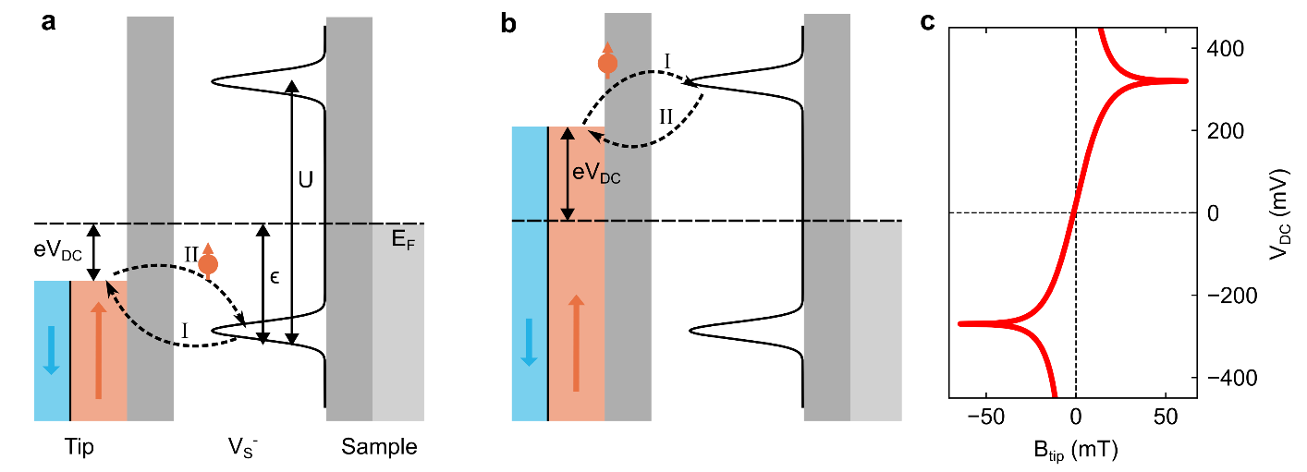
Supplementary Fig. 8. Theory of exchange-mediated Spin-Electric-Coupling. a, Schematic drawing of the tunnel junction with the tip electrode on the left and sample electrode on the right. The solid black line shows the defect states which lie in the band gap of the MoS₂. The bars in dark grey represent the two tunneling barriers. The chemical potential of the magnetic tip is shifted via the bias voltage $V_{DC}$. The arrows indicate the virtual tunneling processes dominant for negative voltages with (I) emptying the defect state and (II) refilling it. b, Analogous to (a) with positive bias voltage enhancing the virtual tunneling process with the unoccupied orbital. (I) virtual tunneling into the state adding a second electron to the defect and (II) virtual tunneling out of the state. c, Plot of the tip exchange field $B_{tip}$ according to Eq. (S5) and the applied bias voltage $V_{DC}$ showing a logarithmic divergence when the voltage matches the energy levels of the orbitals.

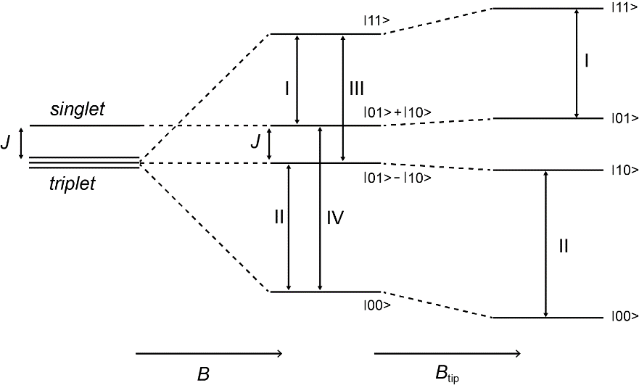
Supplementary Fig. 9. Schematic energy level diagram of the two spin 1/2 as a function of $B$ and $B_{tip}$ for given $J$ (ferromagnetic). Labels I, II, III, IV denote the possible transitions when performing ESR on the first spin.

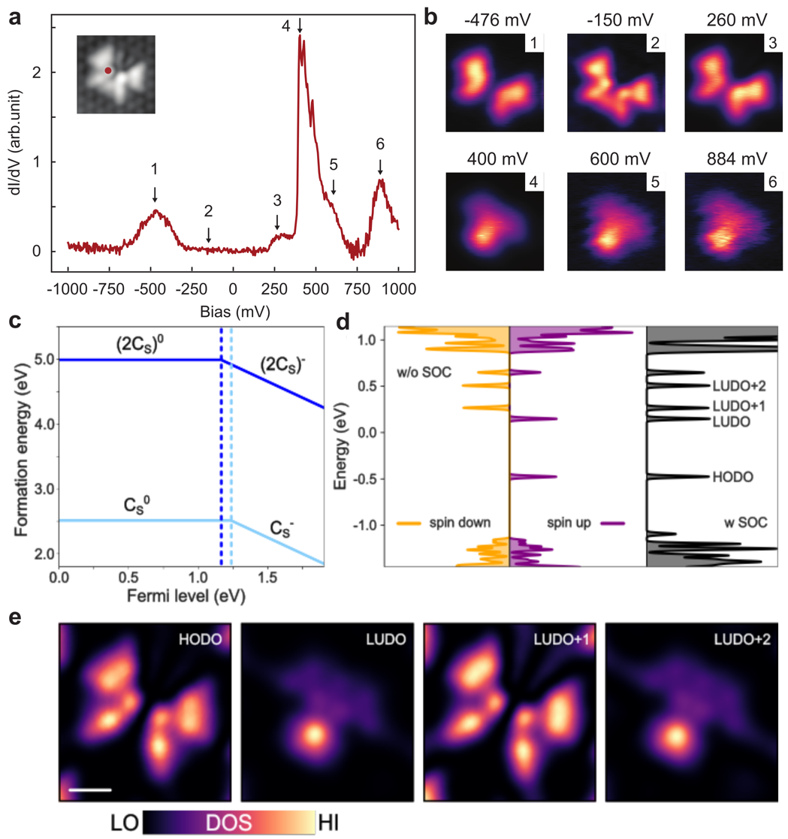

Supplementary Fig. 10. Experimental and DFT-calculated electronic structure of the carbon disubstitution ${\left(2C_{S}\right)}^{-}$ defect. a, dI/dV spectrum measured on the closest possible (0,1) configuration of two carbon substitution defects, forming a carbon dimer defect denoted ${\left(2C_{S}\right)}^{-}$ (Fig. 4c). Compared to the isolated $C_{S}^{-}$ defect (Supplementary Fig. 3c), the spectrum exhibits additional resonances and pronounced changes in spectral weight, indicating the emergence of new electronic states. Arrows mark the bias voltages at which spatially resolved dI/dV maps were acquired. The inset shows the STM topography of the defect, with the position of the spectroscopy measurement indicated (setpoint: $I=100$ pA, $V_{DC}=1$V). b, Corresponding dI/dV maps (1.92 nm × 1.92 nm) recorded at the bias voltages indicated in (a), revealing the spatial evolution and symmetry of the defect’s electronic states. The maps are distinct from those of isolated carbon substitution defects, reflecting the modified electronic structure of the ${\left(2C_{S}\right)}^{-}$ complex. In addition to the resonant states marked in (a), the in-gap state at –150 mV is shown. c, DFT-calculated formation energies of a single carbon substitution defect ($C_{S}$, light blue) and a carbon substitution dimer ($2C_{S}$, dark blue) in nearest-neighbor configurations as a function of Fermi level position. A transition between a charged and neutral defect can be identified by the change of slope, as the Gibbs free energy of defect formation changes linearly with Fermi level when the defect is charged by an amount q ⁴. Here q changes from zero (neutral) to -e, with e being the elementary charge. d, Density of states of ${\left(2C_{S}\right)}^{-}$ calculated without spin–orbit coupling (left, spin-polarized) and including spin–orbit coupling (right). The Fermi level was set to fit the energy of the highest occupied defect orbital (HODO) in experiment. e, Simulated images of four in-gap defect states of ${\left(2C_{S}\right)}^{-}$ calculated by DFT (Scale bar: 0.5 nm).
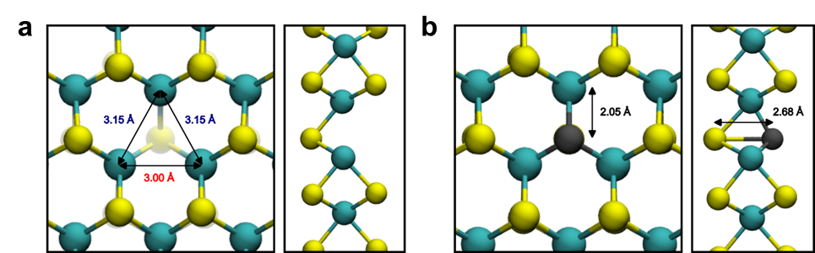
Supplementary Fig. 11. Atomic structure model of point defects computed by density functional theory. a, Top (left) and side view (right) of a single negatively charged top-layer sulfur vacancy $V_{S}^{-}$ in the type 2 Jahn-Teller distorted state. The arrows mark the distances between Mo atoms surrounding the sulfur vacancy. b, Top (left) and side view (right) of a substitutional carbon atom in the negative charge state $C_{S}^{-}$. The arrows mark respective bond lengths.

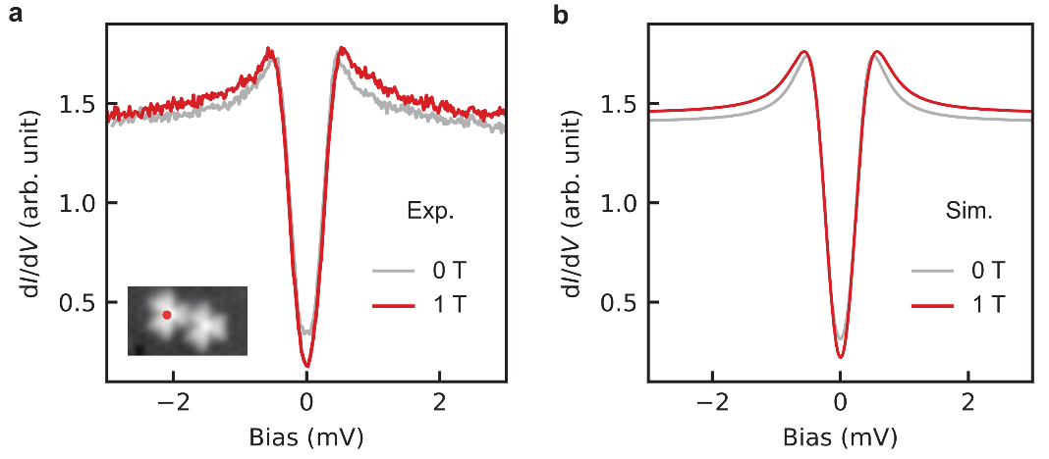
Supplementary Fig. 12. Comparison between experiment and simulation of the differential conductance of the $C_{S}^{-}$ defect dimer. a, Experimental dI/dV spectra measured on the left $C_{S}^{-}$, as indicated in the inset, at 0 T (gray) and at 1 T (red, Setpoints: $V_{DC}=10 mV$, $I=300 pA$, $V_{mod}=50 μV$). b, Corresponding simulated dI/dV spectra at 0 T (gray) and 1 T (red). The simulations are performed using inelastic electron spin-transport calculations for two antiferromagnetically coupled spins $S=1/2$, with an exchange coupling $J = 354 μeV$ and g = 2 for both spins.

Supplementary Note 1. Stochastic Resonance Spectroscopy Analysis
In this section, we discuss in greater detail the results of stochastic resonance spectroscopy (SRS). We point to Ref. ⁵ for an in-depth discussion on the SRS technique. Moreover, we follow the framework of spin relaxation established in Ref. ⁶ for inelastic scattering between on-surface spins and tunneling electrons. We employ SRS to quantify the spin relaxation time $T_{1}$, identify dominant relaxation channels, and probe the spatial extent of individual defect spins. In STM-based SRS, an oscillating bias voltage $V_{AC}$ drives stochastic transitions between the two spin states |0⟩ and |1⟩, and the resulting frequency-dependent tunneling current yields the transition rate $Γ=Γ_{0→1}+Γ_{1→0}$, with $T_{1}=1/Γ_{1→0}≈1/Γ$ (Fig. 2c) ⁵. This is observed as a characteristic step at $f_{AC}=Γ/2π$.

We first investigate the dependence of $Γ$ on tunneling current $I$ in greater detail. For both defect types and different tips, the transition rate increases strongly with current (Supplementary Fig. 5a), indicating that relaxation is dominated by scattering processes involving tunneling electrons and nearby metallic electrodes. While $Γ(I)$ is linear for $V_{S}^{-}$ defects over the measured range, $C_{S}^{-}$ defects exhibit an additional non-linear contribution, consistent with enhanced coupling to the tip electrode (see below).

To model this behavior, we write $Γ$ as the sum of inelastic tunneling processes $Γ_{ij}$, in which electrons from the tip (t) and sample (s) exchange energy with the spin ⁶ [assuming $V=0 V$]:

$Γ= Γ_{t-t}+Γ_{t-s}+Γ_{s-t}+Γ_{s-s}=\frac{P_{T_{1}}E_{01}}{e^{2}}{( G}_{t-t}+G_{t-s}+G_{s-t}+G_{s-s})$ (S1)

Here, $P_{T_{1}}$ denotes the probability that a tunneling electron induces a spin relaxation event (assumed to be identical for all electrode pairs) and $E_{01}$ is the energy splitting between the ground and excited spin states. The conductances $G_{t-s}=G_{s-t}=I/V$ describing tunneling from tip to substrate and vice versa are equal for a symmetric junction. The terms $G_{s-s}$ and $G_{t-t}$ account for scattering processes in which electrons originate from and return to the same electrode. For an additionally applied bias voltage $V$ and assuming $k_{B}T≪E_{01}≤|eV|$ the transition rate can be rewritten as [Eq. (S32) and (S33) in Ref. ⁶]

$Γ≈Γ_{0}+2\frac{P_{T_{1}}}{e}|V|G_{t-s}+Γ_{t-t},$ (S2)

where $Γ_{0}$ denotes the transition rate in the absence of tunneling current corresponding to the intrinsic lifetime $T_{1,0}≈1/Γ_{0}$ . $Γ_{t-t}$ denotes scattering with the tip electrode only, responsible for a quadratic dependence (see below).

The fits to Eq. (S2) [and using (S3), see below] shown in Supplementary Fig. 5a (see Supplementary Table 1) yield relaxation probabilities $P_{T_{1}}$in the range of 10–45%. These values are comparable to those reported for other spin-1/2 molecular systems, such as FePc on MgO/Ag(001) ($P_{T_{1}}=32\%$) ⁷ and are consistent with expectations from inelastic electron spin-transport theory ¹. In contrast, it can be several orders of magnitude smaller in the presence of magnetic anisotropy, e.g. Fe on MgO/Ag(001) (S = 2, $P_{T_{1}}=0.0003\%$) ⁶. Variations between defects and tips are attributed to differences in tip spin polarization and local geometry of tip and defect. The extracted intrinsic lifetimes are consistent across datasets, yielding an average $〈T_{1,0}〉=40±5 ns$, with one longer-lived outlier attributed to a double-tip configuration.

Consistent with the analysis of $P_{T_{1}}$, we attribute the current-independent relaxation rate $Γ_{0}$ primarily to inelastic scattering with substrate electrons. This mechanism has been identified as the dominant relaxation channel in closely related systems, such as Fe adatoms on MgO/Ag(001) ⁶. Applying the same considerations here, point contact measurements on $V_{S}^{-}$ (in which the tip is approached atop the MoS₂ defect until current saturation is reached) yield a substrate conductance of $G_{S}≈2.8 µS$. Using this value, we can estimate an associated substrate-scattering-limited lifetime $T_{1,s-s}=\frac{e^{2}}{k_{B}T}\frac{G_{0}}{G_{S}^{2}} ≈370 ns$ [See analysis in Supplementary Section 7 in Ref. ⁸]. Because the experimental temperature ($T=50$ mK) represents a lower bound on the effective electron temperature, this estimate constitutes an upper bound and supports that the residual relaxation mechanism is dominated by substrate-induced electronic scattering.

$Γ(I)$ is linear for $V_{S}^{-}$defects, while $C_{S}^{-}$ defects exhibit an emergent quadratic dependence. We attribute this to the proximity to the tip electrode which increases $G_{t-t}$. For a symmetric tunneling barrier, $G_{t-t}={G_{t-s}}^{2}/G_{s-s}$ ² and we can substitute in Eq. (S2):

$Γ_{t-t}=\frac{P_{T_{1}}E_{01}}{e^{2}}\frac{G_{t-s}^{2}}{G_{s-s}}≈Γ_{0}({\frac{G_{t-s}}{G_{s-s}})}^{2}$ (S3)

using $Γ_{0}≈Γ_{s-s}$. Here, $G_{s-s}$ should be understood as an effective substrate-substrate conductance within the scattering model ⁶: It captures all substrate-related contributions to spin relaxation, such as $P_{T_{1}}$, $E_{01}$ and the number of conductance channels. Assuming a single conduction channel, this yields an effective substrate conductance $〈G_{S}〉≈\sqrt{〈 G_{s-s}〉 G_{0}}≈520±80 nS$ for $C_{S}^{-}$. This can be compared to independent point-contact measurements on $C_{S}^{-}$ defects, which estimate $G_{S}$ to be $30 nS-4.2 µS$. These measurements are experimentally more challenging than for adatoms on surfaces, since the tip apex is often modified before a saturation current is reached. Despite the large variations, it agrees with the results from the rate equation model for $〈G_{S}〉$ and therefore the emergence of a quadratic term for $C_{S}^{-}$ is reasonable. We attribute the absence of the latter for $V_{S}^{-}$ to the spatial delocalization of the $V_{S}^{-}$spin density, which reduces coupling to the tip electrode.

Additionally, we examine the dependence of $Γ$ on an external out-of-plane magnetic field $B_{ext}$. As shown in Supplementary Fig. 5b, $Γ$ remains strongly dependent on tunneling current, while its variation with $B_{ext}$ is limited over the range 0–500 mT and shows no systematic trend. This variation is small compared to the much stronger dependence on current or tip position. We therefore attribute the residual field dependence of $Γ$ to changes in the tip spin polarization ${P(B}_{ext})$ and the effective tip field $B_{tip}(B_{ext})$, rather than to an intrinsic magnetic-field dependence of the defect spin.

Defect (Tip) | $V$ (mV) | $P_{T_{1}}$ (%) | $Γ_{0}$ (1/µs) | $T_{1,0}$ (ns) | $G_{s-s}$ (nS)
$V_{S}^{-}$ (#2) | $$-1.5$$ | $$45±1$$ | $$23±1$$ | $$44±1$$ | $$-$$
$V_{S}^{-}$ (#1) | $$-2.0$$ | $$11±1$$ | $$7±1$$ | $$137±6$$ | $$-$$
$C_{S}^{-}$ (#1) | $$+2.0$$ | $$12±9$$ | $$25±2$$ | $$41±4$$ | $$2.3±0.1$$
$C_{S}^{-}$ (#2) | $$+2.0$$ | $$37±7$$ | $$23±2$$ | $$43±6$$ | $$4.5±0.2$$
$C_{S}^{-}$ (#2) | $$+2.0$$ | $$15±18$$ | $$31±8$$ | $$32±8$$ | $$3.8±0.2$$
Supplementary Table 1. Fit parameters obtained from modeling the SRS transition rate $Γ(I)$ using Eq. (S2) for different defect types and tips. Since $Γ(I)$ is linear for $V_{S}^{-}$defects, no values are obtained for $G_{s-s}$.

Supplementary Note 2. Exchange-mediated spin-electric-coupling
In this section, we discuss the bias-dependent shift of the ESR resonance frequency in Fig. 2e of the main text in greater detail, see also Ref. ^{9,10} for respective discussions for adatoms and molecular spins. Spin–electric coupling (SEC) has previously been reported for adatoms and molecular spins on insulating MgO surfaces ^{9,11} with different explanations for the underlying mechanism. Recent theoretical ¹⁰ and experimental work ⁹ has shown that such exchange-mediated coupling arises when a localized spin is exchange-coupled to a magnetic electrode and can account for both static frequency shifts ¹⁰ as well as the ESR driving mechanism ^{10,12}.

To describe the SEC observed for monolayer MoS₂ defects, we adopt an analogous description ^{9,10} using a single-impurity Anderson model (Supplementary Fig. 8) in the STM junction. The defect is represented by a singly occupied orbital at energy $ϵ<0$ (highest occupied defect orbital, HODO). The addition of a second electron would require to overcome the on-site Coulomb repulsion $U$, leading to an unoccupied state at $ε+U$ (lowest unoccupied defect orbital, LUDO). The magnetic STM tip is treated as a spin-polarized electrode that couples to the defect via virtual tunneling processes. For negative bias voltages near the HODO, virtual emptying and refilling of the singly occupied orbital dominate (Supplementary Fig. 8). In contrast, at positive voltages near the LUDO, virtual double occupation becomes relevant (Supplementary Fig. 8). Because the tip has an imbalance of spin-up and spin-down electrons, these processes give rise to a spin-dependent energy correction of the defect states. This energy correction can be expressed as an effective exchange field acting on the defect spin, which depends on the applied bias voltage

$B_{tip}=\frac{-Pγ_{T}}{2π}ln\left(\left|\frac{ϵ-eV_{DC}}{ϵ+U-eV_{DC}}\right|\right)+B_{0}$ (S5)

Here, $P$ is the spin polarization of the magnetic tip, $γ_{T}$ is the coupling between tip and impurity spin and $B_{0}$ is a residual magnetic field that accounts for other contributions such as tip dipolar fields. This local exchange field adds to the externally applied magnetic field and can thus shift the ESR resonance frequency locally.
A key characteristic of this mechanism is its bias dependence: At low voltages $B_{tip}$ scales approximately linear with $V_{DC}$ (as in Fig. 2e), whereas pronounced non-linearities appear as the bias approaches the HODO or LUDO energies (Supplementary Fig. 8c). This divergence distinguishes exchange-mediated SEC from conventional electric-field effects.

Experimentally, we first demonstrate control of the exchange field via the tip-impurity coupling $γ_{T}$. ESR measurements at different tunneling current setpoints $I$ (Supplementary Fig. 7a) show systematic linear shifts of the resonance frequency. Since higher setpoint currents decrease the distance to the surface, $I∝γ_{T}$. Correspondingly, the linear shift in $f_{0}$ results from $I∝γ_{T}∝B_{tip}$ using Eq. (S5). Depending on the relative alignment of the tip spin polarization $P$ and the external field, the resonance shifts to higher or lower frequencies (left and right plot in Supplementary Fig. 7a, respectively).

To access the non-linear SEC regime, we performed ESR frequency sweeps over a wide bias range on a sulfur vacancy whose defect orbitals lie closer to the Fermi level than usual: The dI/dV spectrum (Supplementary Fig. 7b) exhibits resonant tunneling peaks at −320 mV and +270 mV, associated with the HODO and LUDO, respectively. Thus, their proximity allows us to probe the non-linear SEC at comparatively moderate voltages.

ESR measurements at fixed tip–sample distance reveal a strongly bias-dependent resonance frequency (Supplementary Fig. 7c). For the tip used in this experiment, each sweep exhibits two resonance peaks $f_{1}$ and $f_{2}$ that move in opposite direction. This splitting likely arises from a bistable tip magnetization in which the polarization $P$flips sign. Such a behavior was observed previously in ESR-STM experiments ¹³. Owing to the bistable tip magnetization, two mirrored resonance branches are observed, corresponding to opposite signs of the tip polarization. At a bias of approximately 100 mV ($f₁ = f₂ = 14.25 GHz$), the two branches cross, indicating that the exchange contribution vanishes and allowing a direct extraction of the defect’s magnetic moment, $μ≈0.997 μ_{B}$.

Fitting the dominant resonance branch using Eq. (S5) yields $ε=-267±11 meV$ and $U=530±17 meV$ (Supplementary Fig. 7d), in excellent agreement with the orbital energies extracted independently observed in the dI/dV measurements (Supplementary Fig. 7b). Further, the mirrored tip field $-B_{tip}$ matches the resonance frequencies of the less pronounced peak $f_{2}$.

Supplementary Note 3. Density functional theory calculations for $V_{S}^{-}$, $C_{S}^{-}$ and ${\left(2C_{S}\right)}^{-}$
DFT calculations were carried out to validate the nature of point defects $V_{S}^{-}$ and $C_{S}^{-}$ studied in the experiments. We show the relaxed atomic structure models for $V_{S}^{-}$ in Supplementary Fig. 11a and $C_{S}^{-}$ in Supplementary Fig. 11b as resulting from DFT calculations. For $V_{S}^{-}$, the surrounding lattice is distorted due to a Jahn-Teller effect. In general, two different types of Jahn-Teller distortions exist ¹⁴. To match the experimental measurements, a Jahn-Teller distortion of type 2 as defined in Ref. ¹⁴ is depicted. In this configuration there are two longer bonds of 3.15 Å and one shorter bond of 3.0 Å between the Mo atoms surrounding the sulfur vacancy. For the $C_{S}^{-}$ defect, all three bonds between the substitutional C and the surrounding Mo atoms are of equivalent length (2.05 Å).

Sulfur vacancy ($V_{S}^{-}$): Supplementary Fig. 2a shows the electronic properties of the negatively charged sulfur vacancy $V_{S}^{-}$ in the Jahn-Teller distorted state (type 2). Here, the density of states (DOS) is plotted in a spin-polarized form, without spin-orbit coupling (SOC) on the left and in non-collinear form including SOC on the right. The Fermi-level position is defined such, that the energy of the highest occupied defect orbital (HODO) matches the experimentally determined value of the sulfur vacancy shown in Supplementary Fig. 3a. From the plot on the left of Supplementary Fig. 2a it becomes apparent that all in-gap states of $V_{S}^{-}$ are spin-polarized. PBE calculations (not shown) underestimate the HODO-LUDO-splitting with 0.3 eV compared to the experimental value of 0.735 eV. Introducing Heyd-Scuseria-Ernzerhof (HSE) hybrid functionals and a mixing parameter of 10% (same as for $C_{S}^{-}$) yields a splitting of 0.62 eV which is in good agreement with experiment and shown in Supplementary Fig. 2a. In Supplementary Fig. 3a, a comparison between simulated STM images and experimentally measured dI/dV maps for the in-gap states are presented. The HODO is shown separately on the left, as it is well-isolated from other states. For the lowest unoccupied defect orbitals (LUDOs) a combination of the three states LUDO, LUDO+1 and LUDO+2 is shown on the right as these states are all close in energy and cannot easily be disentangled. The simulated images were generated by evaluating the defect DOS at a distance of 4.3 Å from the top-layer sulfur plane.

We can rationalize the DFT results by the interaction of the sulfur vacancy with the surrounding MoS₂ lattice: A single sulfur vacancy in the neutral charge state $V_{S}^{0}$ in monolayer MoS₂ leaves three neighboring Mo atoms in a C_{3v} environment; their three dangling-bond orbitals form symmetry-adapted linear combinations (SALC) that split into one A₁ singlet and two E pairs with orbital degeneracy. In the neutral case all E orbitals are unoccupied. Spin-orbit coupling splits them into two Kramers doublets (often labelled E_{5/2} and E_{3/2}) ¹⁵. In the negatively charged state $V_{S}^{-}$ the configuration is A₁²E¹ (S = ½). In this case, we do not find any significant shifts or splitting when including SOC, see Supplementary Fig. 2a. Therefore, we conclude that the unpaired electron behaves as a spin-1/2 system with a g-factor close to 2.

Carbon substitution ($C_{S}^{-}$): In Supplementary Fig. 2b the electronic properties of $C_{S}^{-}$ are shown. Including the density of states. On the left the spin-polarized DOS calculated without the influence of SOC is depicted. As can be seen, both the HODO as well as the LUDO are spin-polarized. On the right side the full spin-averaged DOS including SOC is shown. The Fermi level is again shifted such that the energy of the HODO matches the experimentally determined value of the carbon substitution in Supplementary Fig. 3c. The DFT calculations using the PBE functional yield an energy separation of 0.57 eV between HODO and LUDO underestimating the actual separation which was experimentally determined to be 0.88 eV. As in the case of sulfur vacancies, a reasonable match with experiment can be obtained when HSE hybrid functionals are employed with a mixing parameter of 10%, which is plotted in Supplementary Fig. 2b.

The spin state can thus be rationalized as in the following: Substituting carbon at a sulfur site ($C_{S}$) hybridizes the carbon’s 2p_{z}-orbitals with the three Mo SALCs to form bonding and antibonding A₁ and E combinations with lower lying E orbitals ¹⁶. In the neutral case ($C_{S}^{0}$) both E orbitals are filled by two electrons, as carbon has two fewer valence electrons compared to sulfur. The A₁ orbital remains empty. In the charged state $C_{S}^{-}$ the configuration is E⁴ A₁¹ ($S=1/2$). Alternatively, one could also rationalize this in the double acceptor picture: Here, removing two protons from S-site leads to S-p_{z} state lifting up from the valence band. In either case, the extra electron added to the A₁ orbital splits the singly and doubly occupied states by Coulomb repulsion ¹⁷. Hence, for $C_{S}^{-}$ a single spin S = ½ resides in the A₁ level with an almost spin-only, near-isotropic g-factor. No Jahn-Teller effect is present as A₁ has no orbital degeneracy. The defect therefore maintains its three-fold symmetry.

Carbon Di-Substitutions ${\left(2C_{S}\right)}^{-}$: Supplementary Fig. 10c shows the formation energy of an isolated carbon substitution defect $C_{S}$ and of carbon substitution dimers ($2C_{S}$) as a function of the Fermi level. Within the MoS₂ band gap, both the isolated $C_{S}$ and the ($2C_{S}$) dimer are stable only in the neutral, $C_{S}^{0}$ and ${\left(2C_{S}\right)}^{0}$, as well as singly negatively charged states, $C_{S}^{-}$ and ${\left(2C_{S}\right)}^{-}$. Notably, the dimer does not support a doubly charged state in the given range and consequently only one electron can be accommodated at most. We attribute this to the enhanced Coulomb repulsion arising from the close proximity of the two defects. In the formation energy calculations, the sulfur chemical potential is chosen in the Mo-rich limit [$µ_{MoS2} - 2µ_{S}$], while the carbon chemical potential is referenced to graphene. Finite-size and charge-correction effects are treated following Ref. ⁴.

The electronic structure of the ${\left(2C_{S}\right)}^{-}$ is shown in Supplementary Fig. 10d. The spin-polarized density of states calculated without spin–orbit coupling (SOC) reveals a singly occupied in-gap state (left) as well as unoccupied in-gap states (LUDOs) above the Fermi level, and the inclusion of SOC does not qualitatively alter the electronic structure (right). As for $V_{S}^{-}$ and $C_{S}^{-}$ defects, HSE hybrid functionals with a 10% mixing parameter were employed in the DFT calculations. Supplementary Fig. 10e shows simulated STM images of all HODO and LUDO states.

The experimental dI/dV maps of ${\left(2C_{S}\right)}^{-}$ states are shown in Supplementary Fig. 10a. Overall, we find close agreement with DFT calculations: The experimental maps at –476 mV, +400 mV, +260 mV, and +884 mV match the calculated HODO, LUDO, LUDO+1 and LUDO+2 states, respectively. The order of LUDO and LUDO+1 differs between DFT and experiment, likely due to their small splitting in energy (~150 meV), which is difficult to capture accurately via DFT wavefunctions. Only the maps at –476 mV and +400 mV are shown in the main text, as they correspond to the most dominant spectral features. Overall, the DFT calculations reproduce the correct number of in-gap states and their spatial structure with good agreement.

Supplementary Note 4. Spin–spin interaction in engineered carbon defect dimers
Magnetic coupling between two spins: In this section, we discuss in greater detail the spin-spin-coupling between two $C_{s}^{-}$ defects. We closely follow the discussions in reference ^{2,18-20}, where the respective spin Hamiltonians are introduced and further discussed. In the (2,2) configuration shown in Fig. 4a, two $C_{s}^{-}$ spins form a weakly coupled dimer, which we infer by the appearance of two distinct ESR resonances. This behavior is well described by an effective Hamiltonian for two coupled spin-½ ^{2,18-20}

$\begin{matrix} & H=gμ_{B}(B_{z}+B_{tip})S_{1,z}+gμ_{B}B_{z}S_{2,z}+J S_{1}⋅S_{2} & & \end{matrix}$ (S6)

where $B_{z}$ is the external magnetic field, $B_{tip}$ is the effective local magnetic field generated by the STM tip acting on spin 1, and $J$ is the Heisenberg exchange coupling. The magnetic dipolar interaction is neglected in this discussion ($D≈38 MHz$for two spins with g = 1.95 separated by 1.09 nm), since it is one order of magnitude smaller than $J$.

The Hamiltonian yields two Zeeman product states $\left.\left|00\right.\right\rangle$ and $\left.\left|11\right.\right\rangle$, and two states $\left.\left|-\right.\right\rangle$ and $\left.\left|+\right.\right\rangle$ that are superpositions of $\left.\left|01\right.\right\rangle$ and $\left.\left|10\right.\right\rangle$, mixed via the exchange interaction. Their eigenenergies are given by¹⁸:
$E_{00}= -\frac{1}{2}g_{z}μ_{\text{B}}\left(2B+B_{\text{tip}}\right)+\frac{1}{4}J$ (S7)
$E_{-}=-\frac{1}{2}\sqrt{δ^{2}+J^{2}}-\frac{1}{4}J$ (S8)
$E_{+}=\frac{1}{2}\sqrt{δ^{2}+J^{2}}-\frac{1}{4}J$ (S9)
$E_{11}= \frac{1}{2}g_{z}μ_{\text{B}}\left(2B+B_{\text{tip}}\right)+\frac{1}{4}J$ (S10)

Where $δ=gμ_{\text{B}}B_{\text{tip}}$. A schematic energy level diagram is shown in Supplementary Fig. 9.

Since the exchange coupling is much smaller than the Zeeman energy, four ESR transitions are allowed in principle. In the experiment, however, only two resonances are observed (Fig. 4a), because $B_{tip}$ tunes the mixed states into Zeeman product states (Supplementary Fig. 9). From Eqs. (S7)-(S10), the difference between the two resonance frequencies directly gives the magnetic exchange coupling between the two spins, $Δf=\left(E_{11}-E_{+}\right)-\left(E_{-}-E_{00}\right)=J≈-400 MHz$ (~2 μeV). Moreover, the higher intensity of the resonance at higher frequencies, reflecting the thermal occupation of the initial states, is consistent with ferromagnetic exchange^{2,18}.

The exchange coupling can be tuned by varying the distance and relative orientation of the two defects. In Fig. 4b, the two spins arrange in a (1,3) configuration, with a separation of 1.136 nm, which is slightly larger than that of the (2,2) configuration shown in Fig. 4a. Nevertheless, the real-space orbital overlap is enhanced due to the relative alignment of the defect orbitals, resulting in a substantially stronger exchange interaction. In this configuration, the coupling is antiferromagnetic. This change in sign and magnitude of $J$ is directly reflected in the spectroscopic signatures. The experimental dI/dV spectra acquired at zero field and at 1 T (Supplementary Fig. 12a) are well reproduced by inelastic electron spin-transport simulations assuming two antiferromagnetically coupled spin-1/2 ($1 μ_{B}$) with $J=354 μeV$ (Supplementary Fig. 12b) ¹. Simulations assuming ferromagnetic coupling fail to reproduce the observed inelastic step positions and intensities, confirming the antiferromagnetic nature of the interaction in this geometry.

References
1 Ternes, M. Spin excitations and correlations in scanning tunneling spectroscopy. New Journal of Physics 17, 063016 (2015). https://doi.org/10.1088/1367-2630/17/6/063016
2 Huang, W. et al. Quantum spin-engineering in on-surface molecular ferrimagnets. Nature Communications 16, 5208 (2025). https://doi.org/10.1038/s41467-025-60409-w
3 Seifert, T. S., Kovarik, S., Gambardella, P. & Stepanow, S. Accurate measurement of atomic magnetic moments by minimizing the tip magnetic field in STM-based electron paramagnetic resonance. Physical Review Research 3, 043185 (2021). https://doi.org/10.1103/PhysRevResearch.3.043185
4 Komsa, H.-P. & Krasheninnikov, A. V. Native defects in bulk and monolayer MoS₂ from first principles. Physical Review B 91, 125304 (2015). https://doi.org/10.1103/PhysRevB.91.125304
5 Betz, N. et al. Stochastic Resonance Spectroscopy: Characterizing Fast Dynamics with Slow Measurements. arXiv preprint arXiv:2412.12647 (2024).
6 Paul, W. et al. Control of the millisecond spin lifetime of an electrically probed atom. Nature Physics 13, 403-407 (2017). https://doi.org/10.1038/nphys3965
7 Willke, P. et al. Coherent Spin Control of Single Molecules on a Surface. ACS Nano 15, 17959-17965 (2021). https://doi.org/10.1021/acsnano.1c06394
8 Yang, K. et al. Coherent spin manipulation of individual atoms on a surface. Science 366, 509-512 (2019). https://doi.org/doi:10.1126/science.aay6779
9 Greule, P. et al. Spin-electric control of individual molecules on surfaces. arXiv preprint arXiv:2507.13699 (2025). https://doi.org/https://doi.org/10.48550/arXiv.2507.13699
10 Reina-Gálvez, J., Nachtigall, M., Lorente, N., Martinek, J. & Wolf, C. Contrasting exchange-field and spin-transfer torque driving mechanisms in all-electric electron spin resonance. Physical Review B 112, 245408 (2025). https://doi.org/10.1103/nzhr-syhs
11 Kot, P. et al. Electric control of spin transitions at the atomic scale. Nature Communications 14, 6612 (2023). https://doi.org/10.1038/s41467-023-42287-2
12 Reina-Gálvez, J., Wolf, C. & Lorente, N. Many-body nonequilibrium effects in all-electric electron spin resonance. Physical Review B 107, 235404 (2023). https://doi.org/10.1103/PhysRevB.107.235404
13 Willke, P., Yang, K., Bae, Y., Heinrich, A. J. & Lutz, C. P. Magnetic resonance imaging of single atoms on a surface. Nature Physics 15, 1005-1010 (2019). https://doi.org/10.1038/s41567-019-0573-x
14 Jansen, D. et al. Tip-induced creation and Jahn-Teller distortions of sulfur vacancies in single-layer MoS₂. Physical Review B 109, 195430 (2024). https://doi.org/10.1103/PhysRevB.109.195430
15 Schuler, B. et al. Large Spin-Orbit Splitting of Deep In-Gap Defect States of Engineered Sulfur Vacancies in Monolayer WS₂ Physical Review Letters 123, 076801 (2019). https://doi.org/10.1103/PhysRevLett.123.076801
16 Li, S., Thiering, G., Udvarhelyi, P., Ivády, V. & Gali, A. Carbon defect qubit in two-dimensional WS₂. Nature Communications 13, 1210 (2022). https://doi.org/10.1038/s41467-022-28876-7
17 Perdew, J. P., Burke, K. & Ernzerhof, M. Generalized Gradient Approximation Made Simple. Physical Review Letters 77, 3865-3868 (1996). https://doi.org/10.1103/PhysRevLett.77.3865
18 Yang, K. et al. Engineering the Eigenstates of Coupled Spin-$1/2$ Atoms on a Surface. Physical Review Letters 119, 227206 (2017). https://doi.org/10.1103/PhysRevLett.119.227206
19 Veldman, L. M. et al. Free coherent evolution of a coupled atomic spin system initialized by electron scattering. Science 372, 964-968 (2021). https://doi.org/10.1126/science.abg8223
20 Bae, Y. et al. Enhanced quantum coherence in exchange coupled spins via singlet-triplet transitions. Science Advances 4, eaau4159 https://doi.org/10.1126/sciadv.aau4159

