Journal: Clean Technologies and Environmental Policy
Article Title: Why Plastic Policies Fail in Some Areas but Succeed in Others: A Cluster Analysis of Implementation Patterns in a University Campus
Authors: Cristian Curi and Norvin Requena
Affiliation: Research Group on Waste for Sustainable Development (GIRDS), Faculty of Environmental Engineering, National University of Engineering, Lima, Peru
Corresponding Author: Norvin Requena (nrequenas@uni.edu.pe)
Supplementary Materials
Fig. S1 Dissemination material used for concessionaire sensitization. | Fig. S2 Training talks given to administrative staff and concessionaires
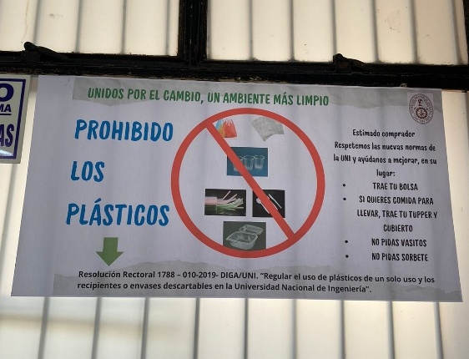 | 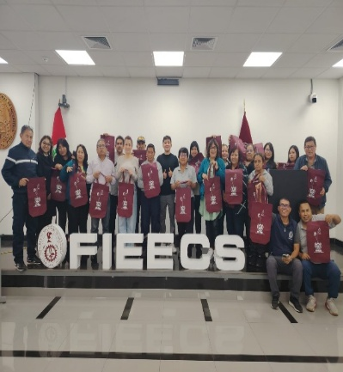  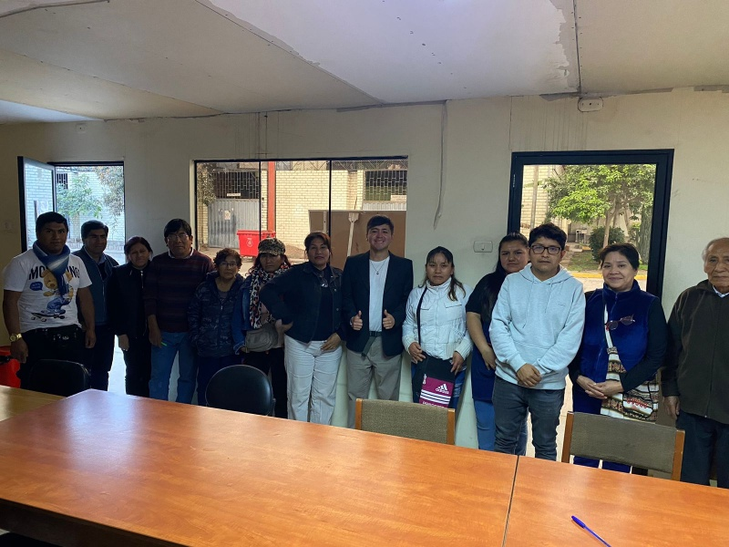
Fig. S3 Sensitization talk for university students of each faculty.
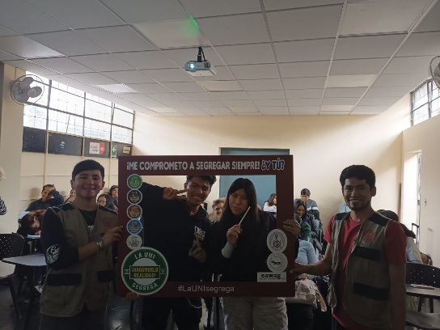
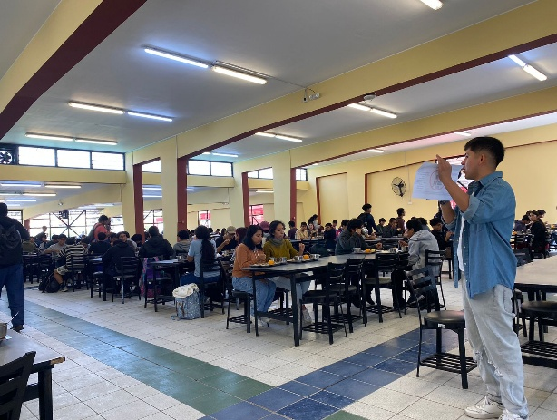
Fig. S4 Inspection and control stage for concessionaires | Fig. S5 Plastic waste characterization carried out on the university campus
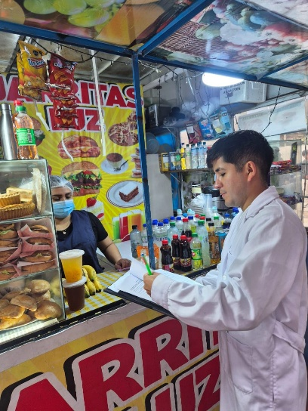 | 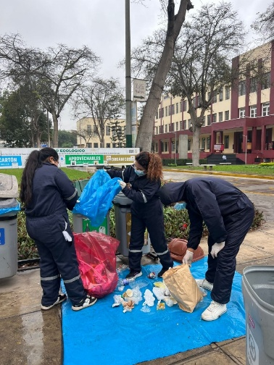

Table S1. Inspection Format
INSPECTION FORM FOR KIOSKS AND RESTAURANTS
Name of the place
Owner
Location
Date of Inspection
Inspection Participants
EVALUATION CRITERIA
The establishment continues the sale and/or distribution of single-use bags, straws, packaging, and/or disposable containers. | YES |  | NO
The establishment distributes bags for printed advertising. | YES |  | NO
The establishment uses and/or sells recyclable material. | YES |  | NO
Observations

Table S2. Plastic Characterization Results
Ecological Point (EP) |  | Phase | Plastic bags (u/day) | Straws (u/day) | Breakfast bottles (u/day) | Beverage bottles (u/day) | Tuppers (kg)
EP1 | Before |  | 96 | 17 | 6 | 11 | 0.434
EP1 | After |  | 34 | 12 | 7 | 0 | 0.076
EP2 | Before |  | 113 | 6 | 23 | 21 | 0.404
EP2 | After |  | 208 | 29 | 24 | 26 | 1.368
EP3 | Before |  | 50 | 12 | 9 | 14 | 0
EP3 | After |  | 226 | 24 | 32 | 24 | 1.634
EP4 | Before |  | 237 | 32 | 8 | 26 | 0.34
EP4 | After |  | 340 | 37 | 42 | 33 | 3.23
EP5 | Before |  | 134 | 9 | 16 | 18 | 0.4
EP5 | After |  | 87 | 4 | 16 | 33 | 2.888
EP9 | Before |  | 190 | 33 | 50 | 84 | 0.25
EP9 | After |  | 128 | 23 | 27 | 37 | 0.418
EP10 | Before |  | 86 | 2 | 10 | 27 | 0.595
EP10 | After |  | 35 | 1 | 6 | 34 | 0.152
EP11 | Before |  | 119 | 0 | 13 | 67 | 0.356
EP11 | After |  | 102 | 7 | 18 | 23 | 1.71
EP12 | Before |  | 170 | 6 | 27 | 82 | 0.278
EP12 | After |  | 158 | 17 | 54 | 59 | 0.76
EP14 | Before |  | 342 | 28 | 43 | 134 | 0.944
EP14 | After |  | 130 | 15 | 33 | 60 | 0.57
EP15 | Before |  | 249 | 14 | 17 | 69 | 1.692
EP15 | After |  | 118 | 17 | 19 | 50 | 0.95
EP16 | Before |  | 104 | 10 | 7 | 18 | 0.355
EP16 | After |  | 167 | 23 | 18 | 83 | 1.672
EP18 | Before |  | 39 | 6 | 6 | 29 | 0.218
EP18 | After |  | 73 | 12 | 1 | 12 | 0.456
EP21 | Before |  | 175 | 11 | 30 | 48 | 0.817
EP21 | After |  | 72 | 17 | 12 | 14 | 0.874
EP22 | Before |  | 92 | 6 | 14 | 55 | 1.147
EP22 | After |  | 87 | 10 | 14 | 15 | 1.026
EP23 | Before |  | 59 | 8 | 18 | 13 | 0.107
EP23 | After |  | 117 | 8 | 8 | 9 | 0.304
EP25 | Before |  | 204 | 15 | 53 | 83 | 0.136
EP25 | After |  | 118 | 7 | 42 | 31 | 0.266
EP26 | Before |  | 105 | 4 | 15 | 36 | 0.293
EP26 | After |  | 18 | 0 | 5 | 2 | 0
EP27 | Before |  | 139 | 11 | 20 | 41 | 0.139
EP27 | After |  | 100 | 2 | 30 | 32 | 0.418
EP28 | Before |  | 138 | 6 | 29 | 47 | 0.119
EP28 | After |  | 160 | 3 | 39 | 48 | 0.304
EP35 | Before |  | 59 | 8 | 18 | 10 | 0.105
EP35 | After |  | 60 | 0 | 12 | 8 | 0.304
EP39 | Before |  | 109 | 8 | 16 | 32 | 0.088
EP39 | After |  | 77 | 0 | 30 | 26 | 0.076
EP40 | Before |  | 32 | 1 | 5 | 16 | 0.075
EP40 | After |  | 43 | 1 | 2 | 8 | 0.114
EP41 | Before |  | 63 | 7 | 7 | 25 | 0.162
EP41 | After |  | 109 | 13 | 41 | 48 | 0.456
EP42 | Before |  | 92 | 3 | 12 | 26 | 0.323
EP42 | After |  | 86 | 6 | 18 | 34 | 0.684
EP43 | Before |  | 117 | 1 | 27 | 34 | 0.797
EP43 | After |  | 106 | 2 | 29 | 51 | 3.42
EP44 | Before |  | 161 | 13 | 34 | 54 | 0.48
EP44 | After |  | 240 | 12 | 63 | 58 | 1.216
EP45 | Before |  | 237 | 12 | 31 | 85 | 1.629
EP45 | After |  | 106 | 6 | 39 | 35 | 0.494
TOTAL | Before |  | 3711 | 289 | 564 | 1205 | 12.683
TOTAL | After |  | 3305 | 308 | 681 | 893 | 25.84

