Extended Data for

Spontaneous Mineral-driven electrochemical synthesis of organic matter under Martian conditions
Chenying Wang¹*, Andrew Steele¹*, Liane G. Benning^{2,3}, Sangyeon Lee⁶, Richard Wirth², Anja Schreiber², Wencheng Lu¹, Burkhard Kaulich⁴, Luis Carlos Colocho Hurtarte^{4,5}, Jeffrey Paulo H. Perez², Anne Pommier¹, George Cody¹, Maria Jesus Herrero Perez^{7,8}, Timothy A. Strobel¹, Karyn L. Rogers^{7,8}.
Corresponding author: cwang11@carnegiesceience.edu, asteele@carnegiescience.edu.

Fig. 1. Schematic of the galvanic CO₂RR cell. Fe₃O₄·aSiO₂ and TiO₂·aSiO₂ thin films on FTO slides are electrically connected to form a bias-free galvanic pair immersed in 1.5 mL brine electrolyte (synthetic seawater). A saturated calomel electrode (SCE) is used as a non-polarized reference (REF-E) to monitor open-circuit potentials, and a pH probe records pH evolution during 30 mins and 2 hrs of CO₂ purging. No external bias is applied in this configuration.
Table 1. Organic product concentrations (µM) quantified by ¹H-NMR for TiO₂·aSiO₂ and Fe₃O₄·aSiO₂ galvanic pair reduced CO₂ at different pH conditions.
Sample | Acetate (µM) | Acetone (µM) | Methanol (µM) | Formate (µM)
Seawater (control) | 8 | 0.0 | 0.0 | 0.0
pH2 seawater (30 mins) | 330 ± 3.03 | 196 ± 1.52 | 6.74 ± 0.21 | 0.0
pH2 seawater (2hrs) | 345 ± 26.0 | 203 ± 9.41 | 5.99 ± 0.67 | 0.0
pH7 seawater (30 mins) | 318 ± 17.4 | 210 ± 5.34 | 7.09 ± 0.11 | 0.0
pH7 seawater (2hrs) | 372 ± 51.2 | 197 ± 3.70 | 5.89 ± 0.86 | 0.0
pH12 seawater (30 mins) | 386 ± 16.3 | 188 ± 2.67 | 6.57 ± 0.54 | 100 ± 6.3
pH12 seawater (2hrs) | 346 ± 0.36 | 187 ± 0.78 | 6.24 ± 1.07 | 50.9 ± 16.1
NaHCO₃ seawater (30 mins) | 424 ± 17.6 | 220 ± 1.36 | 5.11 ± 0.09 | 454 ± 13.7
NaHCO₃ seawater (2hrs) | 361 ± 0.36 | 210 ± 0.40 | 5.93 ± 0.46 | 181 ± 32.9

Fig. 2. A) Overview of FIB section cut from the control sample showing Pt coating and a white box enclosing the area shown in B. (Scale bar 200 nm) B) Higher magnification image of the area shown within the white box in A. Magnetite nanoparticles are white and surrounded by silica (white arrows). Void space is denoted by the letter V. (Scale bar 200 nm) C) shows a higher magnification image of the white box shown in B), revealing the clusters of magnetite nanoparticles, void space, bubbles and silica coating (Black arrows show small void space or bubbles within the silica coating. Letters D and E in boxes denote the areas that EDX spectra were obtained and that are shown in the corresponding Figs D and E. (Scale bar 400 nm) D) shows the silica rich coating contains Si, O but small amounts some Fe and K. E) reveals Fe and O rich particles (Magnetite) as well as small amounts of Si. Carbon is marked to show no significant presence of carbon in the analyses.
Fig. 3. Overview of the magnetite silicate electrode after CO₂RR pH 2 experiment. A) dark field image of magnetite (black) trapped within silica coating (black arrows). (scale bar 200 nm) B) Bright field area showing agglomerations of magnetite nanocrystals some revealing hollow centers (scale bar 200 nm). Red box in Fig. B is an area mapped by EELS across the C1S edge and shown in Fig S10D.
Fig. 4. A) Magnetite silicate electrode after CO₂RR composition at pH 7 showing the distribution of magnetite (Mt) and amorphous silica (Si). (Scale bar 500 nm) B) Higher magnification image silica interface showing void space (V) and irregular edges of the electrode (El). (Scale bar 50 nm) X = approximate area of the EDX spectrum shown in C. C) EDX spectrum showing peaks ascribing to C, Mg, O and Si, from the area shown by an X in Fig B. Sn and Cu are stray signals from the electrode surface and FIB holder respectively.
Fig. 5. A) Shows several magnetite grains, within silicate coating in a ¹³CO₂ labelled experiment and illustrates that pristine magnetite grains (PM) with intact sharp facets are mixed with grains that show distinct signs of corrosion (CM). Box illustrates area shown in B. (scale bar 200 nm) B) Bright field TEM image of grains marked within the white box in A, showing two grains, one pristine (PM) with distinct facets (white arrows) and another with corroded edges (CM) denoted by black arrows. (scale bar 20 nm)
Fig 6. A) Shows a dark field TEM image of a pH 2 sample showing magnetite (dark material) surrounded by lighter silica-rich material that contains many larger and small void spaces and honeycomb concentrations of bubbles. B) a close-up of a different area of the same sample, showing magnetite grains (black). C) - E) are EELS Electron energy loss spectra from the areas marked by letters and arrows in B) marked C - E, respectively. Arrows mark two prominent peaks at ~285 eV and 290 eV that differ in the three different areas. The peak at 290 eV possibly corresponds to amorphous CO₃.
Table S2. Characteristic Carbon K-edge Transitions Identified by STXM in Post-CO₂RR Products⁵¹.
Energy (eV) | Transition | Chemical Species | Source
285.0 | C 1s → π* | C=C  (sp² carbon) | Aromatic hydrocarbons
287.4 | C 1s → π* | C=O  (carboxyl) | HCOO⁻,  early-stage CO₂ reduction product
288.4 | C 1s → π* | O=C–O (carboxylate) | Organic acids
290.4 | C 1s → π* + σ* | Carbonate  (CO₃²⁻) | Surface-bound CO₂ adsorption products

1.1. Single-electrode CO₂RR control experiments
To disentangle the contributions of TiO₂·aSiO₂ and Fe₃O₄·aSiO₂ in the galvanic cell, we performed controlled three-electrode CO₂RR experiments with each material serving as the sole working electrode and a Pt counter electrode. (Extended Data, Fig. 7)
TiO₂·aSiO₂ films on FTO were used as working electrodes with Pt counter and SCE reference in synthetic seawater at pH 12. After N₂ saturation, the electrolyte was purged with CO₂, and the working electrode was held at -1.5 V vs SCE for 2 hrs. Electrolytes were analyzed by ¹H-NMR, acetate, methyl, and formate were observed, but no aromatic proton resonances (7.42-7.49 ppm) were present. These results show that TiO₂·aSiO₂ alone primarily reduces CO₂ to small oxygenated species (formate, acetate, methyl) under strongly reducing bias, without forming aromatic carbon.
Fe₃O₄·aSiO₂ films on FTO were used as working electrodes at pH 12 with Pt counter and SCE reference. Two sets of experiments were performed at -1.7 V vs SCE for 2 hrs: (1) No sodium formate added. Electrolyte contained only synthetic seawater and CO₂. ¹H NMR showed small amounts of acetate and formate, but no significant methanol and aromatic proton resonances. (2) With sodium formate added. The same configuration was used, but sodium formate was added to the synthetic seawater prior to CO₂ purging. Under these conditions, ¹H-NMR revealed substantially higher concentrations of acetate, methanol, acetone, and formate, as well as clear aromatic proton resonances. These single-electrode controls confirm that Fe₃O₄·aSiO₂ alone is not highly efficient for direct CO₂-to-aromatic conversion but is highly effective at upgrading CO₂RR intermediates (e.g., formate) into methanol and aromatic products under strong reducing bias.
Fig. 7. ¹H-NMR analysis of single-electrode CO₂RR showing distinct reactivity of TiO₂·aSiO₂ vs. Fe₃O₄·aSiO₂. A) TiO₂·aSiO₂ films biased at –1.5 V vs SCE generate only small, oxygenated products (formate, acetate). B) Fe₃O₄·aSiO₂ biased at –1.7 V vs SCE without added formate produces only trace acetate and formate. C) With formate present, Fe₃O₄·aSiO₂ upgrades CO₂RR intermediates to methanol, acetone, acetate, and aromatic species, evidenced by clear aromatic proton resonances.
1.2. H-cell experiment:
To verify that organic products originate from Fe₃O₄·aSiO₂ itself rather than from SnO₂ or Fluorine (F) impurities in the FTO substrate, we performed an H-cell experiment using TiO₂·aSiO₂ and Fe₃O₄·aSiO₂ films deposited on non-conductive glass slides. (Extended Data, Fig.8) TiO₂ and Fe₃O₄ nano powders were mixed with sodium silicate solution as described above and drop-cast onto glass slides (no FTO). TiO₂·aSiO₂ and Fe₃O₄·aSiO₂-coated glass electrodes were mounted in an H-cell separated by a polymer membrane and electrically connected through an external circuit. CO₂ was purged into one compartment (designated the “cathode” side) containing synthetic seawater at pH 12. After 2 hrs of CO₂RR, the catholyte solution was collected and analyzed by ¹H-NMR. The experiment was repeated three times to test reproducibility. In all three runs (fig. S3), ¹H-NMR spectra of the catholyte exhibited acetate, acetone, methanol, formate and aromatic proton resonances, confirming that TiO₂·aSiO₂-Fe₃O₄·aSiO₂ galvanic pair is intrinsically capable of driving CO₂ reduction and that the observed organic products are not artifacts arising from SnO₂ or fluorine in the FTO substrate.

Fig. 8. ¹H-NMR spectra of electrolytes from the TiO₂·aSiO₂-coated glass side of the H-cell after 2 hrs pH 12 CO₂RR, showing reproducible formation of acetate, acetone, methanol, formate, and aromatic hydrocarbons.
1.3. Dark vs ambient-light experiments:
To test whether photochemistry contributes to CO₂RR, pH 12 galvanic experiments were conducted both under ambient laboratory lighting and under strictly dark conditions, (Extended Data, Fig. 10) in which the entire electrochemical cell and tubing were wrapped in aluminum foil. For each condition (light and dark), three independent experiments (n = 3) were performed for 2 hrs at pH 12, and product distributions were analyzed by ¹H-NMR. Within experimental uncertainty and speciation of acetate, acetone, methanol, formate, and aromatic protons were identical for light and dark runs.

Fig. 9. ¹H-NMR of dark-condition galvanic CO₂RR showing product distribution identical (acetate, acetone, methanol, formate and aromatic hydrocarbon) to room-light experiments, confirming absence of photocatalytic effects.
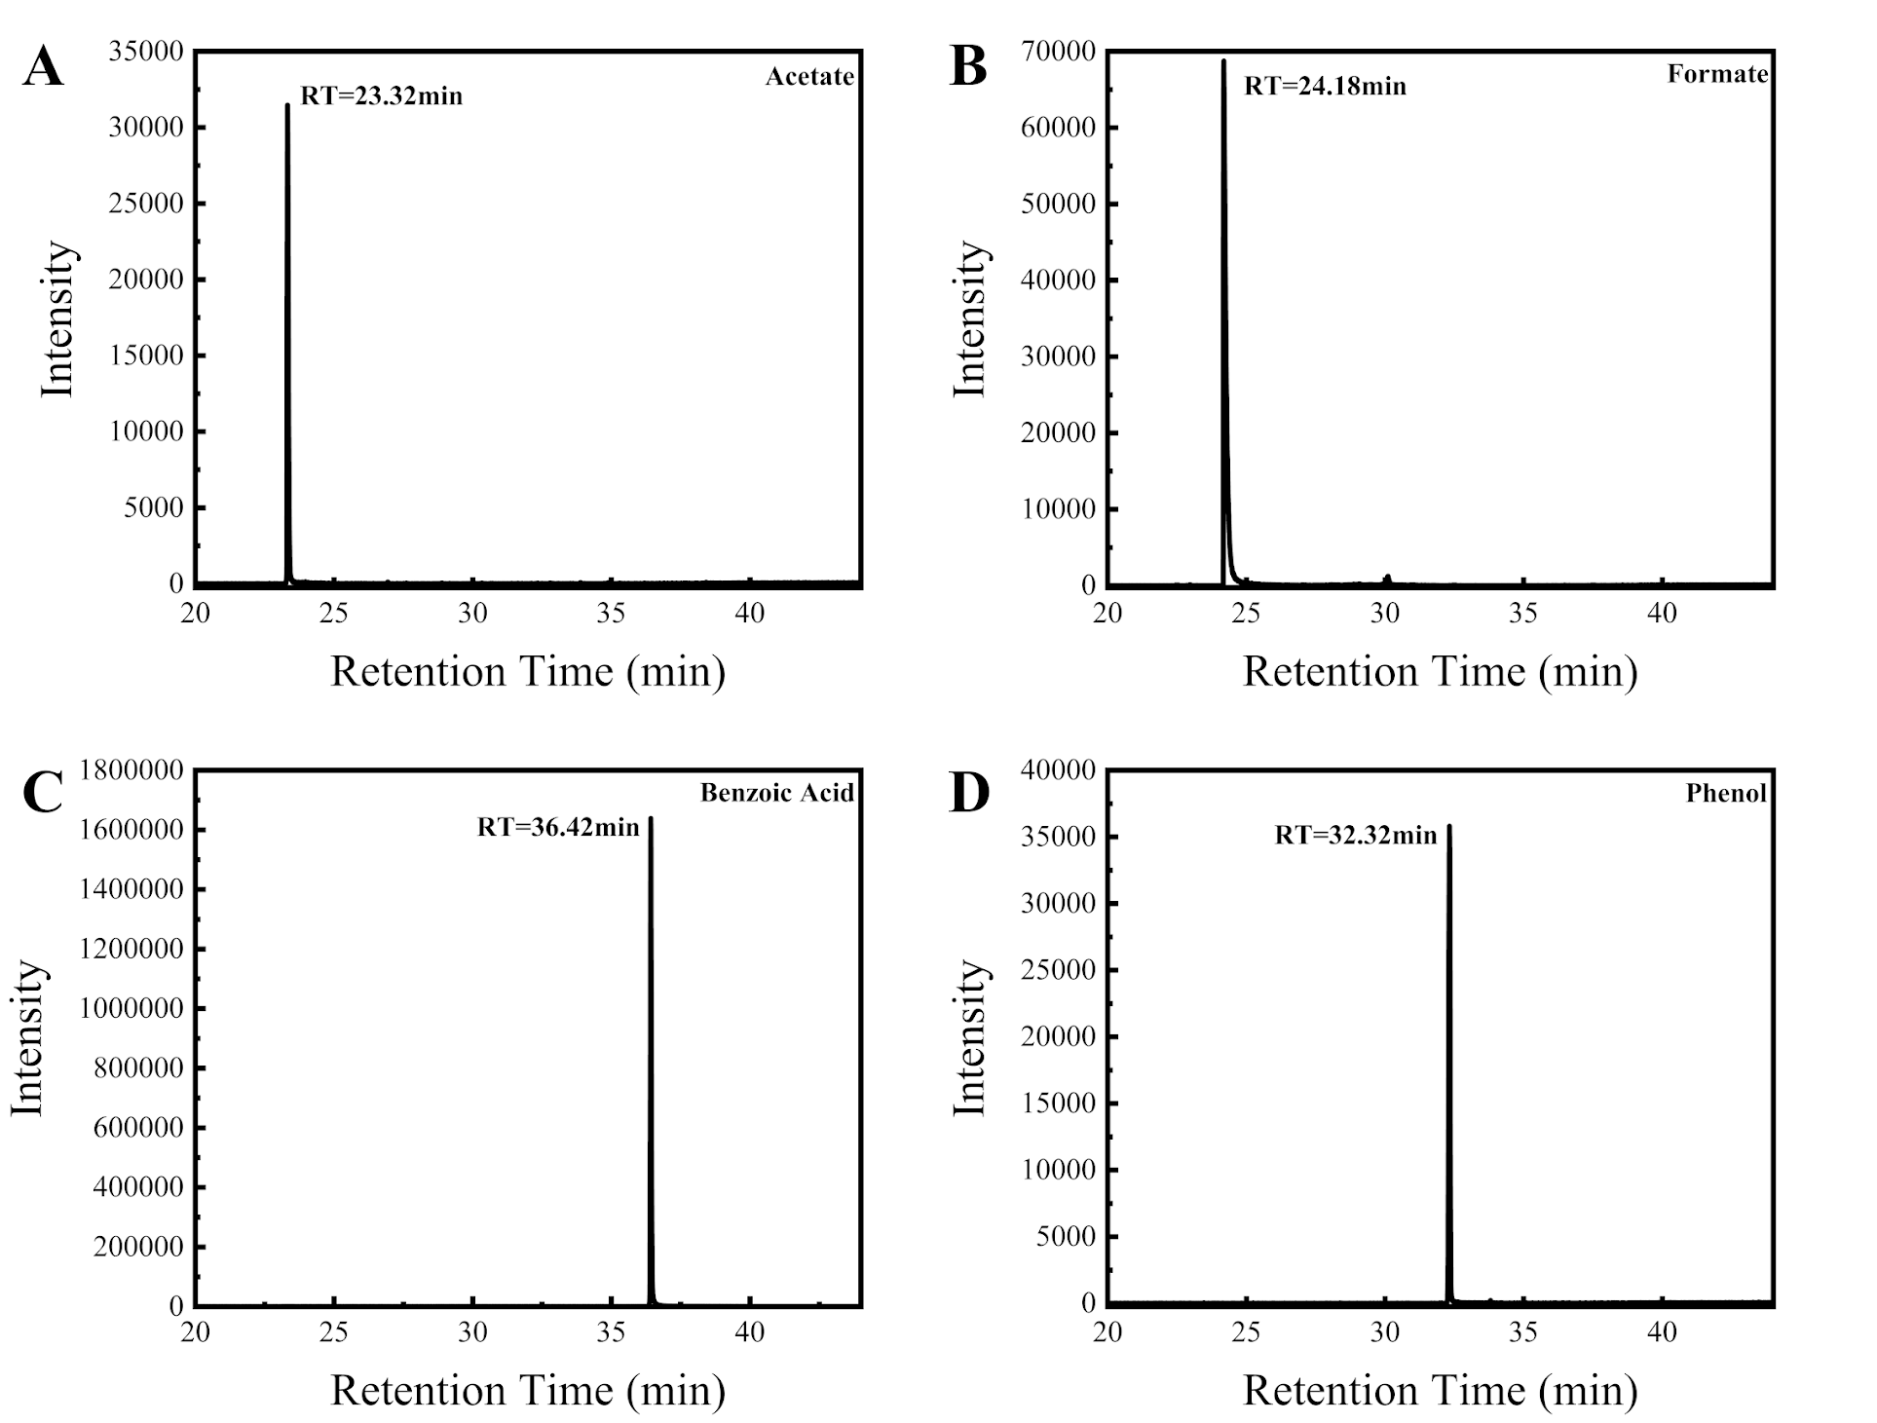
Fig. 10. GC-MS retention times of standard organic compounds: A) Acetate (retention time = 23.32 min); B) Formate (24.18 min); C) Phenol (32.32 min); D) Benzoic acid (36.42 min). These reference standards were used to identify corresponding products in experimental samples.

