Appendix
Table A1. ANCOVA results for MADRS and HARS outcomes at the end of the study (Intention-to-treat analysis)
 | df | Adjusted between-group difference | F | 95% CI | p | Partial η²
MADRS
Biofeedback therapy | 1 | 1.94 | [0.098; 3.780] | 4.4 | 0.039 | 0.057
Diagnosis | 2 | ⸻ | ⸻ | 0.885 | 0.417 | 0.024
Antidepressant prescribed (yes vs no) | 1 | −0.53 | [−2.64; 1.58] | 0.25 | 0.62 | 0.001
Anxiolytic prescribed (yes vs no) | 1 | 0.39 | [−1.66; 2.44] | 0.14 | 0.71 | 0.001
Mood stabilizer prescribed (yes vs no) | 1 | 1.52 | [−0.81; 3.86] | 1.69 | 0.20 | 0.02
Baseline MADRS | 1 | ⸻ | ⸻ | 10.16 | 0.001 | 0.12
HARS
Biofeedback therapy | 1 | 1.099 | [−0.709; 2.907] | 1.47 | 0.23 | 0.02
Diagnosis | 2 | ⸻ | ⸻ | 0.98 | 0.380 | 0.026
Antidepressant prescribed (yes vs no) | 1 | −1.162 | [−3.223; 0.900] | 1.261 | 0.265 | 0.017
Anxiolytic prescribed (yes vs no) | 1 | 1.980 | [−0.058; 4.018] | 3.749 | 0.057 | 0.049
Mood stabilizer prescribed (yes vs no) | 1 | −0.404 | [−2.685; 1.877] | 0.125 | 0.725 | 0.002
Baseline HARS | 1 | ⸻ | ⸻ | 12.319 | 0.001 | 0.144
Note - N=80. MADRS scores at the second assessment point were specified as the dependent variable. All factors listed in the table were entered into a single model (“biofeedback therapy,” “diagnosis,” “antidepressant prescribed,” “anxiolytic prescribed,” and “mood stabilizer prescribed” as fixed factors; baseline MADRS or baseline HARS as the covariate). The “adjusted between-group difference” column reports the difference in the dependent variable (MADRS or HARS score at follow-up) between categories after adjustment for the other model variables. Partial η² represents the proportion of variance in the dependent variable explained by the predictor after accounting for the remaining predictors. The diagnosis variable had three categories: 1) unipolar depressions (F32 and F33); 2) bipolar spectrum disorders (F31 and F34); 3) anxiety disorders (F41 and F42).

Table A2. Changes in MADRS and HARS scores over the course of the study across different diagnostic groups
Diagnosis | N (baseline) | Baseline Median (Q1–Q3) | N (endpoint) | Endpoint Median (Q1–Q3) | Change Score Median (Q1–Q3) | H-statistic | p
MADRS
Unipolar depression | 34 | 17 (16–22) | 30 | 12 (9–14) | 6 (4–9) | 3.21 | 0.2
Bipolar spectrum | 29 | 19 (16–22.5) | 26 | 10 (8–13) | 8 (5–13.5)
Anxiety disorders | 21 | 17 (16–21) | 18 | 10 (7–12) | 7 (5–12)
HARS
Unipolar depression | 34 | 19 (17–24) | 30 | 11 (8–14) | 6 (4–9) | 2.88 | 0.24
Bipolar spectrum | 29 | 19 (15–22.5) | 26 | 10 (8–14) | 8 (5–13.5)
Anxiety disorders | 21 | 21 (18–28) | 18 | 11 (8–13) | 7 (5–12)
Note – H and p are reported for the change score.
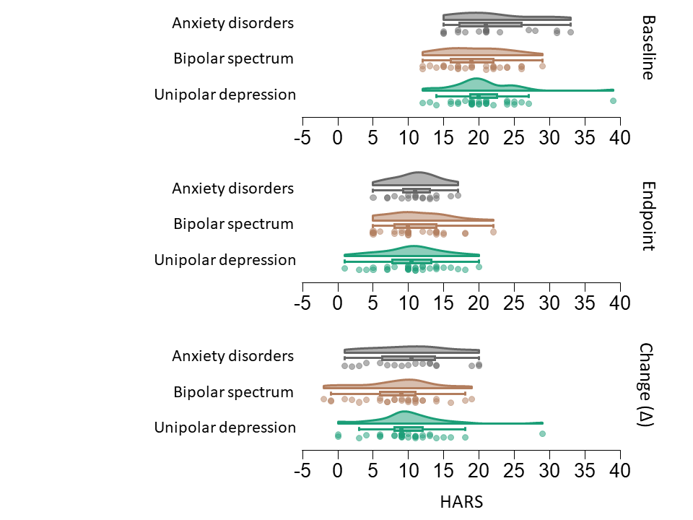Figure A1. Change in HARS scores over the course of the study across different diagnostic groups
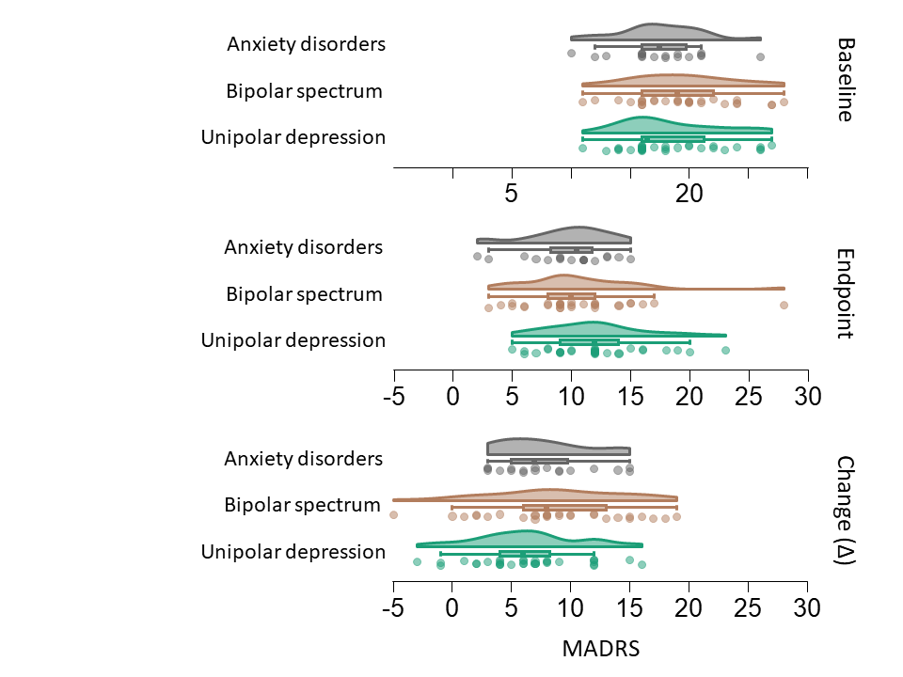Figure A2. Change in MADRS scores over the course of the study across different diagnostic groups

Table A3. Baseline characteristics of study completers and dropouts
 | Completed | Withdrawn | p
Total N | 74 | 6 | -
N in the BFB group | 41 (55%) | 6 (100%) | 0.039
Age, median (Q1–Q3) | 27 (23–38.5) | 21 (20–45) | 0.48
Female, n (%) | 33 (44.6%) | 4 (66%) | 0.4
Illness duration, median (Q1–Q3) | 2.5 (1.5–4) | 2.5 (0.75–4) | 0.32
Receiving an antidepressant, n (%) | 49 (66%) | 4 (66%) | 1.0
Receiving an anxiolytic, n (%) | 44 (59%) | 1 (16%) | 0.07
Receiving a mood stabilizer, n (%) | 37 (50%) | 2 (33%) | 0.67
MADRS, median (Q1–Q3) | 18 (16–21) | 19.5 (16–22) | 0.5
HARS, median (Q1–Q3) | 20 (16–24) | 16 (14–22) | 0.34
Depressive episode (F32), n (%) | 12 (16%) | 1 (17%) | 0.97
Recurrent depressive disorder (F33), n (%) | 18 (24%) | 2 (33%) | 0.63
Mixed anxiety and depressive disorder (F41.2), n (%) | 12 (16%) | 1 (17%) | 1.0
Generalized anxiety disorder (F41.1), n (%) | 6 (8%) | 0 | 0.63
Bipolar disorder, current depressive episode, n (%) | 16 (23%) | 2 (33%) | 0.63
Cyclothymia, n (%) | 10 (14%) | 0 | 0.35
Note - Baseline characteristics were summarized for study completers and dropouts. Continuous variables are reported as median (Q1; Q3). Categorical variables are presented as n (%), and between-group comparisons for categorical data were performed using Fisher’s exact test.

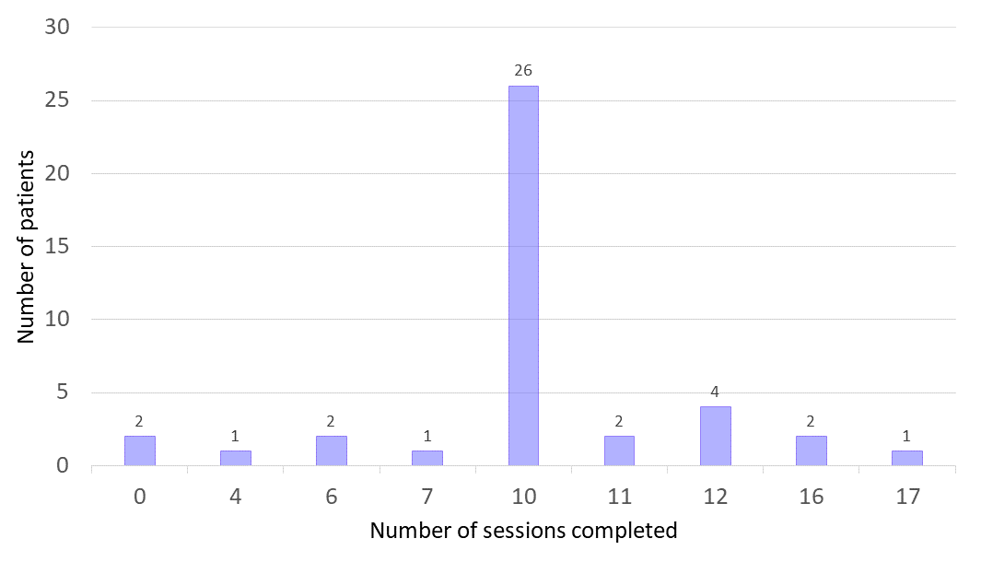Figure A3. Distribution of completed sessions

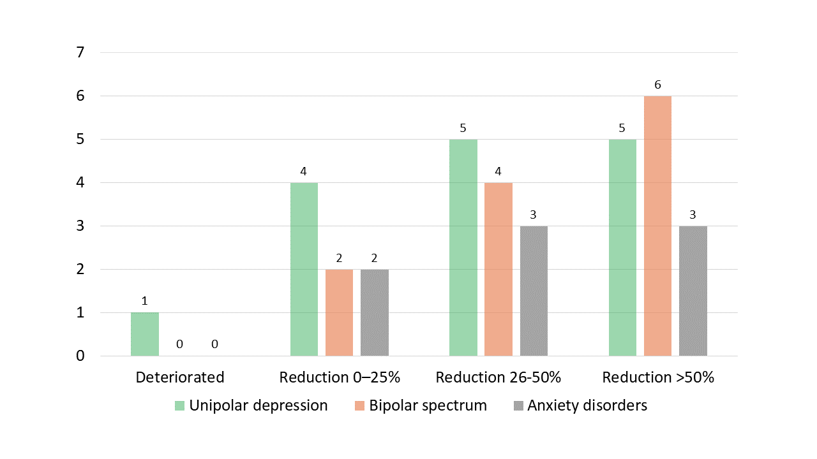Figure A4. Percentage reduction in MADRS scores in the biofeedback therapy group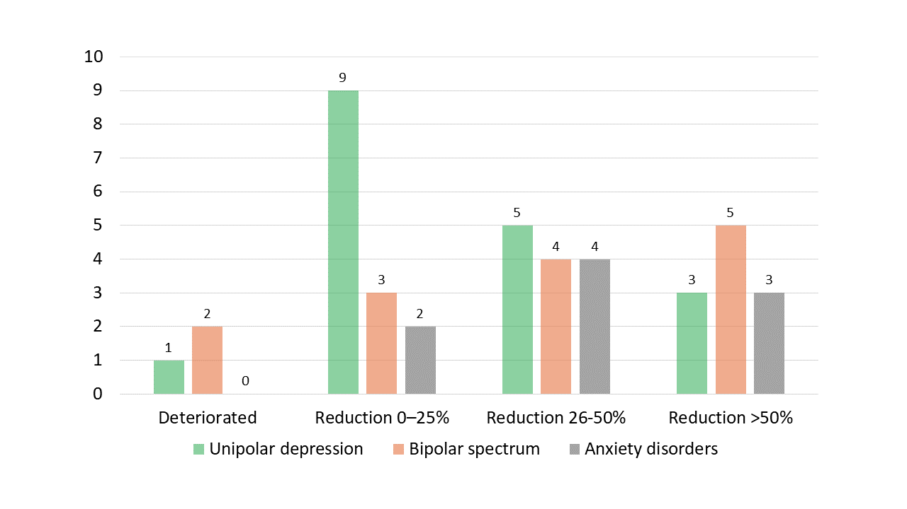Figure A5. Percentage reduction in MADRS scores in the control group

