SUPPLEMENTARY INFORMATION
Optimisation and application of an ex vivo organ bath model to study contractile function and insulin signalling in intact adult skeletal muscle

Maheen Wahid*, Graeme Mackenzie, Kirsty Tinto, Euan Hannah, Susan Currie, Gwyn W. Gould, Margaret R. Cunningham*
Strathclyde Institute for Pharmacy and Biomedical Sciences (SIPBS), University of Strathclyde, 161 Cathedral Street, Glasgow, UK
Corresponding Authors
Maheen Wahid - maheen.wahid.2022@uni.strath.ac.uk
Strathclyde Institute for Pharmacy and Biomedical Sciences (SIPBS), University of Strathclyde, 161 Cathedral Street, Glasgow.
Margaret Cunningham – margaret.cunningham@strath.ac.uk
Strathclyde Institute for Pharmacy and Biomedical Sciences (SIPBS), University of Strathclyde, 161 Cathedral Street, Glasgow.

Supplementary Tables 1-6
Supplementary Figures 1-6

Supplementary Table S1: List of chemicals/products with their manufacturers
Manufacturer | Chemical/Product | Catalogue Number
Thermo Fischer Scientific (Massachusetts, USA) | Pierce™ BCA protein assay kit | 23227
Thermo Fischer Scientific (Massachusetts, USA) | Isopentane (2-methylbutane) | 019387.AY
Thermo Fischer Scientific (Massachusetts, USA) | NuPAGE™ LDS sample buffer (4x) | NP0007
Thermo Fischer Scientific (Massachusetts, USA) | Sodium Chloride | S/3160/60
Thermo Fischer Scientific (Massachusetts, USA) | Ammonium Persulfate | 17874
Thermo Fischer Scientific (Massachusetts, USA) | Tetramethylethylenediamine (TEMED) | 17919
Thermo Fischer Scientific (Massachusetts, USA) | PageRuler™ Plus Prestained Protein Ladder | 26619
Merck (Germany) | Sodium Dodecyl Sulphate (SDS) | 8170341000
Merck Millipore (Illinois, USA) | Probumin® Bovine Serum Albumin Universal Grade | 81-003-3
Merck Millipore (Illinois, USA) | Insulin from porcine pancreas | I5523
VWR Chemicals, UK | Glycine | 101196X
Fisher Bioreagents | Tris Base | BP152-1
Carl Roth ® (Schoemperlenstr. 3-5, Karlsruhe, Germany) | Acrylamide (Rotiphorese® ) 30% (w/w) | Art. No. 3029.1
Cytiva (UK) | Amersham™ Protran 0.45 NC nitrocellulose Western blotting membranes | 10600002
Merck
Roche Pharmaceuticals (Basel, Switzerland) | cOmplete EDTA-free protease inhibitor cocktail tablets | 4693159001
Santa Cruz Biotechnology (Dallas, Texas, USA) | Autoradiography Film (UltraCruz®) | SC-201696
Sigma-Aldrich (USA and UK) | Methanol | 179957
Sigma-Aldrich (USA and UK) | EDTA | EDS-100G
Sigma-Aldrich (USA and UK) | EGTA | E4378
Sigma-Aldrich (USA and UK) | Sodium pyrophosphate | P8010
Sigma-Aldrich (USA and UK) | Sodium orthovanadate | 13721-39-6
Sigma-Aldrich (USA and UK) | β-glycerophosphate | G9422
Sigma-Aldrich (USA and UK) | β-mercaptoethanol | M6250-100ML
Sigma-Aldrich (USA and UK) | Hydrogen Peroxide | 516813
Sigma-Aldrich (USA and UK) | Luminol | A8511-5G
Sigma-Aldrich (USA and UK) | p-coumaric acid | C9008-5G
Sigma-Aldrich (USA and UK) | TWEEN® 20 | P1379-25ML
Sigma-Aldrich (USA and UK) | Triton™ X-100 | T8787-50ML

Supplementary Table S2: List of antibodies and stains
Stain/Antibody | Supplier | Reference ID | Concentration | Dilution
pAkt | Cell Signalling, UK | 4060S | Not provided | 1:1000 in 0.3% BSA
tAkt | Cell Signalling, UK | 2920S | Not provided | 1:1000 in 0.3% BSA
HRP-Goat anti-Rabbit IgG (H+L) | Jackson Immuno-Research Labs, USA | AB_2307391 | 0.8 mg/mL | 1: 7500 in 0.3% BSA
HRP Donkey anti-Mouse IgG (H+L) | Jackson Immuno-Research Labs, USA | AB_2340770 | 0.8 mg/mL | 1: 7500 in 0.3% BSA

Supplementary Table S3: List of Buffers and Solutions
Buffer/Solution | Recipe
Krebs-Henseleit solution | 118 mM sodium chloride, 25 mM sodium hydrogen carbonate, 10 mM D-Glucose, 2 mm potassium chloride, 1.2 mM sodium dihydrogen orthophosphate dihydrate, 1.2 mM magnesium sulphate, 2.5 mM calcium chloride hexahydrate, bubbled with carbogen (95% oxygen; 5% carbon dioxide)
Buffer 1 (for resolving gel) | 1.5 M Tris base, 14 mM SDS in distilled water (pH 8.8)
Buffer 2 (for stacking gel) | 0.5 M Tris base, 14 mM SDS in distilled water (pH 6.8)
Stripping buffer | 63 mM Tris base, 69 mM SDS in distilled water (pH 6.7)
Running buffer | 25 mM Tris base, 3.5 mM SDS, 192 mM glycine in distilled water
Transfer Buffer | 25 mM Tris base, 192 mM glycine, 20% (v/v) methanol in distilled water
ECL1 | 100 mM Tris Base (pH 8.8), 2.5 mM luminol (in DMSO), 1.2 mM p-coumaric acid (in DMSO) in distilled water
ECL 2 | 100 mM Tris base (pH 8.8), 6.3 mM hydrogen peroxide in distilled water
Sample buffer | 4x Sample buffer, 200 µM DTT
Tris-Buffered Saline-TWEEN (TBS-T) | 150 mM sodium chloride, 20 mM Tris in distilled water, pH 7.5, then 0.1% (v/v) Tween 20 in TBS-buffer
Lysis Buffer | 1 M Tris Base, 1 M sodium chloride, 0.5 M EDTA, 100 mM EGTA, 25 mM Sodium pyrophosphate, 1% (v/v) Triton X-100, 100 mM β-glycerophosphate, 0.5 M sodium orthovanadate, 1 cOmplete protease inhibitor cocktail tablet in 10 mL distilled water

Supplementary Table S4: List of equipment used and their supplier
Equipment | Supplier
Dual Pulse Isolated Stimulator (TSS10) | Intracel
USB-6008 data acquisition device | National Instruments
Flex Station 3 Multi-Mode Microplate Reader | Molecular Devices
Automatic X-RAY Film Processor (JP33) | JPI Healthcare
Ultra-Turrax T8 Homogeniser | IKA Labortechnik

Supplementary Table S5: List of software used and their application
Software | Version | Application
CHART (John Dempster, University of Strathclyde) | Version 5.1.5 | Organ bath trace acquisition and analysis
GraphPad Prism | Version 8.0.2 | Generation of bar graphs and statistical analysis
(Fiji is Just) ImageJ | Version 1.54p; Java 1.8.0_322 [64-bit] | Blotting analysis
EndNote | 21.5 (Bld 18513) | Reference manager
Microsoft PowerPoint | Version 2511 | Figure composition
Microsoft Excel | Version 2511 | Data organisation and structuring of measurements

Supplementary Table S6: Coefficient of variation (CV) for key morphological, functional and signalling outcomes stratified by sex.
Outcome | Group/Condition | Male CV (%) | Female CV (%) | Number of animals (M/F)
Mass | - | 12.65 | 10.55 | 18/11
Lo | - | 13.46 | 4.37 | 18/11
Specific force | EFS Only (EFS1) | 119.8 | 57.97 | 7/6
Specific force | EFS Only (EFS2) | 97.02 | 71.42 | 7/6
Specific force | EFS-Insulin (Pre-Insulin) | 78.52 | 68.84 | 11/5
Specific force | EFS-Insulin (Post-Insulin) | 98.19 | 98.77 | 11/5
pAkt/tAkt raw density | Control | 57.26 | 15.91 | 5/5
pAkt/tAkt fold change | Insulin Only | 63.21 | 13.43 | 8/4
pAkt/tAkt fold change | EFS Only | 78.71 | 88.89 | 7/5
pAkt/tAkt fold change | EFS-Insulin | 55.59 | 85.19 | 11/6

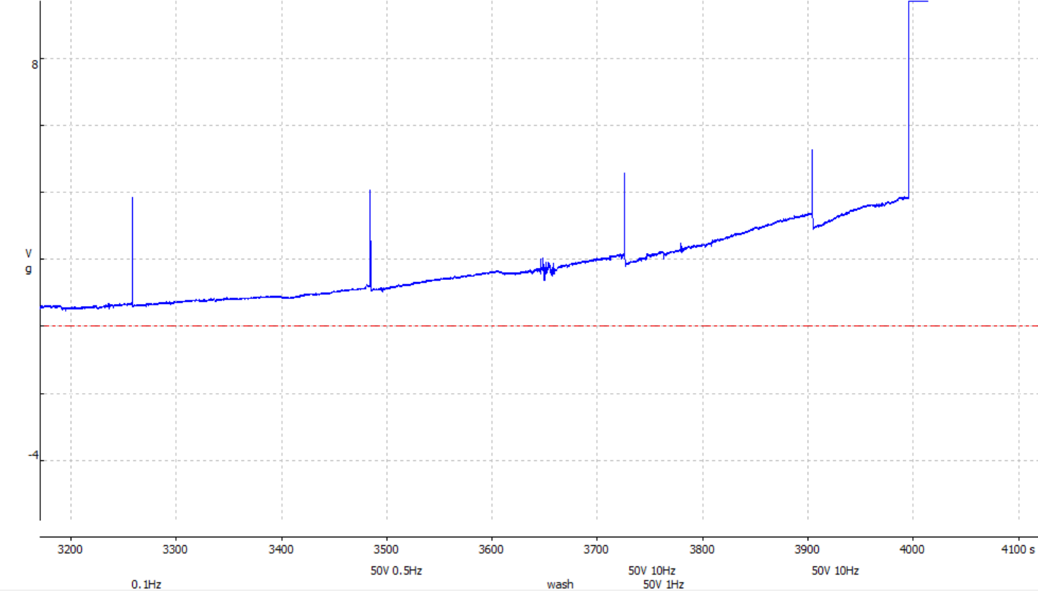
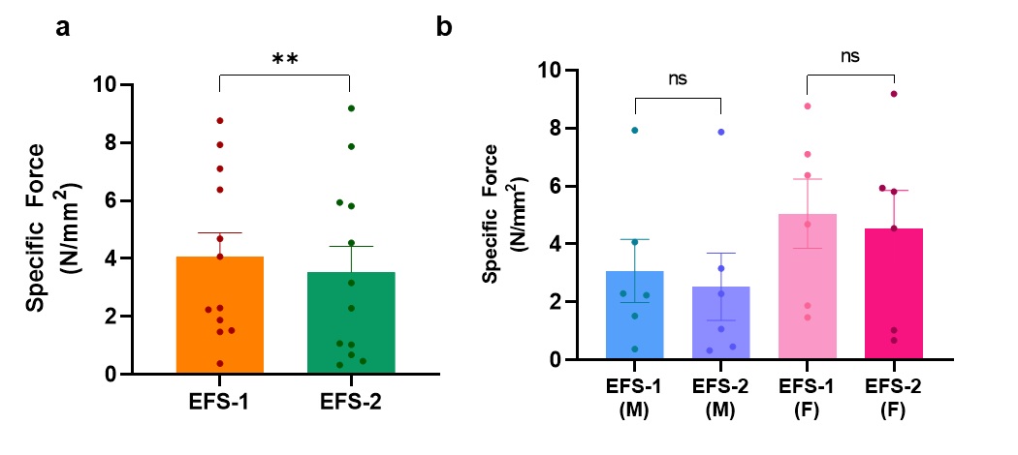
Supplementary Figure S1: Frequency-response curve using 60 V stimulation at increasing frequencies (0.1, 0.5, 1, and 10 Hz). Higher frequencies induced progressive baseline elevation, indicative of temporal summation and early tetanus.

Figure S2: Reanalysis of specific force following removal of an outlier from the EFS Only group. a) Combined dataset and b) male/female dataset showing specific force during EFS1 and EFS2 in the EFS Only group with one evident male outlier removed to assess the robustness of the observed effect. Removal of these outliers did not alter the statistical outcomes: the combined dataset remained significant (EFS1: 4.06±0.83; EFS2: 3.53±0.89; p=0.009), while the male dataset remained non-significant (EFS1: 3.07±1.09; EFS2: 2.53±1.16; p=0.08). Data are presented as mean±SEM.
Time to peak was assessed before and after repeated stimulation in both EFS Only and EFS-Insulin groups (Figure S3). In the EFS Only group, combined analysis of males and females showed a significant reduction in time to peak between EFS1 and EFS2 (EFS1: 0.059±0.004; EFS2: 0.055±0.002; p=0.02) (Figure S3a). When stratified by sex, males did not show a significant difference (EFS1: 0.060±0.007; EFS2: 0.055±0.003; p=0.58), whereas females exhibited a significant reduction in time to peak (EFS1: 0.058±0.002; EFS2: 0.054±0.001; p=0.02) (Figure S3b). In the EFS-Insulin group, a consistent and statistically significant reduction in time to peak was observed between the first and second stimulation bout in the combined analysis (PreInsulin:0.060±0.002; Post Insulin: 0.056±0.002; p=0.0008) (Figure S3c). This effect remained significant when analysed separately for males (Pre Insulin: 0.060±0.003; Post Insulin: 0.056±0.002; p=0.01) and females (Pre Insulin: 0.060±0.003; Post Insulin: 0.057±0.003; p=0.04) (Figure S3d). Outliers were evident in the combined and male datasets for both the EFS Only and EFS-Insulin groups. Reanalysis following their removal did not change statistical outcomes (Supplementary Figure S4).

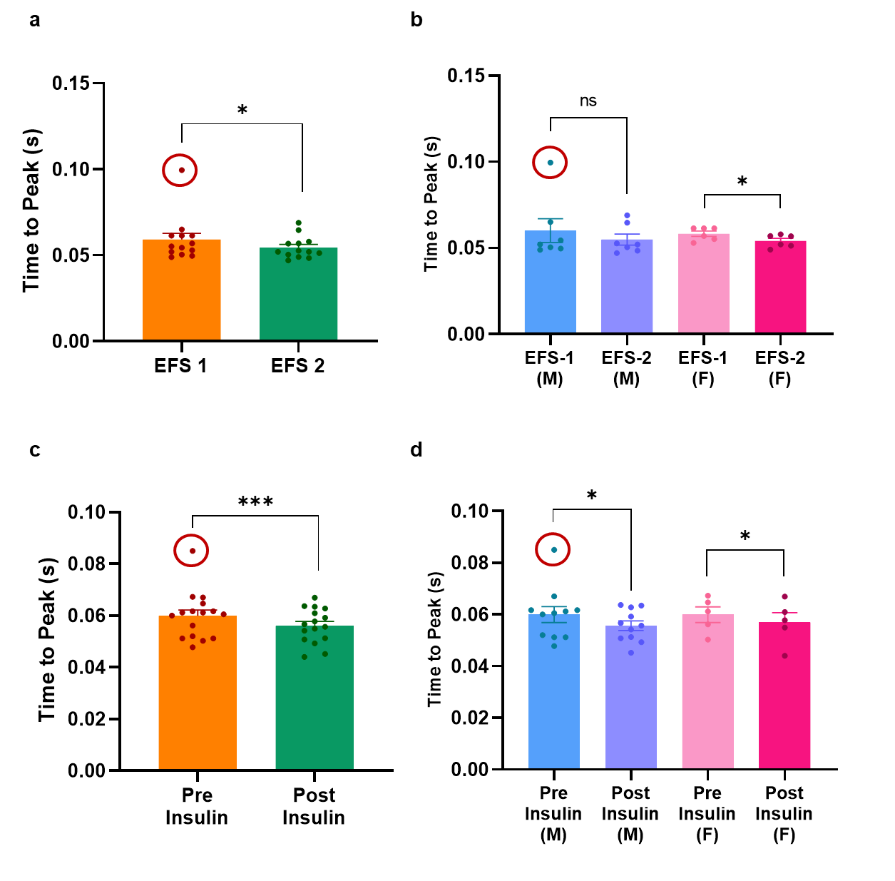
Figure S3: Effects of repeated stimulation and insulin on twitch time to peak. a) Paired comparison of average time to peak between the first (EFS1) and second (EFS2) repeated stimulation bout in the EFS Only group (all samples combined); b) The same comparison stratified by sex (males, n=7; females, n=6); c) Paired comparison of average time to between the first (before addition of insulin: labelled pre-insulin) and second (after insulin incubation: labelled post-insulin) stimulation in the EFS-Insulin group (all samples combined); d) The same comparison stratified by sex (males, n=11; females, n=5). All values represent mean±SEM. Statistical analysis was done using paired t-test or Wilcoxon test depending on normality. M=males; F=females

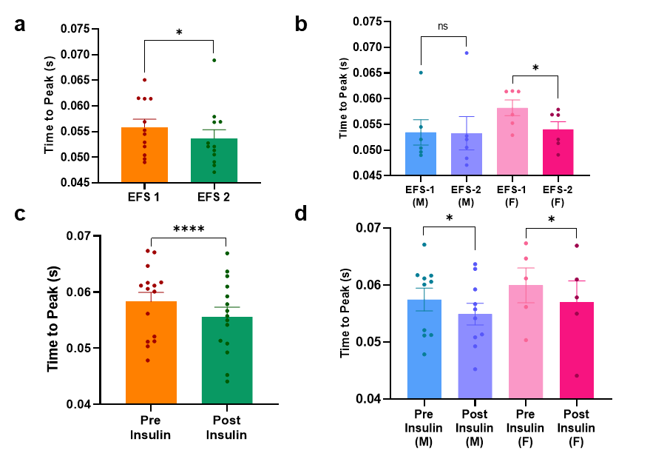
Figure S4: Reanalysis of time to peak following removal of outliers. a) Combined dataset and b) male dataset showing time to peak during EFS1 and EFS2 in the EFS Only group, and c) combined dataset and d) male/female dataset showing time to peak during Pre and Post Insulin in the EFS-Insulin group. One evident male outlier was removed to assess the robustness of the observed effects. For the EFS Only group, the combined dataset remained significant (EFS1: 0.056±0.002; EFS2: 0.054±0.002; p=0.04), while the male dataset remained non-significant (EFS1: 0.053±0.002; EFS2: 0.053±0.003; p>0.99). Similarly, in the EFS-Insulin group, the same pattern was observed, with significance retained in the combined dataset (PreInsulin:0.058±0.002; Post Insulin: 0.056±0.002; p=0.0007) and in the male dataset (Pre Insulin: 0.057±0.002; Post Insulin: 0.055±0.002; p=0.01).Removal of these outliers did not alter the statistical outcomes. Data are presented as mean±SEM.

Half relaxation time was evaluated before and after repeated stimulation in both the EFS Only and EFS-Insulin groups (Figure S5). In the EFS Only group, combined analysis across sexes showed a significant reduction in half relaxation time (EFS1: 0.073±0.017; EFS2: 0.049±0.007; p=0.004) (Figure S5a). When stratified by sex, males did not demonstrate a significant change (EFS1: 0.067±0.020; EFS2: 0.047±0.008; p=0.22), whereas females exhibited a significant decrease in half relaxation time (ESF1: 0.080±0.031; EFS2: 0.051±0.011; p=0.03) (Figure S5b).
In the EFS-Insulin group, combined analysis across all preparations also revealed a significant reduction in half relaxation time between the two stimulation bouts (Pre Insulin: 0.113± 0.058; Post Insulin: 0.049± 0.003; p=0.0006) (Figure S5c). This effect remained significant in males (Pre Insulin: 0.139±0.084; PostInsulin:0.049±0.004; p=0.005) but did not reach significance in females (Pre-Insulin: 0.055±0.002; Post Insulin: 0.050±0.004; p=0.08) (Figure S5d). A single outlier can be seen in the EFS-Insulin group. Removal of this outlier from the combined and male datasets had no changes in statistical outcomes (Figure S6).

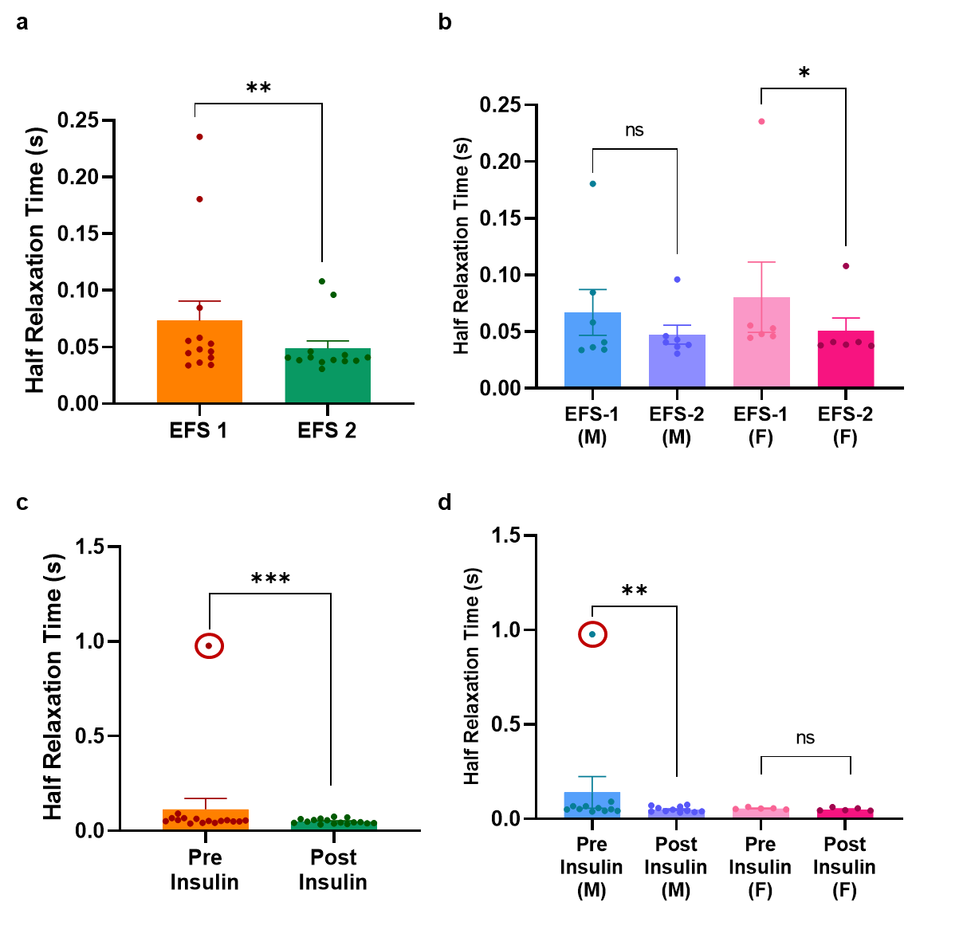
Figure S5. Effects of repeated stimulation and insulin on twitch half relaxation time. (a) Paired comparison of average half relaxation time between the first (EFS1) and second (EFS2) repeated stimulation bout in the EFS Only group (all samples combined); b) The same comparison stratified by sex (males, n=7; females, n=6); c) Paired comparison of average half relaxation time between the first (before addition of insulin: labelled pre-insulin) and second (after insulin incubation: labelled post-insulin) stimulation in the EFS-Insulin group (all samples combined); d) The same comparison stratified by sex (males, n=11; females, n=5). All values represent mean±SEM. Statistical analysis was done using paired t-test or Wilcoxon test depending on normality. M=males; F=females

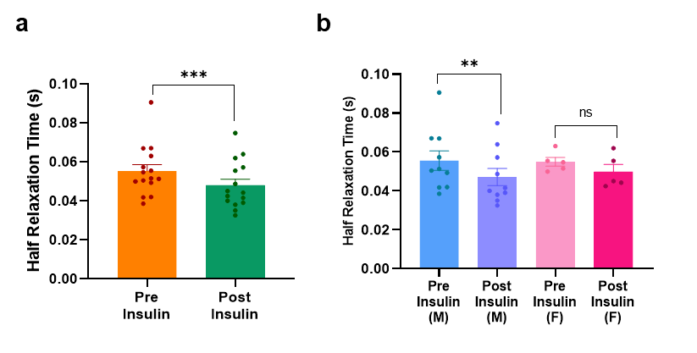
Figure S6: Reanalysis of half relaxation time following removal of outliers in the EFS-Insulin group. a) Combined dataset and (b) male/female dataset showing half relaxation time during Pre and Post Insulin stimulation in the EFS-Insulin group. One evident male outlier was removed to assess the robustness of the observed effect. For the combined dataset, removal of the outlier did not alter the statistical outcomes (Pre Insulin: 0.055±0.003; Post Insulin: 0.048±0.003; p=0.0006). The same was true for the male dataset (Pre Insulin: 0.056±0.005; Post Insulin:0.047±0.004; p=0.004). Data are presented as mean±SEM.

