Supplementary Material

- Pattern identification in FDG-PET
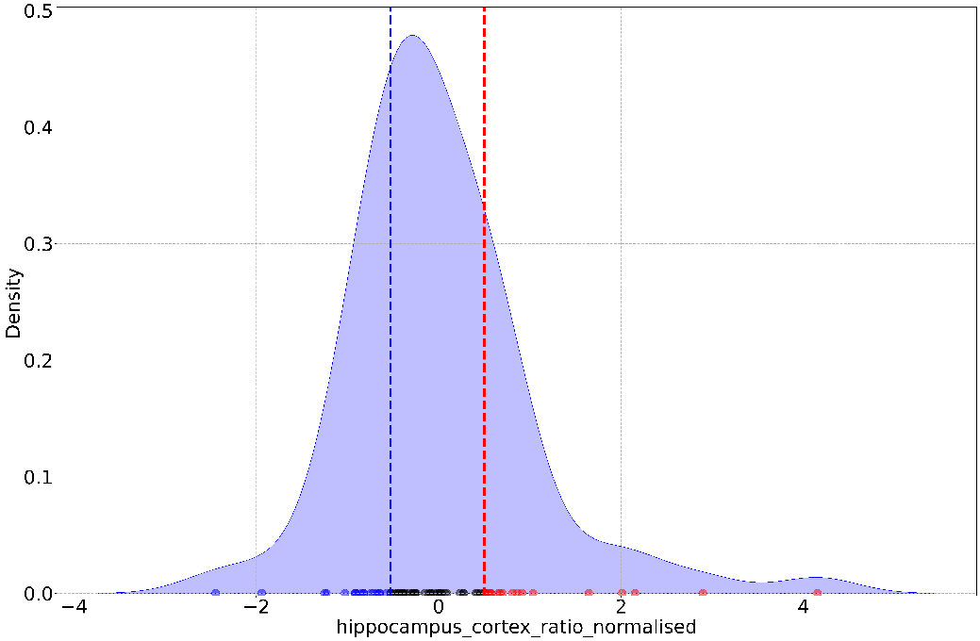
Hippocampus-to-Cortex SUVR Ratio (normalized)
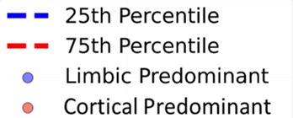
- Pattern identification in MRI
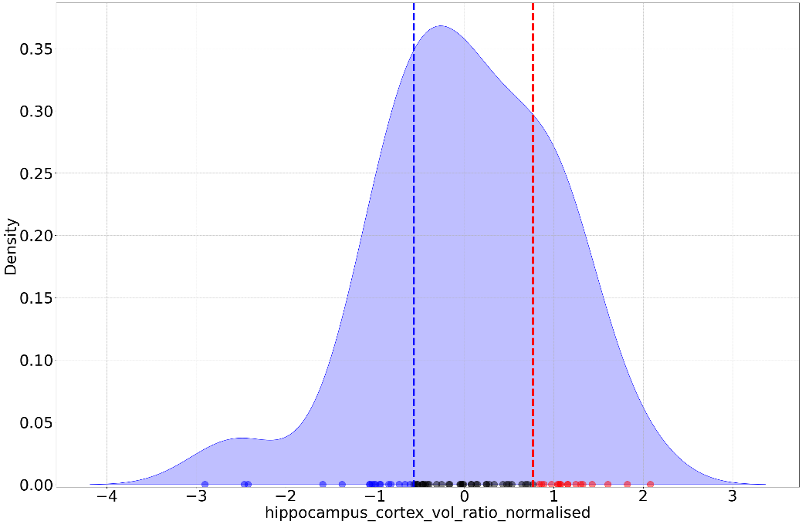
Hippocampus-to-Cortex Volume Ratio (normalized)

Supplementary Figure 1: Categorical approach to identify neurodegenerative patterns using hippocampus-to-cortex ratio. Density plots show the distribution of hippocampus-to-cortex ratio (normalized values) using a) FDG-PET SUVRs and b) grey matter volumes. Individuals are plotted as separate datapoints along the bottom, whilst highlighting the Limbic Predominant and Cortical Predominant patterns in blue and red respectively. The patterns are not defined solely by the 25th and 75th percentiles alone, but additionally by assessing the median hippocampal SUVR/volume and total cortical SUVR/grey matter volumes.

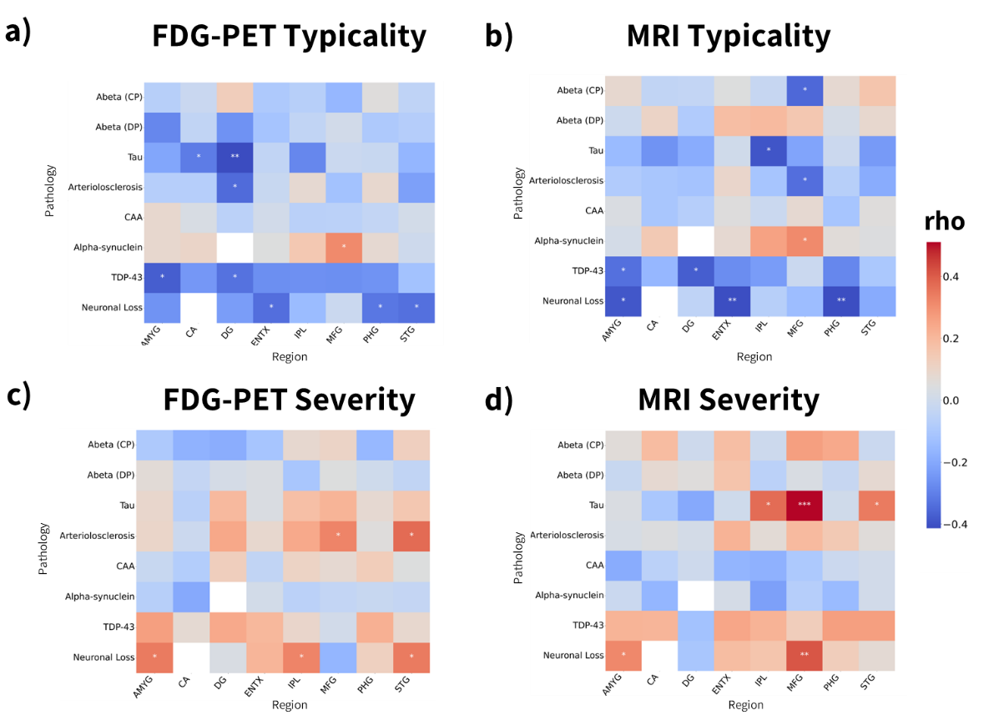
Supplementary Figure 2: Linear partial correlations between measures of FDG-PET and MRI typicality and severity measures with pathology. All correlations shown here, not just significant correlations. Linear partial correlations between measures: a) FDG-PET typicality, b) MRI typicality, c) FDG-PET severity, d) MRI severity with regional pathologies (n=43). Adjustment for severity was calculated for measures of typicality and vice versa as well as age at scan and additionally field strength for MRI measures. The pathologies with significant correlations, *p<0.05, **p<0.01, ***p<0.001 were plotted with the rho coefficients. Abbreviations: AMYG = amygdala; Abeta (CP) = amyloid-beta (core plaques); Abeta (CP) = amyloid-beta (diffuse plaques); CA1 = hippocampus at the level of lateral geniculate nucleus including cornu Ammonis 1 subfield; DG = hippocampus at the level of lateral geniculate nucleus including dentate gyrus; ENTX = entorhinal cortex; IPL = inferior parietal lobe (angular gyrus); MFG = middle frontal gyrus; PHG = hippocampus at the level of lateral geniculate nucleus including parahippocampal gyrus; STG = superior and middle temporal gyri; Tau = phosphorylated tau assessing neurofibrillary tangles; TDP-43 = phosphorylated TAR DNA-binding protein 43 neuronal cytoplasmic inclusion; α-syn = alpha-synuclein Lewy body pathology.

