Supplementary Material

Supplementary Figures – Posterior predictive checks

Fig. S1 Posterior predictive distributions of overall RED Ratio means
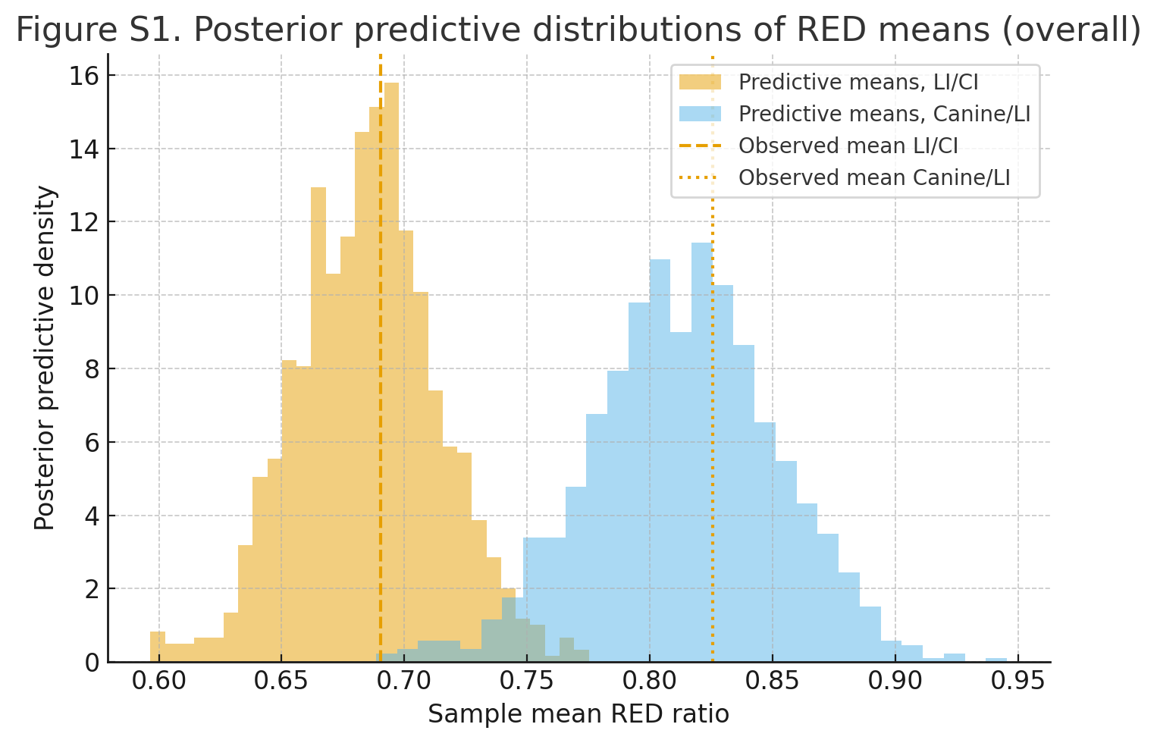

Fig. S1 Posterior predictive distributions of overall RED Ratio means
- Posterior predictive distributions were obtained from intercept-only Bayesian normal models fitted to averaged lateral incisor/central incisor (LI/CI) and canine/lateral incisor (Canine/LI) RED ratios.
- Density plots represent posterior predictive sample means generated from replicated datasets, with vertical lines indicating the observed sample means.
3.The close correspondence between observed means and the central mass of the posterior predictive distributions indicates that the model adequately reproduces the central tendency of both RED ratios.
4.No evidence was observed that the specified priors or model structure systematically constrained estimates away from the observed data.

Figure S2. Posterior predictive gender-specific RED means
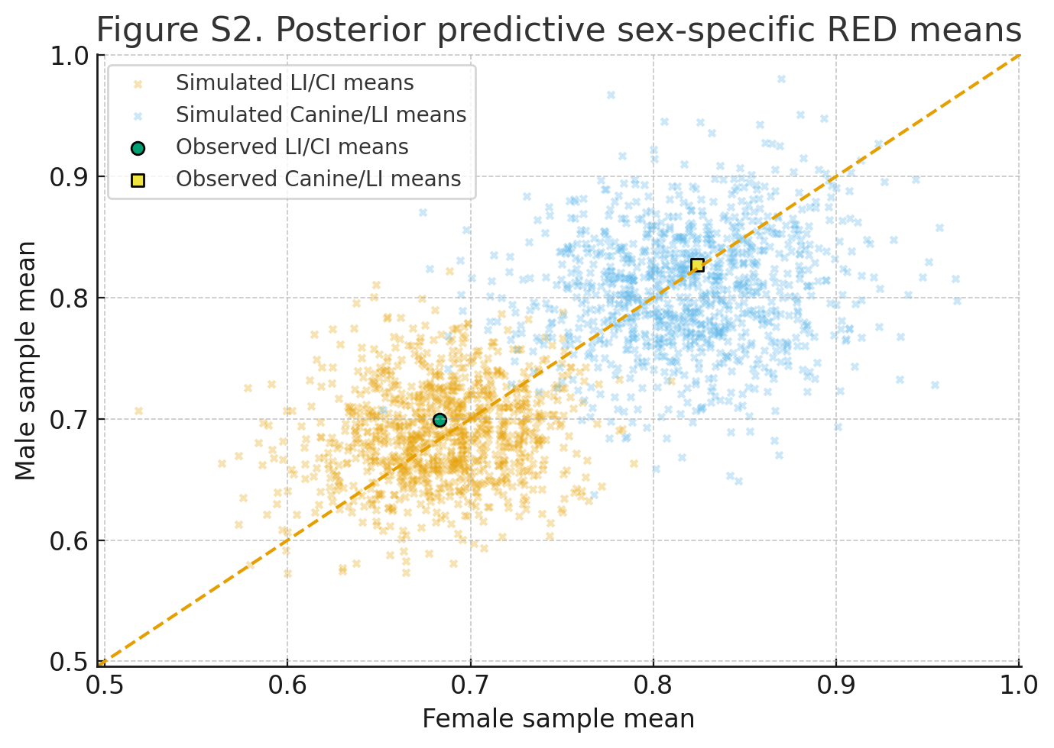

Fig. S2 Posterior predictive gender-specific RED means
- Posterior predictive distributions were generated from Bayesian normal regression models including sex (Female vs. Male) for LI/CI and Canine/LI RED ratios.
- For each posterior draw, sex-specific sample means were simulated, with dots showing LI/CI and crosses showing Canine/LI; observed means are indicated by separate markers.
- The 45° reference line (y = x) denotes equality between Female and Male means.
- Observed sex-specific means fall within the cloud of simulated points and close to the 45° line, indicating adequate model fit and no systematic sex-specific misfit.

Figure S3. Posterior predictive distributions of Golden proportion counts
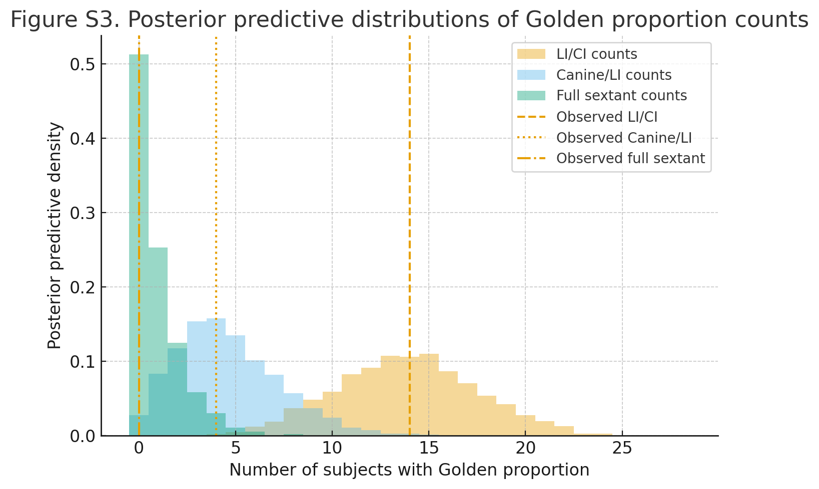

Fig S3. Posterior predictive distributions of Golden proportion counts
- Posterior predictive distributions of Golden cases were simulated for LI/CI, Canine/LI, and full sextant using Beta-Binomial models; vertical lines show observed counts.
- Observed counts for LI/CI and Canine/LI lie near the center of the predictive distributions, indicating good model fit.
- For the full sextant, observed zero counts are compatible with the posterior predictive distribution despite occasional nonzero simulations, reflecting small-sample uncertainty.

Supplementary Tables – Sensitivity analyses

Table S1. Sensitivity of RED population means to wider priors
Ratio | Baseline Mean | Baseline 95% CrI§ Lower | Baseline 95% CrI§ Upper | Wide-Prior Mean | Wide-Prior 95% CrI§ Lower | Wide-Prior 95% CrI§ Upper
LI*/CI† | 0.685 | 0.647 | 0.721 | 0.690 | 0.650 | 0.733
Ca‡/LI* | 0.813 | 0.766 | 0.864 | 0.821 | 0.780 | 0.875
*Lateral Incisor.
†Central Incisor.
‡Canine
§ Credible Interval
- RED population means were estimated using Bayesian normal models with baseline priors (truncated [0,1] for LI/CI and Canine/LI; Half-Normal(0.10) for SD) and wider priors with the same means but increased dispersion.
- Widening priors slightly broadened credible intervals and shifted means by only a few thousandths.
- Posterior estimates remain essentially unchanged (LI/CI ≈ 0.69, Canine/LI ≈ 0.81–0.82), indicating robustness to prior specification.

Supplementary Table S2. Sensitivity of sex-effect (β) parameters to wider priors
Table S2. Sensitivity of sex-effect ( $β$ ) parameters to wider priors Baseline
Ratio | Baseline β Mean | Baseline β 95% CrI|| Lower | Baseline β 95% CrI|| Upper | Wide-Prior β Mean | Wide-Prior β 95% CrI|| Lower | Wide-Prior β 95% CrI|| Upper
LI*/CI† | -0.005 | -0.065 | 0.056 | -0.007 | -0.087 | 0.063
Ca‡/LI* | 0.010 | -0.058 | 0.076 | 0.017 | -0.062 | 0.109
*Lateral Incisor.
†Central Incisor.
‡Canine.
§ Sensitivity of sex-effect.
||Credible Interval

- Sex-effect (β) parameters for LI/CI and Canine/LI RED ratios were estimated using Bayesian normal models with baseline and wider priors.
- Baseline priors: [specify baseline prior details, e.g., Normal(0, 0.1)]; wider priors used the same means but increased dispersion.
- Sex effects remain small and centred near zero under both priors.
- Credible intervals under wider priors are slightly broader but still cover a narrow band around zero.
- The conclusion of no clinically meaningful sex difference in RED ratios is robust to reasonable prior changes.

Table S3. Sensitivity of Golden proportion prevalence to prior choice
Prior | Definition | Posterior Mean | 95% CrI§ Lower | 95% CrI§ Upper
Beta (1,1) | LI*/CI† | 0.500 | 0.325 | 0.675
Beta (1,1) | Ca‡/LI* | 0.167 | 0.058 | 0.317
Beta (1,1) | Full sextant | 0.033 | 0.001 | 0.119
Beta (0.5,0.5) | LI*/CI† | 0.500 | 0.322 | 0.678
Beta (0.5,0.5) | Ca‡/LI* | 0.155 | 0.050 | 0.305
Beta (0.5,0.5) | Full sextant | 0.017 | 0.000 | 0.085
Beta (2,2) | LI*/CI† | 0.500 | 0.331 | 0.669
Beta (2,2) | Ca‡/LI* | 0.188 | 0.075 | 0.337
Beta (2,2) | Full sextant | 0.062 | 0.008 | 0.167
*Lateral Incisor.
†Central Incisor.
‡Canine.
§Credible Interval
- Counts of Golden cases (n = 28) were assessed for LI/CI, Canine/LI, and full sextant.
- Posterior prevalence was estimated using Beta-Binomial models under Beta(1,1), Beta(0.5,0.5), and Beta(2,2) priors.
- Posterior estimates were consistent across priors, indicating robustness of Golden proportion prevalence to prior choice.

