Supporting Information

Ionic liquid grafted PVDF membrane incorporating g-C₃N₄–Fe₃O₄ for selective cationic dye removal and antibiofouling performance

Ameneh Lari¹, Abdolmajid Bayandori Moghaddam ^{2, *}, Mohammad-Hossein Sarrafzadeh ^{1, *}

¹ School of Chemical Engineering, College of Engineering, University of Tehran, Tehran, Iran. P.O. Box: 11155-4563, Tehran, Iran
² School of Engineering Science, College of Engineering, University of Tehran, P.O. Box 11155-4563, Tehran, Iran
* Corresponding authors:
sarrafzdh@ut.ac.ir , bayandori@ut.ac.ir

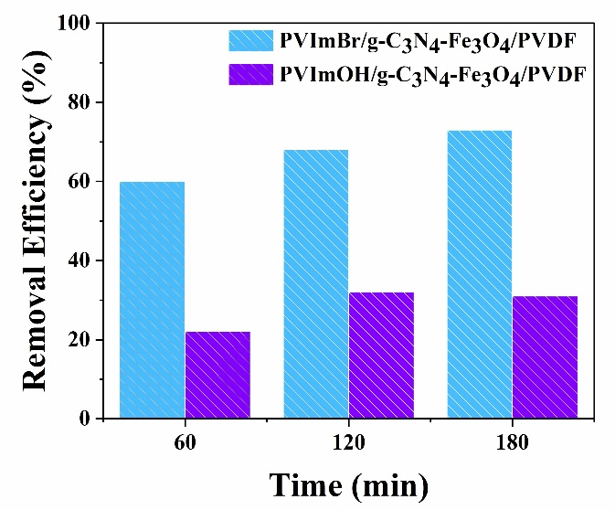
Fig. S1. Removal efficiency of methyl orange by PVImOH/g-C₃N₄-Fe₃O₄/PVDF and PVImBr/g-C₃N₄-Fe₃O₄/PVDF at 20 ppm.

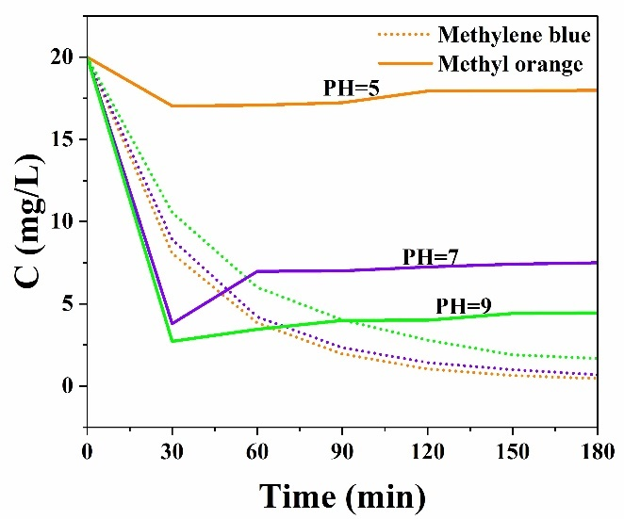
Fig. S2. Concentration changes of anionic and cationic dyes at pH 5, 7, and 9.

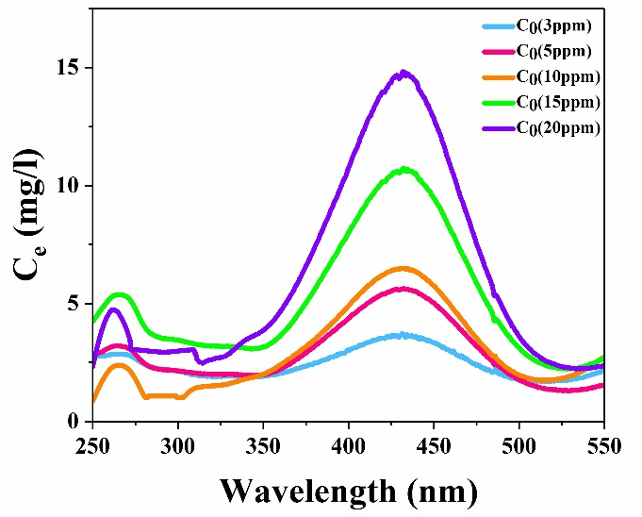
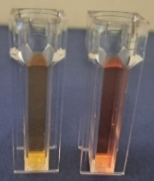

Fig. S3. Equilibrium plot of methylene blue at different initial concentrations.

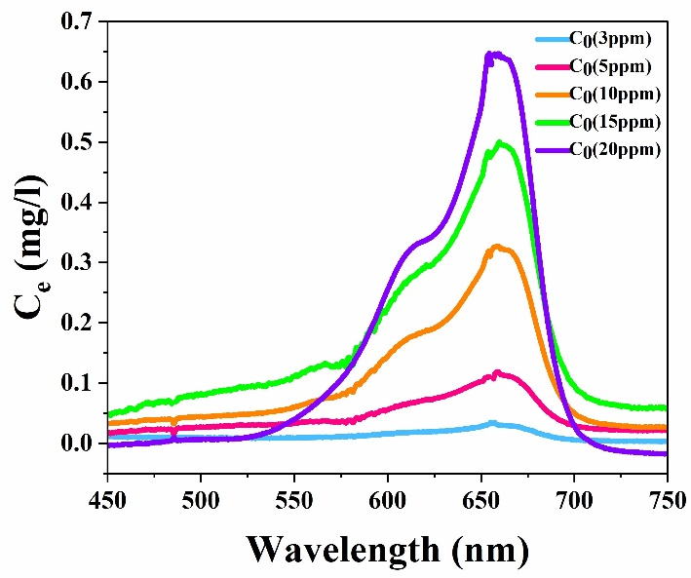
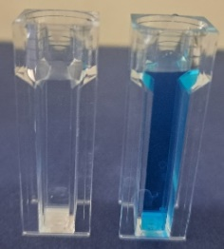

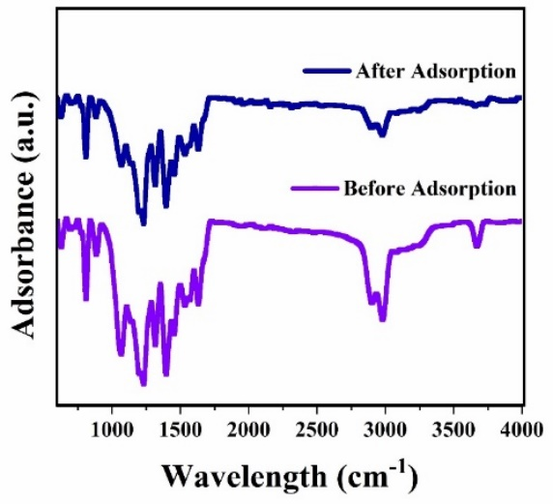
Fig. S5. ATR of the modified membrane before and after the methylene blue adsorption process.
Fig. S4. Equilibrium plot of methyl orange at different initial concentrations.

