SUPPLEMENTARY MATERIAL

Figure S1: Participant flow diagram 2
Table S1: EMA characteristics 3
Figure S2: Association between maximum daily temperature and change in mental wellbeing score (complete-case analysis) 4
Figure S3: Association between maximum daily temperature and change in mental wellbeing score (25% response dataset) 5
Figure S4: Association between maximum daily temperature and change in wellbeing score by lag and model 6
Figure S5: Stratified plots by environmental factors for extreme heat exposure 7
Figure S6: Stratified plots by demographic and clinical subgroups 8
Figure S7: Stratified plots by demographic and clinical subgroups for extreme heat exposure 9

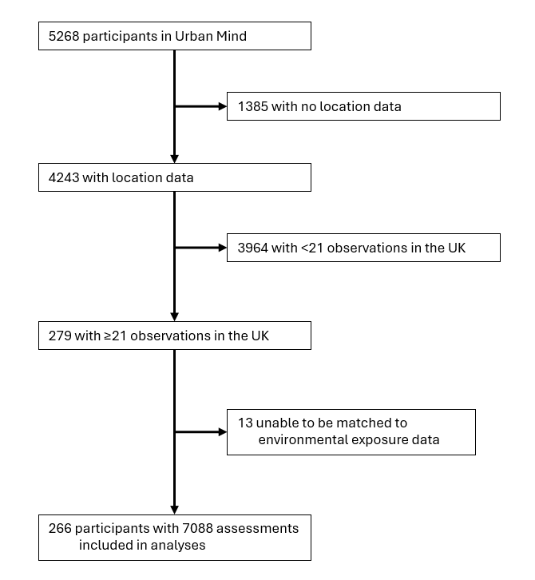

Figure S1: Participant flow diagram

Table S1: EMA characteristics
 | EMAs (N=7088)
Location
Indoors | 5725 (80.8%)
Outdoors | 1363 (19.2%)
Wellbeing score | 35 (7)
10 to <20 | 194 (2.7%)
20 to <30 | 1431 (20.2%)
30 to <40 | 3610 (50.9%)
40 to 50 | 1853 (26.1%)
Daily maximum temperature (°C) | 16.6 (5.7)
Daily minimum temperature (°C) | 7.6 (4.4)
Maximum temperature ≥28°C | 139 (2.0%)
Daily mean PM_{2.5} (µg/m³) | 8.0 (5.9-11.7)
Daily mean PM₁₀ (µg/m³) | 15.0 (11.5-20.1)
Daily mean NO₂ (µg/m³) | 20.0 (11.7-31.9)
Mean NDVI | 0.24 (0.18–0.29)
Data are n (%), mean (SD), or median (IQR). EMA=ecological momentary assessment. PM=particulate matter. NDVI=Normalized Difference Vegetation Index. NO₂=nitrogen oxide.

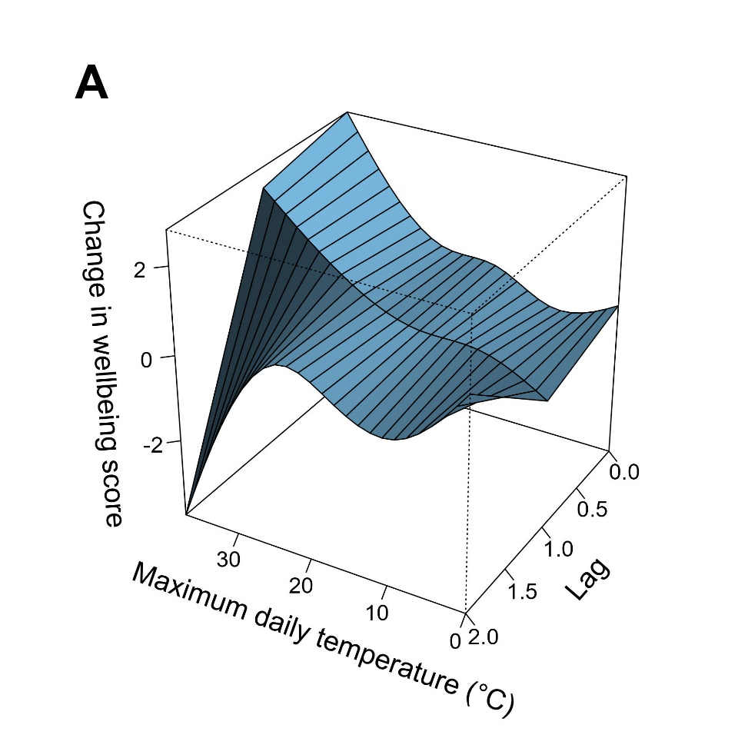
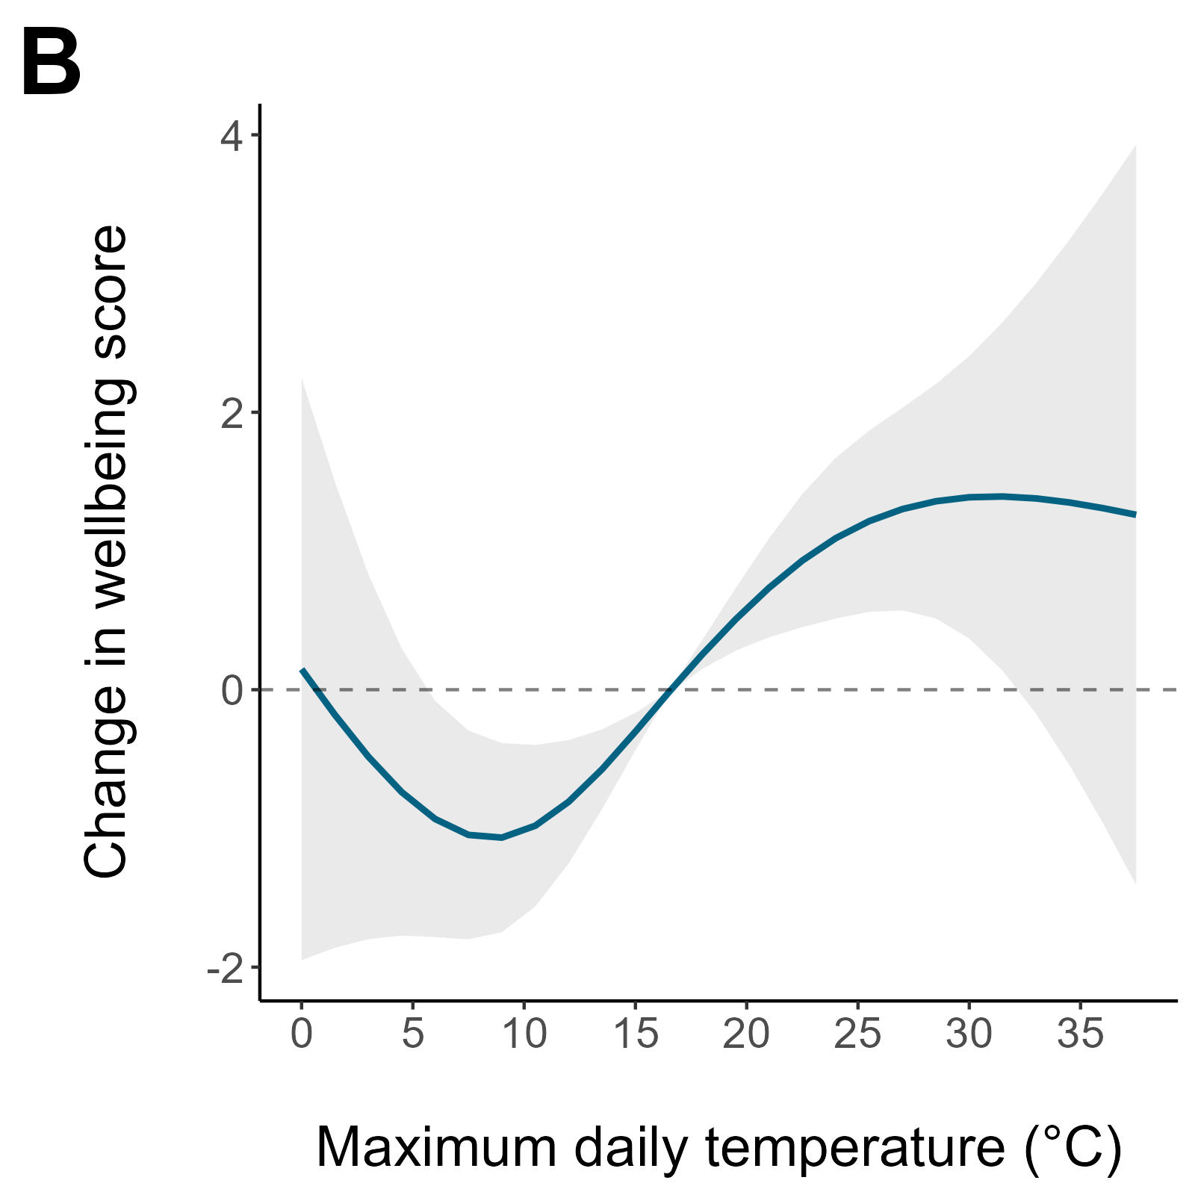
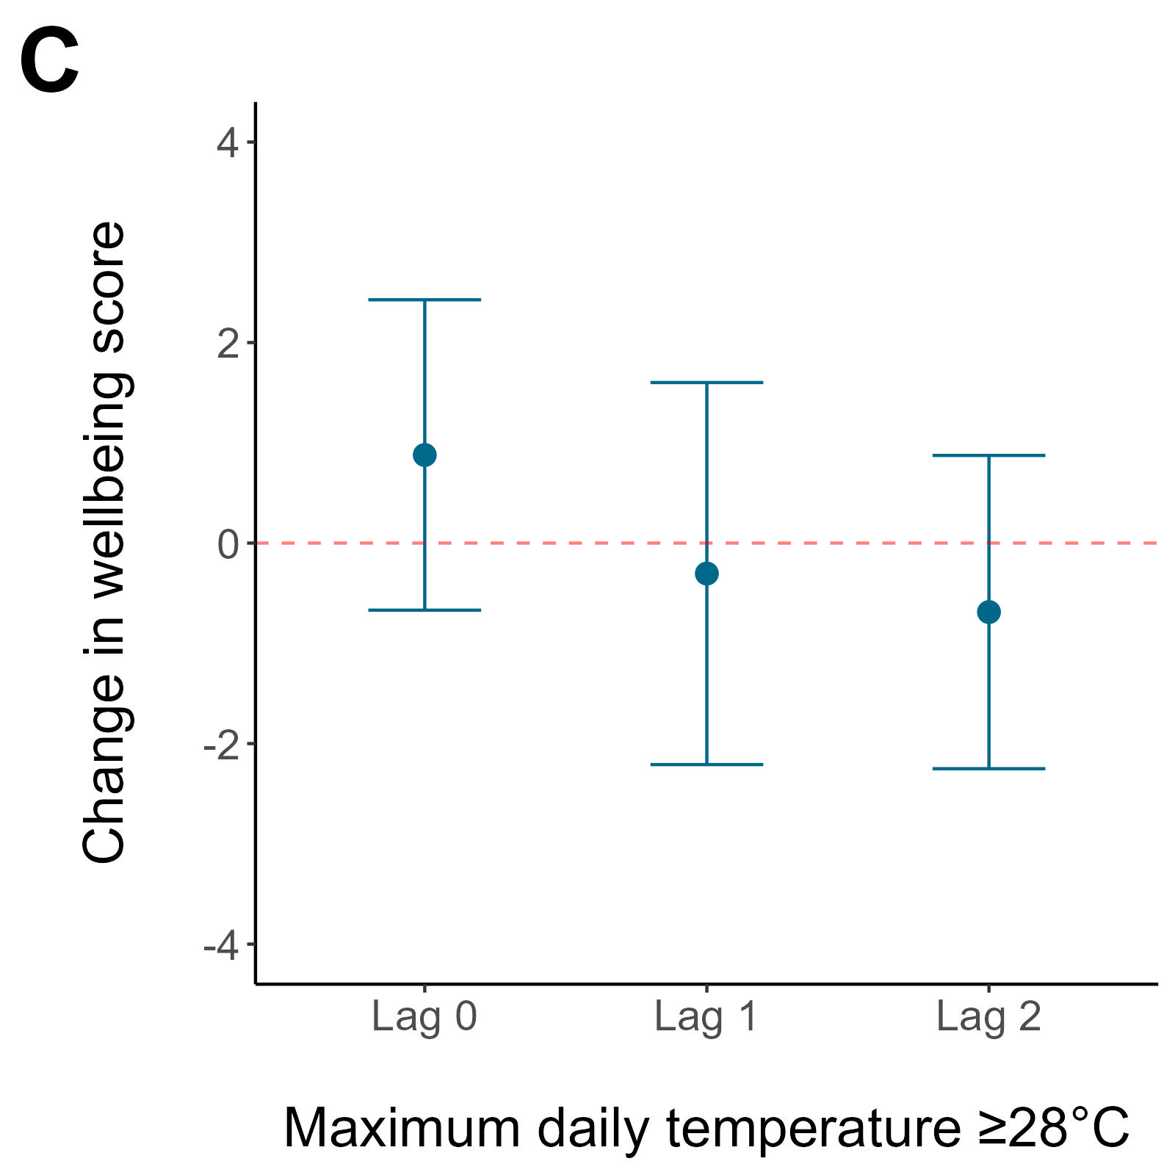
Figure S2: Association between maximum daily temperature and change in mental wellbeing score (complete-case analysis)
Figure shows a 3D contour plot of the change in wellbeing score by maximum temperature and lag (A), the overall cumulative exposure–response relationship (B), and the change in wellbeing score associated with maximum daily temperatures of at least 28°C (C). Changes in wellbeing score are predicted against the reference temperature of 16.6°C (the median maximum temperature in the dataset).
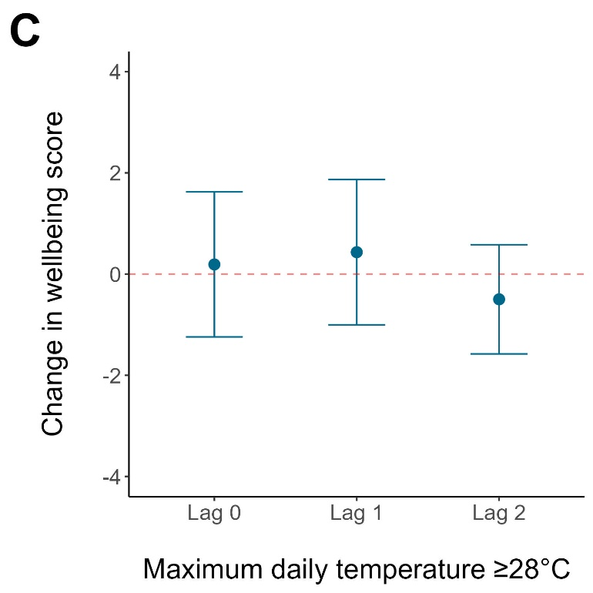
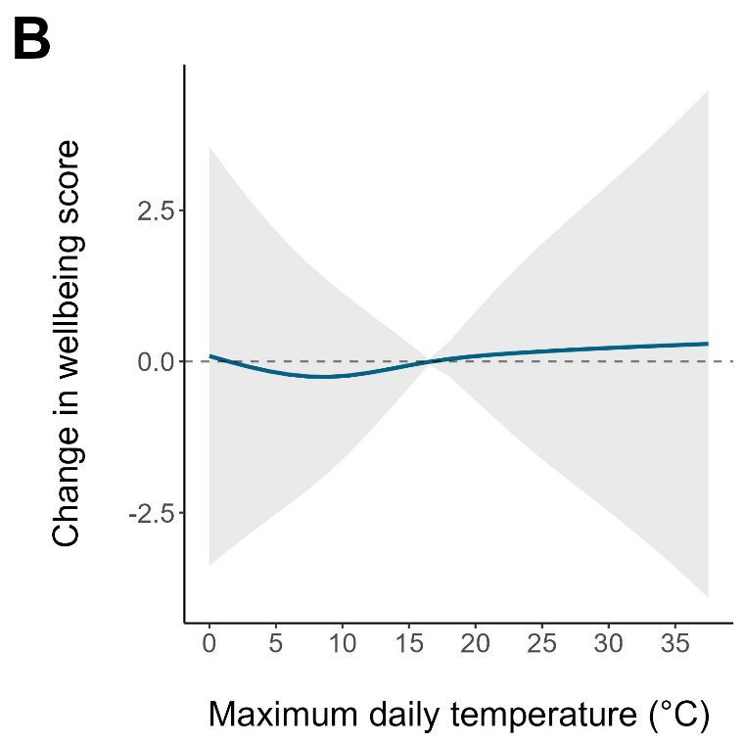
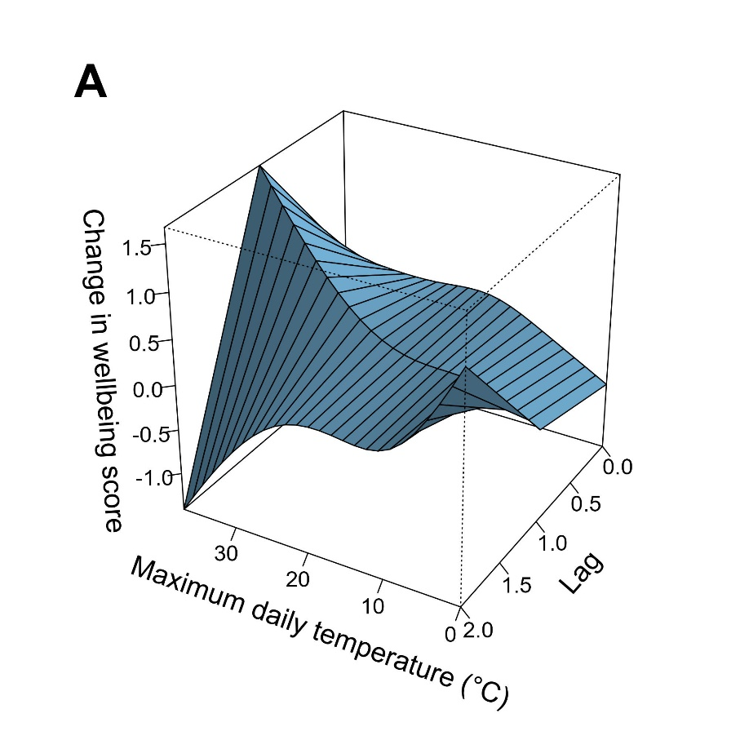

Figure S3: Association between maximum daily temperature and change in mental wellbeing score (25% response dataset)
Figure shows a 3D contour plot of the change in wellbeing score by maximum temperature and lag (A), the overall cumulative exposure–response relationship (B), and the change in wellbeing score associated with maximum daily temperatures of at least 28°C (C). Changes in wellbeing score are predicted against the reference temperature of 16.6°C (the median maximum temperature in the dataset).
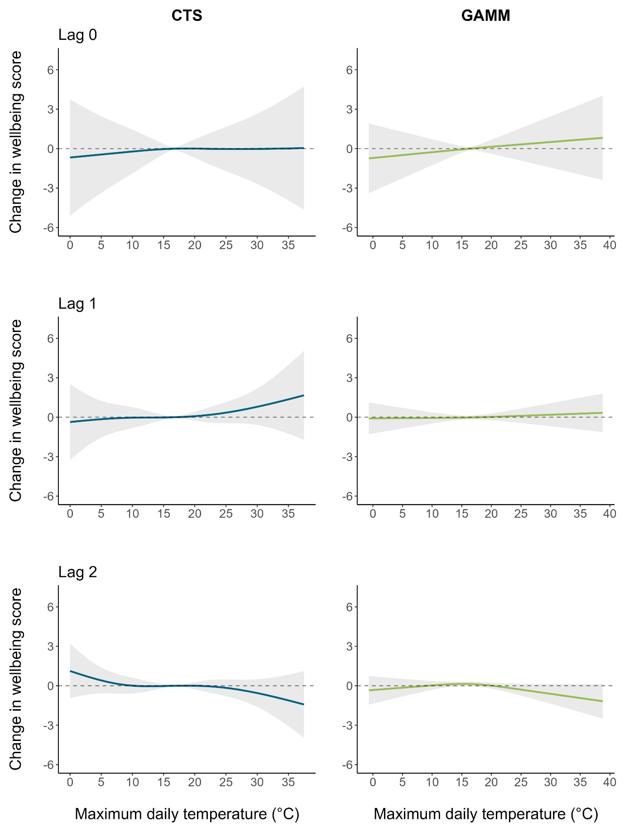

Figure S4: Association between maximum daily temperature and change in wellbeing score by lag and model
CTS=case time series. GAMM=generalised additive mixed model.
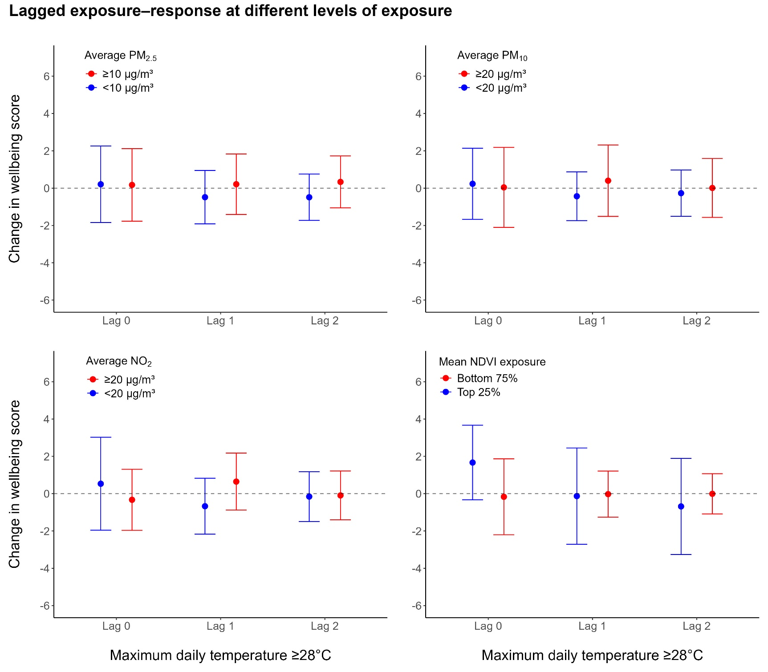

Figure S5: Stratified plots by environmental factors for extreme heat exposure
WHO interim thresholds are used for the three pollutants. Quartiles are used for mean NDVI exposure. Extreme heat is defined as maximum daily temperatures of at least 28°C.
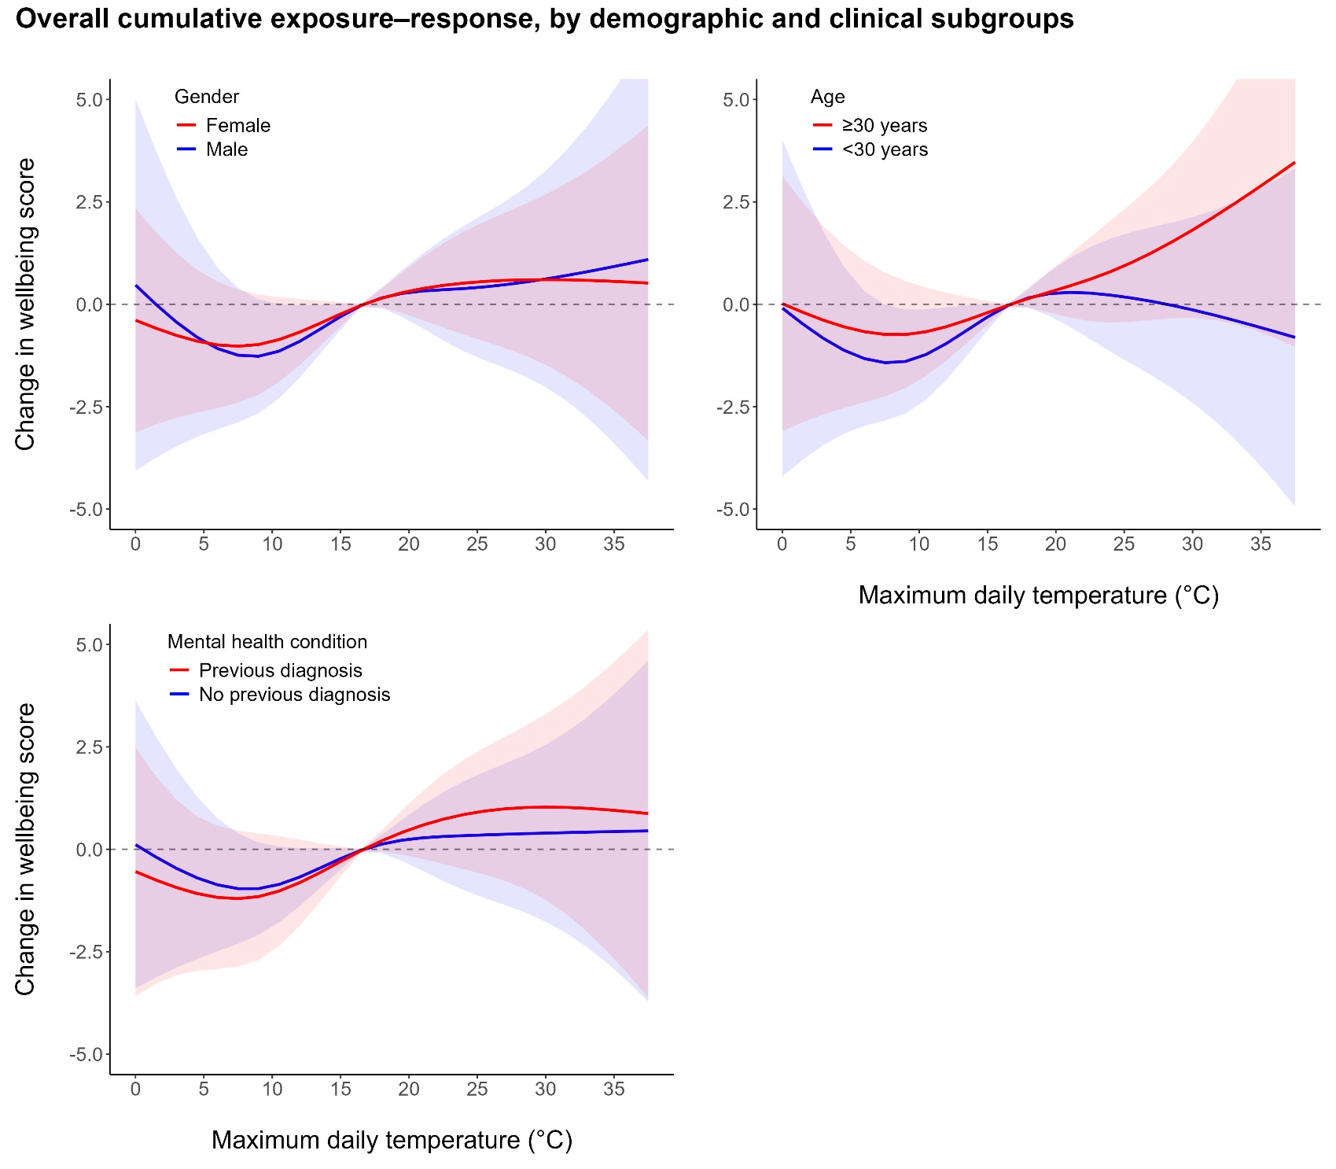

Figure S6: Stratified plots by demographic and clinical subgroups

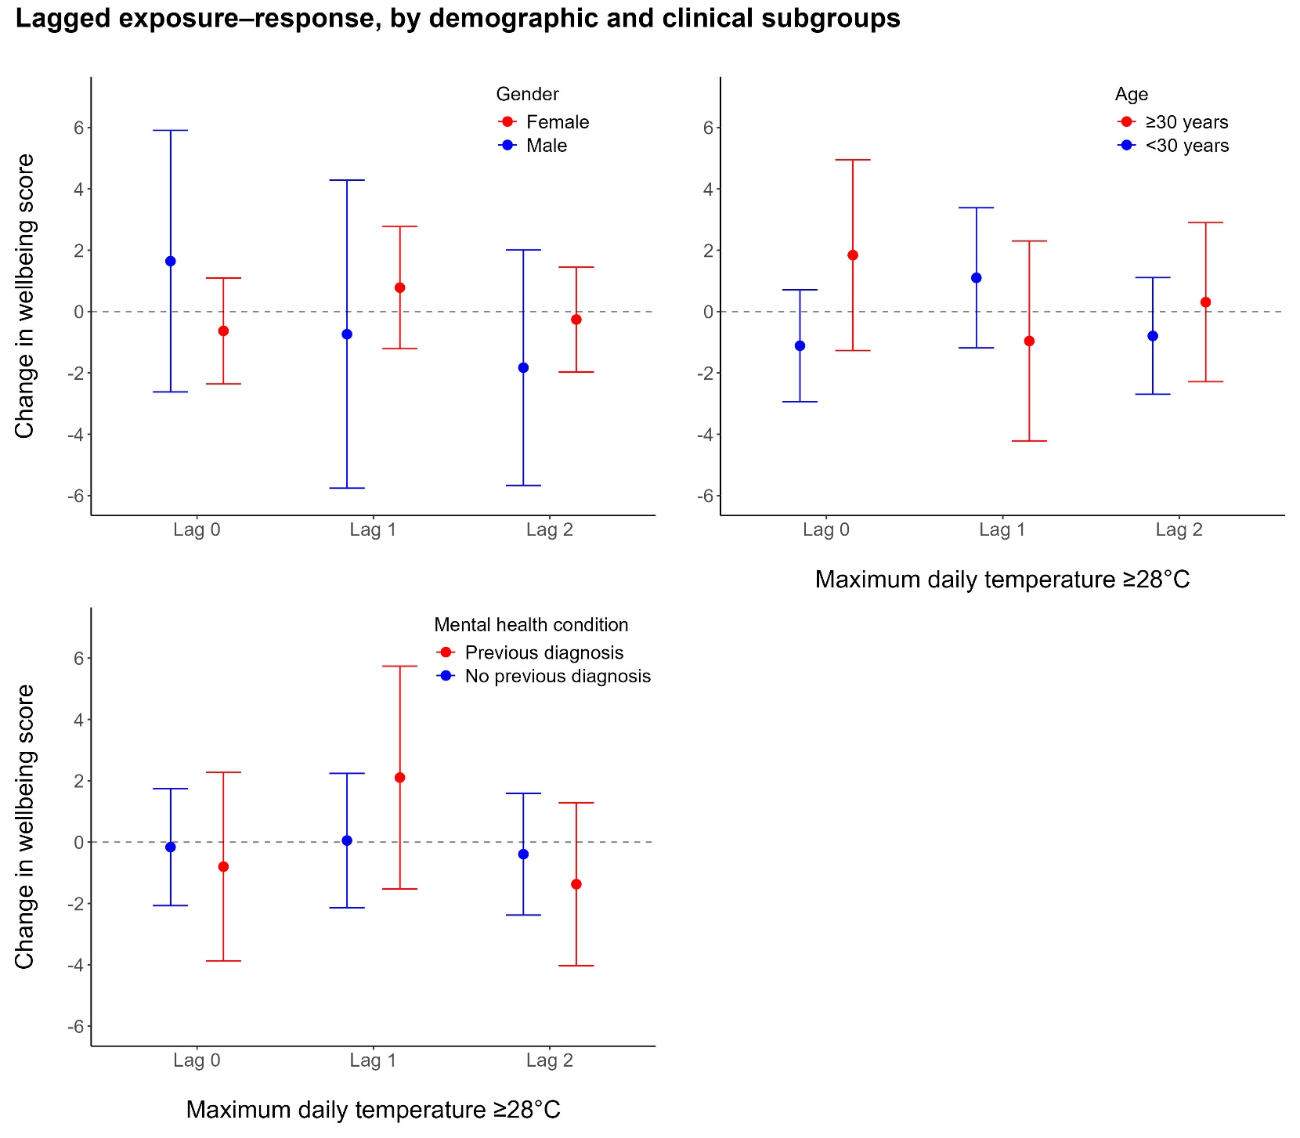

Figure S7: Stratified plots by demographic and clinical subgroups for extreme heat exposure
Extreme heat is defined as maximum daily temperatures of at least 28°C.

