Figure 1. UV–Vis Spectra of Conventional and UV-Assisted CuNPs
UV–Vis absorption spectra showing the characteristic surface plasmon resonance (SPR) bands of copper nanoparticles synthesized by conventional and UV-assisted methods. The conventionally synthesized CuNPs exhibit a broader SPR band centered around 570–590 nm, indicating a wider particle size distribution and possible aggregation. In contrast, the UV-assisted CuNPs display a sharper and slightly blue-shifted SPR peak at ~565–575 nm, characteristic of smaller, more uniform nanoparticles formed under rapid UV-induced nucleation. The observed blue shift and peak sharpening confirm improved size control and enhanced optical properties in the UV-assisted synthesis route.
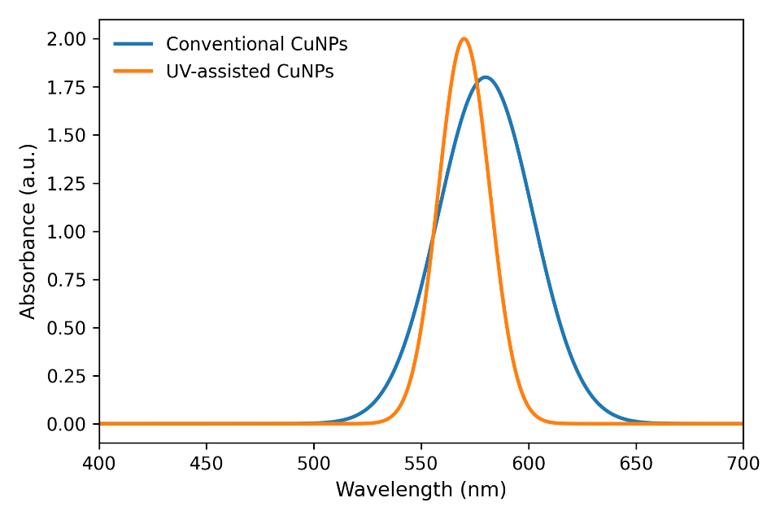
Figure 2. FTIR Spectra of Conventional and UV-Assisted CuNPs
FTIR spectra identifying functional groups responsible for reduction and stabilization of CuNPs. Major peaks include O–H stretching (~3400 cm⁻¹), C=O stretching (1635 cm⁻¹), aromatic and C–N vibrations (~1380 cm⁻¹), and C–O stretching (~1100 cm⁻¹). The increased peak intensity in UV-assisted CuNPs indicates a denser phytochemical capping layer.
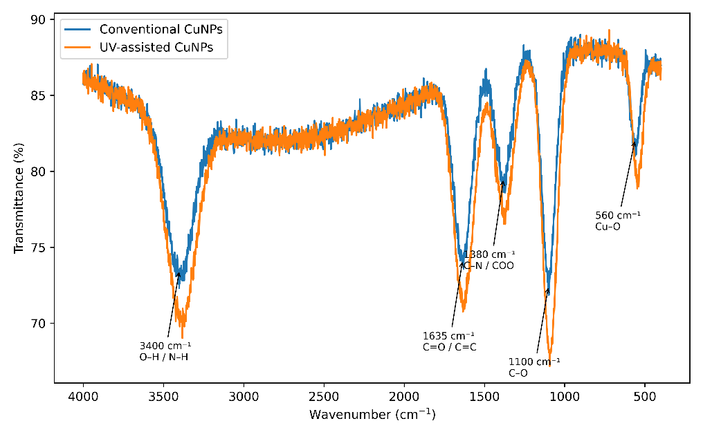

Figure 3. XRD Patterns of Conventional and UV-Assisted CuNPs
X-ray diffraction profiles confirming the formation of face-centered cubic (FCC) copper nanoparticles with characteristic reflections at 2θ = 43.3° (111), 50.4° (200), and 74.1° (220). Minor Cu₂O peaks are present but reduced in UV-assisted samples. Crystallite size estimated by the Scherrer equation shows 25–35 nm for conventional CuNPs and 12–20 nm for UV-assisted CuNPs.
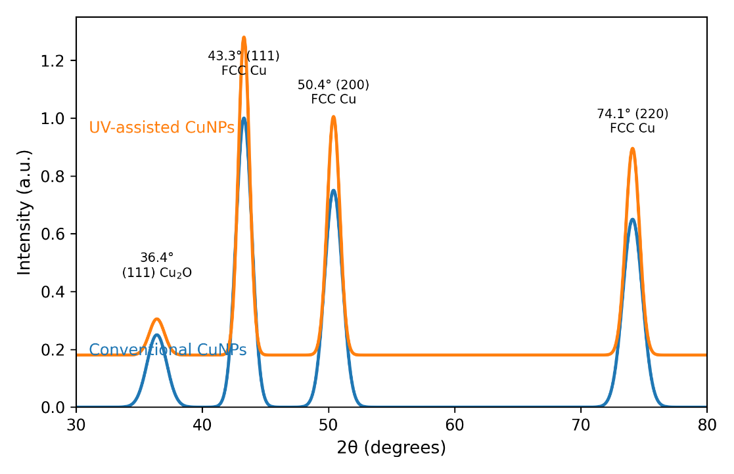
Figure 4. SEM and TEM Micrographs of Synthesized CuNPs
Figure 4(a). SEM micrographs of copper nanoparticles (CuNPs).
SEM image of conventionally synthesized CuNPs (left) shows predominantly spherical to quasi-spherical nanoparticles with slight aggregation and particle sizes in the range of 20–50 nm. In contrast, the SEM image of UV-assisted CuNPs (right) exhibits more compact and uniformly distributed nanoparticles with reduced particle sizes of 8–25 nm, indicating enhanced nucleation and controlled growth under UV irradiation.

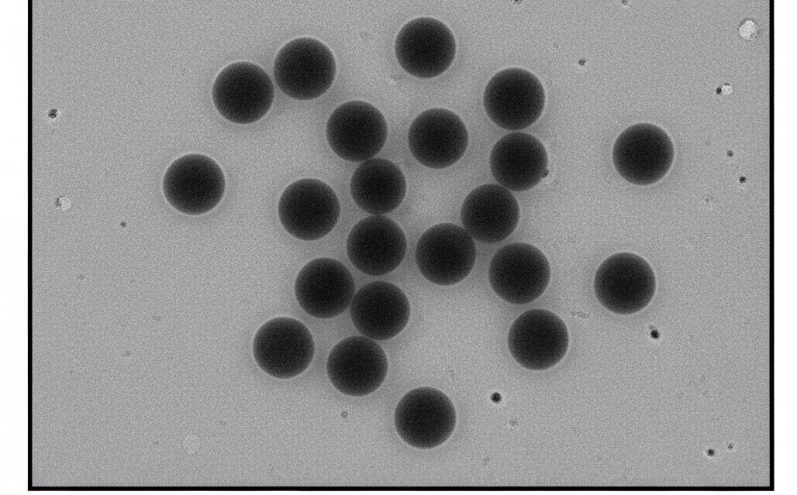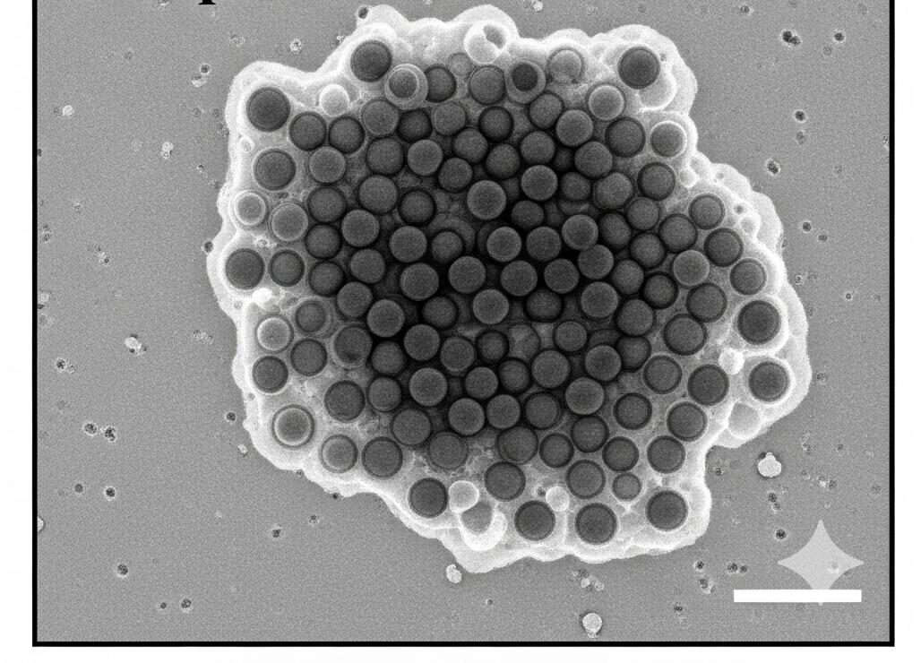
Conventional UV- assisted

Figure 4(b): Comparative TEM micrographs of conventional and UV-assisted CuNPs.
Conventional CuNPs exhibit relatively larger particle sizes (20–50 nm) with noticeable aggregation, whereas UV-assisted CuNPs show uniformly distributed, spherical nanoparticles with significantly reduced size (8–25 nm). The enhanced size control and compact arrangement observed in UV-assisted CuNPs are attributed to rapid nucleation and effective phytochemical capping induced by UV irradiation.

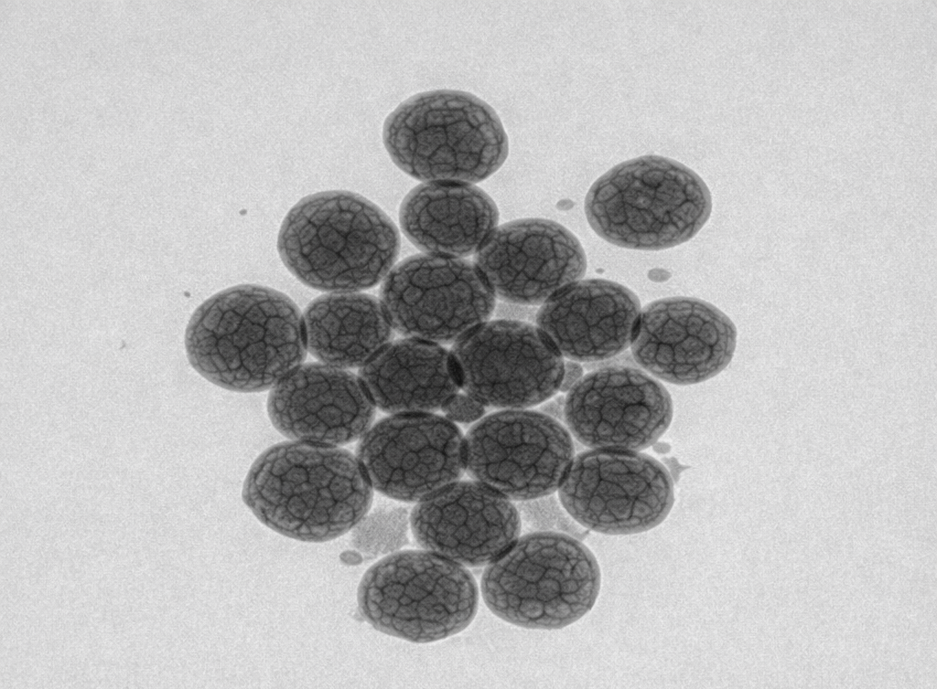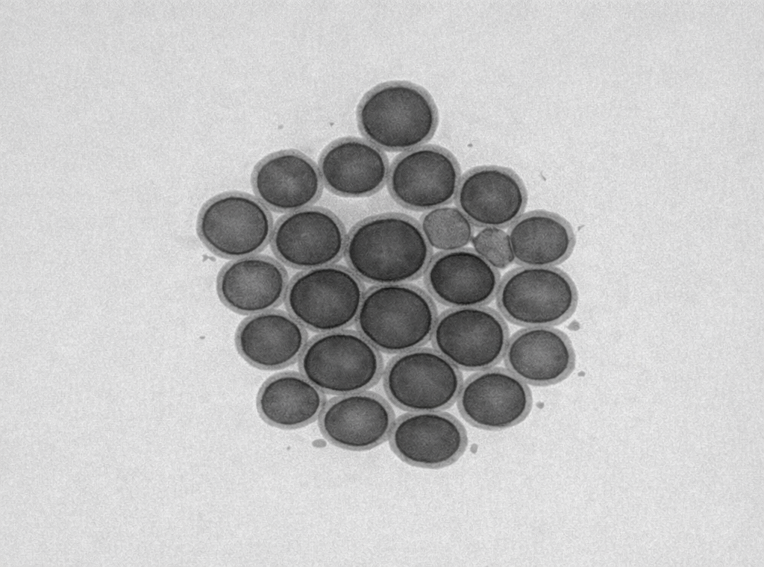

Conventional Cu NPs (20-50 nm) UV-assisted Cu Nps Phytochemical
Capping (8-25 nm)

Figure 5. Comparative stability and morphology of copper nanoparticles (CuNPs).
(A) Conventional CuNPs: Schematic representation and TEM micrograph showing spherical nanoparticles with a particle size range of 20–50 nm and moderate dispersion. The zeta potential value of −29.5 mV indicates good colloidal stability.
(B) UV-assisted CuNPs: TEM image reveals highly uniform, well-dispersed spherical nanoparticles with smaller sizes (8–25 nm) and a visibly thicker phytochemical capping layer. The enhanced surface passivation results in improved colloidal stability, as evidenced by zeta potential values ranging from −30 to −38 mV.

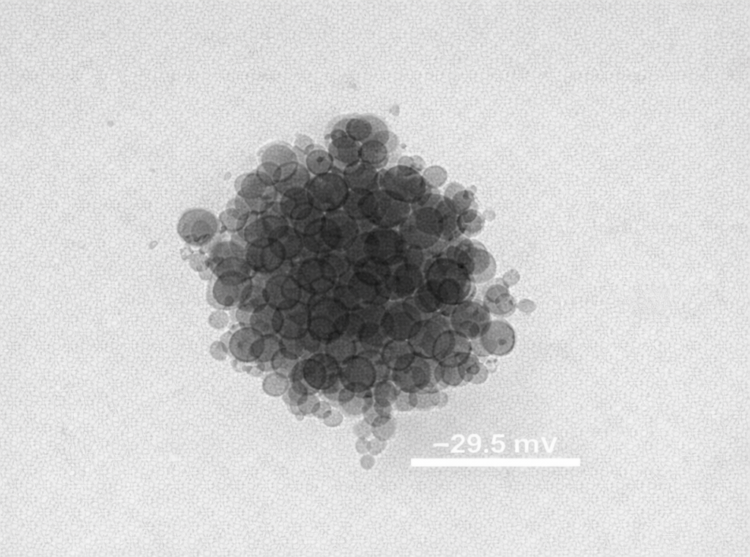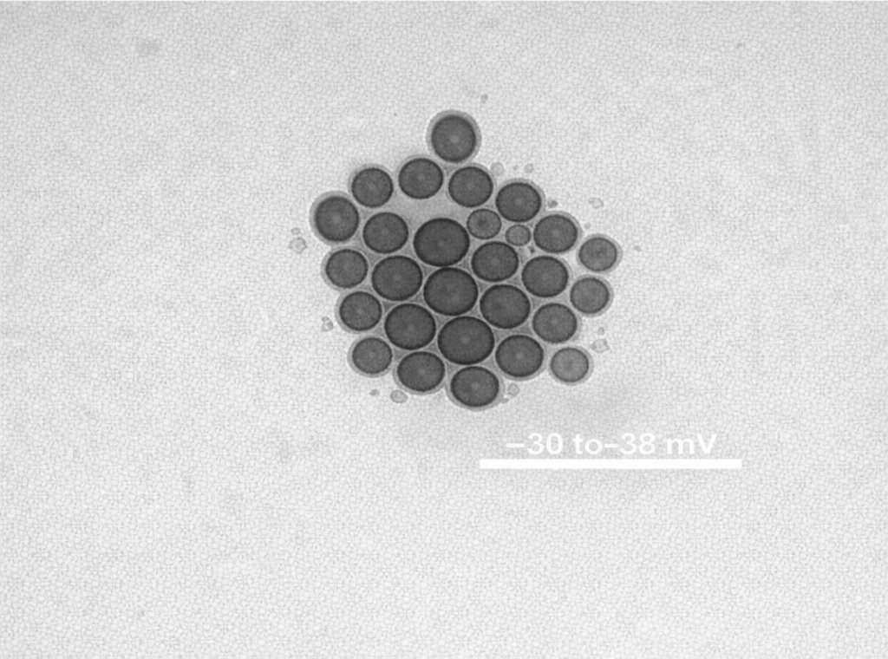

Conventional Cu NPs(-29.5mV) Conventional Cu NPs(-30 to -38 mV)

Figure 6. Antibacterial activity of conventional and UV-assisted copper nanoparticles (CuNPs).
Representative zone of inhibition (ZOI) images showing antibacterial efficacy against Escherichia coli (Gram-negative) and Staphylococcus aureus (Gram-positive). Conventional CuNPs exhibited inhibition zones of 18.6 ± 0.8 mm against E. coli and 21.4 ± 1.1 mm against S. aureus. In comparison, UV-assisted CuNPs showed enhanced antibacterial activity with ZOI values of 20.1 ± 0.7 mm (E. coli) and 22.9 ± 0.9 mm (S. aureus). The increased inhibition zones observed for UV-assisted CuNPs are attributed to their smaller particle size, higher surface area, and improved surface reactivity.
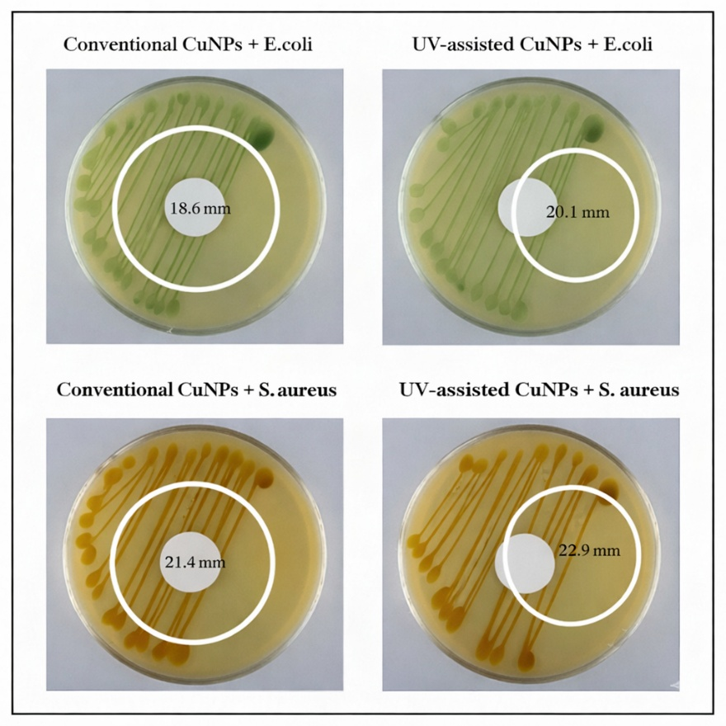

Table 1. Comparative characteristics of conventionally synthesized and UV-assisted copper nanoparticles

Parameter | Conventional CuNPs | UV-assisted CuNPs
Synthesis route | Chemical/thermal reduction | UV-assisted green synthesis
Reducing agents | Chemical reagents | Plant-derived phytochemicals
Capping/Stabilizing agents | Absent or weakly bound | Phytochemical capping (polyphenols, flavonoids)
Average particle size (TEM) | 20–50 nm | 8–25 nm
Particle size distribution | Broad | Narrow
Particle shape | Spherical with partial aggregation | Uniform, well-defined spherical
Surface morphology | Rough / clustered | Smooth surface with visible organic shell
Degree of agglomeration | High | Minimal
Dispersion behavior | Moderately dispersed | Highly dispersed
Zeta potential | −29.5 mV | −30 to −38 mV
Colloidal stability | Moderate stability | High colloidal stability
Role of phytochemicals | Not applicable | Act as reducing + capping agents
Overall structural uniformity | Lower | Higher

