Supplementary information for

Is Platinum a Proton Blocking Catalyst?
  - Aparna Saksena*ª, Bingxin Liª, Yujun Zhaoª, J. Manoj Prabhakar^{a,b}, Jörg Neugebauerª, Mira Todorovaª, Dierk Raabeª, Baptiste Gault^{a,c}, Yug Joshi*ª

ª Max Planck Institute for Sustainable Materials, Max-Planck-Straβe 1, Düsseldorf 40237, Germany
^{b} Department of Metallurgical and Materials Engineering, Indian Institute of Technology Madras, Chennai, 600036, India
^{c} Univ Rouen Normandie, CNRS, INSA Rouen Normandie, Groupe de Physique des Matériaux, UMR 6634, F-76000 Rouen, France
*corresponding author: a.saksena@mpi-susmat.de, y.joshi@mpi-susmat.de

Atom probe Tomography (APT)
For APT measurements and D analysis of the specimen extracted from Pt_{DER}, the probability of molecular ions detected at 2 and 3 Da cannot be neglected. The contribution to these peaks is convoluted as for peak at 2 Da either/both H₂⁺ molecular ion or/and D⁺ ion is possible. Similarly peak at 3 Da can have contributions from either/both H₃⁺ molecular ion and/or DH⁺ ion. This depends on the instantaneous field conditions, where the charge state ratio (CSR) of the detected Pt can be used as a proxy. To accurately estimate the observed D in the Pt_{DER} specimen that underwent DER at a constant current density of −2.4 mA∙cm⁻² for 12 h, reference Pt specimens are extracted from pristine Pt samples. The field condition is varied by changing the laser pulse energy from 70 pJ to 150 pJ, where the overall mass spectra obtained from 3 such specimens are shown in Fig. S1. Since these specimens are not influenced by any D interaction, the peak at 2 Da exclusively corresponds to the field evaporation of H₂⁺ molecular ion.
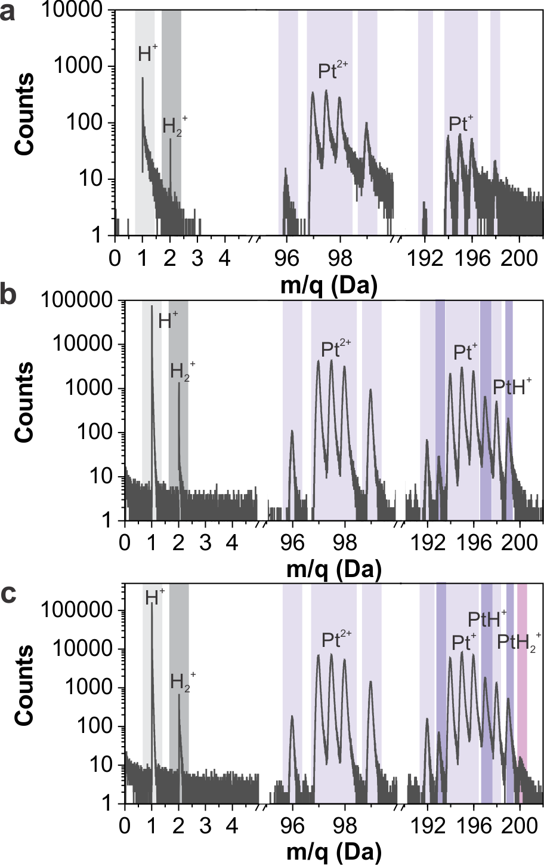
Fig. S1 shows the overall mass spectrum collected from Pt reference specimens, where the field conditions are varied by changing the applied laser pulse energy.
Based on the reference measurements shown in Fig. S1, log of CSR of Pt¹⁺ is plotted as a function of the relative concentration of the H₂⁺ with respect to the detected H⁺, shown in Fig. S2a, represented by black open circles. Also, for this quantification only the first isotope of Pt, for both charge states, is considered to avoid any influence of the detected PtH⁺ ions. The quantitative values of the instantaneous field are shown at various CSRs which are extracted from the calculated Kingham plots for Pt. Similar analysis is performed for the Pt_{DER} specimen, shown in Fig. S2A with red squares. Field conditions similar to Pt_{DER} specimen is successfully reproduced by the reference measurements, where overlap between 26.5 V∙nm⁻¹ and 29.3 V∙nm⁻¹ can be clearly observed. It is evident that at similar field conditions, Pt_{DER} specimen shows much higher 2 Da/H⁺ ratio compared to the reference measurements, clearly indicating contributions of D within this peak. At these field conditions, no peak at 3 Da is observed in the reference measurements which also indicates the sole contribution from DH⁺ ions in the case of Pt_{DER}. These findings allowed us to correct the one-dimensional concentration profile extracted from the Pt_{DER} specimen, where the unprocessed concentration is shown in Fig. S2b. The contributions from peaks at 3 Da and 4 Da is shown in Fig. S2c along with the expected H₂⁺ ion contributing to the peak at 2 Da. The expected H₂⁺ ions are estimated by multiplying the measured H⁺ ion concentration in the Pt_{DER} specimen by the 2 Da/1 Da ratio obtained from the reference measurements for the corresponding field conditions. Fig. S2c also shows the background hits that are estimated by ranging the region in the vicinity of a peak (at 2, 3 and 4 Da) in the mass spectrum, of the same width. The final estimation of D as a function of distance is obtained by adding all of the contributions from peak at 2 Da, 3 Da, twice from 4 Da (D₂⁺ ion) while subtracting the expected H₂⁺ ion and background associated for all 3 peaks, as shown in Fig. S2d.
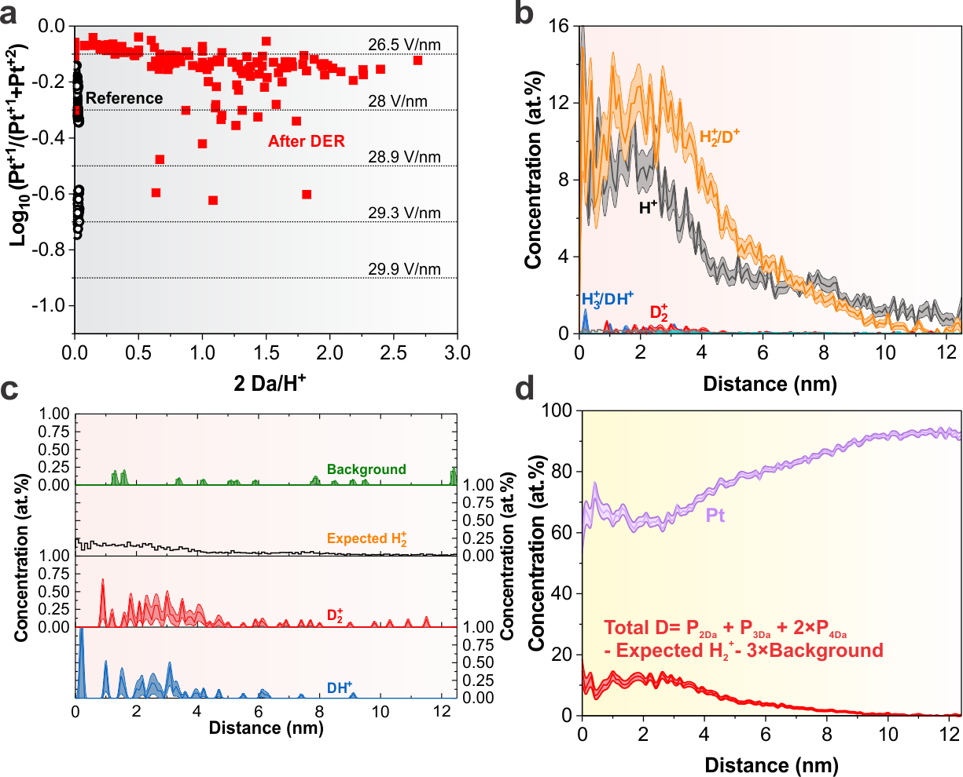
Fig. S2: a) shows the relative concentration of peak at 2 Da with respect to the peak at 1 Da as a function of the field, estimated by the charge state ratio of Pt⁺¹ and Pt⁺². b) shows the unprocessed one dimensional concentration profile of the Pt specimen after DER. c) shows the one dimensional concentration profile of the observed background, expected H₂⁺ contribution, estimated from the reference data in A), D₂⁺ and DH⁺. d) shows the corrected, total D observed in the specimen as a function of distance from the measurement direction.

Thermal desorption spectroscopy
Fig. S3 shows the thermal desorption spectra where the desorbed hydrogen as a function of temperature is monitored using a mass spectrometer. A heating ramp of 8 °C∙min⁻¹ is applied. The reference Pt sample is monitored to detect the background and compared to the Pt sample that underwent constant current HER at a current density of −2.4 mA∙cm⁻² for 12 h.
Fig. S3: Thermal desorption spectrum of the reference Pt and after constant current HER

Error function fitting for D in Pt
The error function used for fitting the composition profile is given in Eq. SE1.
$C\left(x,D,t\right)=C_{1}+\left(C_{0}-C_{1}\right)erf⁡\left(\frac{x-x_{0}}{2\sqrt{Dt}}\right)$ SE1
Where $C$ is the concentration of D in Pt in at. %; $C_{1}$ is surface concentration; $C_{0}$ is concentration at infinite distance; $D$ is the diffusion coefficient of D in Pt; $t$ is time; $x$is the depth of the thin-film. $C_{1}$ is kept constant to be 50 at.% with the assumption that any correction is done automatically via the displacement of the error function by $x_{0}$ which is a fitting variable; $C_{0}$ is set to zero as the concentration goes to zero at 10 nm; and $t$ is kept constant at 12 h or 43200 sec.

Calibration curve for the electrochemical Quartz Crystal Microbalance (eQCM)
Fig. S4. The calibration curve, it is used to determine the sensitivity factor.

Kingham, D. R., The post-ionization of field evaporated ions: A theoretical explanation of multiple charge states. Surface Science 1982, 116 (2), 273-301.

