Table 1s. Risk of Bias Assessment using the RoB 2 Tool.
Study | Randomization Process | Deviations from Intended Interventions (Performance Bias) | Missing Outcome Data (Attrition Bias) | Measurement of the Outcome (Detection Bias) | Selection of the Reported Result (Reporting Bias) | Overall Risk of Bias
Coratella 2019 (61) | Low | High | Low | Moderate | Low | Moderate
de Hoyo 2015 (65) | Low | High | Low | Moderate | Low | Moderate
Edvard 2020(20) | Low | Moderate | Low | Low | Low | Moderate
Raya-González 2021(66) | Low | High | Low | Moderate | Low | Moderate
Nuñez 2019 | Low | High | Low | Moderate | Low | Moderate
Jarosz 2023 | Low | High | Low | Low | Low | Moderate
Pecci 2023 | Low | High | Low | Moderate | Low | Moderate
Fajardo 2016(21) | Low | High | Low | Moderate | Low | Moderate
Table 2s. GRADE Certainty of Evidence Table for the Main Outcomes.
Outcome | No. of Studies | Study Design | Risk of Bias | Inconsistency | Indirectness | Imprecision | Publication Bias | Certainty (GRADE)
CMJ Height | 7 | RCTs | Moderate | Not serious | Not serious | Serious | Unlikely | Moderate
10-m Sprint Time | 6 | RCTs | Moderate | Not serious | Not serious | Serious | Unlikely | Moderate
20-m Sprint Time | 4 | RCTs | Moderate | Not serious | Not serious | Serious | Unlikely | Low–Moderate
30-m Sprint Time | 4 | RCTs | Moderate | Serious | Not serious | Serious | Unlikely | Low
COD Performance | 4 | RCTs | Moderate | Serious | Not serious | Serious | Unlikely | Low

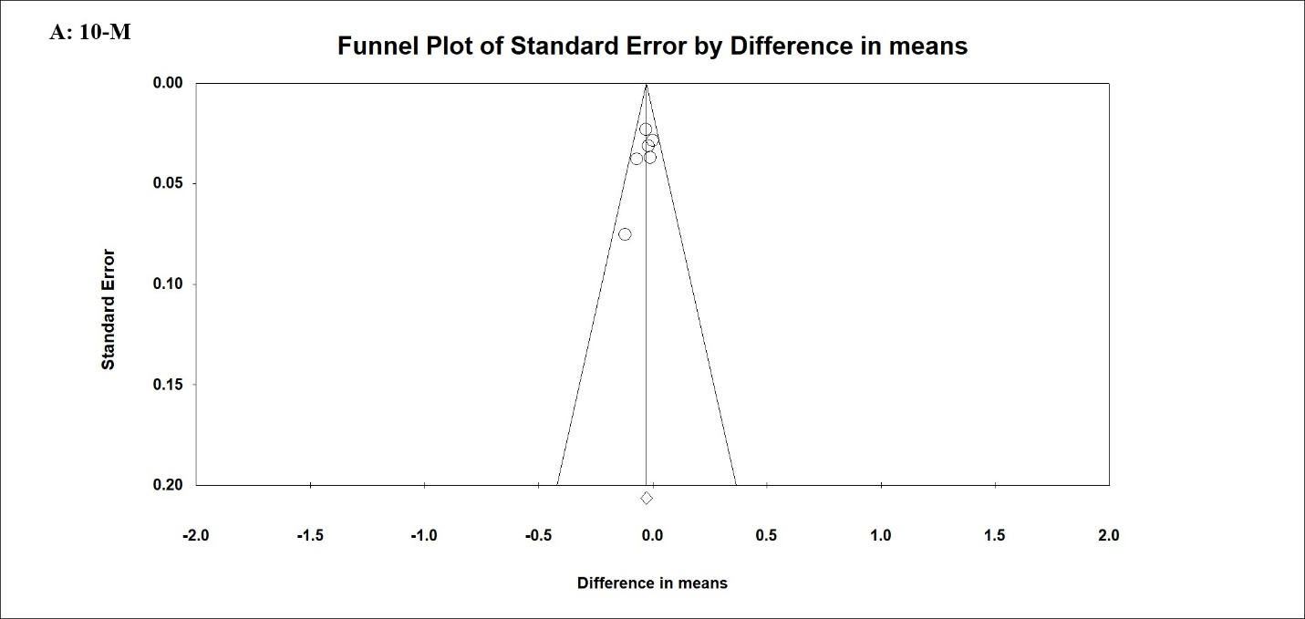
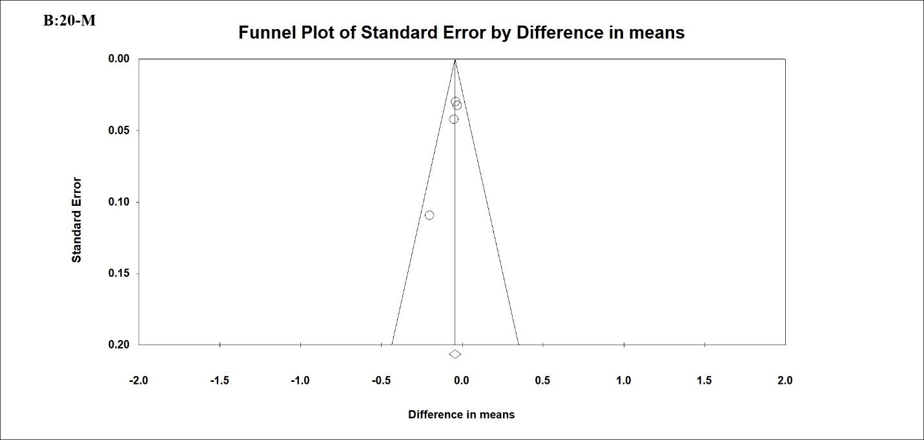
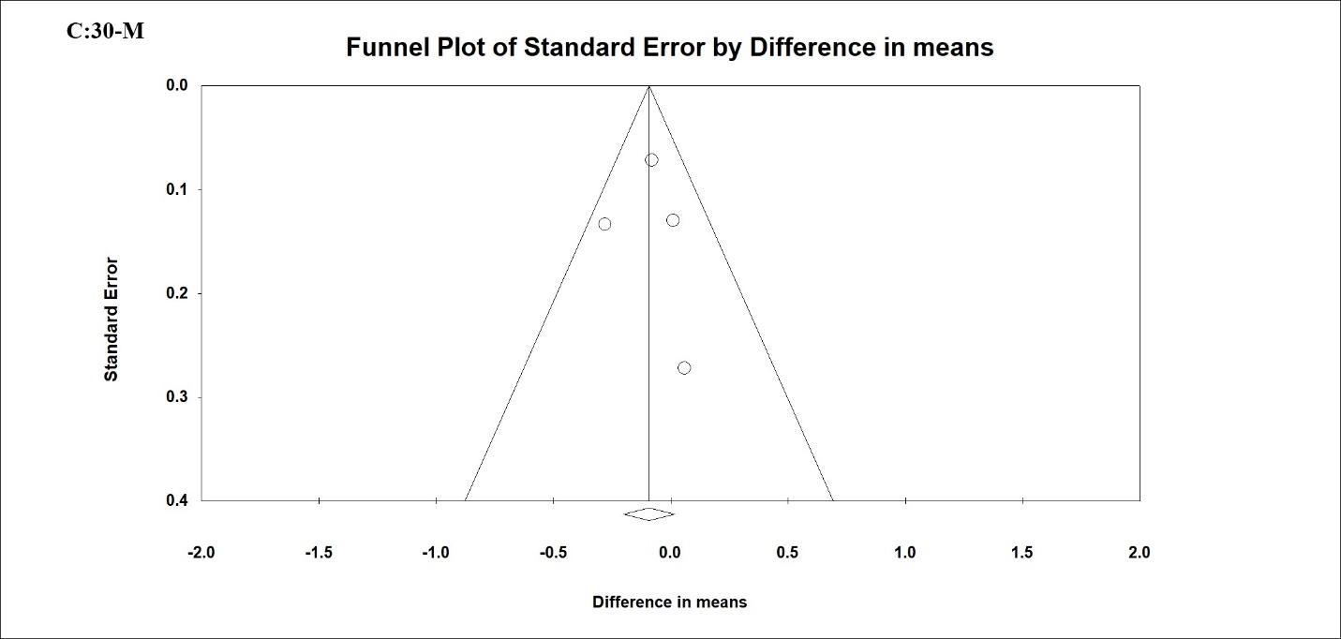
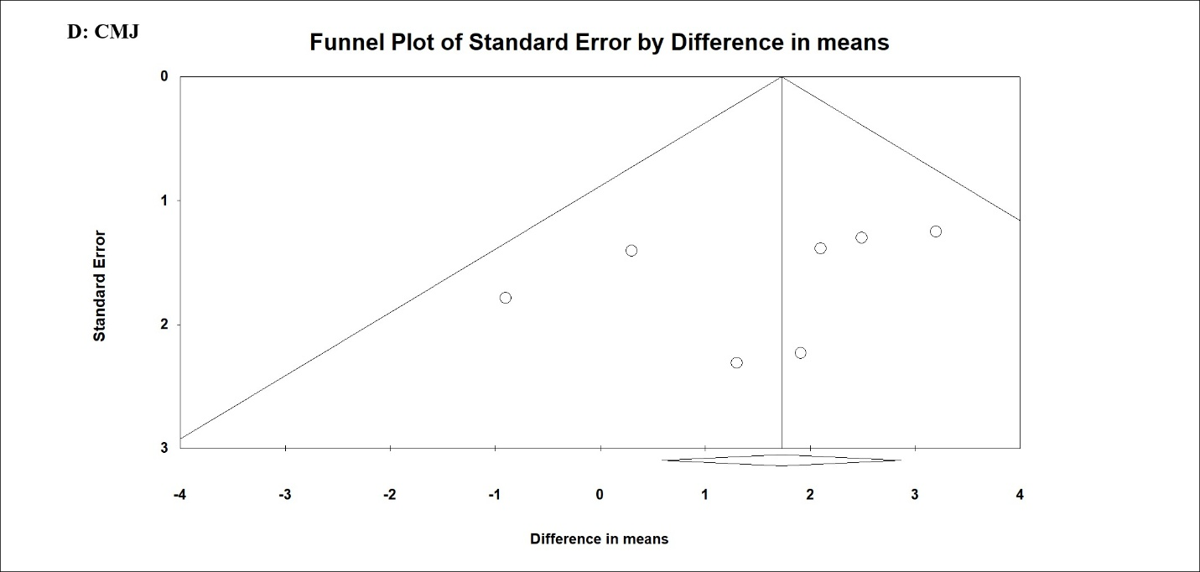
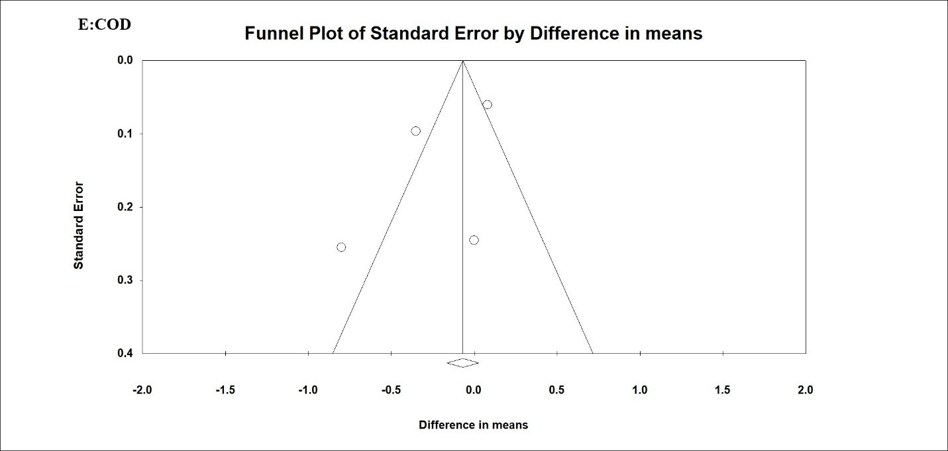
Fig. 1s. Panels A–E. Funnel plot of standard error by difference in means.

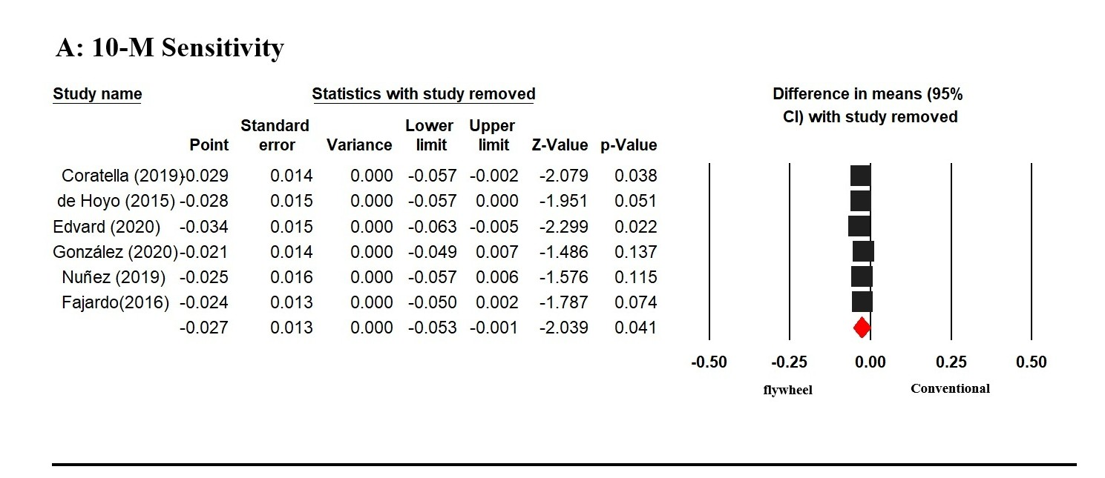
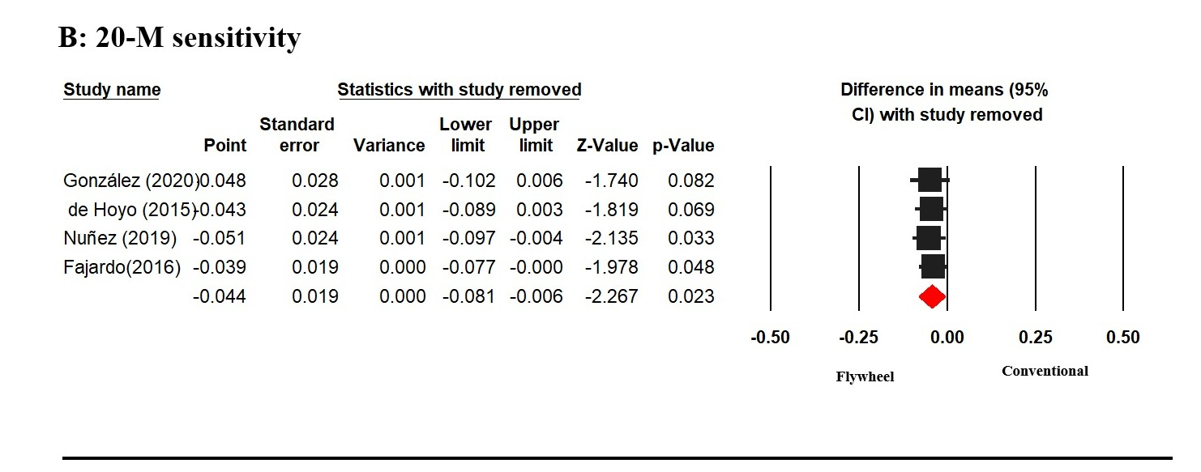
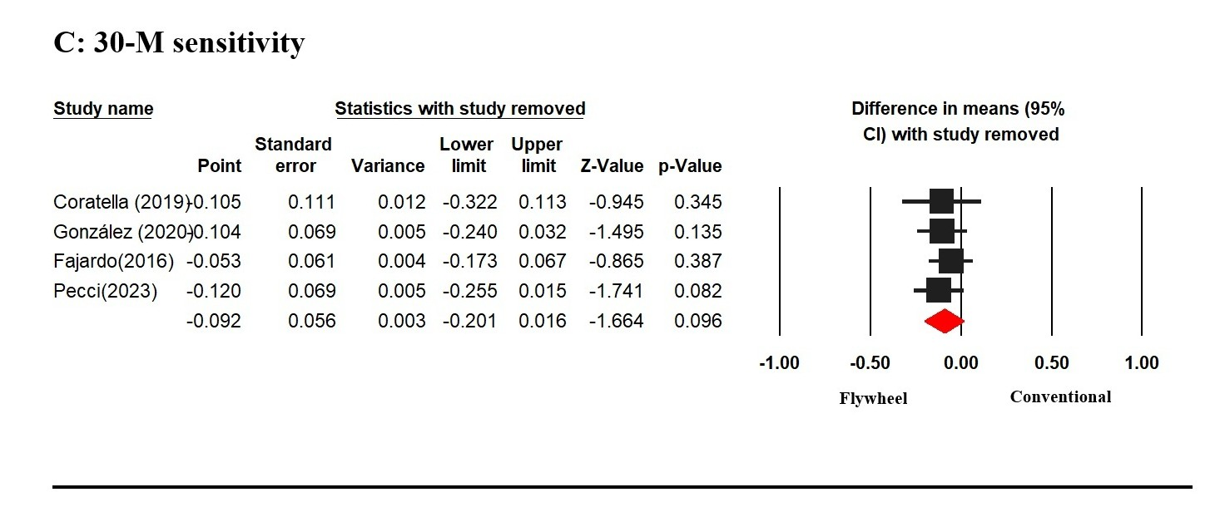

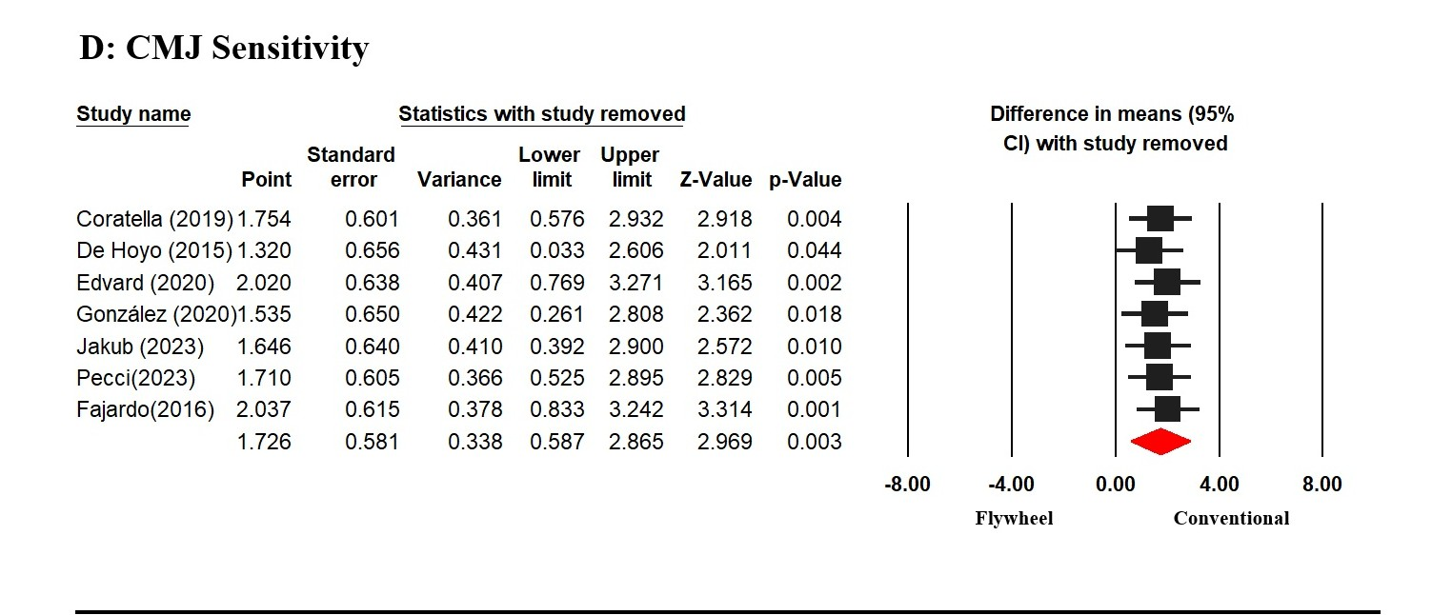
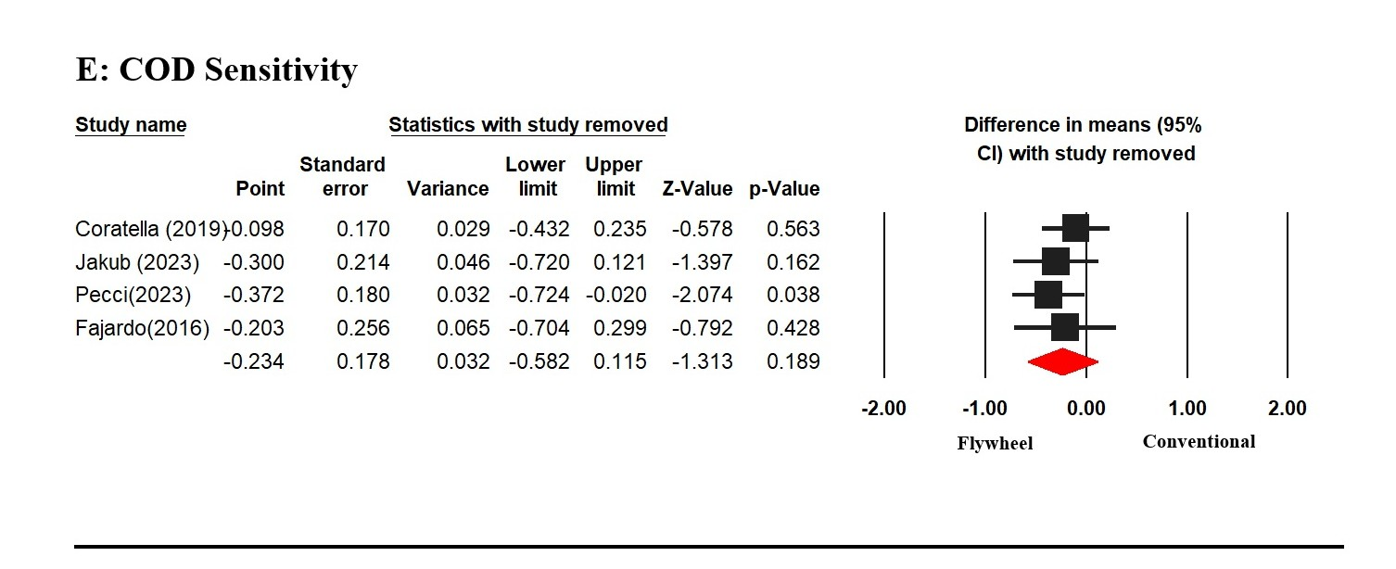
Fig. 2s. Panels A–E. Forest plot of sensitivity analysis by one leave out test.

